URBS 230: Final Exam Review
23 October 2018 (After MT)
Socialist and Post-Socialist Cities (Week 8)
- Engels was concerned with inequality on the condition of the working class in England
- Conditions of different classes of society, pollution, etc.
- The working class had no capital at the time

- Timeline
  - Laissez-faire capitalism: mid 1800s to early 1900s
  - Rise of welfare states/Keynesianism, state socialism: early 1900s-1970s
  - Post WWII boom in First World: 1945-1970s
  - Changes in global economy: 1960s-1970s
  - The shift towards “neo-liberal’ economic policies: 1970s-1980s
  - Rise of global cities, collapse of the Second World, and urbanization of the former Third World/Global South: 1970s to present

- Poverty in London
  - Charles Booth, a wealthy Liverpool businessman, was a skeptical about a socialist claim in 1885 that a quarter of London population lived in extreme poverty, so he employed teams of young people to investigate. Partly through interviews and partly from census returns and School Board visitors’ records, they concluded that the true figure was 30%. The findings were entered by hand onto a very detailed ‘Master Map’ using seven colour categories ranging from black…through…gold…This sheet shows the variety to be found in Westminster. The published report and maps which appeared from 1891 were taken seriously. The first Council houses were built shortly afterwards (Barber, 2012, p. 235-6).

- Political & Economic Ideologies
  - Socialism: Communism, Social Democratic
  - Liberalism: Classical Liberalism, Reform Liberalism, Neoliberalism

- Economic Systems
  - Liberal Market Economies:
    - US, UK, Canada, Australia, New Zealand, Ireland
  - Coordinated Market Economies:
    - Germany, japan, Sweden, Austria, Singapore, South Korea
  - Centrally-Planned Economies:
    - Cuba, North Korea
  - Transition Economies:
    - China, Russia (and other former USSR), Vietnam

- Friedrich Engels
  - Social Warfare
  - “Now every enterprising man sought to be a despot”
  - “Brutal indifference”
  - “Narrow self-seeking behaviour”
25 October 2018
Socialist and Post-Socialist Cities (Week 8)
- Three Main Points Covered Today:
- Why government intervention activity increased
- What did it look like in terms of city building
- Neo-liberalism

- Problems with Free Market Capitalism
  - Boom/bust cycles in the market economy/business and recession/depressions, resulting in mass unemployment and business failures.
  - Markets/private business fail to provide some goods (things that fulfill wants and needs) called “public goods” (classic example of a “pure public good” is national defense); urban planning (coordination of infrastructure and land use) and basic infrastructure networks (water supply, roads) are others.
  - Negative externalities/social costs of market/business activity (e.g. air and water pollution) are borne by all, and not paid for by the businesses).

- Problems with Free Market Capitalism: Response of Socialist Economies
  - Socialism (implemented through systems of communist or social democracy) proposes to address these problems by replacing market/business activity with non-profit provision of goods (both public and private)

- Keynesian (from economist John Maynard Keynes) Economic Theory
  - “Keynesian” -governments could increase expenditures and decrease taxation when signs of recession appear in order to keep employment high and offset downturn – pursued in liberal market economies from 1940s to 1970s (and revised following 2008/2009 global economic crisis)

- Nationalization of government is a public takeover
- Federal government of Canada doesn’t do much in city building
- In 1911, there was nationalization of the transportation companies in Montreal
- In 1919, Canadian National Railways was created
- In 1936, CBC was created to provide public radio broadcast and later on, video broadcast
- CMHC created in 1946 to address major shortages in housing
  - Provides mortgage loan insurance

- Public/non-market and private/market provision and ownership in different types of economies
 | Centrally Planned Economies | Coordinated Market Economies | Liberal Market Economies | Neo-Liberal
Land | Public | Public & Private | Private (& Small Public) | Private
Housing | Public | Public & Private | Private (& Small Public) | Private
Infrastructure | Public | Public | Public (& Small Private) | Private

- Examples of urban growth with high level of public sector participation: Vallingby, Granville, Habitation Jeanne Mance
- Granville, Vancouver: Example of high level of government planning
- There has been a turn towards private sector development
- “Neoliberalism is principally a political project of embedding market values and structures not just within economic, but also within social and political life. Its objective is a reshaping of power relations” (Rodan, 2004, p. 1).
30 October 2018
Global Cities (Week 9)
- Neo-Liberalism: A set of beliefs of how society should be organized. It is kind of like a reaction against socialism
- “Neoliberalism is in the first instance a theory of political-economic practices that proposes that human well-being can best be advanced by liberating individual entrepreneurial freedoms and skills within an institutional framework characterized by strong private property rights, free markets, and free trade. The role of the state is to create and preserve an institutional framework appropriate to such practices” (Harvey, 2005, p. 3).
- One of the effects of neoliberalism is the Government seeking to reduce expenditures

- 1945 Bretton Woods (all that was designed in the aftermath of WWII):
  - Development of the UN
  - IBRD (“World Bank”)
  - IMF (International Monetary Fund)
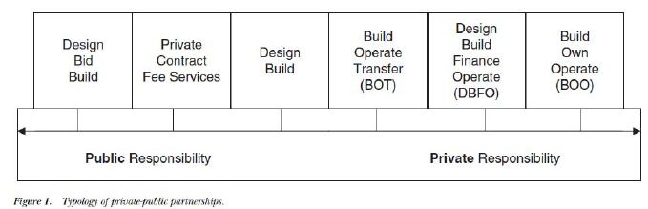

- Changes in the Global Economy in 1970s and 1980s
  - “…geography and composition of the global economy changed so as to produce a complex duality: a spatially dispersed, yet globally integrated organization of economic activity” (Sassen, 2001, p .3).

- Global City – “a new strategic role (Sassen)
  - Highly concentrated command points in the organization of the world economy
  - Key locations or finance and specialized service firms
  - Sites of production, including of innovations
  - Markets for products and innovations

- Why Global Cities in the 1980s?
  - Territorial dispersal of economic activity (globalization) creates need for expanded central control and management
  - Sites of production, of (i) specialized services needed by complex organizations (ii) production of financial innovations & making of markets (“The ‘things’ a global city makes are highly specialized services and financial goods.”) (Sassen).
Megalopolis
• “On the North eastern Atlantic sea board, ...there is an almost continuous chain of impressive cities...[including]five of the larger metropolitan areas in America–Boston, New York, Philadelphia, Baltimore, and Washington ‐ each of which had a population of well over a million in 1950” (Gottmann,1961, p.17).
• “Because of its concentration of people, wealth, and economic activities, Megalopolis stands out on the map of the present world” (Gottmann,1961, p.23).

1 November 2018
Global Cities (Week 9)
- P. 45 (the dynamics of urbanization)
- P. 46 (the dynamics of urbanization)
- P. 3 (Sassen)
- The territorial dispersal of current economic activity creates a need for (Sassen) p. 4
- They are sites for (1) the production of specialized services (Sassen) p. 5
- They are the most advance production sites for creating these services (p. 6)
- These cities constitute a system… (p. 9)
- Greater incidence of jobs at the high… (p. 9)
- Vast supply of low-wage (p.9)
- Polarization is the division of things into poles
6 November 2018
Urban Poverty in the Global South (Week 10)
- Urbanization takes off after WWII

- Metropolitan New York Economy
  - Constantly increasing division of labor – more complex
  - Banking, insurance, wholesale, entertainment, transportation services
  - Attraction of other activities: management of corporations, retail business, travel agencies, advertising, legal & technical consulting offices, universities, research organizations

- Defining Less Developed/Developing World
  - Nation-states and colonized territories
  - Nation-states in the Cold War (First, Second & Third)
  - Global North/Global South
  - Developed/Undeveloped/Developing/Less Developed/Underdeveloped
  - GDP per capita (high, upper-middle, lower-middle, low)
8 November 2018
Urban Poverty in the Global South (Week 10)
- Aggregated GDP/national figures mask inequalities, particularly in low- and middle-income countries. Similarly, within urban areas.
- Within cities (particularly low- and middle-income cities) differentials are great in the housing conditions (home and neighborhood environment) which are major factors in influencing peoples’ health. -What are some of those factors and how do they fit with others?
- How do people end up housing and neighborhoods with many things lacking? They migrate and establish settlements with little support – government does not provide much in way of support for infrastructure – either because it cannot or will not. They don’t move out and upwards – incremental upgrading with little government support (Perlman, 1973).
- Attitudes towards these informal settlements from the 1970s – probably similar today – people including experts and leaders see them as fundamentally a problem, some see them as fundamentally positive, contributing to modernization and growth in income/productivity, some see them as undesirable but should be supported rather than bulldozed, and not encouraged.

- Singapore
  - It is a tiny city-state in the highly populated South East Asia region (600 million, compared with 425 million in South America and 750 million in Europe).
  - A model of a developmental state, and a highly planned city.
  - Why is it a model, and to whom does the model appeal? Appealing to leaders of non-Western autocracies, including People’s Republic of China and United Arab Emirates. Political legitimacy. Results.

- Public Housing Estates
  - 80% of the population living in housing provided by the public Housing Development Board – leasing to own at low rates.
  - Modernist planning principles followed.
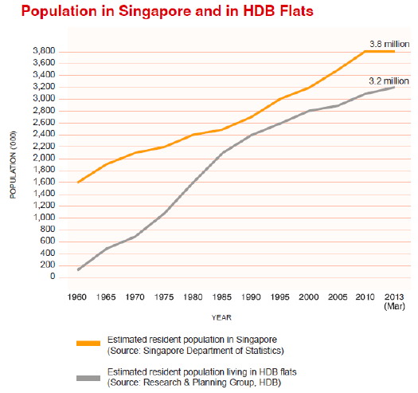

- Urbanization is happening rapidly
- Spatial Differential
- Multilateral Development Agencies get their budgets and staff from different national governments.
- Bilateral Development Agencies: involves relationship between a government and a donor country.
13 November 2018
Urban Water Infrastructure (Week 11)

Water‐Related Challenges in the Global South (p.378)
1. Ensuring supply and access
2. Providing affordable services
3. Guaranteeing acceptable water and service quality

- 3 Major Components to an Urban Water System
  - Storage
  - Storm water system
  - Wastewater system

- Early Pre-Industrial (Grigg)
  - A period up to the 1880s (age of miasmas), the idea was that diseases passed through air, but it was actually the impurities in the water that was making people sick.

- Late Industrial Revolution (Grigg)
  - Cities grow in size
  - Microscopes invented to view organisms (bacteriological revolution)

- New Ecology of Water Movement
  - In the 1960s

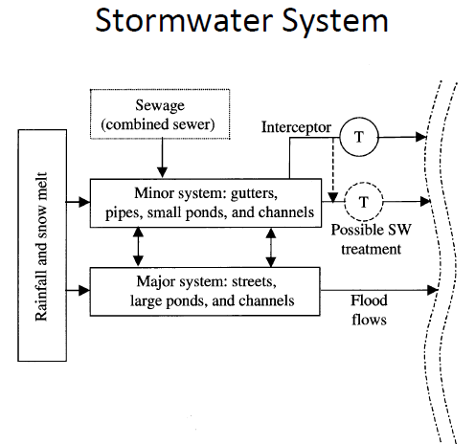
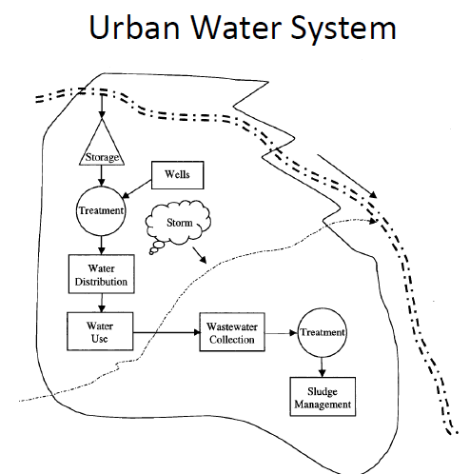

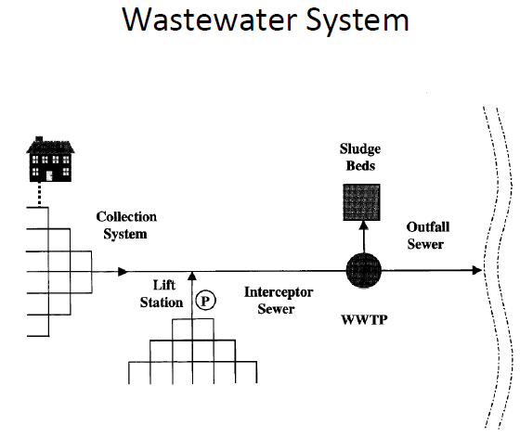

15 November 2018
Urban Water Infrastructure (Week 11)
- Infrastructure Finance: it’s about how infrastructure is paid for
  - MTL water is publicly paid for
- Public Provision vs private provision = privatization
- Egalitarianism:
- Concern of the cost for providing infrastructure.
- Reading
  - Public Agency (Provincial Waterwork Authority).
  - Build-Operate-Own-Transfer (BOOT) approach
  - Thames Water International
    - They set up a joint venture
  - Bottom of page 385
  - Government announces privatization
    - Sometimes community (civil society) protests

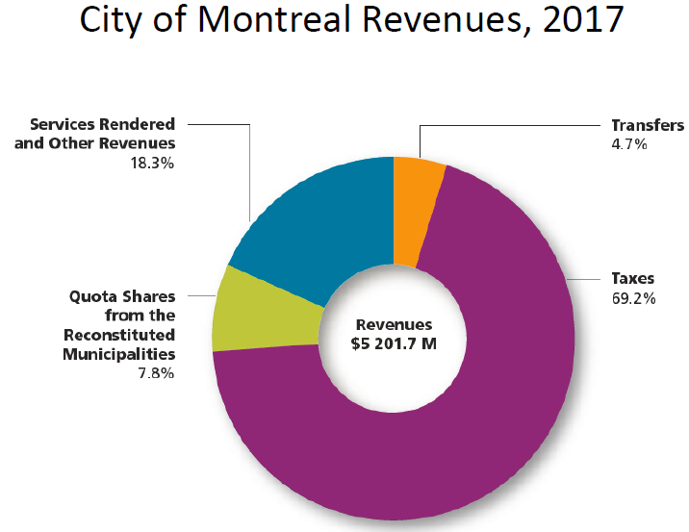
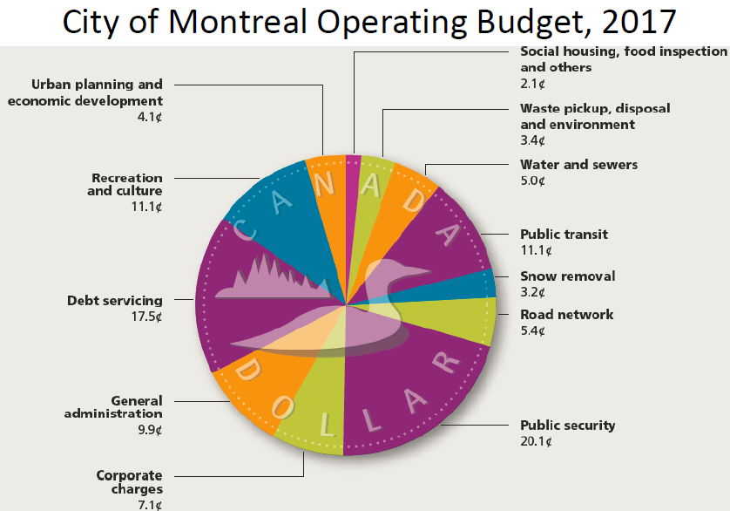

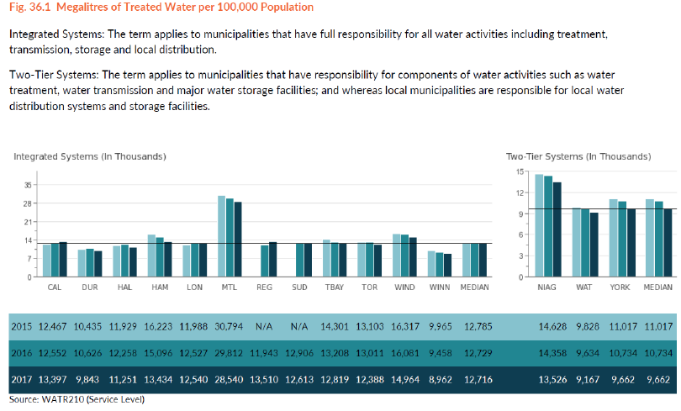

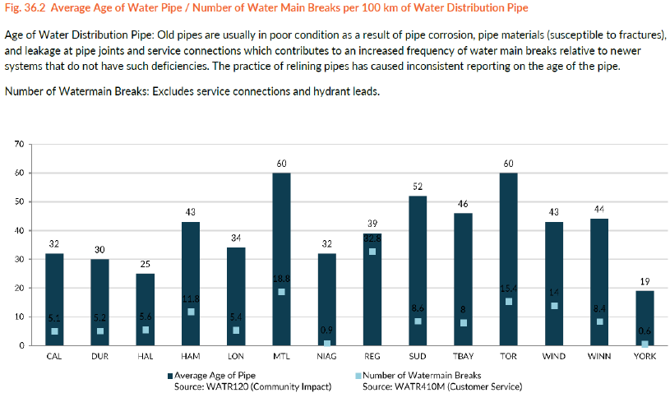

20 November 2018
Urban Transportation (Week 12)
- Motorization: the process of change from movement requiring human (or animal) power to the use of vehicles (automobiles, buses, trucks, motorcycles) which have fuel-burning engines.

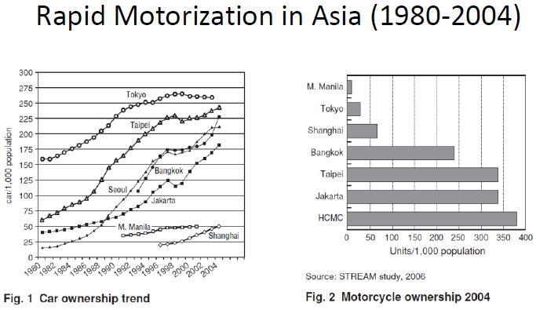

- Transportation infrastructure includes roads, railways, automobiles, trains, stations, airports, airplanes, ships (all this infrastructure is bound up with urbanization and bound up with city expansion/growth)
- They are both causes or consequences of urbanization and city growth
- It makes it possible to make people turn around, which leads to more interactions, more job opportunities, to have a higher standard of living

- 4 Main Topics in the Urban Transportation Reading
- Rapid motorization
- Human health impact of automobiles
- Informal transport
- Foreign investment

- Vehicle Collisions
  - Collisions between automobiles, motorcycles, and people accounted for more than one million deaths in 2013 (WHO, 2013).
  - South East Asian and South Asian countries reporting data to the WHO: 75,331 fatalities of riders of 2 and 3 wheeled vehicles in 2007.

22 November 2018
Urban Transportation (Week 12)
- Informal Transport
  - Not very present in China
  - “Small vehicle” modes-minibuses, vans, taxis, station wagons, M3W, M2W.
  - “Illicit” – lacking official endorsement (license, permit, registration paper) – privately operated by self-employed entrepreneurs – operated mainly by the poor, for the poor and middle class.
  - “Gap fillers” in places with large shortfalls in services.
  - High externalities per unit of productivity (lack of insurance, health and safety, unhealthy competition).

- Some Problems
  - High externalities
  - Low productivity
  - Lack of insurance for drivers and passengers
  - Problems with safety
  - Unhealthy competition
  - “Cream skimming” for higher fares
  - Financial benefits to corrupt officials and owner/operators – costs borne by users and wider society

- Foreign Investment in Urban Transport Infrastructure
  - Governments lack capital for investment in transport infrastructure
  - WB –in the 1970s, it began providing big loans to countries that were little or low-income countries.
  - Development banks (JBIC)

- Free-Flowing Automobile Movement & Rail-Based Transit-Oriented Development
  - Limiting car ownership and use by charging high prices
  - Congestion pricing
  - Revenues from car ownership used to finance “world class” transit system

27 November 2018
Urban Policy and Urban Planning (Week 13)
- Policy
  - A definite course or method of action selected from among alternatives and in light of given conditions to guide and determine present and future decisions.
  - A high-level overall plan embracing the general goals and acceptable procedures especially of a governmental body.
  - Public Policies: government policies that affect the whole population.

- Public Policy
  - Preferences of the polis (Greek city-state/government)
  - Connected to politics, process through which values and preferences are expressed
  - A general term used to characterize collections of actions taken by governments on behalf of their citizens

- Examples of Public Policy
  - Tax Policy (taxation levels overall, and by income groups; property tax; income tax (corporate & household); sales tax; exemptions; brackets).
  - Infrastructure Policy (levels of involvement of private/for-profit firms; charges for use – variable or flat).
  - Environmental Policy (reduce air pollution; reduce GHG emissions).
  - Land Use Policy (subdivision of agricultural land for new subdivisions, protection of natural land from urban uses).

- Urban Planning
  - Public policies guiding growth and change of use of land in urban areas; regional (town and country) planning are concerned with non-urban uses adjacent to an urbanized area.
  - Analyzing future courses of action to promote “…the public interest in land development, more particularly with public action that seeks to assure livability and sound development in the city as land put to urban use” (Chapin, 1965, p.39).
  - “The job of the city planner is to propose courses of action, … to improve the total quality of urban living. Some planners articulate this objective purely in terms of physical and aesthetic satisfaction, preferring to de-emphasize the effects of physical design on economic and social problems. But most planners conceive the potential contribution of planning to urban life in grand terms” (Altshuler, 1965, p.1).

29 November 2018
Course Wrap-Up (Week 13)
- Capital of post WWII (NYC)
- Certain activities become concentrated in these cities
- Cities are growing, people are migrating (rural to urban)
- Water consumption (lack of freshwater in Rio de Janeiro for example)

- Climate Change, Urban Policy & Urban Planning
  - Burning more and more fossil fuels
  - These gases are causing changes to our climate
  - Increasing consumption of natural resources

- New York Storm Resilience Plan
  - New project underway to change the edges of NYC
  - Adding more green spaces in order to absorb more water during big storms

- Urban Planning to Reduce Emission in MTL
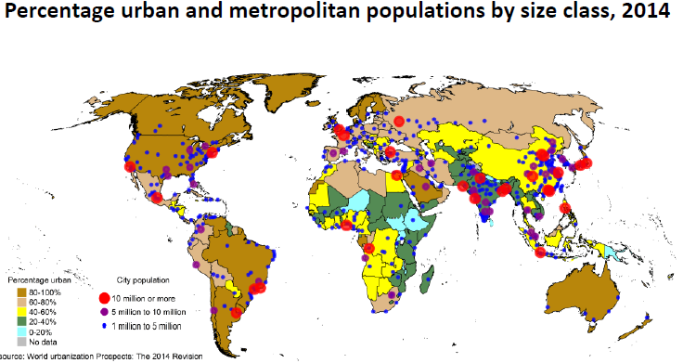
  - Reduce heating or working area we are heating



