PHI 1101 MIDTERM 2 CHEAT SHEET
CHAPTER 4
Sentential Form: representation of an argument using letters to replace the simple sentences that make up the compound structure of the argument
Sentential Variable: letters used in sentential form to represent sentences (P, Q, R, S, …)
Connectives:
Ordinary Words | Symbol | Name
either… or  …or…  Either it is a cat or it is a dog | V  C V D | Disjunction
And, but, yet  It is a dog, and it bites | •  D • B | Conjunction
If…, then…  If it bites, then you should be wary | $$⊃$$  B $⊃$ W | Implication
Negation:
Ordinary Words | Symbol | Name
Not (and other forms of denying)  It is not a dog | ~  ~ D | Negation
Eight Valid Argument Forms:
Modus Ponens  (MP) | Modus Tollens  (MT) | Conjunction  (CONJ) | Simplification  (SIMP) | Disjunctive Syllogism  (DS) | Hypothetical Syllogism  (HS) | Constructive Dilemma  (CD) | Addition  (ADD)
P $⊃$ Q  P____  Q | P $⊃$ Q  ~Q___  ~P | P  Q___  P • Q | P • Q  P | P V Q  ~P___  Q | P $⊃$ Q  Q $⊃$R  P $⊃$ R | P V Q  P $⊃$ R  Q $⊃$ S  R V S | P____  P V Q
Two Invalid Argument Forms: - FALLACIOUS
Denying the Antecedent – NOT VALID | Affirming the Consequent – NOT VALID
P $⊃$ Q  ~P___  ~Q | P $⊃$ Q  Q____  P
Equivalent Forms:
Double Negation  (DN) | Commutativity  (COM) | Transposition  (TRANS) | Implication  (IMPL) | Exportation  (EXP) | De Morgan’s Rule  (DM)
P :: ~~P | (P • Q) :: (Q • P)  (P V Q) :: (Q V P) | ( P $⊃$ Q) :: (~Q $⊃$ ~P) | (P $⊃$ Q) :: (~P V Q) | [(P • Q) $⊃$ R] :: [P $⊃$ (Q $⊃$ R)] | ~(P • Q) :: (~P V ~Q)

Deductive Proof Strategies:
Conditional Proof (CP): assume the antecedent of the conditional you wish to prove and derive the consequent
Indirect Proof (IP): assume the opposite of the claim you wish to prove and derive a contradiction (or absurdity) from your assumption
Proof by Cases (PC): Derive conclusion by assuming each disjunct in turn and separately deriving the conclusion in each case

CHAPTER 5
Categorical Statements: statements that put any variety of things into categories or classes
i.e. all dogs are mammals – all thins belonging to the category of dogs also are in the category of mammals
There are different types – universal and particular
Universal: make a claim about all the members of a certain category
Particular: make a claim about an undermined number of members of a certain category
Universal Affirmative
Form: All A are B
i.e. all men are mortal
Universal Negative
Form: No A is B
i.e. no humans are lizards
Particular Affirmative
Form: Some A is B
i.e. some prisoners are innocent
Particular Negative
Form: Some A is not B
i.e. some cars are not fast
The word “some” means “at least one”
The word “some” can denote (mean):
One
More than one, but not all
All
Two Circle Venn Diagram:
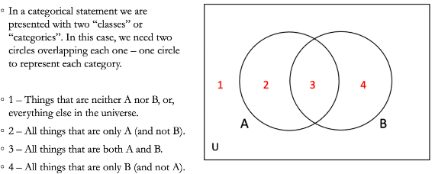
There are two tools we use in order to depict a categorical statement:
Shading
Used to represent universal categorical statements – shows that an area is empty
Marking with an x or *
Represents particular categorical statements – shows that an area contains some/at least one
RULES:
1. Show an area is empty by shading it
2. Show there is at least one in an area by placing X or *
3. Always diagram universal statements first, THEN particular statements
Categorical Syllogisms – arguments with two premises and a conclusion (syllogism), all of which are categorical statements
i.e. all dogs are mammals
some animals are mammals
so some dogs are animals
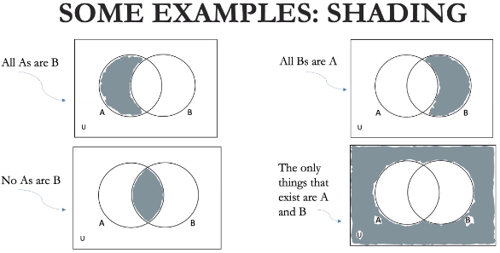
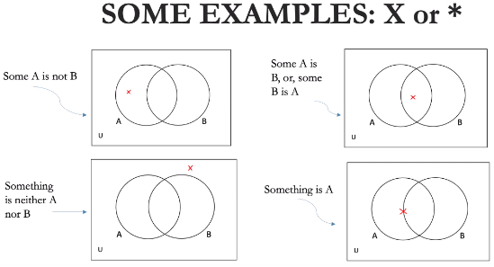

Three Circle Venn Diagrams:
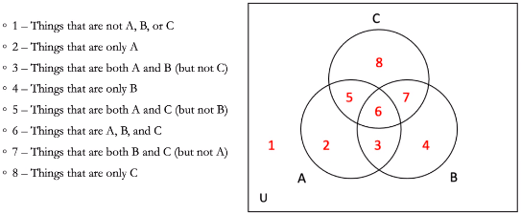
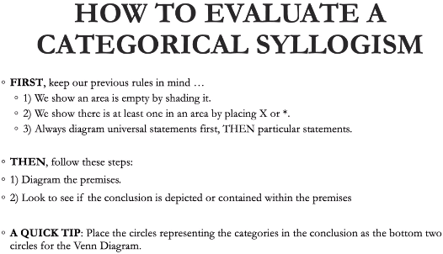

CHAPTER 6
Causal claim is an assertion about the cause of something
Causal argument justifies, or supports such a claim
1. Explanation
Want to explain why an event occurred, so we can attempt to discover its cause
2. Responsibility
Want to know whether we can hold anyone responsible for an event – ask what someone did to cause it
Let’s us decide if anyone deserves blame or praise
3. Control
If causal factors are known that produce an event, we may be able to manipulate them and obtain results we want
4. Prediction
Want to know if we can expect an event to happen, so we can attempt to discover what causes such events
Basic Causal Relationships
Term cause is used in several distinct but related ways
Not possible to give the word a single definition without being arbitrary
Must review several prominent uses of the term
Necessary Condition: a factor is a necessary condition for an event does not occur in the absence of the factor
A factor is a necessary condition for an event if the event does not occur in the absence of the factor
Can represent the relationship of a necessary condition to the occurrence of an event more formally
Let A stans for the causal factor and B for the event
1. If B, then A (if polio occurs, then the virus is present)
2. If not-A, then not-B (if the virus is not present, then polio does not occur)
Both schemes express the meaning of sentences of the form “A is a necessary condition for B”
Sufficient Condition: a factor is a sufficient condition for the occurrence of an event if whenever the factor occurs, then the event occurs: Whenever A, then B
If A is a sufficient cause of B, then the presence of A sufficiently implies the presence of B
Whenever A occurs, B must also occur
If A, then B
Causal Chain: we say that Y caused Z, but know that Y also had a cause, X, and that X in turn has a cause, etc.
Contributing Factor: each factor making up a set of factors sufficient for the occurrence of an event
1. Proximate Cause: the triggering factor of an event
Sometimes everything is in place to produce a certain effect as soon as one further step is taken
Last step to occur and completes the causal chains
2. Unusual Factor: often single out an unusual contributing factor as “the” cause of an event
3. Controllable Factor: when we are interested in control, prevention, etc., we may single out things that are potentially under control as causes
Mill’s Methods
1. Method of Difference: involves comparing situation in which an event to be explained (E) occurs with situations that are largely similar but E does not occur.
Case 1: P, Q, R, S EVENT OCCURS
Case 2: P, Q, R EVENT DOES NOT OCCUR
The only difference between Case 1 and Case 2 is the condition S, so S must be/may be/probably is the cause of the event.
2. Method of Agreement: involves comparing situations in each of which the event E occurs. If the presence of a certain factor is the only respect in which the situations are the same (that is, agree), then this factor may be identified as the probable cause of the event.
Case 1: P, Q, R, S EVENT OCCURS
Case 2: T, U, V, S EVENT OCCURS
The only factors Case 1 and Case 2 have in common (the only point of agreement) is S, so S must be/may be/probably is the cause of the event.
3. Joint Method of Agreement and Difference: involves the simultaneous application of the previous two methods. We compare cases in which an event of interest occurs with ones in which it does not occur. The cause of the event will be the only factor present in each case in which the event occurs and absent in each case in which the event does not occur.
Case 1: P, Q, S EVENT OCCURS
Case 2: P, T, U EVENT OCCURS
Case 3: R, V, S EVENT DOES NOT OCCUR
The event occurs only in Case 1 and Case 2, and the only factor they have in common is P, so P must be the cause. Although Case 1 and Case 3 have factor S in common, the event does not occur in Case 3, so S cannot be the cause.
We have found a factor that Case 1 and Case 2 have in common (agreement), but Case 3 does not (difference).
4. Method of Concomitant Variation: involves varying a factor and determining whether a change in it is accompanied by variation in some other factor we wish to explain. If the two factors vary together, this is a reason to consider the first factor causally related to the second.
Case 1: When P increases in a population, EVENT E occurs more often.
Case 2: When P decreases in a population, EVENT E occurs less often.
Case 1 and Case 2 indicate that changes in P and E occur concomitantly (at the same time), so this suggests that P may be the cause of E.

