Lab 2 --- Understanding Oracle’s architecture and key parameter files

Purpose: This lab reinforces your classroom discussions concerning Oracle architecture
Requirements: Complete the required tasks and submit the required responses in the same word document renamed as lab2_fname_lname (e.g., Lab2_Doug_King) via Brightspace by the end of the lab and demonstrate your work to the lab professor.
A complete and on-time submission will earn 2 marks.

Resources: https://docs.oracle.com/cd/B28359_01/server.111/b28318/startup.htm#CNCPT1293
https://docs.oracle.com/database/121/CNCPT/startup.htm#CNCPT601
https://docs.oracle.com/cd/B28359_01/server.111/b31189/ch12042.htm
https://docs.oracle.com/cd/B28359_01/server.111/b28286/statements_6008.htm#SQLRF01308

Lab Submission tasks:
- Demo / Problem Solving: During Week 2's lab, you will be required to confirm your Oracle 12c installation is working properly.

- Concepts: Refer to the above noted resources. Copy your answers to your submission document.
  - Without using virtual tables or similar mechanisms, a database instance can be associated with ___mounted database__ database(s).
  - To start a database instance, configuration parameters must be read. This information is contained in binary format in ____initialization parameter file________ and in text format in ___server parameter file___________.
  - During STARTUP, the instance knows where the data files are located by reading the _____control_________ file.
  - The main difference between a TRANSACTIONAL SHUTDOWN and an IMMEDIATE SHUTDOWN is, in a TRANSACTIONAL SHUTDOWN __________ This mode prevents users from starting new transactions, but waits for all current transactions to complete before shutting down. This mode can take a significant amount of time depending on the nature of the current transactions. IMMEDIATE SHTDOWN: This mode is typically the fastest next to SHUTDOWN ABORT. Oracle Database terminates any executing SQL statements and disconnects users. Active transactions are terminated and uncommitted changes are rolled back.___________________________________.

- Review the Startup/Shutdown Process (Write the queries and their results):
  - Logon as SYS as SYSDBA.
  - Enter SHOW PARAMETERS
    - From the SHOW PARAMETERS results, determine where the SPFILE file is located. Record this location in your lab file below.
C:\APP\JKMAL\PRODUCT\12.1.0\DBHOME_1\DATABASE\SPFILEORCL.ORA
  - Create a PFILE: Enter: CREATE PFILE from SPFILE;
  - Locate and resulting PFILE and in your lab document, specify:
    - the name of the pfile
INITorcl
    - Open the file and determine the oracle_base name
orcl
    - the location of the control_files
'C:\app\jkmal\oradata\orcl\control01.ctl','C:\app\jkmal\oradata\orcl\control02.ctl'
  - Enter: SHUTDOWN
  - Enter: STARTUP
  - Indicate, in your lab document, the sequence of objects being started.
Total System Global Area 5150605312 bytes
Fixed Size 4629192 bytes
Variable Size 1191185720 bytes
Database Buffers 3942645760 bytes
Redo Buffers 12144640 bytes
Database mounted.

- DATA DICTIONARY: From the SQL prompt, enter DESC DICT- this command describes the structure (the columns) of the internal data dictionary.

Hint: Throughout the course, when you forget the names of special tables you can return to the dictionary and determine the name.

In your lab document answer the following questions (Write the queries and their results):
  - List the number of rows that are in this table (you may not want to select the rows as there are a lot). _____3228__________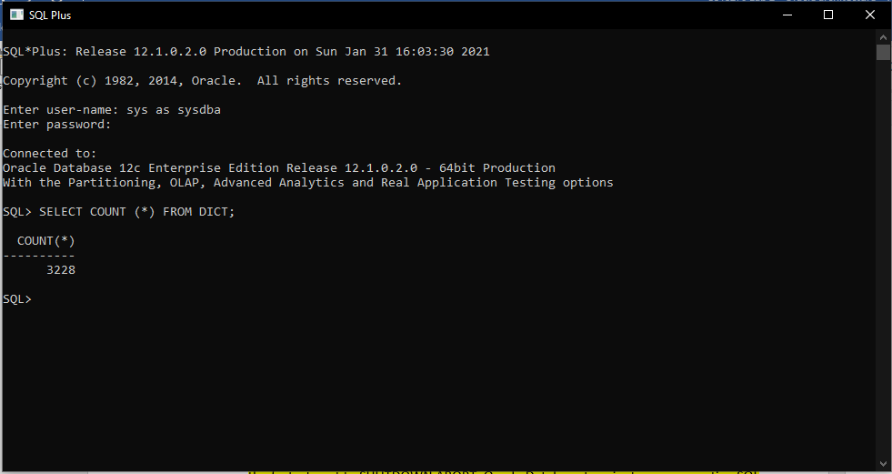
  - List the name of the view or table that describes Tablespaces: ___________
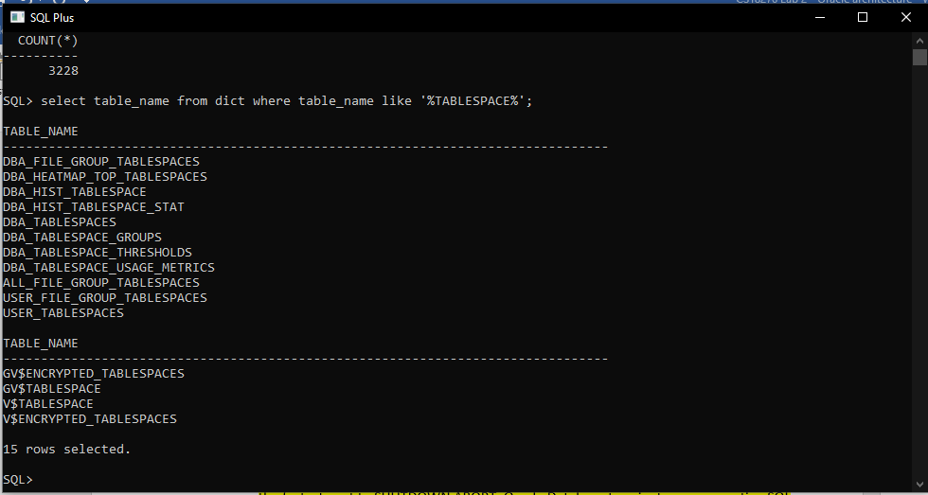
  - List the name of the view or table that describes Datafiles: ___________
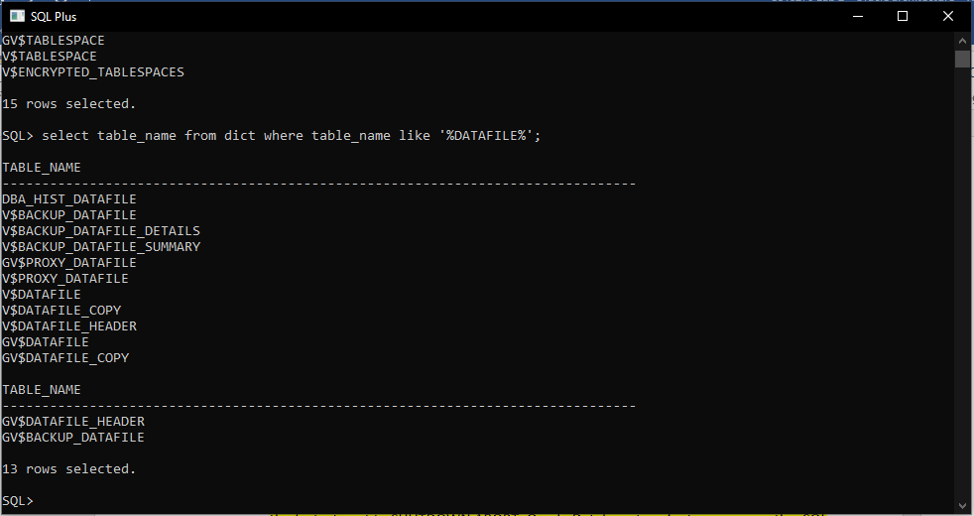
  - Write a query that joins the V_$DATAFILE and V_$TABLESPACE tables, then use the query results to answer the following questions:
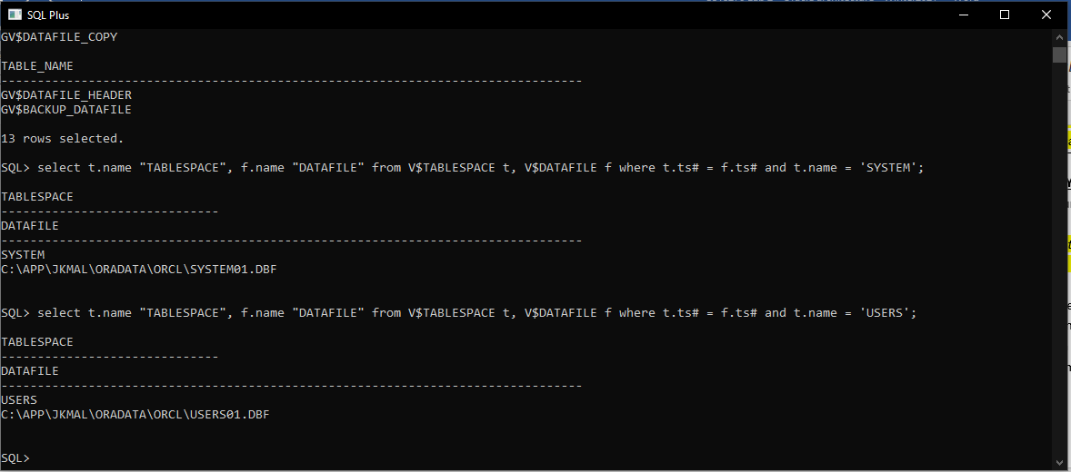
    - What is the location and name of the datafile associated with the SYSTEM tablespace. ____ C:\APP\JKMAL\ORADATA\ORCL\SYSTEM01.DBF _______________________________
    - What is the location and name of the datafile associated with the USERS tablespace. _________ C:\APP\JKMAL\ORADATA\ORCL\USERS01.DBF ___________________________

You're done. Submit your lab.

