Standardizing Arguments
Once you can recognize an argument there are some things you need to be able to do before you can evaluate it. To evaluate an argument one requires an understanding of the logical structure of the argument. To see this structure one must be able to identify the premises and conclusions and show how they are related to one another. That is, which premises support which claims. This is what is called standardizing an argument. Doing this is helpful because once one can clearly see which premises support which conclusions, one is in a better position to evaluate the argument. Think of it this way. If I build a mousetrap you cannot say whether it is a good or a bad mousetrap or offer ways to improve the design unless you have some understanding of how my mousetrap works. Similarly, unless you understand how someone's argument works, you cannot offer a useful criticism of that argument.
The first step in standardizing an argument is to identify the conclusion.
Here are a few hints to help you identify conclusions.
- Look for indicator words associated with conclusions.
- The conclusion is usually the main point of the passage.
- The conclusion usually appears at the beginning or at the end of the passage.
We will employ the diagram method for our standardizations. This involves the use of boxes and arrows. Identify the conclusion of the argument. Put it at the top of your page in a box. Identify the supporting premises by listing them below, each premise in its own box, with an arrow illustrating that the premise supports what is above it.
The Diagram Method
Schematically, we arrive at a diagram that looks something like this:
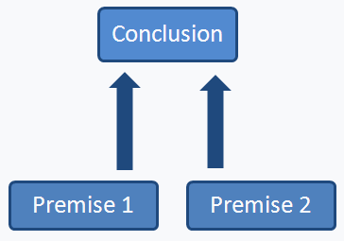
Let's try an example.
Philosophy is one of the best subjects one can study at university because it teaches you how to think clearly.
The place to start is by identifying the conclusion of the argument. The conclusion is: Philosophy is one of the best subjects one can study at university. This is the main point of the passage and seems to be a claim the truth of which the speaker wishes to convince the reader.
The rest of the passage is made up of the following proposition: Philosophy teaches you how to think critically. Notice the indicator word because (which is associated with premises) that precedes this proposition. This therefore serves as a premise in support of the conclusion.
The standardization of this argument would look like this:
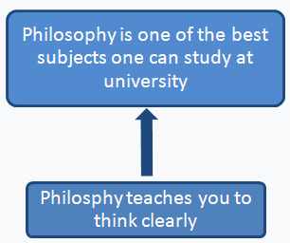
Let's try another example.
Since Pat was a professional soccer player, and since she is a born leader, she should be the captain of the team.
What is this passage trying to convince us about? The main point it wants to convince us about is that Pat should be the captain of the team. This is therefore the conclusion. The other two claims, that Pat was a professional soccer player and is a born leader, each lend independent support to the conclusion and thus are intended to be separate premises. The standardization of the argument will look like this:
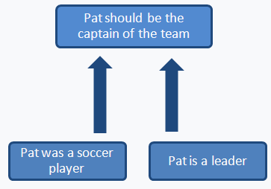
Subarguments
Subarguments are used to support one or more of the premises of an argument.
When an argument contains a subargument, it has a "mini-argument" within it to justify one or more of the premises used to support the main conclusion.
Schematically, an argument containing a subargument might look like this:
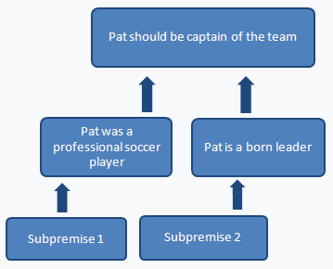
Here everything represented inside the dotted line is a subargument. The conclusion of the subargument is premise 1, of which subpremises 1 and 2 are the premises.
An argument can frequently be made stronger by adding subpremises. If any of the main premises are questionable, then it is a good idea to support them. This is the function of a subargument.
Let's take our argument about Pat, the soccer player. If I want to convince you that she should be the captain of the team and offer the reasons mentioned above, it might not be obvious that she is a born leader. To make my argument stronger I would provide a subargument the conclusion of which is that she is a born leader. For instance, I might say that when lost in the woods with her friends she took charge and kept everyone calm until the park rangers found them.
By adding this subargument we would need to amend the standardization above in the following way:
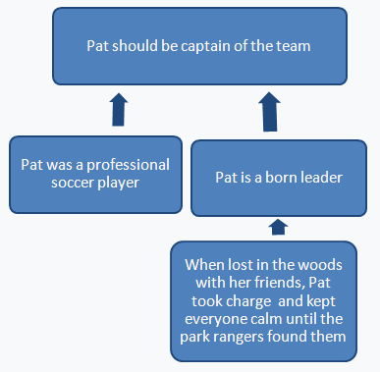
Let's try a few more examples.
Example
Jones took it. Frank knows Jones did it because he saw the whole thing on the surveillance tape.
Here we have three propositions:
Jones took it
Frank knows Jones did it
Frank saw the whole thing on the surveillance tape
When you are asked to standardize an argument, sometimes it can be helpful to write each proposition down on a scrap piece of paper. This way you can try alternative standardizations until you find one that best represents the structure of the argument.
The main point of the passage seems to be that Jones took it, so this proposition would be the conclusion. How are the other propositions related to the conclusion and to each other?
The proposition Frank knows Jones did it certainly seems to support the conclusion, that Jones took it, but so does the third proposition.
Here you need to ask yourself whether the proposition about the surveillance tape makes the argument stronger by supporting the conclusion directly, or by functioning as a subpremise supporting the claim about Frank's knowledge. If we are given reasons to believe that it is true that Frank knows Jones did it, then that would make for a stronger argument than if we were just told that Frank knows this without any support. Hence, it looks as though the argument contains a very simple subargument and should be standardized like this:
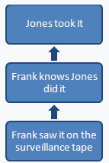
Now let's try a much more complicated example.
Boston is a more interesting city than Toronto. It has more interesting architecture and there is more to do in the Boston area. There are many terrific shops and beautiful places to visit nearby.
This time, let's look at the standardization and then discuss why it is an accurate way of representing the argument.
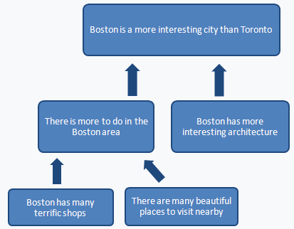
It should be reasonably clear that the conclusion is the proposition Boston is a more interesting city than Toronto. This is the main point of the passage and appears at the beginning of the paragraph. Why are the other propositions arranged in this way?
First, let's look at the claim that Boston has more interesting architecture. Clearly this does not support the claim that Boston has many terrific shops or that there are many beautiful places to visit near Boston. Shops are not ordinarily considered to be terrific because of their architecture, and the claim about Boston's architecture is a claim about Boston itself, not about places near Boston.
Could this premise be thought of as supporting the claim that there is more to do in the Boston area?
This sounds plausible but is not the best way to standardize the argument for two reasons. First, the conclusion is about how interesting Boston is relative to Toronto, and saying that Boston is architecturally more interesting than Toronto gives this conclusion direct support. Second, the fact that Boston is architecturally more interesting than Toronto does not necessarily support the claim that there is more to do in Boston. A city can be full of beautiful buildings, yet there might be nothing to do in that city.
What about the rest of the argument? It seems pretty clear that having places to shop and beautiful places to visit nearby are things to do, and hence, are best thought of as supporting the claim that there is more to do in the Boston area. Clearly, the claim that there is more to do in Boston does not support the claim that Boston has more interesting architecture, but is directly related to the conclusion. If one city offers more things to do than another, then it is probably the more interesting city.
Kinds of Premises
We have already seen that there is more than one kind of premise. There are premises and subpremises. Premises support a conclusion directly, and subpremises are used in subarguments to support either premises or other subpremises.
There is another difference between premises that concerns their logical relationship to the propositions they support. Premises can be either convergent or linked. A single argument can have both kinds of premises, though for clarity in the examples that follow I will show only one or the other.
Convergent Premises
Convergent premises work independently to support the conclusion.
By independently the idea is that a convergent premise supports its conclusion without requiring the truth of other premises. So far, all of our examples have involved convergent premises.
Consider the previous example. The claim that there are more terrific shops in Boston than Toronto supports the claim that there is more to do in Boston than Toronto all by itself; it does not need to be accompanied by the claim that there are many beautiful places to visit near Boston.
Similarly, in order for the claim that there is more to do in the Boston area to support the conclusion that Boston is a more interesting city than Toronto, it does not have to be true that Boston has more interesting architecture. Each claim gives the conclusion independent support.
Linked Premises
Linked premises are interdependent and must work together to support the conclusion.
This means that if two premises are linked, they must both be asserted to support the conclusion. Neither premise supports the conclusion at all without the other.
When we standardize an argument with linked premises, we represent linked premises by connecting them with a line or a bar. Schematically, such an argument will look like this:
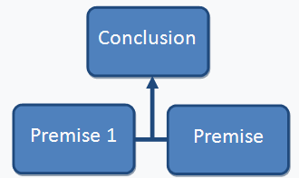
Example
If Jesse makes that shot, then I'll be a monkey's uncle. Jesse made the shot. I'm a monkey's uncle!
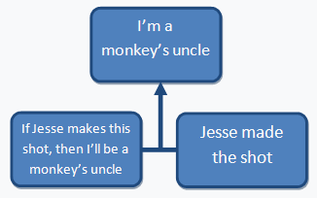
The conclusion of this argument appears at the end of the passage. It is supported by the other two propositions that appear as linked premises. The reason they are linked is because neither one gives the conclusion any support unless the other is asserted as well. The claim that Jesse made the shot does not support the claim that I'm a monkey's uncle unless we are also told that if Jesse makes the shot, then I'll be a monkey's uncle.
The same is true of the other premise. The claim that if Jesse makes the shot, then I'll be a monkey's uncle does not give any support to the conclusion (I'm a monkey's uncle) unless we are also told that Jesse made the shot. Hence, these are linked premises.
Let's look at another example.
Example
Either we go to the movie or we go out for dinner. We can't afford to go to dinner, so we should go to the movie. We don't have much cash because we don't get paid until next week.
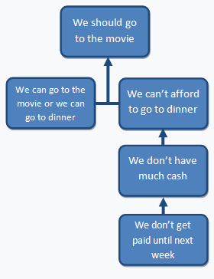
Standardizing Arguments
Once you can recognize an argument there are some things you need to be able to do before you can evaluate it. To evaluate an argument one requires an understanding of the logical structure of the argument. To see this structure one must be able to identify the premises and conclusions and show how they are related to one another. That is, which premises support which claims. This is what is called standardizing an argument. Doing this is helpful because once one can clearly see which premises support which conclusions, one is in a better position to evaluate the argument. Think of it this way. If I build a mousetrap you cannot say whether it is a good or a bad mousetrap or offer ways to improve the design unless you have some understanding of how my mousetrap works. Similarly, unless you understand how someone's argument works, you cannot offer a useful criticism of that argument.
The first step in standardizing an argument is to identify the conclusion.
Here are a few hints to help you identify conclusions.
- Look for indicator words associated with conclusions.
- The conclusion is usually the main point of the passage.
- The conclusion usually appears at the beginning or at the end of the passage.
We will employ the diagram method for our standardizations. This involves the use of boxes and arrows. Identify the conclusion of the argument. Put it at the top of your page in a box. Identify the supporting premises by listing them below, each premise in its own box, with an arrow illustrating that the premise supports what is above it.
The Diagram Method
Schematically, we arrive at a diagram that looks something like this:
Let's try an example.
Philosophy is one of the best subjects one can study at university because it teaches you how to think clearly.
The place to start is by identifying the conclusion of the argument. The conclusion is: Philosophy is one of the best subjects one can study at university. This is the main point of the passage and seems to be a claim the truth of which the speaker wishes to convince the reader.
The rest of the passage is made up of the following proposition: Philosophy teaches you how to think critically. Notice the indicator word because (which is associated with premises) that precedes this proposition. This therefore serves as a premise in support of the conclusion.
The standardization of this argument would look like this:
Let's try another example.
Since Pat was a professional soccer player, and since she is a born leader, she should be the captain of the team.
What is this passage trying to convince us about? The main point it wants to convince us about is that Pat should be the captain of the team. This is therefore the conclusion. The other two claims, that Pat was a professional soccer player and is a born leader, each lend independent support to the conclusion and thus are intended to be separate premises. The standardization of the argument will look like this:

Subarguments
Subarguments are used to support one or more of the premises of an argument.
When an argument contains a subargument, it has a "mini-argument" within it to justify one or more of the premises used to support the main conclusion.
Schematically, an argument containing a subargument might look like this:
Here everything represented inside the dotted line is a subargument. The conclusion of the subargument is premise 1, of which subpremises 1 and 2 are the premises.
An argument can frequently be made stronger by adding subpremises. If any of the main premises are questionable, then it is a good idea to support them. This is the function of a subargument.
Let's take our argument about Pat, the soccer player. If I want to convince you that she should be the captain of the team and offer the reasons mentioned above, it might not be obvious that she is a born leader. To make my argument stronger I would provide a subargument the conclusion of which is that she is a born leader. For instance, I might say that when lost in the woods with her friends she took charge and kept everyone calm until the park rangers found them.
By adding this subargument we would need to amend the standardization above in the following way:
Let's try a few more examples.
Example
Jones took it. Frank knows Jones did it because he saw the whole thing on the surveillance tape.
Here we have three propositions:
Jones took it
Frank knows Jones did it
Frank saw the whole thing on the surveillance tape
When you are asked to standardize an argument, sometimes it can be helpful to write each proposition down on a scrap piece of paper. This way you can try alternative standardizations until you find one that best represents the structure of the argument.
The main point of the passage seems to be that Jones took it, so this proposition would be the conclusion. How are the other propositions related to the conclusion and to each other?
The proposition Frank knows Jones did it certainly seems to support the conclusion, that Jones took it, but so does the third proposition.
Here you need to ask yourself whether the proposition about the surveillance tape makes the argument stronger by supporting the conclusion directly, or by functioning as a subpremise supporting the claim about Frank's knowledge. If we are given reasons to believe that it is true that Frank knows Jones did it, then that would make for a stronger argument than if we were just told that Frank knows this without any support. Hence, it looks as though the argument contains a very simple subargument and should be standardized like this:
Now let's try a much more complicated example.
Boston is a more interesting city than Toronto. It has more interesting architecture and there is more to do in the Boston area. There are many terrific shops and beautiful places to visit nearby.
This time, let's look at the standardization and then discuss why it is an accurate way of representing the argument.
It should be reasonably clear that the conclusion is the proposition Boston is a more interesting city than Toronto. This is the main point of the passage and appears at the beginning of the paragraph. Why are the other propositions arranged in this way?
First, let's look at the claim that Boston has more interesting architecture. Clearly this does not support the claim that Boston has many terrific shops or that there are many beautiful places to visit near Boston. Shops are not ordinarily considered to be terrific because of their architecture, and the claim about Boston's architecture is a claim about Boston itself, not about places near Boston.
Could this premise be thought of as supporting the claim that there is more to do in the Boston area?
This sounds plausible but is not the best way to standardize the argument for two reasons. First, the conclusion is about how interesting Boston is relative to Toronto, and saying that Boston is architecturally more interesting than Toronto gives this conclusion direct support. Second, the fact that Boston is architecturally more interesting than Toronto does not necessarily support the claim that there is more to do in Boston. A city can be full of beautiful buildings, yet there might be nothing to do in that city.
What about the rest of the argument? It seems pretty clear that having places to shop and beautiful places to visit nearby are things to do, and hence, are best thought of as supporting the claim that there is more to do in the Boston area. Clearly, the claim that there is more to do in Boston does not support the claim that Boston has more interesting architecture, but is directly related to the conclusion. If one city offers more things to do than another, then it is probably the more interesting city.
Counterarguments
A counterargument is an argument that responds to another argument. Counterarguments have the goal of denying the conclusion of the original argument, either by offering new premises in support of a different conclusion, by undermining the premises used to support the conclusion, or by showing that the conclusion of the original argument does not follow from the premises offered to support it.
To help you identify counterarguments, look for the following indicator words:
but, however, on the other hand
When standardizing a counterargument, one should first identify and standardize the original argument it is responding to. It is very important to standardize it properly. Otherwise, it is difficult to evaluate the counterargument. Once you have done this, standardize the counterargument below the argument.
Example
Some argue that Ridley Scott is a better Director than Stanley Kubrick. They point out that Scott has already made more films than Kubrick, and that experience is the key to being a good director. But experience does not always make one a good director. Ed Wood made many films, all of which were awful.
First, identify the argument this passage is responding to. The argument seems to be that Scott is a better director than Kubrick because Scott has made more films than Kubrick and experience is the key to being a good director.
Now let's standardize this argument:
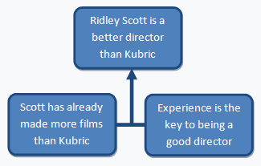
Notice that the two premises are linked. Unless both premises are asserted together neither one supports the conclusion.
Now, let's identify the counterargument.
Notice the indicator word but. This introduces the counterargument: But experience does not always make one a good director. Ed Wood made many films, all of which were awful.
Before we go any further we need to consider the purpose of the counterargument. Recall that we saw above that the aim of any counterargument is to deny the conclusion of the argument to which it is responding. What was the conclusion of the original argument? It was this: Ridley Scott is a better Director than Stanley Kubrick. The conclusion of the counterargument must be a cautious denial of this claim: Ridley Scott is not necessarily a better director than Kubrick.
Why is the conclusion this rather than say, Ridley Scott is not a better director than Kubrick or, Kubrick is a better director than Scott?
In this case, and this will be true of many counterarguments, the aim of the speaker is only to show that the conclusion of the original argument does not follow from the premises offered. This does not mean that the conclusion is false. It might still be true that Scott is a better director than Kubrick, but the argument has not given us good reason to believe this is true.
When you reconstruct counterarguments you will often need to formulate and add the conclusion of the counterargument yourself. When you do, remember that you should do so cautiously. Don't make the conclusion stronger than it needs to be or stronger than the premises warrant.
In light of all this, the counterargument is something like this:
Ridley Scott is not necessarily a better director than Kubrick. Although Scott has made more films than Kubrick, experience does not always make one a good director. Ed Wood has a lot of experience as a director, but all of his films were awful.
The standardization of the counterargument should look like this:
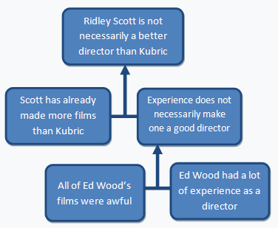
Notice here that the premises are all linked rather than convergent. Once again, the reason for this is that the linked premises depend on each other. Without also saying that all of Ed Wood's films were awful, the claim that Ed Wood had a lot of experience as a director does not lend any support to the claim that experience does not necessarily make one a good director.
Example
Sure, I see the merit in raising taxes next year. As you say, it will fund some needed social programs, but we already pay too much tax in Canada. In fact, we pay the highest amount in taxes of any G7 nation. Taxes should come down, not go up.
Argument
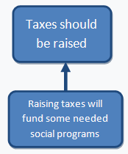
Counterargument
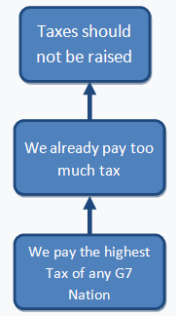
Counterconsiderations
Counterconsiderations are claims or propositions that count against the conclusion. These differ from counterarguments in the following way. Counterconsiderations are not used as premises to support an opposing argument. They merely serve as an acknowledgement that there exist points the author is aware of that tend to detract from or weaken the author's conclusion. Identifying counterconsiderations in one's own argument is like giving a nod to the opposing side or saying the opposition has a point, but without surrendering what is important in one's own views. It is like saying, I am aware of certain problems with this argument, but these problems are not serious enough to undermine my conclusion.
There are certain indicator words that tend to be associated with counterconsiderations and can help you identify them:
although, it is true that, on the other hand, despite
When we standardize an argument with counterconsiderations, we list them underneath the standardization of the argument.
Example
Despite the fact that the fetus is genetically human, abortion early on in a pregnancy is not equivalent to murder. What is important is the status of the fetus as a moral being or a person, and a fetus does not become a person until the third trimester.
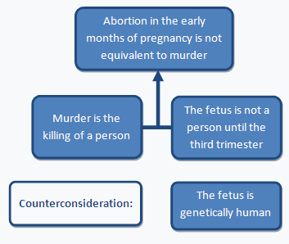
Example
Although Durkheim provided convincing arguments to show that the concept of God emerged as an inevitable mechanism of social control, these arguments do not prove that God does not exist. Durkheim merely identifies possible origins of the concept of God. The idea of something can have social origins and yet exist in reality as well.
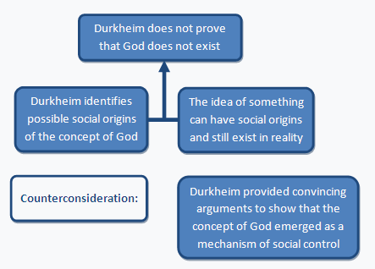
Missing Premises and Conclusions
Often arguments have missing premises, conclusions, or both.
This can happen under the following conditions:
- The speaker asks a rhetorical question (one that anticipates a particular answer).
- The speaker has simply failed to make all the premises (or conclusions) explicit.
Example
You shouldn't eat that Whopper. What about your diet?
Here the conclusion is that you shouldn't eat that Whopper. The premises used to support this conclusion are implied but have not been made explicit. The question about the diet suggests that the person being addressed is on a diet, so one of the premises is something like:
You are on a diet.
There must be more to this argument, however. It seems there is also a missing premise about Whoppers being the wrong sort of thing to eat when on a diet.
Each Whopper contains 42 grams of fat (or something similar) would be a suitable premise to motivate the conclusion.
So we can rephrase the argument more explicitly as follows:
Since you are on a diet and each Whopper contains 42 grams of fat, you shouldn't eat that Whopper.
Now that the premises have been made explicit we can standardize the argument.
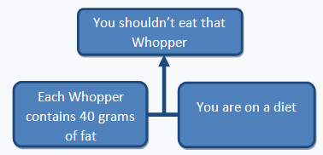
Now let's look at an example that is missing other elements.
You're not going to wear that outfit tonight, are you? It's a formal function.
In this example the first thing you should notice is that the conclusion is missing. We can figure out what it is from the question You're not going to wear that outfit tonight, are you? The expected answer when someone asks a question like that is No. So the conclusion of the argument must be You shouldn't wear that outfit tonight.
The fact that the event in question is a formal occasion, by itself, gives no support to the conclusion. Hence, there must be an additional premise that is also implied and which needs to be made explicit.
That outfit is inappropriate for a formal occasion is a good candidate for this role, and is clearly implied by the question that starts off the argument.
So the argument, in expanded form, is this:
It is a formal occasion tonight and that outfit is inappropriate, so you shouldn't wear that outfit tonight.
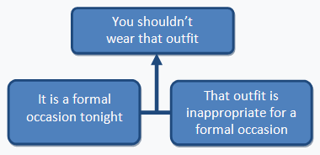
Often, when the speaker fails to make all of the premises explicit, we can ask the speaker for more details and he or she can then provide us with the missing premises or conclusion.
Example
It is Sharon's birthday tomorrow. Therefore, Bob should buy her a present.
One thing we will want to know to evaluate this argument is whether or not there is a special relationship between Bob and Sharon.
If the speaker tells us that Bob and Sharon are married, then this should be used as a further premise to support the conclusion.
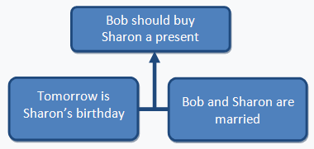
Other times we can't ask the speaker to give us more information (perhaps you are reading an article). In such cases we must fill in the missing premises ourselves. On occasions like this we must use the principle of charity.
- The added premises must help make the argument as strong as possible.
- We should not attribute to the speaker claims that are too strong to be plausible.
- Strike a balance between these two guidelines.
Example
High crime rates are caused by the widespread use of probation and suspended sentences. Therefore, we should amend the Criminal Law to provide for mandatory prison sentences for all crimes.
The conclusion of the argument is:
We should amend the law to provide for mandatory prison sentences for all crimes.
This is clearly supported by the following premise:
High crime rates are caused by the widespread use of probation and suspended sentences.
What are some additional premises that are implied but have not been made explicit in this passage?
Here are two possibilities:
- A policy of mandatory prison sentences for all crimes will lead to a reduction in crime rates.
- A policy of mandatory prison sentences for all crimes is likely to lead to a reduction in crime rates.
Which of these two premises does the principle of charity suggest we should adopt?
(2) because (1) is too strong to be plausible whereas (2) will support the conclusion but is less contentious (but can still be questioned). The reason (1) is implausible is that it claims that a certain policy will have definite results. (2) states that a certain result is likely, but offers no guarantee about what will happen. Since one can't predict the future, claims about what will happen are more plausible if they are qualified to say what will probably happen.


