STUDENT NAME: ________________________________________________

I.D. NUMBER: ________________________________________________

1. The ____ index is a measure of _________ volatility. It measures fear in the stock market and it tends to _________ during periods of panic.
A. OVX; historical; increase
B. VIX; implied; increase
C. VIX; historical; decrease
D. OVX; implied; increase

2. A moving average crossover system is an accepted method of generating buy and sell signals. An oscillator can be created from such a system that utilizes a histogram to measure the distance between the two moving averages. Which of the following would not be an application of such an oscillator?
- Identifying areas of accumulation and distribution
- Identifying divergences
- Identifying short-term variations from the long-term trend when the shorter average moves too far above the longer average
- Identify points where the two moving averages cross

3. Mutual Fund managers typically have their greatest position in cash at which point of the market cycle?
- At the end of a bear market
- At the peak of the bull market
- Midway through the bull market
- Midway through the bear market

4. If one is studying a cycle of 8 weeks, the assumption is that the next longest cycle would be:
A. 10 weeks
B. 12 weeks
C. 16 weeks
D. 24 weeks
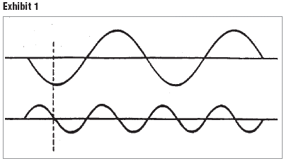
5. The chart in Exhibit #1 would be characterized as lacking:
A. Harmonicity
B. Synchronicity
C. Nominality
D. Proportionality
6. The four year cycle, also known as the Presidential Cycle, realizes the best returns in the stock market to be:
- Mid-term (year 3) and election (year 1)
- Election (year 1) and pre-election (year 4)
- Pre-election (year 4) and post election (year 2)
- Post election (year 2) and mid-term (year 3)

7. Which of the following is not considered to be an important aspect of Elliott Wave Theory?
A. Cycle amplitude
B. Form according to the Fibonacci sequence
C. Alternation
D. Waves are fractal

8. Which aspect of Elliott Wave Theory is considered most useful in determining retracement points and price objectives?
A. Cycle
B. Pattern
C. Time
D. Fibonacci Ratios

9. If you were interested in studying the relationship between cycles of different lengths, which of the qualities of cycles would be most helpful?
A. Frequency
B. Amplitude
C. Phase
D. Period

10. The idea that all price movement is the addition of all active cycles is the basis for the principle of:
A. Synchronicity
B. Summation
C. Proportionality
D. Harmonicity

11. You want to trade in the 24-hour foreign exchange market. If you prefer to use a method that uses arbitrary time periods not related to price action, the best charting method for you to use would be:
  - Line charts.
  - Bar charts.
  - Candlestick charts.
  - Point-and-figure charts.

12. In a trending market, when price reaches a new high:

A. and OBV is positive, confirmation has occurred, warning that the price advance may soon reverse downward.

B. and OBV does not reach a new high, positive divergence has occurred, suggesting that price advance will continue.

C. and OBV does not reach a new high, negative divergence has occurred, warning that the price advance may soon reverse downward.

D. on lower volume, buyers are stronger than sellers, suggesting that the price advance will continue

13. A technician utilizing an individual stock chart is attempting to:
A. Discover exploitable trends
B. Evaluate the validity of any discernible trend
C. Is really trying to assess the supply and demand factors for that security
D. All of the above

14. You work as an analyst for a long/short hedge fund in New York. A portfolio manager asks for your opinion about the stock of Continental Resources (NYSE: CLR) based on its year-to-date chart shown below. Which of the following responses is (are) consistent with traditional technical analysis principles?
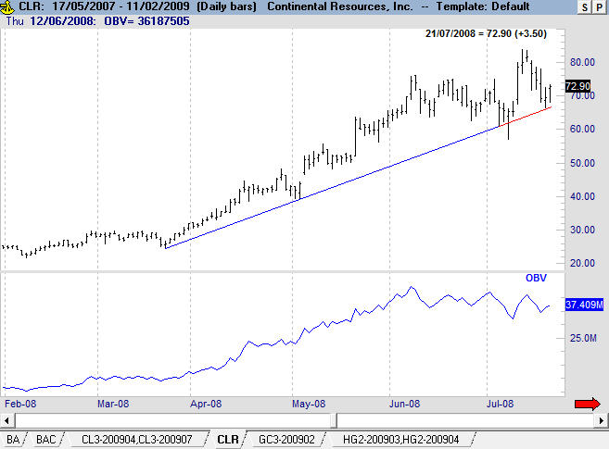
- “We should go long CLR based on the bullish divergence between price and OBV in July.”
- “We should be cautious of going long CLR because of a bearish divergence between price in July and OBV in June.”
- “The risk/reward of shorting CLR is high (i.e. high risk) since the stock is in an uptrend and near the trendline.”
- Choices “a” and “c” only.
- Choices “b” and “c” only.

15. High readings in all of the following flow of funds indicators is bearish except:
- Margin debt
- Public offerings
- Short term interest rates
- Money

16. According to the Dow Theory, secondary or intermediate-term trends:
A. Last for less than a month
B. Last at least 6 months
C. Serve as corrections in the primary trend
D. Always occur in the same direction as the primary trend
17. Choose the best answer. Intermarket analysis implies investors are concerned with other markets, such as bonds, commodities and currencies because:
A. The interactions tells us something about the economic environment
B. Stocks and bonds sometimes move in opposite directions
C. Investment funds flow from one market to another
D. All of the above

18. According to the Dow Theory, major trends have 3 phases. What is the third phase of a major uptrend?
A. Accumulation
B. Markdown
C. Distribution
D. None of the above

19. The stochastic indicator is based on the observation that
A. as prices fall, the closing price tends toward the mid-point of the range
B. as prices rise, the closing price tends toward the low price of the range
C. as prices fall, the closing price tends toward the high price of the range
D. as prices rise, the closing price tends toward the upper end of the range
E. none of the above

20. All of the following exit strategies are a viable way of exiting a trade except:
- Time stop
- Percentage stops
- Trailing stop
- Gradual stop
- Initial protective stop

21. Fill in the following table as it applies to RSI in different circumstances.

TYPE OF MARKET OVERBOUGHT OVERSOLD
Trading Range X 30
Bull Market 85 Y
Bear Market Z 25

a) X is 80, Y is 25, Z is 80
- X is 70, Y is 30, Z is 70
- X is 60, Y is 55, Z is 70
- X is 70, Y is 55, Z is 60

22. What is the primary purpose in designing and testing a trading system?
- To determine if an entry technique is valid
- To determine if it is the optimal system based on historical data
- To determine if the implementation of the strategy will give the trader an disciplined edge
- To generate the largest net profit on historical data
- To prove to fundamentalists that technicians can make money

  - Point-and-figure chart analysis focuses on:
- Markets with official opening and closing times and cannot be used in 24-hour markets.
- Periods of high volume when the market is in a trading range and disregards periods of low volume when the market is trending.
- Periods when trading is active and disregards dormant periods.
- The interaction between volume and trend.

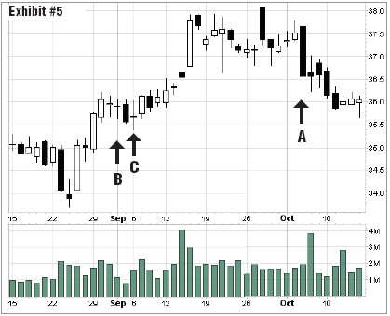
Refer to the above chart for questions 24 & 25
24. The one day candlestick pattern at A in Exhibit #5 above is a:
A. Dark cloud cover
B. Hanging man
C. Window
D. Bearish engulfing pattern

25. The one day candlestick patterns B & C in Exhibit #5 above are:
A. Hammers
B. Dojis
C. Engulfing pattern evening stars
D. Evening stars

26. Cash in the hands of portfolio managers, such as equity mutual fund cash, is:
A. Bullish when it is high
B. Bearish when it is very low because it reflects excessive optimism
C. A supply/demand indicator as well as a sentiment indicator
D. All of the above
- A & C only

27. A point-and-figure chart is described by the variables
- Box size and time
- Box size and volume
- Box size, reversal amount, and time
- Box size and reversal amount

28. A trend line is helpful in determining:
A. The rate of speed of a trend
B. How powerful the trend is
C. Helps determine when a trend is changing
D. All of the above

29. Which of the following would not be considered a means of identifying a trend?
A. Regression lines
B. Trend lines
C. Relative strength lines
D. Moving averages

30. A breakaway gap usually:
- Occurs during the accumulation phase of a market cycle
- Provides a major divergence signal
- Signals the beginning of an important price move
- None of the above

31. An entry stop is:
- Used to purchase a security once price has fallen to the desired level during a downturn.
- Used to exit a position
- Defensive in nature, and its use will cause profits to deteriorate
- Placed too far from the current price action causes the investor to be whipsawed.
- Used to initiate a position once breakout above resistance occurs

32. Which of the following would be considered to be the most important factor(s) in determining the significance of a trend line?
A. Time the trend is in force
B. Distance from price
C. Number of times prices touch the trend line
D. Angle of ascent or descent
E. A and C, and D only

33. A retracement or pullback:

A. Indicates that a major trend reversal is on the horizon.

B. Is a continuation of price movement in the direction of the primary trend.

C. Is an internal trend line that has a large number of minor reversals touching the line.

D. Is a smaller trend that runs counter to the principal trend.

34. In a _____________ system, entries and exits are determined mechanically by a computer; in a ___________ system, entries and exits are determined by intuition.

A. Technical; fundamental

B. Fundamental; discretionary

C. Nondiscretionary; discretionary

D. Discretionary; technical

35. Which is the least significant penetration of a rising trend line drawn on a daily chart?
A. A 3% penetration of the trend line
B. A close below the trend line
C. An intraday penetration of trend line
D. All of the above are equally significant

36. Late in a secular (very long term) rise in equities, investors:
A. Have moved a lot of money from stocks to bonds
B. Have moved a lot of money from cash equivalents to stocks
C. Have a relatively large percentage of financial assets in stocks and relatively small
percentage in bonds and cash
D. A and B
E. B and C

37. To be considered a correction and not a trend reversal, a throwback in an uptrend should:
A. Come on decreasing volume
B. Price should retrace below the prior trough
C. Should not retrace more than 67% of the prior uptrend
D. A and C only

38. Which of the following would not be considered a support level?
A. Previous high of a trading range once price breaks above the high
B. A rising trend line
C. The low price level of a trading range
D. All the above are considered as potential support levels

39. What is meant by the statement “volume precedes price”?
A. Buying pressure usually precedes selling pressure
B. Selling pressure is greater than buying pressure
C. Price is less important than volume
D. Changes in supply and demand are often apparent in volume before price

40. Which of the following is false about volume?
A. A rally that develops on declining volume is suspect
B. A rally that occurs on rising volume is suspect
C. Both price and volume can fall off sharply after a buying climax
D. A downside break of a moving average or trend line should occur on heavy volume to qualify as a bearish signal

41. A descending triangle that forms after a downtrend should be considered a:
A. Reversal pattern
B. Continuation pattern
C. Bullish pattern
D. Probably wouldn’t be useful in forecasting the future direction of the trend

42. Which of the following pattern is most likely a signal of a resistance area, a decline in momentum in the trend?
- pipe formation
- outside bar
- spike pattern
- inside bar

43. Decreasing volume as the pattern develops characterizes each of the following patterns except:
A. Broadening /Megaphone top formation
B. Wedges
C. Symmetrical triangles
D. Pennants
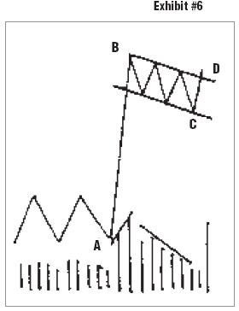
44. Using Exhibit #6 above, assume that the distance from point A to B is 7 points, that point B is 27, point C is at 24 and point D is at 26. Given the measured move or rule for this pattern, what would be the least conservative upside price target?
A. 34
B. 31
C. 33
D. 30.75
45. Which of the following is false of a doji pattern?
A. It represents indecision
B. It is usually a continuation pattern
C. It is usually a reversal pattern
D. The opening and closing prices are at identical levels

46. Relative strength analysis is useful in identifying:
A. Declining volume trends
B. Reversal in price momentum
C. Significant price gaps
D. Industry group rotation
E. None of the above

47. Which of the following is false about gaps?
A. Common gaps are of little or no forecasting value
B. Breakaway gaps usually occur on heavy volume
C. Runaway gaps occur at the end of a trend
D. When exhaustion gaps are filled it is often the sign of a trend reversal

48. In the below chart of Oilexco, areas/lines denoted by letters A, B, C, and D respectively refer to which patterns?
- Gap, wedge, symmetrical triangle, ascending triangle
- Gap, pennant, wedge, ascending triangle
- Gap, flag, symmetrical triangle, descending triangle
- Gap, flag, symmetrical triangle, ascending triangle

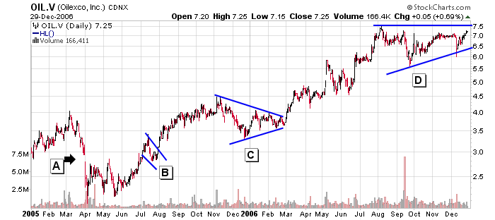

49. In the chart below, choose the most complete answer.
A
F
E
D
B
C

Arrows referring to a line E and point D are referred to as:

A. Support, pullback
- Throwback; resistance
- Resistance; pullback
- Support, throwback
- Support; resistance

50. In a valid double top:
A. The highs need to occur at exactly the same level
B. Volume increases on the second peak but the price fails to break through to a new high
C. The height of the pattern after breaking the previous low can be used to confirm a downside target
D. Can be determined immediately following the test of the first top

51. MACD above zero indicates that
- Prices are rising on increased volume.
- Volume is increasing at an increasing rate.
- The slower moving average is above the faster moving average.
- The shorter-term moving average is above the longer-term moving average.

52. The price level at which selling is expected to exceed demand and temporarily stop or reverse an advance is called a
A. Relative Strength Line
B. Trend Channel
C. Resistance
D. Extended
E. Climax

53. Two parallel trend lines that contain between them all, or virtually all, of the price movement data is a
A. Relative Strength Line
B. Trend Channel
C. Resistance
D. Extended
E. Climax

54. How would you use relative strength analysis when comparing sectors to find the leading sector to invest in?
- Divide the price of each sector by an industry benchmark and compare
- Compare RSIs – the higher the number, the more bullish the sector
- Divide the price of one sector by another and compare
- We don’t compare sectors it is more useful to compare industry groups

55. The acronym CANSLIM summarizes William O’Neil’s philosophy. The “C” stands for:
A. Current assets minus current liabilities
B. Current earnings per share growth
C. Continuation pattern
D. Classy management

56. The acronym CANSLIM summarizes William O’Neil’s philosophy. The “N” stands for:
A. Near term improvement
B. Net profit growth
C. New products or services
D. NYSE Listing

57. Which statement is most accurate?
A. Highs and lows on a price chart in a trading range often correspond with extreme overbought and oversold readings on an oscillator
B. Oscillators are generally less useful in trading range markets
C. Oscillators give more useful overbought or oversold signals in the early stages of a
rally or decline
D. Oscillators tend to give more false overbought or oversold signals in the latter stages
of a rally or decline

58. ________ are more profitable in trending markets, and ___________ are more profitable in trading range markets.
- Moving averages; oscillators
- Oscillators; moving averages
- Oscillators; momentum indicators
- Momentum indicators; moving averages
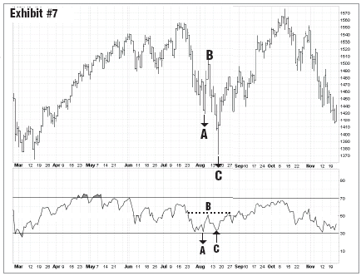
59. In Exhibit #7, comparing the points of A, B, C on the top price chart to points A, B, C for the momentum oscillator (on the bottom half of the chart) is an example of a:
A. Negative divergence
B. Positive divergence
C. Failure swing
D. Both B & C

60. Which statement is true of an up trending market?
A. Momentum indicators will tend to hit greater oversold extremes
B. Momentum indicators will tend to stay overbought longer
C. The MACD Momentum indicators is very useful
D. Both B & C

61. Which of the following statements is false about volume and trend:
- When prices are rising, increasing volume is good
- When price advance halts with high volume, it is a potential top
- When prices are rising, decreasing volume is good
- When prices are declining, increasing volume is bad
- When prices are declining, decreasing volume could stop a downward trend

62. Which of the following tenets of Technical Analysis is derived from Dow Theory?
A. Price movements of the averages are completely random
B. Price history is of little value in forecasting trends
C. The averages discount virtually everything
D. All of the above

63. All the following are true about behavioural finance except:
- Mental accounting contributes to positive feedback and treats gains different from losses
- Support and resistance can be explained by the psychology of investors
- Only individual investors make behavioural mistakes such as overconfidence
- Behavioural finance supports technical analysis

64. Which would normally be considered a measurable sentiment indicator most useful to traders?
A. Corporate buy backs
B. Price/earnings ratios
C. Insider buying
D. Put/call ratios

65. Contrary opinion is a useful investment tool because:
A. The “little guy” is always wrong
B. Traders are often most bearish near market tops
C. Institutional investors have access to better information
D. You look to sell when the majority is buying and to buy when the majority is selling. When short-term oriented participants are fully committed to the long side, they are more likely to become sellers than buyers

66. Sentiment polls are generally believed to be contrary opinion indicators because:
A. They measure investment attitudes of the unsophisticated
B. They measure investment attitudes of the informed
C. When short-term participants are excessively optimistic, they are most fully invested
D. None of the above

67. Which of the following tools is not valuable to the contrarian investor:
- Studying insiders’ trading activity, looking at the consensus bullish sentiment index
- Looking at the put-call ratio, studying insider’s trading activity
- Looking at margin balances, VIX index readings
- Studying insider’s trading activity. Studying large block trade transactions

68. Which of the following is not a valid method to determine an uptrend?
- Using a positive sloping best fit regression line
- Connecting two successive lower troughs lows
- Drawing channel lines for a rectangle pattern
- Using a ruler to draw a upward trend line by connecting as many lows as possible
- Using an accelerated trend line
69. All the below are important aspects of using the CANSLIM system developed by William J. O’Neil, except for:
A. Looking to buy cup and handle breakouts
B. An 8% stop loss rule from initial purchase point
C. Looking at fundamental factors such as revenue and earnings
D. Having a complete disregard to the market index movements
E. Volume confirmation greater than the average volume

70. One reason why price oscillators are useful is because:
- Momentum tends to lead price
- An oversold reading on the oscillator is always a good time to buy
- An overbought reading on the oscillator is always a good time to sell
- Prices never revert to the mean

For 71 -75, True or False:
71. Divergences are most useful on an RSI indicator when they occur below the 70 and above the 30 line.
A. True
B. False

72. The retracement levels of 31.8%, 50%, 68.2% derived from the Fibonacci sequence is the mathematical basis of the Elliott Wave Theory
A. True
B. False

73. A Time magazine cover story reporting on the stock market’s recent historic highs should be viewed as bullish.
A. True
B. False

74. A simple moving average is slower to respond to price changes than a weighted moving average
A. True
B. False

75. Oscillators are secondary indicators in the sense that they are subordinate to basic trend analysis.
A. True
B. False
76. The very short term trading method that takes very small profits by providing liquidity with a reliable order entry system is called:
- Swing trading
- Screen trading
- Scalping
- Day trading
- Paper trading

77. What are the ways in which oscillators provide useful buy and sell signals?
- Measuring overbought and oversold levels
- Crossing the “0” line
- Measuring divergences
- Using trend, support and resistance lines on the oscillators themselves
- I only
- I and II only
- I, II, and III only
- All of the above

78. Which notion about the Relative Strength Index (RSI) is false?
- It is calculated as a ratio of one security versus another
- Oversold readings in an uptrend is bullish
- Positive divergences are expected to lead to a positive trend reversal
- It is not used in asset allocation

79. One of the problems with price oscillators like momentum and rate of change is that there is no established range to identify overbought and oversold levels. Identify an oscillator(s) that was created to address this problem
- RSI
- Stochastics
- MACD
- Both A and B
- None of the above

80. Relative strength analysis is studied for all the below reasons except
- Help a portfolio manager outperform his peers
- Determine which security to buy
- Allocate capital most efficiently
- Determine when price is over extended and due to revert to the mean
81. In Exhibit #8 below, based on combining the price trend (in the upper part of the chart) with relative strength analysis (in the below part of the chart), which chart would you consider to be the better buy at present?
A. Index in Chart A
B. Index in Chart B
C. Both A and B
D. None of the above

82. By studying the relative strength line of General Electric Stock relative to the S&P
500 index, the analyst can determine if
- The stock is appreciating in value
- There is a large amount of participation in the stock
- The stock’s trend
- GE is outperforming the S&P 500
- Both A & C

83. The analysis of cycles provides
- An objective determination of trend
- An indication of time duration of a trend
- Relative strength of related price indices
- An approximation of price support

84. Inter-market analysis relates to _________ and _________ to make forecasts.
- Stocks & bonds
- Options & stocks
- Domestic & foreign markets
- A & B only

85. In its most basic form, Elliott Wave Theory says
- That the stock market follows primary and secondary trading cycles
- Accumulation takes place at the beginning of the primary trend
- That financial markets follow a repetitive pattern of a five wave advance followed by a three wave decline
- That financial markets follow a repetitive pattern of a three wave advance followed by a five wave decline
- None of the above

86. The Elliott Wave rule of alternation states
- That alternative waves are complimentary
- That alternative waves are regressive
- That the market usually doesn’t act the same way two times in a row
- That price waves combine by twos and threes
- Types of corrective waves in wave 2 and 4

87. Oscillators are most helpful to gauge price behavior in
A. sharply rising markets
B. sharply falling markets
C. sharply rising and sharply falling markets
D. non-trending markets where prices fluctuate in a well defined trading range
E. all of the above

88. Which statement about trends is false ?
- To spot a trend, look for peaks and troughs within a series of price oscillations
- Previous resistance once broken will become support, and this is called the change of polarity
- Trends can also be drawn using a regression line
- The steeper the trend line, the longer it will take to be broken

89. Efficient Market Hypothesis assumes all the following except
- Investors are rational
- The market cannot be beaten
- Prices follow a random walk
- Markets and prices adjust gradually
- Arbitrage is always possible

90. An increasing Canadian dollar would be viewed as being __________ and would be ___________ for the bond market and __________ for the equity market as per the Intermarket model.
- inflationary, negative, negative
- deflationary, negative, positive
- inflationary, positive, positive inflationary, positive, negative
- disinflationary, positive, negative

91. Which of the following is false about Intermarket analysis?
- Stocks lead bonds, bonds lead commodities
- Bonds lead stocks, stocks lead commodities
- All financial markets are linked and interrelated
- Bonds go down, stocks go up when the economy is actually strengthening because of increased credit demand and improved pricing, and rising earnings

92. The decoupling of the bond and stock price relationship apparent during a deflationary period can be best described as having:
- Commodities prices ↑, bonds prices↑, stocks prices↓
- Commodities prices ↓, bonds prices ↑, stocks prices ↑
- Commodities prices ↑, bonds prices ↓, stocks prices ↑
- Commodities prices ↓, bonds prices ↑, stocks prices ↓

93. An upward sloping relative strength line between the CRB (Commodities Research Bureau) Index and the US 30 Year Bond price should signal a portfolio manager to invest in the:
- Technology sector
- Financial sector
- Utilities sector
- Basic materials & metals sectors

94. Which of the following statements is false about using the RSI (Relative Strength Index)?
- It can be used as an overbought and oversold indicator when RSI hits 70 and 30 respectively
- In strong trending markets RSI can stay above 70 for a while
- When a peak in RSI over 70 fails to exceed a previous peak in an uptrend this may signal a top
- Pattern analysis and trend lines cannot be used on RSI
- Divergences can occur between the highs/lows of RSI lines and highs/lows of price

95. Locate an example of one bullish divergence and one bearish divergence in the following chart of BP (NYSE: BP) with the slow stochastic indicator shown in the lower part of the chart.
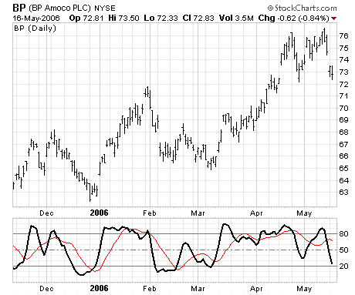
D
B
C
A
- Bullish divergence at C; bearish divergence at D.
- Bullish divergence at D; bearish divergence at C.
- Bullish divergence at A; bearish divergence at B.
- Bullish divergence at B; bearish divergence at A.

96. One reason why volume indexes are useful is because they can be used for divergence analysis.
A. True
B. False

97. An extreme overbought reading on a momentum indicator in the early stages of a rally
A. shows that the market is ready to correct
B. indicates that the rally is strong and may consolidate, and will probably carry further
C. is a clear indication that the pace of the rally is about to slow down
D. is a clear indication that the pace of the rally is about to accelerate

98. The acronym CANSLIM summarizes William O’Neil’s philosophy. The “I” stands for:
A. Investment opportunity
B. International exposure
C. Interest rate background favourable
D. Institutional sponsorship

99. “Random Walk Theory” is:
A. A useful tool of Technicians
B. A useful tool of Fundamentalists
C. Implies that returns are normally distributed, and mistakes are uncorrelated
D. How you decide to get home after drinking
E. None of the above

100. Which best describes a window in the chart below?
- Candle 1
- Area between Candle 2 & Candle 3
- Candle 3
- Area between Candle 3 & Candle 4
- Candle 5

