CHM 2353 – C00
Descriptive Inorganic Chemistry

Experiment 2
Production of Alum from Coke Cans

Joseph Costello - 300119374

Lab Date: October 7, 2020
Date Experiment Submitted: October 21, 2020
T.A.: Tegan O’Brien
Lab Group: C00
Lab partners: Joseph Costello, Megan Facette
Objectives
The goal of this experimentation is to explore the chemical properties of aluminum specifically aluminum hydroxide and alum (aluminum potassium sulfate dodecahydrate). This experimentation will demonstrate aluminum chemistry but will not be an accurate representation of industrial level aluminum chemistry due to the high cost required to produce alum in mass. Additionally, this experimentation will explore how the solubility of aluminum hydroxides vary with the pH of the solution.
Procedure¹
- The label from a soda can was first sanded off using sandpaper. The can was then cut first into a 10 by 10 cm square sheet and then into smaller 0.5 by 0.5 cm squares. This process was then repeated using another can and the small pieces were placed in a small bag.
- In two separate 150 mL beakers 0.5-0.6 g of aluminum was added and recorded to the nearest 1/100th of a gram. To both beakers 25 mL of 1.4 M potassium hydroxide was added. In a fume hood the mixture was heated at low heat.
- To sample 1 10 mL of 9 M sulfuric acid was rapidly but carefully added. The solution was stirred carefully and thoroughly. The mixture was then reheated upon the formation of crystal precipitate.
- After the complete dissolution of aluminum within sample 2 the solution was filtered hot by placing a filter paper in a glass funnel. 10 mL of 9 M sulfuric acid was then added.
- Sample 2 was then filtered using the same methodology as sample 1.
- An ice bath was prepared and both 150 mL beakers were placed within. Occasional stirring and temperature measurement were implemented.
- A suction filtration apparatus was assembled using a Büchner funnel, a large Büchner flask, moist filter paper, and a three-finger clamp. Once the liquid had cooled to <6 °C the two mixtures were filtered separately with new filter paper being used following the first filtration.
- Using two portions of cold methanol the crystals were washed to remove any excess sulfuric acid.
- Air was allowed to be sucked through the filter an additional 10 – 15 minutes to ensure the crystals were thoroughly dried.
- The crystals were then weighed on filter paper and their mass was recorded.
Observations
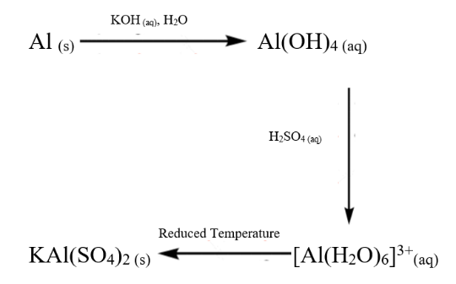
The qualitative observations can be compared with the primary chemicals in solution utilizing Figure 1. Initially the aluminum metal chips appeared silvery and shiny with noticeable scratches from the sanding process. Upon weighing both samples weighed 0.51 g in mass. Following the addition of potassium hydroxide solution, a strong bubbling was observed in the solution. Once the solutions were heated bubbling continued and the solution took on a black colour. Upon the addition of sulfuric acid to sample 1 white crystals formed which quickly disappeared following the reheating of the solution. When the solutions were filtered using simple gravity filtration no precipitate was observed in the filter, but small plastic squares were recovered. Sulfuric acid was added to sample 2 and an identical white precipitate formed which disappeared upon reheating. When the solutions were added to the ice bath a white precipitate formed once more in the solution which was able to be recovered and measured following a suction filtration and methanol washing. The mass of the precipitate within sample 1 was found to be 7.51 g and the mass of sample 2 was found to be 0.62 g.
Figure 1. Reaction Scheme of Alum Production.
Calculations

initial
m_{Al1} = 0.51 g
m_{Al2} = 0.51 g
final
m_{Alum1} = 7.51 g
m_{Alum2} = 0.62 g
mm_{Al}=26.981539 g/mol
mm_{Alum}=474.390399 g/mol

n = m/mm
n = 0.51 g / 26.981539 g/mol
n = 0.01890181283 mol
m = n * mm
m = 0.01890181283 mol*474.390399 g/mol
m = 8.96683853 g

Sample 1
$$\%yield= \frac{Measured mass}{Theoretical mass}*100\%$$
$$\%yield= \frac{7.51 g}{8.96683853 g }*100\%$$
$\%yield= 83.7530416$%
$$\%yield= 84\%$$
Sample 2
$$\%yield= \frac{Measured mass}{Theoretical mass}*100\%$$
$$\%yield= \frac{0.62 g}{8.96683853 g}*100\%$$
$\%yield= 6.914365614$%
$\%yield= 6.9$%

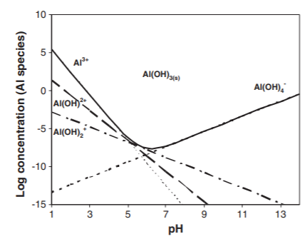
Discussion
Throughout this experiment the aluminum underwent very few visible chemical changes however, the pH of the solution change drastically between the aluminum’s initial dissolution and its final precipitate as K-alum. Initially the aluminum was dissolved under highly basic conditions which as shown in figure 2 produces Al(OH)₄⁻ ions along with K⁺ ions. Following this one sample was first filtered and then treated with sulfuric acid while another sample was treated with sulfuric acid then filtered. In both samples a white precipitate formed shortly but disappeared upon the solution’s reheating. As shown in figure 2 when an aluminum solution moves from basic to neutral conditions the solubility of aluminum decreases significantly resulting in the formation of Al(OH)₃ which is likely what the precipitate observed was. Following heating and stirring the solution became more homogenous resulting in any neutral precipitate quickly becoming acidified by the sulfuric acid in solution. Once the aluminum was recovered there was a very large discrepancy in percent yields observed as ideally about 8.97 g of hydrated K-alum should be recovered however, one sample recovered 7.51 g (84%) and the other sample recovered only 0.62 g (6.9%). While there was only one ‘minor’ change between the samples this resulted in a very clear difference of results. The key difference between the samples is that sample 2 was acidified following the filtration while sample one was acidified prior to filtration. As seen in figure 2 aluminum is much less soluble under basic conditions, so it is likely a significant amount of aluminum was lost during the first filtration process since some white Al(OH)₃ could have easily clung to the plastic and not be noticed in the white filter paper.²
Figure 2. Dissolved Aluminum Structures with pH Variability.²
While it is very likely this experiment produced a significant amount K-alum precipitate based upon the previously mentioned theories it is also very possible the final product contained some Al(OH)₃ especially since it is identical in colour. To verify the product is in fact K-alum the solution can be dissolved in water once more and barium chloride may be used as an indicator as this will quickly lead to the production of barium sulphate a compound completely insoluble in water. Based upon the mass of the barium sulphate produced the amount of aluminum which existed as aluminum sulphate prior to dissolution can be determined.³
Reaction Sequence²
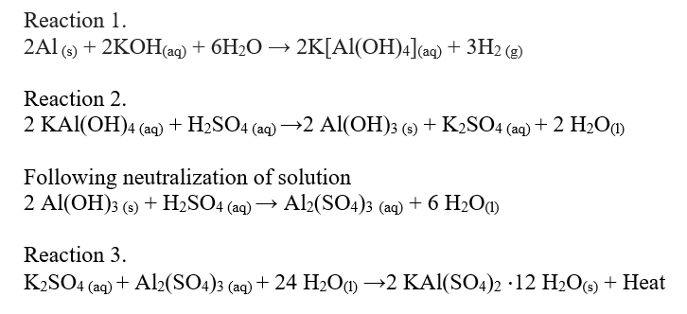
Conclusion
In conclusion, this experimentation was successful in demonstrating the chemical properties of aluminum metal specifically aluminum hydroxide and alum. This experimentation additionally demonstrated that simple changes in a procedure can have a significant effect on an overall reaction as illustrated by the drastic difference in percent yields between the two samples (84% vs. 6.9%). The aluminum in sample 2 was likely lost during the gravity filtration since aluminum hydroxide is less soluble under basic conditions and the filter would simply remove any precipitate from the solution. In order to improve the yield, it is clear the solvent must first be treated with acid then filtered as to recover as much aluminum as possible. Additionally, some alum powder would have been lost during the final filtration process since even at low temperatures alum is still slightly soluble in water. In order to improve the yield even further it would be best to first evaporate all the water using a vacuum desiccator and then wash the precipitate using methanol. Overall, this experiment very clearly illustrated how solubility varies with pH and some of the various chemical properties of aluminum.
Questions
- If acid is added slowly, a white precipitate appears and subsequently disappears. What is the white precipitate? Support your answer with appropriate chemical equations.

Due to the acidic properties of sulfuric acid it is incredibly likely that the white precipitate which appears is Al(OH)₃. This can be explained based upon the following chemical reaction: 2 [Al(OH)₄]⁻_{(aq)} + H₂SO_{4 (aq)} → Al(OH)_{3 (s)} + 2 H₂O_{(l)} + SO₄²⁻_{(aq)}.

- Experiments show that the solubility of alum in 25 mL 1.4 M KOH and 10 mL of 9 M H₂SO₄ is ca. 1.0 g at 1.0 °C and 1.7 g at 6.0 °C. Estimate the amount of alum left in the 65 mL of a solution chilled to 4 °C. What might you do reduce the amount of alum remaining in solution?

y represents the concentration of alum in solution and x represents the temperature of the solution. m is representative of the slope between the two points and b represents the y intercept.

C₁ = y₁ = m₁/V₁
C₁ = y₁ = 1.0 g / 35 mL

C₂ = y₂ = m₂/V₂
C₂ = y₂ = 1.7 g / 35 mL

y = mx + b
y - mx = b
y₁ – mx₁ = y₂ – mx₂
(1.0g / 35 mL) – m(1.0 °C) = (1.7 g / 35 mL) – m(6.0 °C)
m = 0.004 g / mL °C

y₁ = mx₁ + b
(1.0g / 35 mL)= (0.004 g / mL °C)(1.0 °C) + b
b = 0.024571429 g / mL

y₃ = mx₃ + b
y₃ = (0.004 g / mL °C)(4 °C) + (0.024571429 g / mL)
y₃ = 0.040571429 g / mL

C = m/V
0.040571429 g / mL = m / 65 mL
m = 2.637142857 g
m = 3 g

There will be approximately 3 g of alum remaining within the 65 mL of solution if it is chilled to 4 °C. It is quite clear that there is a direct relationship between the temperature of the solution and the amount of alum dissolved within it. In order to decrease the amount of alum in solution the solvent must be cooled to as low of a temperature as possible without freezing the solvent. Assuming the solvent used is water that temperature is 0 °C so the solution must be cooled to just above that value.

- Provide examples of:
- an acidic oxide;
Sulfur Dioxide

- a basic oxide;
Potassium oxide

- an amphoteric oxide (other than Al₂O₃)
Zinc oxide

- a neutral oxide.
Carbon monoxide

References
- Fogg, D.E. Descriptive Inorganic Chemistry Laboratory Manual. University of Ottawa: Ottawa, 2020; 16-17.
- Emamjomeh, M. M.; Sivakumar, M. Analysis and the understanding of fluoride removal mechanisms by an electrocoagulation/flotation (ECF) process. Desalination. 2011, 275, 102-106.
- Giblin, J. C. A Volumetric Method For The Determination of Barium and of Sulphates. Analyst. 1933, 58, 752-753.

