CHM 2353 – C00
Descriptive Inorganic Chemistry

Experiment 5
Spectrophotometric Determination of Nitrite & Nitrate

Joseph Costello - 300119374

Lab Date: November 11, 2020
Date Experiment Submitted: November 25, 2020
T.A.: Tegan O’Brien
Lab Group: C00
Lab partners: Joseph Costello, Megan Facette
Objectives
The goal of this experimentation is to explore the chemical properties of nitrogen compounds specifically nitrite and nitrate. This experimentation will explore the solubility properties of these chemicals and the highly accurate process utilized to identify their concentrations in public drinking waters. This experimentation will provide a clear and accurate representation of nitrogen chemistry which is utilized regularly to ensure the safety of drinking water and the health of the public.
Procedure¹
(Fogg,2020)
Note: during “Part B nitrate calibration curve” the zinc powder was added gradually in staggered additions as opposed to all at once as outlined in lab manual.
Observations
Initially, all of the solutions were transparent in colour and most solutions did not change colour upon mixing. The two chemicals which were an exception to this, however, were N-(1-napthyl)ethylenediamine dihydrochloride solution and the sodium acetate solution. Upon addition of the N-(1-napthyl)ethylenediamine dihydrochloride to the nitrate, hydrochloric acid, and sulfanilic acid solution the solution turned a translucent violet colour. This violet colour was observed in every nitrate solution tested with a slightly darker colour being observed in the more concentrated solutions. Additionally, it was observed that when sodium acetate was added to the solution around the area of contact between the two liquids a bright orange colour appeared however, this colour did not persist.
Results
Table 1. Ideal Wavelength at Maximum and Minimum Solution Concentrations
 | Wavelength (nm) | Absorbance (L/ mol · cm)
Minimum | 797.60 | 0.002
Maximum | 526.20 | 0.821
Figure 1. Determining Optimal Wavelength for Nitrite Solution Absorption

Part A Nitrite
Table 2. Absorption of Light by Nitrite Solutions at Ideal Wavelength of 526.20 nm
Concentration (ppm) | Absorbance (L/ mol · cm)
0 | 0.007
0.2 | 0.123
0.4 | 0.241
0.6 | 0.514
1.0 | 0.806
Unknown 4 (trial 1) | 0.251
Unknown 4 (trial 2) | 0.212
Unknown 6 (trial 1) | 0.650
Unknown 6 (trial 2) | 0.784

Figure 2. Dependence of Absorption on Concentration of Nitrite solutions

Part B Nitrate

Table 3. Absorption of Light by Nitrate Solutions at Ideal Wavelength of 526.20 nm
Concentration (ppm) | Absorbance (L/ mol · cm)
0 | 0.010
5.0 | 0.184
10.0 | 0.517
15.0 | 0.546
20.0 | 0.675
Unknown 4 (trial 1) | 0.683
Unknown 4 (trial 2) | 1.053
Unknown 6 (trial 1) | 0.557
Unknown 6 (trial 2) | 0.632
Figure 3. Dependence of Absorption on Concentration of Nitrate solutions

Calculations
Unknown Nitrite solution 4 Trial 1

C = ?
A = 0.251
Slope = 0.83
y intercept = - 0.027

A = mC + b
0.251 = (0.83)C – 0.027
C = 0.334939759 ppm
C = 0.33 ppm

Unknown Nitrite solution 4 Trial 2

C = ?
A = 0.212
Slope = 0.83
y intercept = - 0.027

A = mC + b
0.212 = (0.83)C – 0.027
C = 0.287951807 ppm
C = 0.29 ppm

Unknown Nitrate solution 4 Trial 1

C = ?
A = 0.683
Slope = 0.0336
y intercept = 0.0522

A = mC + b
0.683 = (0.0336)C + 0.0522
C = 18.77380952 ppm
C = 18.8 ppm

Unknown Nitrate solution 4 Trial 2

C = ?
A = 1.053
Slope = 0.0336
y intercept = 0.0522

A = mC + b
1.053 = (0.0336)C + 0.0522
C = 29.78571429 ppm
C = 29.79 ppm

Remaining Nitrate in unknown 4 Nitrite solution Trail 1
C_{No3} = ?
C_{i} = 18.8 ppm
C_{f} = 0.33 ppm

C_{No3} = C_{i} – C_{f}
C_{No3} = 18.8 – 0.33
C_{No3} = 18.47 ppm
C_{No3} = 18.5 ppm

Remaining Nitrate in unknown 4 Nitrite solution Trail 2
C_{No3} = ?
C_{i} = 29.79 ppm
C_{f} = 0.29 ppm

C_{No3} = C_{i} – C_{f}
C_{No3} = 29.79 – 0.29
C_{No3} = 29.5 ppm
C_{No3} = 30 ppm

Discussion
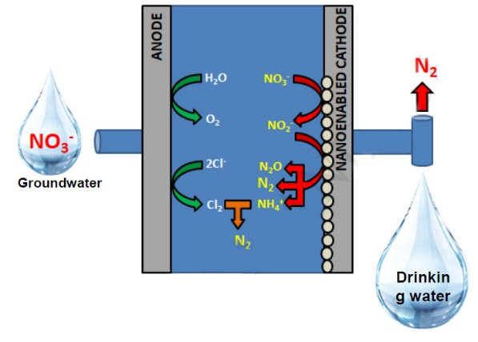
Seeing that this experiment focused on the concentration of nitrates and nitrites in water it is important to understand how this science can be applied in the real world. The water consumed by the public must be carefully cleaned and analyzed to remove any fecal matter, bacteria, or harmful chemicals which could have a negative affect on the water’s taste and the health of the general population. One method utilized to remove nitrates and nitrites from drinking water is known as electrochemical reduction for denitrification. In large containers impure groundwater is inserted where it is allowed to interact with two high surface area electrodes. The electrode allows for electrical current circulation within the solution and allows for the exchange of electrons between electroactive species in solution such as nitrate and nitrite molecules. For electrochemical denitrification to occur the nitrate and nitrite ions must be reduced to form nitrogen gas as seen in figure 4.²
Figure 4. Nitrate removal from groundwater.²

When comparing the data collected with accepted drinking water tolerances it can be determined if the water has undergone enough treatment for it to be safe for human consumption. Within the Canadian province of Ontario, the accepted amount of nitrates in potable water must be no greater than 10.0 mg/L. Additionally, the concentration of nitrites in solution must not exceed 1 mg/L and their combined concentration must also not exceed 10 mg/L.³ The unknown sample 4 provided would not have fallen into this acceptable range since their concentration was measured to be 30 mg/L and 18.5 mg/L between several trials. This large difference between trials shows the importance of testing data multiple times and is why this data is to ideally be collected and analyzed by machines which are much more accurate than humans.

Throughout this experimentation it was crucially important that equipment was thoroughly cleaned prior to measuring the solution since the data being collected was incredibly precise and any contamination could severely influence the results of the experiment. For this reason the least concentrated solution was measured first then the equipment was rinsed and the next most concentrated solution was analyzed. This allowed for the minimal amount of contamination to be transferred between trials.
Reaction scheme
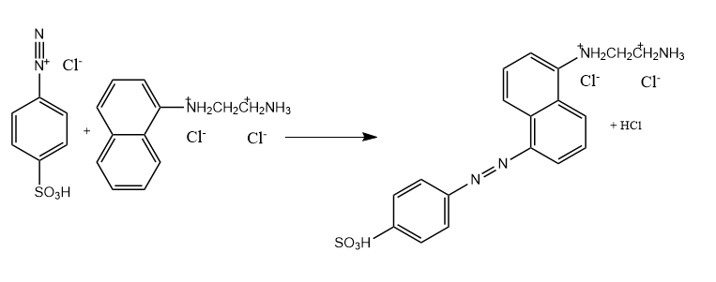
Conversion of acidic nitrite to visible azo dye

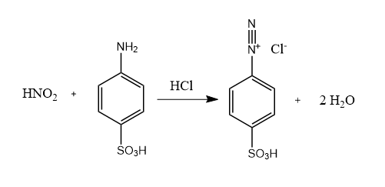
Since nitrate and nitrite salt is translucent in solution its concentration cannot be directly measured through light absorbance so it must be converted into a colourful azo dye which will have an identical concentration assuming complete conversion.
Conversion of nitrate to nitrite
HNO_{3 (aq)} + Zn _{(s)} + 2 HCl _{(aq)} → HNO₂ + ZnCl_{2 (aq)} + H₂O_{(l)}
Conclusion
In conclusion, this experiment was successful in demonstrating some of the various chemical properties exhibited by nitrate and nitrite compounds. This experimentation additionally, demonstrated a prolonged analysis on how spectrophotometry works and its utilization in the real world application that is drinking water safety measurement. There wer several challenges with this experiment however, as the equipment was incredibly precise any minute flaw in the procedure would result in drastic changes in the measured absorbance. This is observed in the deviations from the trendline seen in both figure 2 and figure 3. Any additional water added would result in a lower absorbance being observed and any additional nitrate salt would result in a higher absorbance being observed. Overall, this experimentation allowed for an in depth analysis into the behavior of nitrate and nitrite salts and how their concentrations can be precisely determined in the water industry.

Questions
- Based on your experimental data, estimate the % nitrate converted to nitrite in 5 min exposure to zinc

%N =
$$\%N= \frac{C_{NO2}}{C_{NO3}} ×100\%$$
$$\%N= \frac{18.5 ppm}{0.33 ppm} ×100\%$$
$$\%N=5606.060606 \%$$
$$\%N=5600 \%$$

- The introduction states that nitrate is partially reduced to nitrite:
- What are the chemical differences between the nitrate and nitrite ions (oxidation states, bond strengths, oxidizing ability)? You may want to draw Lewis structures.

As seen below the nitrate ion and nitrite ion have noticeable geometric and formula differences. This results in the two chemicals additionally having different chemical properties such as oxidation state with nitrates being -2 and nitrites being -1. Additionally, due to the fact that the nitrate ion has a greater amount of resonance structures when compared to the nitrite ion the electron density is less dense when compared to the nitrite ion. This results in the nitrate ion having shorter stronger bonds then the nitrite ion. Another key difference between the molecules is that nitrate ions are stronger oxidizing agents then nitrite ions due to their higher reduction potential.

Lewis Structure of nitrate and nitrite
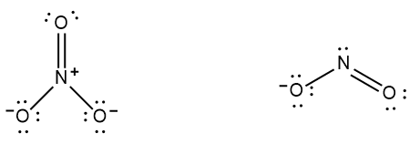

Lewis structure with fractional oxidation states to illustrate resonance and electron density for nitrate and nitrite.
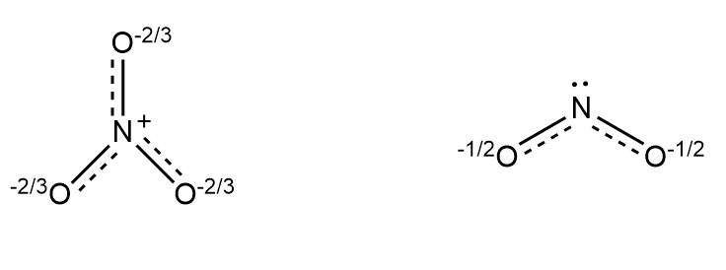
- What was oxidized? (include appropriate chemical reaction)

As shown in the below chemical reactions first the nitrous oxide was oxidized and the sulfanilic acid was reduced to yield water and diazonium salt. The produced diazonium salt is then further reduced and the N-(1-naphthyl)ethylenediamine dihydrochloride is oxidized to yield a purple coloured azo dye.

- Why is the time that the nitrate solution and Zn powder are in contact important in this procedure?

The amount of time the nitrate solution is in contact with the zinc during this procedure is crucially important since the amount of nitrite in solution is directly proportional to the length of time allowed to react with the zinc. In order to get accurate data on how the concentration of nitrite affects the transparency of the liquid a precise concentration needs to be known. If the actual concentration is inconsistent with what it is calculated to be this data becomes meaningless.
References
- Fogg, D.E. Descriptive Inorganic Chemistry Laboratory Manual. University of Ottawa: Ottawa, 2020; 26-30.
- Sergi, G. Electrocatalytic reduction of nitrate: Fundamentals to full-scale water treatment applications. Applied Catalysis. 2018, 41, 35-121.
- Technical Support Document for Ontario Drinking Water Standards, Objectives and Guidelines . https://cvc.ca/wp-content/uploads/2011/03/std01_079707.pdf.

