Canadian Comm. in Context

Week 1:

What is communication?: Communication is not something that simply exists out there, but something that we do – an activity. It can be defined as the process of creating, or sending and receiving, or interpreting a message or idea.

- Harold Innis (1894-1952) was a significant figure in the study of Canadian economic history, as well as a founder of the Toronto School of communication theory, which produced thinkers like Marshall McLuhan.
- Marshall McLuhan (1911-1980) is known around the world for coining the term ‘global village’ and the expression ‘the medium is the message’.
- In “Considering Critical Communication Studies in Canada”, Sheryl Hamilton (2014) identifies the origin of the distinction between administrative and critical approaches in the work of Paul Lazarsfeld, who in 1941 established this founding narrative. Recognized as one of the founders of the field of communication studies, Lazarsfeld distinguished his administrative research from the critical theory of the Frankfurt School.
- Critical theory is an approach to research oriented on examining societal relations in order to understand cultural assumptions. Developed by a group of German-Jewish scholars, such as Max Horkheimer, Theodor Adorno, and Herbert Marcuse at the Institute for Social Research in Frankfurt (Frankfurt School), critical theory famously developed the concept of the culture industry, which warns that a society where culture is something that you increasingly buy rather than create results in a repetition of the same cultural products and a narrowing of thought.

Critical Thinking:
- Critical thinkers reflect on what they read. They do not assume that what they read is the entire truth. They ask questions. They are open to new ideas and new perspectives. They aim to uncover meaning in seemingly obvious issues, and power relations at work behind apparently self-evident facts. In contrast, non-critical thinkers tend to passively accept what they read. They assume that the facts they know are the only relevant ones and they have trouble recognizing a variety of possible interpretations. They tend to answer questions with yes or no and few subtleties.

Week 2:

Choice and Content: Media Ownership and Democratic Ideals in Canada:

- This article explores concerns regarding media ownership in Canada from a “marketplace of ideas” perspective. It assesses evidence indicating whether the ideals associated with this perspective are threatened and proposes steps that seem best suited to achieving those broad ideals. It concludes that regulations limiting ownership levels by single corporations combined with relaxed foreign ownership controls would likely increase the range of choice and diversity of content in the news media. The latter, it also suggests, would allow regulators to more effectively enforce the ownership guidelines already in place for maintaining a vibrant and competitive media market.
- The mass media sets the context for the facts that are gathered, determine s how such facts should be viewed and debated, and offers in‐depth analysis and positions on significant events and issues.
- Dean Alger suggests that a democracy is “a ‘market place of ideas,’
- “Black Tuesday,” August 27, 1980, when a competitive trade‐off was made between the two largest chain newspaper owners at that time – Southam and Thomson.
- the media should inform, but should not direct, the democratic process.
- Presumably, “news”, to a greater or lesser degree, should reflect some element of the real world – or “facts”.
- 3 basic forms of assessing the impact of ownership on content (or ownership bias),
- 1. looking at the practices of specific media corporations, and whether certain specified interests of each organization appear to have influenced the content of output of such organizations
- 2. looking at whose interests are served by the media agenda more broadly.
- 3. To compare differences in content on a topic between those organizations that have an apparent interest in a given topic or outcome versus those organizations that have no clear interest
- 2006 Senate Report also highlighted a number of problems identified by observers and journalists that were associated with increased cross‐ownership

- If the government feels that it is all right for the same company to control 100 percent of the daily newspapers and 70 percent of the local television news market in Canada’s third largest city — as is the case with CanWest Global in Vancouver — or that there is no problem with one company being the dominant player in newspapers, television and cable distribution in one of our two official languages — as is the case with Quebec or — then let it say so and take the consequences

Media ownership and convergence

Media, Culture & Society

Public vs. Private Media Ownership

privately-owned media are primarily interested in financial profit, publicly owned media are devoted to providing communication as a public service based on public goals.

The goals of publicly owned media tend to focus on facilitating the development of a certain type of public.

privately-owned media are devoted to providing communication for profit.

media convergence refers to the merging of previously distinct media.

Media convergence happens in two ways:

First, media converge through digitization. We read newspapers on our smartphones, we watch TV on our laptops, and we read books on our tablets

Second, Media also converge as a result of a business strategy - this is called corporate convergence, this describes a situation when media companies specializing in different forms of media come together to take advantage of the presumed synergies enabled by digital content.

three types of media concentration: horizontal integration, vertical integration, and conglomerates.

horizontal integration - occurs when a company expands into other areas of the same media industry.

vertical integration - occurs when communications companies own media content companies, with resulting access to production, distribution, exhibition, broadcast, streaming, etc.

Conglomerate - are corporate entities that own multiple businesses that might be related or unrelated, and can contain other kinds of concentrated ownership

Why care about media concentration?

First, a diverse media is essential for a healthy democracy

To ensure that we have a broad choice of media content

media scholars raise concerns about the influence of media owners on content

fourth issue has to do with labour in the media industry. The story of the concentration of the media in fewer hands is also the story of the increasingly profit-seeking orientation of the industry. Not only do these companies have to be profitable but even profitability can be insufficient to prevent job loss in the quest for even greater profits. For example, Quebecor, in 2009, even though they made a $45 Million profit, still cut 600 staff from the Sun Media division and locked out 253 workers from Journal de Montreal for two years.

Google, Amazon, Facebook, Apple and Microsoft (the so-called GAFAM group of internet giants)

Globe & Mail = Private
Bell = Private
The cord = Public
CBC = Public
Facebook = Private

These three media companies receive almost all revenue Canadians spend on wireless telephone access?
Answer: Bell, Rogers, Telus

The National Post, The Montreal Gazette, The Toronto Sun, and 33 other daily newspapers are owned by this corporation?
Answer: The Postmedia/Sun Media

This company owns the Toronto Blue Jays?
Answer: Rogers

The Record (a newspaper from the Waterloo, Ontario region) is owned by this company?
Answer: Torstar

These 4 vertically integrated companies account for more than half of the market share of networked media in Canada?
Answer: Bell, Rogers, Shaw and Quebecor
Limits to Convergence & Concentration in Canada
- Limiting newspaper ownership to 5 individual newspapers or one cross-provincial newspaper.
- The forced break up of current media monopolies.
- Prevention of cross market monopolies such as owning radio, television and newspapers in one area.
- Guarantees of editorial independence, newspapers would have editors who would be independent of ownership.
- The setup of a press ownership review board similar to the one the Davey report recommended.

Week 3:

Media, Society, and Culture

The term culture can be understood in three ways: the tending of crops and animals, practices involved in one’s intellectual, spiritual or aesthetic development, to indicate a particular way of life for a group of people

Fake News: deliberate creation and sharing of false and/or manipulated information that is intended to deceive and mislead audiences, whether for the purposes of causing harm, or for political, personal or financial gain

- Fabricated content: completely false content;
- Manipulated content: distortion of genuine information or imagery, for example a headline that is made more sensationalist, often popularised by ‘clickbait’;
- Imposter content: impersonation of genuine sources, for example by using the branding of an established news agency;
- Misleading content: misleading use of information, for example by presenting comment as fact;
- False context of connection: factually accurate content that is shared with false contextual information, for example when a headline of an article does not reflect the content;
- Satire and parody: presenting humorous but false stories as if they are true. Although not usually categorised as fake news, this may unintentionally fool readers;
- Deep fakes: audio and videos that look and sound like a real person, saying something that that person has never said. These will become more complex and harder to spot, the more sophisticated the software becomes.

Early Broadcasting Policy
In 1929, the Royal Commission on Radio Broadcasting (Aird Commission) was the first public consultation of its kind and it resulted in the recommendation that a national and publicly owned broadcasting network be introduced into a field that up until then was dominated by local and privately owned radio stations.

In the 1930s, Canada established a national public broadcaster, following the model of the British Broadcasting Corporation (BBC).

In 1952, CBC/Radio-Canada started television transmission. In 1957, the Royal Commission on Broadcasting recommended the establishment of a separate regulator, which led to the 1958 Broadcasting Act that created a Board of Broadcast Governors (BBG), and the introduction of the first loose requirements of Canadian Content (Can Con) in Canadian broadcasting.

The Broadcasting Act
- Canadian media companies remain effectively owned and controlled by Canadians.
- That they operate primarily in English and French, and have public, private, and community elements.
- That they serve to safeguard, enrich and strengthen the cultural, political, social and economic fabric of Canada.
- That they encourage the development of Canadian expressions by providing programming that reflects Canadian attitudes, opinions, ideas, values, and artistic creativity.
- That they serve the needs and interests (and reflect the circumstances) of Canadians, including equal rights, linguistic duality, multicultural and multiracial society, and the special place of Indigenous Peoples in Canada. The idea is that people should see themselves in their media. An example of this was the establishment of the Aboriginal Peoples Television Network (APTN), which was licensed in 1999. APTN provides news, variety and dramatic programming and other broadcasts in a variety of Aboriginal languages, including Inuktitut, Cree, Ojibway, Mohawk, Dene, Gwich’in, Mi’kmaq, Chiewyan, Tlingit, and even more. More than 80 percent of its programming originates from Canadian producers.
- That Canadian media make maximum use of Canadian creative talent and resources.

MAPL
MAPL is a points system that is used to determine if a musical recording qualifies as Canadian.

- M (music): the music is composed entirely by a Canadian
- A (artist): the music is, or the lyrics are, performed principally by a Canadian
- P (performance): the musical selection consists of a live performance that is recorded wholly in Canada, or performed wholly in Canada and broadcast live in Canada/1

- L (lyrics): the lyrics are written entirely by a Canadian

Canadian Audio-Visual Certification Office (CAVCO)
- Points system for Canadian audio-visual production
  - To meet CanCon qualifications a production must get 6 points
- # of programs have been established to boost distribution & production of CanCon

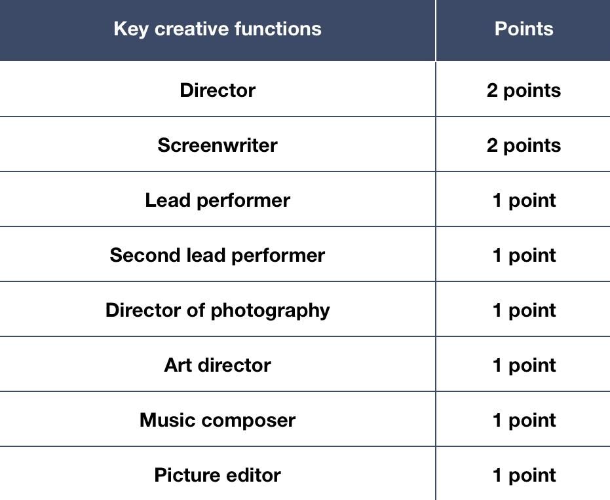
Week 4:
OTT, Netflix, and CRTC

examines the impact of companies like Netflix, Hulu, and others, which use new methods of distributing media content.

over the top or OTT, generally refers to any online service or application that delivers content over the top of traditional distribution methods such as cable and satellite.
- (e.g. Netflix, Hulu, Amazon Prime, YouTube, etc.).

The impact of OTTs on Canadian media can be seen in a number of ways, including the issue of CanCon

OTTs are exempt from regulation in Canada, which means that they are not confined to the rules and regulations that govern traditional media, or what is sometimes called legacy broadcasting.

One of the most important OTT companies operating in Canada is Netflix.

Net neutrality (the principle that internet providers must treat all communications equally)

Reducing barriers to access by all Canadians to advanced telecommunications networks.
- This includes access based on cost, rural vs. urban access, and access for people with disabilities (e.g., for closed captioning and described video).

Supporting the creation, production and discoverability of Canadian content.
- This includes making it easier for broadcasters to create profitable Canadian content, which they linked to the expansion of the Canadian Media Fund, with a view to ensuring innovation and content from diverse voices, such as Indigenous peoples and communities. The report also recommended that OTTs such as Netflix be obliged to pay a sales tax. “We recommend that the federal government require foreign media content undertakings to collect and remit the GST/HST (p.36).” Quebec & Saskatchewan have already begun to do this.

Improving the rights of the digital consumer.
- This includes asking CRTC to revisit its consumer protection framework, in order to better capture emerging trends such as increasing complaints about internet services and cost.

Renewing the institutional framework for the communications sector.
- The report recommends that the name of the CRTC be changed to the Canadian Communications Commission. The current name – the Canadian Radio-television and Telecommunications Commission – is out of step in a world that has moved beyond conventional radio and television stations, and in which telecommunications now encompasses a wide range of electronic communications.

Week 5:
Representation is the act of encoding, or putting ideas into a variety of forms such as words, or a painting, or a play, or a radio program, or a TV show, or a film, etc. For instance, a photo of a plane crash is not the crash itself (obviously!) the photo of a plane crash is a representation of the crash. Similarly, a map is not an actual place but, rather, something that presents a way of looking at that place. Even the live telecast of a hockey game is not the game itself, but rather, a series of carefully chosen and constructed camera shots and commentary that represent the event in an audiovisual format.
When we study media, we sometimes refer to representations as texts.
Lipton writes that ‘text’ is broadly defined so as to acknowledge how all media construct and carry meaning; and as a result, all media are subject to analysis and critical thinking
Intertextuality refers to the meaning we make of one text depending on the meanings we draw from other texts we have encountered.
Individual texts are inescapably related to other texts and, as a result, we too can create new relationships between existing texts, whether such texts are music, visual images such as film, television programs, or internet content.
Polysemy refers to the capacity to be open to multiple interpretations. For example, an image of an apple might be interpreted as knowledge, as a computer company, or simply as a fruit.
The process of interpreting media messages is known as decoding,
encoding – the process of creating media messages.
ENCODING
- Frameworks of knowledge refer to social and cultural customs, including ideas we hold about gender, family, individualism, work, leisure, Canadianness, the good life as well as laws, regulations, etc. Frameworks of knowledge also includes where and by whom media texts are made or consumed. Personal influences include age, education, family background, religion, gender, race, ethnicity, citizenship status, disability, etc.
- Relations of production refer to one’s position in relation to the media companies. These include questions of media ownership, labour – who works for media companies? Who produces (encodes) media content? Who consumes (decodes) it?
- Technical infrastructure refers to the medium through which representations are communicated. It can have great influence on the form and structure of ideas and information. Telling a story on radio to conjure images in the listener’s mind is different from telling a story on a television screen with moving images. We have expectations of genres as well, such as drama versus comedy or action. These factors affect both the encoding and decoding of texts.

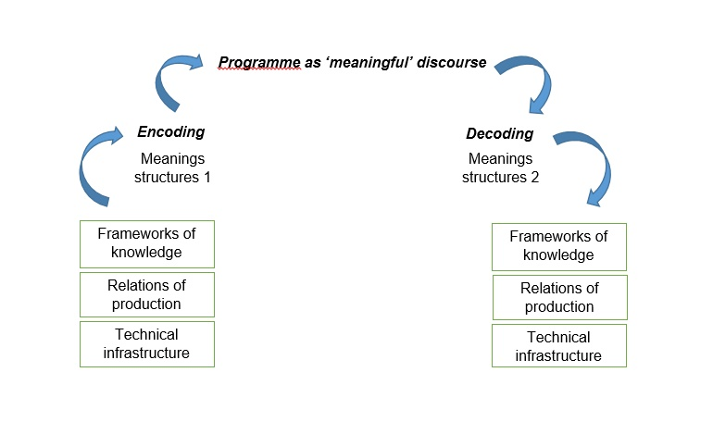

DECODING
- The dominant reading is one where the reader recognizes what a text is saying and broadly agrees with it. In other words, it is a reading that interprets the text in the way it was meant to be interpreted. For example, the Apple logo above would be understood to refer to the company and is accepted as such without much thought.
- The oppositional reading is one where the reader recognizes the dominant meaning in a text but rejects it for a variety of personal, cultural, political or ideological reasons. The Apple logo is recognized as referring to the company, but the typical connotations of the logo (luxury, originality, innovation) are entirely rejected.
- The negotiated reading is one that is more nuanced, where the reader recognizes and refines elements of a text in light of their own views and assumptions. Here, the reader of the Apple logo accepts some of its intended connotations and rejects others. In some ways, these three readings all exist on a spectrum with the dominant reading and the oppositional reading at opposite ends, while the majority of readings are, in fact, negotiated.
- decoding is a process of meaning making

Media audiences are of interest to scholars and to industry researchers because we want to understand:
- the nature of the interaction between media and their audiences
- what audiences do with media content
- how media might influence perceptions and understandings of the world
- how media might guide or influence social action and social relationships
Key concepts highlight some transitions among audiences from more passive to more active

Media Effects
The media effects approach studies the direct impact of media messages on an audience. Early studies of the media following WWI assumed media to have various effects on human behaviour and attitudes. Scholars looked at how messages flowed from media industries to audiences. They were inspired by the study of the effects of propaganda on masses during WWI. This approach has been called the ‘hypodermic needle’ or ‘magic bullet’ approach to communication – i.e. it was assumed that media could simply inject ideas into people’s minds. It borrowed from simple behavioural modes of mass society developed in early social science. Post-WWII scholarship saw these studies as flawed and noted that direct impact of the media was weak. Instead, it identified indirect effects of the media: media did not simply tell audiences what to think but what to think about.

Agenda Setting
This “agenda setting” approach claimed that media serve an agenda-setting function, that they work selectively to draw our attention to particular events and circumstances. Scholars following this approach noted that what appears on the front page of select national newspapers set the agenda for discussion.

Cultivation Analysis
The cultivation analysis approach focuses on how media cultivate particular attitudes. For instance, consider Gerbner’s (1976) work on people who watch a lot of TV overestimating violence in society and developing a bunker mentality.

Uses and Gratification
All of the above models are contested and limited. Criticism tends to focus on the lack of clear, strong effects from media exposure. Beginning in the 1960s, scholarship increasingly focused on the agency of the audience. Instead of “What do media do to the audience”, the question became, “What do audiences do with media?” Scholars started to pay more attention to how audiences consume media content, not just what media content they consume.

Active Audience and ‘Prosumers’
Audiences came to be understood as active in producing meaning in the course of their consumption of media content. Sometimes, audiences would participate in secondary production, such as fan cultures formed around a passionate attachment to forms of media culture (e.g. Trekkies). The rise of the internet has allowed for larger international fan communities connected through websites, email lists, Facebook groups, and other new media to emerge. Such participation is called ‘prosumption’, or simultaneous production and consumption of content.

Social Media Audiences and Networks
Prosumers is the term media scholars use to describe those who share content on social media. Such sharing of media content was already noted in the early 1990s with the emergence of Blogs and citizen journalism. Today, much of the media content that we consume is produced or shared by other prosumers. This approach studies how prosumers create various networks, using hashtags, for example.

Maker culture refers to a community of prosumers who create new devices or modify existing ones. It takes something from DIY subculture and something from hacker subculture. In 2006, a collective of artists known as Mister Jalopy published a “Maker’s Bill of Rights” which identified certain principles of maker culture.

Week 6:
The term globalization is often used to refer to the worlds’ increased economic dependence
Globalization refers to the increased mobility of people, capital, commodities, information and images with the development of increasingly rapid and far-ranging communication and transportation technologies, and with people’s improved (albeit inequitable) access to these technologies
Globalization involves overlapping processes, notably economic, political, social, cultural and environmental

Economic - Many more people work for companies with operations in a number of countries around the world, not even just one other country. If we work in the auto industry, or the video game industry, our specific job may be part of a production process organized as a transnational assembly line. It may be coordinated from a distant head office, and the products or services we are involved in creating may be destined for export markets.

We consume products and services in a global marketplace, even buying goods from marketplaces like Alibbaba, which is Asia’s Amazon. When we shop, we buy clothes made in China, wine from Chile, furniture that is said to be from Sweden but may be manufactured in China or Mexico, etc.

Political - In the political arena, globalization means that governments are increasingly implicated in events that occur well beyond their own borders. These events may be unfortunate events that Canadians are caught up in, such as war or natural disaster. Or Canadians may be implicated in events beyond our borders because of our involvement with international governing bodies such as the United Nations. And we learn about the activities of these bodies not through direct involvement, but through media of course.

Social - In the social sphere, globalization means that friendships and family ties extend around the world. It means that our grandparents, parents or neighbours come from different countries, speak different languages, and worship different religions. Like the political dimensions of globalization, the relationships that comprise the social dimensions of our lives mean that we are increasingly implicated in world affairs or they may be linked to other social connections. We are implicated in world affairs through leisure and media consumption of, for example international sports.

Cultural - In the cultural realm, globalization means that some Hollywood films are as popular in Tokyo, Japan and Sydney, Australia as they are in Toronto and Los Angeles. It means that we come into contact with more and more cultures virtually through social media links or offline through travel for work or vacation. It means that what we consider to be Canadian art and cultural performance are increasingly infused by an array of international influences. Some of our leading artists have roots in other places, like Michael Ondatjee, who is a Canadian Sri-Lankan poet, Atom Egoyan, who is a Canadian film director who emigrated to Canada from Egypt. Similarly, globalization also means that Margaret Atwood can be recognized and celebrated internationally as a Canadian writer, and recently so with the British Man Booker prize.

Environmental - In the environmental sphere, we are becoming increasingly aware that how we use our natural resources in one corner of the world has significant implications for the rest of the planet, including the problem of electronic waste and how it flows from the rich global north to the poor global south for hazardous recycling. Some media artists have made environmental awareness a key theme in their art. For example, in 2013, Canadian singer-songwriter Neil Young drew attention to the environmental impact of oil sands drilling on indigenous communities with his cross-Canada tour, entitled Honour the Treaties Tour.
As we have seen, globalization involves multiple intersecting processes that reinforce each other. We now turn to take a closer look at the role of media in this development.
Mediascapes - What is the role of the media in the process of globalization? Cultural theorist, Arjun Appadurai’s (1990) concept of mediascapes (media landscapes) offers a way of understanding the role the mass media play as agents of globalization. He maps and explains cultural flows, or how culture moves and is transformed in a global context according to 5 spheres, none of which alone can drive globalization.

Ethnoscapes - Ethnoscapes refer to persons who constitute the shifting world in which we live, such as tourists, immigrants, refugees, exiles, guest-workers, and other moving persons who affect the politics of and between states.

Technoscapes - Technoscapes refer to the global configuration of technologies, such as digital divides (highspeed internet & broadband vs low access or no access) and the shifting configurations of designers, engineers, tech people, and new communication technologies.

Financescapes - Financescapes refer to global capital flows through currency markets, stock exchanges, commodity speculation, bit coin and other cryptocurrencies, etc.

Ideoscapes - Ideoscapes refer to big ideas and dominant images that are often political and frequently have to do with the ideologies of states and the counter-ideologies of activist movements that want to challenge governments. These often include images and ideas of the good life, progress, freedom, democracy, etc.

Mediascapes - Mediascapes refer to the production and dissemination of written, visual, sound and other texts, whether produced by private or public media owners. The key concept of mediascapes describes how we use media to represent and understand the world and, increasingly, how media moves around the world across a variety of platforms.

Critiquing Globalization - The key features of globalization are not as new as they might seem. Some theorists argue that the process of globalization is as old as humankind. International movement is as old as human exploration around the globe, which included global circulation of money, resources and rudimentary cultural products. What is new about globalization is its intensity; its expanded reach and the immediacy of contemporary social interactions—thanks in part to global communication and media networks.
The term globalization can be misleading if it is taken to mean that all significant economic, political, social, cultural and environmental processes are taking place on a global scale. People around the world do not, cannot participate, equally in the processes that underpin globalization. Globalization impacts us unevenly and tends to divide people along class lines in particular. While relatively wealthy, educated urban dwellers have considerable access to the fruits of globalization, those with less mobility and more immediate priorities, such as clean water, shelter and personal safety, are largely excluded from acces sing the fruits of globalization. Also, some portions of our everyday economic, political, social and cultural lives continue to operate at the level of local, regional, provincial and national scales.
These are among the critiques of globalization, including its promotion of neoliberalism, or the notion that promotes individualism, a shift away from the state’s involvement in our lives including social programs, state welfare, universal health care and for us, media regulation.
Communications Final Questions
Which of the following acts regulate the telecommunication and
broadcasting spheres in Canada?
Answer: broadcasting and telecommunications act

Indie Game: the movie explored some of the difficult working conditions of
the video game
Answer: Witheford

In the Glenn Greenwald interview, we watched in class, he mentions that
this social media company is particularly good at objecting to government
demands for info and protecting of their users
Answer: Twitter

As Hartowitz discusses, under the CRTC’s recently abandoned priority
programming program, Canadian entertainment shows would need to air in
prime time and devote this percentage of content to Canadian
entertainment news:
Answer: ⅓

Edge writes that monetizing convergence was easy because it was easier
for converged companies to sell advertising over multiple media, leading to
increased revenue
Answer: False

The MAPL system requires that the music be entirely composed by a
Canadian in every case to be considered CanCon?
Answer: False

The article about the blog EASpouse is about a woman who made a blog
complaining about how her husband spent too much time playing video
games and not enough doing his share of the house work?
Answer: false
Canada’s copyright modernization Act, Bill C-51, displays SOPA-style
restrictions
Answer: False
Did tencer say Tv wasn’t going anywhere but broadcast model will be
replaced by public domain?
Answer: No
Looking at what kinds of audiences are attracted to which kinds of advertising?
Answer: Administrative

Looking at what meanings audiences make out of popular culture products?
Answer: Critical

Studying the Canadian Radio-television and Telecommunications Commission (CRTC) to write about how it might become more diverse in its programing?
Answer: Critical

Doing a study for the CRTC to write about how it might become more diverse in its programing?
Answer: Both critical and administrative

Researching branding strategies and how to apply them to open new markets?
Answer: Administrative

Looking at an organization’s communication practices in order to improve efficiency?
Answer: Administrative

Looking at an organization’s communication practices in order to address structural diversity issues?
Answer: Critical

Examining fan fiction on the internet as an expression of taste cultures?
Answer: Critical

Coolhunting new taste cultures by sampling data from people’s click-streams upon leaving the CBS website?
Answer: Administrative

Looking at ways to Coolhunting new taste cultures by sampling data from people’s click-streams upon leaving the CBS website?
Answer: Both

