Chapter 9: Foundations of Planning

Planning: Managerial function that involves:
- Defining the organization’s goals
- Establishing an overall strategy for achieving those goals
- Developing a comprehensive set of plans to integrate and coordinate organizational work
Concerned with ends (what is to be done) and means (how it’s to be done)

Types of planning
- Informal: not written down, short-term focus; specific to an organizational unit
- Formal: written, specific, and long-term focus, involves shared goals for the organization

Planning & Performance – why should managers plan?
- Provides direction to managers and nonmanagers alike
  - Without planning, departments and individuals might work at cross purposes prevents optimal efficiency in achieving goals
- Reduces uncertainty by forcing managers to:
  - Look ahead
  - Anticipate change
  - Consider the impact of change
  - Develop appropriate responses
- Minimizes waste and redundancy.
  - when work activities are coordinated around plans, inefficiencies become obvious and can be corrected and eliminated
- Planning establishes the goals or standards used in controlling.
  - Without planning, there would be no goals against which to measure work effort

Relationship Between Planning and Performance
- Formal planning is associated with:
  - Higher profits and returns on assets
  - Other positive financial results
- The quality of planning and implementation affects performance more than the extent of planning
- External environment can reduce the impact of planning on performance
  - Ex. Governmental regulations, powerful labour unions.
- Formal planning must be used for several years before planning begins to affect performance

Elements of Planning
- Goals (also objectives)
  - Desired outcomes or targets
  - Provide direction and performance evaluation criteria
- Plans
  - Documents that outline how goals will be met
  - Describe how resources are to be allocated and establish activity schedules

Types of Goals
- Stated Goals: official statements of what an organization says, and what it wants it stakeholders to believe its goals are.
  - Nike’s goal is “delivering inspiration and innovation to every athlete”
  - Deutche Bank’s goal is “to be the leading global provider of financial solutions, creating lasting value for our clients, our shareholders”
- Real Goals: goals that an organization actually pursues, as defined by the actions of its members. Actions define priorities

Types of Plans
- BREADTH
  - Strategic Plans:
    - Apply to the entire organization
    - Establish the organization’s overall goals
    - Seek to position the organization in terms of its environment
    - Cover extended periods of time
  - Operational Plans:
    - Specify the details of how the overall goals are to be achieved
    - Cover short time period
- TIME FRAME
  - Long-Term Plans: time frames extending beyond three years
  - Short-Term Plans: time frames of one year or less
- SPECIFICITY
  - Specific Plans: clearly defined and leave no room for interpretation.
    - A specific plan states its objectives in a way that eliminates ambiguity and problems with misunderstanding.
  - Directional Plans: plans that are flexible and set out general guidelines.
    - Provide focus but don’t lock managers into specific goals or courses of action
- FREQUENCY OF USE
  - Single-use Plan: a one-time plan specifically designed to meet the needs of a unique situation
  - Standing Plans: ongoing plans that provide guidance for activities performed repeatedly
Traditional Goal Setting
- Broad goals are set at the top of the organization
- Goals are then broken into sub-goals for each organizational level
- Goals are intended to direct, guide, and constrain from above
- Goals lose clarity and focus as lower-level managers attempt to intercept and define the goals for their areas of responsibility
Maintaining the Hierarchy of Goals
- Means-Ends Chain: an integrated network of goals in which the accomplishment of goals at one level serves as the means for achieving the goals, or ends, at the next level.
- Management By Objectives (MBO): process of setting mutually agreed-upon goals and using those goals to evaluate employee performance.
  - Studies have show that it can increase employee performance and organizational productivity
  - Rewards are allocated on the basis of progress towards the goals
Goal specificity, participative decision making, an explicit performance/evaluation period, and feedback are key elements of MBO
Steps in MBO
- Organization’s overall objectives and strategies are formulated
- Major objectives are allocated among divisional and departmental units
- Unit managers collaboratively set specific objectives for their units with their managers
- Specific objectives are collaboratively set with all department members
- Action plans, defining how objectives are to be achieved, are specified and agreed upon by managers and employees
- The action plans are implemented
- Progress towards objectives is periodically reviewed, and feedback is provided
- Successful achievement of objectives is reinforced by performance-based rewards
Reasons for MBO Success: top management commitment and involvement
Potential Problems with MBO Programs:
- Not as effective in dynamic environments that require constant resetting of goals
- Overemphasis on individual accomplishment may create problems with teamwork
- Allowing the MBO program to become an annual paperwork shuffle
Characteristics of Well Written Goals
Well written goals are:
- Written in terms of outcomes rather than actions
- Measurable and quantifiable
- Clear as to a time frame
- Challenging yet attainable
- Written down (-_-)
- Communicated to all necessary organizational member

Steps in Goal Setting:
- Review the organization’s mission statement
  - Do goals reflect the mission?
- Evaluate available resources
  - Are resources sufficient to accomplish the mission
- Determine goals individually or with input from others
  - Are goals specific, measurable, and timely?
- Write down the goals and communicate them
  - Is everybody on the same page?
- Review results and whether goals are being met
  - What changes are needed in mission, resources, or goals?
Three Contingency Factors Affect the Choice of Plans
- Organizational Level
  - Lower-level managers do operational planning while upper-level managers do strategic planning
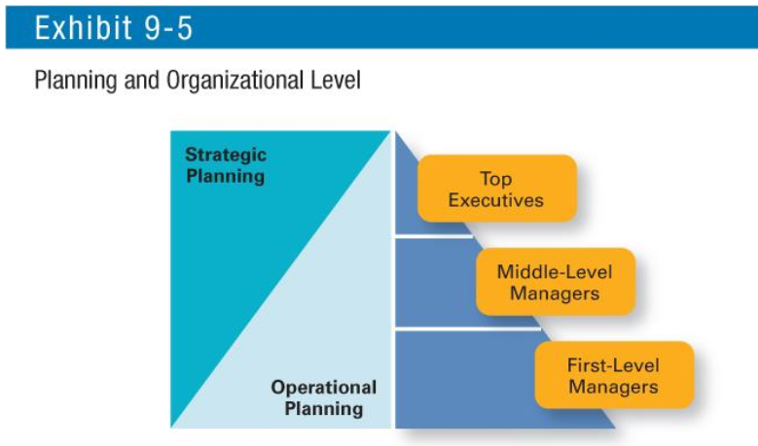
- Degree of Environment Uncertainty
  - Stable environment specific plans
  - Dynamic environment: when uncertainty is high, plans should be specific but flexible. Managers must be prepared to change or amend plans as they’re implemented
- Length of Future Commitments
  - Current plans affecting future commitments must be sufficiently long-term to meet the commitments
Approaches to Planning
Traditional Approach: planning is done entirely by top-level managers who often are assisted by a formal planning department a group of planning specialists whose sole responsibility is to help managers write organizational parts
Another approach involves organizational members in the process
- Plans are not handed down from one level to the next but instead are developed by organizational members at various levels and in various work units to meet their specific needs
- When organizational members are more actively involved in planning, they see that the plans are more than something just written down on paper
  - They can actually see that the plans are used in directing and coordinating work
Current Issues in Planning
How can managers effectively plan when the external environment is continually changing?
- Develop plans that are specific but flexible
- Understand that planning is an ongoing process
- Change plans when conditions warrant
- Persistence in planning eventually pays off
- Flatten the organizational hierarchy to foster the developments of planning skills at all organizational levels
Environmental Scanning: screening information to detect emerging trends
Competitor Intelligence: gathering information about competitors that allows managers to anticipate competitors’ actions rather than merely react to them

The commitment concept states that plans should extend far enough to meet the commitments made when the plans were developed.
Plans are documents that outline how goals are going to be met (different from planning)

Chapter 10: Managing Strategically

Importance of Strategic Management
What is strategic management? what managers do to develop organization’s strategies
Strategies: plans for how an organization will do what it’s in business to do, how it will compete successfully, and how it will attract and satisfy its customers in order to achieve its goals
Business Model: a strategic design for how a company intends to profit from its strategies, work processes, and work activities.
A company’s business model focuses on two things:
- Whether customers will value what the company is providing
- Whether the company can make any money from what it is they’re providing
Why is strategic management important?
- Results in higher organizational performance.
  - Studies have shown a positive relationship between strategic planning and performance
- Requires that managers examine and adapt to business environment changes, allowing them to better cope with uncertain environments
- Involved in many of the decisions that managers make
Not-for-Profits & Strategic Management
- Strategic management has moved beyond for-profit business organizations to include government agencies, hospitals, and other not-for-profits organizations.

Strategic Management Process
Strategic Management Process: a six-step process that encompasses strategic planning, implementation, and evaluation
Components of a Mission Statement:
- Customers: who are the firm’s customers?
- Markets: where does the firm compete geographically?
- Concern for survival, growth, and profitability: is the firm committed to growth and financial stability?
- Philosophy: what re the firm’s basic beliefs, values, and ethical priorities?
- Concern for public image: how responsive is the firm to societal and environmental concerns?
- Products or services: what are the firm’s major products or services?
- Technology: is the firm technologically current?
- Self-concept: what are the firm’s major competitive advantages and core competencies?
- Concern for employees: are employees a valuable asset of the firm?
Step 1: Identify the Organization’s Current Mission, Goals, and Strategies
Every organization needs a mission
- Mission: the firm’s reason for being
  - the scope of its products and services
  - also important for managers to identify goals and strategies consistent with the mission being pursued
- Goals: the foundation for further planning
  - Measurable performance targets
Step 2: Conduct and External Analysis
- Environmental scanning of specific and general environments
  - Managers need to know, for instance, what the competition is doing, what pending legislation might affect the organization, or what the labour supply is like in locations where it operates
  - In analysing the external environment, managers should examine both the specific and general environments to see what trends and changes are occurring
  - Focuses on identifying opportunities and threats
- Assessing organizational resources, capabilities, activities, and core competencies:
  - Opportunities: positive trends in external environment factors
  - Threats: negative trends in external environment factors
Step 3: Conduct and Internal Analysis
- The environmental scanning of specific and general internal areas including:
  - Mission: a statement of an organization’s purpose
  - Resources: an organization’s assets – financial, physical, human, intangible – that are used to develop, manufacture, and deliver products or services to customers
  - Capabilities: an organization’s skill and abilities that enable it to do the work activities needed in its business
  - Core Competencies: an organization’s major value-creating skills, capabilities, and resources that determine its competitive advantage
- After doing the internal analysis, managers should be able to identify organizational strengths and weaknesses
- Assessing organizational resources, capabilities, activities, and core competencies:
  - Strengths (core competencies) create value for the customer and strengthen the competitive position of the firm
  - Weaknesses (things done poorly or not done at all) can place the firm at a competitive disadvantage
SWOT: steps 2 and 3 combined are called a SWOT analysis
- Strengths, Weaknesses, Opportunities, and Threats

Step 4: Formulate Strategies
Once the SWOT analysis is complete, managers need to:
- Develop and evaluate strategic alternatives
- Select appropriate strategies that provide relative advantage over competitors
- Match organizational strengths to environmental opportunities
- Correct weaknesses and guard against threats
Step 5: Implement Strategies
After strategies are formulated, they must be implemented,
- Implementation: effectively fitting organizational structure and activities to the environment
- the environment dictates the chosen strategy effective strategy implementation requires an organizational structure matches to its requirements

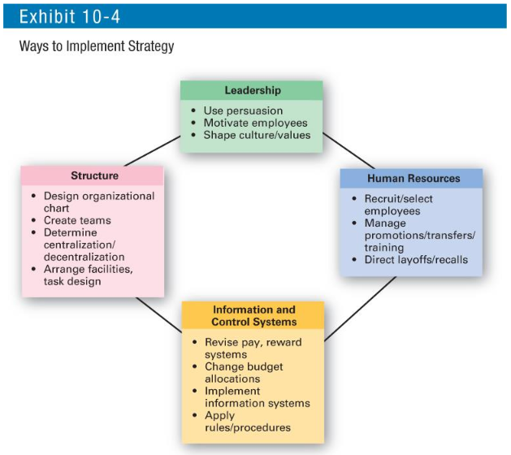

Step 6: Evaluate Results
- How effective have the strategies been?
- What adjustments, if any, are necessary?

Types of Organizational Strategies
Corporate Strategy: strategy that evaluates what businesses an organization is in, should be in, or wants to be in, and what it wants to do with those businesses Managers at the top level of the organization typically are responsible for corporate strategies. Three types of corporate strategies:
- Growth: expansion into new products and markets
- Stability: maintenance of the status quo
- Renewal: address organizational weaknesses that are leading to performance declines
Growth Strategy: when an organization expands the number of markets served or products offered, either through its current business(es) or through new business(es). Because of tits growth strategy, an organization may increase revenues, number of employees, or market share.
- Concentration: growth through concentration is achieved when an organization concentrates on its primary line of businesses and increases the number of products offered or markets served in this primary business.
  - no other firms are acquired or merged with instead the company chooses to grow by increasing its own business operations.
- Vertical Integration:
  - Backward Vertical Integrations – attempting to gain control of inputs (become its own supplier). example: eBay owns an online payment business that helps it provide more secure transactions and control one of it most critical processes.
  - Forward Vertical Integration – an organization becomes its own distributor and is able to control its outputs. example: Apple has more than 80 retail stores to distribute its product
- Horizontal Integration: a company grows by combining with other organizations in the same industry – that is, combining operations with competitors.
  - ex. French cosmetic giant L’Oréal acquired The Body Shop
- Diversification:
  - Related Diversification – when a company grows by combining with firms in different, but related, industries.
  - Unrelated Diversification – when a company grows by combining with firms in different and unrelated industries.
- Many companies use a combination of these approaches to grow. For instance, McDonald’s has grown using the concentration strategy by opening more than 36 000 outlets in more than 100 countries, of which about 30 percent are company owned. In addition, it’s used horizontal integration by purchasing Boston Market and Chipotle Mexican Grill (which it spun off as a separate entity in 2006), and by spinning off Restaurant Technology Services (which it sold to Xerox in 2012). McDonald’s newest twist on its growth strategy is a move into “All Day Breakfast” and other menu innovations.
Stability Strategy: strategy characterized by an absence of significant change in what the organization is currently doing. Examples of this strategy include continuing to serve the same clients by offering the same product or service, maintaining market share, and sustaining the organization’s business operations. The organization does not grow, but it does not fall behind either.

Renewal Strategy: when an organization is in trouble, something needs to be done managers needs to develop strategies, called renewal strategies, that address declining performance
- Retrenchment Strategy: short-run renewal strategy used for minor performance problems. This strategy helps an organization stabilize operations, revitalize organizational resources and capabilities, and prepare to compete once again.
  - Reduces the company’s activities or operations
  - Retrenchment strategies include:
    - Cost reductions
    - Layoffs
    - Closing underperforming units
    - Closing entire product lines or services
- Turnaround Strategy: a renewal strategy for situation in which the organization’s performance are more serious.

How Corporate Strategies are Managed
When an organization’s corporate strategy involves several businesses, managers can mange this collection, or portfolio, of businesses using a corporate portfolio matrix.
- BCG Matrix: a strategy tool that guides resource allocation decision based on market share and growth rate of business; classifies firms as:
  - Cash Cows: low growth rate, high market share
    - Managers should “milk” cash cows as much as they can, limit any new investment in them, and use the large amounts of cash generated to invest in stars and question marks with strong potential to improve market share
  - Stars: high growth rate, high market share
    - Heavy investment in stars will help take advantage of the market’s growth and help maintain market share.
    - The stars will eventually develop into cash cows as their markets mature and sales growth slows
  - Question Marks: high growth rate, low market share
  - Dogs: low growth rate, low market share
    - Dogs should be sold off or liquidated as they have low market share in markets with low growth potential

Creating Strategic Competitive Advantage
Competitive Strategy:
- An organizational strategy that focuses on how the organization will compete in each of its businesses
- For a small organization in only one line of busines or for a large business that has not diversified into different products or markets, the competitive strategy simply describes how the company will compete in its primary or main market
- For organizations in multiple businesses, each division will have its own competitive strategy that defines its competitive advantage, the products or services it will offer, the customers it wants to reach, and the like each division has developed its own unique approach for competing
- When and organization is in several different businesses, these single businesses that are independent and formulate their own strategies are often called Strategic Business Units (SBUs)
Developing an effective business or competitive strategy requires an understanding of competitive advantage, a key concept of strategic management.
Competitive Advantage: what sets an organization apart its distinct edge
Quality as a Competitive Advantage:
- Differentiates firm from its competitors
- Can create a sustainable competitive advantage
- Represents the company’s focus on quality management to achieve constant improvement and meet customers’ demand for quality and reliability
Design Thinking as a Competitive Advantage:
- Design thinking has been described as “approaching management problems as designers approach design problems”
Social Media as a Competitive Advantage:
Successful social media strategies should
- Help people both inside and outside the organization
- Connect and reduce costs and/or increase revenue possibilities
Sustaining Competitive Advantage:
- Every organization has resources (assets) and capabilities (how work gets done)
- The trick is to effectively use these elements to create a sustainable competitive advantage
Competitive Strategies:
In any industry, five competitive forces dictate the rules of competition. Together, these five forces determine industry attractiveness and profitability.
- Threat of New Entrants: the ease or difficulty with which new competitors can enter an industry
  - characterized by factors such as economies of scale, brand loyalty, and capital requirements to determine how easy or hard it is for new competitors to enter an industry
- Threat of Substitutes: the extent to which switching costs and brand loyalty affect the likelihood of customers adopting substitute products and services
  - characterized by factors such as switching costs and buyer loyalty to determine the degree to which customers are likely to buy a substitute product.
- Bargaining Power of Buyers: the degree to which buyers have the market strength to hold sway over and influence competitors in an industry
  - characterized by factors such as number of customers in the market, customer information, and the availability of substitutes to determine the amount of influence that buyers have in an industry.
- Bargaining Power of Suppliers: degree of supplier concentration and availability of substitute inputs determine the amount of power that suppliers have over firms in the industry
- Current Rivalry: intensity among rivals increases when industry growth rates slow, demand falls, and product prices descend
  - characterized by factors such as industry growth rate, increasing or falling demand, and product differences determine how intense the competitive rivalry will be among firms in the industry.
Choosing a Competitive Strategy: once managers have assessed the five forces and determined what threats and opportunities exist, they are ready to select an appropriate competitive strategy
Competitive Strategies:
- Cost Leadership Strategy: the organization sets out to be the lowest-cost producer in its industry examples: Walmart, WestJet Airlines.
- Differentiation Strategy: a company seeks to offer unique products that are widely value by customers
- Focus Strategy: a company pursues a cost or differentiation advantage in a narrow industry segment
- Stuck in the Middle: an organization is unable to develop a competitive advantage through cost or differentiation.
- Functional Strategy: a strategy used by a functional department to support the business strategy of the organization
  - Functional-level strategies are the strategies used by an organization’s various functional departments
Marketing, human resources, research and development, and finance all support competitive strategy. Problems occur when employees or customers don’t understand a company’s strategy.

Current Strategic Management Issues
Strategic Leadership: the ability to anticipate, envision, maintain flexibility, think strategically, and work with others in the organization to initiate changes that will create a viable and valuable future for the organization.
Strategic Flexibility: the ability to recognize major external environmental changes, to quickly commit resources, and to recognize when a strategic decision was a mistake.
Three strategies are important in today’s environment:
- E-Business Strategies
- Customer Service Strategies
- Innovation Strategies

Current Strategic Competitive Advantage
New directions in organizational Strategies: E-Business Strategies
Cost Leadership: online activities bidding, order processing, inventory control, recruitment, and hiring
Differentiation: internet0based knowledge systems, online ordering, and customer support
Focus: chat rooms and discussion boards, targeted web sites
Customer Service Strategies:
- Giving the customers what they want
- Communicating effectively with them
- Providing employees with customer service training
Innovation Strategies:
- Possible Events
  - Not always radical breakthroughs in products
  - Application of existing technology to new uses
- Strategic Decisions about Innovation
  - Basic scientific research
  - Product development
  - Process innovation
  - First Mover: an organization that is first to bring a product innovation to the market or to use a new process innovation

