Assignment 2
Part 1
1. If a variable is normally distributed
a. 50% of the observations will be less than the mean, and 50% of the observations will be
greater than the mean.
b. 49.51% of the observations will be between the mean and +2.58 standard deviations above
the mean.
c. 49.51% of the observations will be between the mean and -2.58 standard deviations below
the mean.
d. 95% of the observations will fall within ±1.96 standard deviation from the mean.
e. All of the above are true for a normally distributed variable.

2. A positive z-score indicates that,
a. The original raw score on a variable is below its mean.
b. The original raw score on a variable is above its mean.
c. The original raw score on a variable is equal to its mean.
d. An error was made in the calculation of z-scores.

3. The closer a raw score is to its mean,
a. The smaller its z-score value.
b. The further its z-score will be from 0.
c. The greater the standard deviation.

Part 2
1. (2-3.2)/1.5 = -0.8 = 0.2881+0.5 = 0.7881 or 78.81%
The probability of the sample that have had more than two children is 0.7881 (78.81%).
2. Score 1: (1.6-3.2)/1.5 = -1.07 = 0.3577
Score 2: (3.1-3.2)/1.5 = -0.07= 0.0279
0.3577-0.0279=0.3298 or 32.98%
The probability that a score selected randomly fall between -0.07 and -1.07 is 0.3298 (32.98%)
Part 2
1. (2-3.2)/1.5 = -0.8 = 0.2881+0.5 = 0.7881 = 78.81%
percent of the sample that have had more than two children is 0.7881 (78.81%).
2. Score 1: (1.6-3.2)/1.5 = -1.07 = 0.3577
Score 2: (3.1-3.2)/1.5 = -0.07= 0.0279
0.3577-0.0279=0.3298 = 32.98%
the probability that a randomly selected person from the sample will have between 1.7 and 3 children =-0.07 and -1.07 is 0.3298 (32.98%)

Part 3

- Using SPSS, generate statistics for the variable mar_q370 using the Analyze -> Descriptive Statistics command. Specifically, obtain the mean and the standard error of the mean (S.E. mean).

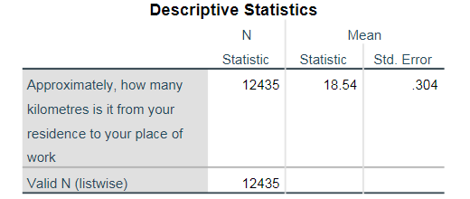
- Fill in the table below for the entire sample (100%), which you will assume is the population.
- Draw a random sample of 5% of the population (refer to pages 32 to 35 in Computer lab session 2)
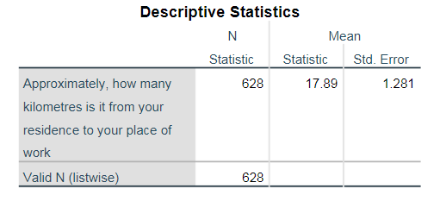

- Repeat step 1 and fill in the table for the 5% sample.
- Draw a random sample of 20% of the population (refer to pages 32 to 35 in Computer lab session 2)
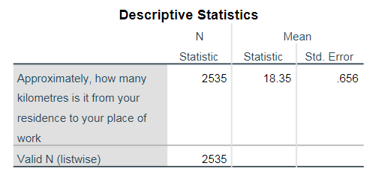
- Repeat step 1 and fill in the table for the 20% sample.
- Draw a random sample of 50% of the population (refer to pages 32 to 35 in Computer lab session 2)
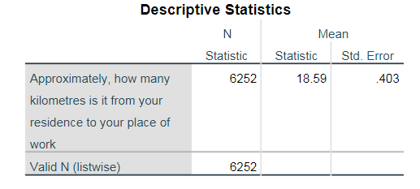

- Repeat step 1 and fill in the table for the 50% sample.
- Draw a random sample of 75% of the population (refer to pages 32 to 35 in Computer lab session 2)
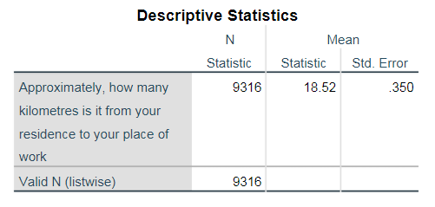
- Repeat step 1 and fill in the table for the 75% sample.
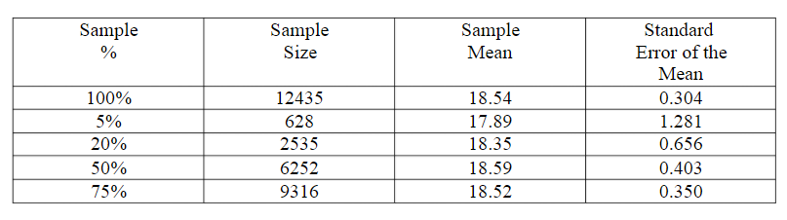
(Summarize these results by providing a brief description about what happens to the sample mean and standard error relative to the population (entire sample/100%) mean and standard error, as the sample size increases/decreases.)
To summarize, when sample N increase there is a smaller standard error of the mean is. Also, when sample N increase the closer the sample mean is to the population mean.

