The common features of math science and engineering science problems are that
- Problems are well posed or put together
- Problem statement is complete and unambiguous
- Problem statement is free from internal contradictions
- Solutions are unique; there is one single correct answer
- Problems have identifiable closure
- Problems require application of specialized knowledge with little doubt about the subject of each problem
Engineering Design Problems have the exact opposite features
What is engineering design?
It is a design making process in which the basic mathematics, sciences and engineering sciences that are applied to meet specified needs to specific complex, open ended engineering problems making sure to keep appropriate attention to health and safety risks, while also considering many environmental, economic, cultural and societal standards.
What is Design Thinking?
An approach to solving design problems by understanding user needs and developing design tools that are required to solve the problem
Steps to Design Thinking:
- Empathize
- Define
- Ideate
- Prototype
- Test
Empathy
- The capacity to understand or feel what another person is feeling from within the other persons frame of reference
- The whole point is to get to know the person better and try to understand them
- MUST use a beginners mindset. You don’t know everything
Define
- Capture your findings
- Synthesize what you learned about the person and put down user needs to help you define your problem.
- Define any constraints
Ideate
- Come up with lots of ideas
- Make sketches
- It’s about quantity not quality
- Need as many solutions as possible to show clients so that they have the ability to choose what they like vs what they do not like so that you have a better idea of what the client is truly looking for.
- When you ideate its important to try and get feedback from customers so that you know what they like.
Prototype
- Build the solution to the problem
- Something that is physical and that the customer can engage with. Something they can play with
Test
- Share the prototype and receive feedback on it.
- Feedback may not be the best but it is important to receive it.
Customer Needs Identification
- In the empathize sector.
- It is the process of determining what and how a user interacts with a product
- User needs are non-technical of the product meaning that they reflect the users perception of the product, not the actual design specifications
- The goal of customer needs identification is to focus the product on the actual needs of the customer. It also helps to identify the more obvious needs vs the less obvious ones.
Customers vs Users
A customer is the person who pays for the product
A user is the person who uses the product.
They are sometimes different ppl but are often the same person
Before starting any problem it is very important to;
- Determine who the customers are
- Determine what info should be gathered from customers
- Determine how that info should be gathered
- Gather raw data
- Interpret the data in terms of customer needs
- Organize the needs
- Establish importance of needs
- Reflect
Gathering Raw Data through:
- Observations: passive: actually going to watch users in natural environment vs active: work side by side with the user
- Interview: make a script, prepare questions but do not be afraid to deviate from questions if something better comes up in conversation.
- Focus groups
Interpreting the Data:
- Write needs in terms of what the product has to do
- Avoid words must and should
Organize the Needs:
- Write out all needs
- Group them
- Choose a label for each group
- Consider “super groups”
- Review and edit
Establish Relative Importance
- A numerical ranking process is a common tool. Rate from 1-5.
Reflect on the Process
- Consider the statements that have been gathered and study their interpretations
- Evaluate how the process was executed
- Look for ways to improve or refine
What is a Problem Definition:
- Under the define sector in design thinking
- It is claim of 1 or 2 sentences that outlines the problem that you are going to address based on customer needs.
- A good problem statement answers; what: is the problem, who: is the client our user, what form: in terms of solution
- The problem definition can not be too specific
Design Criteria
- A precise description of what the product has to be, based on interpreted needs
Functional Requirements: design criteria that affect the solutions function
Non functional requirements: Design criteria that does not affect the function of the solution
Constraints: Set of important considerations that must be taken into account of the design
Metrics
- A list of measurable attributes that the solution will have; (weight, size, speed etc)
- Have units of measure
- Are obtained from functional design criteria and through benchmarking
Engineering Design Specifications
- Target Specifications are numerical values based on defined metrics
- To set these specifications you need to set values that are considered to be; ideal vs acceptable
*Always make sure to translate user needs into design criteria, split them into fuctional, non functional and constraint groups
Benchmarking
- 2 types: benchmarking in terms of customers perceptions vs in terms of technical performance.
- Benchmarking helps to create a superior product; must know what the competition is doing.
- Also able to learn specific design approaches
- Have to then evaluate benchmarking product or even your product using specs
- Better specs depend on customer needs and priorities
- Used prioritized needs evaluated from user needs evaluated before and multiply it by the weight of the spec ( usually from 1-3)
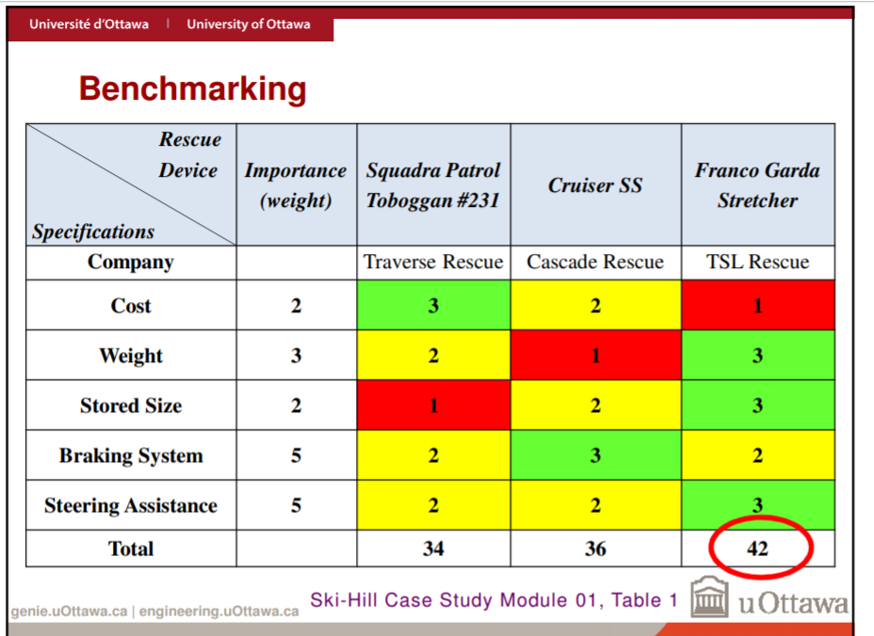

Summary
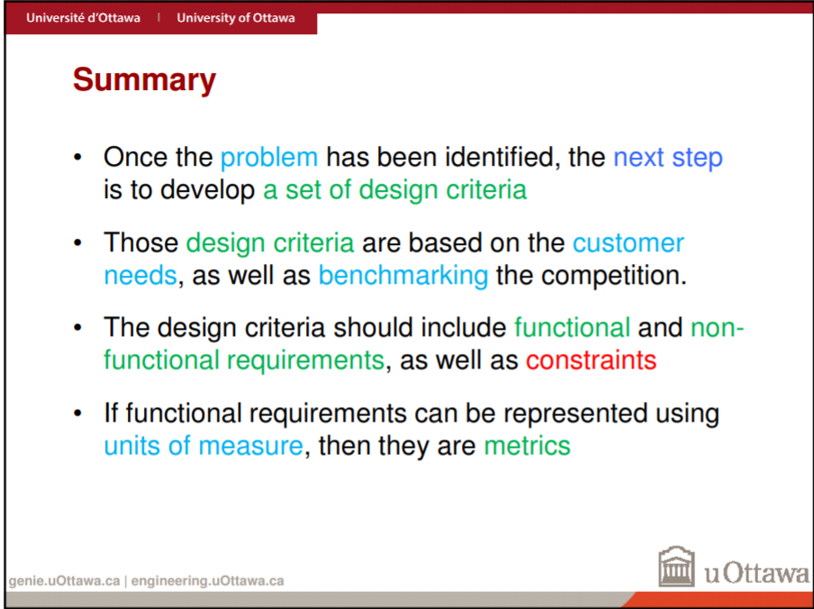
Conflict Management
- In teams it is important to have diversity
- Different opinions
- Creates open environment
- Improves success rate
- Enthusiasm is needed
Team Conflict
- Healthy and constructive conflict promotes success
- Diverse opinions create better success but teams must be open to these differences among members
When things are going bad….
- Conflict resolution is required
- Human experience of conflict requires: our emotions, our perceptions and our actions
Three Step process to dissipate conflict
- Prepare for a Resolution
- Acknowledge the conflict
- Discuss its impact on the teams dynamics
- Agree to a cooperative process
- Agree to communicate
- Understand the Situation
- Clarify positions
- List facts assumptions and beliefs
- Analyze in smaller groups
- Then come back together as a team and convene
- Reach an agreement
- What course of action will the team members take to solve their problems
5 Conflict Management Styles (each can be beneficial)
- Dominating ( low concern for others, high concern for self)
- Avoiding ( Low concern for self and others)
- Accommodating (high concern for others, low concern for self)
- Integrating ( High Concern for others and self)
- Compromise(usually best solution) right in the middle)

Concept Generation
- The creative phase of the design process
- In the ideate sector of design thinking
- It is a sector where many possibilities are considered without judgement
- At least 3 conceptual design alternatives should be generated.
- Should be well documented using sketches with descriptions
- Helps engineers enhance their inherit creativity
- Very important in facilitating the generation of new ideas
Freehand Sketching
- Under the concept generation
- It is used to explore, study an d communicate design concepts
- When sketching, minimum detail is preferred to communicate the idea
- The fundamental rule is to maintain proportions
- Use lines and arcs to make diagrams
Types of Sketches
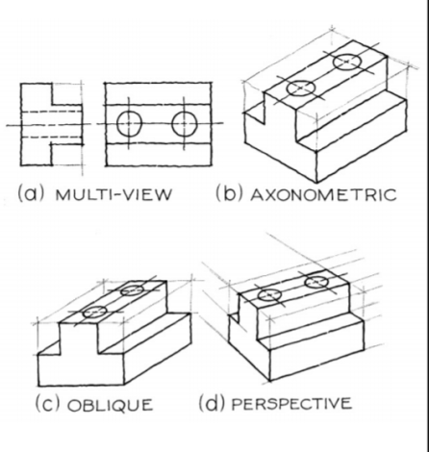
- Orthographic ( Multi-view)
- Allows you to dee the design from many different views
- It allow you to see the true faces
- The only disadvantage is that it can be hard to visualize
- Isometric
- A type of axonometric & perspective drawing
- Easy to visualize the object
- Only disadvantage is that you cannot see true face
- Oblique
- Only one true face
- But the only thing is that it is not photorealistic
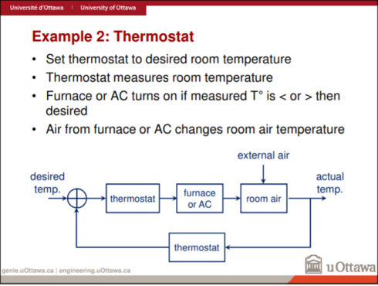
Block diagrams
- Provide and understanding of signal flows in a system
- Enable modelling of complex systems from simple building blocks
- Allow us to generate the overall system transfer function
- System components (software code, electrical systems etc) can be represented by blocks in block diagrams
- Many of these systems are hierarchical
- Systems have at least one input variable and at least one output variable

Brainstorming Ideas
- Cross Stimulation - provocation is important; it amplifies the number of ideas that will be generated.
- Suspended Judgement - Avoid this because no attempt to even evaluate and think about the other idea even though it may seem crazy
- Formality of setting- the more formal the environment of the session is, the higher the rate of success
What is a Project?
A project is a serious of tasks that requires planning and then monitoring once the task execution starts. A project has a specific goal, a schedule and requires resources.
What is Project Management?
The process of doing the planning, execution and monitoring of the tasks required for the project.
Personal Time Management
- Very important; takes time and effort
- Multi- tasking wastes time, focus on one thing at a time
Task Dependencies
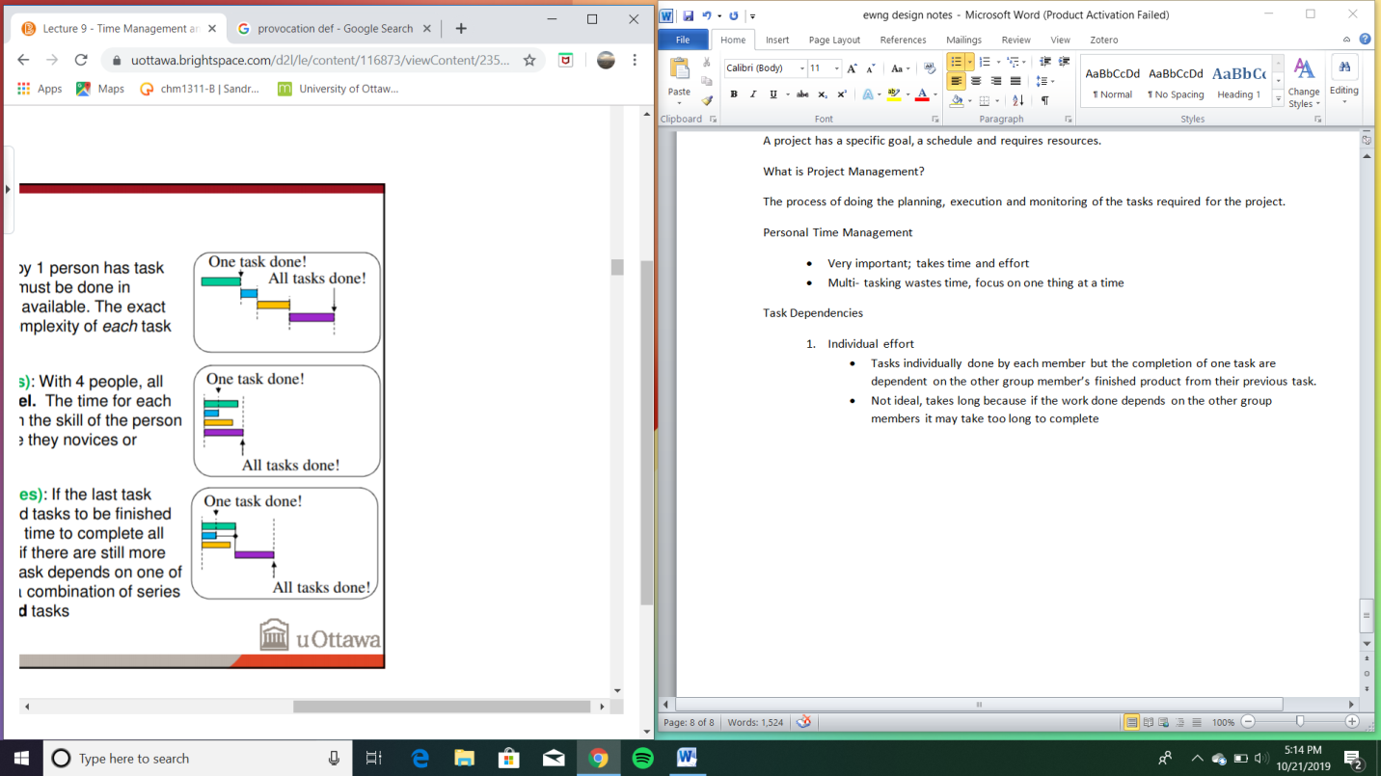
- Individual effort
- Tasks individually done by each member but the completion of one task are dependent on the other group member’s finished product from their previous task.
- Not ideal, takes long because if the work done depends on the other group members it may take too long to complete
- Group Effort (No dependencies)
- All tasks are done in parallel
- Nobody depends on the other person
- Group Effort (With Dependencies)
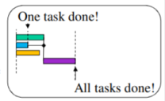
- Some things done in parallel, while other tasks depend on the completion of previous tasks.
- Yields the best results.

What is a task?
It is an activity with a duration and an owner who is responsible for making sure it is completed on time.
What is a milestone?
It is a significant event with a date when a deliverable is due/ available.
Creating a Schedule
- A schedule lists the project’s tasks, milestones and deliverables
- Need to know; what, how long and who.
- What: define all tasks and required milestones
- How Long: estimate task durations
- Who: what is assigned to whom?
Task Duration Estimation
- Time task taken depends on person’s level of expertise
- How motivated the person is
- Dependencies
- Task duration estimate needs to be 75% pessimistic and 25% optimistic
Project Cost
- Projects have time constraints and cost constraints
What is Engineering Design Analysis?
It involves the application of principles and scientific analytical processes to study the properties and state of a system, apparatus or mechanism
- It is important because it is one of the fundamental pillars of our profession
- It allows us to guarantee our work
- Allows us to predict results and prevent possible system failure
Done in Stages;
- Separate the system being analyzed into constituent modules or operational subcomponents
- Analyze or examine each operational subcomponents
- Recombine the analyzed subcomponents using basic principles of physics and laws of nature

The Engineering Analysis Process
- Determine a list of initial components and materials based on target specifications
- Use the values of these components to accurately calculate specific values of the design based on metrics
- Compare these newfound values to the target specifications and change components and materials until satisfied.
How is the Engineering Analysis Process Done?
- Uses mathematical calcs, models, simulations and experimental prototyping to ensure that all subsystems meet the design specifications
- BE SURE TO USE EXISTING KNOWLEDGE
- Always try to use the simplest method first to get a satisfactory result
- If you feel as if you are missing info or tools, recognize it then go find what is needed
- Don’t be shy to verify work with others
- DO NOT MAKE RANDOM CHOICES FOR MATERIALS
- Check the compatibility between materials and components
- Check availability of selected components and materials
- BUT do not be afraid to try and use new materials and components if you feel it is justified.
Personal Feedback
- In feedback control systems, the output is “fed back” to a decision point where it is compared to an unchanging desired value
- The difference between the actual value vs desired value is then processed to fine tune the system output
- Personal feedback can be viewed as a feedback system
- We adjust our actions and behavior to have a desired result
- Personal feedback is filtered through observations and opinions of other people
- The difference between feedback control systems and personal feedback is that people are involved
- People are not always logical
- Their observations are not always accurate nor correct
- Their emotions can cloud their ability to give and receive feedback
- Personal feedback is needed to correct poor behavior and to enhance good behaviors
- Feedback can be both positive and negative but they can both be useful
Productive Personal Feedback
- There is a basic way of giving feedback to maximize the chance that it will be productive feedback.
- “When you do X, it makes me feel Y.” => the format for feedback
- Give it using neutral terms(avoid using emotionally loaded terms) describing the behavior and its effect on you
- The behavior should be described precisely and without judgement or opinion
- You give a neutral description because it is hard to dispute
- Feedback is given this way because one cannot contest the way their behavior is effecting you
Elements of Productive Feedback
- Should be as specific and actionable as possible
- Should NOT be given for other people (speak for yourself)
- Should be timely
- Should be given at the right time (when the perceiver is receptive. Its not smart to do it if the receiver is already mad)
Receiving Feedback
- You don’t have to agree with what has been said but you should acknowledge it (do this by rephrasing what you think you have been told in your own words.)
- The giver of the feedback that you understand what he/she has said to you
What is a Prototype?
A representation of part or all of a design concept to learn something useful
They are useful for:
- Learning/ understanding a problem better
- Communication/ feedback from users
- Reducing the risk associated with a particular aspect of a design
- Measuring performance of the overall functionality of the design
What Makes a Good Prototype?
- Fidelity: Degree to which the prototype testing represents the final product under real condition. Prototypes range from; high, medium and low fidelity.
- Cost: Total cost of designing, building & testing
- Iteration Time: the time from designing to the time when analyzed results are available to then iterate again (Iterate: a process of achieving a desired result by repeating a sequence of steps and successively getting closer to that result)
- Signal to Noise Ratio (SNR): Extent to which the variable of interest is obscured by experimental noise.
*An important objective of prototyping is that it reduces uncertainty
*It is important to plan the timing of prototype cycles. The earlier versions must be simpler to validate earlier concepts. After there must be time taken to execute and learn from prototyping cycles.
Different Types of Prototyping
- Focused:
- Implement ONE or a FEW attributes of the product
- Answers specific questions about the product design
- There are generally SEVERAL generated.
- Comprehensive:
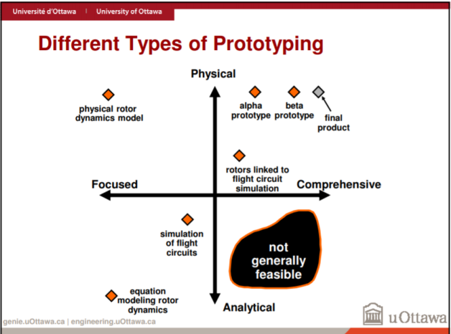
- Implements MANY or ALL product attributes
- Offers opportunity for rigorous testing
- Often best for milestones(significant team progress deliverable) and integration(multiple subsystems are being combined for the first time)
- Physical:
- Tangible approximation of the product
- Exhibits un-modelled behavior
- Behavior may be an artifact of the approximation
- Often best for communication
- *Simulations can also be used to complement. (the fidelity question is still very important and depends on the simplifying assumptions that are being made)
- Analytical:
- Mathematical model of the product (like an equation)
- Explicitly modeled phenomena
- Behavior is artifacts if the analytical method
- Allows more experimental freedom than physical models
- Cheaper and easier to modify
Project Fidelity
A prototype uses a simplified version of the final product to arise questions about fidelity (trueness)
Value of Model Testing
- Reduces the investment in time and money
- Allows control of specific design aspects
- Simplifies analysis tasks]
Testing
- After prototypes are created, they must be tested
- Prototypes are the first of their kind so they should be used for lots of testing.
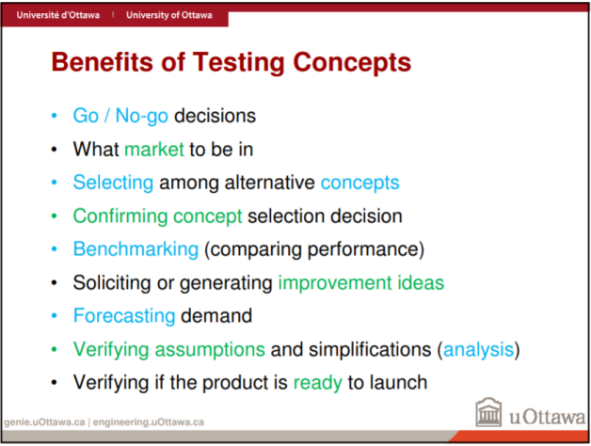
Benefits of Testing
- Avoids critical problems such as design flaws and ease-of-use issues
- Ensures proper functionality
- Helps ensure that the user can figure out how to make it work as well
- Saves time and money

Steps to Testing:
- Define the purpose of the test
- Choose a specific design concept (target measurable attributes)
- Choose a testing method.( analytical simulation, physical prototype test etc.)
- Perform the test
- Measure the important attributes, observe and record the results
- Interpret the results
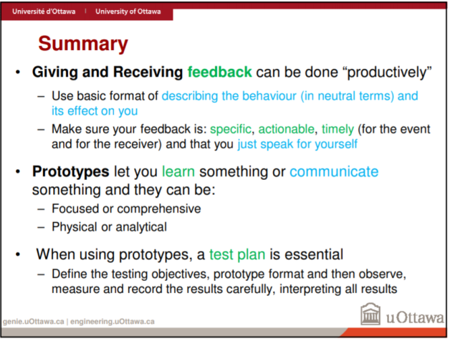
*Too much testing is not a thing. You must create prototypes and test them until you run out of time, money, energy or once you are satisfied with the results.

Designing for Task Efficiency
- Factory Based Production ( Ex. Henry Ford assembly line)
- Organizational Behaviour: emphasizes the cultural effects and effects of change aa well as the role that social and psychological factors play in organizations
Designing for Users
- Design starts with the user
- Ergonomics (Human Factors design): design of products, systems, or processes to take proper account of the interaction between them and the people who use them
What is “user experience”?
It encompasses all aspects of the end-users interaction with the company, its services and its products.
What is user experience about?
- People’s emotions and attitudes about using a particular service of product
- It can help designing to create an experience for the user through a device
- It is often used in software, BUT the principles apply to the design of anything used by people
- It is practical, experiential and affective
- Includes user perceptions about efficiency, ease-of-use and utility
Basic Concepts of Usability
- Can be understood in the context of human behavioural and cognitive processes:
- Attention: Ability of a person to selectively concentrate on a discrete aspect of info, whether deemed subjective or objective while ignoring other perceivable info.
- Memory: Process used to encode, store and retrieve info.

- Attention
- People are easily distracted. Provide cues about what to focus on.
- People get lost in complexity so keep it simple.
- Structure info so it’s easy to find and browse. Don’t have too many or few items. Make sure to group them logically.

B. Memory
- The more meaningful, the more easily it is remembered
- Use effective names and icons
- Combine icons with words
- People more easily recognize than they do recall so it is better to use menus, icons, and quick lookup shortcuts.
Studying Usability- Experiments
- Experiment Requirements:
- Establish a hypothesis
- Compare 2 user interfaces
- Measure some aspect of usability
- Perform Statistical analysis of the results
- Conducting an Experiment:
- Users perform the tasks
- Measure various factors and compare various conditions
- Record usability problems
Process for Usability Analysis
- Understand Users
- Understand tasks the users will need to perform
- Pick representative sets of tasks (Prioritize tasks that are more important)
- Pick a representative set of user
- Determine exactly what questions need to be answered about usability
Understanding Users:
- Experience
- Job function – different tasks & knowledge for different jobs
- Domain specific experience: Low experience vs High experience
- Background experience level: Familiarity with different things
- Personality
- Hard to know in advance, so thought and research may be requires
- Attributes
- Can have physical disability, colour blindness, dyslexia, illiteracy
- Interests
- Different kinds of users have different interests usually determined by experience, personality and other attributes
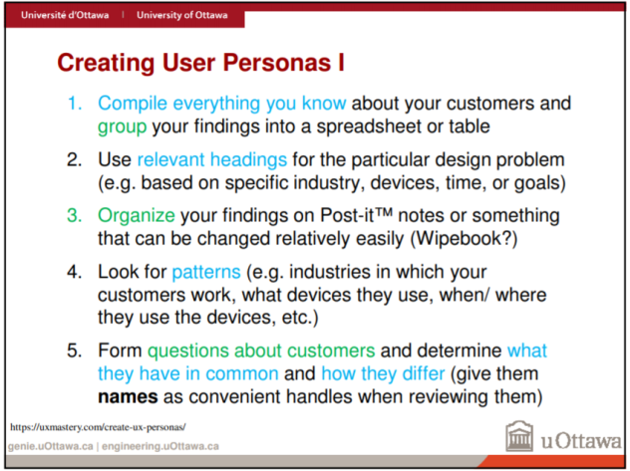
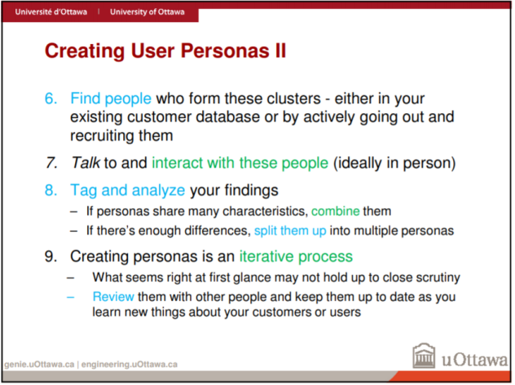
- Create user personas for each distinct type of user and give them simple names or handles
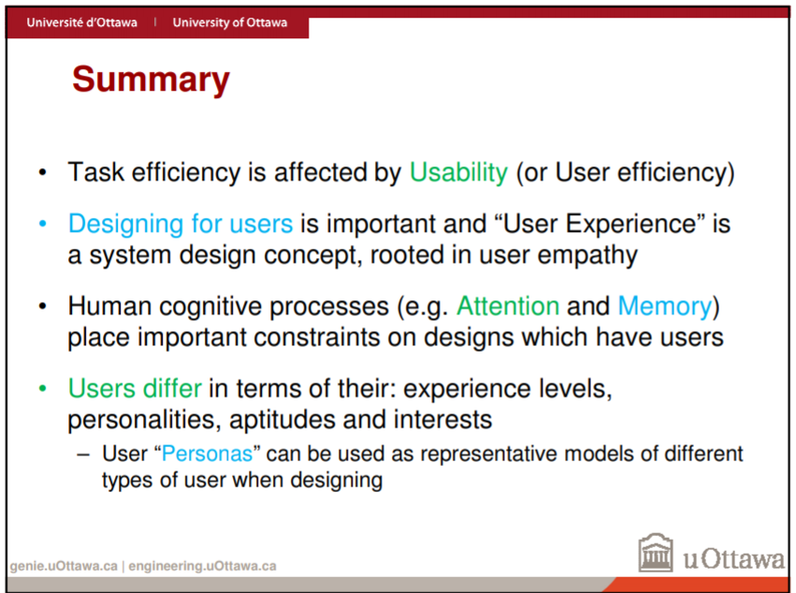

What is modeling?
Refers to using physical or mathematical prototypes to simulate and analyze systems, entities, phenomenon or processes.
Modeling helps to:
- Reduce cost
- Increase quality of products and systems
- Document and archive lessons learned
When modeling, it is important to understand:
- Assumptions
- Conceptualizations
- Implementation of constraints
Modeling
- Can be used to estimate the quantitative & qualitative behaviour of the system
- Multiple modeling techniques should be used to validate the results and identify modeling strength and weaknesses.
What is an analytic model?
A mathematical representation that has closed form solutions. It is best used when a closed form solution exists and the solution procedure is straightforward. It may be used to extrapolate insight of un-modeled cases.
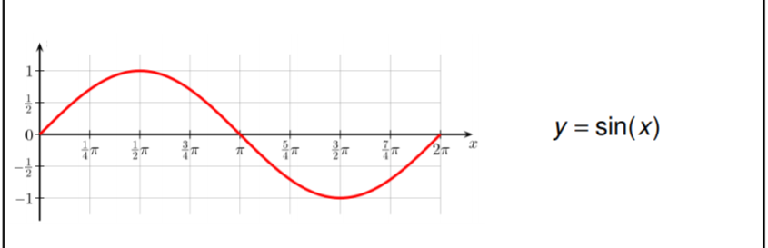
What is numerical modeling?
Mathematical representations that use discretization or time-stepping methods to approximate a solution or describe a behaviour over time. They are best used when no closed form solutions exist or the solution procedure is very complicated. It is usually used to extrapolate a large number of results.
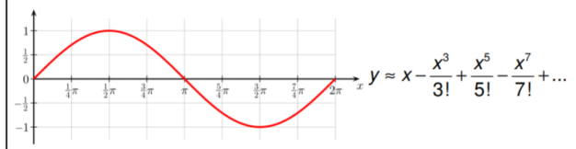

Assumptions
- All numerical tools are assumptions. Make sure to know what those assumptions are.
- Classical equations usually have clearly defined assumptions
- Numerical tool often provide false confidence:
Discrete Time
- Numerical simulators all work on discrete time
- Model variables only get updated at “each separate point in time”
- Ensure that all these steps are small enough so that ppl are not missing out on important results
What is Experimental Modeling?
Physical representations which can be used to measure outputs or behaviour to given inputs or stimuli. They are best used when no mathematical solutions exist or the solution to the procedure is EXTREMELY complicated and requires too much time to solve computationally.
Modeling Fidelity
- Modeling is used on simplified versions of the actual intended design.
- The models purpose is to 1. Reduce financial investments 2. Control out aspects to the real situation to simplify analysis
When designs are incomplete, 2 types of error are possible;
- Designing for failure modes that will not occur.
- Failure to detect true problem.
Modelling Noise
- Occurs when; certain variables can not be controlled, too many variables are being manipulated, independent variables have too high a variability
- Makes it difficult to discern what is happening during testing
- Prevents effective learning from occurring.
What is Failure?
- Omission of occurrence or performance; a state of inability to perform a normal function; a fracturing or giving away under stress.
*System failure is normal and expected
What is criticality?
- Turning point or specially important juncture
Handling Critical Failures
Detection: critical failures must be identified if and when they occur
Prevention: using different strategies, failure can be prevented
*BUT it is important to accept that the above assumption is not realistic, therefore system recovery is a liable alternative. It is achieved by adding component redundancy to cope with failures
Prediction: If a failure is not detected or prevented, some kind of warning of imminent failure is required which allows recovery techniques to be applied.
Protecting and Recovering Using Redundancy
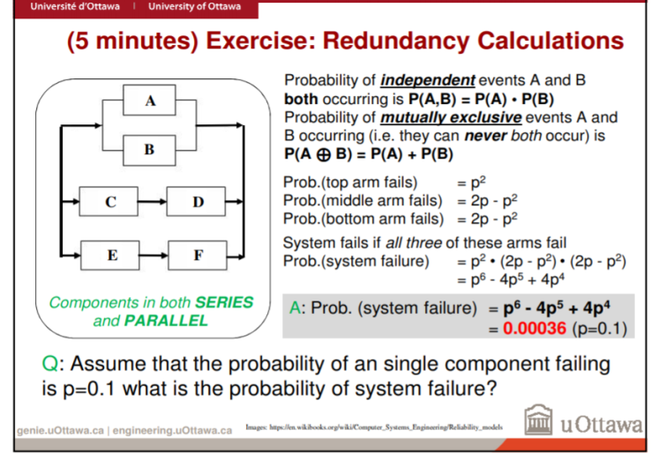
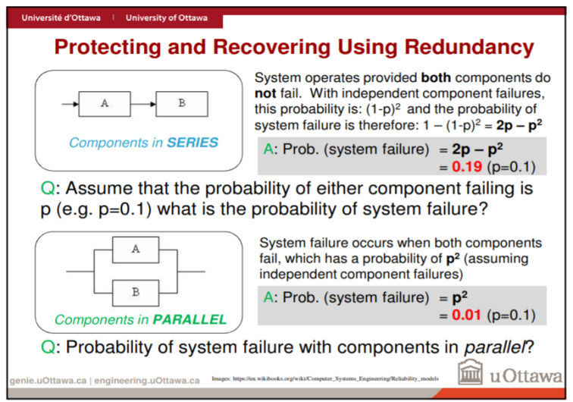

Predicting Failures
- Model and measure component reliability
- Determine the effects of component failures
- Analyze the root cause for failures that already happened
- Build prototype of the system in question
Three kind of potential failure:
- Inadequate or Missing Performance Level
- Improper or Incorrect Function
- Giving way(under stress)
Testing Process- Performance Level Failures
- Determine required and desired level of performance for the design or portion of the design
- Define a test to measure what level of performance the design can achieve
Testing Process- Functional Failures
- Determine required performance attributes and desired functions to be verified
- To verify functionality:
-Measure specific test conditions where functional operation stops
-Verify that specific critical features can acc be realized
- Verify it at the boundary cases or extremes of operating conditions
Testing Process- Stress Induced Failures:
- Determine specific extreme test conditions where failures occur
Testing Steps with Prototypes
- Define the testing objectives and type of prototype
- Define the level of fidelity
- Make required assumptions
- Define and plan execution of tests
- Execute the tests. Observe and record all results
- Analyze and interpret results

Iterative Prototype Testing Strategies
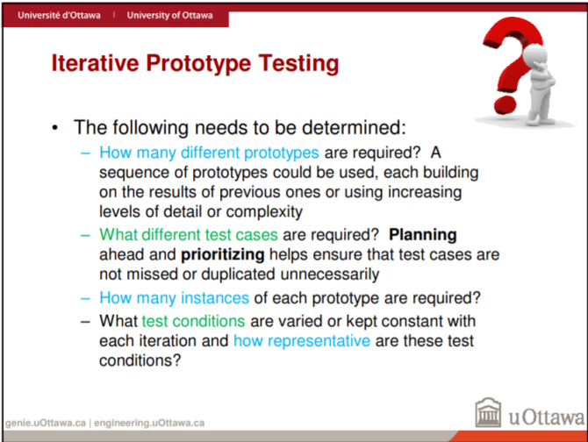
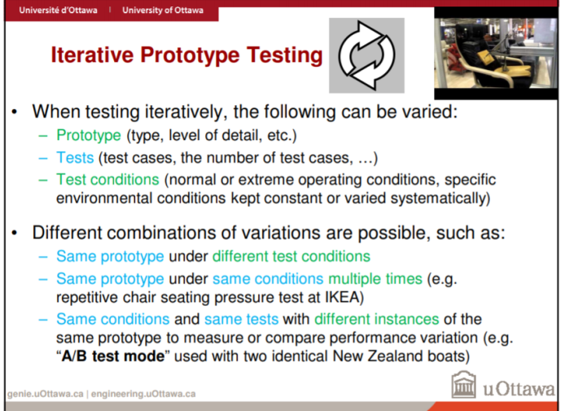

Uncertainty and Risk
- Not all failures are understood or predictable
- “what if” analysis helps cover cases when unpredictable and misunderstands happen
- There is a way to handle uncertainties: adding design margin
- This is improving the design significantly so that failures are less likely
FMEA (Failure Modes and effects analysis)
-For each design component:
- Identify failure modes
- Determine the possible effects or consequences of each failure mode
- Assess potential severity of the effects by quantifying them with a severity table
- Identify causes of the failure mode. These are called design deficiencies
- Estimate probability of occurrence on a scale of 1-10
- Assess likelihood of failure detection
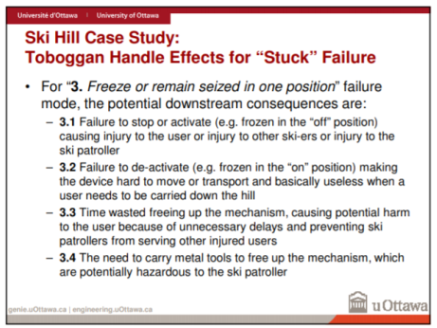
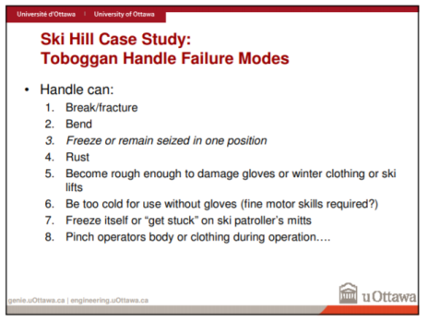
Ski question as an example



