CHM 2123 — Pre-Lab Document

Tools of the trade : Thin-Layer Chromatography and Liquid-Liquid Extractions
Student(s) Name(s) and Number(s) :
Date:
Teaching Assistant:
Lab Period
COMMENTS
- Your completed pre-lab is submitted electronically via Brightspace into the dedicated folder.
- This pre-lab exercise can be completed individually or in pairs, with your assigned lab partner, to each student’s preference. If done in pairs, each student must submit an identical copy of the pre-lab. Make sure to include both your names and student numbers above. Both students will receive the same marks and comments.
- Exceptionally, this pre-lab exercise is due by the beginning of your respective lab section for Experiment 1, on the week of September 21st. Do not trust Brightspace’s due date: since every students share the same Brightspace page, the due date found online is for the last section of the week.

- Answer the questions directly in the space provided.
- Late penalty is 20%/day, starting the moment the report is due and going up every 24h.

Point distribution
Question 1 /3
Question 2 /2
Question 3 /2
Question 4 /5
Question 5 /3
Question 6 /2
Question 7 /6
Question 8 /4
Question 9 /2
Question 10 /5
TOTAL /34

- Which of the following solvent pairs are completely immiscible?
  - Ethyl Acetate/Methanol
  - Chloroform/Water
  - Acetone/Water
  - Acetone/Hexanes
  - Hexanes/Water

Pair B & Pair E are completely immiscible

- For each immiscible pair in a), identify which solvent would be the top layer if placed in a separatory funnel. What factor determines their relative position?

For Pair B, Water would be on top, as density of water (1g/mL) are smaller than chloroform (1.49g/mL).
For pair E, Hexane would be on top, as the density of Hexane(0.67g/mL) are smaller than water(1g/mL).

- Rank the following eluent mixtures in order of increasing polarity.

1:1 ethyl acetate/methanol, ethyl acetate, 1:1 hexanes/ethyl acetate, 2:1 hexanes/ethyl acetate.

2:1 Hexanes/EtOAc < 1:1 Hexanes/EtOAc < EtOAc < 1:1 EtOAc/MeOH

- What are the various uses of TLC to a synthetic organic chemist?

Identifying chemicals and monitor reaction progress.

- For each of the following compound, determine the most acidic hydrogen and provide an approximate pK_{a} value. Enter your results in the table below.

Molecule | Most acidic hydrogen | Approximate pK_{a}
A | R-OH | 16
B | R-NH2 | 35
C | R-OH | 10
D | R-NH3 | 4.6
E | R-COOH | 4.8

- Ricky Bobby is analyzing a sample by TLC: he sees a single spot, with a R_{f} of 0.01. Satisfied, he decides to proceed with his reaction, but his partner Cal Naughton advises him to reconsider his analysis. Why? How should he address the situation?

The distance sample has migrated are less than 1% of the solvent front, which means the eluding power of the solvent is too little for the samples under test. Ricky should address the situation by switching into a more polar solvent as it increase the eluding power.

- In liquid-liquid extractions, what is the difference between an extraction step and a washing step?

Extraction step concentrate the material in the added phase, whereas washing generally concentrate impurity/unreacted material in the phase added.

- You wish to purify the following mixture by liquid-liquid extraction. Using ChemDraw, draw a flowchart indicating how you could separate each of the three compounds into separate solutions. You are particularly interested in morpholine (A); propose additional steps to isolate the pure neutral molecule from the solution.

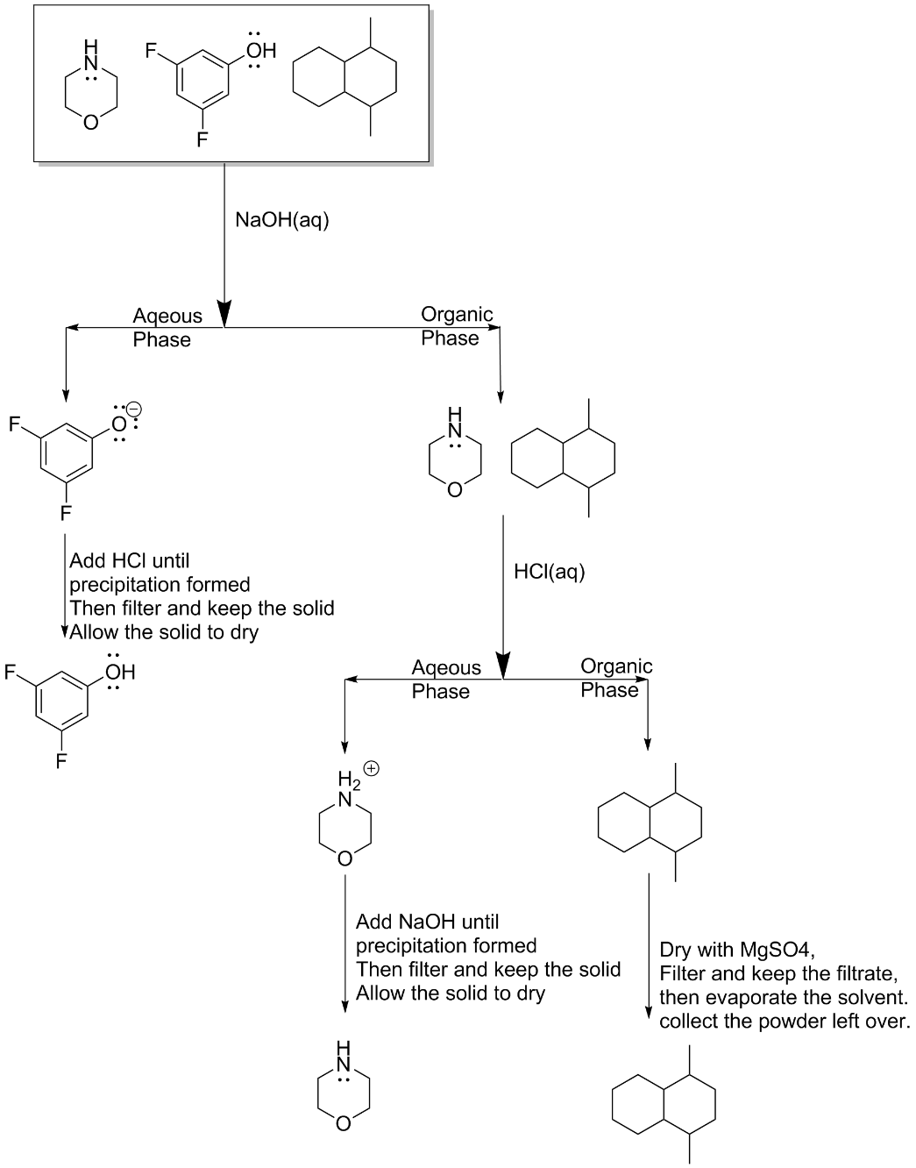

- Rank the relative order of elution of the following sets of compounds, from the fastest eluting compound to the slowest, and explain your assignment.

2 > 3 > 4 > 1
The less polar compound will have a greater Rf, which in turn corresponds to faster eluding compound.
Since only the functional group is different , we can ignore the rest and only compare the functional group.
A methoxy group (2) is less polar than the carboxylic acid group, and the carboxylic acid (1) is more polar than an amide (4), and 3 is more polar than 2 since it is less symmetric, however it is less than 1 or 4.

2 > 1 > 4 > 3
3 is more polar than 4 due to the alcohol group instead of amine group.
2 is the least polar as it has an extra aromatic ring, which decreased its dipole moment.

- Identify which of the following compounds would preferentially dissolve in the aqueous phase in a liquid-liquid extraction. Why would they preferentially dissolve in water?

1&4 would easily dissolve in aqeous phase as they are ionic compound
2 as it have 2 alcohol group, which increased its solubility in water.
- The following TLC plate was obtained from a reaction mixture. (The drawing is not to scale)

- Calculate the R_{f} for each of the spots.

Spot | R_{f}
A | .46
B | .34
C | .63
D | .46
E | .14

- Provide an example of how you calculated an R_{f}, briefly explaining each relevant term.

Rf is calculated by dividing the length of solvent front from the sample’s origin with the length samples have travelled form origin. Solvent refers to the line where solvent was when the development process is stopped.

- Which of these spots correspond to the most and least polar compound?

C corresponds to least polar compound, E corresponds to the most polar compound.
- Is the reaction over?

Yes, As the starting material B has completely disappeared in the reaction lane, therefore we can draw the conclusion of reactant B has be depleted, therefore Reaction is over.

