Question 1 |  | Quiz 1  1 / 1 point
What operating system is Android based on?
Linux
Windows
Unix
Dos
View Feedback

Question 2 |  | 1 / 1 point
Who is the founder of Android Inc.?
 | Bill Gates
 | Steve Jobs
 | James Gosling
 | Andy Rubin
Question 3 |  |  | 1 / 1 point
Is this legal XML syntax:
<LinearLayout> <Button /> <Button> </Button> </LinearLayout>
 | No
 | Yes
Question 4 |  |  | 1 / 1 point
Where does Android Studio specify the minimum API level for a project?
 | The command line
 | The XML files
 | The build.gradle file
 | The main activity
Question 5 |  |  | 1 / 1 point
Is the following legal XML syntax:
<LinearLayout> <RelativeLayout> <Button /> <Text /> <relativeLayout></linearLayout>
 | Yes
 | No
Question 6 |  |  | 1 / 1 point
If you see an error in Android Studio that says that the R class in Java is undefined, what does that mean?
 | You didn't import R.java.
 | There is a problem somewhere in your XML files
 | The project is not configured properly.
 | You should change the class to Resources.java
Question 7 |  |  | 1 / 1 point
Which is the first function in your Java files that gets called when you start an Android project?
 | public static void main(String [] args)
 | public void start(Stage stage)
 | protected void onCreate(Bundle savedInstanceState)
 | public void onRun( void )
Question 8 |  |  | 1 / 1 point
Which file does the following represent:
R.layout.starting_transaction
 | The R.java file in the folder: /starting_transaction/layout
 | The class file: starting_transaction.java
 | The file: starting_transaction.xml in the folder /res/layout
 | None of the above
Question 9 |  |  | 1 / 1 point
Which of the following letters represents the region code in the folder name:
values-en-rNZ
 | values
 | NZ
 | en
Question 10 |  |  | 1 / 1 point
Assume there are three different values folders in your Android project:
values-en-rUS has a strings.xml file with <string name="quiz">Quiz</string>
values-en has a strings.xml file with <string name="quiz">This is a quiz</string>
values has a strings.xml file with <string name="quiz">Many quizzes</string>
If you set text="@string/quiz" and set the phone's language to English in UK, what string will show on the screen?
 | Quiz
 | Many quizzes
 | This is a quiz
Question 11 |  |  | 1 / 1 point
Assume there are three different values folders in your Android project:
values-en-rUS has a strings.xml file with <string name="quiz">Quiz</string>
values-en has a strings.xml file with <string name="quiz">This is a quiz</string>
values has a strings.xml file with <string name="quiz">Many quizzes</string>
If you set text="@string/quiz" and set the phone's language to French in France, what string will show on the screen?
 | Quiz
 | This is a quiz
 | Many quizzes
Question 12 |  |  | 1 / 1 point
Which Android Virtual Device will take less resources from your laptop to run (Memory and CPU time):
 | Pixel 2 XL
 | Galaxy Nexus
Question 13 |  |  | 1 / 1 point
Have a look at this git commit window. Select all the files in the list that are included as part of this git commit:
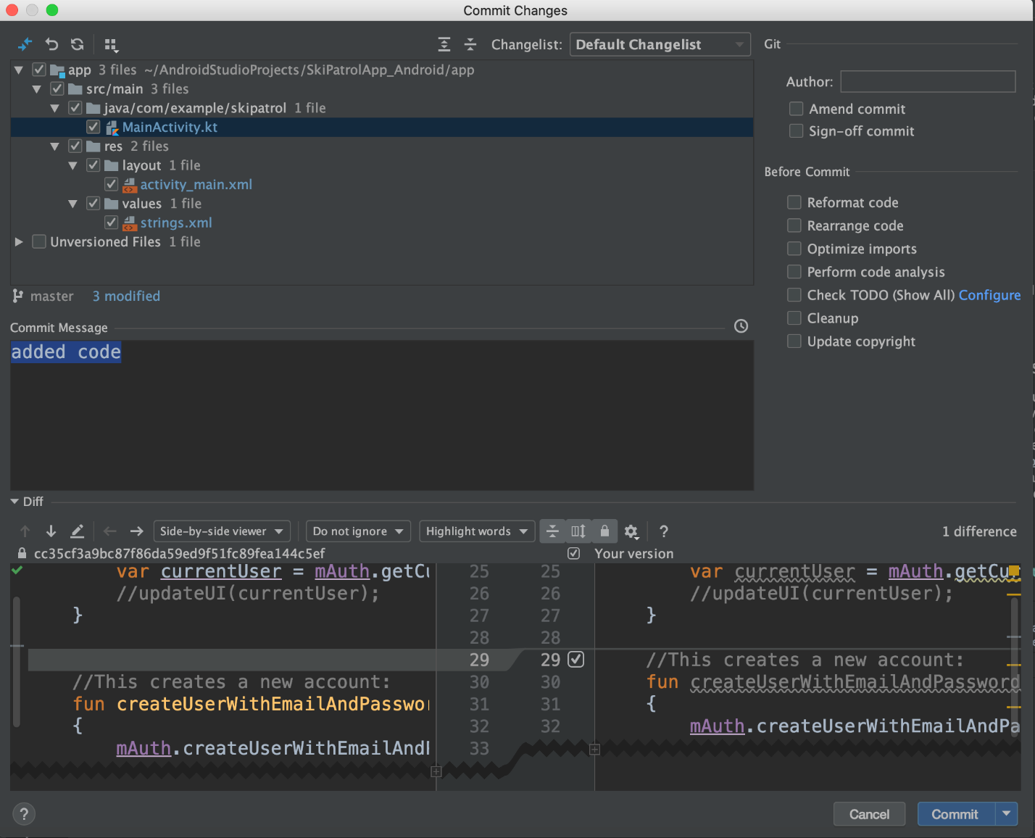
AndroidManifest.xml
MainActivity.kt
MainActivity.java
strings.xml
View Feedback

Quiz2
Question 1 |  | 1 / 1 point
Is this valid XML syntax:
<?XML version="1.0" encoding="UTF-8"?>
<TagA> < TagB /> <TagB> </TagB> </TagA>
 |  | True
 |  | False
Question 2 |  |  |  | 1 / 1 point
Where must namespace declarations go in Android XML files?
 | Root tag
 | Namespace tag
 | Closing tags
 | Opening tags
Question 3 |  |  | 0 / 1 point
What is the return type of the function findViewById(int id)?
 | ID
 | Object
 | String
 | View
Question 4 |  |  | 1 / 1 point
If you see an error in AndroidStudio that the java class R is undefined, what does that mean?
 | You need to import the R.java class
 | R is only supported in version 1.8 of Java
 | There is a bug in your XML files.
Question 5 |  |  | 1 / 1 point
If you want an EditText widget to take the whole width of the screen, what should you set the layout_width parameter to be?
 | whole_screen
 | 100%
 | match_parent
 | wrap_content
Question 6 |  |  | 1 / 1 point
What is the default placement of objects in a RelativeLayout
 | The top left corner of the screen.
 | The middle of the screen
 | The bottom left corner of the screen.
 | The top right corner of the screen.
Question 7 |  |  | 1 / 1 point
What is the default orientation of a LinearLayout
 | Horizontal
 | Neutral
 | Vertical
Question 8 |  |  | 1 / 1 point
In a RelativeLayout, which parameter would you use to make a widget appear at the bottom of the screen?
 | layout_alignBottom
 | align_bottom
 | alignParentBottom
 | layout_alignParentBottom
Question 9 |  |  | 1 / 1 point
For a CheckBox or Switch widget, what function do you call to listen for when the user clicks on it?
 | setOnClickListener
 | setOnCheckedChangedListener
 | setOnCheckboxChangedListener
 | setOnButtonClickListener
Question 10 |  |  | 1 / 1 point
If a function has a parameter of type SomeClass:
void functionName(SomeClass sc)
and SomeClass is an Interface that has one function called:
void onSomethingChanged(Object obj, int oldValue, int newValue)
which answer is the correct way to write the lambda function version of calling functionName()?
functionName( (Object obj, int oldValue, int newValue) -> { } )
functionName( Object obj, int oldValue, int newValue -> { } )
functionName( (obj, oldValue, newValue) -> { } )
functionName( obj, oldValue, newValue -> { } )
Quiz3
Question 1 |  | 1 / 1 point
Which of these functions gets called first in an Activity?
 | onStart()
 | onCreate()
 | onResume()
 | onPause()
Question 2 |  |  | 1 / 1 point
If you have an Intent object, and you call putExtra("Login", "LoginName"), which function do you have to call to retrieve your value?
 | getStringExtra("Login")
 | getStringExtra("LoginName")
 | getExtra("Login")
 | getExtra("LoginName")
Question 3 |  |  | 1 / 1 point
If you go to another Activity using startActivity( ), does onActivityResult( ) get called when the next activity terminates?
 | Yes
 | No
Question 4 |  |  | 1 / 1 point
If you go to another Activity using startActivityForResult( ), does onActivityResult( ) get called when the next activity terminates?
 | No
 | Yes
Question 5 |  |  | 1 / 1 point
What function do you call to stop an Activity and go back to the previous Activity?
 | setResult()
 | goBack()
 | terminateActivity()
 | finish()
Question 6 |  |  | 1 / 1 point
If you call getSharedPreferences("Settings", Context.MODE_PRIVATE), what is the full path of the Activity that gets created on the phone?
 | /data/Settings.xml
 | /data/data/<package-name>/shared_prefs/Settings.xml
 | /shared_prefs
 | /Settings.xml
Question 7 |  |  | 1 / 1 point
If you call the function: Log.d("Activity", "in onResume()");
What should the filter level be on to view the message?
 | Info
 | Error
 | Warning
 | Debug
Question 8 |  |  | 1 / 1 point
If you call:
SharedPreferences prefs = getSharedPreferences("Settings", Context.MODE_PRIVATE);
and this is the first time you run the application, what will be returned if you call prefs.getString("Login", "email@domain.com"); ?
 | email@domain.com
 | Login
 | prefs
 | null
Question 9 |  |  | 1 / 1 point
Where should you look to get more information if you see a message "Unfortunately, AndroidLabs has Stopped"

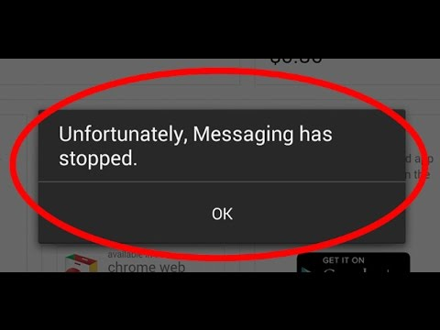
 | In the Console
 | In the LogCat tab
 | In the Debug tab
 | On the emulator window
Question 10 |  |  | 1 / 1 point
Assume that these two lines of code are in the onCreate() function of an Activity whose layout is called saveLayout.xml:
Button saveButton = (Button)findViewById(R.id.saveButton);
setContentView(R.layout.saveLayout);
What will the value of the variable saveButton be?
0
Layout
"Save"
null

Quiz 4
Question 1 |  | 1 / 1 point
What function causes a ListView to draw items
Question options:
 | setAdapter()
 | drawItems()
 | drawList()
 | setItems()
Question 2 |  | 1 / 1 point
What function of ListAdapter tells how many items there are to draw?
Question options:
 | getListSize
 | setNumItems
 | getNumItems
 | getCount
Question 3 |  | 1 / 1 point
Which function do you call on a ListView to listen for users selecting something from the list
Question options:
 | setOnClickListener
 | setOnItemClickListener
 | setOnListClickListener
Question 4 |  | 1 / 1 point
What should the function getItemId(int position) return?
Question options:
 | The database id of the item at position.
 | The position in the list that was clicked.
 | The item to draw at position.
 | None of the above.
Question 5 |  | 1 / 1 point
What should the function getView(int position, View old, ViewGroup parent) use to load a view?
Question options:
 | XMLLoader
 | LayoutInflater
 | ViewLoader
 | ListLoader
Question 6 |  | 1 / 1 point
Which function gets called first when you call setAdapter()?
Question options:
 | getCount
 | getItemId
 | getView
 | getItem
Question 7 |  | 1 / 1 point
What function do you call to redraw the ListView when data has been added or removed from the Adapter?
Question options:
 | refresh()
 | notifyDatasetChanged()
 | notifyListChanged()
 | redrawList()
Question 8 |  | 1 / 1 point
What is the use of the View Holder pattern?
Question options:
 | To draw lists faster.
 | None of the above.
 | To make lists smaller.
 | To minimize memory usage.
Question 9 |  | 1 / 1 point
How do you make a ListView listen for a swipe refresh gesture?
Question options:
Surround the ListView with SwipeRefreshLayout in XML
Call listenForRefresh() in Java.
Call setOnSwipeListener() in Java.
Surround the ListView with RefreshListenerLayout in XML

Quiz 5
Question 1 |  | 1 / 1 point
If you call getWriteableDatabase() from an SQLiteOpenHelper object for the first time on an Android device, which function gets called?
 | onCreate()
 | onDowngrade()
 | none of the above
 | onUpgrade()
Question 2 |  |  | 1 / 1 point
If you call getWriteableDatabase() from an SQLiteOpenHelper object and the old version is 1 and the new version is 3, what function will get called?
 | onDowngrade()
 | onUpgrade()
 | onCreate()
 | none of the above
Question 3 |  |  | 1 / 1 point
If you call getWriteableDatabase() from an SQLiteOpenHelper object and the old version is 2 and the new version is 2, what function will get called?
 | onUpgrade()
 | none of the above
 | onDowngrade()
 | onCreate()
Question 4 |  |  | 1 / 1 point
Look at the query command:
query(false, "ORDERS", new String[] { "Customers" }, "Quantity > ?", new String[] {"50"}, null, null, null, null )
What is the table name?
 | false
 | ORDERS
 | Customers
 | 50
Question 5 |  |  | 1 / 1 point
Look at the query command:
query(false, "ORDERS", new String[] { "Customers" }, "Quantity > ?", new String[] {"50"}, null, null, null, null )
What is the column name?
 | false
 | 50
 | Customers
 | ORDERS
Question 6 |  |  | 1 / 1 point
Look at the query command:
query(false, "ORDERS", new String[] { "Customers" }, "Quantity > ?", new String[] {"50"}, null, null, null, null )
Will the results be distinct?
 | Not applicable
 | No
 | Yes
Question 7 |  |  | 1 / 1 point
What does the insert() function return?
 | The number of rows inserted.
 | The id of the row inserted.
 | void
 | A cursor object
Question 8 |  |  | 1 / 1 point
When you call a query() function on a database, and it returns a Cursor object, what row index is the cursor pointing to? Assume you haven't moved the cursor to any other rows yet.
 | 0
 | -1
 | 1
Question 9 |  |  | 1 / 1 point
What does the update() function return?
void
The id of the row that was updated.
A Cursor object
The number of rows updated.

Quiz 6
Question 1 |  | 1 / 1 point
If you create a subclass of AsyncTask<String, Integer, Double>, what is the parameter type of the doInBackground( ?? ) function?
 | Integer
 | String
 | Double
 | void
Question 2 |  |  | 1 / 1 point
Which function from the list gets called last?
 | publishProgress
 | onPostExecute
 | onCreate
 | doInBackground
Question 3 |  |  | 1 / 1 point
What function do you call to start an AsyncTask?
 | execute()
 | start()
 | main()
 | run()
Question 4 |  |  | 1 / 1 point
Which function runs on a background thread?
 | onProgressUpdate
 | onActivityResult
 | onPostExecute
 | doInBackground()
Question 5 |  |  | 1 / 1 point
Can you open a connection to a web server on the GUI thread?
 | No
 | Yes
Question 6 |  |  | 1 / 1 point
For an XML Pull Parser, which is the first XML event type?
 | START_TAG
 | START_DOCUMENT
 | BEGIN_DOCUMENT
 | TEXT
Question 7 |  |  | 1 / 1 point
If there is a tag: <car brand="ford" />, what function do you call to read what brand is written in the tag?
 | getTagParameter("ford")
 | getAttributeValue(null, "brand")
 | getParameterValue("brand")
 | getParameterName("ford")
Question 8 |  |  | 1 / 1 point
For writing files to the disk, what function tells the file path where an application is installed?
 | getInstallPath()
 | getFilesDir()
 | getFilePath()
 | getExternalFilesDir()
Question 9 |  |  | 1 / 1 point
If a JSON object has the attribute: "value":24.5, what function would you call to retrieve the data?
 | getJSONArray("value")
 | getDouble("value")
 | getBoolean("value")
 | getJSONObject("value")
Question 10 |  |  | 1 / 1 point
Will it work if you call a button's setText() function from the doInBackground() function?
No
Yes
Quiz 7
Question 1 |  | 1 / 1 point
What folder should you place a layout file if it is for a 10 inch tablet screen?
 | layout-large
 | layout-sw720dp
 | layout-sw600dp
 | layout
Question 2 |  |  | 1 / 1 point
If a tablet has a screen of 1920 x 1080 pixels, what is the smallest width?
 | none of these answers
 | 1080
 | 720
 | 1920
Question 3 |  |  | 1 / 1 point
What XML tag should you use for loading a Fragment on a layout?
 | FragmentLayout
 | EmptyLayout
 | RelativeLayout
 | FrameLayout
Question 4 |  |  | 1 / 1 point
If your Java Activity inherits from AppCompatActivity, what function should you call to get a FragmentManager object?
 | getFragmentManager()
 | new FragmentManager()
 | getSupportFragmentManager()
Question 5 |  |  | 1 / 1 point
Which of these items is not a type of Fragment Transaction?
 | delete
 | add
 | replace
 | remove
Question 6 |  |  | 1 / 1 point
Which function passes a Bundle object to a Fragment?
 | setArguments(Bundle b)
 | passInformation(Bundle b)
 | sendBundle(Bundle b)
 | sendData(Bundle b)
Question 7 |  |  | 1 / 1 point
Which function do you need to call to actually run a fragment transaction?
runTransaction()
show()
commit()
finalize()

Quiz 8
Question 1 |  | 1 / 1 point
If you declare an XML tag: <androidx.appcompat.widget.Toolbar >, is this using the normal Android libraries, or the AppCompat libraries?
 | normal Android
 | AppCompat
Question 2 |  |  | 1 / 1 point
It is possible to place a <Toolbar> at the bottom of the screen.
 |  | True
 |  | False
Question 3 |  |  |  | 1 / 1 point
If you are using the normal Android libraries, you call setSupportActionBar( ) to load a Toolbar
 |  | True
 |  | False
Question 4 |  |  |  | 1 / 1 point
In a MenuItem tag, where will an item appear if you set showAsAction="Never"?
 | In the logcat message area.
 | As a title string in the overflow menu.
 | It depends if there is room
 | As a picture in the top of the screen
Question 5 |  |  | 1 / 1 point
If set a MenuItem to showAsAction="always", which parameter will get used?
 | title
 | icon
Question 6 |  |  | 1 / 1 point
If you click on an item on the Toolbar, which function gets called?
 | onMenuItemSelected
 | onOptionsItemSelected
 | onNavigationItemSelected
 | onItemSelected
Question 7 |  |  | 1 / 1 point
If you click on an item on the NavigationView, which function gets called?
 | onItemSelected
 | onMenuItemSelected
 | onOptionsItemSelected
 | onNavigationItemSelected
Question 8 |  |  | 1 / 1 point
In a SearchView, which function gets called when a user types a letter?
 | onQueryChange
 | onQueryTextChange
 | onQueryTextSubmit
 | onQuerySubmit
Question 9 |  |  | 1 / 1 point
In a NavigationView, which parameters of the MenuItem are used?
 | both
 | none
 | android:title
 | android:icon
Question 10 |  |  | 1 / 1 point
How many sub-items do you put in a DrawerLayout?
2
1
3
as many as you want

Midterm
Question 1 |  | 1 / 1 point
What operating system is Android based on?
 | Windows
 | Dos
 | Linux
 | Apple OS
Question 2 |  |  | 1 / 1 point
Who is the founder of Android?
 | Steve Jobs
 | Linux Torvalds
 | Mark Zuckerberg
 | Andy Rubin
Question 3 |  |  | 1 / 1 point
Which type of files get compiled first by AndroidStudio?
 | XML
 | TXT
 | JPEG
 | Java
Question 4 |  |  | 1 / 1 point
Which function gets called first when starting an Android application?
 | onCreate
 | onStart
 | onRun
 | onBegin
Question 5 |  |  | 1 / 1 point
Is this correct XML syntax?
<Begin> <Item1> <Item2> </Item2> <Item3 /> </Item1> </Begin>
 | Unsure
 | Yes
 | No
Question 6 |  |  | 1 / 1 point
How would you call setContentView( ) so that it loads a layout file called loading_screen.xml?
Answer: | setContentView(R.layout.loading_screen) | (setContentView\(\s*R\.layout\.loading_screen\s*\)(;)?)
Question 7 |  |  |  | 0.6 / 1 point
Match up the correct widget with the correct function for listening for events for that widget
   | __1__ |  | setOnClickListener( )
   | __2__ |  | setOnCheckedChangeListener
   | __3__ |  | addTextChangedListener
   | __5__ | (4) | setOnItemClickListener
   | __4__ | (5) | setOnItemSelectedListener
  1. | Button
  2. | Switch
  3. | EditText
  4. | ListView
  5. | Spinner
Question 8 |  |  | 1 / 1 point
Assume that you have a RadioButton whose id is: "@+id/radio_on"
How would you get reference of that widget in Java?
(RadioButton rb =?)
Answer: | findViewById(R.id.radio_on); | ((RadioButton\s+\w+\s*=\s*)?findViewById\(\s*R\.id\.radio_on\s*\)(;)?)
Question 9 |  |  |  | 1 / 1 point
What does findViewById( ) return if it doesn't find a View object with the matching id?
Answer: | null
Question 10 |  |  |  | 1 / 1 point
In an XML layout file, copy and paste the part of the code that is the android namespace declaration. Make sure that you copy all of the line before you paste it.
Answer: | xmlns:android="http://schemas.android.com/apk/res/android"
Question 11 |  |  |  | 2 / 2 points
Select the parameters that are required for an XML widget. Which ones must be there?
 | layout_width
 | layout_height
 | text
 | id
 | hint
Question 12 |  |  | 1 / 1 point
If you use a widget in XML called <OptionSelecter android:id="@+id/os" >, what would be the Java class you would declare the object returned by:
??? optSelect = findViewById(R.id.os );
Answer: | OptionSelecter
Question 13 |  |  |  | 1 / 1 point
Look at the following XML tags in various strings.xml files:
values-EN-rUK
<string name="truck">Lorry</string>
values-EN
<string name="greeting">Oi</string>
values
<string name="truck">Truck</string>
<string name="greeting">Hello</string>

If you set the phone's language to US English, what would be returned by @string/truck?
Answer: | Truck
Question 14 |  |  |  | 1 / 1 point
Look at the following XML tags in various strings.xml files:
values-EN-rUK
<string name="truck">Lorry</string>
values-EN
<string name="greeting">Oi</string>
values
<string name="truck">Truck</string>
<string name="greeting">Hello</string>

If you set the phone's language to Spanish from Cuba (ES-rCU), what would be returned by @string/greeting?
Answer: | Hello
Question 15 |  |  |  | 1 / 1 point
Look at the following XML tags in various strings.xml files:
values-EN-rUK
<string name="truck">Lorry</string>
values-EN
<string name="greeting">Oi</string>
values
<string name="truck">Truck</string>
<string name="greeting">Hello</string>

If you set the phone's language to English from Australia (EN-rAU), what would be returned by @string/greeting?
Answer: | Oi
Question 16 |  |  |  | 1 / 1 point
What type of Keyboard Input method should you use in an EditText if you want to be able to type in positive and negative numbers? inputType="???"
Answer: | numberSigned
Question 17 |  |  |  | 1 / 1 point
If a function is written like this:
void setOnScreenCrackedListener( OnScreenCrackedListener scl), and OnScreenCrackedListener is an interface that has only 1 function, called:
onScreenCracked(String expletive, int cost, boolean shouldReplace);
When you write the code:
object.setOnScreenCrackedListener( (a, b, c) -> Log.e( "Phone", "Cracked!") );
What type of object is the lambda parameter a?
Answer: | String
Question 18 |  |  |  | 1 / 1 point
If a function is written like this:
void setOnScreenCrackedListener( OnScreenCrackedListener scl), and OnScreenCrackedListener is an interface that has only 1 function, called:
onScreenCracked(String expletive, int cost, boolean shouldReplace);
When you write the code:
object.setOnScreenCrackedListener( (a, b, c) -> Log.e( "Phone", "Cracked!") );
What type of object is the lambda parameter c?
Answer: | boolean
Question 19 |  |  |  | 1 / 1 point
Which version of Java supports Lambda functions?
 | 1.8
 | 1.6
 | 1.7
 | 1.5
Question 20 |  |  | 0 / 1 point
For a checkbox, if you call:
checkbox.setOnCheckedChangeListener( ??? )
What is the parameter type that is needed in the parentheses? What is the name of the class that goes in the parentheses?
Answer: | CompoundButton | (OnCheckedChangeListener)
Question 21 |  |  |  | 1 / 1 point
What type of dialog box comes up from the bottom of the screen, has an extra Action button to Undo something, and needs an extra line added to the build.gradle file in order for it to compile? Just type in the class name, not the full package name.
Answer: | Snackbar
Question 22 |  |  |  | 1 / 1 point
Look at this XML code that you would find in the AndroidManifest, and write how many Activities this application has:

<activity android:name=".CameraProperties">
<intent-filter>
<action android:name="android.intent.action.MAIN" />
<category android:name="android.intent.category.LAUNCHER" />
</intent-filter>
</activity>
<activity android:name=".PhotoAlbum"/>
<activity android :name=".AccountSignup"/>
Answer: | 3
Question 23 |  |  |  | 1 / 1 point
Look at this XML code that you would find in the AndroidManifest, and write which activity gets started when you start your application? In other words, which Java class will call onCreate() first?

<activity android:name=".CameraProperties">
<intent-filter>
<action android:name="android.intent.action.MAIN" />
<category android:name="android.intent.category.LAUNCHER" />
</intent-filter>
</activity>
<activity android:name=".PhotoAlbum"/>
<activity android :name=".AccountSignup"/>
Answer: | CameraProperties
Question 24 |  |  |  | 0 / 1 point
When an Activity is starting, what function gets called when the Activity is first visible on screen?
Answer: | onResume | (/onStart(\s*\(Bundle\s+\w+\s*\)(;)?)?/)
Question 25 |  |  |  | 1 / 1 point
What function should you call if you want to go to another Activity, and you expect to receive data back through the onActivityResult( ) function?
Just write the function name, not the parameters
Answer: | startActivityForResult
Question 26 |  |  |  | 1 / 1 point
What function do you call to end and Activity and return to the previous Activity? Just write the function name, not the parentheses.
Answer: | finish | (finish(\(\s*\))?(;)?)
Question 27 |  |  |  | 1 / 1 point
If you hit the back arrow at the bottom of an Android phone to return to the previous screen, what will the resultCode equal?
 | RESULT_BACK
 | RESULT_CANCEL
 | RESULT_OK
 | RESULT_FINISH
Question 28 |  |  | 1 / 1 point
Look at the following code:
Intent nextPage = new Intent( MainActivity.this, LoginPage.class);
nextPage.putExtra("STRING1", "STRING2");
startActivity(nextPage);

Now in the next Activity, you have in the onCreate( ) function:
Intent fromPage = getIntent();
????
what should you write to get the string that was passed from the first page?
 | fromPage.getStringExtra("STRING1");
 | fromPage.getStringExtra("STRING2");
 | fromPage.getStringExtra()
Question 29 |  |  | 1 / 1 point
What is the predefined Intent for launching a web browser in Android?
 | Intent.ACTION_URL
 | Intent.ACTION_VIEW
 | Intent.ACTION_BROWSE
 | Intent.ACTION_WEB
Question 30 |  |  | 1 / 1 point
If you load the SharedPreferences on a phone for the first time so there is no XML file, what will be returned by the getString function:
SharedPreferences prefs = getSharedPreferences("SavedData", Context.MODE_PRIVATE);
prefs.getString("EMAIL", "NOTHING");
Answer: | NOTHING
Question 31 |  |  |  | 1 / 1 point
In a class that inherits from BaseAdapter, which function determines how a row will look like? Will it be a button, TextView, Checkbox, etc?
 | getCount
 | getItemId
 | getItem
 | getView
Question 32 |  |  | 1 / 1 point
In a class that inherits from BaseAdapter, which function determines what object should represent a row? In other words, what string should go at that row?
 | getItem
 | getView
 | getCount
 | getItemId
Question 33 |  |  | 1 / 1 point
In a class that inherits from BaseAdapter, which function determines how many rows will be built?
 | getView
 | getItem
 | getCount
 | getItemId
Question 34 |  |  | 1 / 1 point
What class do you use for loading a layout file from XML to use in a row? What is the class name?
Answer: | LayoutInflater
Question 35 |  |  |  | 1 / 1 point
Which object works almost exactly like a ListView?
 | ListMenu
 | Spinner
 | MenuList
 | DropList
Question 36 |  |  | 1 / 1 point
When you use adb shell to log on to your emulator, you first arrive at the root of the file system: "/"
What linux command do you run to get from the filesystem root to the directory where your application is installed on the android device? It's the command you put before the package name.
Answer: | run-as
Question 37 |  |  |  | 1 / 1 point
What function do you use to listen for when a user touches one of the rows of a list view?
 | setOnItemClickListener
 | setOnItemSelectListener
 | setOnListClickedListener
 | setOnRowClickListener
Question 38 |  |  | 1 / 1 point
On a SwipeRefreshLayout, what function do you call to hide the spinning progress bar?
 | setProgressVisible(false)
 | setProgressVisible(false)
 | setRefreshing(false)
 | hideProgressBar()
Question 39 |  |  | 1 / 1 point
For a Toast message, what is the first parameter in the make function?
Toast.makeText( ??? , "Hello world", Toast.LENGTH_SHORT)
 | Any view object on screen.
 | The Activity object that is showing the message.
 | The amount of time to show the message for.
Question 40 |  |  | 1 / 1 point
For a Snackbar message, what is the first parameter in the make function?
Shackbar.make( ??? , "Hello world", Snackbar.LENGTH_SHORT)
The Activity object that is showing the message.
The amount of time to show the message for.
Any view object on screen.

