Quiz #1

Module 1

Financial Management
Primary goal of Financial management:
- Three equivalent goals
  - Maximize shareholder wealth
  - Maximize share price
  - Maximize firm value

Principal-Agent Relation:
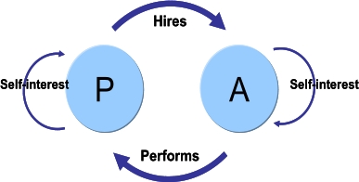

The Agency Problems
Agency relationship
- Principal hires an agent to represent their interests
- Stockholders (principals) hire managers (agents) to run the company
- Example: real estate broker
Agency problems
- Problems due to conflicts of interest can exist between the principal and the agent
- Example: agent is paid on commission so they may be less willing to let the buyer know that a lower price might be accepted.
Agency costs
- The costs associated with agency problems
  - Direct agency costs
  - Indirect agency costs

Managing Managers:
- Managerial compensation
  - Incentives can be used to align management and stockholder interests.
  - The incentives need to structured carefully to make sure that they achieve their goal
  - For example, tying bonuses to profits might encourage management to pursue short-run profits and forego projects that require a large initial outlay. Stock options may work, but there may be an optimal level of insider ownership. Beyond that level, management may be in too much control and may not act in the best interest of all stockholders. The type of stock can also affect the effectiveness of the incentive.
  - Executive compensation serves 3 main purposes
    - It must attract executives with the skills, experiences and behavioral profile necessary to succeed in the position
    - It must be sufficient to retain these individuals, so they do not leave for alternative employment.
    - It must motivate them to perform in a manner consistent with the strategy and risk-profile of the organization and discourage self-interested behavior.
  - KEY WORDS: Attract, Retain and Motivate.
- Corporate control
  - The threat of a takeover may result in better management
  - Low stock prices may entice a Corporate Raider to buy enough stock so they have enough control to replace current management
    - The stock price will rise after the new management team “fixes” the company.
  - Different types of turnover:
    - Voluntary turnover
      - Due to poor health/death
      - Retirement
      - Resignation with succession in place
      - CEO stays as chairman after resignation
    - Involuntary turnover
      - Resignation due to poor performance
      - Merger (takeover)
      - Scandal
        - Enrol Corp
        - Worldcom
        - Parmalat
  - Only 1 in 4 corporate frauds is detected in the U.S
  - Captured Board
    - Board of directors’ duties can be compromised by connections, perceived loyalties to management or compensation/incentive structure.
- Conflicts with stakeholders
  - Other groups also have a financial stake in the firm. They can provide a valuable monitoring tool, but the can also try to force the firm to do things that are not in the owner’s best interest.

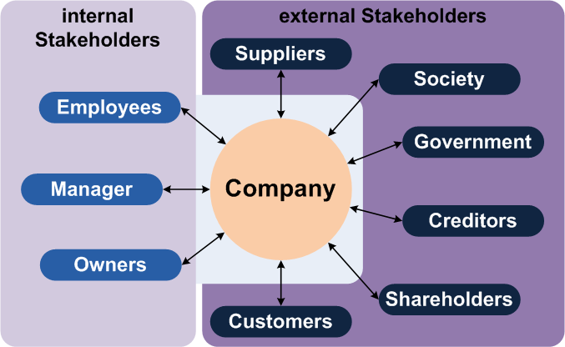

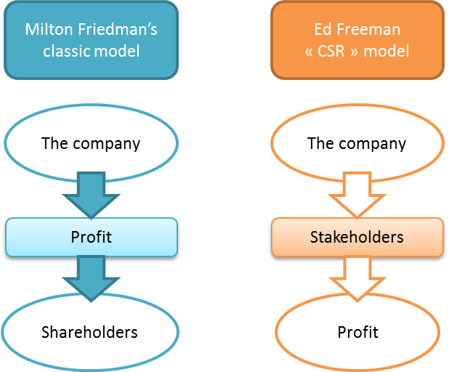
- The Stakeholder Theory

- Social Responsibility and Ethical Investing
  - Investors are increasingly demanding that corporations behave responsibly
  - Issues include how a corporation treats the community in which it operates, their customers, corporate governance, their employees, the environment and human rights.
  - Controversial business activities include alcohol, gaming, genetic engineering, nuclear power, pornography, tobacco and weapons.

Relation between Corporate Social Responsibility and Profitability
  - Strong economic performance and good social and environmental performance are not mutually exclusive.
  - Firms with social citizenship records and a real commitment to corporate responsibility are arguably more sustainable, better managed and, therefore, better long-term investments.
  - CSR is understood to be the way firms integrate social, environmental and economic concerns into their values, cultures, decision making, strategy and operations in a transparent and accountable manner and thereby establish better practices within the firm, create wealth and improve society.

What is the role of financial markets in corporate finance?
- Cash flows to and from the firm
- 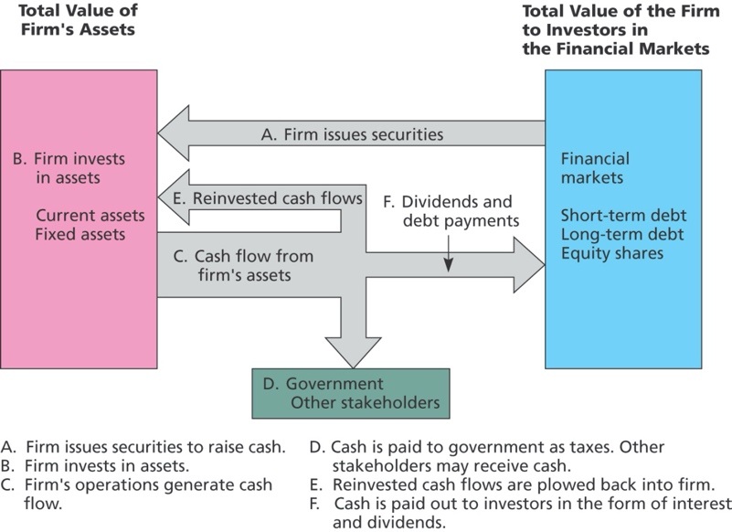
- Money vs capital markets
- Primary vs secondary markets

Financial Institutions
- Financial institutions act as intermediaries between suppliers and users of funds
- Institutions earn income on services provided
  - Indirect finance
    - Earn interest on the spread between loans and deposits
  - Direct finance
    - Service fees (i.e. bankers’ acceptance and stamping fees)
- Trends in Financial Markets and Management
  - Financial engineering
  - Derivative Securities
  - Advances in Technology – i.e. E-business
  - Deregulation
  - Corporate Governance Reform
  - Hedge Funds
  - Shareholder Activisms

Module 2

Interest Rates and the Time Value of Money:

Time Value of Money:
- Cost: $100,000 today
- Benefit: $105,000 in one year
  - The difference in value between money today and money in the future is due to the time value of money.
The Interest Rate:
- An Exchange Rate Across Time
- The rate at which we can exchange money today for money in the future is determined by the current interest rate.
- Risk-free interest rate, r_{f} is the interest rate at which money can be borrowed or lent without risk.
- Interest rate factor = 1 + r
- Discount factor = 1 / (1 + r)
Making Consumption Choices over Time:
- Consider a person who has an income of $50,000 this year and an income of $60,000 next year.
- The market allows him not only to consume $50,000 worth of goods this year and $60,000 next year, but also to borrow and lend at the equilibrium interest rate.
- If the rate of interest is 10%:
  - What is the maximum amount available for this person to consume this year?
  - What is the maximum amount of wealth that this person can spend in the second year?
  - Here are all the possibilities:
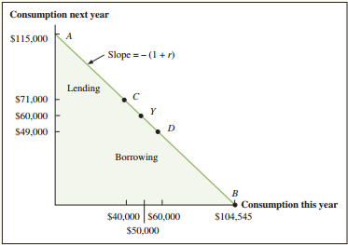
  - Point C: Lend $10,000
    - Consumption this year: $50,000 - $10,000 = $40,000
    - Consumption next year: $60,000 + [$10,000 x (1 + r)] = $71,000 at an interest rate of 10%.
  - Point D: Borrow $10,000 and repay next year
    - Consumption this year: $50,000 + $10,000 = $60,000
    - Consumption next year: $60,000 – [$10,000 x (1 + r)] = $49,000 at an interest rate of 10%.

Present Value and the NPV Decision Rule:

Net Present Value:
- The Net Present Value (NPV) of a project or investment is the difference between the present value of its benefits and the present value of its cost.
  - NPV = PV (Benefits) – PV (Costs)
  - NPV = PV (All project cash flows)
NPV Decision Rule:
- When making an investment decision, take the alternative with the highest NPV.
- Choosing this Alternative is equivalent to receiving its NPV in cash today.
Accepting or Rejecting a Project:
- Accept those projects with positive NPV
- Reject those projects with negative NPV
Example:
- Your firm needs to buy a new $9,500 copier. As part of a promotion, the manufacturer has offered to let you pay $10,000 in one year, rather than pay cash today. Suppose the risk-free interest rate is 7% per year. Is this offer a good deal? Show that its NPV represents cash in your pocket.
  - PV (cost): N=1, I/Y=7%, FV=$10,000, PV= CPT PV= $9,345.79
  - NPV = $9500 - $9,345.79 = $154.21 today
  - NPV is positive, so the investment is a good deal. It is the equivalent to getting a cash discount of $154.21 today and only paying $9,345.79 for the copier.
Individual’s Consumption Preferences and Optimal Investment Decision:
- Consider a person who is concerned only about this year and the next. She has an income of $100,000 this year and expects to make the same amount next year. The interest rate is 10%.
- This individual is thinking about investing in a piece of land that costs $70,000. She is certain that next year the land will be worth $75,000, a sure $5,000 gain. Should she undertake the investment?
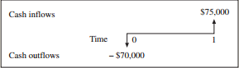
- By investing $70,000 she will have $75,000 next year.
- Suppose instead that she puts the same $70,000 into a loan in the stock market at 10%.
  - $70,000 x (1 + 0.10) = $77,000 next year.
- Knowing that, it would be foolish to buy the land knowing the market would give an extra $2,000.
Separation of the Individual’s Consumption Preferences from the Optimal Investment Decision:
- Always maximize NPV first
Arbitrage and the Law of One Price:

Arbitrage:
- The practice of buying and selling equivalent goods in different markets to take advantage of a price difference.
- An arbitrage opportunity occurs when it is possible to make a profit without taking any risk or making any investment.
Normal Market:
- A competitive market in which there are no arbitrage opportunities.
Law of One Price:
- If equivalent investment opportunities trade simultaneously in different competitive markets, then they must trade for the same price in both markets.

No – Arbitrage and Security Prices:

Valuing a Security with the Law of One Price:
- Assume a security promises a risk-free payment of $1,000 in one year. If the risk-free interest rate is 5%, what can we conclude about the price of this bond in a normal market?
  - PV ($1,000 in one year): N=1, I/Y=5, FV=1,000, PV= CPT PV= 952.38
  - Price of Bond = $952.38
- What if the price of the bond is not $952.38
  - Assume the price is $940
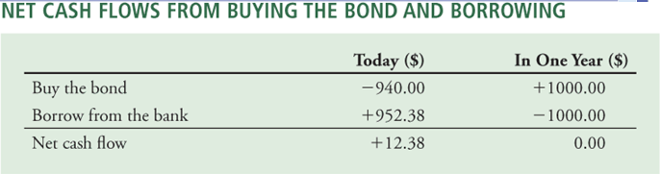
    - The opportunity for arbitrage will force the price of the bond to rise until it is equal to $952.38
  - Assume the price is $960
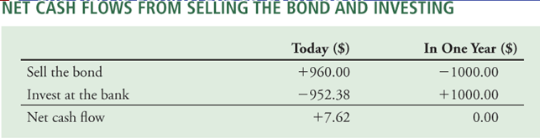
    - The opportunity for arbitrage will force the price of the bond to fall until it is equal to $952.38
- Determining the No-Arbitrage Price:
  - Unless the price of the security equals the present value of the security’s cash flows, an arbitrage opportunity will appear.
  - No Arbitrage Price of a Security
    - Price (Security) = PV (All cash flows paid by the security)
Example:
- Consider a security that pays its owner $100 today and $100 in one year, without any risk. Suppose the risk-free rate is 10%. What is the no-arbitrage price of the security today (before the first $100 is paid)? If the security is trading for $195, what arbitrage opportunity is available?
  - PV of the 2nd cash flow = N=1, I/Y=10, FV=100, PV= CPT PV= 90.91
  - Total PV is $100 + $90.91 = $190,91 which is the no-arbitrage price.
    - Knowing the security trades for $195
    - $195 - $190.01 = $4.09 become the arbitrage profit.
Determining the Interest Rate from Bond Prices:
- If we know the price of a risk-free bond, we can use
  - Price (Security) = PV (All cash flows paid by the security)
  - To determine what the risk-free interest rate must be if there are no arbitrage opportunities.
- Suppose a risk-free bond that pays $1,000 in one year is currently trading with a competitive market price of $929.90 today. The bond’s price must equal the present value of the $1,000 cash flow it will pay.
  - N=1, PV=-$929.80, FV=$1000, I/Y= CPT = 7.55%
The NPV of Trading Securities and the Optimal Investment Decision:
- In a normal market, the NPV of buying or selling a security is zero.
  - NPV (Buy security) = PV (All cash flows) – Price (Security) = 0
  - NPV (Sell security) = Price (Security) – PV (All cash flows) = 0
- Separation of the Investment and Financing Decisions:
  - Security transactions in a normal market neither create nor destroy value in their own.
  - We can evaluate the NPV of an investment decision separately from the decision the firm makes regarding how to finance the investment or any other security transactions the firm is considering.
Example:
- Your firm is considering a project that will require an upfront investment of 10M today and will produce 12M in cash flow in one year. Rather than paying 10M in cash, the firm wants to raise additional funds by issuing a security that will pay investors 5.5M in one year. Risk-free rate is 10%. Is it a good decision with and without the new security?
  - Without: 12M in one year = 10.91M
    - NPV = 10.91M – 10M = 0.91M
  - With: Price (Security) = 5.5M in one year is 5M today
    - Firm will get 12M in one year but owes 5.5M, Leaving them 6.5M
    - 6.5M in one year is 5.91M today
    - NPV = 5.91M – 5M = 0.91M
  - We get the same result.
Valuing a Portfolio:
- Portfolio is a collection of securities
- Value Additivity and Firm Value:
  - To maximize the value of the entire firm, managers should make decision that maximize NPV.
  - The NPV of the decision represents its contribution to the overall value of the firm.
Example:
- Horton Holdings is a publicly traded company with only 2 assets: It owns 60% of Tim’s Donuts chain and 100% of the Caribou hockey team. Suppose the market value of HH is $160M, and the market value of the entire Tim’s chain is $120M. What is the market value of the Caribou hockey team?
  - $120M x 60% = $72M
  - $160M – $72M = $88M
  - Caribou hockey team has a value of $88M

The Price of Risk:

Risk:
- When an actual outcome may be different from its expected outcome.
Risky Versus Risk-free Cash Flows:
- Suppose the risk-free rate is 4% and the economy is equally likely to strengthen or weaken.
- A risk-free bond pays $1,100 in one year.
- An investment in the market index will pay either $1,400(strong) or $800(weak).
  - Price today of the bond:
    - FV=1,100. N=1. I/Y=4. PV= $1,057.69
  - Expected payoff in one year
    - ½ ($800) + ½ ($1,400) = $1,100
  - It is the same pay-off as the risk-free bond!

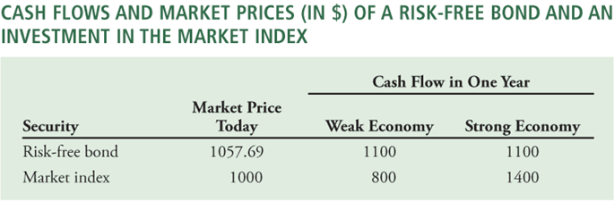
Risk Aversion and the Risk Premium:
- The benefits of receiving an extra $300 ($1,400 vs $1,000) is less important than the loss of $300 ($800 vs $1,100).
- Risk aversion
  - The personal cost of losing a dollar in bad times is greater than the benefit of an extra dollar in good times.
- Expected return of a risky investment = expected gain at end of year / initial cost
  - Market return in weak state = (800 - 1,000) / 1,000 = -20%
  - Market return in strong state = (1,400 – 1,000) / 1,000 = 40%
  - Expected return = ½ (40%) + ½ (-20%) = 10%
  - Risk Premium on market index is 10% - 4% = 6%
- Consider security A that pays $600 in a strong economy and $0 in a weak economy
  - According to the LOOP, what should be the price of security A if the risk-free rate is 4%.su
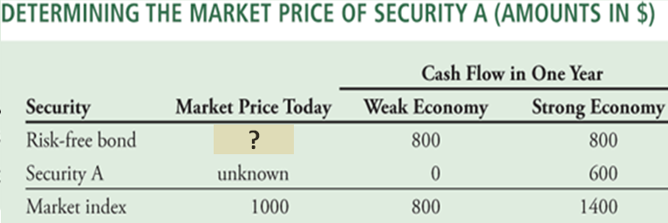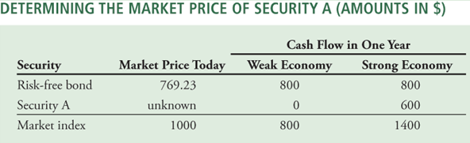
  - The LOOP says security A must trade for $230.77
- Risk Premiums Depend on Risk
  - Given more variable returns, security A pays investors a higher risk premium
    - Given an initial price of $230.77 and expected payoff of ½ (0) + ½ (600) = 300, security A has an expected return of (300 – 230.77) / 230.77 = 30%
    - Security A’s risk premium is 30% - 4% = 26%
  - The risk of a security must be evaluated in relation to fluctuations of other investments in the economy.
  - A security’s risk premium will be higher the more its returns tend to vary with the overall economy and the market index.
  - If the security’s returns vary in the opposite direction of the market index, it offers insurance and will have a negative risk premium.

Example:
- Suppose security B pays $600 if the economy is weak and $0 if the economy is strong. What is its no-arbitrage price, expected return and risk premium?
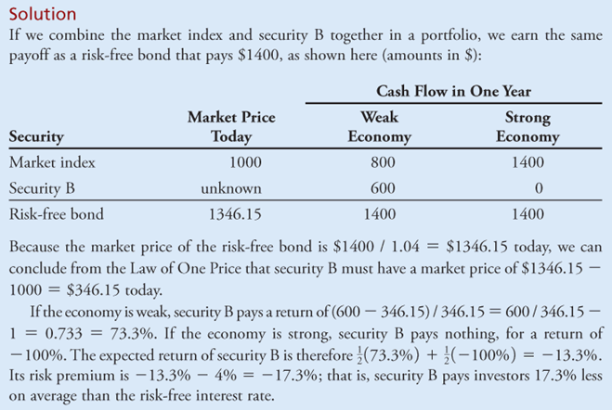
- 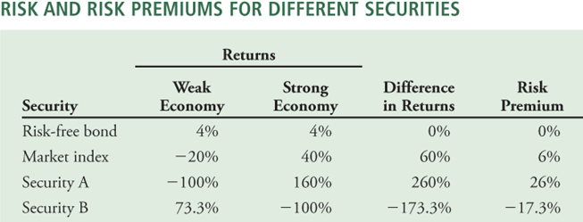
Risk, Return and Market Prices:
- The discount rate, r_{s}, includes a risk premium appropriate for the investment’s risk
  - R_{s =} r_{f} + (Risk premium for investment S)
Using the risk premium to compute a price:
- Consider a risky bond with a cash flow of $1,100 when the economy is strong and $1,000 when the economy is weak. Suppose a 1% risk premium is appropriate for this bond. If the risk-free rate is 4%, what is the price of the bond today?
  - R_{bond} = r_{f} + (Risk premium for the bond) = 4% + 1% = 5%
  - Expected cash flow of the bond is ½ ($1,100) + ½ ($1,000) = $1,050 in one year.
  - Price of bond today is: FV= 1,050, N= 1, I/Y= 5, CPT PV= 1,000
Arbitrage with Transaction Costs
- Commissions paid to your broker.
- Bid – ask spread
  - Difference of the price you receive when you sell (bid price) and when you buy (ask price) a security
- For most financial markets these costs are small

The No-Arbitrage Price Range:
- Consider a bond that pays $1,000 at the end of the year. Market rate for deposits is 6%, but market rate for borrowing is 6.5%. What is the no-arbitrage price range of the bond? That is, what is the highest and lowest price the bond could trade for without creating an arbitrage opportunity?
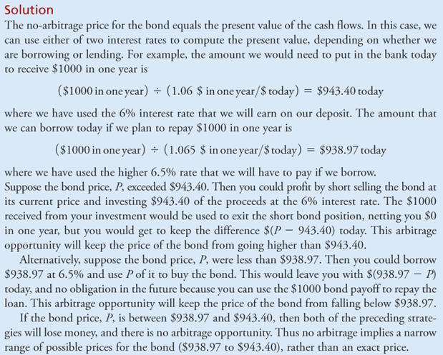

Module 3

Utility Theory

- It’s the foundation of the theory of choice under uncertainty. It used by economists to determine how people and societies choose to allocate scarce resources and to distribute wealth among one another over time.
- Economists defined the relation between psychological satisfaction and wealth as utility
- Rational investors are expected to prefer a higher expected future wealth to a lower value and are generally risk averse.
Goals
- Individual maximizes their expected Utility
- Individual preferences over risk and return
Fair Gambles
- If {the cost to play these gambles} = {expected value of the outcome}
  - Then the gamble is said to be actuarially fair
- Common empirical findings
  - Individuals may agree to flip a coin for small amounts of money, but usually refuse to bet large sums of money.
  - People are willing to pay small amounts of money to play actuarially unfair games but will avoid paying a lot.
    - Lotto 649
- Why do these empirical findings occur?
  - Because it is not about E(W)
    - Individuals do not make decisions based purely on wealth, but rather on the utility of their expected wealth: max U(E[W])
Utility Functions
- Utility functions must have 2 properties
  - Order preserving: if U(x) > U(y) => x > y
  - Expected utility can be used to rank combinations of risky alternatives: U[G(x,y:a)] = aU(x) + (1-a) U(y)
- Utility functions are unique to individuals
  - If we give 2 people $1,000 there is no way to determine who is happier.
Risk Aversion
- If prefer the gamble, you are a risk loving
- If indifferent to the options, risk neutral
- If prefer the expected value over the gamble, risk averse
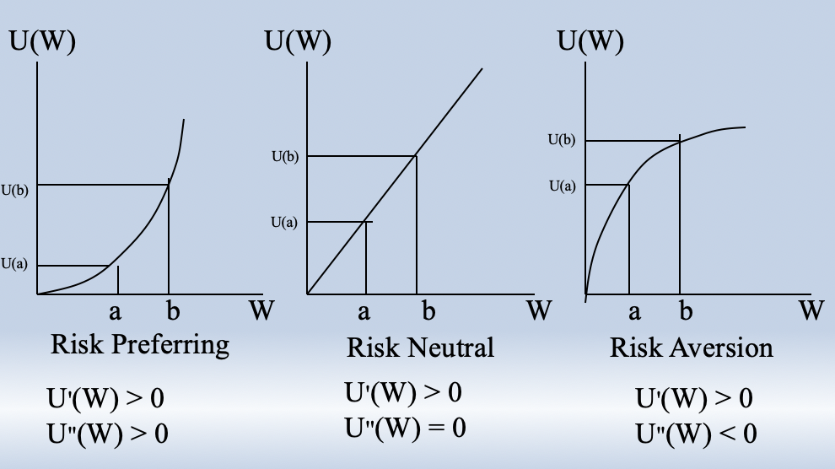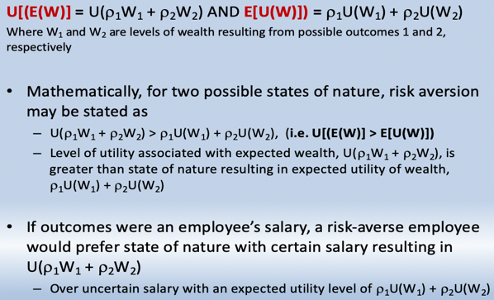
- U[(E(W)] is the utility associated with the known level expected wealth (although there is uncertainty around what the level of wealth will be, there is no such uncertainty about its expected value).
- E[U(W)] is the expected utility of wealth is utility associated with level of wealth that may obtain

Expected Utility
- Assume that the utility function is natural logs: U(W) = ln(W)
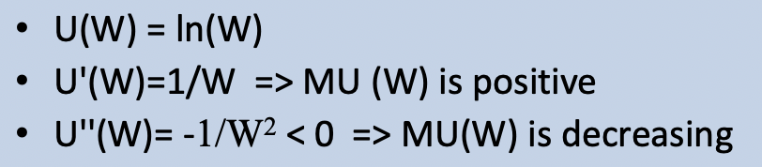
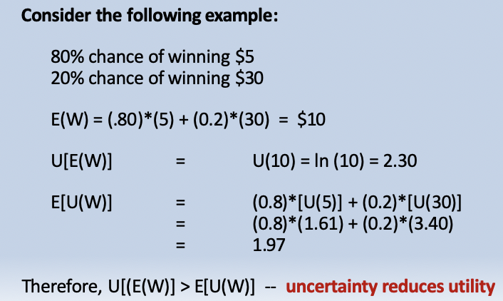
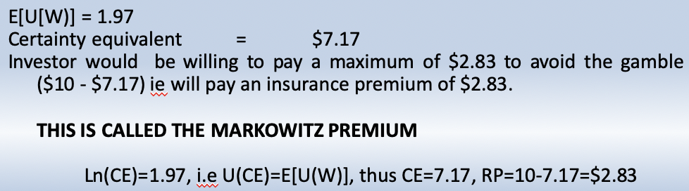
Risk Premium
- Risk premium = an individual’s expected wealth, given he plays the gamble – level of wealth the individual would accept with certainty if the gamble were removed (the certainty equivalent).
- 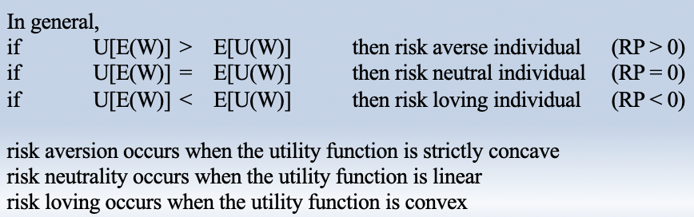
- R = r_{f} + risk premium
Common Measures of Risk and Return
- Assume BFI stock currently trades for $100 per share. In one year, there is 25% chance the price will be $140, 50% $110 and 25% it will be 80$.
- 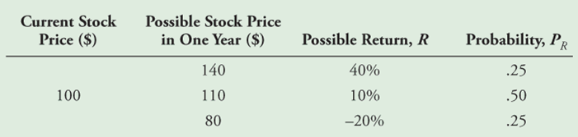
Expected Return
- Calculated as a weighted average
- E(R) = Σ_{R} P_{R} x R
  - E(R) = 25% (0.40) + 50% (0.10) + 25% (-0.20) = 10%

Variance and Standard Deviation

Variance
- The expected squared deviation from the mean
- $Var\left(R\right)=E\left[{\left(R-E\left[R\right]\right)}^{2}\right]= rPr X (R-E{\left[R\right]}^{2})$
  - $Var\left(R\right)=25\%{\left(0.40-0.10\right)}^{2}+50\%{\left(0.10-0.10\right)}^{2}+25\%{\left(-0.20-0.10\right)}^{2}=0.045$
Standard Deviation
- Square root of the variance
- SD(R) = $\sqrt{var(R)}$
  - $\sqrt{0.045}=21.2\%$
- SD of a return is also referred to as its volatility.

Historical returns of stocks and bonds

Computing historical returns
- Realized return
  - The return that actually occurs over a particular time period
  - 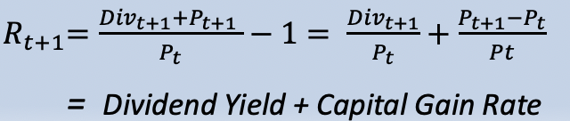
Average Annual Return
- 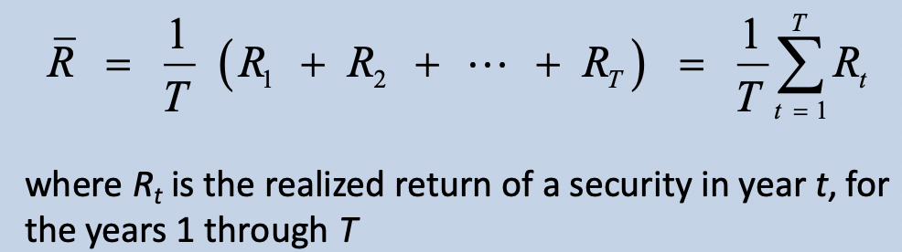
The Variance and Volatility of Returns
- Variance estimate using realized returns
- 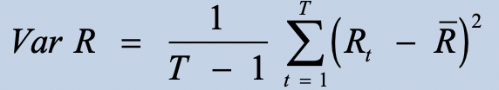
Example:
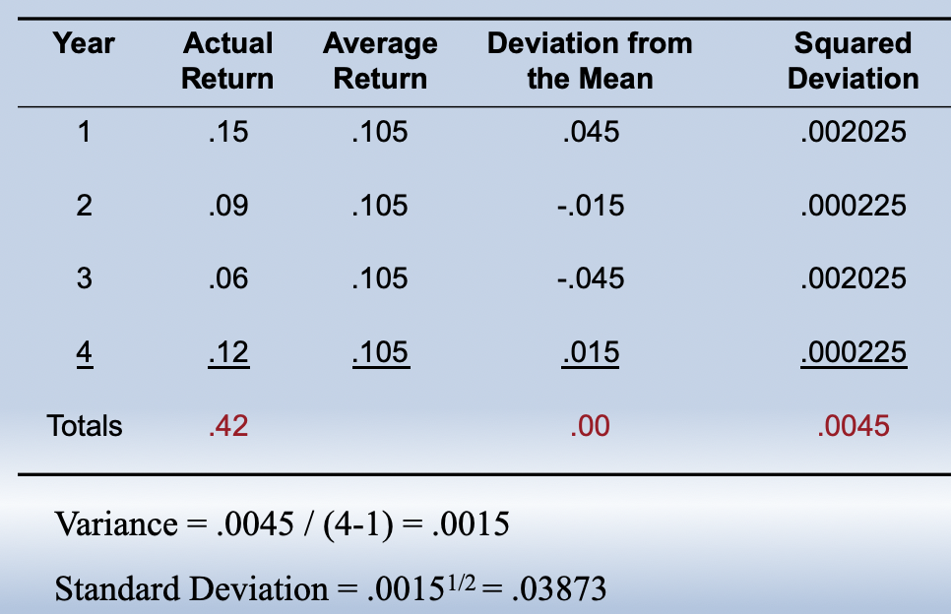
- Variance for a sample = Squared Dev / N-1
- Average return = 0.42/4=0.105
The historical tradeoff between risk and return
- The returns of large portfolios
  - Excess returns
the return of individual stocks

positive relationship between volatility and average returns
- There is no precise relationship between those two
  - Larger stocks tend to have lower volatility than smaller ones
  - All stocks tend to have a higher risk and lower returns than large Portfolios

Common versus independent Risk

Types of Risk
- Common risk
  - Risk that is perfectly correlated
    - Risk that affects all securities
- Independent risk
  - Risk that is uncorrelated
    - Risk that affects a particular security
- Diversification
  - The averaging out of independent risks in a large portfolio
Diversification in stock portfolios
- Firm-specific versus systematic risk
  - Independent risks
    - Due to firm-specific risk also known as:
      - Firm-specific risk
      - Idiosyncratic risk
      - Unique risk
      - Unsystematic risk
      - Diversifiable risk
  - Common risk
    - Due to market-wide news also known as:
      - Systematic risk
      - Undiversifiable risk
      - Market risk
- Firm-specific news
  - Good or bad news about an individual company
- Market-wide news
  - News that affects all stocks, such as news about the economy
- When many stocks are combined in a large portfolio, the firm-specific risks for each stock will average out and be diversified
- The systematic risk, however, will affect all firms and will not be diversified,

