- 5 UN Global Compact stages
- Goal:
  - Determine current sustainability stage according to Global impact sustainability Stages Model
  - Recommend a key next step for progressing to the next sustainability stage
  - Letter to the CEO
  - Explain analysis, findings and recommendations
  - Letter: clearly explain the stage of the company
  - Letter: identify a key next step the company can take for it to reach the next sustainability stage
  - Recommendation: Lesson 5 to 7

Notes:

Lesson 5:

- Sustainability being in the top 5 global challenges
- 7 pillars of sustainability leadership:
- Board: board of directors is actively engaged in sustainability issues
- CEO: CEO & C-suite champion sustainability
- Strategy: Sustainability is embedded in strategic planning
- Goals: Sustainability goals are strategic, ambitious and long term
- Compensation: Executive compensation is tied to sustainability performance
- Innovation: Sustainability is part of the innovation process
- Reporting: Sustainability is woven into company reporting and engagement
- Board:

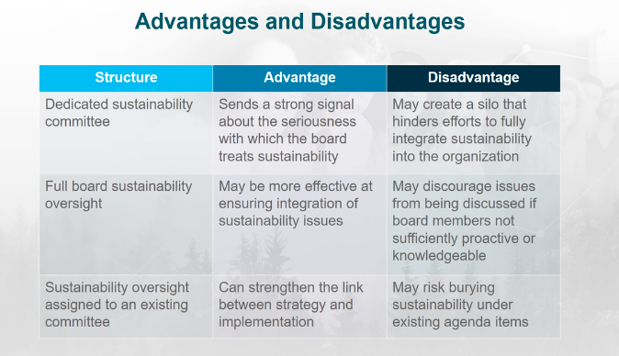
- CEO:
  - Prioritize long-term growth
  - Set ambitious sustainability goals that “stretches” the org.
  - Identify sustainability as a driver of innovation and business opportunities
  - Promote radical transparency
  - CSO (chief sustainability officer)
  - CSO’s role in companies depending on the level of sustainability commitment
    - 14% commitment -> compliance with regulations and securing license to operate
    - 27% commitment -> efficiency and focus on the bottom line
    - 36% commitment -> innovation and exploitation of opportunities for growth
  - Structure that clearly indicated a company’s commitment to sustainability: Board of directors -> CEO -> CSO
  - Sustainability: Top business challenge
- Important to have a clear mission
- Social purpose business:
  - Financial value -> socially responsible business where it realizes that solving a social issue is an important part of doing business
  - Social value -> Built for the intention of solving a social issue
  - Blended value -> Solving a social issue is a core to the business model, this measures the success on profit and its impact on the environment and society
- Benefit corporation: modified governance structure that promotes the creation of durable value for all stakeholders

Lesson 6:

- Ceres roadmap for sustainability
- Ceres: Performance
  - Achieving ground results regarding climate change, natural resources and human rights
  - Performance expectations in operations, supply chain, transportation & logistics, products & services, and employees
- Sustainability performance is about integrating sustainability into its core business systems and decision-making across a corporation’s value chain, and achieving sustainable outcomes
- UN Global Compact roadmap for integrated sustainability:
  - Global compact’s mission:
    - Global movement of sustainable companies
    - Do business responsibly
    - Advance broader societal goals

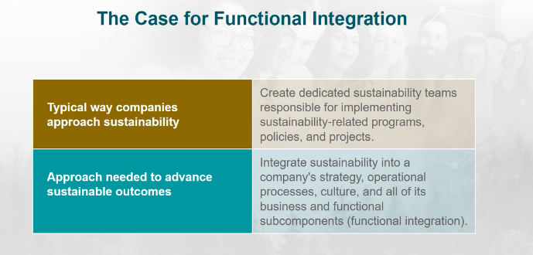

- Sustainability Stages Model:
  - Stage 1: Crisis Management -> They solve crisis as it comes, the company is usually not prepared
    - Short-term problem solving
    - Minimizing Liability
    - Protecting the company’s brand
    - Protecting the company’s license to operate
  - Stage 2: Compliance
    - Manages liabilities by complying with the Law and all labor, environmental, health and safety regulations and standards
    - May engage in initiatives that may improve with future regulations and standards
    - These are still covered as they come
  - Stage 3: Resource Optimization
    - Begins to recognize potential gains from environmental and social initiatives
    - Tend to focus on reducing cost through increased productivity and reducing risk through improved environmental and social performance
    - Efforts tend to be implemented by specialized functions, conducted on a small scale, and marginalized by leadership
    - Efforts on small scale
  - Stage 4: Market Differentiation
    - Focus on sustainability-driven innovation, differentiation, and growth
    - Results in innovative products and business models, and new markets
    - Transitioning from resource optimization to market differentiation, their attention on sustainability shifts
    - Sustainability is seen as an opportunity to also develop partnerships
    - Most companies as sustainable leaders are in this stage
  - Stage 5: Purpose driven
    - Sustainability issues inseparable from the company’s core vision, mission and brand
    - Committed to improving the state of the world
    - Seek shared-value
    - Use this as a source of competitive advantage
    - Motivation separates them from market differentiation
    - They wont sacrifice long term values for short term gains

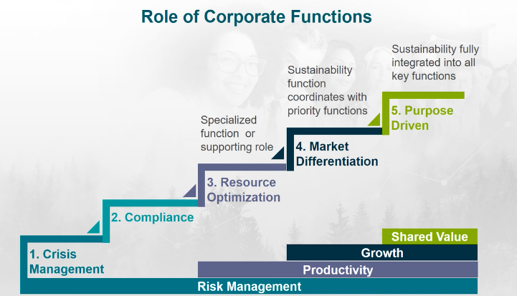

- Functional Integration of Sustainability: engaging leaders and employees of different functions to achieve sustainability
- Three lenses:
  - Strategic integration: tough choices company’s have to make
  - Operational Integration:
    - Integrate sustainability into the existing operation routine
    - Reinforce purpose, priorities, and goals expressed in the strategy
    - Create desired behaviors, norms, and habits
  - Cultural integration:
    - Understanding the beliefs, values, and behaviors of groups within a company
    - Leveraging the beliefs, values, and behaviors that will help advance sustainability
- Sustainability must be:
  - Woven into the core business strategy rather than tacked on as a discretionary activity
  - Integrated into each function purpose, priorities and goals

Lesson 7:

- Sustainability performance: society, environment and economy
- Governance: responsiveness to investors, board structure, equality & fairness, transparency, and corruption
- Performing measure and target setting:
  - Objective
  - Measure: observable value for evaluating progress toward achieving the objective
  - Target
  - Initiative
- Key Performance indicators:
  - Mission & vision
  - Strategy
  - Strategic objectives: progress over time
  - Operational Objectives: day-to-day performance
- Sustainability objectives example:

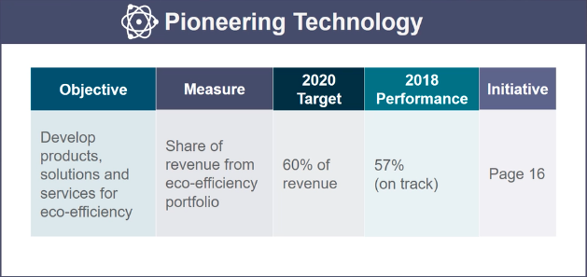

- Responsible operations example:

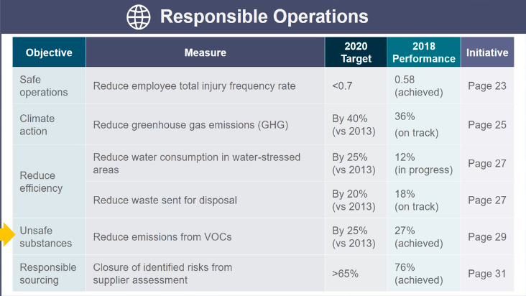

- Responsible relations:

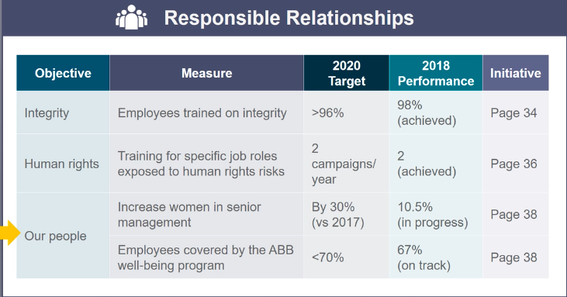

https://www.nytimes.com/2020/04/22/style/canada-goose-no-new-fur.html
https://www.canadagoose.com/on/demandware.static/-/Library-Sites-CG-Global/default/dw1f2c4bc8/pages/sustainability/CG_2019_CSR_Report_PDF_030620.pdf
https://www.newswire.ca/news-releases/canada-goose-launches-sustainable-impact-strategy-and-commits-to-carbon-neutrality-by-2025-884355780.html
https://www.canadagoose.com/ca/en/sustainability/our-purpose.html
- Sustainability has been in the top global challenges
- Importance if having a clear mission and vision
- Canada Goose follows the 7 pillars of sustainability leadership
  - There is a board engaged in the sustainable issues
  - Canada goose executive steering committee + global sustainability working group
  - Strategy and goals: regarding sustainability, carbon emissions, energy use, habitat preservation, to reduce waste, raw materials, manufacturing and chemical use
  - Compensation
  - Innovation:
  - Reporting: the global sustainability working group reports and engages with the executive committee for a common goal of elevating the company to be more environmentally friendly and sustainable
- Board structure: dedicated sustainability committee which reports monthly discussing sustainability risks and reporting them in order to solve, improve or avoid them for long term improvement as mentioned in the company’s sustainability report
- Very transparent
- Focusing on long-term growth
- Structure that shows the company’s commitment to sustainability
- According to the Ceres roadmap for sustainability, it is important to achieve results regarding climate change, natural resources and human right
  - Climate change: company wants to reduce their environmental impact
  - Natural Resources: revaluate their practices and move towards more responsible raw materials and recycling of other materials as well
  - Human rights: example of excess material being sent to communities in northern Canada
- Blended value social purpose: becoming more sustainable and have a positive impact, the company analyzes its success through its profits and its impact on the environment and the society
- Want to identify and support UN sustainable development goals
- Through the UN Global Compact sustainability stages we can analyze Canada Goose being in the 4th stage although making movements and high efforts of reaching the 5th
- Canada Goose is working on being able to identify with the UN sustainable development goals and are now continuingly publicly supporting it
- Stage 4: Market Differentiation currently transitioning into stage 5 with their new 2025 plan
  - Canada Goose sees the opportunity sustainability has brought to the company leading to new partnerships such as the one with Polar Bears International
  - Sustainability is part of the company’s important function
  - Canada Goose is determined to lead its company
- Stage 5:
  - Canada goose’s commitment to their sustainability plan brings the global issues to the core of the business’ vision and vision
  - They are determined to do their part for climate change
  - Moving towards a competitive advantage for a company who’s previously had many controversial situations
  - Their strong motivation brings them already closer to the 5th stage
  - Their plans are long term
Although as mentioned in your plan that animals are currently properly treated and recycling existing fur, trying to walk away from the fur trade and farms with a new line considering vegan materials or incorporating vegan materials to the existing models.

