Reading: VHDL and Verilog
- Hardware description languages can describe distinct aspects of a design at different levels of abstractions. Including behavioral, structural and physical
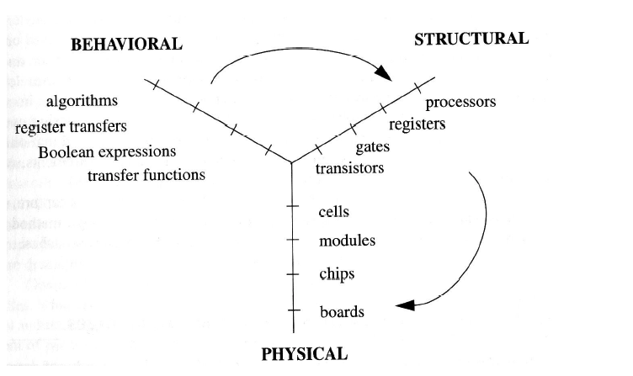
Using VHDL, we can describe the interface and the functional (behavioral and structural) aspects of a digital system

The interface in VHDL is described by the Entity keyword:
inout is for bidirectional signals
Examples:
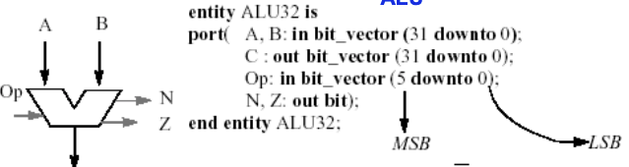
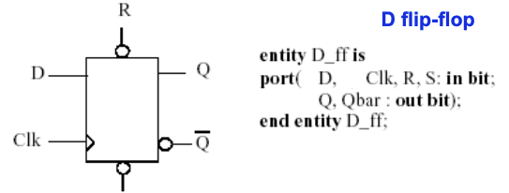
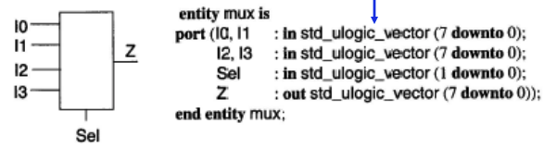

the behavioral description is described by the Architecture keyword:
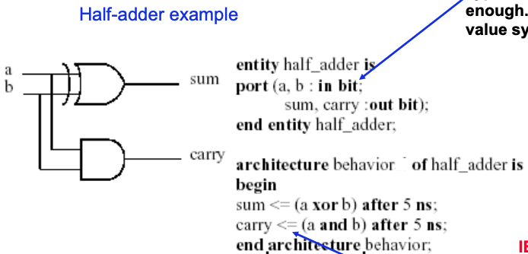
the strength of a signal reflects the ability of the source device to supply energy to drive the signal
the strength can be weakened by the resistance of wires causing signals to have different strengths
unknown or uninitialized values do not have a meaning for a signal

to use IEEE 1164 value system we just have to use: library IEEE;

Objects:
4 basic objects: variables (value), constants, signals (time-val pair), file types

Full-Adder Example: Signal Assignment
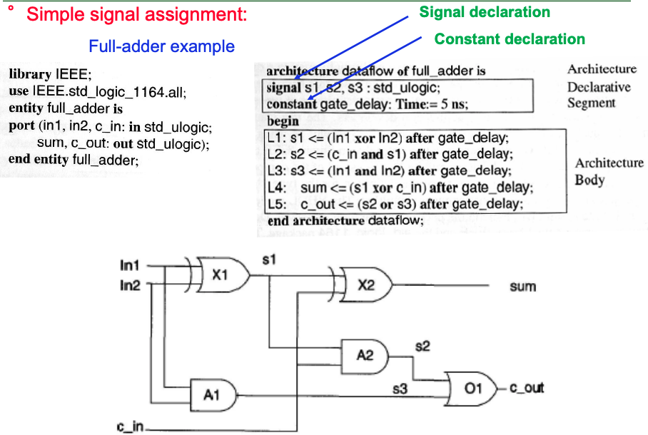

- to change signal transitions on a waveform:
signal <= ‘0’, ‘1’ after 10ns, ‘0’ after 20ns, ‘1’ after 40ns;

when using a conditional signal assignment: the first true conditional expression determines the output value.
ex) MUX4 (4-to-1, 8-bit MUX)
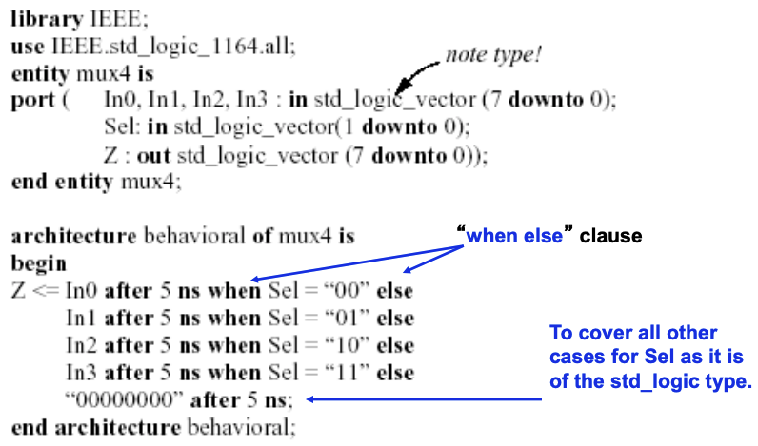
ex) Priority encoder (4-to-2):
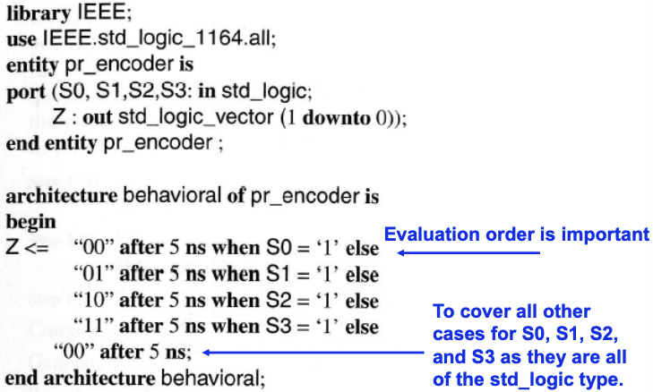

unaffected signals means the value of the signal is not changed.
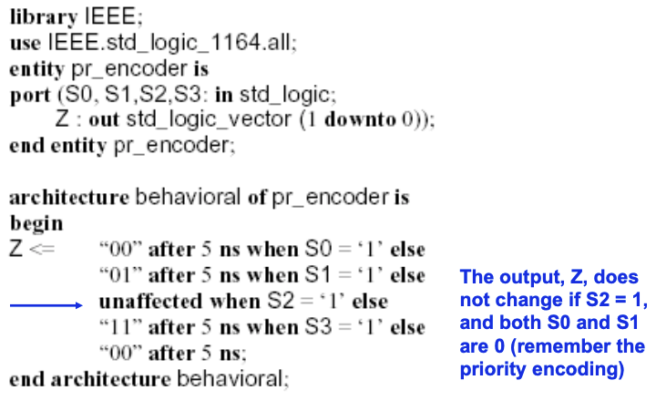

selected signal assignment statement: the when others keyword is to ensure that all options covered

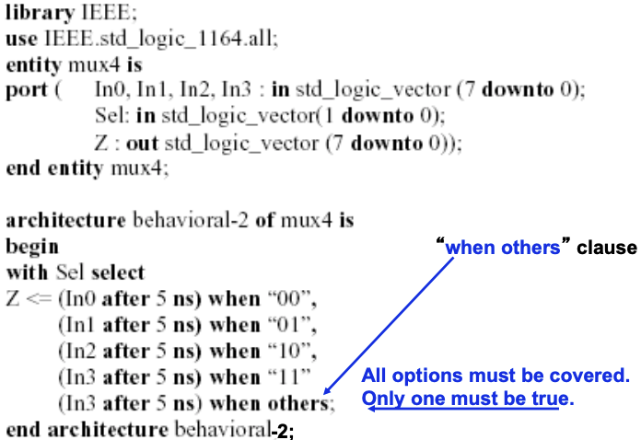

Delay Models:
- there’s 3 different delay models, inertial, transport and delta

- Inertial delay:
default delay model, suitable for modeling delays for devices like gates. The input must persist for a certain amount of time to ensure that the output will response. If a gate has an inertial delay, T, in addition to delaying the input signals by time T, any pulse with a width less than T is rejected.
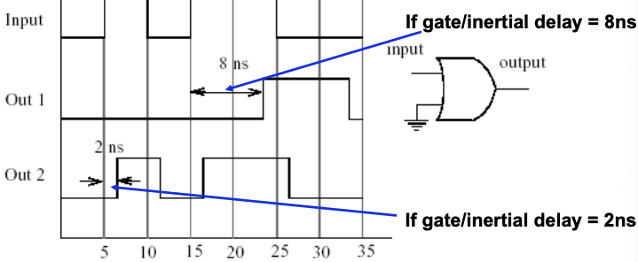
we can model devices which reject only very narrow pulses:
Signal name <= reject pulse width inertial expression after inertial delay time;

- Transport delay:
models delays through devices with very small inertia, such as wires
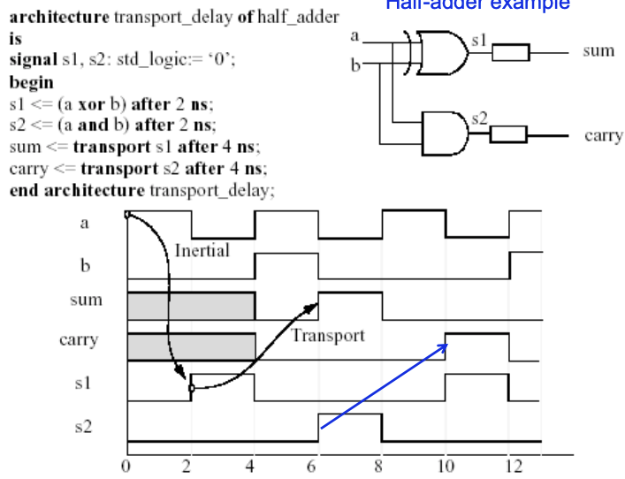

- Delta Delay:
where very small delays are automatically inserted by the simulator to preserve correct ordering of events
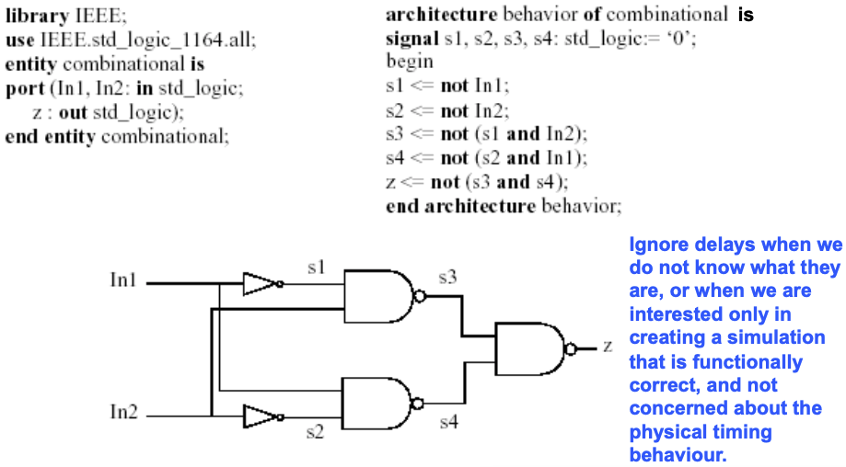
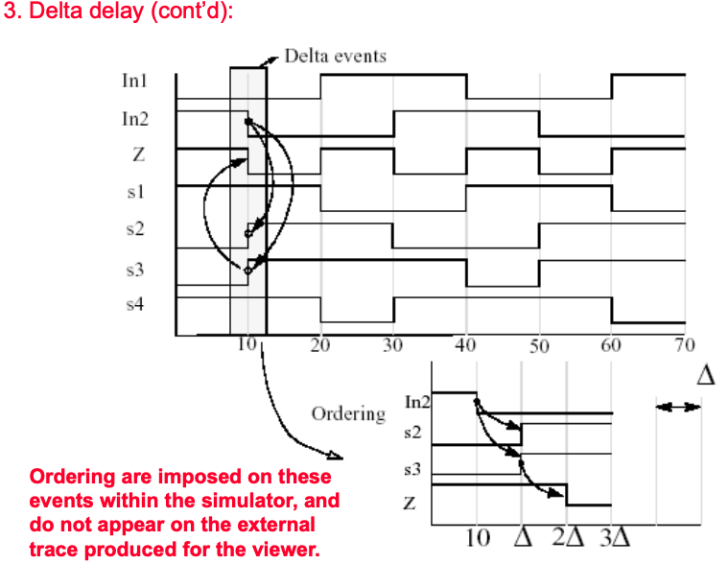

Modeling Behavior:
features like I/O behaviour, working with data structures or utilizing state info needs to be support, with the process construct.
- the process body is similar to C programs
- it has declarations as well as constructs such as: if-then-else, case, for, and while
- the process can contain signal assignment statements
- sequentially executed and processes communicate with eachother through signals
- processes executed once after startup, then the dataflow determines their initiations
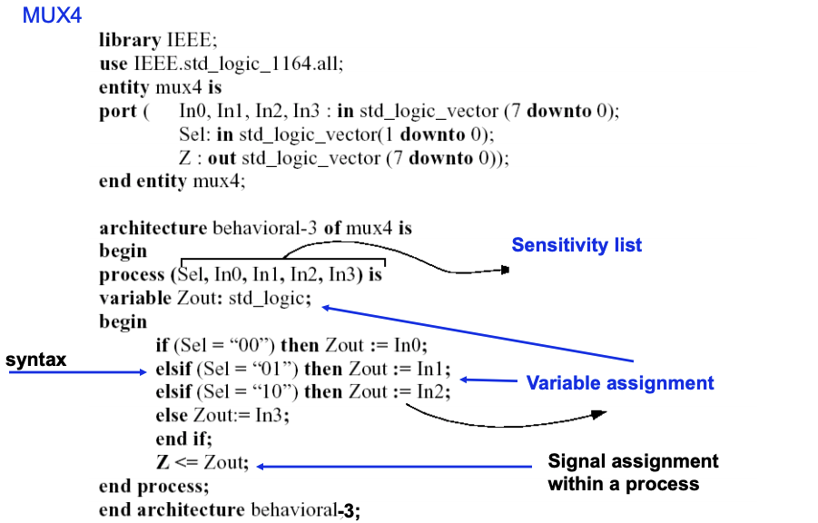
Ex) Memory module:
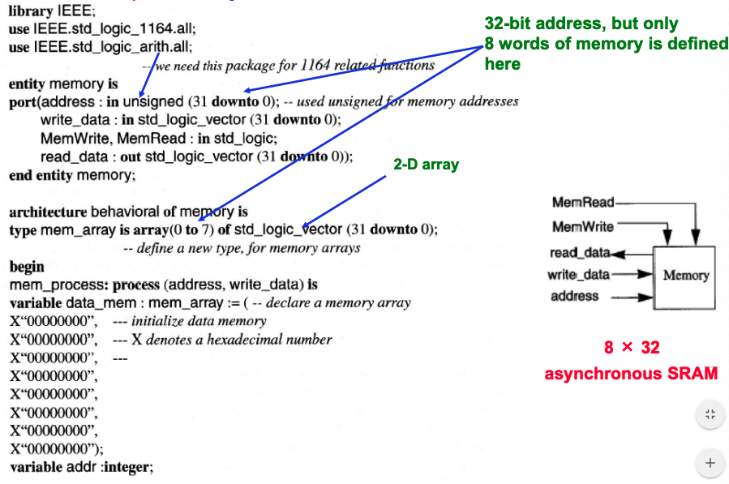
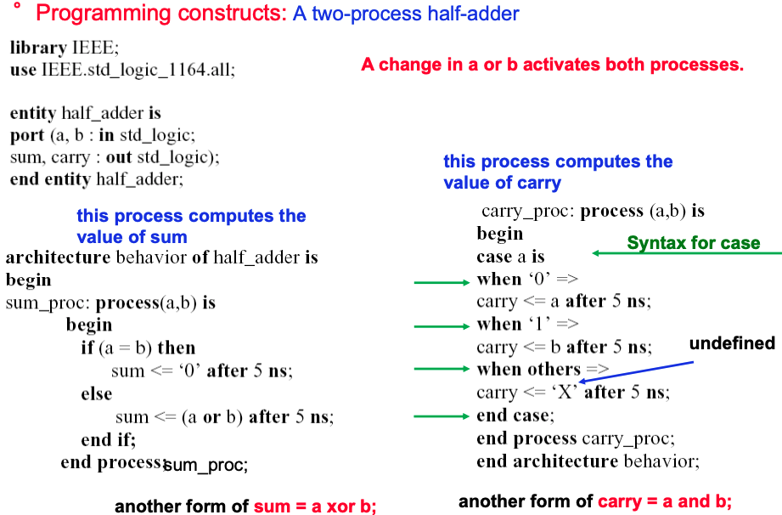

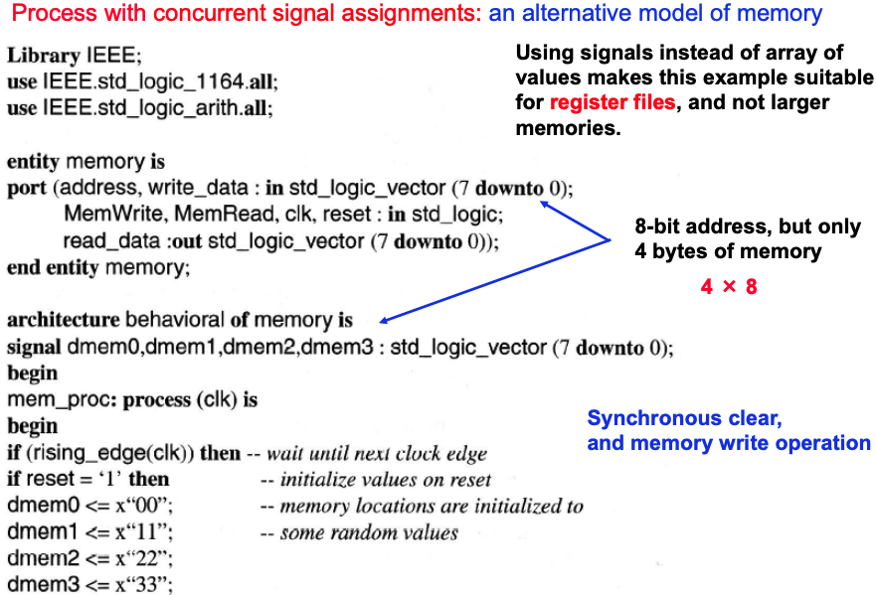

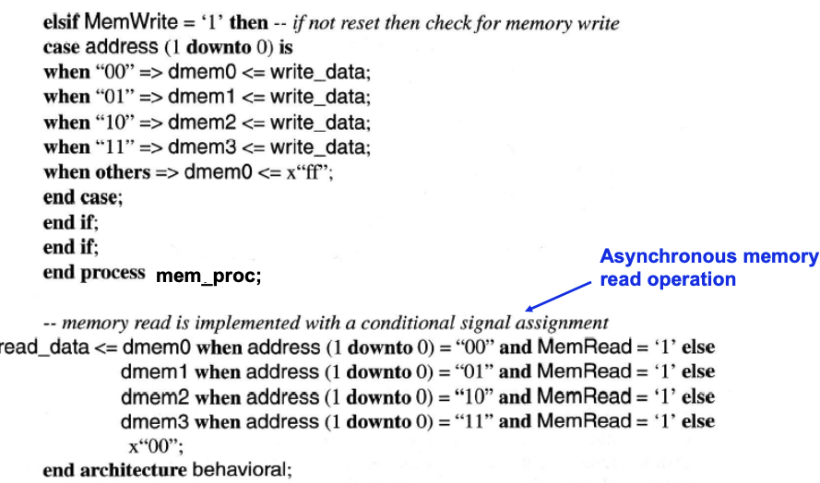

Ex) Sequential circuit multiplier: two 32-bit numbers
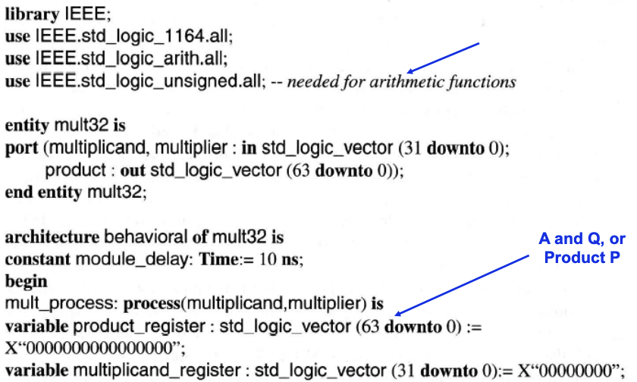
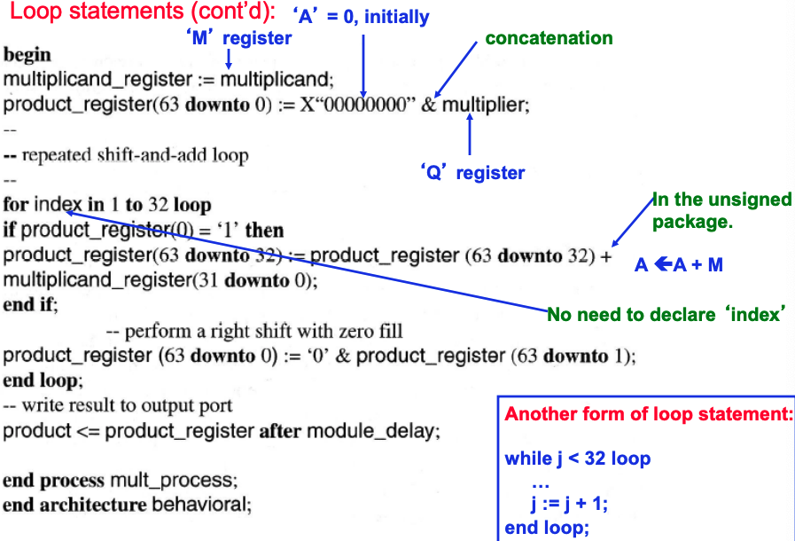

signals vs variables: variables compute values, which signals include timing additionally
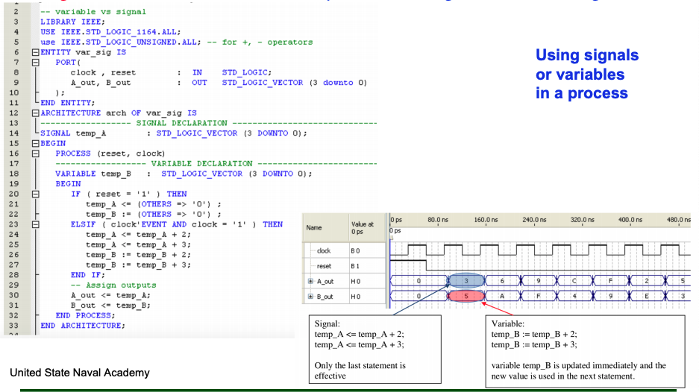
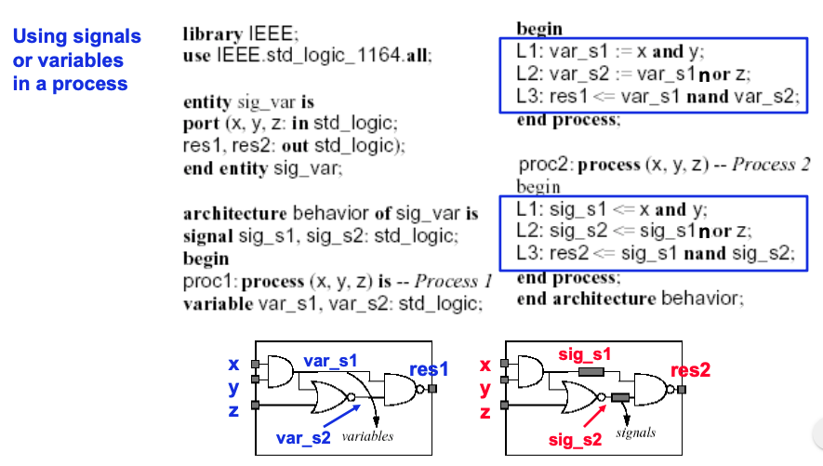
objects that represent signals in the modeled system could be represented as signals
objects that are used simply to computer future values of signals can use variables

Ex) Communicating process of full-adder:
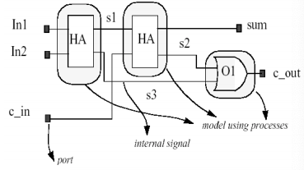
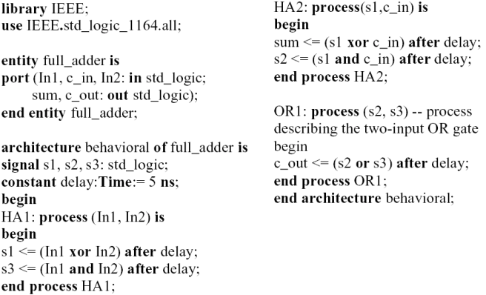

Wait keyword can describe synchronous or asynchronous timing operations, sensitivity list and wait statement cannot be used at the same time

Ex) positive-edge triggered D FF:
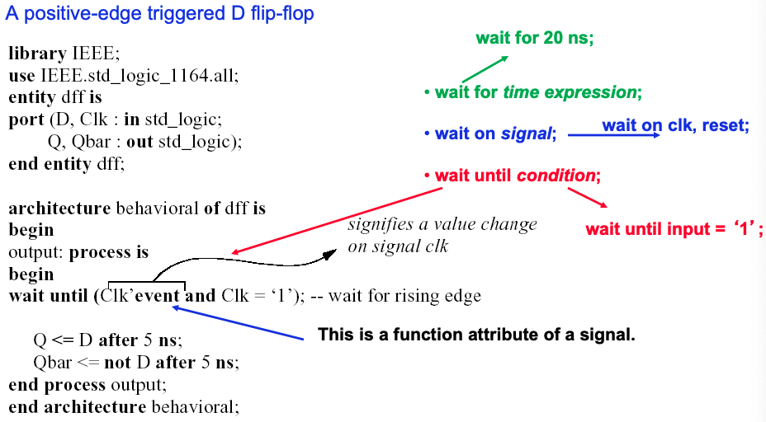
Attributes: data can be obtained about VHDL items such as types, arrays and signals
Classes of attributes: value, function, signal, type, range (loops)

- Value attributes: return a constant value
Type statetype is (state0, state1, state2, state3);
statetype’left = state0; statetype’right=state1;

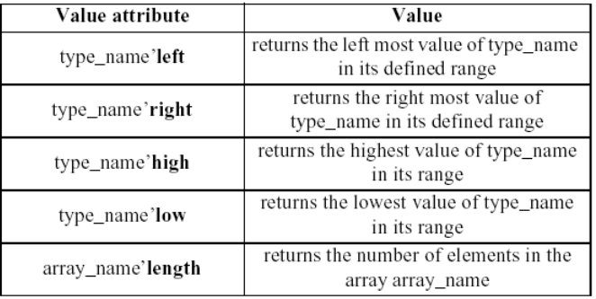

- Function attributes: invoke a function call which returns a value
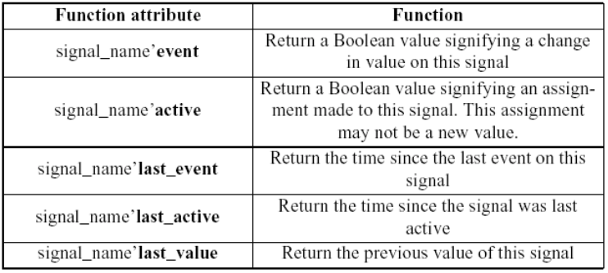

- Signal attributes: create new, implicit signals from the signals explicitly declared before
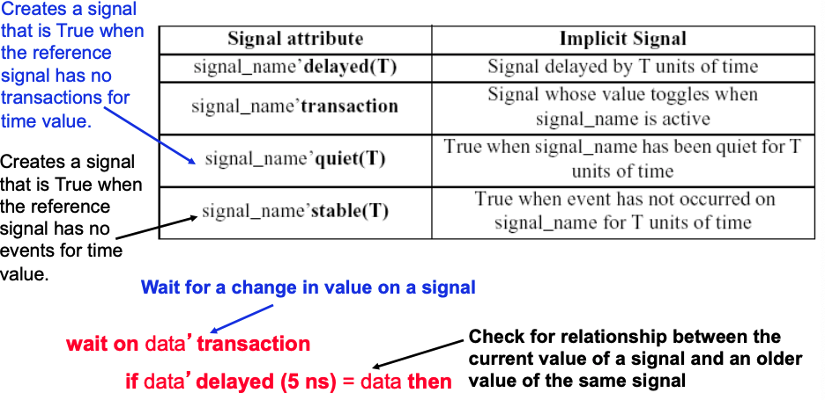
ex) Waveforms with signal attributes:
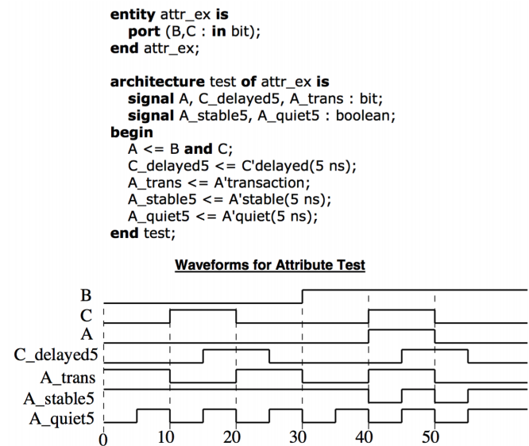

ex) D flip-flop with asynchronous inputs: wait can be implemented using sensitivity list
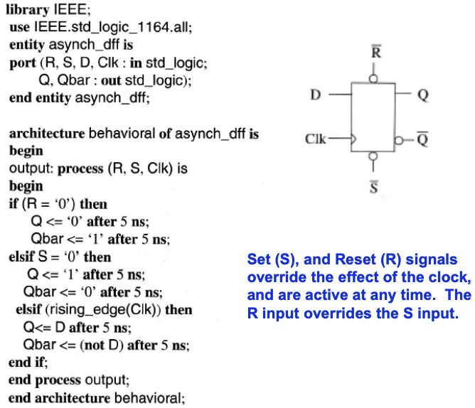

ex) a 4-bit register with asynchronous enable signal
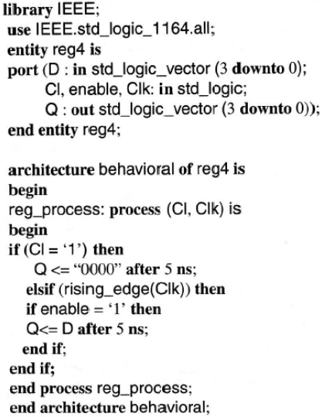

ex) 4-phase handshake asynchronous

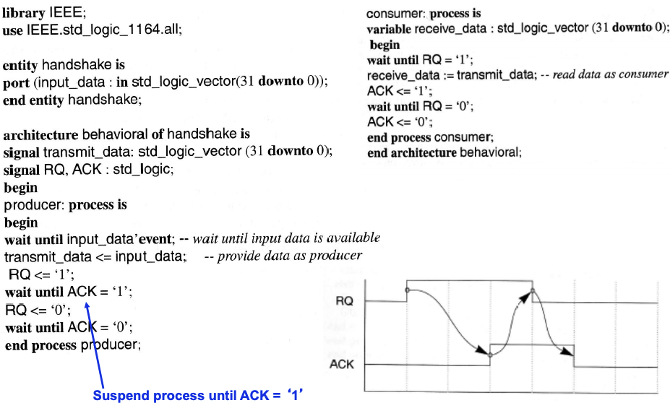

ex) Waveform generation:
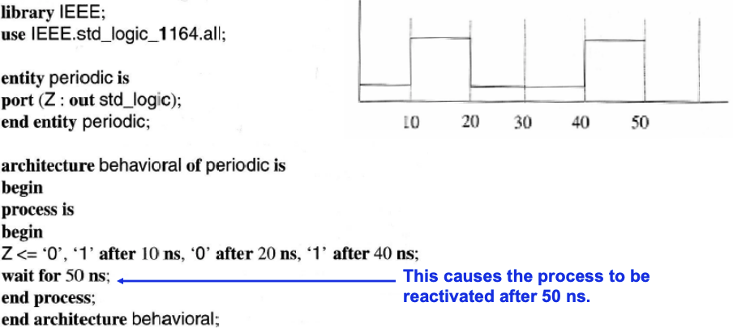

Modelling State Machines:
using communicating concurrent processes
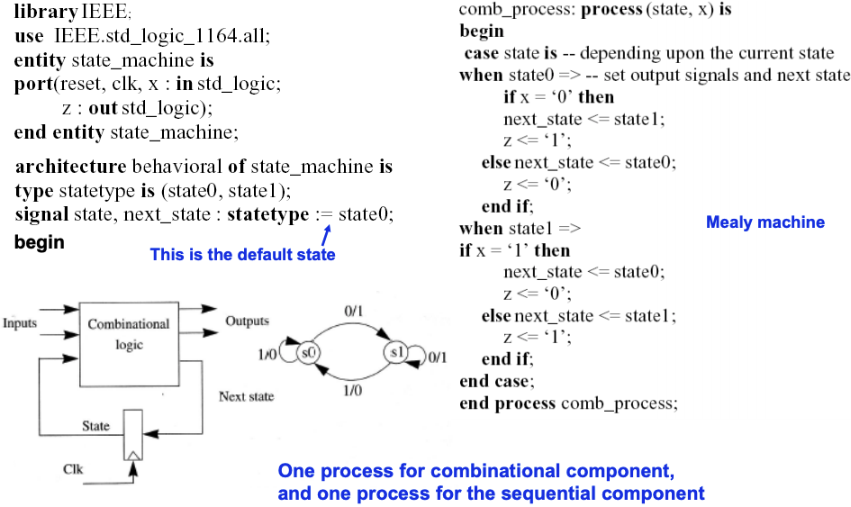

ex) An alternative model for a finite state machines: 3 processes, one for each output function, next-state function and state transition
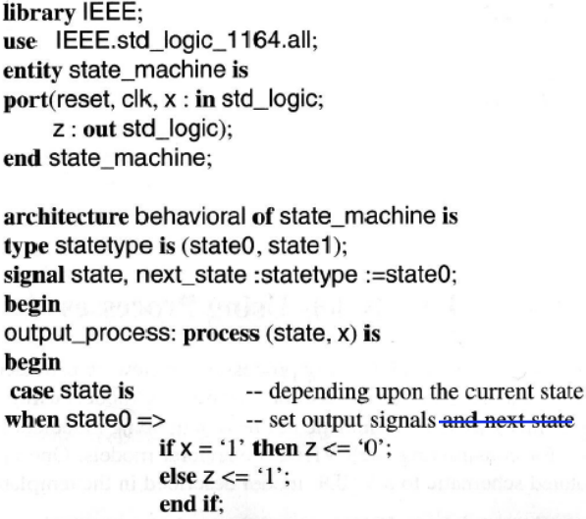
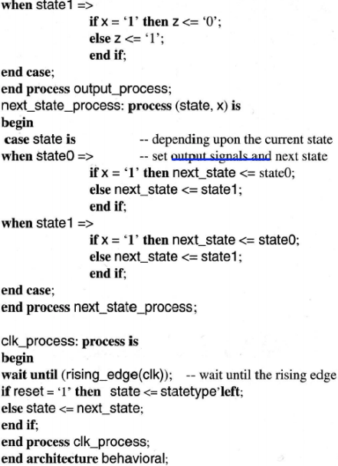

Modeling Structure:
- behavioral descriptions of a component may be specified using concurrent signal assignments
- when this isn’t feasible due to the complexity of the event generation models, the behavioral models of each component are specified using 1 or more processes and sequential statement
- another approach to describing a system is simply in terms of its interconnection of its components
Ex) Structural model of a FA
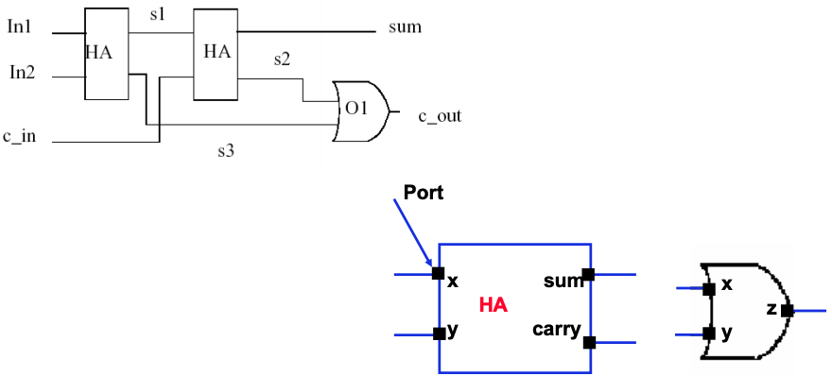
the structural model of the full-adder in VHDL would be as:
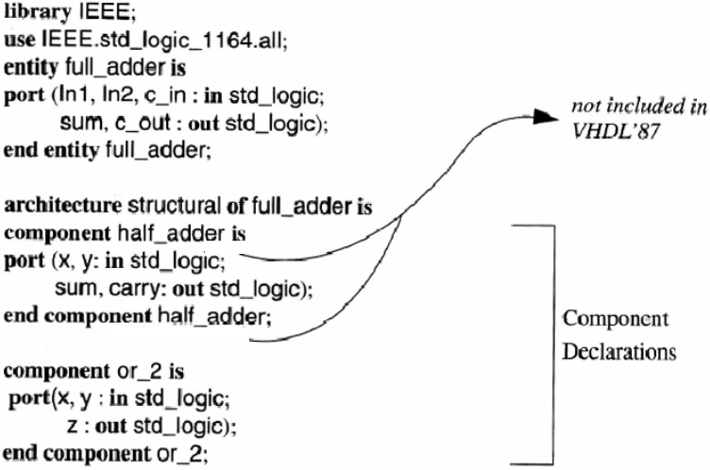
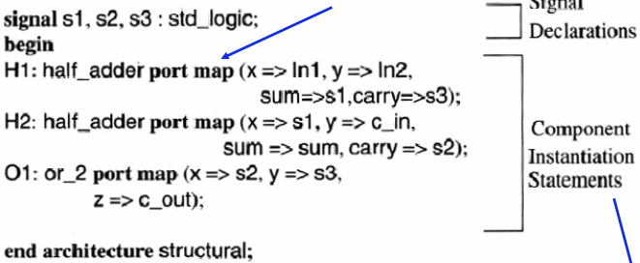
instantiation: first acquire the components, by labelling them, and laying them out on the design and then connecting them to other components using the signal wires

Ex) State Machine – Bit-serial Adder:
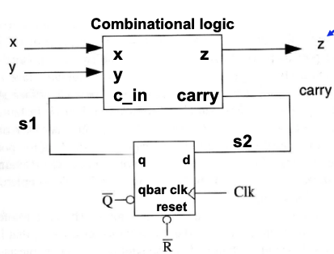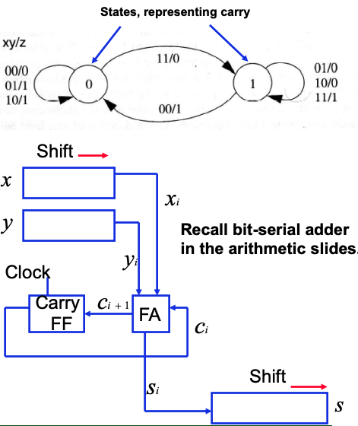
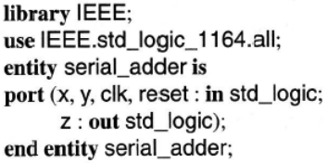

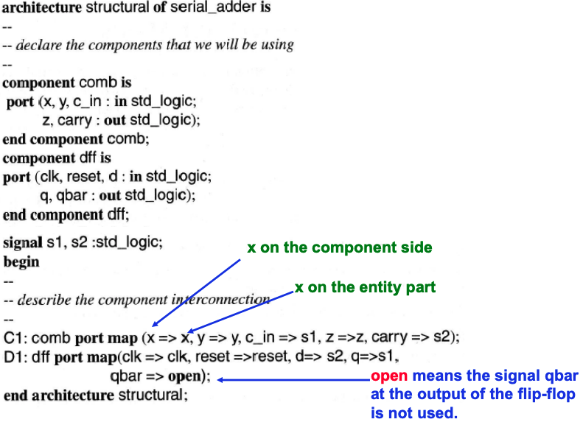
Generic Statements and Models:
generic statement is used to avoid hard coded values in models, and to keep the model current and used to multiple instantiations.
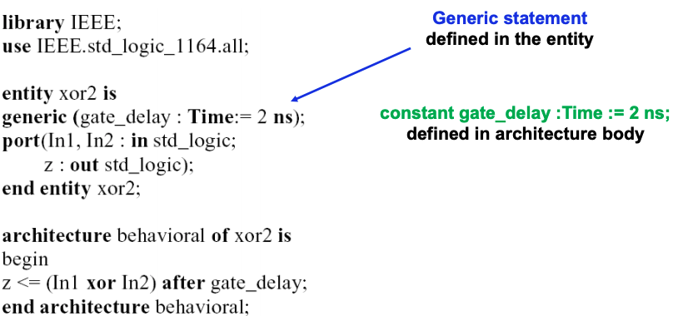

ex) a generic n-input gate OR
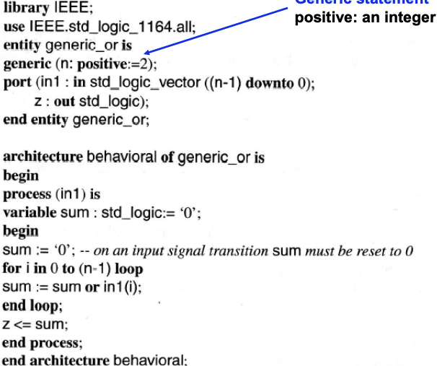

ex) a generic map in the component instantiation

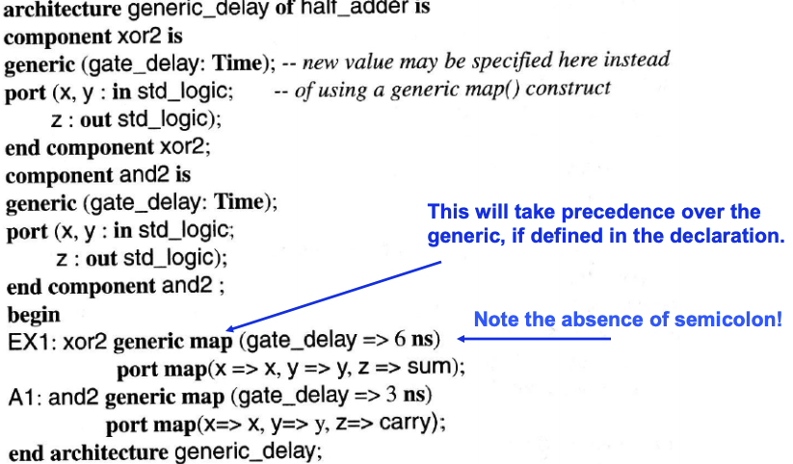

the generate statement can be used instead of writing multiple instantiation statements, to write the model compactly

ex) N-bit register:
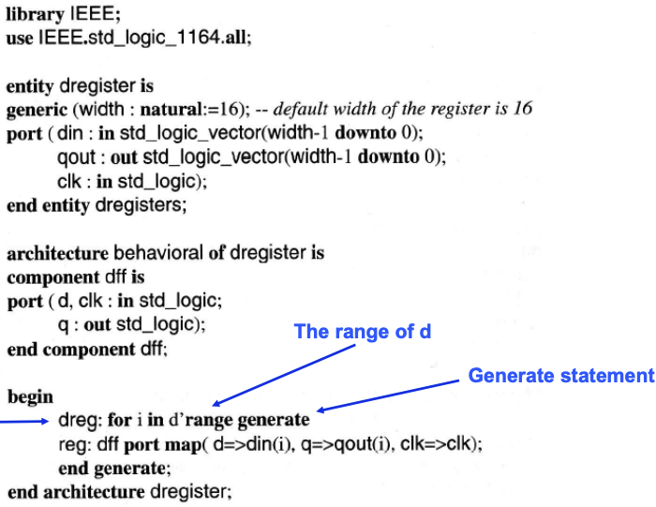

ex) N-bit ALU:
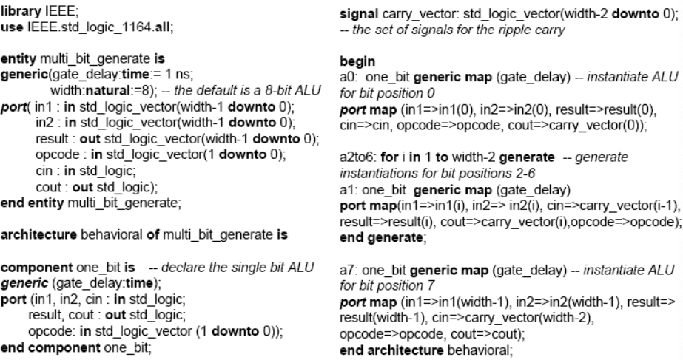

Subprograms:
- the key feature is the repeated use of similar structures, and they can only return a single value through return statement
- the function executes a sequential algorithm

the structure of a function:
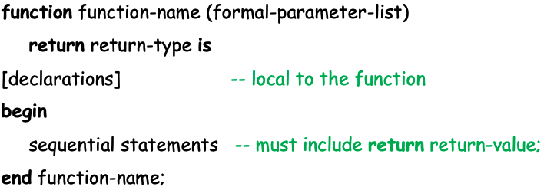

to call a function: function-name (actual-parameter-list)

the number and type of parameters on the actual-parameter-list must match the formal-parameter-list
the parameters are treated as input values, can’t be changed during the execution of the function

Ex) rotate_right function: returns a std_logic_vector equal to the input std_logic_vector (reg) rotated 1 position to the right
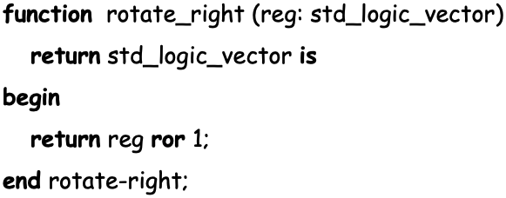

if A = 1001 1010 1, then B <= rotate_right(A) would cause B = 1100 1010
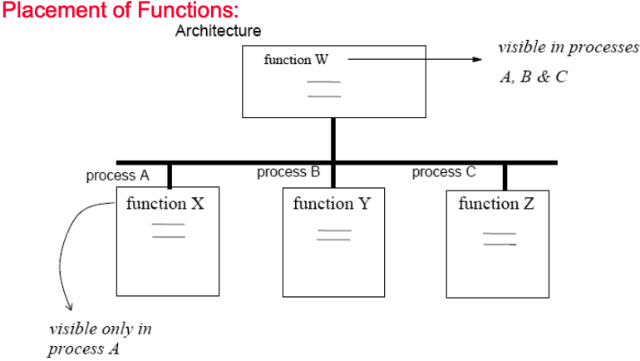

we should place the function code in the declarative region of architecture or process

Ex) use of a function:
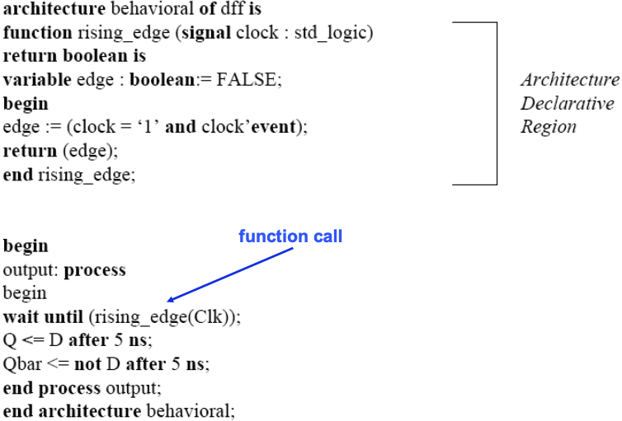
Ex) Computer squares of an array of unsigned numbers
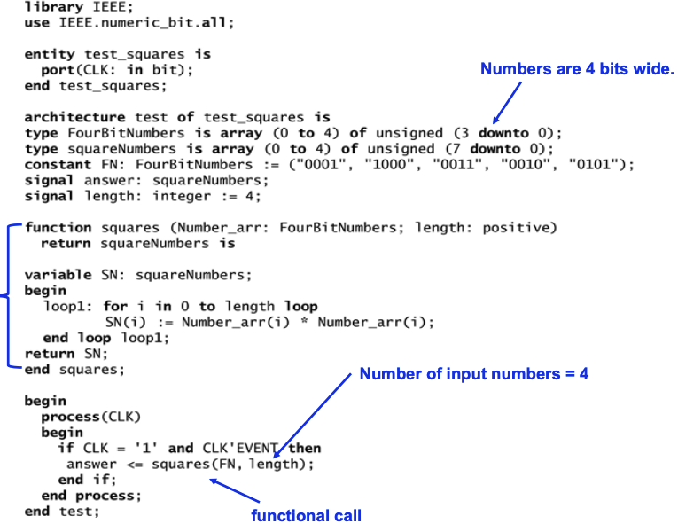

Procedures:
it can return any number of values using output parameters, and they can modify input parameters

the structure of a procedure is as follows:
procedure procedure-name (formal-parameter-list) is
[declarations]
begin
sequential statements
end procedure-name

to call the procedure:
procedure-name (actual-parameter-list)

Example Procedure) Addvec adds two N-bit vectors, a carry, returns the N-but sum and carry
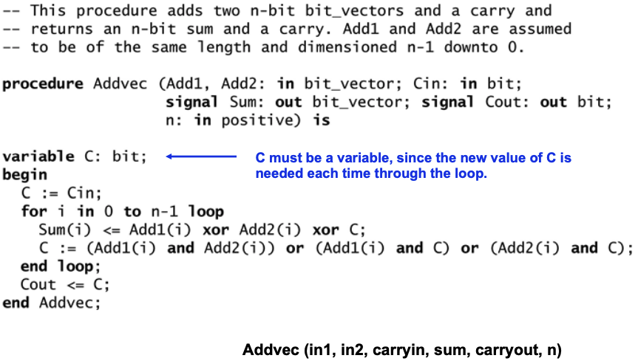

Placement of procedures:
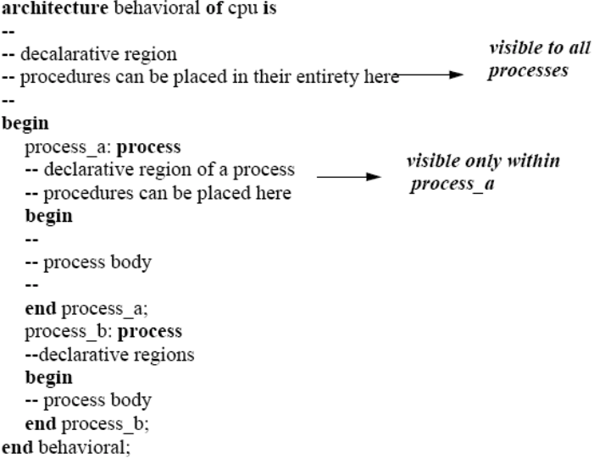

Concurrent Procedure calls EXAMPLE) Bit-serial adder
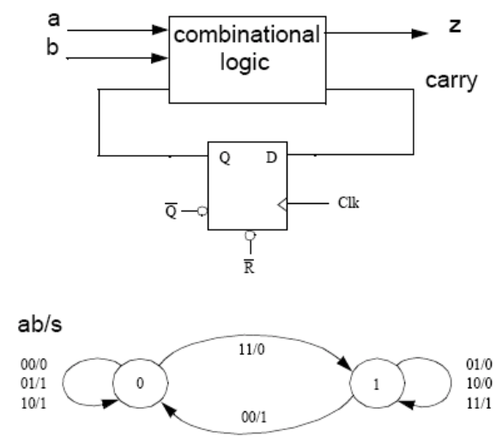
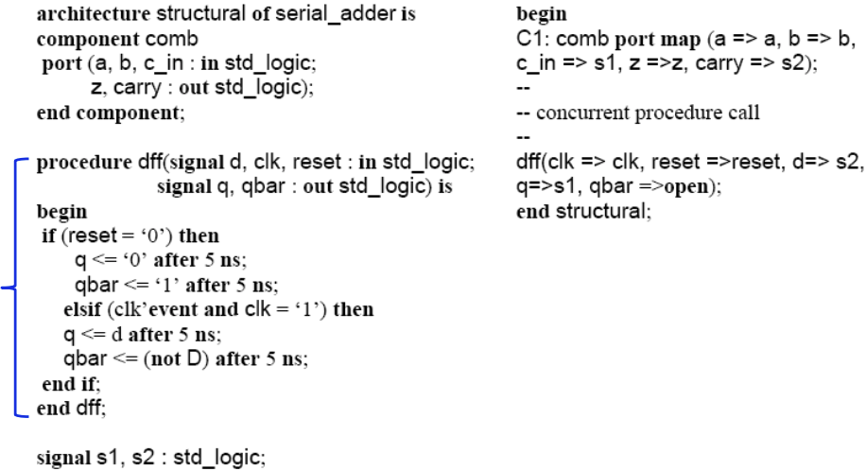

Files and TEXTIO:
- need to input files and text
- files are frequently used with testbenches to provide a source of test data and to provide storage for test results
- before a file is used, it must be declared using form:

Ex)
- there’s a standard TEXTIO package that can be used to R/W lines of text from or to a file
- the package contains procedures for reading lines of text from a file of type text and for writing lines of text to a file
readline, read, write, writeline

Ex) Testbench for a D FF:
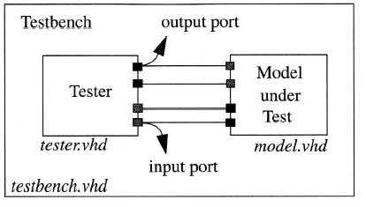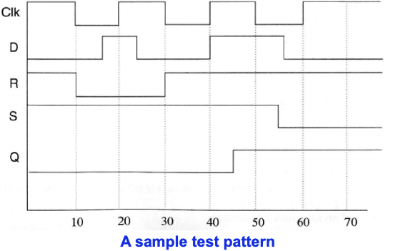
Behavior and Declaration of D FF:
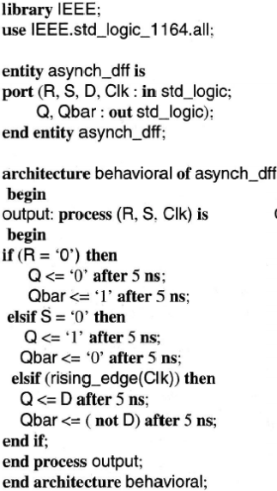

Testbench of D FF:


