Class 5
Stress and Fetal Development

The moment you are conceived, you start to experience stress what’s happening to mother
    - In the 9 month there is a lot of developing
    - Stress developing what part of the pregnancy.

Barker’s Hypothesis
‘Coronary heart disease, Type 2 diabetes, stroke and hypertension originate in developmental plasticity, in response to undernutrition during fetal life’

Stress during sensitive periods in fetal development may explain the origin of adult diseases.

    - Even if you develop a disease when you are 60 cause of the disease an be from the womb

Programming Hypothesis
- Non-genetic factors can organize or imprint permanently on physiological systems stress can directly affect the structure of biological system .
  - Maternal stress can directly affect the structure and function of biological systems.
  - Expansion of Barker’s theory
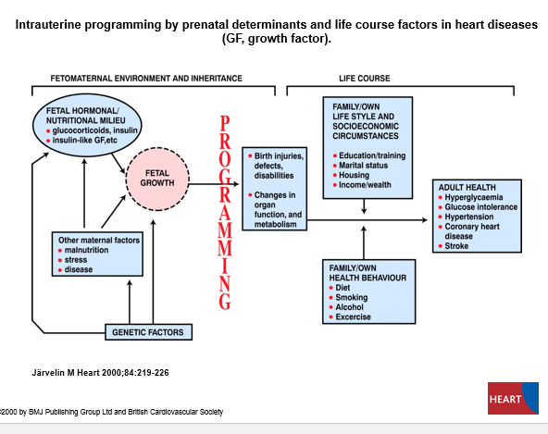
Intrauterine programming by prenatal determinants and life course factors in heart diseases (GF, growth factor).

    - Stress can modify our genetic makeup
    - Stress will also affect insulin ( hormonal)
    - Stress impact programming life course impact

Family/ own lifestyle -> <- family/ own health behavior
= meditate about health coming from stress affected fetus development.

HPA Axis

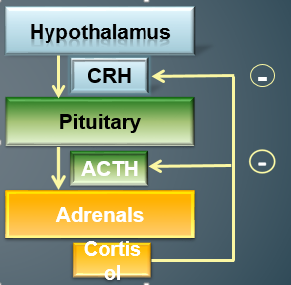
- Cortisol also diminishes the immune response.

-estrogen stimulates cortisol production
-increases during pregnancy
-↑ cortisol is bound
-ACTH secretion ↑
-Cortisol production ↑

-cortisol increases until free cortisol back to original level
-free cortisol inhibits the ACTH secretion
-cortisol inhibits immune system to prevent it from overreacting and attacking healthy cells and tissue
-why pregnant women have increased cortisol blood levels, but not the symptoms of glucocorticoid excess
-bioavailable levels of cortisol remain the same until 25 weeks gestation
-same for women taking estrogen containing oral contraceptives.

- cortisol is super important in pregnancy
- HPA working without stress its very important
- cortisol increases during pregnancy
- ** pregnant women increases cortisol
- it is important for developing fetus.

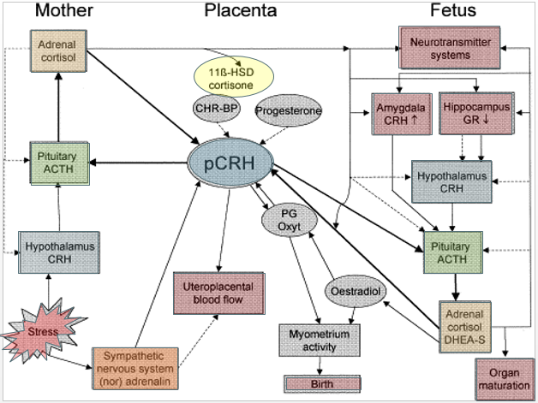

- Mother’s hpa axis is reset, positive feedback loop created by crh from placenta
- Cortisol and acth increase throughout pregnancy
- Up to 20 times regular levels.
          - Cortisol are higher during pregnancy but when there is stress it significantly increases.

Positive Aspects
- Glucocorticoid in Fetal Development
  - Influence growth in uterus, activity of pancreas, HPA axis & cardiovascular activity
  - Maturation of organ system
- End of pregnancy ↑ in level of glucocorticoid
    - Trigger of mechanism that leads to birth
- Postnatal survival & postnatal adaptation
- Accelerate lung maturation, decreases respiratory distress syndrome in premature infants
- Ready to give birth cortisol spikes
- Hpa axis very important for healthy pregnancy
- Very critical when baby comes out
- Baby is exposed to completely different environment
- Adapting to the environment
- Depends on what level of cortisol level they have from their mothers.

Moderate levels of stress may be beneficial for optimal development
  - Sensitizes developing nervous system
  - Develop adaptive response to stress
  - Rats: benefits later learning
- Little bit of stress little bit of cortisol optimal development
- Moderate stressed mothers create babies that can adapt to stressful situations.

Physiological impact of maternal stress
  - ↑ infant mortality and preterm births
  - ↓ birth weight and head circumference
  - Foetal movement & heart rate
  - HPA axis response
  - Brain structure
    - Higher more than moderate stress = increases level stress
    - Heart rate decreases
    - HPA axis Increases

  - Preterm Births and Low Birth Weights
    - Inuterine Growth Restrictions (IUGR) = birth weight <10th percentile for gestational age
    - Low Birth Weight (LBW) = <2500gm
    - Spontaneous Preterm Birth = preterm labour or rupture of membranes at less than 35 weeks
    - - same numbers
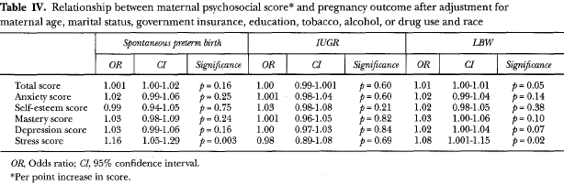
- Some more numbers ( anything higher than one represent a risk)

Physiological impact of maternal stress
- Fetal Heart Rate (FRH)
  - Vibroacoustic Stimuli (VAS)
  - Habituation/Dishabituation
  - Decreased FHR variation
- Changes in HPA axis response
  - Disregulation in the Hippocampus
- Long-Term Psychological effects
  - Deficits learning and memory
  - Temperament
  - ADHD
  - Schizophrenia
  - Regulation of Behaviour and emotion
- Schizophrenia highly senetic but high maternal, stress amplify
- Cannot regulate of behavior and emotion called cry baby potentially learn to by use.
Types of Stress
- Chronic Stress
  - Trait anxiety, state anxiety, and daily hassles
  - linked to delayed language development
  - lower intellectual functioning
- Daily hassels cannot find ky, late, uber doesn’t show up.
- Have a much longer impact because it is ongoing
- Mother’s stress while pregnant
State at the moment stress
Daily struggles -> linked to delayed language development and lower intellectual functioning

Trait generally stressed

- Pregnancy Specific Anxiety ( PSA )
  - Stressors related to pregnancy
  - Shorter gestation
  - Decreased mental and motor development
  - Disruptive temperament, attention regulation problems & higher levels of restlessness
- - significantly high stress = pregnant specific anxiety.
- Shorter gestation = premature
- Attention regulate = ADHD.

Timing and Threats to Fetal Development
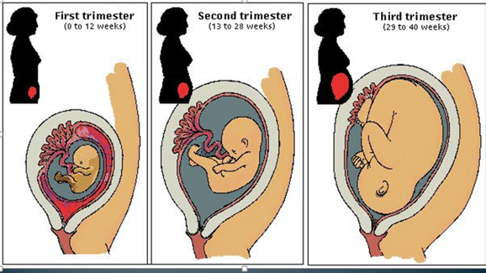

Threats to Normal Fetal Development
- Critical period or period of susceptibility
  - Susceptible to damage
  - Environmental factors that interfere with growth during critical period can alter development of organs and systems
  - Differs depending on system or organ

- Pass that critical period is a win
- Depend when you stress In the critical period -> have a problem (damage)

Threats
- Determines the developmental process affected
  - Teratogen in early pregnancy may result in major structural malformation
  - Same teratogen later may result in neurobehavioural deficits

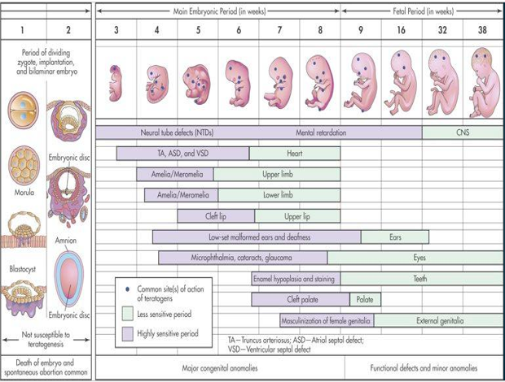

Stress Threats
- Research is mixed on impact on timing of stress
  - Mid-gestation exposure = worse outcomes
  - 3rd timester exposure ↑ negative outcomes
  - Non-human: early gestation exposure more detrimental than mid-gestation
  - Cumulative stress throughout pregnancy vs. 1 particular period?

- In 12 early weeks -> if there are problems – because of viable signs are impacted

***WHICH IS THE TRISEMSTER THE STRESS HAS THE BIGGEST IMPACT?
IN ALL THE TRIMESTSERS, JUST DIFFERENT THINGS

Timing of Threat
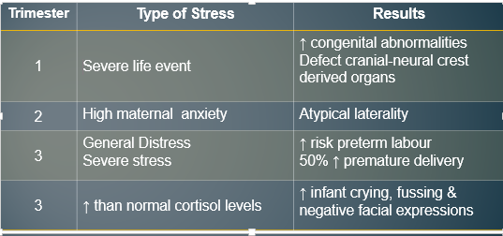

Congenital abnormalities -> ex: no formed face – deformation

Types of Stress
- Traumatic events
  - Ice Storm
    - Maternal stress & cognitive development
    - 141 women in various trimesters

1st trimester = storm by strorm – low iq
2nd trimester = stress – low iq
3rd trimester = doesn’t matter

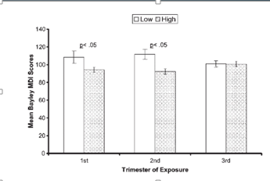
Reducing Stress During Pregnancy

- Stress is subjective perception
  - Personality, attitude & resources
- Gurung et al. 2005
  - Factors enhancing or reducing parental anxiety
    - Mastery
    - Attitude towards pregnancy
    - Social support

- Healthy balanced diet
- Regular exercise
- Relaxation
- Communication with partner
- Prenatal classes

Seek social support because – do not let your husband control all the process our body take control (to the overprotective husbands)

