April 11th 2018
Mutual funds
COMM 215 Section x
Presented to: Shahla Hodai Hemami
Presented by:
Student Order Number | Student Name | Student ID
x | xxxx | xxx
x | xxxxx | xxxx
x | xxxx | xxxxx
x | xxx | xxxx
x | xxxx | xxx
x | xxxxx | xxxxx

Table of contents

Analysis
- Introduction………………………………………………………………………………3
- Description………………………………………………………………………………..3
- Conclusion………………………………………………………………………………..3
Appendices
- Appendix I - Descriptive statistics………………………………………………………4
- Appendix II – Investment Objectives…………………………………………………...6
- Appendix III – Patterns and Outliers…………………………………………………..6
- Appendix IV – Fund Objectives and Sales Charge……………………………………8
- Appendix V – Average Risk Level………………………………………………………9
- Appendix VI – Expense Ratio………………………………………………………….10
- Appendix VII – 3Yr Return Estimation 1…………………………………………….11
- Appendix VIII - 3Yr Return Estimation 2……………………………………………12

Analysis
This report uses statistical methods to study the data set of Mutual funds in order to make appropriate recommendations as to which mutual fund is appropriate for specific fund objectives, related sales charge and risks.
The sample used consists of 137 funds, from which, 65 funds didn’t have a sales charge, and 72 did. The distribution for expense ratio was left-skewed. A hypothesis test confirmed that the mean expense ratio was more than 1.25 at a significance level of 1%. The related rate of risk was measured as low, average and high. The results were 14, 76 and 47 respectively. A hypothesis test showed lack of evidence supporting the claim that the average risk level is not 0.5 at a 5% significance level with a 95% confidence interval of [0.4715, 0.6379]. Through the use of a contingency table, it was found that there is insufficient evidence to conclude that Fund Objectives and Sales Charges are not independent. A regression analysis was used to predict 3-Yr Return funds on the basis of 1999 Return and Return Q1-2000. It was found that there’s a positive linear relationship between the three variables. The slope of the line shows that for every increase in 3-year return funds, there’s a 0.199 increase in 1999 return and 1.402 increase in return Q1-2000. At a 5% significance level, an F-test showed that the model was statistically significant. Furthermore, a multiple regression analysis was conducted to predict 3-year return funds using 1999 return, Q1-2000 return and sales charge. The model was statistically significant and individually only the 1999 return fund was a significant variable. Moreover, the 1999 return as well as Q1-2000 both have a high correlation with 3Yr return which shows the possibility of multicollinearity.
Based on these results, it can be concluded that the mutual funds have an average level of risk. Investors can expect an average expense ratio of 1.25 and they should be aware that fund objectives and sales charges are not independent. Finally, it should be noted that the more accurate way to predict 3-year funds is by using 1999 return fund.
Appendix I - Descriptive statistics

Fund Objective

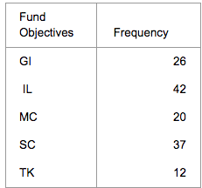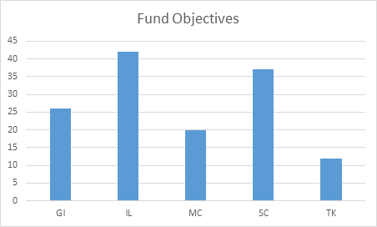

Sales Charge

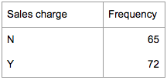
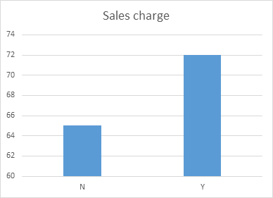

Expense Ratio

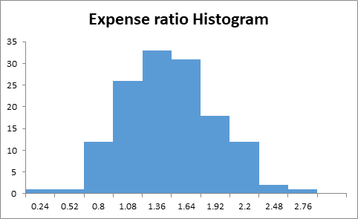

Mutual Fund Risk

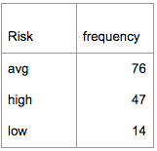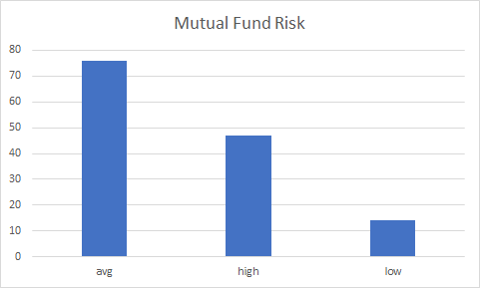

Return 1999

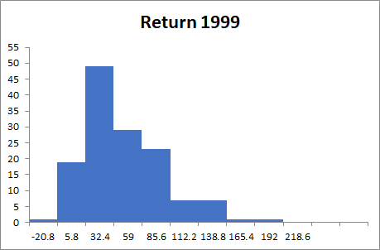

Return Q1-2000

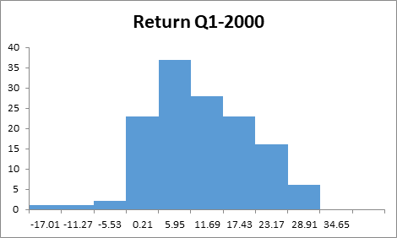

Three-Year Return

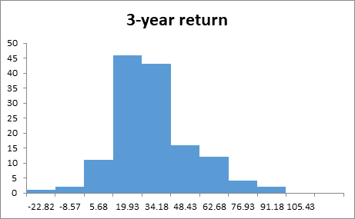

Appendix II – Investment Objectives

We can conclude that the 70% most popular investment objectives are IL and SC.

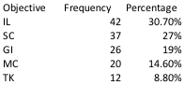

Appendix III – Patterns and Outliers

Sales Charge

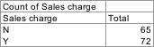

Expense Ratio

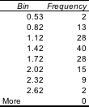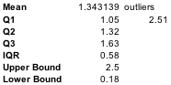

Mutual Fund Risk

Return 1999

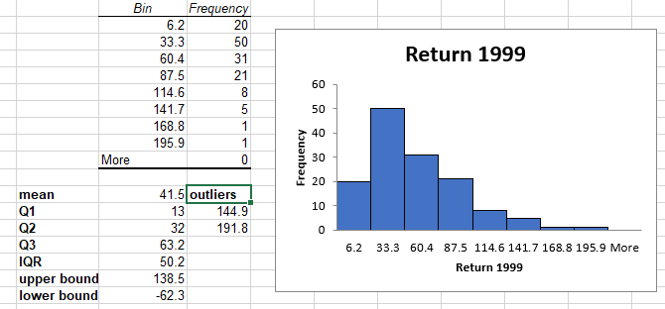

Three-Year Return

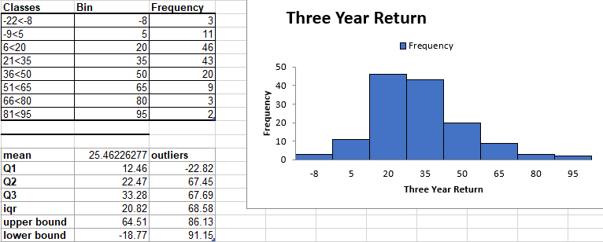

Appendix IV – Fund Objectives and Sales Charge

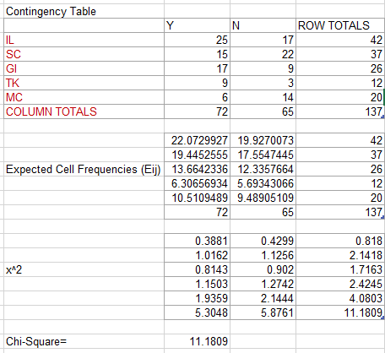

$$\left\{\begin{aligned}Ho:Fund objectives and Sales Charges are independent variables \\ Ha:Fund Objectives and Sales Charges are dependent variables\end{aligned}\right.$$

df= (5-1) (2-1) = 4

α= 0.05

CV =9.48773

Since 9.48773 < X²=11.1809, we reject Ho.

Based on these data, we can conclude that there is a relationship between the two variables Fund Objectives and Sales Charges.

Appendix V – Average Risk Level

In order to conclude whether the proportion of the average risk level equals 0.50 or not, we used the following statistical test:

α =0.05 α/2=0.025
AVG=76
n=137

$$\left\{\begin{aligned}Ho:p=0.50 \\ Ha:p≠0.50\end{aligned}\right.$$

_
P =76/137 = 0.554744525

$$z=\frac{0.5547-0.50}{\sqrt{0.50\left(0.50\right)}/137}$$

z= 1.28

zα/2=1.96 zα/2=-1.96

Since z= 1.28 < 1.96 we do not reject Ho.

We have insufficient evidence to reject Ho; therefore, the average risk level is 0.50

_
P =76/137 = 0.554744525
α =(1-0.95)=0.05 α/2=0.025
n=137

0.5547 ± 1.96 √ 0.5547(1-0.5547)/137
0.5547 ± 0.0832
[0.4715, 0.6379]

We can conclude that there is a 95% probability that the proportion for the Mutual Funds is going to fall within 0.4715 and 0.6379.

Appendix VI – Expense Ratio

In order to conclude whether the mean is more than 1.25 or not, we procced by applying the following statistical test:
_
x = 1.343138686

α =0.01

s=0.4303

$$\left\{\begin{aligned}Ho: μ=1.25 \\ Ha: μ>1.25\end{aligned}\right.$$

$$t=\frac{1.3431-1.25}{\sqrt{0.4303}/√137}$$
t= 2.5334

tα=2.326

Since t=2.5334 > 2.326, we reject Ho

We can conclude that the mean expense ratio of mutual funds is more than 1.25

Appendix VII – 3Yr Return Estimation 1

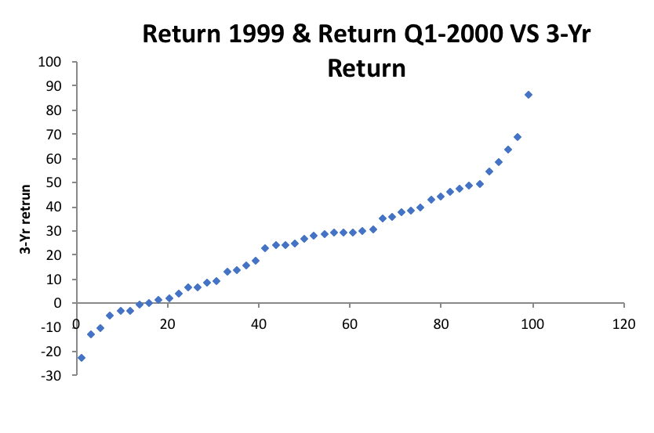
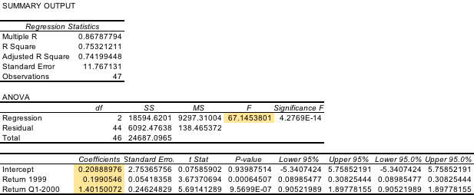

Y = 0.209+0.199X₁+1.402X₂

As shown in the graph, there’s an upward linear relationship between 3-year return funds and the two independent variables. The slope of the line is positive shows and it represents that for every increase in 3Yr return, there’s a 0.199 increase in 1999 return and a 1.402 increase in return Q1-2000.

In order to test the significance of the model we used the following test:

$$\left\{\begin{aligned}Ho: β1=β2=0 \\ Ha: β1≠0 or β2≠0\end{aligned}\right.$$

The F-statistics = 67.145

CV= F (5%, 2, 44) = 3.23

Since 67.145 > 3.23, we reject Ho

In conclusion, at 5% significance level, we have enough evidence to conclude that the model is statistically significant.

Since R is 0.8678, which is significantly close to 1, we can conclude that there is a strong relationship between the independent variables and the dependent variable.

Based on the model equation:
Y = 0.209+0.199X₁+1.402X₂

We can estimate the 3Yr return funds= 0.209 + 0.199*102 + 1.402*9.5 = 33.826

Appendix VIII - 3Yr Return Estimation 2

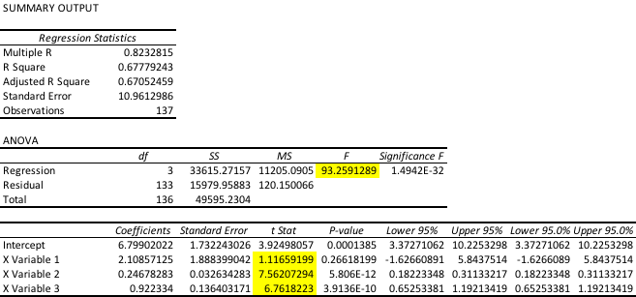

$$\left\{\begin{aligned}Ho: β1=β2=β3=0 \\ Ha:at least one B≠0\end{aligned}\right.$$

In this case, we can use F-test to test if the model is significant or not.
As the data shows above,

the F-statistics = 93.259

CV= F (0.05;3, 133) = 2.60

Since 93.259 > 2.60, we reject Ho.

In conclusion, at 5% significance level, we have enough evidence to conclude that the model is statistically significant.

In order to conclude what variables are significant, we used the t test:

$$\left\{\begin{aligned}Ho: βj=0 \\ Ha: βj≠0\end{aligned}\right.$$

where j = 1,2, and 3

Since it is two-tail test with significance level 5%
CV(s) = ± 1.645

For Sales charge, t-stats = 1.117 < 1.645, we fail to reject Ho.
For Return 1999, t-stats = 7.562 > 1.645, we reject Ho.
For Return Q1-2000, t-stats = 6.762 > 1.645, we reject Ho.

In conclusion, we have enough evidence to state that at 5% significance level, the variable Return 1999 is statistically significant in estimating 3-Yr return of funds; However, the variables Sales charge, and Return Q1-2000 are not statistically significant in estimating 3-Yr return of funds individually.

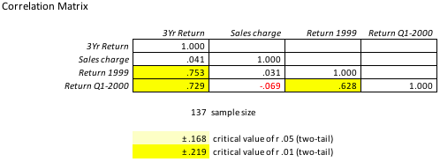

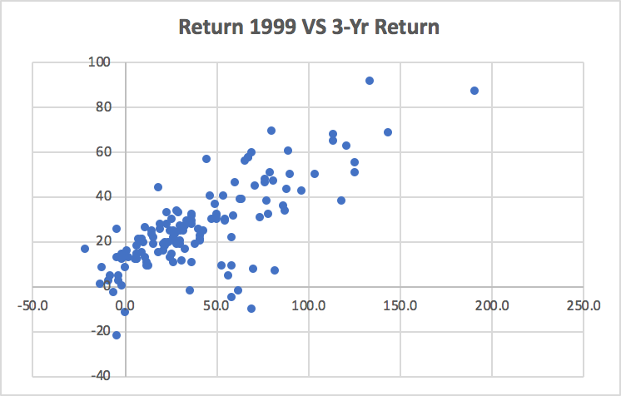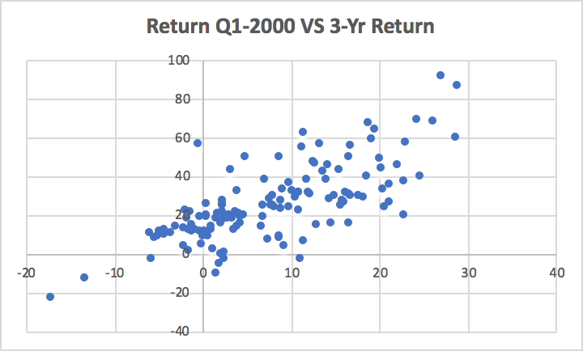
The correlation coefficients table shows that for each independent variable except sales charge; both Return 1999 and Return Q1-2000 are highly correlated with 3-Yr Return. Moreover, the scatter plot graphs also show that there is high correlation between Return 1999 and 3-Yr Return, Return Q1-2000 Return and 3-yr return. It also illustrates that there is a possible multicollinearity problem is possible in the model.

