MANA341 Class 3
Basic concepts of organizational structure
1.Why is organizational structure important?
It’s a core question that managers face:
- How to organize all the people at work, each day?
- Jobs: what responsibilities does each person have?
- Departments: how are the jobs grouped?
- Coordination: how do people work together?
- Hierarchy: who has what authority - who reports to whom - who’s in charge?
Structural choices are enormously consequential
- Structure determines which customers, products, and regions an organization can address & how well they do so
- An individual’s location in the structure can fundamentally shape their goals, perceptions, attributions, interests, identities
Organizational Structure is one of the “big levers”

2. Organizational structure: Fundamental concepts
Organization Structure defines how job tasks are formally divided, grouped, and coordinated
Two basic components in organizational structure design:
    - Specialization: how work is divided up
    - Coordination: keeping everyone ‘in sync’
Purposes of organizational structure:
    - Designates formal relationships
    - Division of labor: create groups, specify who does what
    - Integration: coordinate across individuals and groups
    - Define boundaries: what we “make” vs. what we “buy”
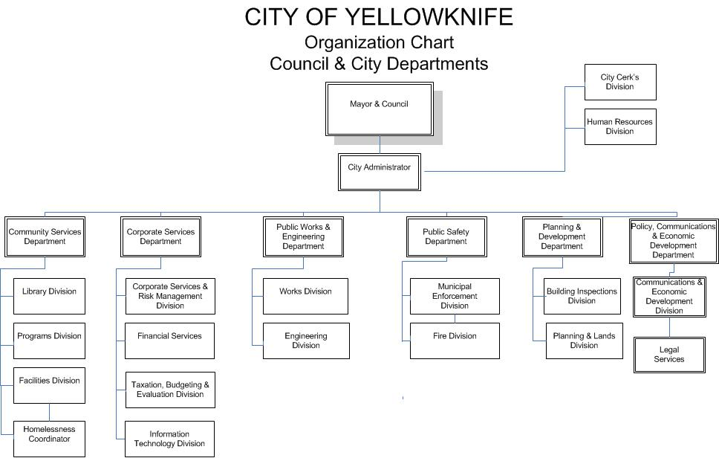

4.Organization Chart (cont’d)
  - Why is a formal organization chart useful?
  - Because it shows:
    - the various sub-units of an organization and what positions exist;
    - the hierarchy of authority and who reports to whom;
    - how different jobs are grouped and how they are related;
    - how each position and department fits into the whole;
    - some indirect clues about the organization’s size.

5. Organization Chart (cont’d)
What are the implications of “where you are on the organization chart”?
    - Location on the chart, particularly departmental affiliation, can shape goals, perceptions, interests, politics
      - Goals: can be shaped by departmental affiliation
      - Perceptions: Problems, opportunities, failures, and successes are interpreted from the department’s perspective
      - Coordination: Communication is easier within the department; goals are coordinated within the department
      - Interests & Politics: Individuals gain as their department does. Credit for success, blame for failure is (generally) fought out between departments
“Where you stand depends on where you sit.”

6. Basic Problems of Organizational Design
Main problem of design is to ensure information flows throughout organization:
    - Vertical information flow is mostly about organizational control
        - Necessary for efficiency and consistency
e.g.: hierarchical referral (the chain of command), rules and plans
    - Horizontal information flow is mostly about coordination
        - Necessary for adaptation, learning, & innovation
e.g.: task-forces or cross-functional teams
There is an inherent tension between vertical and horizontal mechanisms in an organization
    - Solving one problem tends to make the other one worse

7. Organizational Design: Efficiency vs Learning
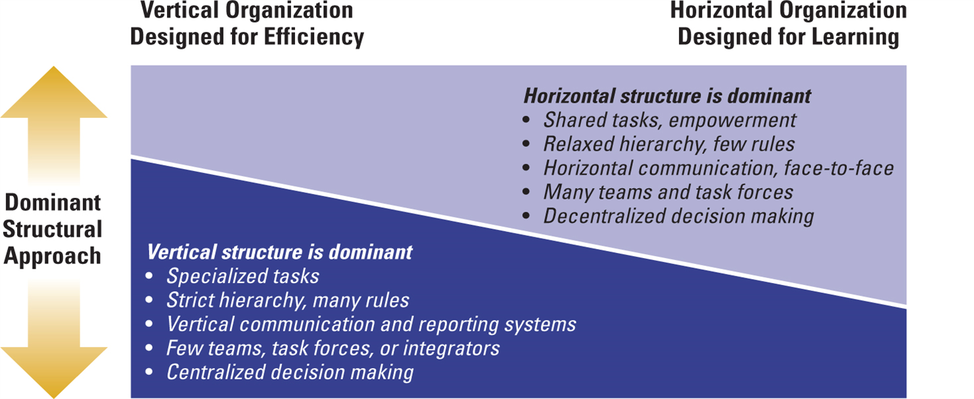

8. Vertical Linkage Mechanisms
  - Hierarchical Referral: chain of command
  - Formalization: rules or procedures so that employees know how to respond without having to talk to a manager
  - Vertical Information Systems
      - Periodic reports
      - Written information
      - Computer-based communications distributed to managers
9. Horizontal Integrating Mechanisms
  - Computerized Information Systems
  - Direct Contact: between managers or employees
      - Liaison Role – communicating with another department
  - Task Forces: temporary and involves a linkage to more than one department; corporate concern usually
  - Full-Time Integrator: coordinates several departments, that are typically located outside the department
  - Project Teams: similar to task force, but they are usually focused on a particular product/service that needs to be addressed
  - Virtual Cross Functional Teams: made up of organizationally/ geographically dispersed members who are linked by tech.

10. Horizontal Linkage Mechanisms
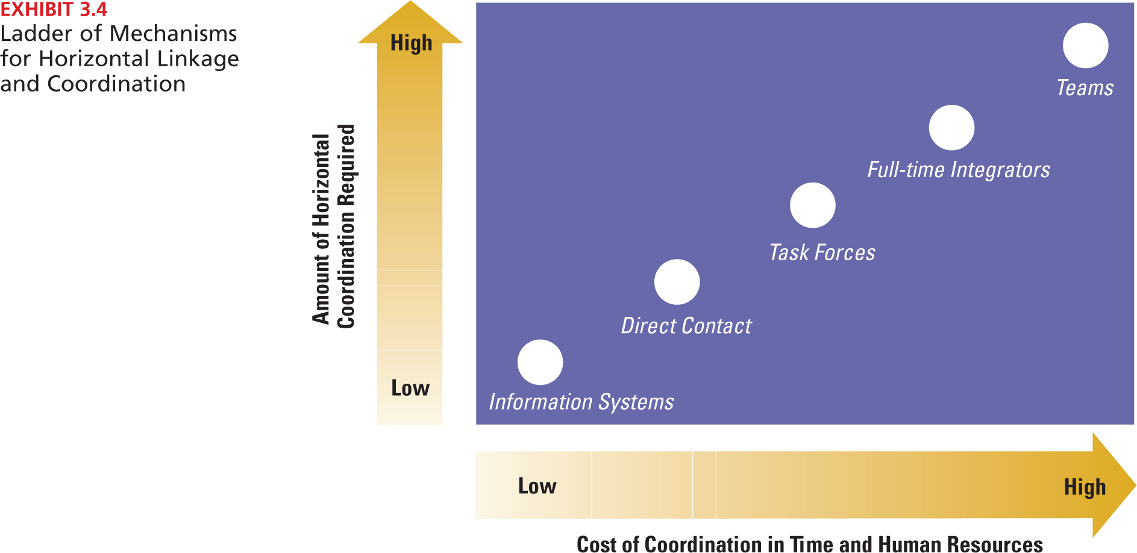

11. Information Processing to Full-Time Integrator
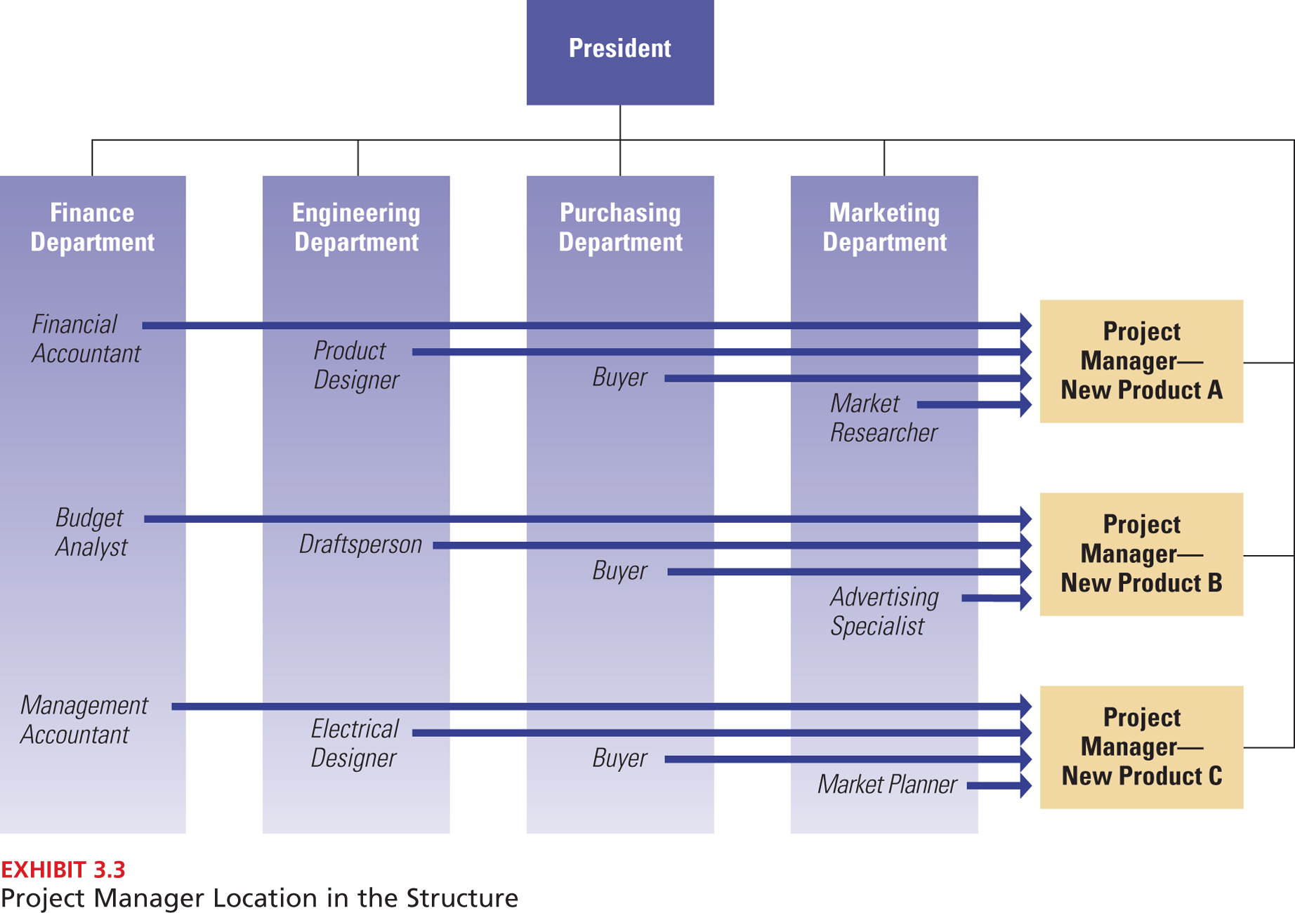

12. Simplified way of thinking about structure
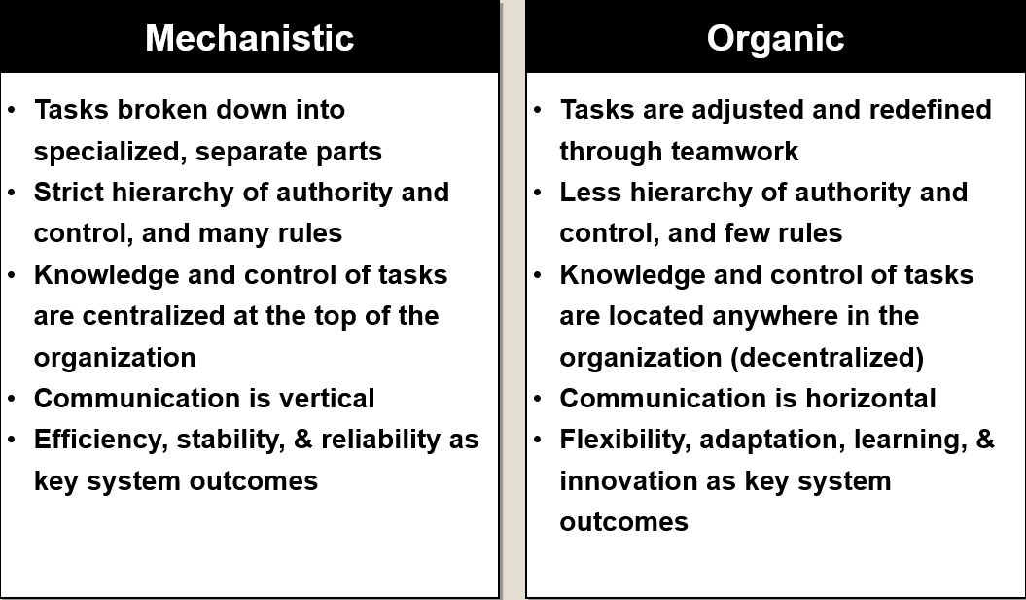

Recap Dimensions of Organizational Designs

- Contingency Theory

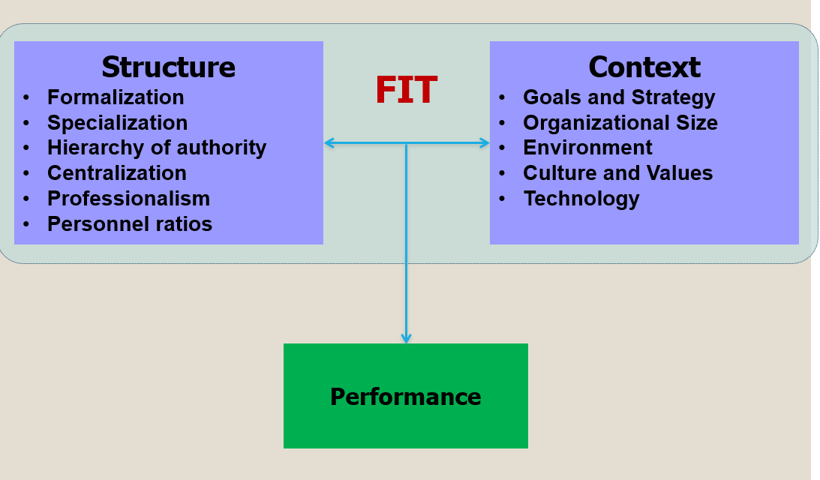

2. Elements of Structure
  - Formalization: The degree to which jobs are guided by standardized rules and procedures.
    - Higher formalization means:
      - more explicit job descriptions
      - more clearly defined procedures
      - less discretion for workers
      - lower flexibility
    - High formalization is appropriate when:
      - jobs are simple and routine
      - consistency is important (safety, legal, equity)
  - Specialization: (sub)division of labor or of tasks
    - Degree to which org tasks are subdivided into separate jobs
    - Extensive specialization: employees perform a narrow range of tasks
  - Hierarchy of authority: An organization’s chain of command that defines the relative authority each manager has.
    - Span of control for each manager
    - Narrow (Tall) or Wide (Shorter)
  - Centralization: who makes decisions; the degree to which decisions are made at higher organizational levels
  - Professionalism: the level of formal education and training of employees
  - Personnel ratios: e.g.: administrative ratio, professional staff ratio, ratio of part-time to full-time employees, etc.

3. Being lean: What does this mean?
What does it mean to be ‘lean’ from a macro perspective? (Also known as ‘Just In Time’ (JIT))
    - creating value for customers with fewer resources
    - ‘perfection’/zero waste
    - involvement of labor (personal responsibility, engagement, ‘ownership’)
    - continuous improvement
Name some companies that are ‘lean’:
    - Toyota
    - NASA
Hospitals

4. Span of control: Tall vs. Flat Structure
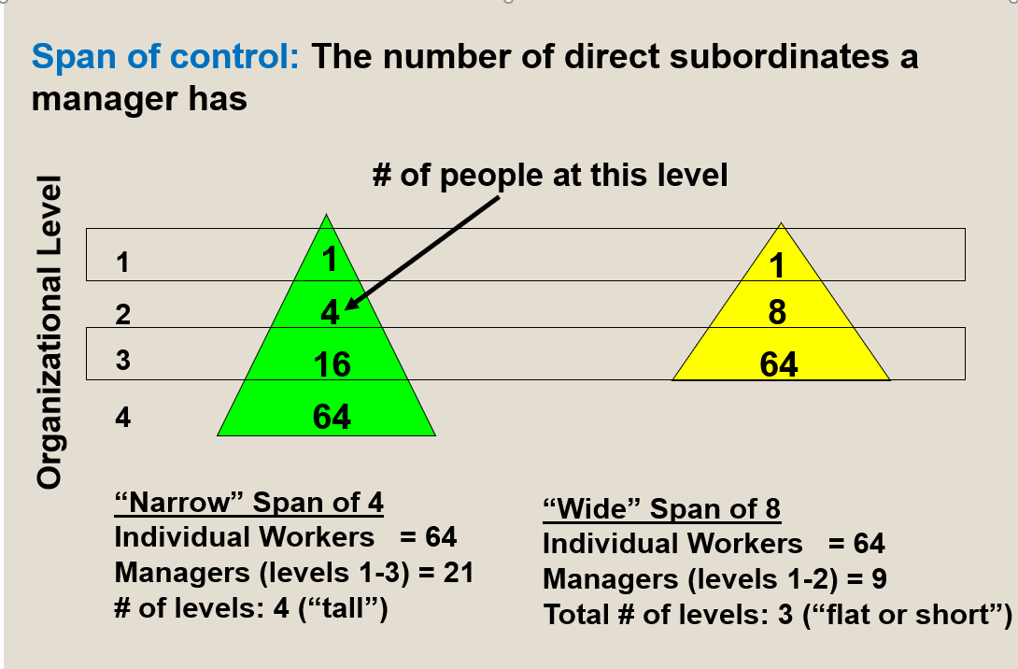

5. It’s not easy being lean….
  - Tall Structure
  - Communication quality and speed
  - Slow decision making
  - Decrease in motivation of employees
  - Increased bureaucratic costs
  - Parkinson’s Law – managers seek to increase the number of subordinates below them
  - Coordination problems
  - Narrow span of control
  - Flat Structure
  - Wide span of control
    - Within dept.: Less control and coordination by manager (more empowerment)
    - Across organization: Quicker communication, decision-making, and implementation
  - Few managers Lower overhead costs

The trend is heading to flatter organizations

What are structural design options? What are pros and cons of each option?
- Basic Design Choices
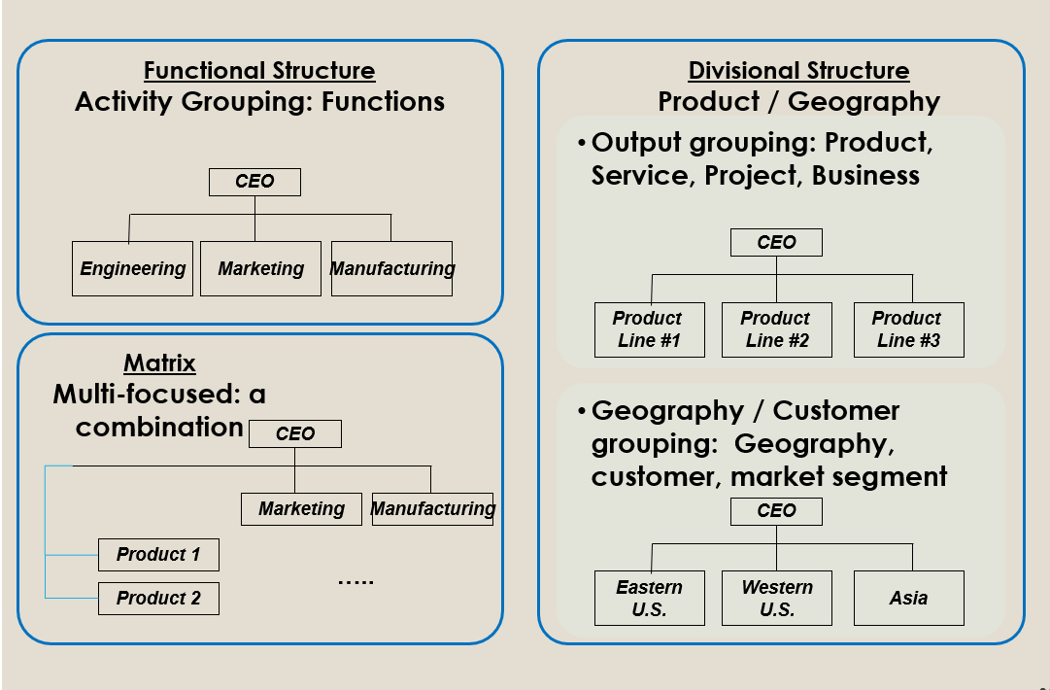

- Functional Structure
Functional Structure: activities are grouped together by common function
    - Functions: marketing, sales, finance, manufacturing, etc.
    - Probably (still) the “standard” concept of an organization
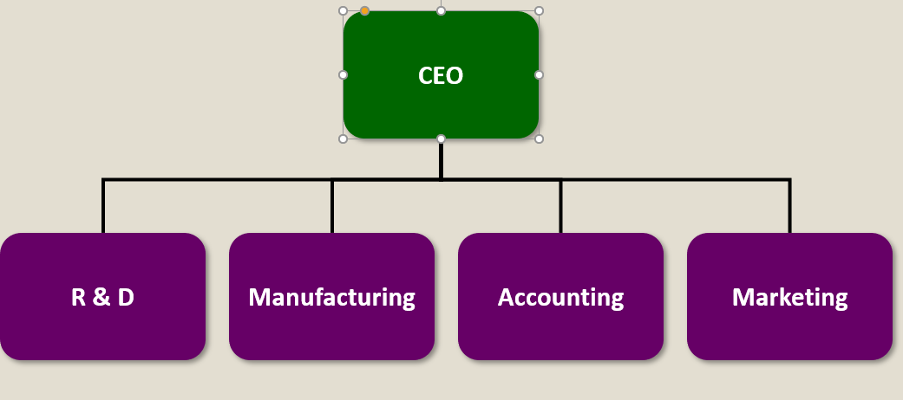

- Example of a Functional Structure
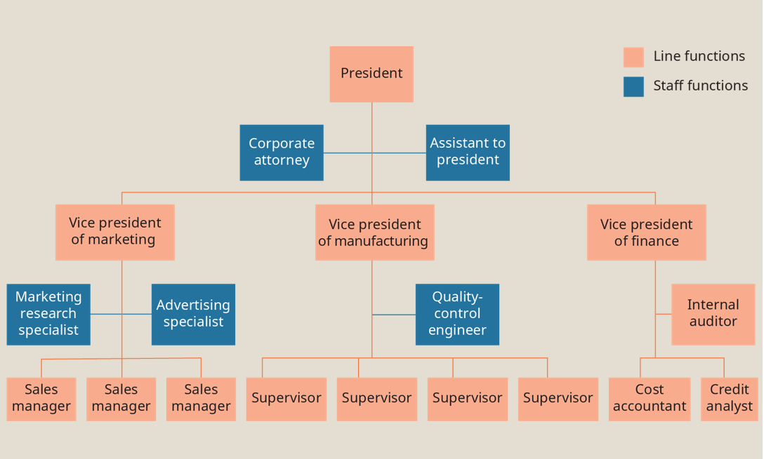

- Advantages and Disadvantages of Functional Structure
- Advantages
- Allows efficiency and economies of scale within functional departments
- Enables in-depth knowledge, technical expertise, and skill development
- Little duplication of resources
- Enables organization to achieve functional goals
- Is best with only one or a few products
- Disadvantages
- Internally focused (e.g., Marketing vs. Engineering)
- People don’t see “big picture” of organization goals
- Poor horizontal communication & coordination among departments
- A slow response to environmental changes
- Results in less innovations
- May cause decisions to pile up, hierarchy overload
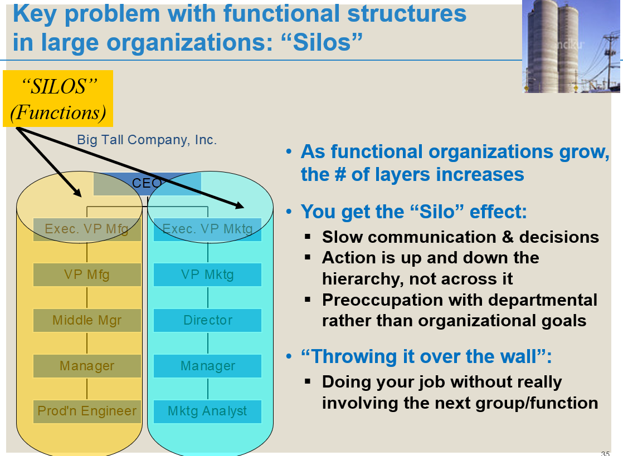

- Appropriate contexts for functional structures
  - Goals: efficiency, consistency, and/or technical quality
  - Size: small/medium. Not too many products or markets
  - Environment: simple and stable
  - Technology: routine, low interdependence between functions

- When to rethink using a functional structure
When functional structures lose effectiveness:
    - What if your organization has many different types of products?
    - What if your organization operates in many (different) countries?
    - What if your organization has customers of many different types?
In these situations, functional structures perform poorly
    - Because loyalties (and focus and expertise) are ultimately based on function rather than one specific product, country, or customer
    - With growing complexity, top managers become overwhelmed by decisions and information flows. As a result performance declines

