Chapter 1
Financial Statements and Business Decisions

Within a business:
- The key players
  - The investors, founders and creditors (local banks or other money lenders) can also function as managers of the business
- The business operations:
- Purchase materials and labor
- Manufacture product
- Sell products to customers
- Collect cash from customers and pay creditors
- Creditors can sometimes be the government, the bank, the suppliers, etc
- Investors who buy smalls percentages of large corporations are called shareholders
  - They gain from their investment by receiving a portion of what the company earns in cash payments (called dividends) and by eventually selling their shares at a higher price to make a profit

The accounting system collects and processes financial information
- Reports information to decision makers
- Managers (internal decision making) need information about the company’s business activities to control and improve the operation, investing and financing activities of the firm
- Shareholders, investors and creditors (external decision making) need information about these same business activities to assess whether the company will be able to pay back its debts with interest and pay dividends.

Accounting system:
Financial accounting reports (periodic financial statements and related disclosures)
- external decision makers (investors, creditors, suppliers, customers, etc)
Managerial accounting reports (detailed plans and continuous performance reports)
- Internal decision makers (managers throughout the organization)
- Financing activities: borrowing or paying back money to lenders and receiving additional funds from shareholders, or paying them dividends
- Interesting activities: buying or selling items and then distribute goods and services to customers
  - such as retail stores, buildings and equipment used to store
- Operating activities: the day-to-day process of obtaining products and services from suppliers, storing and then delivering them to customers, collecting cash from customers, and paying suppliers

Four Basic Financial Statements:
- *Statement of financial position = what the company owes and what the company has (the SFP)
  - Assets, liabilities, owners/shareholders’ equity
  - Balance sheet
- Statement of earnings (performances) = revenue can come from sales or interest from a bank deposit
  - Revenue - Expenses = net income
  - comprehensive income —> Statement of earnings or a statement of income
  - It can be in the form of a profit or a deficit
- Statement of change in cash flows = activities from operations that alter the cash
  - cash can flow in and out from customers, payment towards the suppliers or manufacturers, shareholders, etc
  - evaluate company’s ability to generate resources
- Change in SHE (shareholders equity) = the way the profit, distribution of profit (dividends), and other changes to shareholders’ equity affected the financial position of the company during the accounting period
  - Statement of changes in equity
- Asset (economic resources) = Liability (creditors) + SHE (investors and shareholders)
- SHE = A - L
called the residual claim (what goes to owners)

*Structure of a financial position:
ex with Canadian Tire
1. name of the accounting entity – Canadian Tire Corporation
2. title of the statement – Statement of Financial Position
3. specific date of the statement – At January 2, 2016
4. unit of measure – (in millions of Canadian dollars)

Prepare the financial statements for 1 year

Management uses of Financial Statements:
- Marketing managers and credit managers use customers’ financial statements to decide whether to extend credit
- Purchasing managers use suppliers’ financial statements to decide whether suppliers have the resources to meet the demand for products
- Employees’ union and HR managers use the company’s financial statements as a basis for contract negotiations overpay rates

The Statement of Financial Position:
reports the financial position (economic resources and sources of financing of an accounting entity at a point in time
- Assets economic resources controlled by the entity as a result of past business events from which future economic benefits may be obtained
  - Cash
  - Short-term investment
  - Accounts receivable
  - Notes receivable
  - Inventory
  - Supplies
  - Prepaid expenses
  - Long-term investments
  - Land
  - Equipment
  - Buildings
  - intangibles
- Liabilities debts or legal obligations of the entity that result from past business events
  - Accrued liability could be like a gift card
    - The store only gets the benefits of the cash once the card is used
    - When u reimburse a bank note, the liability will decrease (?) when using the accounting equation
  - Accounts payable
  - Notes payable
  - Taxes payable
  - Deferred revenue
  - Bank loan payable
  - Bonds payable
- Shareholders’ Equity amount of financing provided by owners of corporation and from earnings over time
  - Contributed capital
  - Retained earnings

The Accounting Equation:
ASSETS = LIABILITIES + OWNERS’ EQUITY
- Assets = sum of everything the company owns
- Labilities = sum of debt claims on the company and what it owes
- Owners’ equity = total value of the owners financial claim on the company
  - Owner/shareholder

Some companies prefer going to the banks in order to increase capital

The Statement of Financial Position:
Prepaid expenses = typically something paid in advance, such as rent, insurance, electricity/other utilities, etc
- Recognized as an expense later on within the statement that hasn’t yet been consumed

Statement of Comprehensive Income:
a.k.a. statement of earnings
- Revenues:
earnings from a good or service
  - Sales revenue
  - Fee revenue
extra payments after the initial payment has already been done
    - Such as destruction fees after an incident
  - Interest revenue
Interest expense is usually paid to the bank on a fixed date
  - Rent revenue
- Expenses:
the dollar amount of resources used up by the entity to earn revenues during a period
  - Cost of sales
  - Wages expense
  - Rent expense
  - Interest expense
  - Depreciation expense
  - Advertising expense
  - Insurance expense
  - Repair expense
  - Income tax expense
- Matching principles need the revenues and expenses to be equal (?)
- Revenue is recognized in the period in which goods and services are sold, not necessarily the period in which cash is received
  - Such as if a sale of a good was made in May, the cash from THAT sale will only be collected in June
- Expenses are recognized in the period in which goods and services are used, not necessarily the period in which cash was paid
  - Such as the newspaper ad being paid for in May, but only being viewed by public in June
  - The expense is only recognized once it is viewed
Revenues (cash/promises received from delivery of goods and services) – Expenses (resources used to earn the period’s revenues) = Net earnings (revenues earned minus expenses incurred)

When creating an income statement, you use the expense typical accounting terms within one’s expenses
- Such as cost of sales, wages expenses, rent expenses, etc
- If the profit is negative it would mean the company is in deficit

Prepaid expense is considered an asset

Financial Statement Items:
- Account payable = amount paid to suppliers, liability
  - can take 60 days
- Rent payable = rent paid later on
- Unearned revenue = statement of financial position, liability
- Property, plant, and equipment = resources controlled and owned by the company, an asset
- Short term investment in the shares of another company = something that the company owes, considered a current asset
- Sales to customers = considered SCI/R
- Interest on a loan owed to a financial institution=
- Common shares = also known as capital, funds owners bring to a company, considered part of SHE
- cash= something that you own, considered an asset
- Loan payable (debt due in 10 years) = amount of money you owe to someone, liability

Statement of Earnings:
- Reports the net earnings achieved during the accounting period

Statement of Changes in Equity:
- Reports all changes to shareholders’ equity during the accounting period
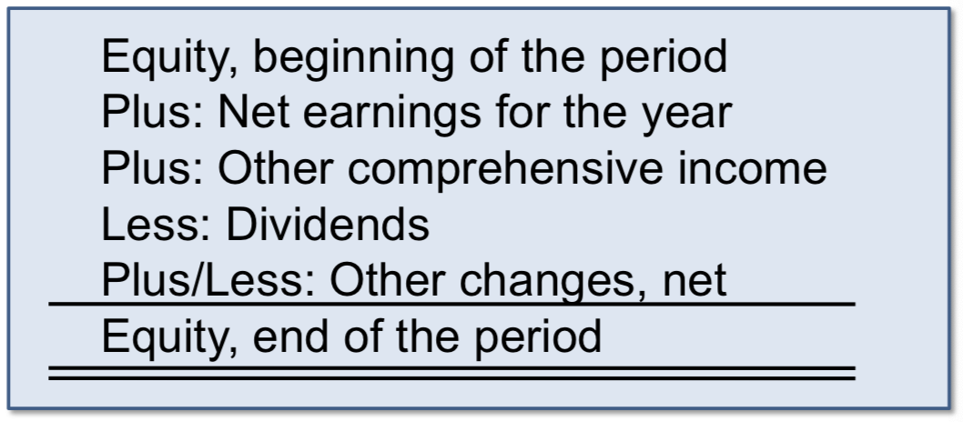
- Retained earnings performance of the company – distributed dividend of the company
  - These should increase each year

Statement of Cash Flows:
- Can include the cash inflows (receipts) and outflows (payments) into primary categories
  - Cash flows from operating activities
  - Investing (activities related to non-current assets, such as equipment)
  - Financing activities (includes the long-term creditors, such as long-term loans, paying dividends, etc)
- Net earnings are usually not equal to the change in cash for the period
  - Because revenues reported do not always equal cash collected and expenses reported do not always equal cash paid
  - There can be a gap between cash collections and revenues earned

Relationships Among the Statements:
- Net earnings from the income statement results in an increase in ending retained earnings on the statement of changes in equity
- Ending retained earnings from the statement of changes in equity ids one of the three components of shareholders’ equity on the statement of financial position
- The change in cash on the statement of cashflows is added to the beginning-pf-year balance in cash to arrive at end-of-year cash on the statement of financial position

Abbreviated Terms:
SFP = statement of financial position or balance sheet
NCA = non- current asset
CL = current liability
SCI = statement of comprehensive income
SHE = shareholders’ equity
R= revenue
NCL = non-current liability

3 types of notes that should accompany financial statements:
- Additional information that can add value to the financial statements of a company
- Describe accounting rules applied
- Present additional detail about an item on the financial statements
- Provide additional information about an item not on the financial statements

Accounting principles:
- Companies incur the cost of preparing the financial statements and bear the following economic consequences…
  - Effects on the selling price of shares
  - Effects on the number of bonuses received by managers and other employees
  - Loss of competitive information to other companies
- Securities Act of 1933
- Securities and Exchange Act of 1934
- The accounting authorities in Canada is called the Accounting Standards Boards (AcSB)

Auditing:
to ensure the accuracy of the company’s financial information
- Maintains a system of controls
- Hires outside independent auditors
  - Auditors express an opinion as to the fairness of financial statements
  - Independent auditors have responsibilities that extend to the general public
  - The Canadian Public Accounting Board (CPAB) issues detailed auditing standards that auditors must follow
- Forms a committee of the board of directors to review these 2 safeguards
- An audit involves…
  - Examining the financial reports to ensure compliance with GAAP
  - Examining the underlying transactions incorporated into the financial statements
  - Expressing an opinion as the fairness of presentation of financial information
Chapter 2
Investing and Financing Decisions & the Statement of Financial Position

In the textbook, it states that Canadian Tire achieved growth and success through acquisition of related wholesale and retail organizations, and geographic expansion of sales. When the sales were expanding, the productivity of goods and services were funded by shareholders and creditors. Overtime, the growth became highlighted through assets, liabilities and SHE.

The Conceptual Framework:
- Objective of financial reporting = to provide useful economic information to external users for decision making and for assessing future cash flows
  - The outside users/investors are getting involved
- Can use this frame work to make a better choice regarding the company
Qualitative characteristics (relevance, faithful representation, comparability, verifiability, timeliness, understandability)
  - Fundamental (to be useful)
    - Relevance: makes a difference in a decision, predictive value, feedback/confirmatory value
    - Faithful representation: complete, neutral, reasonably free from error or bias
  - Enhancing (degrees of usefulness)
    - Comparability: across companies, allows comparison over time without change in accounting methods
    - Verifiability: similar results under independent measures
    - Timeliness: information must be available before it loses its usefulness
    - Understandability: allows reasonably informed users to see the significance of the information
  - For example, if you’re comparing the relevance and comparability, you would need to compare each of each characteristic to determine which is better for the company overall. The methods of accounting wouldn’t change but they would take into account the relevance of time period, investments, etc
  - A lease can be considered to be an asset since they don’t have ownership in the place
- Assumptions:
  - Separate entity = activities of the business are separate from the activities of owners
  - Continuity (going concern) = the company is assumed to continue to operate into the foreseeable future
  - Stable monetary unit = accounting measurements will be in the national monetary unit (i.e.$ in Canada) without any adjustments for changes in purchasing powers (i.e. inflation)
- we need to make sure the company is able to pay their liabilities and avoid bankruptcy. If they have a lot of liquidity within themselves its usually a good sign they will succeed.
- Principle:
  - Historical cost = cash equivalent cost given up is the basis for the initial recording of elements
    - An advantage of this is that the original price is fiable (?).
Elements of statements (asset, liability, SHE, revenue, expense, gain, loss)
- Asset: economic resource with probable future benefits
- Liability: probable future sacrifices of economics resources
- SHE: financing provided by owners and business operations
- Revenue: increase in assets or settlement of liabilities from ongoing operations
- Expense: decrease in assets or increase in liabilities from on-going operations
- Gain: increase in assets or settlement of liabilities from peripheral activities
- Loss: decrease in assets or increase in liabilities from peripheral activities
  - To enhance future request and acquire better income in the long-run

Elements of the Classified Statement of Financial Position:
- Current assets
  - assets that will be used or turned into cash
  - Inventory is always considered to be current asset, regardless of the time needed to produce or sell
  - Will be consumed in 12 months, short-term assets
- Non-current assets
  - long-term assets
  - they will be turned into cash over a longer period of time
- Current liabilities
present debts or obligations of the entity that result from past transactions
  - Will be paid in cash (or other current assets) or satisfied by providing service for the coming year (12 month period)
- Non-current liabilities
the company’s debts or obligations that have maturities that extend beyond one year from the statement of financial position date
- Shareholders’ equity (owners’ or shareholders’) is the financing provided by the owners and the operations of the business
  - Typically include:
- Contributed capital
- Retained earnings (accumulated earnings that have not been declared as dividends)
- Other components
- Canadian companies typically list assets/liabilities in decreasing order of liquidity

Financing provided by shareholders = contributed capital
Financing provided by operations = earned capital or retained earnings

Nature of Business Transactions:
- External events (assets, goods or services by one party for assets, services or promises to pay by opposing parties)
  - Most transactions with external parties involve an exchange where the business entity gives up something but receives something in return
- EX. Borrowing money from the bank, sale of merchandise, buying machine from supplier, investment of cash by owners, etc
- Internal events (events not exchanged between the business and other parties, yet have direct and measurable effect on the accounting entity)
- EX. Using up insurance paid in advance, using building and equipment over several years

Accounts are an organized format used by companies to record transactions
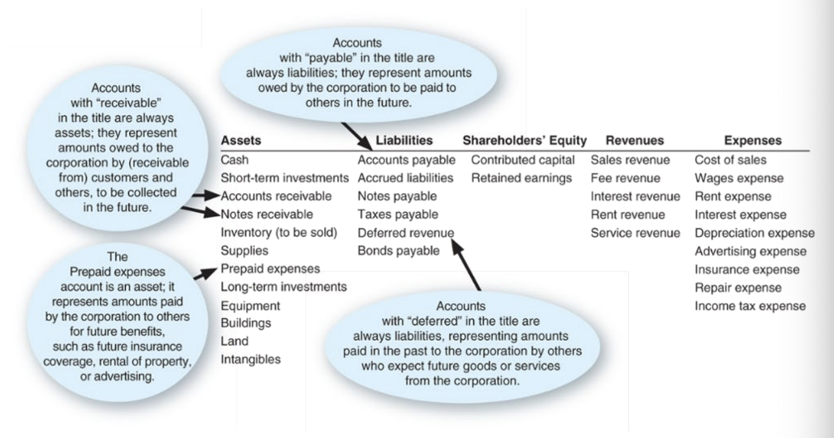
- a chart of accounts lists all account titles and their unique numbers

Double Entry system:
On the left side Assets (debit = increase)
On the right side liabilities (credit = increase) and shareholders’ equity (credit = increase)
- The double entry system always has a debit and credit amount

Balancing the Accounting Equation:
In any situation is should resemble A = L + SHE
- Identify and classify accounts and effects
  - Check accounts (by title) affected and make sure at least 2 accounts change
  - Classify them by type of account
  - Determine the direction of the effect
- Verify account equation is in balance

Accounts:
a standardized record that organizations use to accumulate the monetary effects of transactions on each financial statement item.

How do companies keep track of account balances?:
- General journal
- General ledger
- T-accounts

T-Accounts:
- has a left side debit side
- right side credit side
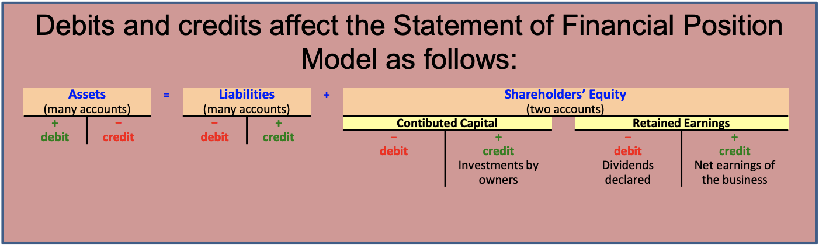
- the direction of transaction effects:
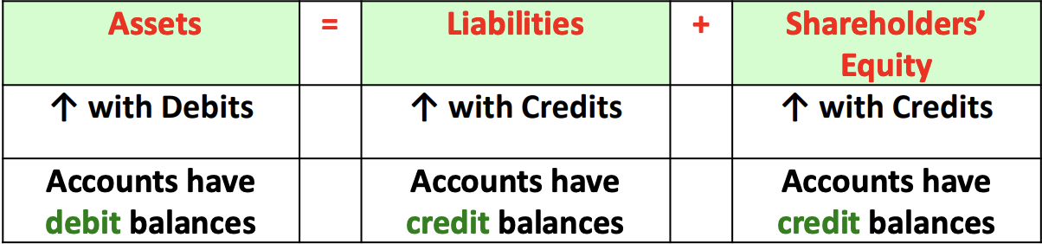
- after journal entries are prepared, the accountants posts (transfers) the dollar amounts to each account affected by the transaction

The Journal Entry:
- For a journal entry, we need to add a reference for the transaction (such as a number or a date)
- To prepare a journal entry, we need to better understand how the account works (increases by debit or credit)
- For example, if u purchase equipment and sign a note, the amount will be recorded on the left side (for a debit entry)
- Assets amount increase by debit, decrease by credit
- Liabilities decrease for debit, increase for credit
Total credit should equal total debit (should always be balanced)

Once you have created you T-account, it is easier to make your SFP

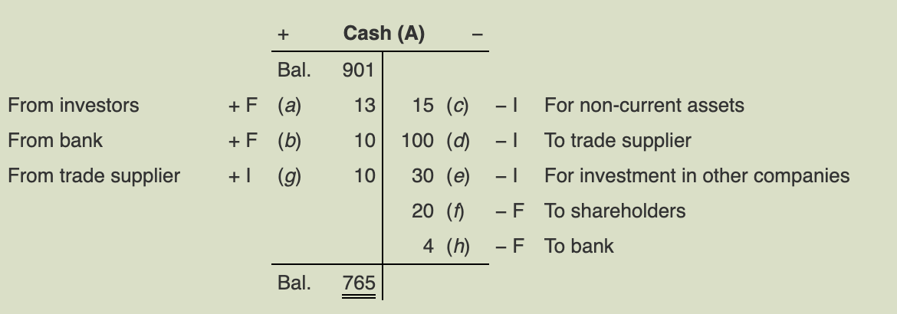

Chapter 3

The Operating Cycle:
Cash-to-cash cycle
the time it takes for a company to pay cash to suppliers, sell those goods and services to customers, and collect cash from customers
- some companies, pay for inventory before it’s sold (such as, at Golteez ;) )
- to improve the company’s cash flow and shorten operating cycle, some companies create incentives for customers to buy sooner/faster
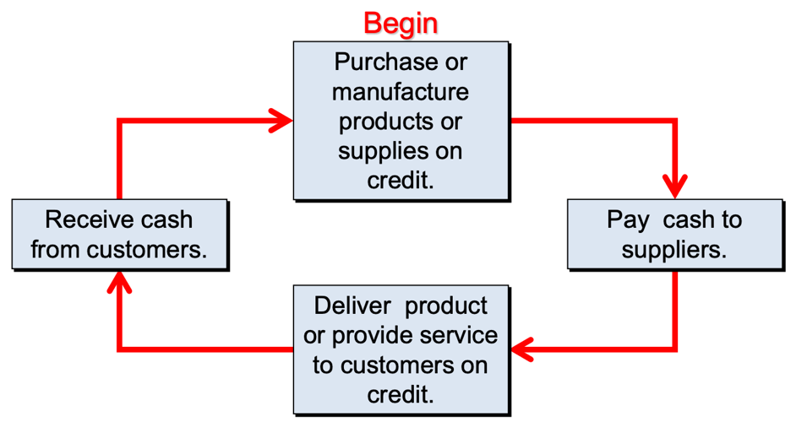

The Periodicity Assumption:
this assumes that the long life of a company can be reported in shorter time periods
- Such as monthly, quarterly and annually
- 2 issues arise:
  - Recognition issues – WHEN should the effects of operating activities be recognized?
  - Measurement issues – WHAT AMOUNTS should be recognized?

Classified Statement of Earnings:
includes a number of sections and subtotals to aid the user in identifying the company’s earnings from operations for the year
helps highlight the effect of other items on net earnings
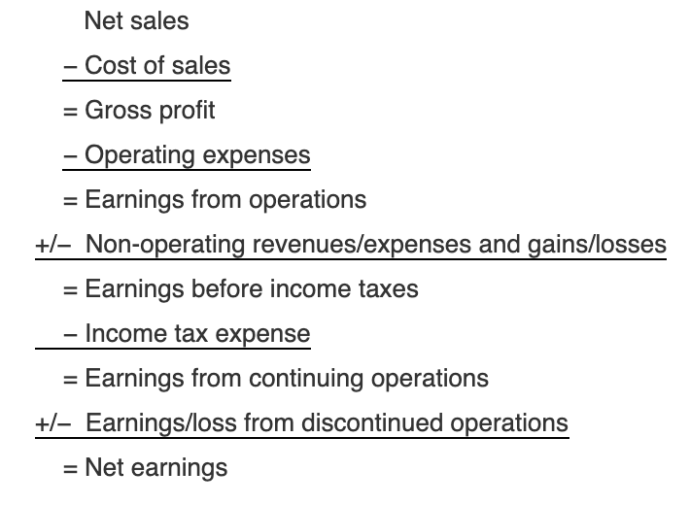
- The operating expenses consist mainly of distribution costs, administrative expenses and other operating expenses
- Basic structure used by most companies
- Most statement of earnings help financial statement users assess the company’s operating performance and predict its future profitability
- Includes 3 major sections
  - Results of continuing operations
  - Results of discontinued operations
  - Earnings per share
    - EPS = Net earnings / common shares
      - Weighted average of shares
    - Net earnings (the sum of sections on the notice)
- Continuing operations: the section that presents the results of continuing operations profits
  - Useful for reference of the conceptual framework outlined
  - Revenue – expenses + gains – losses
  - 2 formats = single step format and multiple step format
- Operating revenues: result from the sale of goods/services
  - When revenues are earned, assets (typically cash or accounts receivable) increase
  - Deferred revenue is created when the company receives cash in exchange for a promise to provide the customer with a good/service
- Operating expenses: typically includes materials, labour, equipment use and property
- Discontinued operations: ******

Cash Basis Accounting:
This takes note of revenues when cash is received
- expenses when cash is paid
- no matter when the revenues are earned, or the expenses gained
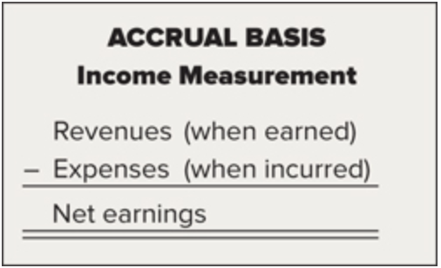
Accrual Accounting:
revenues are recorded when they are earned in accordance with the revenue recognition criteria
expenses are recorded when they are incurred
- accountants are guided by the revenue recognition principle and the matching process

Revenue Recognition Principle:
- To guard against identification of critical events to increase net earnings, 5 conditions must be met:
  - (if any condition is not met, revenue is normally not recognized and cannot be recorded)
- The entity has transferred to the buyer the significant risks and rewards of ownership
- The entity retains neither continuing managerial involvement nor effective control over the goods sold
- The amount of revenue can be reliably measured
- Collection is reasonably assured
- The costs in respect of the transaction can be measured reliably
- A credit to revenue would appear in the financial statements if revenue was recognized and recorded before the customer paid for the good/services

4 way of Adjusting Entries: (discussed more in the next chapter)
recorded at the end of the period
- Accrued expenses
- Accrued revenue
- Deferred expenses
- Deferred revenue (aka unearned revenue)
  - Cash is received before the service is provided (before revenue is earned)
  - EX gift cards – once the gift card is used, the company will cancel the liability since the goods are finally delivered
    - Other examples, plane ticket, subscription services, gym memberships, etc

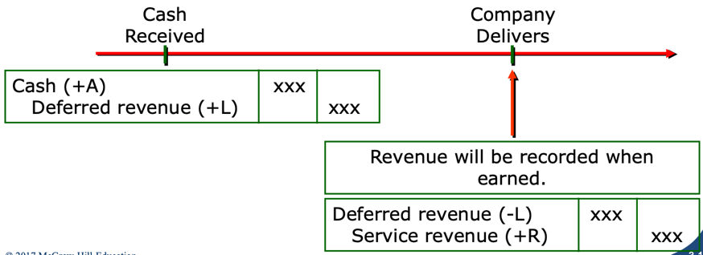

Cash is received on the date revenue is earned
- normal transaction

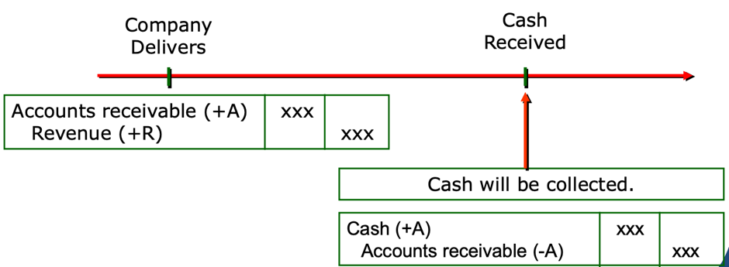
Account receivable: Cash is received after good/service is provided (revenue is earned)

Matching Process:
- Requires expenses to be recorded when incurred in earning revenue
  - Resources consumed to earn revenues in an accounting period should recorded in that period – regardless of when cash is paid
  - All the resources consumed in earnings revenues during a specific period must be recognized in that same period – a matching of costs with benefits
- The costs of generating revenue include expenses incurred, such as:
  - Salaries to employees (wage expenses)
  - Utilities for electricity used (utilities expenses)
  - Inventory items that are sold (cost of sales)
  - Facilities rented (rent expenses)
  - Use pf buildings and equipment for production process (depreciation expenses)

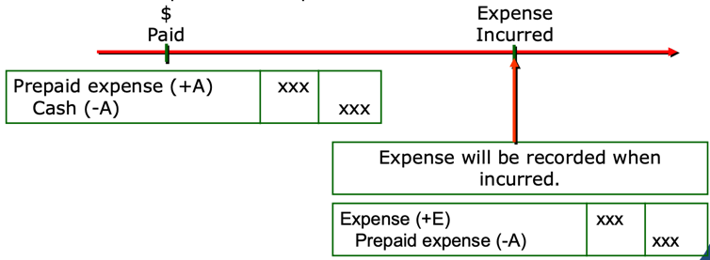
Cash is paid before expense is incurred
- Prepaid expense:
- The company has not incurred yet this cost
- When the expense is incurred prepaid expense is reduced and an expense is recorded
- Ex prepaid insurance, prepaid rent, etc
- Let’s say a company bought a building for 2,400,000$ and estimated they will be able to use it for ~20 years. This means the building would need about 120,000$ of renos each year
  - They would debit the cost of each year’s expense of 120,00$
    - This would be titled accumulated depreciation a contra (?) asset

The Expanded Transaction Analysis Model:
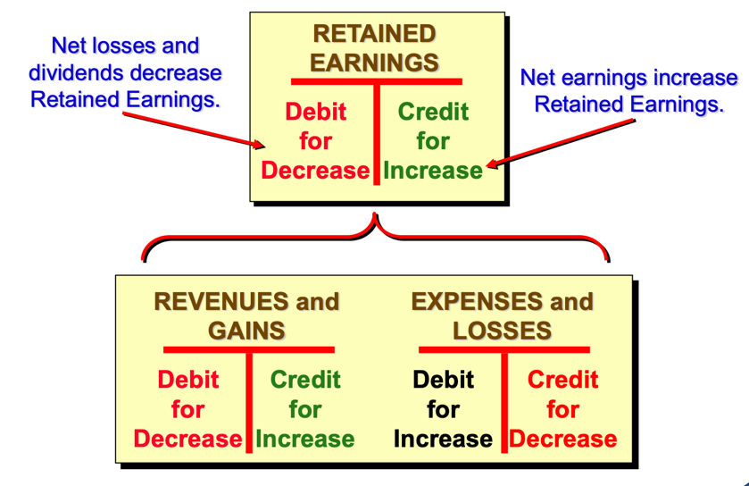

Total Asset Turnover Ratio:
- The more assets saved, the high turnover ????

Return on Assets (ROA) ratio:
Return of each dollar of investment and how much the firm earned on each

Chapter 4

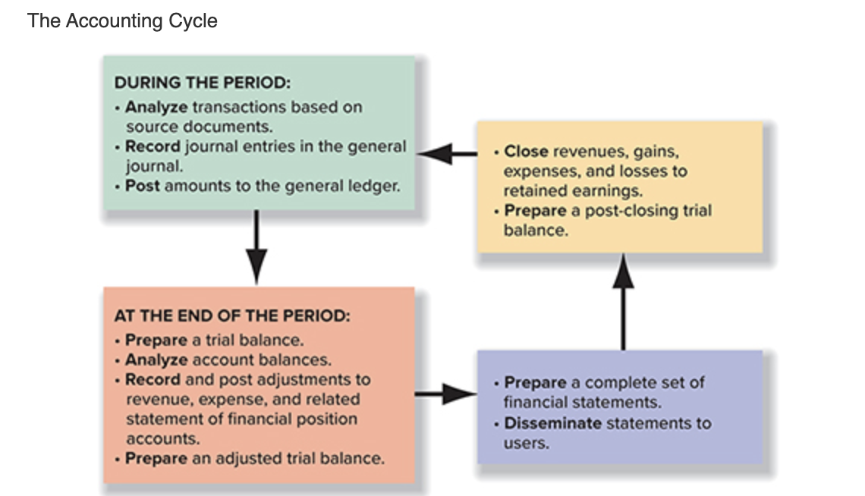

The unadjusted trial balance:
If total debits do not equal total credits on the trial balance, errors have occurred

Four ways of adjusting entries:
- revenues are recorded when earned
- expenses are recorded when incurred
- Deferred revenues a liability representing the company’s promise to perform or deliver the goods or services in the future
  - Cash was received in advance but the recognition of it is postponed (~deferred~) until the obligation is met
  - EX subscription revenue, ticket revenue
  - Liabilities decrease, revenue increase
- Accrued revenues revenues that have been earned but not yet recorded in the accounting period
  - Cash will be received after service is performed
  - EX interest receivable, rent receivable
  - Asset increase, revenue increase
- Deferred expenses represent resources with probable future benefits to the company
  - Assets are used over time to generate revenues
    - Such as supplies, prepaid rent, prepaid insurance, buildings, equipment and intangible assets (patents and copyrights)
  - Expense increase, assets decrease
- Accrued expenses Expenses are incurred in the current period without being paid for until the next period
  - EX interest expense, incurred on debt, wages expense owed to employees and utilities expenses (like water, gas, and electricity) for which company has not yet received the bill
  - Accumulate over time. But aren’t recognized until end of period
  - Increase expense, increase liabilities
Materiality and Adjusting Entries:
- Materiality suggests that minor items that would not influence the decision of the financial statement users are to be treated in the easiest and most convenient manner.
- The process of making adjusting entries can be simplified if we account for immaterial items in the easiest and most convenient manner

Certain circumstances require adjusting entries to record accounting estimates. This can include depreciation, bad debts, and income taxes
- PP&E: depreciation
  - Land – historical costs
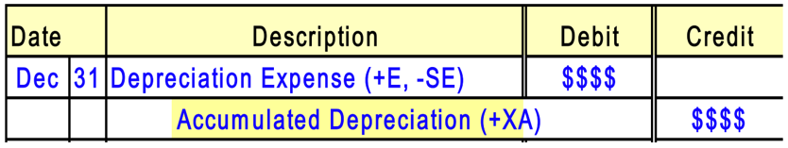
  - Building – its on land, land is bought separately, and the buildings are constructed on the land, it can be easy to keep the cost of last separate from the cost of the building
  - The required journal entry includes a debit to depreciation expense and a credit to an account accumulated depreciation
- The bad debt has to do with the debts on a customer of which they will not pay

Preparing Financial Statements:
- Before we prepare a complete set of financial statements, we update the trial balance to reflect the adjustments and provide us with adjusted balances for the statements
  - Statement of earnings
    - Earnings per share the amount a shareholder can receive over the net earnings, how much profit each share has
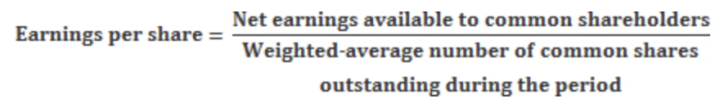

  - Statement of changes in equity
    - Final amount from statement of earnings, net earnings, is carried forward to the retained earnings column of the statement of changes in equity
  - Statement of financial position
    - Includes the contributed capital, retained earnings, other component headings
  - Statement of cash flows
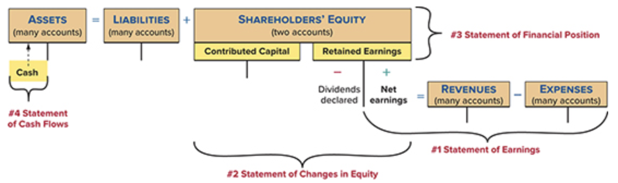

Because net earnings is a component of retained earnings on the statement of financial position, it is necessary to compute net earnings first by preparing the statement of earnings (#1). The statement of changes in equity (#2) is then prepared because it reports the changes and ending balances in contributed capital and retained earnings, providing the connection to the statement of financial position (#3). Finally, the sources and uses of cash are reported on the statement of cash flows (#4), and the ending balance for cash on the statement equals the cash balance on the statement of financial position:
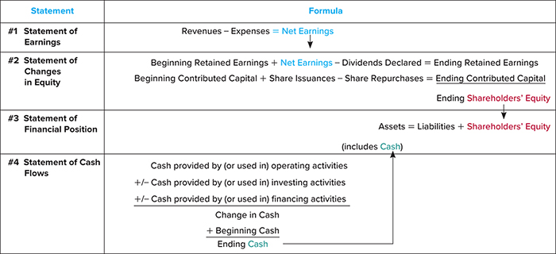

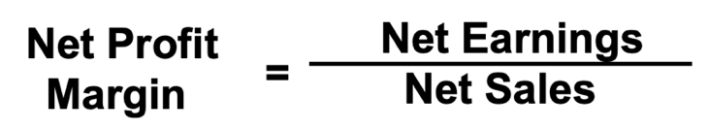
Net profit margin:
Indicates how effective management is at generating earnings on every dollar of sales


Return on Equity (ROE):
measures how much the firm earned for each dollar of shareholders’ investment

Closing the Books:
- Permanent (real) account: statement of financial position whose ending balances are carried into the next period
  - never closed accounts
  - Assets, liabilities, SHE
  - Not reduced to zero at the end of the accounting period
- Temporary (nominal) accounts: statement of earnings and dividends declared accounts that are closed to retained earnings at end of period
  - Accounts that close at the end of each period
  - revenue, expenses, gains, loss, and dividend accounts are used to accumulate transaction effects for the current accounting period only
- Closing entries: 2 purposes includes….
  - To transfer the balances in the temporary accounts to retained earnings
  - To establish a zero balance in each of the temporary accounts to start the accumulation in the next accounting period
- 4 steps to close the books:
  - Close the revenues and gains to income summary
    - Income summary is a temporary account
  - Close expenses and losses to income summary
  - Close the income summary account to retained earnings
  - Close dividends to retained earnings

Chapter 5

Classification of Cash flows:
- Cash typically includes cash and cash equivalents
- Cash equivalents are short-term, highly liquid investments
  - They are readily converted to known amount of cash
  - They are less than three months to their maturity and subject to an insignificant risk of changes in value
  - Ex include treasury bills, money market funds, and commercial paper
- Statement of cash flow reports cash inflow/outflow based on 3 broad categories
  - Operating activities
  - Investing activities
  - Financing activities
- together these explain the change in cash from the beginning balance to the ending balance on the SFP

Cash flows from operating activities:
inflows and outflows that are directly relate to revenues and expenses from normal operations
- Direct method reports the components of cash flows from operating activities listed as gross receipts and gross payments
  - All the transactions within the period
- Indirect method the operating activities section of the statement of cash flows starts with net earnings for the period and then eliminates non-cash items to arrive at net cash inflow
  - Starts with accrual profit and converts to cash basis
- A result of day to day business operation, future debt repayment, future dividend payments
  - Ex. Sales of goods/services, rent payment, wage payment, etc.
- Inflows: received from customers or dividends/interest on investments
- Outflows: paid for purchase of goods for resale/services, salaries and wages, income taxes, interest on liabilities

Cash flows from investing activities:
cash inflows and outflows related to the acquisition or sale of long-lived productive assets and investments in the securities of other companies
- The amount isn’t typically a high number
- Investment, sale or disposal of long-term assets
  - Ex. Property, plant, equipment, long-term marketable securities
- Inflows: received from sale/disposal of property, plants and equipment, sale/maturity of investments in securities
- Outflows: paid for purchase of property, plant, and equipment, investments in securities

Cash flows from financing activities:
cash inflows/outflows related to external sources (owners and creditors) to finance the enterprise and its operations
- Obtaining and repaying resources from shareholders and lenders
  - Ex. Shares, bonds, mortgages and notes
- The difference is called net cash inflow from financing activities
- Inflows: received from borrowing on notes, mortgages, bonds, etc. from creditors, and issuing shares to shareholders
- Outflows: paid for repayment of principal to creditors, repurchasing shares from shareholders, and dividends to shareholder
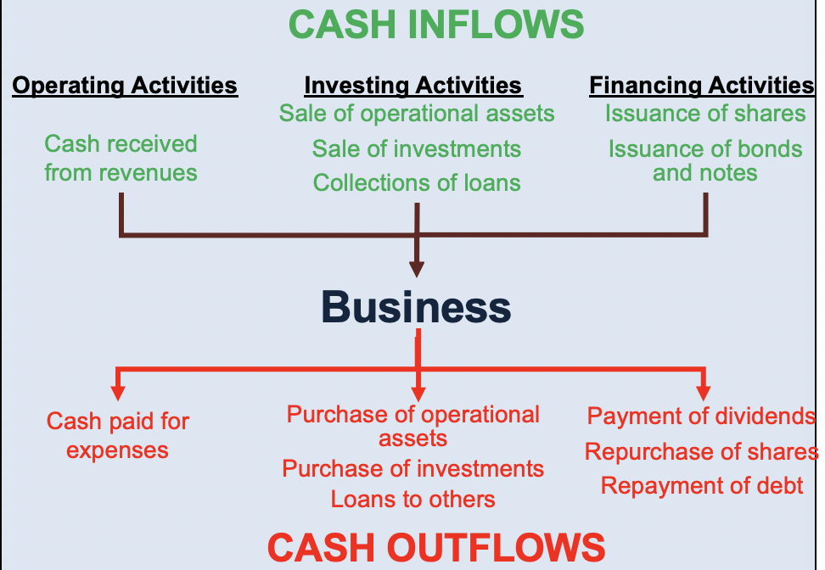

Relationships to the statement of financial position and statements of earnings:

- to prepare you need:
- Comparative statements of financial position
  - Used to compute the cash flows from all activities (operating, investing and financing)
  - A complete statement of earnings
    - Used to identify cash flows from operating activities
  - Additional details
    - Net change in an account balance during the year does not reveal the underlying nature of the cash flows
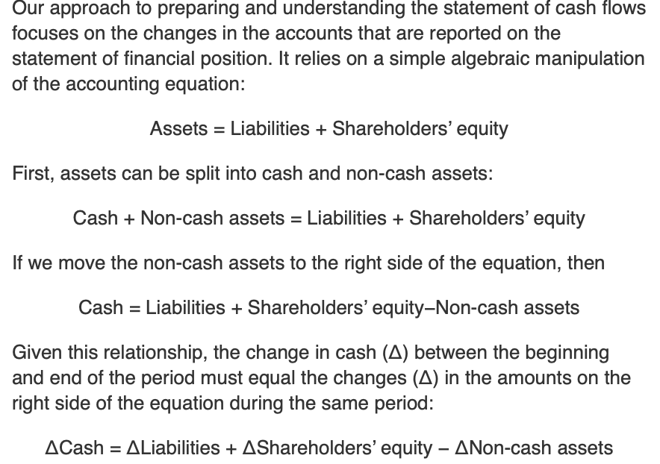

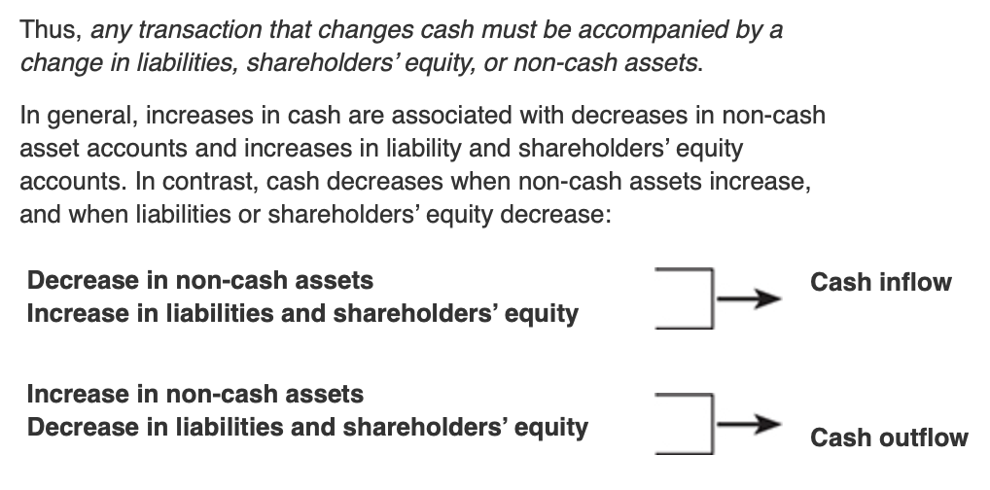

Next:
- Determine the change in each account on the SFP by subtracting this year’s ending balance from the last year’s ending balance
- Classify each change as relating to operating (O), investing (I), or financing (F) activities

Reporting cash flows from operating activities – indirect method:
- This method adjusts profit by eliminating non-cash items
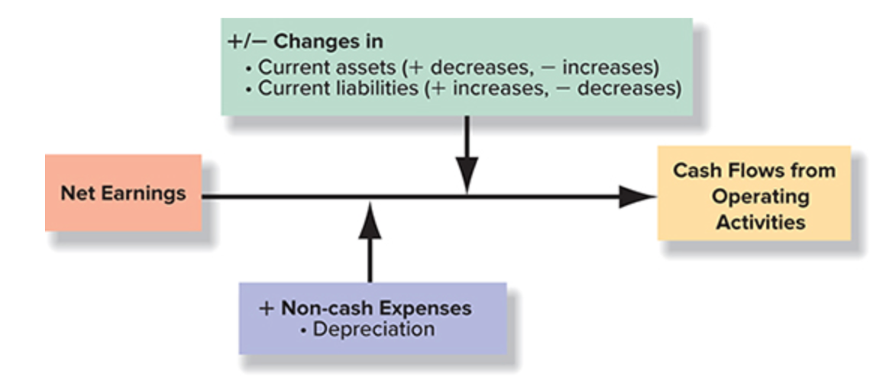
- Starts with net earnings and converts it to cash flows from operating activities. This involves adjusting net earnings for the differences in the timing of accrual basis earnings and cash flow
This table summarizes how to adjust net earnings for changes in current assets and current liabilities. If a current asset account has increased, the increase would be subtracted from accrual basis earnings. Similarly, if a current asset account has decreased, the decrease would be added to accrual basis earnings. For liabilities, increases are added to and decreases are subtracted from accrual basis earnings.
the decision table

STEPS for statement of earnings:
- Adjust net earnings for depreciation and amortization expense and other items not affecting cash
- Adjust net earnings for changes in non-cash operating working capital items
- Make adjustments for changes in current assets and current liabilities using the decision table
- ***

Quality of earnings ratio:
measures the portion of earnings that was generated in cash
- All other things equal, higher quality of earnings ratio indicates greater ability to finance operating and other cash needs from operating cash inflows


Capital expenditures ratio:
reflects the portion of purchases of property, plant and equipment, intangible assets and acquisition of other businesses that were financed from operating activities without the need for outside debt or equity financing or the sale of other investments or property, plant, and equipment
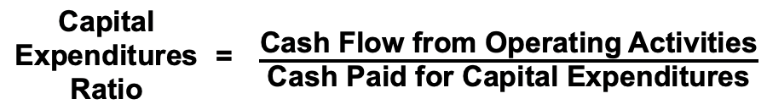

Reporting cash flows from financing activities:
-these activities include:
- Proceeds from insurance of short and long-term debt
- Principal payments on short- and long-term debt
- Proceeds from the issuance of shares
- Purchase of shares for retirement
- Interest and dividends

Non-cash investing and financing activities:
transactions that do not have direct cash flow effect – reported as a supplement to the statement of cash flows in narrative or schedule form

Interpreting cash flows from operating activities:
- Accounts receivables changes managers sometimes attempt to boost declining sales by extending credit terms or lowering credit standards
  - The resulting increase in accounts receivable can cause net earnings to outpace cash flows from operations
- Inventory changes inventory growth can be a sign that planned sales growth did not materialize
  - A decline in inventory can be a sign that the company is anticipating lower sales in the next quarter
- A rule of thumb is to avoid firms with rising net earnings but falling cash flow from operations

Chapter 6

Accounting for Sales Revenue:
- Motivating sales and collections is when the company motivates its consumers to buy its products and make payment for their purchases. This is done by…
- Allowing all customers to use credit cards to pay
- Providing business customers direct credit and discounts for early payment
- Allowing returns from all customers under specific circumstances
- these methods affect the way sales are computed
- When credit card sales to consumers are made, the company must pay the credit card company a fee for the service it provides.
  - Called the credit card discount (the fee for the service provided)
  - The seller accepts credit cards for multiple reasons:
    - To increase sales (increase customer traffic in store)
    - To avoid providing credit directly to customers
    - To avoid losses due to bad cheques
    - To avoid losses due to fraudulent credit card sales
    - To receive payment quicker
- Sales discounts to business a cash discount offered to encourage prompt payment of a trade account receivable
  - If not paid in cash, it often includes making a purchase on credit
  - The credit terms are abbreviated (using symbols) and written out on the documents
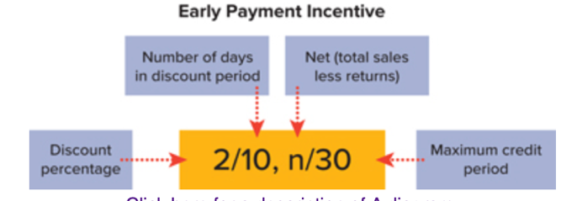
For example: if a company has “2/10, n/30” written on a notice, this means the customer may deduct 2% from the invoice if paid cash payment is made within 10 days. If cash payment is not made within that time, the full invoice is owed within a maximum of 30 days

- Benefits of the sales discounts include:
  - Prompt receipt of cash from customers reduces the necessity of borrowing money to meet operating needs
  - Since customers tend to pay invoices providing discounts first, a sales discount also decreases the likelihood that the customer will run out of funds before the company’s invoice paid
- Sales returns and allowances Customers return damaged merchandise for a full refund or may also return merchandise that is damaged but usable (problem of quality) or ask for a price reduction
  - Would be deducted from gross sales revenue in determining net sales
- Reporting net sales companies record credit card discounts, sales discounts and sales returns and allowances separately to allow management to monitor these transactions
  - Sales revenue (R)
  - Less: credit card discounts (XR), sales discounts (XR), sales returns and allowances (XR)

Gross Profit Percentage:
measures how much profit is generated form every sales dollar
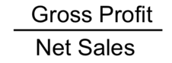
- GPP =

Measuring and Reporting Receivables:
- Classifying receivables:
- Accounts receivable created when companies have sales to customers with open accounts
- Note receivable written promises from another party (such as a customer) to pay with specified terms
    - In the form of a financial asset
- Trade receivables amounts owed to the business for normal credit sales of goods or services on credit
- Non-trade receivables amount owed to the business for other than normal business transactions
    - Such as payment for insurance on an accident
- Classified statement of financial position
    - In the form of current or non-current (short tern or long term) depending when cash is to be collected

Accounting for bad debts:
- Companies use the allowance method to estimate the amount of receivables that will NOT be collected
allowance method bases bad debt expense on an estimate of uncollectible accounts
  - Steps must be met in order to apply the allowance method
    - Establish the allowance and recording bad debts expense
    - Writing off specific amounts’ receivable (determined to be uncollectible during the period)
    - Recovery of a specific receivable that has been previously written off
- Allowance for doubtful accounts:
  - Statement of financial position – disclosure

Estimating bad debts:
- Estimated based on an aging of accounts receivable
- Receivables turnover ratio measures how many times average receivables are recorded and collected for the year
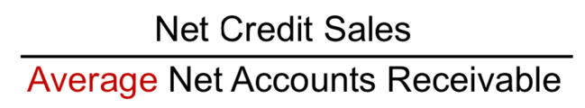
- Receivables turnover ratio =

Internal controls process by which the company’s board of director, managers and other personnel provide reasonable assurance regarding the reliability of the company’s financial reporting the effectiveness and efficiency of its operation, and its compliance with applicable laws and regulations.

Controls over accounts receivable:
to guard against the extending credit to non-worthy customers, the following practices can help minimize bad debts
- By guarding against extending credit to non-worthy customers, things must be done:
- Require approval of customer’s credit history by a person independent of the sales and collection functions
- Monitor the age of trade receivables periodically and contact customers with overdue payments
- Reward both sales and collection personnel for speedy collections so that they work as a team

Reporting and Safeguarding cash:
Cash managements:
- Procedures by management to safeguard the cash received to the business to protect from fraud, theft, or loss through carelessness
- Management responsibilities include:
  - Accurate accounting so that reports of cash flows and balances may be prepared
  - Controls to ensure that enough cash is on hand to meet current assets, maturing liabilities and unexpected emergencies
  - Prevention of the accumulation of excess amounts of idle cash
    - Idle cash earns no revenue; it is often invested in securities to earn revenues (return) until it is needed for operations
Internal control of cash:
- Effective internal control of cash should include:
- Separation of duties related to cash handling and recordkeeping
- Prescribed policies and procedures
Bank reconciliation of cash accounts:
bank reconciliation is the process of comparing (reconciling) and verifying the accuracy of both the ending cash balance in the company’s record and the cash balance recorded to bank on the monthly statement (the difference between the general ledger and the bank statement)
- Identifies any errors that need to be corrected by the company
- Common differences between the ending bank balance and book balance:
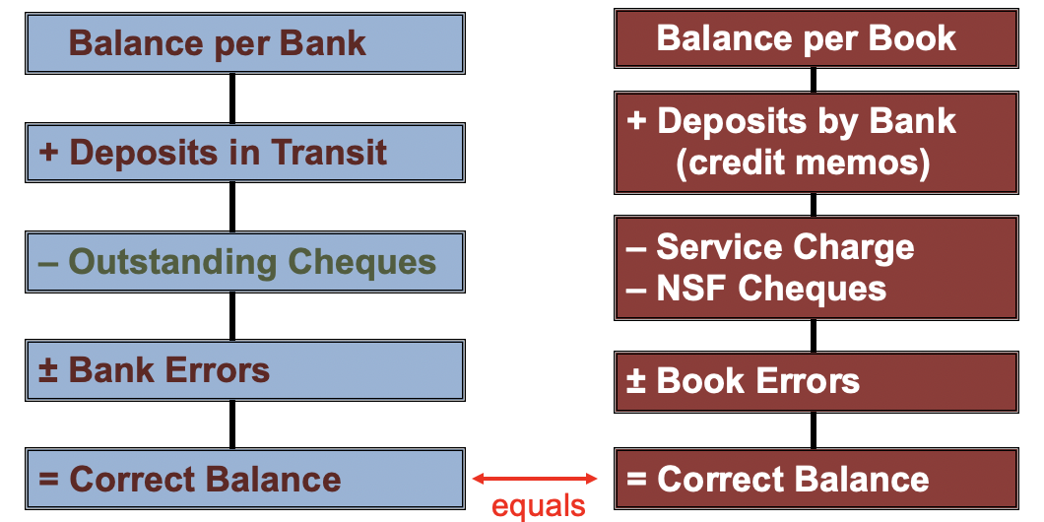

Chapter 7

Nature of Inventory and Cost of Sales:
Items included in inventory:
inventory = tangible property held for sale in the normal course business or used in producing goods or services for sale
- an asset that is (1) held for sale in the ordinary course of business or (2) used in the process of production of goods for sale or rendering of services
- goals of inventory management are to provide sufficient quantities of high-quality inventory AND to minimize the costs of carrying inventory
- reported on SFP as current asset since its usually converted into cash within 1 year or next operating cycle
- Merchandise inventory goods (or merchandise) held for resale in the course of business
  - Usually acquired in a finished condition and are ready for sale without further processing
  - From merchandisers (wholesale or retail business)
- *Raw materials consists of items acquired by purchase, growth (food products), extraction (natural resources) for processing into finished goods
- *Work in progress includes goods in the process of being manufactured but not yet complete
- *Finished goods inventory consists of manufactured goods that are complete and available for sale
* manufacturing businesses

Costs included in inventory purchases:
- Inventory costs includes the sum of the costs incurred in bringing an article to a usable or saleable condition and location
  - Such as cost of purchase and transportation costs
- The cost principle requires that inventory be recorded at the price paid or the consideration given
- Invoice price, freight, inspection costs, preparation costs
Flow of inventory costs:
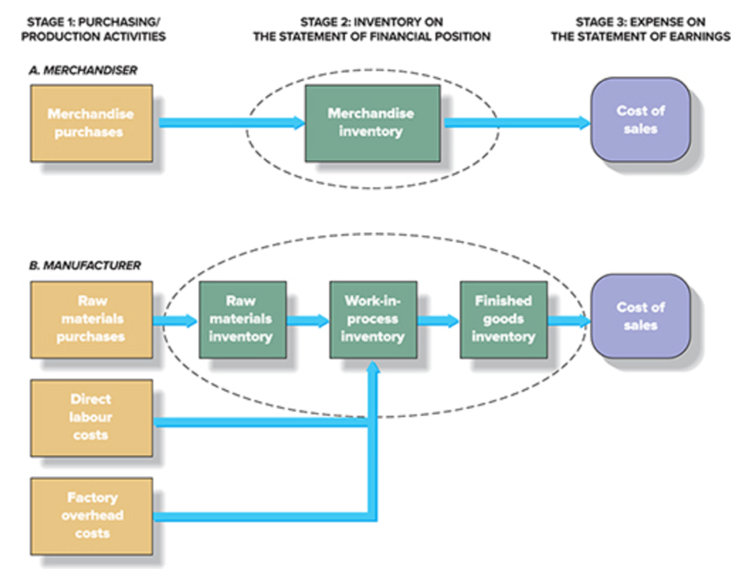
- When merchandise is purchased, the merchandise inventory account goes up. When items are sold, the merchandise inventory goes down but cost of sales increases.
  - For merchandisers !!
- First, raw materials (or direct materials) are purchased – they can include zippers, buckles, buttons, etc. as the materials are used in production, their cost is removed from raw materials inventory and added to cost of work-in-progress inventory.
  - Other components can include the direct labour (earnings of employees) and factory overhead (all the manufacturing costs that are not raw materials – cost of utilities, salary of factory supervisor…) which are included in the work-in-progress aspect
  - Although costs in the manufacturing environment is clearly more complex.

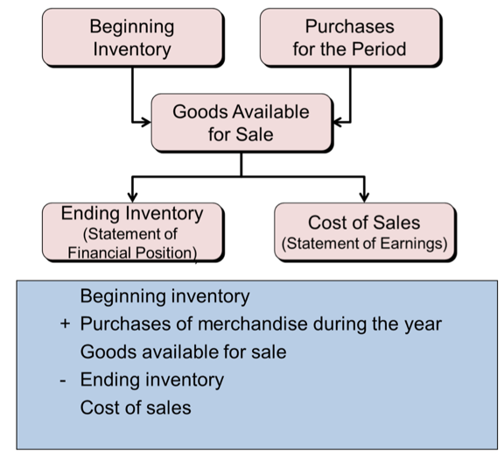
Cost of sales equation:
BI + P – EI = COS
- Cost of sales (COS) directly related to sales revenue (number of units sold multiplied by sales price). Costs of sales is the same number of units, multiplied by their unit costs.
(goods available for sale is the maximum the company was able to sell)
- The sum of the cost of beginning inventory (BI) and the cost of purchases (P) is the cost of goods available for sale for that period
  - What is left after the period is then ending inventory (EI)

Perpetual and Periodic Inventory systems:
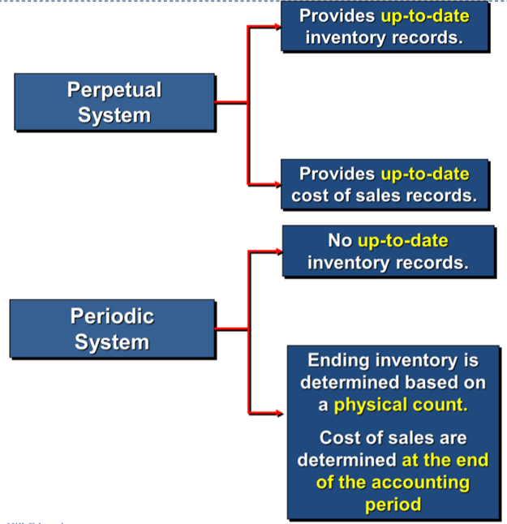
perpetual inventory systems = a detailed record of purchases and sales during the accounting period
- Detailed record is maintained for each type of merchandise stocked showing….
- Units and cost of the beginning inventory
- Units and cost of each purchase
- Units and the cost of the goods for each sale
- Units and cost of the goods on hand at any point in time
- Maintained on transaction-by-transaction basis and is necessary for purchasing, manufacturing and distribution decisions
- Can cause shrinkage (over consumption with not efficient management on inventory) or theft
periodic inventory systems = ending inventory or cost of sales based on the physical count of goods remaining
- The cost of sales cannot be determined reliably until the inventory count is done
- Inventory purchases are recorded in a purchases account
- Require regular inventory counts
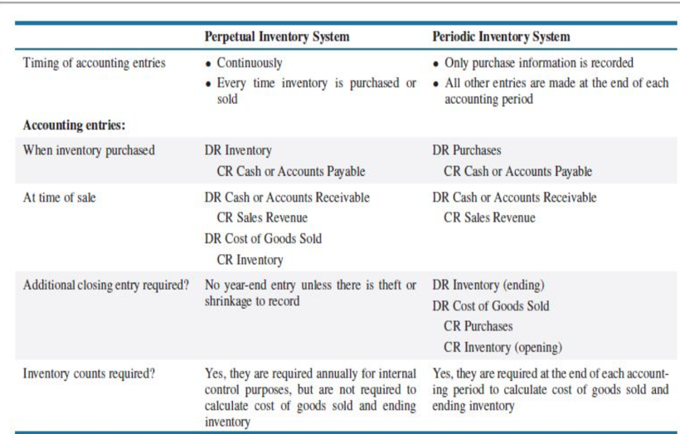
- At the end of period, calculate cost of goods sold (COGS)

Inventory Costing Method (3 kinds):
all kinds of allocating the total cost of goods available for sale to cost of sales on the statement of earnings and ending inventory on the SFP.
Specific identification method:
the cost of each item sold is individually identified and recorded as cost of sales
- Impractical for large quantities of stock, but great for luxury items
- Keeping track of the purchase cost of each item includes (1) coding the purchase cost on each unit before placing in stock and (2) keeping a separate record of the unit and identifying it with a serial number
- COGS = (# of units x beg. Price) + (# of units x purchase price)
- Ending Inventory (EI) = COGAS _{(beg. Price + purchase price)} - COGS
Cost flow assumption:
- The choice of inventory costing method is NOT based on the physical flow of goods on and off the shelves
2 methods:
- first in, first out method (FIFO) =assumes the earliest goods purchased are the first units sold and the last goods purchased remain in ending inventory
  - oldest costs cost of sales
  - recent costs ending inventory
  - when using this method, we assign the older costs to the units sold and the most recent costs will be used to value the ending inventory
  - usually uses increasing costs
  - advantage: the ending inventory approximates current replacement cost
- weighted average cost method = requires computation of the weighted average unit cost of the goods available for sale
  - in the table, there are total units, COGAS and Cost/Units
  - advantage: smoothes out price changes

Managers choice of inventory costing methods:
- they generally accept accounting methods on 2 factors:
- effect on net earnings (managers prefer to report higher earnings for their companies)
- effect on income taxes (managers prefer to pay the least amount of taxes allowed by law, as late as possible; the least – latest rule)

Valuation at lower of cost and net realizable value (LC&NRV):
- ending inventory is reported at the lower of cost or net realizable value (LCNRV)
- NRV = selling price – estimated selling costs (eg. Repair and disposal costs)
an estimate of the amount that a company expects to receive for selling its inventory in an ordinary course of business
- Would credit the inventory and use the cost of sales expense account in the debit
- Valuation the lower amount should be used as the inventory valuation because it faithfully represents that inventory values cannot exceed the amount that can be obtained from selling the inventory.
- Lower of cost and net realizable value (LC&NRV) serves to recognize a loss when the NRV drops below its cost
  - Using the valuation rule

Internal control of inventory:
- Separation of inventory accounting and physical handling of inventory
- Storage in a manner that protects from theft or damage
- Limiting access to authorized employees
- Maintain perpetual inventory records
- Comparing perpetual records to periodic physical counts
- first 3 protect inventory, last 2 ensure the accuracy of reporting inventory costs

Inventory turnover:
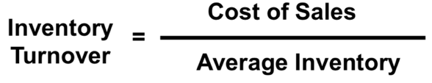
how efficient are inventory management activities
- Reflects how many times average inventory was produced and sold during the period
- Average inventory turnover is (beginning inventory + ending inventory)/ 2

Average days to sell inventory:
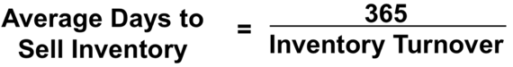
ratio that reflects the average time (in days) it takes a company to produce and deliver inventory to its customers

Chapter 6 : Cash account receivable – prepare bank reconciliation
Prepare journal for bad debt (bad debt expense entry, write off entry – cant be recovered and customer going bankrupt), debit ADA
3rd journal entry to recover the write off

Chapter 8 (long problem on final exam)

Classifying long-lived assets:
- Tangible – physical substance (also called fixed assets)
  - Land
  - Assets subject to depreciation
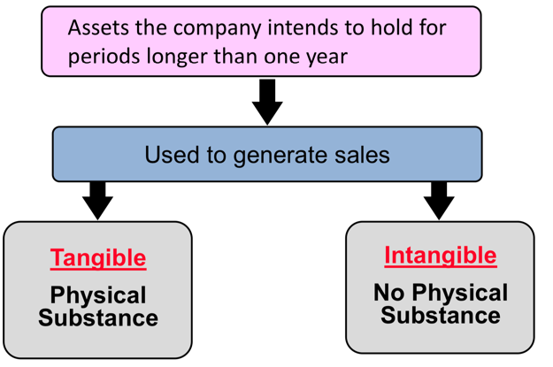
    - buildings and equipment
    - Furniture and fixtures
  - Natural resource assets subject to depletion
    - Mineral deposits and timber
- Intangible – no physical substance
  - Definite life
    - Patents
    - Copyrights
    - Franchises
  - Indefinite life
    - Trademarks
    - goodwill

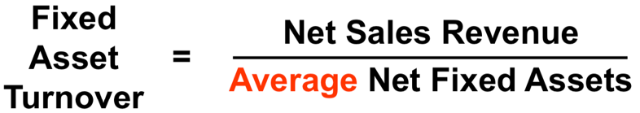
Fixed Asset Turnover:
ratio measures a company’s ability to generate sales given an investment in fixed assets

Measuring and Recording Acquisition costs:
- acquisition cost includes the purchase price and all expenditures needed to prepare the asset for its intended use
  - acquisition cost does not include financial charges and cash discounts
- Equipment:
  - Purchase price
  - Installation costs
  - Modification to building necessary to install equipment
  - Transportation costs
- Land: no depreciation expense
  - Purchase price
  - Real estate commissions
  - Title insurance premiums
  - Delinquent taxes
  - Surveying fees
  - Title search and transfer fees

Subsequent costs:
***

Impairment: (pg 447)
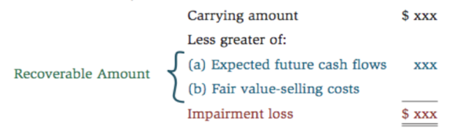
the loss of a significant portion of the utility of an asset through a casualty, obsolescence or lack of demand for the asset’s services
- The recoverable amount: MAX (the total of all the future cash flows that are expected to be generated from the assets use; the asset’s fair value less any selling costs

***
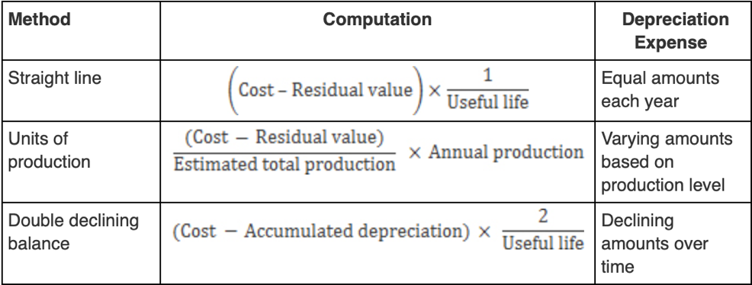
3 Methods of calculating depreciation:
- Straight-line
- Units of production
- Accelerated method: declining balance

Changes in Depreciation Estimates:
**
Add EX

Depreciation and Federal Income Tax:
have 2 sets of reports, 1 is prepared under accounting rules for reporting to shareholders. The other one is prepared to determine the company’s tax obligation and is computed in conformity with the tax rules
- For tax purposes, most corporations use the capital cost allowance (CCA)
- CCA provides for rapid write-off of an asset’s cost in order to stimulate new investments

International Perspective – IFRS vs ASPE:
****

Disposal of Property, plant and equipment:
- Voluntary disposals sales, trade in, retirement
- Involuntary disposals fire, accident
***missing info
When you de-recognize an asset, you remove form the SFP
- If cash > NBV, record a gain (gain)
- If cash < NBV, record a loss (debit)
- If cash = NBV, no gain or loss

Acquisition and Depletion of Natural Resources:
ex. Oil, coal, gold
- Extracted from natural environment
  - Total cost of asset is the cost of acquisition, exploration and development
- A non-current asset is presented at cost less accumulated depletion
  - Total cost is allocated over periods benefited by means of depletion
- Depletion is like units of production depreciation

Acquisition and Amortization of Intangible Assets:
- Non-current assets without physical substance
- Useful life is often difficult to determine
- Often provide exclusive rights or privileges
- Usually acquired for operational use
Record at current cash equivalent cost, including purchase price, legal fees and filing fees
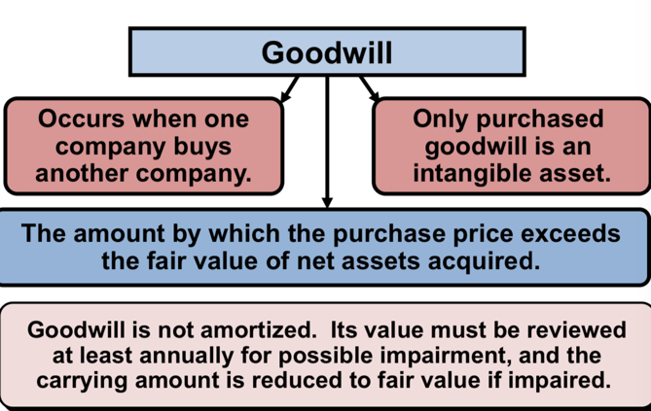
- Definite life amortize over shorter of economic life or lgal life, subject to rules specified by IFRS (GAAP)
  - Use straight line method
- Indefinite life not amortized
  - Tested at least annually for possible impairment, and carrying amount is reduced to fair value if impaired
Amortization a cost allocation process similar to depreciation and depletion
- Trademarks a symbol/design associated with a business (usually good for 10 years)
- Copyrights exclusive right to publish, use and sell work (good for life of creator plus 50 years)
- Patents exclusive right granted by government (good for 20 years)
- Technology a category of intangible assets that include a company’s website or anything created by employees

Chapter 9

Significance of current liabilities:
*
- Company needs to have sufficient funds to meet its obligations

Current liabilities with lenders:
- Notes payable obligations due supported by a formal written contract
- Current portion of long-term debt
  - Portion of the principal payment due within the next year is considered the current position of LTD
- **

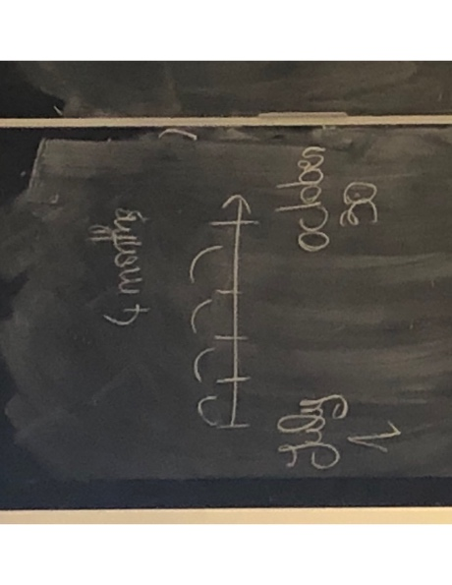
Current Liabilities with suppliers:
**

Current liabilities with customers:
-provision with warranty claims
- Warranty provisions (assurance – type warranty)
  - Recorded as:
DR. Warranty expense
CR. Warranty provision
  - When claim is claim:
DR. warranty provision
CR. Inventory or cash or unearned revenue
- customer loyalty provision
- Used to encourage customers to buy from them
  - Involves treating the original sale as a bundle consisting of 2 parts (initial goods and services and additional goods/services)

Current liabilities with customers:
- Unearned revenue
- Gift card liability
- Customer loyalty provision
- Provision for warranty claim

Current liabilities with employees:
**

**

Current liabilities with government:
- Government remittances can consist of:
  - Property taxes, workplace safety insurance, provincial sales taxes, GST, payroll taxes
- Corporate taxes
  - Based on a company’s annual net income**
  - **

Current liabilities with shareholders:
*

Deferred income taxes:
- Permanent differences
  - Arise from specific differences between rules that govern the preparation of financial statements and tax returns
  - Some types of revenues are exempt from tax while other are not deductible in computing taxable income
- Temporary differences
  - Timing differences that cause deferred income taxes and will reverse or turn around in the future
EX.
Deffered expense = 70$ CCA (capital cost allowance)
- can depreciate 70 based on the useful life and then the CCA with authorize u to deduce 100$
- this will mean you will pay less taxes the following year because of the higher deductions
- reverse lower deduction higher tax
- you benefit today to help with future business causes

Accounts payables turnover ratio:
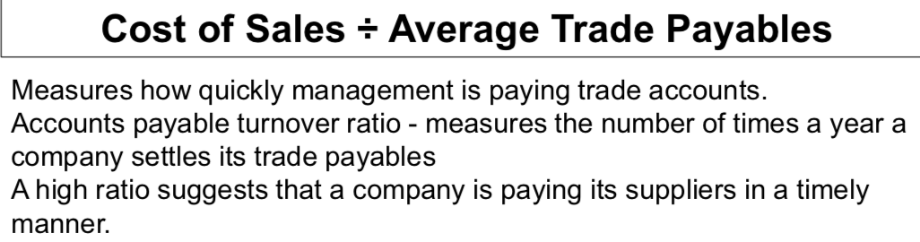

- Average age of payables = 365 / turnover ratio

Working capital management:
changes in working capital accounts are important to managers and analysts because they have a direct impact on cash flows from opening activities reports on the statement of cash flows
- Working capital = current assets – current liabilities

Quick ratio:
an indicator of a company’s ability to meet its short-term obligations
- Quick ratio = quick assets / current liabilities
- How much cash the company needs and has in order to pay

Contingent liabilities:
potential liabilities that are created as a result pf a past event
- Not affective liability until some future event occurs

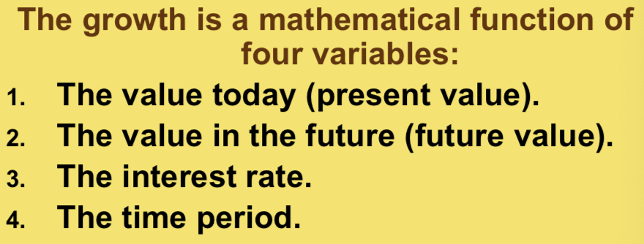
Present value concepts:
present value = the importance of the time
- Money grows over time and can earn interest
- Present value ---- future value
- An annuity is a series of consecutive equal periodic payments
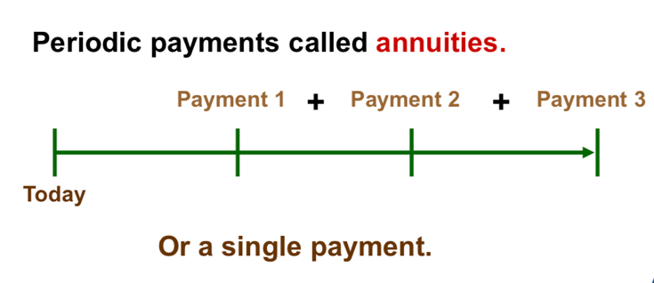

- Present and future values tables are available for:
  - Future value, single amount
  - Present value, single amount
  - Future value, annuity
  - Present value, annuity
- The present value of a single amount is worth to you today of receiving that amount sometime in the future
- Future value sum to which an amount will increase as a result of compound interest
  - Interest compounding periods

Chapter 10

Type of long-term debts:
Long term debt is available to companies in various forms
- Bank loans
- Notes
- Mortgages
- Bonds

Bonds can be traded on established exchanges that provide liquidity to bondholders
- As liquidity increases, cost of borrowing decreases

Characteristics of Long-term notes and bonds payable:
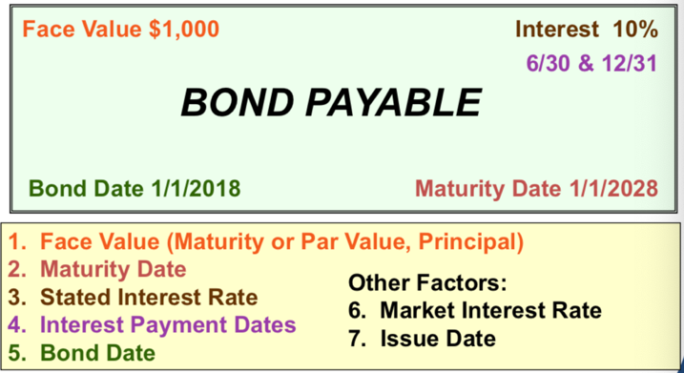
- Unsecured bond no assets are pledged as guarantee of repayment at maturity
- Secured bonds specific assets are pledged as guarantee of repayment at maturity
- Callable bonds bond may be called for early retirement by the issuer (can be cancelled)
- Convertible bonds bond may be converted to other securities (usually common shares)
- Retractable bonds bond may be turned in for early retirement at the option of the bondholder
- some advantages can be…
- Shareholders maintain control
- Interest expense is tax deductible
- The impact on earnings is positive
- some disadvantages can be…
- Risk of bankruptcy
- Negative impact on cash flows

- Single-lender debt is typically in the form of a note or a mortgage note, whereas multiple-lender debt is typically in the form of a debenture or a bond
- bonds can be traded in established markets that provide bondholders with liquidity

A bond typically requires the payment of interest over its life, with the repayment of principal on the maturity date
- The bond principal the amount payable at the maturity date
  - The basis for computing periodic cash interest payments
  - Also called the per value and face amount (maturity value)
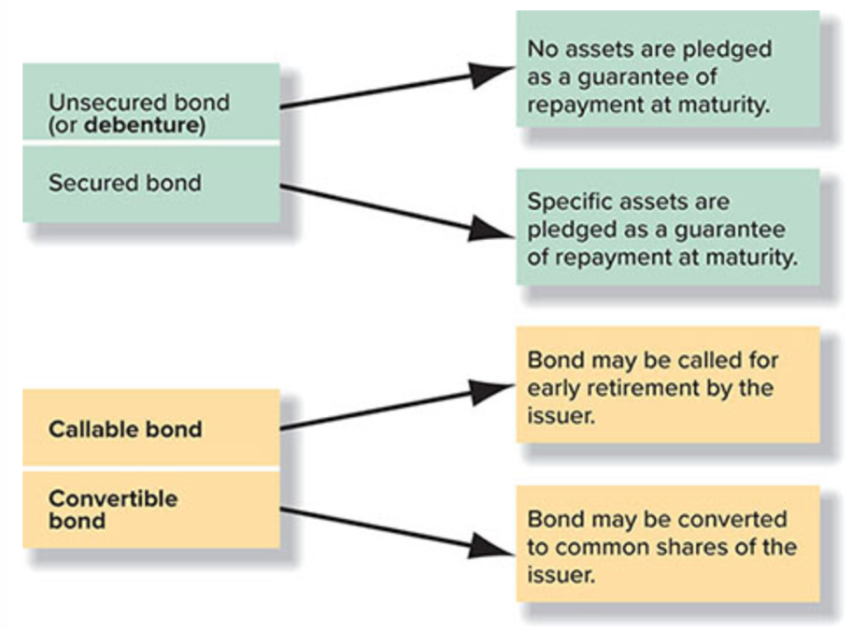
- Bonds always specify the stated rate of interest and the timing of periodic cash interest payments
- Bonds also can be issued and secured by the amount of revenues expected from the completed project.
- A company will issue an indenture (bond contract) specifies the legal provisions of the bonds issued
  - Includes the maturity date, rate of interest to be paid, date of each interest payment and any conversion privileges
- When a bond is issued, the investor receives a bond certificate
- An independent party called a trustee is appointed to represent bondholders’
  - The trustee is to ascertain whether the issuing company fulfills all of the provisions of the bond indenture

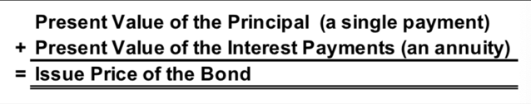
Reporting bond transactions:
the issue price of the bond is determined by the market, based on the time value of money
- The interest rate used to compute the present value is the market interest rate
- The stated (coupon) rate is only used to compute the periodic interest payments

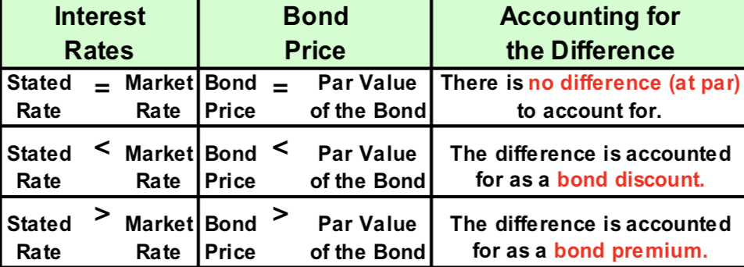

Cash interest payments:
- These payments are computed by multiplying the principal amount times the interest rate
  - Called the coupon rate stated interest on bonds

Creditors demand a certain rate of interest to compensate them for the risks related to bonds
- Called market interest rate (aka effective interest rate)
The present value of the bond may be the same as par, above par (a bond premium) or below par (bond discount)
- The relationship between the coupon rate and market value
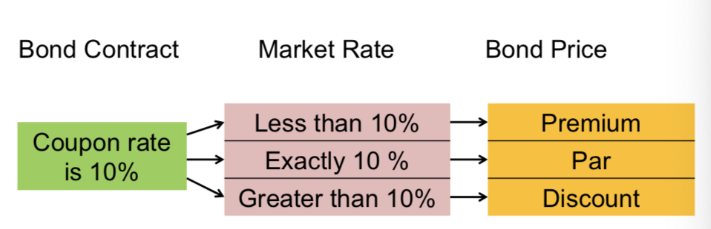

Bonds issued at par:
- Bonds sell at their par value when buyers are willing to invest in them at the interest rate stated on the bond

Bonds issued at a discount:
- bonds sell at a discount when the market rate of interest demanded by the buyers is higher than the stated interest rate offered by the issuer
- to compute the issue price of the bonds, we need to compute the present value of the future cash flows specified on the bond
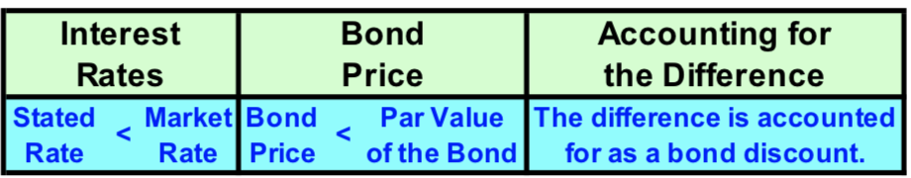

Bonds issued at a premium:
- bonds sell at a premium when the market rate of interest is lower than the stated interest rate
- The bonds payable account is credited for the par value and the premium is recorded as a credit to premium on bonds payable

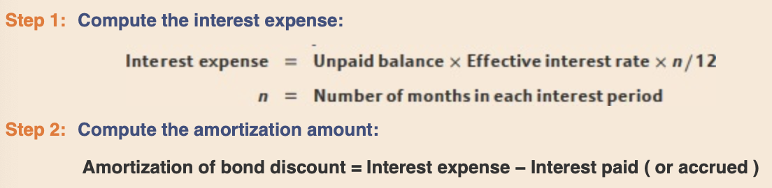
Effective-interest method interest expense for a bond is computed by multiplying the current unpaid balance by the market rate of interest that existed on the date the bonds were sold

Early retirement of debt:
- Retractable bonds may be turned in for early retirement at the option of the bondholder
- Convertible bonds may be converted to other securities of the issuer at the option of the bondholder

Lease liabilities:
- Operating lease does not transfer substantially the risks and rewards of ownership from the lessor to the lessee
- Finance lease transfers substantially the risks and rewards of ownership from the lessor to the lessee
- Satisfies the following:
- ownerships of the asset `are transferred to the lessee at the end of the lease term
- the lease contract provides the lessee with an option to purchase the asset in the future at a price that is expected to be sufficiently lower than its fair market value at the time the option becomes exercisable
- the lease term is for the major part of the asset’s economic life even if title is not transferred
- the present value of the minimum lease payments is substantially all of the fair value of the leased assets when the lease is signed
- the leased assets are of such a specialized nature that only the lessee can use them without major modifications

Employee retirement benefits:
- defined contribution plans
  - paying fixed amount each month and doesn’t know how much they will receive once they actually retire
- defined benefit plans
  - the company employing the individual will decide how much the individual earns based on how long they worked there for


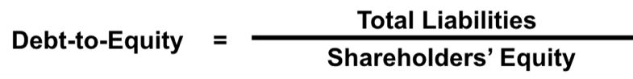
Debt-to-equity ratio:

Chapter 11

Benefits of share Ownership:
- A voice in management
- Dividends
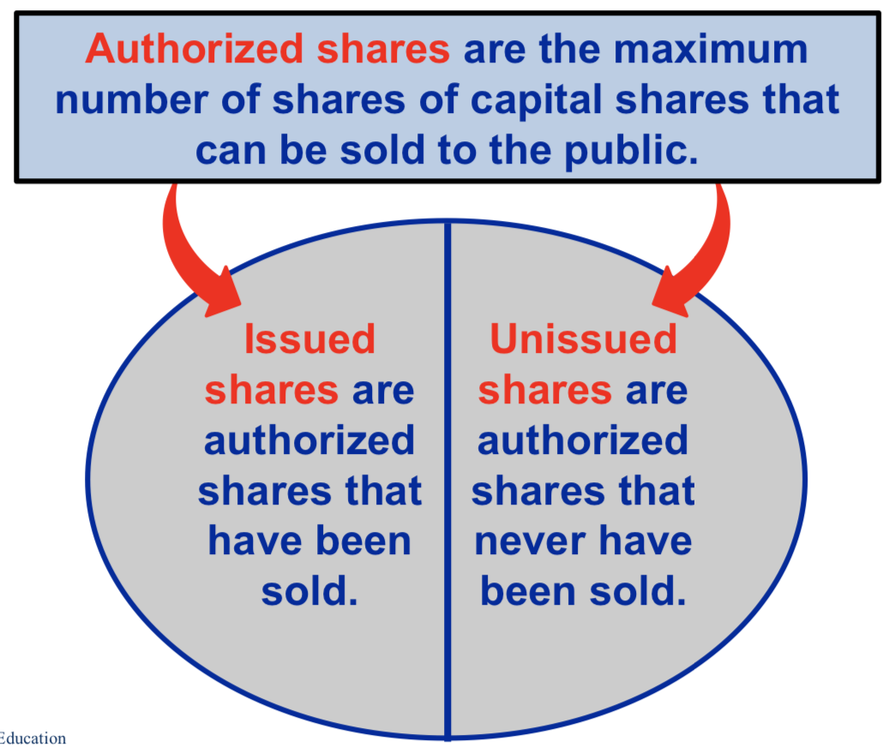
- Residual claim
- owners unlike creditors are able to vote at the annual shareholders’ meeting

Authorized, issued and outstanding shares:
- Authorized number of shares maximum number of shares that can be sold to the public (as specified in the articles of incorporation)
  - Many companies establish an unlimited number
- Issued shares and outstanding shares total number of shares that are owned by shareholders on any particular date and sold by the company
  - Determined by the corporation’s equity transactions
  - Considered to be outstanding shares

Repurchase of shares:
- Reduces the number of shares outstanding
- Can be used to meet obligations under stock option plans
- Can be repurchased and subsequently retired or cancelled
Journal entry looks like:
Dr common shares
Cr cash

2 classes of shares = common shares and preferred shares
- Differ in the rights that accrue to the shareholders
- Disclosed in the notes to the financial statements

Common shares:
basic voting shares issued by a corporation
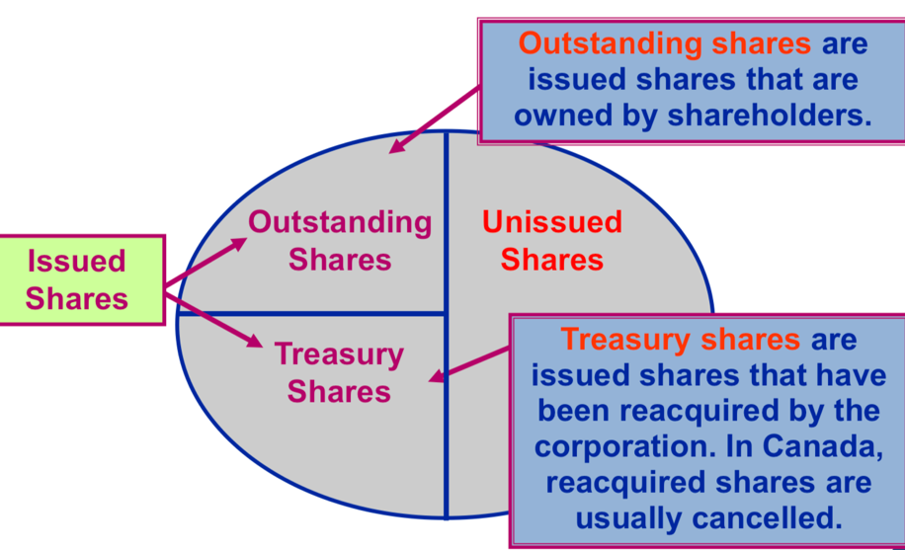
- Often called residual equity
- At least one class of a company’s common shares must have ALL three of the following rights:
  - Vote at meetings of the company’s shareholders
  - Receive dividends if declared
  - Share in the company’s net assets upon liquidation
Preferred shares preference over common shares, usually has voting rights, usually a fixed dividend rate
No par value and par value shares:
- Par value nominal value per share established in the charter of a corporation
  - No relation to market value per share
- No par value do not have an amount per share specified in the corporate charter
- Legal capital the permanent amount of capital

Cumulative preferred shares:
if a dividend is not declared in one year, the dividends carry over to the next year
any unpaid dividends from previous years (dividends in arrears) must be paid before common dividends are paid
Non-cumulative preferred shares:
lose any dividends that have not been declared in the current period
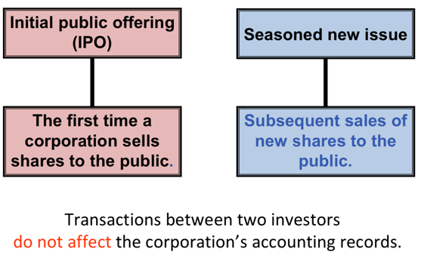
Initial sale of shares:
- An initial public offering involves the very first sale of a company’s shares to the public

Shares issued for non-cash assets or services:
- Record assets or services received at the market value of the shares given up at the date of the transaction
- If the market value of the shares cannot be determined, then the market value of the assets or services received should be used

Paying dividends:
- Companies are not required to declare dividends
- In order to declare dividends a company must have both
- sufficient retained earnings
- sufficient cash
Dividends on common shares:
- 3 important dates
- The declaration date when the board of directors officially approve the dividend, creates a dividend liability
- Date of record the date on which the corporation prepares the list of current shareholders, based on records
  - follows the declaration
- payment date the date on which the cash is distributed to pay the dividend liability
  - follows the date of record

Cash dividends:
- cash dividends entitle shareholders to cash payments and are the most common type of dividend
- paid only if the board of directors has voted to declare a dividend
- declaration results in a legal liability
- not paid on treasury shares
- paid only on outstanding shares

Redeemable vs retractable preferred shared:
- Redeemable preferred shares
  - Can be bought back by the company (retired)
  - Price and time are specified
  - Considered to be equity
  - Have fixed redemption dates that are classified as debts
- Retractable preferred shares
  - Can be sold back to the company (retired) at the option of the shareholder

Convertible preferred shares:
- Convertible at the option of the shareholder
- Can be converted into common shares based on the preset ratio

Stock Dividends:
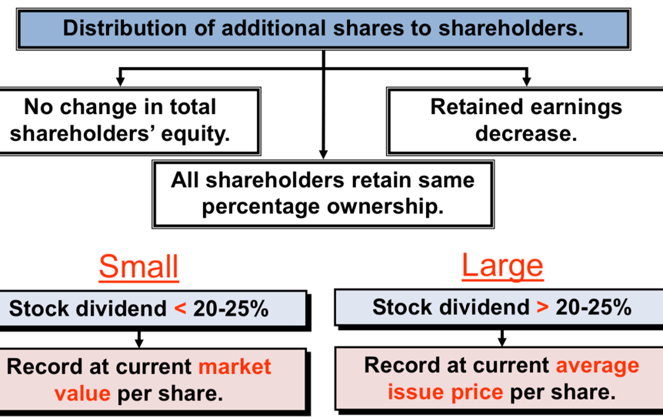
a distribution of additional shares of a corporation’s own share capital to its shareholders on a pro rata basis, at no cost to the shareholder
- you give the current shareholders more stock/shares and the company will issue more shares for free to the SHE
- the consequence of stock dividends:
- increase retained earnings
- increase in common shares
- “stock dividend” is sometimes a misused in annual reports and new articles
  - The value is the subject of much debate
  - For small amount that are less than 20-25 percent of the outstanding shares, the amount transferred from the retained earnings account to the common shares account based on the market price

Stock split splitting the stocks which increases the number of shares distributed
- EX - 2 for 1 (number of shares x 2)
- Doesn’t need a journal entry because there is no effect on the books
  - Just info to be noted down
- No change to the shareholder’s equity account

Earnings per share ratio:
- Same ratio as before except if there are preferred dividends, the amount is subtracted from the net earnings

Dividend yield ratio:
Dividend yield = dividends per share/market price per share
- Used to compare the dividend-paying performance of different investment alternatives

Equity financing:
-advantages:
- It does not have to be repaid
- Dividends are optional
- disadvantages:
- Ownership interests may be diluted
- Dividends are not tax deductible

Shares issued for employee compensation:
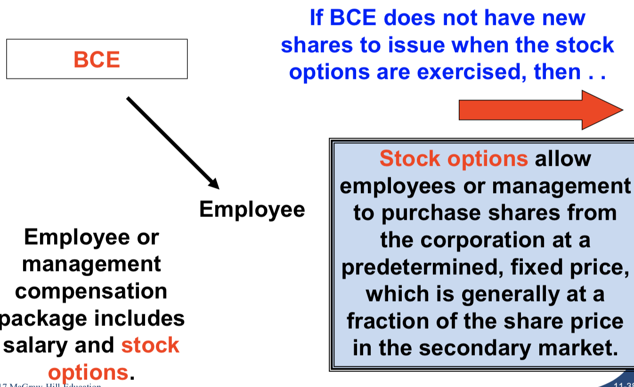

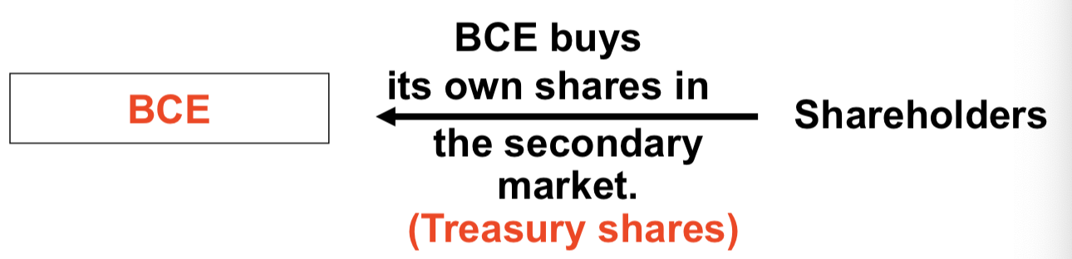
Repurchase of shares – treasury shares:
- Those that are not cancelled are called treasury shares
- A corporation records treasury shares at cost
- Treasury shares have no voting or dividends rights
  - Not an asset, contra-equity account

Chapter 12

Auditors:
Unqualified (clean) audit option the auditors’ declaration that the financial statements are fair presentations in all material respects in conformity with IFRS
Financial analysts receive accounting reports and include forecasts of share price and future quarterly and annual earnings per share
- Earnings forecasts predictions of earnings for future accounting periods

Users: institutional and private investors, creditors and others:
- Institutional investors private and public pension funds, mutual funds, endowments and trust funds, and charitable foundations
- Private investors individuals who purchase shares in companies, lack the expertise to understand financial statements and the resources to gather data efficiently
- Lenders (creditors) suppliers, banks, commercial credit companies and other financial institutions that lend money to companies

Press releases:
a written public news announcement normally distributed to major news services as soon as the figures are available
- also includes condensed, unaudited financial statements that form part of the formal quarterly report to shareholders, distributed after the press release

Annual reports:
- Basic financial statements
    - Statement of earnings, SFP, statement of changes in equity, statement of cash flows
- Related notes
- Report of independent accountants (auditor’s opinion)
- Public companies split it into 2 (non-financial section and a financial section)
- The financial section includes
  - Summarized financial data
  - Management’s discussion and analysis covering financial condition and results operations
  - Report of the independent accountants (auditor’s opinion) and the management report
  - The basic financial statements
  - Notes to the financial statement

Quarterly reports:
- Begin with a short letter to shareholders
- There is a condensed statement of earnings and a condensed SFP

Investment decisions:
- when considering an investment, the investor should evaluate the future net earnings and growth potential
- Economy wide factors
- Industry factors
- Individual company factors
- besides these factors, investors should understand a company’s business strategy

DuPont model:
- 2 strategies:
- Product differentiation offer products with unique benefits
- Cost advantage similar products with lower prices to attract customers
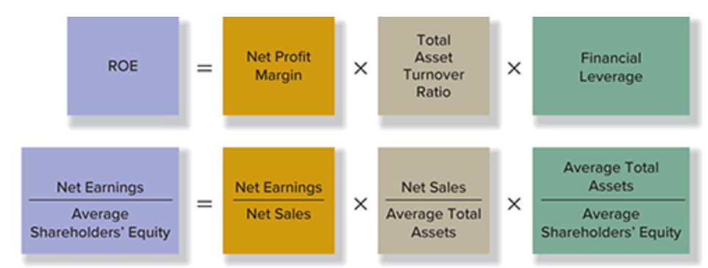

- A useful starting point for financial statement is the ROE profit driver
  - A logical relationship among 3 ratios (based on financial statement elements) = profit drivers
    - They describe the 3 ways that management can improve ROE
- The company is targeting a higher net profit margin against its competitors
  - Differentiation strategy
    - EX Holt Renfrew, Ogilvy’s, etc.
- When the asset turnover rate is high for the company, enhancing the use of the assets
  - Cost advantage strategy

Financial statement analysis:
- Management uses accounting data to make product pricing and expansion decisions
- External decision maker use accounting data for investment, credit, tax and public policy decisions
- Time series analysis information for a single company is compared over time
- Comparison with similar companies (cross sectional) this can help an analyst obtain better insight into its performance

Ratio and percentage analyses:
an analytical tool designed to identify significant relationships; it measures the proportional relationship between 2 financial statements amounts
Component percentages expresses each item on the financial statement as a percentage of a single base amount, the denominator ratio
- Net sales on the statement of earnings
- Total assets on the statement of financial position

Major ratio categories:
- Test of profitability
- Test of liquidity
- Test of solvency

Test of profitability:
compare net earnings with one or more primary activities
- profitability is a primary measure of the overall success of a company
- Return on equity
- Return on assets
- Financial leverage percentage
  - ROE - ROA
  - Measures the advantage or disadvantage that occurs when a company’s ROE differs from its ROA
  - Describes the relationship between the 2 returns
- Earnings per share ratio
- Quality of earnings ratio
- Net profit margin ratio
  - Also the gross margin ratio = sales revenues – cost of sales
- Fixed asset turnover ratio

Test of liquidity:
ratio that measures a company’s ability to meet its short-term obligations
- Cash ratio
- Current ratio
- Quick (acid test) ratio
  - Remove the prepaid and the inventory when calculating
- Receivables turnover ratio
- Inventory turnover ratio
- Accounts payable turnover ratio

Test of solvency:
measures the company’s cash flow and its ability to meet its long-term obligations
- Times interest earned ratio
- Cash coverage ratio
- Debt-to-equity ratio

Market tests:
ratios that tend to measure the market worth of a common share
- Price/earnings (P/E) ratio
- Dividend yield ratio

Other financial information:
- Rapid growth
- Uneconomical expansion
- Subjective factors

Information efficient markets:
- Efficient markets the price of a security fully reflects all publicly available information

Final Review

8 – how to measure and record acquisition costs
- subsequent costs
- 3 depreciation methods
- E8-2
- E8 – 22 = change in estimate
- p8-10 = how to record a disposal (calculating loss or gain)

9 – p9- 6 - how to record warranty provision
- gift card and redemptions
- changing long term to current portion

10 – extra problem 2 on moodle (when calculating use t-accounts)
- calculate the issuance price (with present values at issue and maturity value)
-

5 – p5-5
- E5- 7
-what affect accounts receivable and ??
- when there is a carrying amount there is no loss or gain on disposal
- dividends paid, interest paid and taxes paid on the cash flow statement

