Textbook Notes:
Financial Accounting
Chapter 1: The Financial Statements
Who uses accounting information?
- Individuals
- Investors and Creditors
- Government and Regulatory Agencies
- Taxing Authorities
- Not-for-Profit Organizations
How to do Accounting: Concepts and Principles
The Entity Concept: is any organization that stands apart as a separate economic unit.
Relevance Characteristic: The predicted value of feedback value of the information.
The Reliability Principle (Objectivity): Accounting records and statements are based on the most objective data available.
Relevance vs. Reliability: Appraisal of undeveloped land vs. historical cost of the land.
Understandability Characteristic: the user must be able to understand the information presented.
Comparability Characteristic: Users of financial statements should be able to compare different companies in terms of their operations and financial position.
The Cost Principle: states that acquired assets and services should be recorded at their historical cost.
The Going-Concern Principle: Assumes that the entity will remain in operation enough to use existing assets for their intended purposes.
The Stable-Monetary-Unit Concept: Assume that the dollar’s purchasing power is relatively stable.
The Accounting Equation:
Assets= Liabilities + Shareholder’s Equity
The Financial Statements:
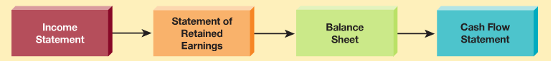
The Cash Flow Statement Measures Cash Receipts and Payments:
- Operating Activities: buying, selling goods and services to customers
- Investing Activities: invest in property, plant and equipment for use in operations
- Financing Activities: Issuing and repurchasing shares of stock and borrowing funds.
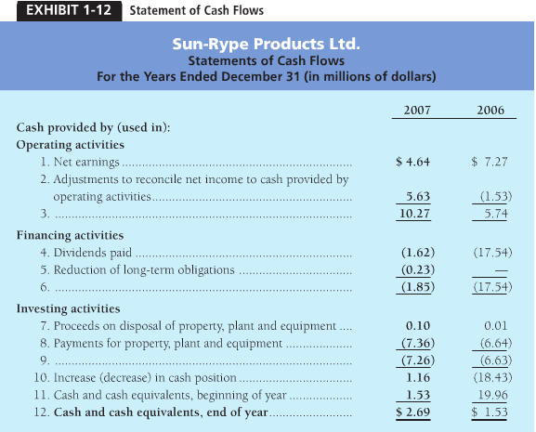
Relationship Among the Financial Statements:
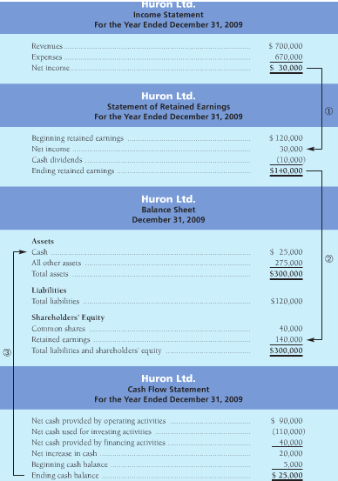
Chapter 11: The Income Statement and the Statement of Shareholder’s Equity
Earnings per share= $\frac{Net Income-Preferred Dividends}{Average number of common shares outstanding}$
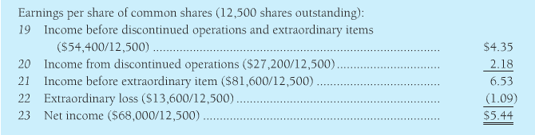
Chapter 3: Accrual Accounting and Income
Accrual accounting: records the impact of a business transaction as it occurs. When the business performs the service, makes a sale, or incurs and expense, the accountants records the transaction even if it receives or pays no cash.
Cash-basis accounting: records only cash transaction.
Accrual accounting and cash flows:
Accrual accounting records cash transactions, including:
- Collecting from customers
- Receiving cash from interest earned
- Paying salaries, rent, and other expenses
- Borrowing money
- Paying off loans
- Issuing shares
Accrual accounting also records noncash transactions such as:
- Purchases of inventory on account
- Sales on account
- Accrual of expenses incurred but not yet paid
- Amortization expense
- Usage of prepaid rent, insurance, and supplies
- Earning of revenue when cash was collected in advance
The Time-Period Concept ensures that accounting information is reported at regular intervals.
The Revenue Principle governs:
- When to record revenue
- The amount of revenue to record
The Matching Principle:
- Identify all the expenses incurred during the accounting period
- Measure the expenses, and match expenses against the revenues earned
The Adjusting Process
Categories of adjusting entries:
- Deferral: when the business paid or received cash in advance.
- Amortization: is the allocation of the cost of a capital asset to expense over the asset’s useful life.
- Accruals: an accrued expense is when an expense was recorded before paying cash. Examples. Prepaid rent and supplies expense.
Amortization of property, plant, and equipment:
Journal entries.
Furniture…………………………………………………16,500
Accounts Payable……………………….16,500
Amortization Expense……………………………..275
Accumulated amortization…………..275
Book value (balance sheet)
Furniture……………………………………………………16,500
Less accumulated amortization (275)
Book value of capital assets………………………..16,250
Accrued Expenses
Example of such an expense is if the payday ends up falling on the week-end, therefore the company will pay it on the following Monday. The following transaction will have to occur:
Salary expense………………….950
Salary payable………950
Accrued Revenue:
If the company is performing a service but is not being paid cash yet, the following transaction occurs:
Accounts Receivable……………. 250
Service Revenue…..... 250
Unearned revenue: an obligation arising from receiving cash before providing service.
Before performing the service:
Cash………………………………………………….. 450
Unearned Service Revenue….. 450
After partially performing a service:
Unearned Service Revenue……………….. 150
Service Revenue…………………….150
To record unearned service revenue that has been earned (450*1/3)
Summary of the adjusting process
Two purposes of the adjusting process are to:
- Measure income
- Update the balance sheet
Therefore, every adjusting entry affects at least one
- Revenue or expense- to measure income
- Asset or liability- to update the balance sheet.

Temporary Accounts: include revenues and expenses and dividends. These accounts get closed at the end of the year.
Permanent accounts are assets, liabilities and shareholder’s equity.
Current Ratio: $\frac{total current asset}{Total current liabilities}$

Debt Ratio: $\frac{total liabilities}{total assets}$

Chapter 4: Internal Control and Cash
Internal Control
- Safeguard assets and records: if you fail to safeguard your cash, it will slip away.
- Encourage employees to follow company policy: everyone in the organization must work towards the same goal
- Promote operational efficiency: eliminate waste, and increase your profits.
- Ensure accurate, reliable accounting records: you could be losing money on every product you sell—unless you keep good records for the cost of your products.
- Comply with legal requirements

The Components of internal control:
- Control environment: top management must show a good example
- Risk assessment: a company must identify its risks
- Control procedures: to ensure that the business goals are achieved
- Monitoring of controls: companies hire auditors to monitor their controls
- Information system: is critical to accurate information
Internal Control Procedures:
- Competent, reliable and ethical personnel
- Assignment of responsabilities
- Proper authorization
- Separation of duties: Separate operations from accounting and separate the custody of assets from accounting
- Audits
- Documents and records
- Electronic devices used for safeguarding assets
- Other controls and security measures
Internal Controls for E-commerce
Pitfalls:
- Stolen credit card numbers
- Computer viruses and Trojan Horses
- Phishing expeditions
Security measures
- Encryptions
- Firewalls

The Bank account as a control device
- Signature Cards
- Deposit Slips
- Cheques
- Electronic Transfer funds (ETF)
- Bank Statements
- Bank Reconciliation

Bank Reconciliation:
A document explaining the reasons for the difference between a depositor’s records and the bank’s records about the depositor’s bank account
Preparing a Bank Reconciliation
Bank Side of the Reconciliation:
- Deposit in transit
- Outstanding cheques
- Bank errors
Book Side of the Reconciliation:
- Bank collections
- Electronic Transfer Funds (ETF)
- Service charge
- Interest Revenue
- Nonsufficient funds (NSF) cheques
- Cost of printed cheques
- Book errors
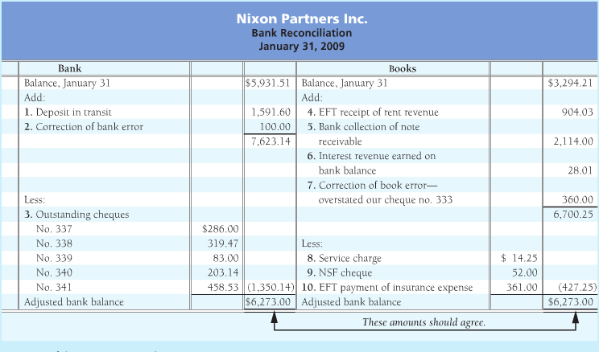
Internal Control over Cash Receipts
Cash receipts over the counter: cash receipts makes it more difficult for the cashier to steal cash.
Cash receipts by mail: discourages theft.
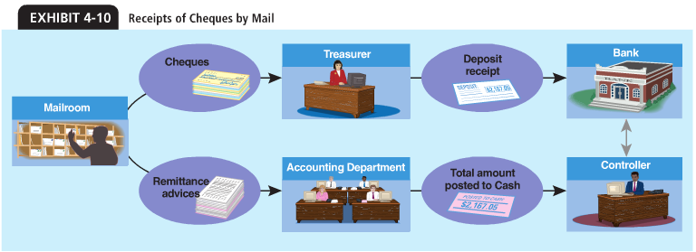
(The transactions are verified by two sources, ensuring that everything is accounted for.)

Internal Control over Cash Payments:
Controls over payment by cheque
- Cheque provides a record of the payment
- Cheque must be signed by authorized official
- Before signing the cheque, the official should study the evidence supporting the payment

Controls over purchase and payment
For good internal control, the purchasing agent should neither receive the goods nor approve the payment.
Companies split the following duties:
- Purchasing goods
- Receiving goods
- Approving and paying for goods
Petty cash is used for minor transactions
Using a budget to manage cash
Budget: is a financial plan that helps coordinate business activities. Cash is the item that is budgeted most often.
- Start with the company’s cash at the beginning of the period
- Add the budgeted cash receipts and subtract the budgeted cash payments
- The beginning balance plus number 2= ending balance
- Compare the expected ending cash balance to the budgeted cash balance at the end of the period.
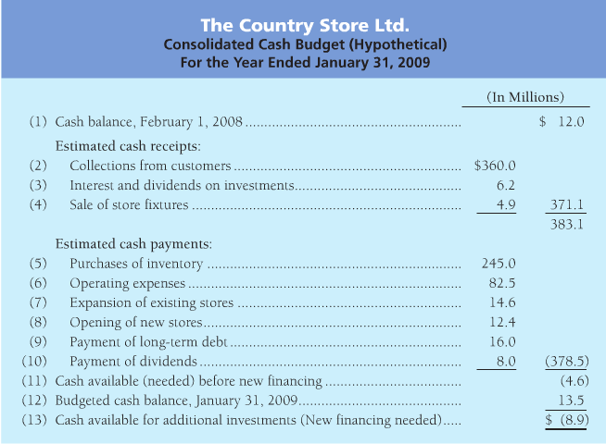
Reporting Cash on the Balance Sheet
Assets:
Current Assets:
Cash and cash equivalents…………………………………………………….. $158.8
(cash equivalents are liquid assets such as time deposits and guaranteed investment certificates. Slightly less liquid than cash, they are sufficiently similar to be reported along with cash)

Ethics and Accounting

Chapter 5: Short-Term Investments and Receivables
Short-term investments, also called marketable securities or temporary investments, are investments that a company plans to hold for one year or less.
Trading Investments:
The purpose of owning a financial asset held for trading investment is to hold it for a short time and then sell it for more than its cost.
Short-Term Investments…………………………………………….. 100,000
Cash……………………………………………………………….. 100,000
Cash……………………………………………………………………………. 800
Dividend Revenue…………………………………………… 800
Received cash revenue
Unrealized Gains and Losses
- Gain because the market value is greater than investment cost.
- Unrealized gain because it has not been sold yet.
GAIN
Short-Term Investments…………………………………………2,000
Unrealized Gain on Investments………………..2,000
Adjusted investment to market value
LOSS
Unrealized Loss on Investments…………………………..5,000
Short-Term Investments………………………….5,000
Adjusted investment to market value

Reporting on the Balance Sheet and Income Statement
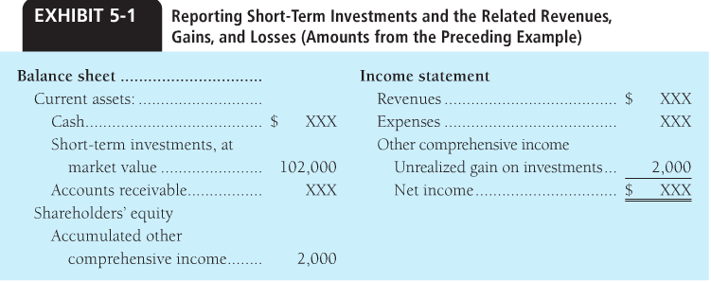
Realized Gains and Losses
Realized gain= Sale price greater than investment carrying amount
Realized loss= sale price less than investment carrying amount
Cash…………………………………………….. 98,000
Loss on sale of Investment………….. 4,000
Short-Term Investments….. 102,000
Sold short-term investment at a loss.
Lending Agreements and the Current Ratio
Lending often require the borrower to maintain a current ratio at a specific ratio, say 1.50
If it falls bellow:
- The lender can call for the loan for immediate payment
- If the borrower cannot pay, then the lender maybe take over the company
To increase the current ratio, you can
- Launch a major sales effort
- Pay off some current liabilities before year-end

Accounts and Notes Receivable
Accounts receivable: amount collectible from customers from the sale of goods and services. It is a current asset.
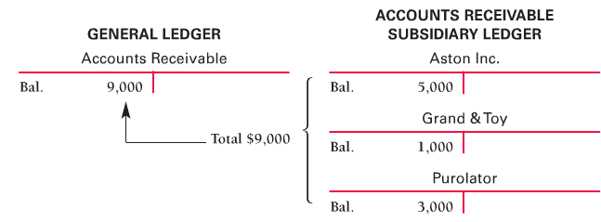
Notes Receivable: More of a formal contract. Borrower signs a written promise to pay the creditor at the maturity date. May require the borrower to pledge security. Which means collateral.
Accounting for Uncollectable Receivables
Selling on credit creates both a benefit and a cost:
- Benefit: Customers who cannot pay now buy on credit; companies profit and sales increase.
- Cost: The company will be unable to collect from some credit customers.

Allowance Method
Balance Sheet
Accounts Receivable xx
Less: Allowance for uncollectible accounts (XX)
Income Statement
Expenses:
Uncollectible-account expense XX

Percentage of Sales: computes uncollectible expense as a percentage of revenue.
Uncollectible-Account Expense (725,532*0.005)…………… 3,628
Allowance for Uncollectible Accounts………………. 3,628
Recorded expense for the year

Aging of Accounts Receivable:
Receivable from specific customers are analyzed based on how long they have been outstanding.
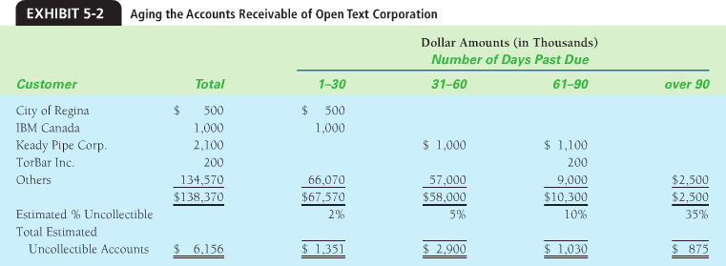
Writing off uncollectible accounts:
Allowance for uncollectible accounts…………………………………….2,300
Accounts receivable—Keady Pipe Corp. …………………2,100
Accounts receivable – Torbar Inc. ……………………………200

Combining Percentage of sales and aging of account method
- For interim statements: (monthly or quarterly), companies use percentage of sales because it is easier to apply.
- At the end of the year, companies use the aging of accounts method to ensure is reported at net realizable value on the balance sheet.
- Using both together works best
Direct Write-off
The company waits until it decides that a specific customer’s receivable is uncollectible. The it is written off.
Uncollectible account expense …………………. 2,000
Accounts receivable………………………2,000
Wrote off an uncollectible account by direct write-off method
- Does not set up for allowance
- Causes poor matching from expenses to revenue
Notes Receivable
1 year or less= current asset
1 year +=long term asset
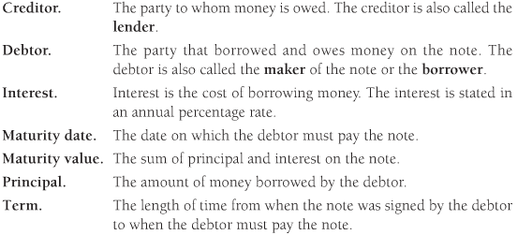
Accounting for Notes Receivable:
Note receivable – L. Holland………………………………………… 1,000
Cash…………………………………………………………………. 1,000
Made a loan
Interest Receivable ($1,000*0.09*4/12)…………………… 30
Interest Revenue………………………………………… 30
Accrued Interest Revenue
Cash…………………………………………………………………………1,045
Note Receivable……………………………………….. 1,000
Interest Receivable…………………………………… 30
Interest Revenue (1,000*0.09*2/12)…………. 15
- Principal*interest rate*time= amount of interest
- The time element (4/12) is the fraction of the year
- Interest if often completed for a number of days.

If a company wants to extend their accounts receivable to a note payable, they complete the following transaction:
Notes Receivable…………………………….. 5,000
Accounts receivable……………. 5,000

How to speed up cash flow
- Credit Card Sales
Cash…………………………………………. 485
Financing expense …………………… 15
Sales Revenue………………… 500
Recorded credit card sale
- Debit Card sale
Cash…………………… 64.48
Interact fee…………1.00
Sales revenue…….. 65.48
Record sale paid using interact
- Selling receivables
Cash……………………………………… 95,000
Financing Expense………………… 5,000
Accounts Receivables 100,000
Sold accounts receivables
Using two key ratios to make decisions
Acid-Test (or Quick) Ratio =$\frac{Cash+Temporary Investments+Net Current Receivable}{Total Current Liabilities}$
The higher the acid-test ratio, the easier it is to pay current liabilities.

Days’ Sales in Receivables =
Determines how long it takes to collect the average level of receivables. Shorter is better because cash is coming in quickly.
One days’ sale = $\frac{Net Sales}{365 days}$

Days’ sale in average accounts receivable= $\frac{Average net accounts receivable}{One days^{'}sale}$
= $\frac{\left(\frac{\left(beginning net receivables+ending net receivables\right)}{2}\right)}{one days^{'}sales}$

Chapter 6: Inventory and Cost of Goods Sold
Accounting for Inventory:
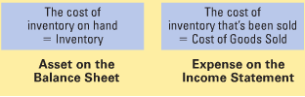
Other Categories of Inventory:
- Manufacturing companies have inventories of raw materials, work in process, and finished goods.
- Service companies have inventories of office supplies and other items.
Accounting Principles and Inventories
Consistency Principle: states that the businesses should use the same accounting methods and procedures from period to period. Consistency enables investors to compare a company’s financial statements from one period to the next.
Disclosure Principle: holds that a company’s financial statements should report enough information for outsiders to make informed decisions about the company.
Conservatism Principle: in accounting means that companies should ensure that assets, revenues, and gains are not overstated and that liabilities, expenses, and losses are not understated. They should be stated at their fair value
- Lower-cost-or-Market-Rule (LCM): is based on accounting conservatism. LCM requires that inventory be reported in the financial statement at whichever is lower—the inventory’s historical cost or its market value.
LCM write down decreases inventory and decreases COGS:
COGS……………………………………………….1000
Inventory…………………………….1000
Write down inventory down to net realizable value:
Net realizable value increased to 2400:
Inventory…………………………………………400
COGS………………………………….400
LCM is not optional. It is required by GAAP.
Sales Price vs. Cost of Inventory:
- Sales revenue is based on the sale price of the inventory sold ($500 per chair)
- Cost of goods sold is based on the cost of the inventory sold ($300 per chair)
- Inventory on the balance sheet is based on the cost of the inventory still on hand ($300 per chair)
Gross Margin is the excess of sales revenue over cost of goods sold. It is called gross margin because expenses have not been subtracted.
Inventory (Balance Sheet)= $\left(number of units of inventory on hand\right)*(Cost per unit of inventory$)
COGS (Income Statement)= (number of units of inventory sold)*(Cost per unit of inventory)
Accounting for Inventory in the Perpetual System:
- Periodic inventory system is mainly used by businesses that sell inexpensive goods. A dollar store, for example, may not keep a running record of every one of the hundreds of items they sell. Instead, these stores count their inventory periodically—at least once a year to determine the quantities on hand.
- Perpetual Inventory system uses computer software to keep a running record of inventory on hand. Today, most businesses use the perpetual inventory system. Even with this system, a manual check is done annually.

Recording transactions in the perpetual system
- When the company makes a sale, two entries are needed in the perpetual system:
- Company records the sale, debits cash and accounts receivable and credits sales revenue for the sale price of the goods.
- Also debits COGS and credits Inventory for the cost of the inventory sold
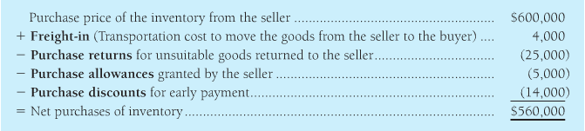
Purchase return: is a decrease in the cost of inventory because the buyer returned the goods to the seller.
Purchase allowance: decreases the cost of inventory because the buyer got an allowance (a deduction) from the amount owed often because of a merchandise defect.
Purchase discount: a decrease in the cost of inventory that is earned by paying quickly.
NET PURCHASES=
PURCHASES
-PURCHASE RETURNS AND ALLOWANCES
-PURCHASE DISCOUNTS
+FREIGHT-IN
NET SALES=
SALES REVENUE
-SALES RETURNS AND ALLOWANCES
-SALES DISCOUNTS
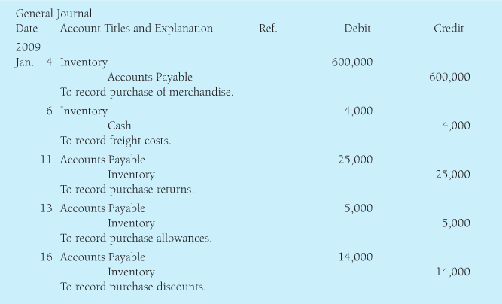
Inventory Costing
The cost of any asset, such as inventory, is the sum of all costs incurred to bring the asset to its intended use, less any discounts.

Various Inventory Costing Methods:
- Specific unit cost
- Weighted-average cost
- First in, first-out (FIFO) cost

- Specific unit cost
Also known as specific identification method. Each unit has a specific price.
- Weighted-Average Cost
Determined by
Weighted-average cost per unit= $\frac{Cost of goods available^{'}}{Number of units available}$
Goods available’= Beginning inventory + purchases
- FIFO Cost
First-in first-out method cost method, the first costs into inventory are the first costs assigned to the cost of goods sold.
Under FIFO, the cost of ending inventory is always based on the latest costs incurred.
- LIFO Cost
Last-in, first-out cost method. The last costs into inventory go immediately to cost of goods sold.
LIFO is not acceptable in Canada anymore, but is used in the USA.
The effects of FIFO and Weighted-Average Cost on COGS, Gross Margin and Ending Inventory.
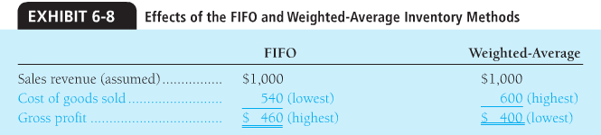
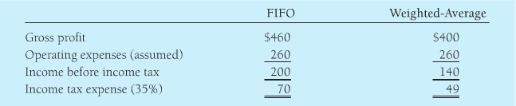
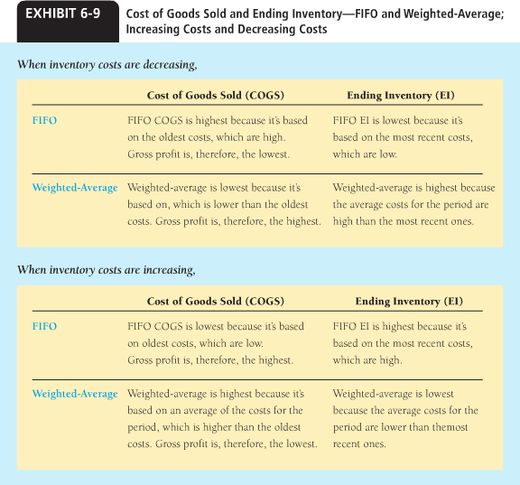
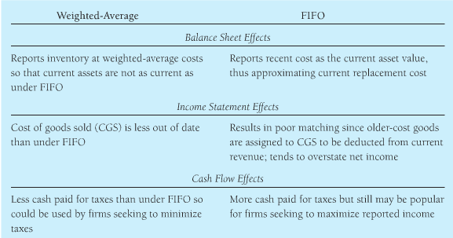
Inventory and Financial Statements:
Analyzing Financial statements:
Gross Margin Percentage: is a key indicator of a company’s ability to sell inventory at a profit. Merchandisers strive to increase gross margin percentage.
Gross Margin Percentage= $\frac{Gross Margin}{Net Sales Revenue}$
Inventory Turnover: the ratio of cost of goods sold to average inventory, indicates how rapidly inventory is sold.
Inventory Turnover= $\frac{\left(COGS\right)}{(\frac{\left(Beginning Inventory+Ending Inventory\right)}{2})}$
Additional Inventory Issues:
Using the COGS Model
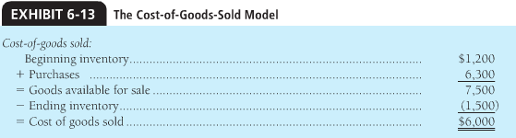
We inverse the COGS to estimate what the manager has to buy for the next period:
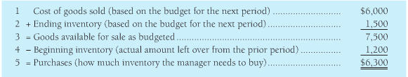
How much inventory should a business buy is an accounting question faced by all merchandisers.
Gross Margin Method
Is widely used to estimate ending inventory.
Effects of Inventory Errors
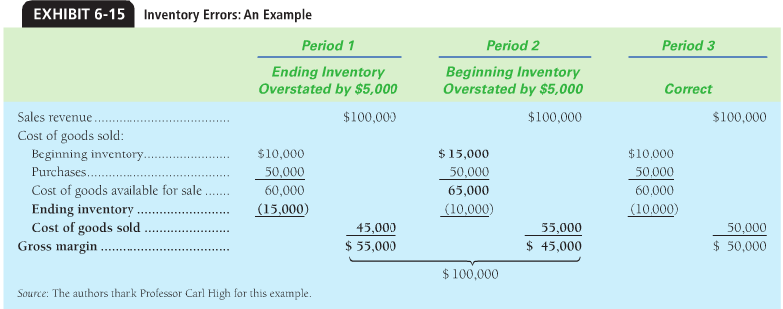
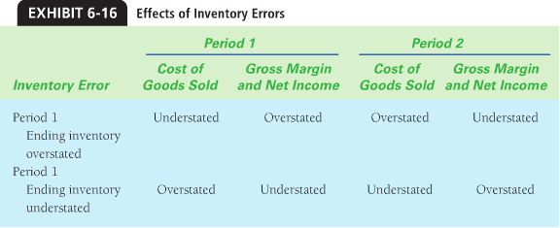
Chapter 7: Property, Plant, and Equipment, Natural Resources, and Intangible Assets
Type of Assets;
- This chapter focuses on the assets such as capital assets and intangible assets, and how to account for them and compute the amortization and expenses.
Measuring the Cost of Property, Plant and Equipment
Land
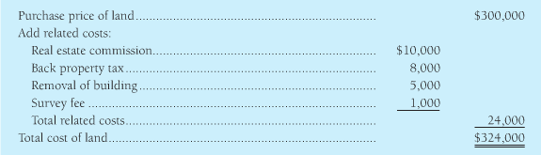
Note that if the owner were to pave a parking lot, it wouldn’t not be included in the land’s cost, but would be a land improvement.
Land…………………………… 324,000
Note Payable……………….300,000
Cash……………………………..24,000
To record the purchase of land
Lump-Sum Purchases of Assets
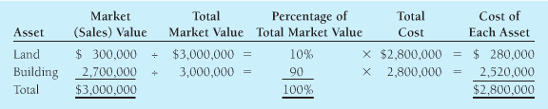
Capital Expenditures: Expenditures that increase the asset’s capacity or extend it’s useful life.
Example:
Capital expenditures:
-Major engine overhaul
-Modification of body for new use of van
Maintenance Expense:
-Repair of transmission
-Oil change
-Replacement tires

Measuring Property, Plant, and Equipment Amortization
Book Value= Cost- Accumulated amortization
Other than land, which has unlimited life, amortization is caused by
- Physical wear and tear
- Obsolescence: is when another asset can do the job more efficiently.

- Amortization is NOT a process of valuation: not based on market price!

- Amortization does NOT mean setting aside cash to replace assets as they wear out.

How to Measure Amortization:
- Cost
- Estimated useful life: length of service expected from using the asset.
- Estimated residual value: expected cash value at the end of its useful life
Amortizable cost= Asset’s cost – Estimated residual value
Amortization Methods:
- Straight-line
- Units-of-production
- Declining-balance

Straight-line Method= $\frac{Cost-Residual Value}{Useful life, in years}$

Units of production method= $\frac{Cost-Residual Value}{Useful life, in units of production}$

Declining-Balance Method=
- Compute the straight line amortization per year.
- Second, multiply the straight line rate by two to compute the DDB
- Multiply the DDB by the period’s beginning asset book value(cost less accumulated amortization)
- Determine the final year’s amortization amount, which is the amount needed to reduce the asset book value to its residual value.
The residual value should not be amortized but should be remain in the books until the asset is disposed of.
DDB differs because:
- Residual value is ignored initially
- Amortization expense in the final year is whatever amount is needed to reduce the asset’s book value to its residual value.
Comparing Amortization Methods:
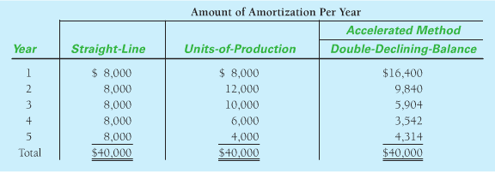
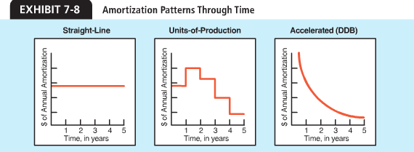

Other Issues in Accounting for Capital Assets
Changing the useful life of an Amortizable Asset
Assets Remaining amortizable book value+ (NEW) Estimable useful life remaining = (NEW) Annual amortization
Fully Amortized Assets: an asset that has reached the end of its estimated useful life.
Accounting for disposal of property, plant and equipment
Accumulated Amortization – Machinery……………………………………. 50,000
Machinery……………………………………………………………………… 50,000
To dispose of a fully amortized machine
If ‘junking’ an asset before it is fully amortized, the following applies:
Accumulated Amortization……………………………………………………. 3000
Loss on Disposal of store fixtures…………………………………………….1000
Store Fixtures…………………………………………………………….1000
Selling Property, Plant, and Equipment
Update Amortization:
Amortization Expense (10000/10 * 9/12)………………….750
Accumulated Amortization- Fixtures…………750

Cash…………………………………………………………….7000
Accumulated Amortization…………………………3750
Gain on Sale of Fixtures……………………..........750
Fixtures…………………………………………………..10000

Exchanging Property, plant, equipment
Delivery Auto (new)……………………………….. 27400
Accumulated Ammortization………………….16600
Delivery Auto……………………………………….20,000
Cash……………………………………………………..24000
Traded in old delivery van for a new one
Accounting for Intangible Assets
Patents
Patents………………….170,000
Cash……………170,000
To acquire a patent
Amortization Expense – Patents (170000/5)
Patents

Copyrights: is issued by the government and is amortized.
Trademarks and Trades names: Protected names such as Tim Hortons and ‘I am Canadian’. Amortized over its useful life.
Franchises and Licenses: privilege granted by a company or government to sell a service or product. Product life is indefinite, therefore not amortized.
Goodwill: defined as the excess of the cost of purchasing another company over the sum of the market values of its net assets.
Assets……………………………….. 189800000
Goodwill………………………………18900000
Liabilities……………………..97900000
Cash……………………………..110,800000

- Goodwill is only recorded when it is purchased in the acquisition of another company
- Goodwill is not amortized because it has an indefinite life.
Accounting for the impairment of and intangible asset
Goodwill Impairment……………… 13.5
Goodwill……………………………..13.5
To record an impairment

Reporting Property, Plant, and Equipment Transactions on the Cash Flow Statement
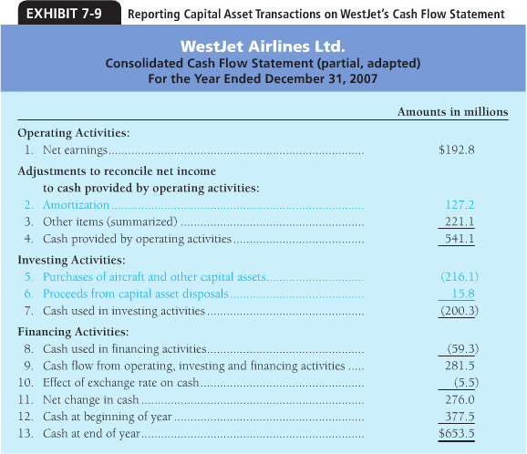

Chapter 8: Liabilities
Current Liabilities
Two types of current liabilities:
- Known amounts
- Estimated amounts
Current Liabilities of Known Amount
- Accounts Payable

- Short-Term Notes Payable: are notes due within one year.

Inventory…………………………………8000
Note Payable, Short-term…. 8000
Purchase of inventory by issuing a 6-month 10% note payable
Interest Expense (8000*.10*3/12)…..200
Interest Payable……………………200
Adjusting entry to accrue interest expense at year-end
Note payment:
Note Payable, Short-term………………… 8000
Interest Payable…………………………………200
Interest expense (8000*.10*6/12)……200
Cash………………………………………………..8400
- Goods and Services Tax Payable: a current liability as it is payable quarterly or monthly depending on volume of business
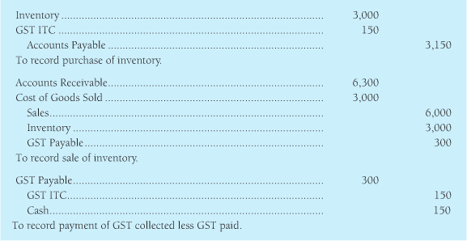
- Sales Tax Payable: applies to good and services that are purchased by a consumer, business and individual alike.
- Accrued Liabilities (Accrued Expenses):
- Salaries and Wages Payable
- Interest Payable
- Income Taxes Payable
- Payroll Liabilities: also called employee compensation, is a major expense. 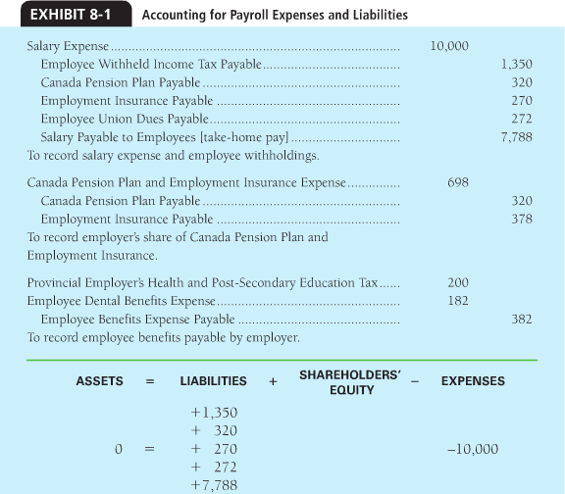
- Unearned Revenues: For all unearned revenue the business has received cash from customers before earning the revenue.
Example: Airplane tickets.
Cash…………………………………………………… 800
Unearned Ticket Revenue…………..800
To receive cash for plane fare (return) form
Unearned Ticket Revenue……………………...400
Ticket Revenue (800/2)………………800
To record revenue earned that was collected in advance.
- Current Portion of Long-term Debt: is the amount of the principal that is payable within one year.
Current Liabilities that must be Estimated:
- Estimated Warranty Payable: many companies guarantee their products under warranty agreements.
Warranty Expense………………………….. 6,000,000
Estimated Warranty Payable…….. 6,000,000
To accrue warranty expense

Estimated Warranty Payable……………. 4,800,000
Inventory…………………………………….4,800,000
To replace defective products sold under warranty
- Contingent Liabilities: is it a potential liability that depends on a future event arising out of past events.
Guidelines for contingent losses and their related liabilities:
- Record a liability if the loss is likely to occur
- If a loss is likely but cannot be estimated (law suit)

Summary of Current Liabilities:
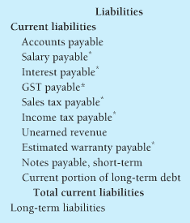
Long-Term Liabilities: Bonds
Bonds: A long-term note payable. Bonds payable are debts of the issuing company
- Types of Bonds: Mature at a specified time (maturity bonds), installments over a period of time (serial bonds). Secured, or mortgage, bonds give the bondholder right to the specified assets of the issuer. Unsecured bonds, called debentures, are backed only by the good faith of the borrower, therefore high interest.
- Bond Prices: the bond market in Canada is called the over-the counter market. 1000$ bond quotes at 100= 1000$. 1000$ bond quoted at 88.375= 883.75$
- Bond Premium and Bond Discount: Bond issued at a price above its face value is said to be issued at a premium. Bond issued at a price below face value is issued at a discount. As bond nears maturity, market prices move towards par.
- The time value of money: The amount that a person would invest at a present time to receive a greater amount at a future date is called the present value of a future amount. Example: 750= Present Value, 250=Interest, 1000=Future value.
- Bond Interest Rates determine Bond Prices: A bond market value is the bond’s current value. Two interest rates work to set the price of a bond:
- Stated interest Rate: the interest rate printed on the bond certificate.
- Market interest rate: is the rate investors demand for loaning their money. This market rate changes by the minute.
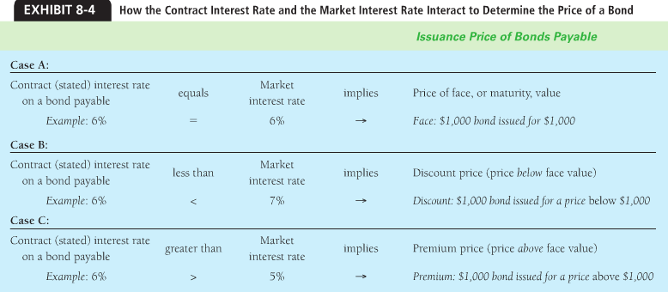

Issuing Bonds Payable at Face Value
Cash…………………………………..50,000
Bonds Payable………….50,000
To issue 6%, five year bonds at face value
Interest Expense……………………….1500
Cash……………………………….1500
To pay semi-annual interest (50,000 *0.06*6/12)
Interest Expense ………………………………………….. 1500
Interest Payable……………………………………..1500
To accrue interest
Bonds Payable………………………………………. 50,000
Cash………………………………………………….50,000
To pay bonds payable at maturity.

Issuing Bonds Payable at a Discount
Cash……………………………………………….. 96,149
Discount on Bonds Payable………………3851
Bonds Payable…………………………………100,000
To issue 9%, five year bonds at a discount.
**note: interest is calculated by full amount.
Interest Expense on Bonds Issued at a discount
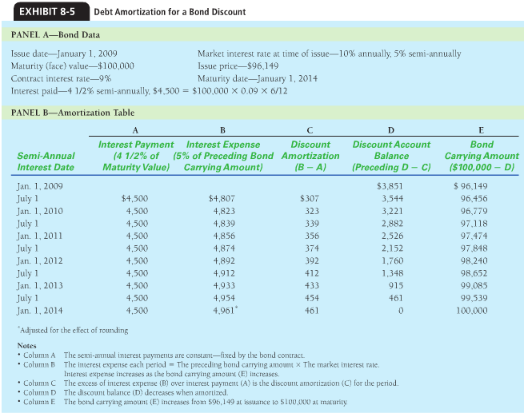
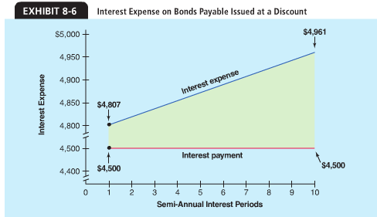
Interest Expense……………………………………………………..4807
Discount on Bonds Payable……………………………………307
Cash……………………………………………………………………….4500
To pay semi annual interest and amortize bond discount.

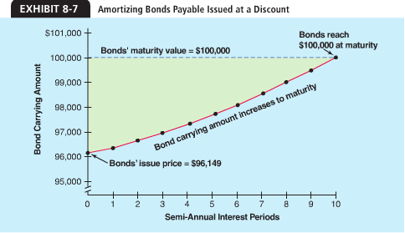

Issuing Bonds at a Premium
Interest expense………………………………………………….4164
Premium on Bonds Payable………………………………….336
Cash…………………………………………………………………….4500
To pay semi-annual interest and amortize bond premium
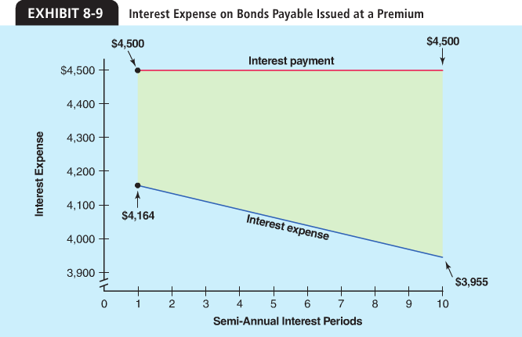
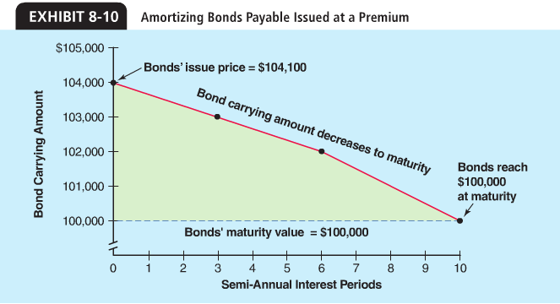

Retire Bonds (buy back early):
Bonds payable
Discount on Bonds Payable
Cash
Gain on retirement of bonds
To record the retirement of bonds
Convertible Bonds: Bonds that can be converted into company shares.

Financing Operations with Bonds or Shares?
- Financing by retained earnings: Means that cash is already available. It is a low-risk strategy
- Issuing shares: Creates no liabilities or expenses. It is less risky but more costly.
- Issuing Bonds or notes payable: does not dilute control of the corp. Higher earnings per share. Increases debt and risky for corp.

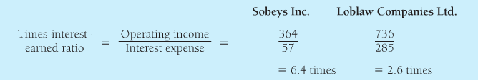

Long-Term Liabilities: Leases and Pensions
Types of leases:
Lease: is a rental agreement in which the tenant (lessee) agree to make rent payment to the owner (lessor) in exchange for the use of the asset.
- Operating lease: short-term of cancellable. Give the right to use but with no continuing rights. The lessee debits Rent Expense and Credits Cash. This indirectly creates a liability
- Capital lease: long-term noncancellable debt.
- The lessee is likely to obtain ownership of the asset because the lease contains a bargain purchase option.
- The term lease is 75% or more of its useful life.
Companies generally prefer operating leases because they don’t affect the debt ratio (capital lease the asset and liability is recorded)

Pensions and Post-Retirement Liabilities
Pension: an employee benefit that will be received during retirement.
At the end of each period, companies compare:
- The fair market value of the cash and investments in the pension plan
- The plans accumulated benefit obligation, which is the current promised value of the pension payments.
Reporting Liabilities on the Balance Sheet
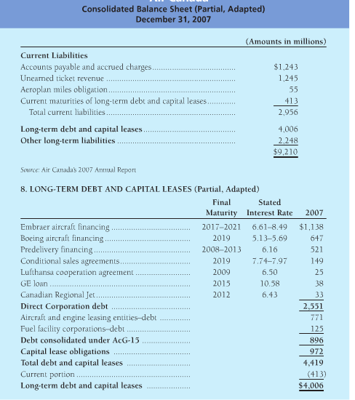
Reporting on the Cash Flow Statement
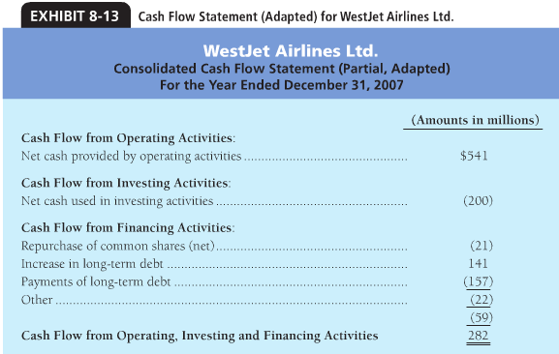

Chapter 9: Shareholder’s Equity
Corporation Traits:
- Separate Legal Entity
- Continuous Life and Transferability of Ownership
- Limited Liability
- Separation of Ownership and Management
- Corporate Taxation
- Government Regulation
Organizing a Corporation:
Shareholders’ Rights:
- The right to sell shares
- Right to vote
- Dividends
- Liquidation
- Preemption

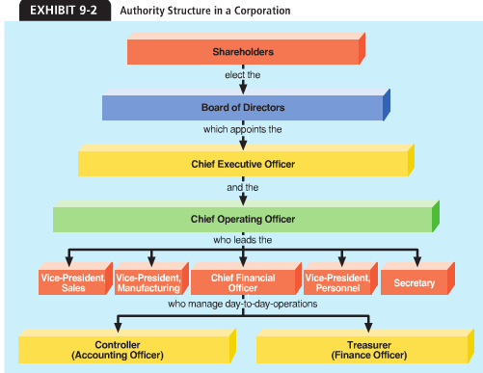
Shareholders’ Equity
- Contributed capital (capital stock): amount the shareholders have contributed to the corporation.
- Retained earnings: Amount the corporation has earned through profitable operations and has not used for dividends.
Outstanding shares: are shares in the hands of the shareholders.
Classes of Shares:
- Common shares
- Preferred shares: Receive dividends before the common shareholders and receive assets before also. Usually receive fixed dividends.
- No-stated-value shares: do not have an assigned value.

Issuing Shares:
Common shares:
Cash…………………………..100,000
Common shares…100,000

Equipment ……………………..4000
Building…………………..10000
Common shares…. 14000
To issue common shares in exchange for equipment and a building

Preferred Shares:
Cash……………………………….. 20,000
Preferred Shares (or Convertible Preferred Shares)…..20,000
Convertible Preferred Shares…………50,000
Common Shares……………….50,000
Investors converted preferred into common
Repurchase of Shares by a Corporation:
May repurchase because:
- Help support the shares current market price.
- Management wants to avoid a takeover

- Issuing shares grows a company’s assets and equity
- Repurchasing shares shrinks assets and equity (because in most cases they must buy them for more than they issued them for)
Common Shares…………………………… 7000
Contributed Surplus…………………….3000
Cash……………………………………………4000
Retained Earnings, Dividends and Splits
Deficit: when the retained earnings are a debit balance (at a loss)
- Cash Dividend
Retained Earnings………………………………………50,000
Dividends Payable……………………………50,000
Declare a cash dividend
Payment date, different from declare date, important
Dividends Payable………………………………….50,000
Cash………………………………………………….50,000
Paid cash dividend
Analyzing the Shareholder’s Equity Accounts
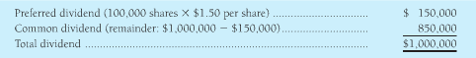
Limited voting right is sometimes granted to the preferred share, which are usually non-voting. Usually when the want to:
- Liquidate large portion of assets
- When company wants to merge with another
- When issuing new shares or bonds.
Call Provisions: When the company repurchases preferred shares at a predetermined price.
Preferred shares………………………………………………….100,000
Loss on call of preferred shares………………………………..2000
Dividends or Retained Earnings…………………………………3000
Cash………………………………………………………………………….105,000

Stock Dividends: when the company issues extra shares to you as a dividend.
They would do this to:
- Continue dividends, but conserve cash
- To reduce the per market share

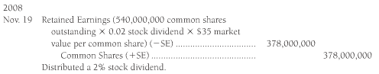
Stock Splits:
Doubles the number of shares. For example a 2:1 ratio.
Measuring the value of Shares:
Market price: price for which a person can buy or sell one share of stock.
Redemption value: the price that the corporation agrees to pay when issued
Liquidation value: value a company must pay a preferred shareholder in the event that the company liquidates
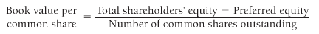
Return on Assets: measures a company’s success in using its assets to earn income for the two groups who finance the business:
- Creditors and shareholders
10% is considered a strong ROA
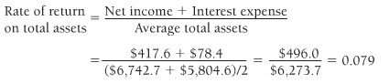
Return on Equity: Rate of return on common shareholders’ equity, shows the relationship between net income and average common shareholders’ equity. The higher the return the better. 15% is considered good.
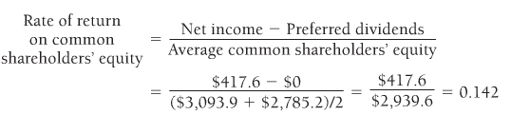
Reporting Shareholders’ Equity Transactions:
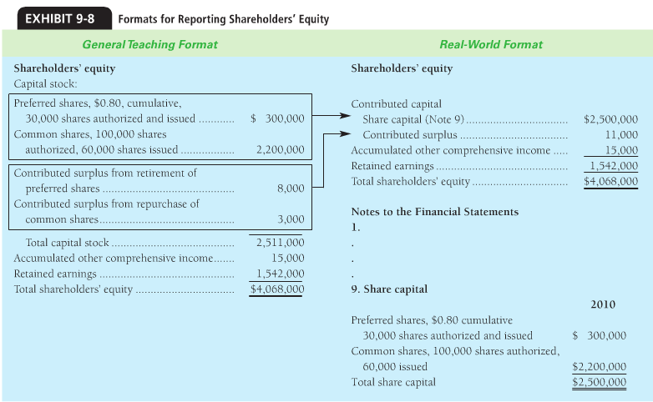

Chapter 12: The Cash Flow Statement
Basic Concepts: The Cash Flow Statement
Helps investors and creditors:
- Predict future cash flows
- Evaluate management decisions
- Determine ability to pay dividends and interest
- Show the relationship of net income to cash flows

- Operating Activities: Creates revenues, expenses, gains and losses--- NET INCOME. A successful business must generate most of its cash from operating activities
- Investing Activities: increases and decreases long-term assets, such as computers and software, land, buildings, equipment.
- Financing Activities: Shares, bonds, dividends

Two formats for operating activities:
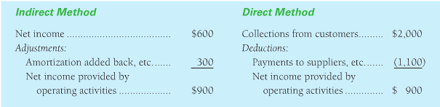
Preparing the Cash Flow Statement: Indirect Method
- Lay out the template in part 1
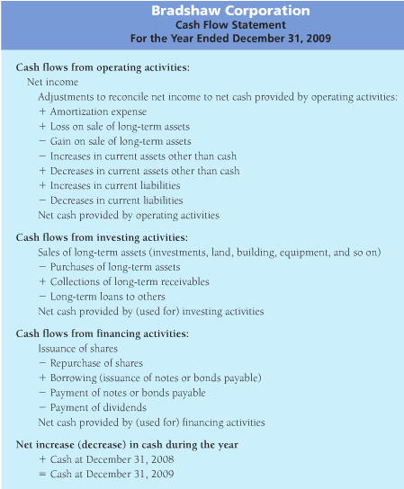

- Use the comparative balance sheet.to determine the increase or decrease in cash during the period. The change in cash is the “check fiqure” for the cash flow statement.
- From the income statement, take net income, amortization expense, and any gains or losses on the sale of long-term assets. Print these items on the cash flow statement.
- Use the income statement and the balance sheet data to prepare the cash flow statement. Cash flow statement is only complete once you have explained all the changes in the balance sheet account.
- Amortization Expense: because the amortization expense is not a cash transactions, it is added back to negate it, so the change in cash equals its correct amount.
- Gains and Losses on the sale of the long term assets: not sure…?
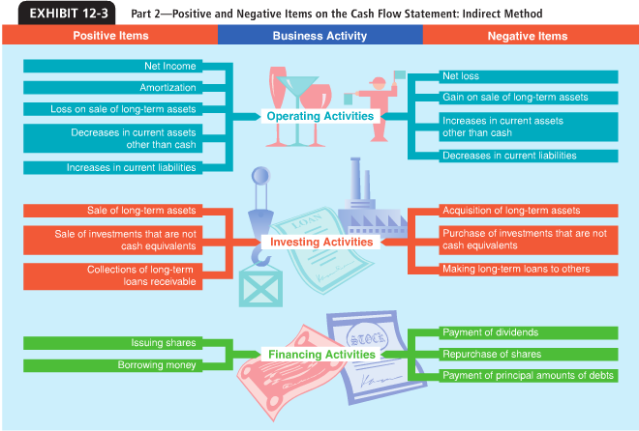
Changes in the Current Asset and Current Liability Accounts:
- An increase in another current asset decreases cash
- A decrease in another current asset increase cash
- A decrease in a current liability decreases cash
- An increases in a current liability increase cash

Preparing the cash flow statement: Direct Method
- Lay out the template of the cash flow statement of the direct method.
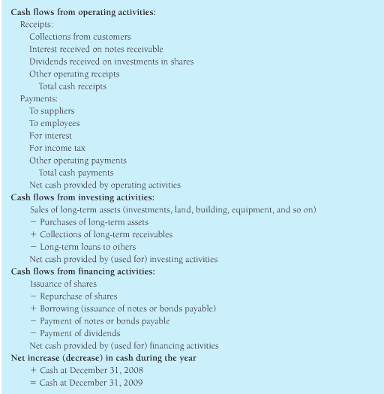
- Use the comparative balance sheet to determine the change in cash to find the check figure for the cash flow.
- Use the available data to complete the cash flow statement.
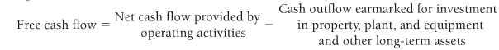

Chapter 13: Financial Statements Analysis
Horizontal Analysis: the study of percentage changes from year to year. Requires:
- Compute the dollar amount of the change from one period to the next.
- Divide the dollar amount of change by the base-period amount.
Example:
Sales 2007: 10645
Sales 2008: 10725
Change = 10645-10725 = 80
Percentage Change= dollar amount of change/ Base-year amount
= 80/10645= 0.8%
Trend Percentage: are a form of horizontal analysis. Trends indicate the direction a business is taking.
Trend %= Any Year $/Base-year $
Vertical Analysis: Shows the relationship of a financial statement item to its base, which is the 100% figure.

Vertical analysis %= Each income statement item/ Sales
Common Size Statement: each item is expressed as a percentage of the net sales amount.
Benchmarking: Is the comparison of a company to a standard set by others.
Benchmarking against a key Competitor:
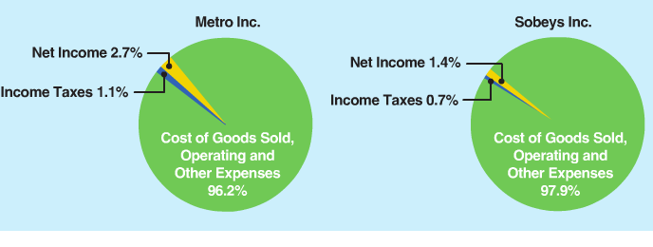
Using Cash flow statement as analysis:
- Shortage of cash can throw a company into bankruptcy, but lots of cash doesn’t ensure success.
- Ordinarily, net cash from operating activities should exceed net income because of the add-back from amortization.
- Cash flow signs of a healthy company :
- Operations are a major source of cash.
- Investing activities include more purchases than sales of capital assets.
- Financing activities are not dominated by borrowing.

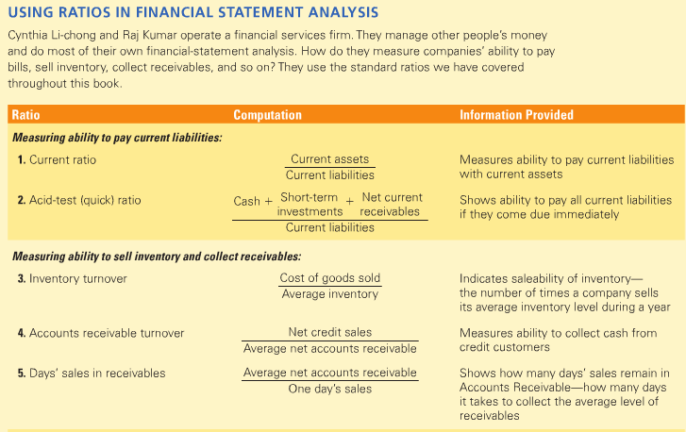
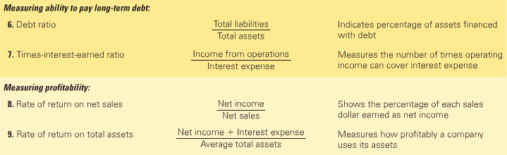
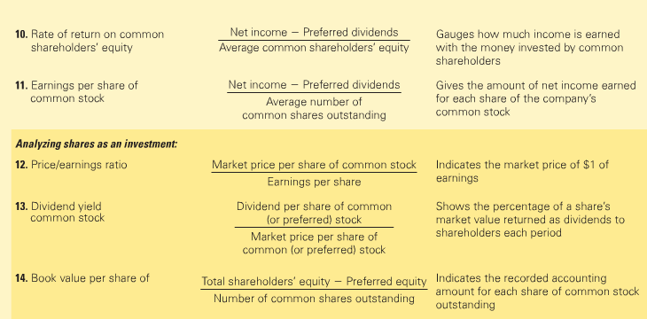

END OF NOTES

