GNG 1106 Lecture 3- Fundamentals of Engineering Computation

Modularization

- Makes a code easier to code and maintain
- Specific tasks are isolated and coded into separate modular subprograms (Function)
- Allows re-use of code elsewhere in order to avoid repetition

Built in Functions

- scanf() and printf()
- fabs(): computes the absolute value
- sine(): computes the sine of an angle
- pow(): computes the power of a number
- main(): a special “sub-program”, the main program
- We can also create our own function

Function in C
- It takes some input data
- It generates returns (output data)

parameterList
- List of input variables that receive data
- Individual declarations are separated by commas
- The list may be empty if the function takes no input

functionName
- The name of the function

aType
- The type of value returned by the function
- If empty, no return
- Variable declaration and commands are in “{}”
- No periods “.”

E.g. - Function with no argument and no return

Void hello(void)
{
printf(“Hello World!\n”);
}

E.g. - A function with argument but without return

void prtmax(int a, int b)
{
if (a > b)
printf("%d is larger.\n", a);
else
printf("%d is larger.\n", b);
}

E.g. - A function with both argument and return

Int max(int a, int b)

{
int larger=a;
if (b > a)
larger=b;
return larger;
}

Calling a function

- Can be made using the function a set of input values (if necessary)

Returning a function

3 ways:
- End of the function “}”
- Execute command “return;”
- Execute command “return expression;”

Program Memory and Programming Model

Typical Layout of Program Memory
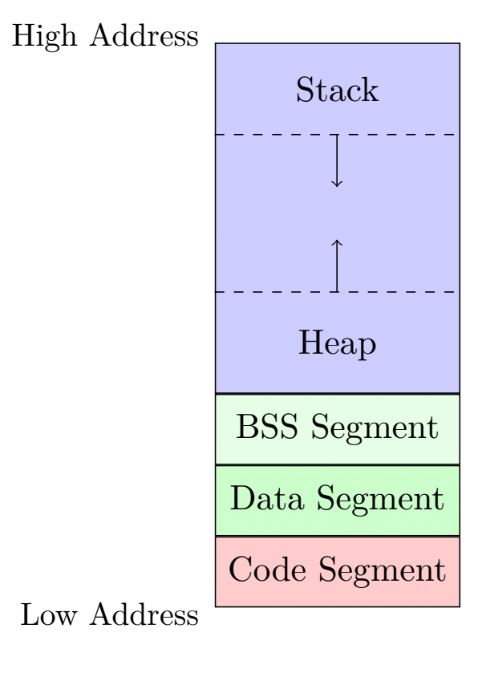
- Stack is for storing local variables during function calls.

- Heap is for dynamically allocated memory.

- BSS (Block Started by Symbol) segment stores uninitialized global or static variables.

- Data segment stores initialized global or static variables

- Code segment stores the program
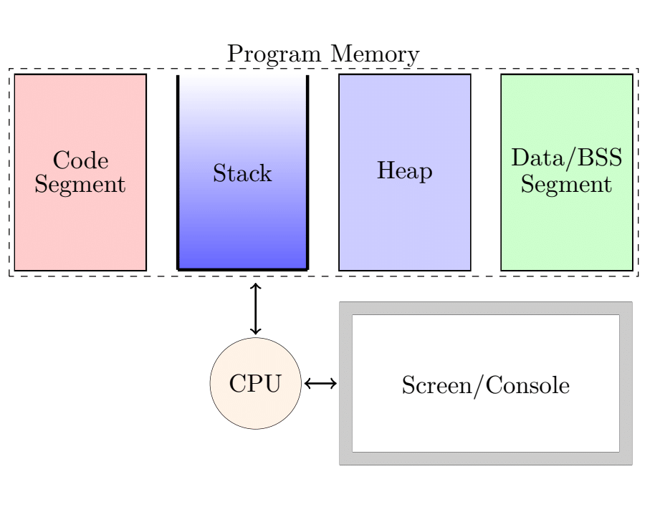

Binary Representation

- A set of rules are built-in to convert between numbers and bytes.
- Converting numbers to bytes is often called “encoding”.
- Encoding rules are machine-dependent.
- Two main classes of encoding rules:
- Fixed-point encoding
- Floating-point encoding

Fixed Point Encoding

- It essentially converts between bytes and integers.
- Ideas:
- 2 bits can represent 4 integers, e.g. 00 → 0, 01 → 1, 10 → 2, 11 → 3
- e.g. 00 → −2, 01 → −1, 10 → 0, 11 → 1

- In standard C, fixed-point types are char, short, int, long,
which are 1-byte, 2-byte, 4-byte and 8-byte encoding of integers.
- Each of these type also has an unsigned version (unsigned char
unsigned short, unsigned int, unsigned long), each encoding
only non-negative numbers.
- In C, numbers (formally, “literal values”) without including the
decimal point, such as “31”, “-10”, “0”, etc. are interpreted as
fixed-point numbers.

Floating Point Encoding

- converts between bytes and rational numbers
- In standard C, floating-point types are float (4 bytes), double (8
- bytes), long double (16 bytes).

Conversion Specifiers for scanf and printf

Type | printf | scanf
int | %d, %i | %d, %i
float | %f, %e, %E, %g, %G | %f, %e, %E, %g, %G
double | %f, %e, %E, %g, %G | %lf, %le, %lE, %lg, %lG
short | %d, %i, %hd, %hi | %hd, %hi

