CMN1148 – Introduction to Organizational Communications

Intro

- Verbal Communication
- Oral
- Written
- Non-verbal Communication
- Body
- Facial
- Images
- Good idea to combine verbal/non-verbal
  - Should not contradict each other
  - Ex: photo/video along with newscast of person speaking

SenderMessageReceiver

- The media does not present reality, they represent it relative to their own agenda
- Representations never reflect the entire reality
- Intra-personal communication: communication/organizing with yourself
- Media is the plural of the Latin word medium

Elements of Communication
- Message
- Medium
- Sender/receiver
- Feedback
- Encoding-decoding
- The sender encodes, the receiver decodes
- Feedback is important so the message is received/understood in a similar way

Chapter 1: The Communication Process
-Feedback element change models from one-way to two-way
-Communications: the process of simultaneously giving and receiving information, verbally or non-verbally
- This definition has all the basic elements of a model:
  - Sender
  - Receiver
  - Channel
  - Feedback
  - Common language
- Verbal Communication: You must have a common language, and avoid using jargon when communicating with large audiences
- Non-verbal Communication: Conveying a message using systems other than linguistics: body language, images, video.
- The best way to communicate is to combine verbal and non-verbal communication
- Elements should match and build on each other, not contradict information or mislead people. Ex: Lad Bible always using unrealistic images in thumbnails of their stories (clickbait)
- Public speaking: non-verbal communication, because it is not “face-to-face”.

Why do Models help?
- Provide a common vocabulary or jargon that allows us to talk about a topic
- Jargon helps us explain specific topics easier
- Models explain the communication process, and how we communicate
- Models give direction, how, why is something happening, why it is important to give feedback
- Models are not comprehensive, cannot only follow one model, every model is unique and important
- Visually depict relationships, arrows show direction/understanding
- Breakdowns: pinpoint reasons for breakdowns
- Noise: distorts message, any interference that distorts a message

Aristotle Model (4th Century BCE)
- A simple communication model with a sender transferring a message orally
- One-way and linear
- Focused on act of persuasion
- No opportunity for feedback from the audience
- Based on knowledge of demographics such as age and status
- Ex: Aristotle wants to persuade people about existence of a God
  - Speeches: Informative, persuasive, occasional
  - Audience: Passive, active/critical
- Passive audiences: take in information without question
- Active Audiences:
  - Verify, challenge, and question information
  - Make sure message is honest/faithful
  - Evaluate the source, research, google
  - Be critical not passive
- Occasional Speech: Wedding speech, convocation speech
- Must have a sense of humour, knowledge, and language.
- 3 kinds of Appeals
  - Ethos – Appeals based on credibility of speaker, is he/she an expert?
  - Logos – Appeals based on logic
  - Pathos – Appeals based on emotion
- Ethos, introduction before speeches, to introduce expert in their filed. Can I trust you? Safety and trustworthiness, expertise and experience.
- Sociability, charisma, human, leader
- Dynamism: able to answer questions, flexibility, elaborating on said questions
- Since you are an expert, you don’t have to stick to the script
- Practice
- Logos – Persuasive speeches must rely on logic, due to its argumentative nature. You must prove your arguments with evidence
- Speakers use of evidence can include examples, statistics, stating POV
- Speakers use of argumentation and reasoning to support POV, if you state causes, you must also state effects
- Use of symbols/analogies can help support position
- Logos is about evidence (logic)
- Pathos – Required, but do not exaggerate. Emotional scale should be relative to the story. Be objective.
- A mother losing someone in a car crash is going to be a sad article, no need to exaggerate sad elements.
- Facebook ads do this all the time
- Communicators make emotional appears based on: fear, compassion, pride, guilt
- Appealing to fear: Trump saying bad things will happen if we don’t build a wall. Important not to go too far/exaggerate fear
- Emotions alone stimulate physical changes to the body, listening to emotion, adrenaline levels rise, makes you hyper, makes you act
- Can result in violent action, ex: political protests turning violent

- To be ethical, message should be based on facts and proof, not only emotions. Do not lie and use fear to persuade people, clouding the judgement of others

Lasswell’s Effect Model (1948)
- Linear model
- Added channels and effects
- Often applied in political contexts
- Propaganda

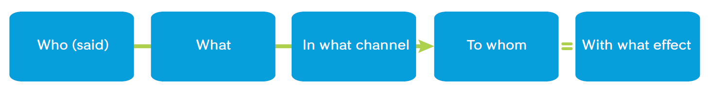

- Lasswell focused on de-construction messages
- Used in WWII for propaganda

Shannon-Weaver Mathematical Model (1949)
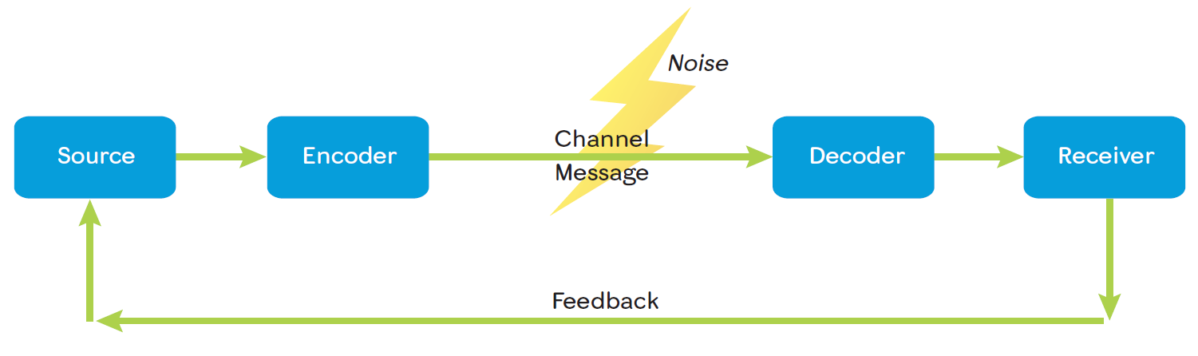
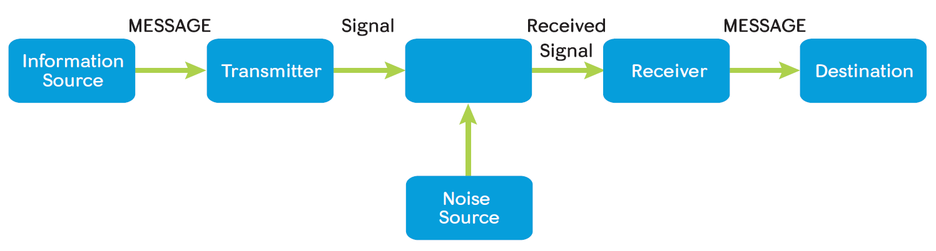

- Extended Aristotelian Model
- Feedback makes the model interactive, 2-way communication
- Noise source appeared in 1949 for the first time
- Noise can be physical, physiological, or psychological
- Anything that distorts/prevents messages

Feedback
- Original model of S.W. is linear, and the second version is 2-way due to feedback
- Why Feedback? Receiver can now contradict, give feedback, suggest new pov
- Feedback is beneficial for sender
- Sender must take feedback seriously

- SW also added concepts of noise, which can be external or internal
- External Noises: Any external, environmental, source or sound, ex: construction
- Internal Noises: 2 types of internal noises: psychological and physiological
  - Psychological: thinking of personal problems, mood, life-events. Will affect information that you are giving/receiving. You will “hear” the message, but you are not listening
  - Physiological: if I have a cold, it will affect how I am receiving/giving information. Biological condition out of our control

Schramm Model (1965)
- Added idea that we can communicate with each other to the extent that we have shared “fields of experiences” (FOE)
- Language can be a FOE
- Endless communication, no one can identify where it starts/ends, a continuous process, an INTERACTIVE process

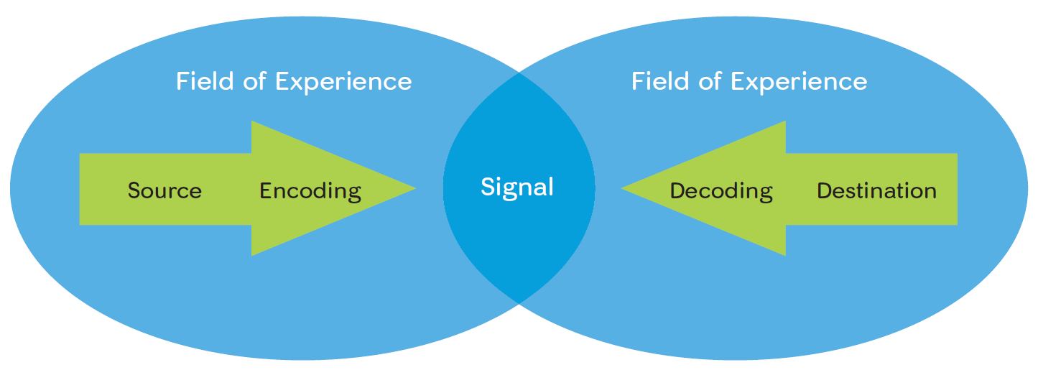

- Lack of shared FOE can create interruptions, questions all the time, won’t understand
- Schramm focuses on encoding/decoding; how we interpret and give information
- Does not include feedback in his model
- It is a circular process, moves away from one-to-one-to-one
- Shared FOE, you can send/receive easier when it agrees with our FOE
- To perform successful enc./dec., must have shared FOE
- Ex: 2 twins raised in different families, shared FOE will be lost regardless of being genetically identical
- This is NOT A COMPREHENSIVE MODEL, it lacks media/feedback/channels
Dance Model (1967)

- Combined idea of endless communication proves, no fixed start/end
- Dynamic, ongoing, unrepeatable, addictive, cumulative in effects
- Every message has an effect; at different levels
- Interpersonal Communication: communicating with
- yourself inside your head, Ex; stressing, planning, etc.
- Like Schramm, communications never end
- You are always involved in a communication process
- Dreaming: un-intentional interpersonal communication proves
- Not all communication is intentional
- Cannot go back and change the message, it is irreversible
- We are accountable for our spoken words
- Focus is how coms are endless, and does not contain many elements

Barlund’s Transactional Model (1970)
- Communicators (senders and receivers) act simultaneously as senders and senders and receivers, including verbal and nonverbal elements
- Can interchange roles simultaneously, no fixed senders and receivers
- Conversational communication involves switching roles simultaneously
- Offering feedback, both ways, only 1 type of noise
- Shannon/Weaver had 2 types of noise (physio/psycho)
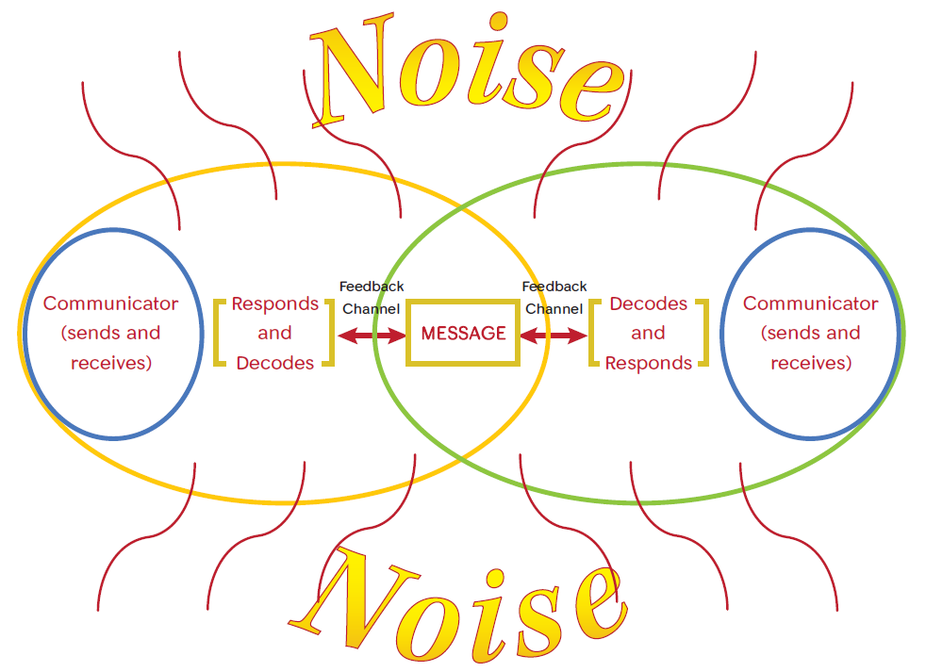

Ferguson’s Critical Communication Model (2006)
- Outcomes of Communication acts
- Based for judging costs
- Costs of achieving

- Outcomes of Communication Acts
  - Short term
  - Long Term
- Costs of Achieving
  - Individuals
  - Groups
  - Society
- Based for Judging Costs
  - Motives of the communicator
  - Means they employ
  - Ethical quality of outcomes

Costs of Achieving
- How are we going to communicate?
- Satellite, TV, internet, face to face
- Communication cannot be done without a cost. Resources are needed.
- Ottawa Sun:3-4k readers. Cannot afford a high cost message
- Globe and Mail: millions of readers, they have more money, resources, employees
- If expectation is high, the cost will also be high, so the message affects audience
Judging Costs
- What is the intent? Informative or persuasive
- Persuasive costs more money
  - Means employed: channels, media, a powerful and appropriate channel to convey a message
- Ethical quality of outcome:
- Lying and slandering in journalism
- Doctored images, manipulation of content is unethical
- Cannot ignore ethical proves
- Need ethical means of arguing information
- Good intentions don’t always mean you are safe
- Rely on many sources to obtain information. Do your research

What can we learn from these Models?
- Communication can be intentional or unintentional
- Intentional: you were prepared, a pre-meditated communication
- Unintentional: a conversation can start instantly, no preparation
- Relational Process: like a puzzle, relationship between all processes and elements, Arrows in all the models
- Fields of Experience: communications benefit from shared FOE
- Irreversible: you cannot delete an existing message, you can modify it but you cannot go back
- Dynamic: Sender can be a receiver and receiver can be a sender
  - Changes simultaneously, both verbal and nonverbal elements
  - The end of one process is the start of another
  - Never ending 24/7 process
- Environment: living in a democracy vs a regime, restrictions and censorship
- Noise: physio/psycho will distort/negatively impact messages, some we can control, some we cannot
- Power Dimension:
  - Gamification/Reward: if you do this, I’ll give you this
  - Legitimate: My title gives me the power, prof, dean, boss, etc.
  - Expert: Giving a speech on a topic of your own expertise, gain power by being an expert of your domain
  - Coercive: if you do not do this, I will punish you

What Can be Contributed to the Breakdown of a Message
- Speed: affects ability to comprehend, can only process info so fast, accents can also affect this
- Personality: If the sender has bad speaking/listening skills, messages can be poorly transmitted/received. Different types of audiences will affect this
- Linguistic: can you understand me? Different vernaculars among the same language. If you can’t understand, com process will break down
- Unfamiliar Jargon: Using specific language to an inappropriate audience. Speech about science to arts students will not go over well…” can you say that in English?”
- Expectancy: Expecting to hear something as receivers. If speaker does not reciprocate what we are expecting them to say, a breakdown can happen
- Redundancy: creates noise, avoid redundancy, unless you are emphasizing something, if not repeating will break process
- Painful Message: Receiver will shut down, and distort message. If someone doesn’t want to hear something, they will stop listening. This happens when someone is contradicting your values, and creates an example of
  - COMMITIVE DESSONANCE: Losing the audience by justifying your means
- AMBIGUOUS/NONSPECIFIC: “Trudeau Meets Trump” vs. “Trudeau discusses climate change with Trump”, one is a lot more specific than the other. A general message will be interpreted differently
Tips for Successful Communication
- Flexibility: Paraphrase, rephrase, dumb-it down
- Succinct/Clear: Use necessary words, don’t let extra words distract. Listening for non-verbal messages such as body language; facial expressions. Avoid jargon
- Wait for Feedback to END: Wait for someone to finish speaking before responding. Need to know when to listen/speak. Do not interrupt, enhance listening skills, know when to interrupt
- Formal language patterns: Be aware of non-verbal signals, unintentional, should be able to tell. Ask Qs, give feedback when you don’t understand. Find alternate ways of explaining a point and use reputation. Use analogies and comparison. Relate it to something they would understand.

Chapter 2: Perceiving Self in Relation to Others

- Self-Concept: relatively stable and organized collection of thoughts and feelings about the self, which lead to attitudes to drive behaviours.
- Self-concept begins to form at 6-7 months of age, when children see themselves as different from others. This is when personalities start to form, start to say NO. Making decisions based on wants/personalities

2 Concepts
- Self-Esteem, how we perceive our sense of value
- Self-Efficacy, how we perceive our ability to accomplish something

- Not being able to speak in public could be due to low self esteem
- If you don’t have required communication skills to give a speech, this could be due to low self-efficacy
Four Faces of Self Concept
- Self-image, how we see ourselves
- Looking glass-self, how we think others see us
- Ideal self, who we want to be
- Real self, who we really are
- When these 4 faces contradict each other, problems arise
- You will be in an internal conflict with yourself

Self-Image
- Image of how you perceive yourself
- Always a basis, which is opinions from significant others; parents, friends.
- Inner voice is important for:
  - Developing storylines to guide us through life
  - Getting ideas from 1st and 2nd hand experience and memories
  - Identifying on a psychic level with settings and places
  - Understanding that life scripts can be positive or negative when unfolding
  - 80% of our self-concepts comes from the media
  - first and second hand experiences reinforce media’s influence
  - Setting and places can make you feel better or worse, but it’s all about your inner voice, what your brain says
  - +/-: Don’t always think of the negatives aspects of your self-concept. This will make your self-esteem very low. If you focus on positives, your esteem and efficacy will rise and you will succeed more.
- Revising life scrips:
  - Focus on recognizing when scrips become outdated
  - Revising scripts is interpersonal communication
  - Let go of negative scripts, focus on the positives, and try to change or replace negatives ones
  - Role transitions: take advantage of new environments/roles. Different roles impose revision of life scripts.
  - Based on facts, experience, interactions
  - Biological: aging, bad health, disease, these all affect self-esteem and self-concept

Looking Glass Self
- Views are influenced by how we think others see us, including significant others who may or may not see us that way
- Significant other are people whose opinions matter to us
- Have a direct influence on how we perceive ourselves
- People telling you that you are not something will force re-evaluation
- Self-fulfilling prophecy: refers to a way by which expectations of others can influence expectations of self
- Others influence you easier if you have low self-concept. Do what your friends say/validation
- Our expectations fluctuate based on others
- SOs can include: parents, peers, coaches, teachers, spouses, partners, etc.

SOs
Parents/Friends
- 1st born receive different messages from parents.
- They then try to play parental roles for the second born
- Opinions of peers, who influence how we see ourselves and our abilities
- Children with low self-esteem tend to have trouble with relationships as they age
Teachers/Coaches
- Expectations of teachers affects students’ performance
- Teachers can evaluate students based on how they interact/don’t interact in class
- Teachers feedback/comments can influence how you interact in class
- Sports: same thing for coaches/players
- Caregivers, doctors can affect SE/SC especially dealing with chronic illnesses, should be positive even though everything is negative
Managers/Employers
- Managers have influence on workers, positive feedback encourages harder working
- Satisfied employees are important, if they are not happy, they will not have high efficiency
- Women pass up promotions, anticipate problems or failure
- Thinking negatively will affect performance

Chapter 3: Perception of Others

Perception
- The process of sensing, interpreting and reacting to the world
Five Vehicles of Perception
- Touch
- Taste
- Hearing
- Smell
- Sight
- These senses interact with each other to perceive how you react to a scenario
- Ex: restaurant, how you perceive your meal
- Reaction comes after the process

Perception is…
- Learned and backward looking, an on-going learning process
- Culturally bound and racially bias
- We feel bias for in-group and bias against out-group
- Selective and self-serving, we select messages we want to interpret
- Spontaneous, largely unconscious
- Relative and context bound
- Mood dependant
- Completion seeking

Learned and Backward Looking
- 5 senses, you can learn that a taste is a table after touching/seeing a table
- the more you use senses, the better your perception will have, and vice versa for less
- We learn through experience, optical illusions, we learn to read black on white, not white on black. Our past experiences lead us to see the picture a certain way
- Even after we see the vase, we still go back to the faces
Culturally Bound/Racially Bias
- Aboriginal people may experience time in a different manner than mainstream cultures
- Past is the same as present for Aboriginal People
- East Asians differ from westerners in the size of the perceptual fields, women cannot drive in other countries like they do here
- Perceptual Field: what you take in, Asians have a big PF, they look everything up and down and inspect to the last inch
- Americans will not do this due to their lower PF
- Optical communities: communities that perceive the physical world in the same way
- Our own race bias refers to being able to identify people of our race more easily, we are always backwards looking, “looking for our parents”
- Innocence projects have demonstrated own-race bias in the justice system
- If a judge has a similar race to the victim/defendant, there may be a conscious/unconscious race-bias
Selective and Self-Serving
- You chose to listen to specific sounds, touch things, taste, etc.*
- We see and retain certain kinds of information while ignoring other
- If you are scrolling through FB, somethings you read, some you scroll right past, share, like, etc.
- We are bombarded with 2M bits of information per second, our brain cannot process all of this, we are forced to only perceive specific messages
- *Selectivity: focus on what is meaningful for us
- We pay attention to and recall what makes us look better
- That’s why we try to become friends with doctors, lawyers, engineers
- We respond more to negative actions more than positive actions
- Ex; you could have the best friend in the world who has done so much good for you and it is ruined in one fight
- We need to push ourselves to find the silver lining in situations
- We judge ourselves more generously than we judge other people; we display a Self-serving bias
- Give ourselves more credit/benefit of the doubt, where if it were another person in our situation we would judge them as wrong
- For bad self-performance, we often blame others, and for good self-performance, we credit ourselves
Spontaneous and Largely Unconscious
- We use obvious cues to decide on personal characteristics
- We connect those characteristics to our personality (boring vs interesting)
- We use personality to anticipate behaviours (social v antisocial)
- We are most likely to perceive what we already believe to be the case
- Frist impressions are often wrong
Relative/Context Bound (7 main characteristics of perception)
- Gender
- Age, not the same mentally, biologically or physiologically
- Sexual orientation
- Ethnicity
- Income
- Religion/nationality
- Other demographic factors
Standpoint Theory (relative, context bound)
- Be aware of your position
- Tells us that we can never escape our place in the economic, social, and political order
- Our perceptions depend on who we are, where we are, and how we got to this place
- Media represents reality, and we perceive this reality
- If we watch the media, telling us about a culture, and we have not experienced this culture, if we believe this representation, we will build a perception of this culture
- This is how representation can help build perception, as perception is backwards learning and learned from past experiences
- If you are on a mountain, you can see a valley, but if you are in a valley, you can only see trees. Where you are standing can affect your perception of reality
- We must be critical thinkers, in order to evaluate and validate our perceptions
- If something does not make sense, we should search for more information on topics/cultures

Relative & Context/cultural Bound
- Perceptions are influenced by who we are and where we are coming from
- My prof. looks at UO as a job, career, whereas I see it as a place to get a degree, but it is still the same “thing”
- Standpoint theory, explains our background and experiences determine our perspective. It tells us that we can never escape our place in the economic, social, and political order. Social groups, education, race, religion, etc.
- We identify ourselves as individuals and as a part of a bigger group
- If someone is not able to identify themselves, they turn to the media. Unfortunately, the media can give you a ‘fake’ identity
- As well context, who we are with and what is happening, influences how we perceive
  - Ex: you cannot say the same joke to your friends as you would to your grandma. We perceive them in a different way, as they perceive us in a different way.
  - Ex: you are chatting w someone in a restaurant, you perceive them as a funny person. You meet the same person in a funeral, they are still telling funny jokes. Your perception changes due to the context, i.e. telling jokes at a funeral is inappropriate. Environment can change your perception of someone.
Mood Dependant
Benefits of positive mood
- When we are in a good mood we talk to everyone, welcome criticism, feedback, comments. When we are in a bad mood, it is the opposite. Reserved, against criticism.
- We perform better at work and perceive our leaders in more positive terms when we are in a positive mood
- We feel painless when we are in a good mood, productivity increases
- Mood contagion, phenomenon: we catch the moods of others; so if our leaders are in a good mood, we are more likely to be in a good mood and take that mood home with us
  - if your SO is in a bad mood, you can also catch that
  - How was your day? Good. Why? My boss was in a good mood. Other people’s mood can directly affect your perception
Benefits of negative mood
- Process information more accurately
- More likely to recall information
- More likely to detect deception
- We are less likely to place undue importance on first impressions, when you are in a bad mood, you know you are in a bad mood, you become aware that your first impression will probably be wrong due to your mood. It will drive you to re-visit your impression later when you are in a better mood, performing inter-personal communication
- When we are in a good mood, we are carefree and take messages as they are, don’t expect deception, do not “think” about messages
- This is the key to being a critical thinker/listener, having reasons, arguments, etc.

Perception is completion seeking (filling in missing info)
- The most obvious example is stereotyping
  - Ex: German student doing a PhD, you want to know more about German culture/interests. Perception is currently incomplete, you go seeking for missing info. Easiest way to do this is by adopting a stereotype, if you watched a movie saying Germans are lazy you will assume this guy is lazy. You did no real research.
- When we stereotype, we force-fit people into categories based on obvious cues = hair, skin colour, age, dress, etc.
  - Ex; People in x country are smart, people in y country are not. The problem is this is not a scientific, tangible measurement, therefore it cannot be accurate. You are only relying on stereotypes, probably represented by the media, perceived by you
- We rely on a limited number of experiences to fill in missing information
Facts about stereotyping
- Tied to nationality, ethnicity, age, gender, sexual orientation, and health.
- Based largely on accessible visual and vocal cues
- Not usually applied to friends and people we know well
- Helps us to know how to interact with unfamiliar situations with strangers
- Encourages discrimination
  - Ex: Costco, long line, someone in line is a visible minority, you avoid this lineup. When in fact, something may have happened to them to have them hold up the line. This is why we need to check our perceptions.
- Leads to poor outcomes, can lead to unwanted behaviours or actions due to our missing perceptions relying on stereotypes to fill missing information
- Stereotypes do not apply to people we know well, or SOs, because we build a perception as we get to know people well, through inter-personal communication, you are constantly validating and re-evaluating your perception. You do not NEED to adopt stereotypes of them, because there is no missing information to fill
Basis of Predicting stance on subjects?
- Physical qualities (age, gender)
- Occupation (student, part-time)
- Personality (visible indications of nervousness or seriousness, or how they interact with others)
- Add rest from slides
How can we combat stereotypes?
- Taking the other person’s POV (perspective taking), do not judge people without talking to them, without considering their situation, motivations, causes, COMUNCATE with them
- Focus on similarities, instead of differences (counter-stereotyping), even though from different cultures, we are all still human beings, and there is always middle ground, common interests
- Making contact with ‘out-groups’, all other different groups other than your ‘in-groups’, it is important to contact with outgroups because we are all in this together, you work with them, go to school with them, take the same bus as them. Do not apply a stereotype before you even talk to them
- Encouraging friends to avoid stereotyping, need to talk to peers, family, friends. If your friend is stereotyping a group, try to correct these views or make them conscious that they are stereotyping.
- Become ‘active perceivers’, always processing, evaluating, searching for reliable sources
Perception Errors
- Our perceptions are not always correct/true
- Primacy Effect
  - When all you pay attention to is the first information we are exposed to, this moves into long term memory. This is dangerous as your first impression of a culture is going to be hard-wired in your brain. You will apply conceived stereotype to every person of that culture
- Recency Effect
  - When we only pay attention to or remember the most recent information we are exposed to
  - Still present, but in short term memory. Ex; only remembering the last sentence of a speech
- Halo Effect
  - When we consider a person good in one context, then we think anything they do is good.
  - Ex; “You’re an angel”
- Horn Effect
  - When we consider a person bad in one context, then we think anything they do is bad.
  - Ex; “You’re a devil”. Not wanting to talk to someone because they were rude to you. You do not give them a second chance. They were rude because they were in a bad mood, and is really an amazing person. You missed out.
Using perception to minimize misunderstandings
- The three steps in perception checking
  - Describe the behaviour you noticed
  - Give two possible interpretations for the behaviour
  - Request clarification on how to interpret the behaviour (interpersonal communication). At this point you wish to interact with the other person, to clarify a situation. “You were rude. I assumed you were having a bad day. Could you please tell me why you acted like you did?” the outcome of this will validate perception
- Note: Perception checking works best in low context cultures (North America), where people are explicit in their verbal patterns. In Low context, clarification will be precise. Asian countries rely more on context when the converse.

Ex
Interpersonal:
You haven’t been talking with me much lately (behaviour). I was wondering whether you are upset with me (interpretation 1), or whether someone happened at work to upset you (interpretation 2), What is going on? (request for clarification)

With the person:
You sounded annoyed when I asked you to come home early this evening (behaviour) get it from slides slow poke

Other tips for controlling perception biases
- Remember that your first impressions are more often wrong than right
- Be aware that you perceive and remember negative and sensational info more quickly and easier than positive information
- Remember that you will have more difficulty identifying differences in people from other racial groups, you always need to seek information, reliable sources, gain more knowledge.
- Be aware not everyone has the same goals, needs, and values, it is a personal process, relative to YOUR own needs.
- Recall that level of confidence in your judgements about people is no measure of correctness
- Recognize that you see the world through a filter that is different from that of everyone else, including your closest friends, parents, and co-workers
- Recognize people from other cultures have different filters
- Be sure you are not judging others against an unrealistic standard, perhaps a standard that you cannot meet yourself
- Realize that your mood influences how you see and react to other people, as well as how they react to you.
  - Ex; your roommates. You interact different with them based on your mood. Maybe you will be quiet and go to your room if you are in a bad mood, or tell them something they did wrong, or perceive things they do differently
- Set an example by using golden rule
- Assume perspective of the other person, ask about their POV, opinion
- Make a conscious effort not to stereotype other people, rely on information and facts.

Perception Checking to Minimize Misunderstandings
- Three step process
  - Describe the behaviour you noticed - interpersonal
  - Give two possible interpretations for the behaviour - interpersonal
  - Request clarification on how to interpret the behaviour – face to face, confront person, clarify misunderstanding. This gives you the exact clarification, so you can either change your perception, or re-inforce current perception.
- We do this because we do not always know what is going on in the other person’s head
- Note: perception checking works best in low context cultures, where people are explicit in their verbal patterns

October 1, 2019 – Ch. 4 Identity

Who are you?
- Your public or presenting self, which includes characteristics that allow others to recognize you:
- Physical, appearance ad athletic ability
- Social, competence in relationships.
  - Social vs. non-social individual, can they build social relationships?
  - Can be observable, or you may need to interact with the person to evaluate their social identity
- Academic, intellectual qualities
  - In a class or our collective identity is that we are students
- Emotional, qualities of feelings
  - Emotional, sensitive, brave, charismatic, etc. Identifying yourself based on emotional characteristics
- The way you describe yourself is how you identify yourself
- You want others to identify you this way
- Collective Identity: when a group has shared characteristics (ex; hockey team, class of students, etc.)
Self-Concept vs. Self-Identity
- Self-concept refers to constant and stable thoughts or feelings about who we are and how we differ from others
- Identity refers to the characteristics that allow others to recognize us, we need to interact with others for people to identify our characteristics
- Our identity is multi-dimensional (we have multiple identities), you may be a teacher, coach, spouse, trainer, etc.

Collective Identity
- Every one of us has a self-identity and a collective identity
- Characteristics of our personal identity that we share with members of a large group
- It is easier to interact with a person who is part of the same collective identity, you have shared fields of interests, common ground
- If you are interacting with someone who has a dif. Collective identity than you, the shared field of experience is not the same
- The media can influence our collective identity: ex, you belong to a minority group in Canada, media says ‘minority groups do not exist in Canada, be a part of large group’, this may force you to revise your collective identity, ex: post-9/11, media represented ALL Muslims as terrorists, media kept feeding audiences about this representation, and some Muslims changed their collective identity due to exposure by the media
Collective Identity is fluid
- It changes over time
  - People learn what is ok and not ok (social norms), by looking to others in their social groups; our significant others, and by the media
- Media and social media have increased our ability and speed to share ideas about social norms and change them
  - In most cases the media works at changing our social norms/relations
  - Ex: 21st century social norms are not the same as they were 10 years ago, now we just sit on our devices checking social media, even with other people present
  - Social interactivity has gone down over the last 10 years
  - Disadvantages of social media is that it dehumanizes us, we are robots
- Much of the changes we are seeing in terms of the social norms today aim to foster equity (not equality)
- Equality = the quality of being equal
- Equity = the quality of being fair
- Ex: We have a 25-question exam, you have 1 hour. Someone else has the same exam but 2 hours. The other person needs extra time due to circumstances. Not equal, but fair.

Multiple Identities
- Multiple identities related to roles, the more roles the more identities we possess:
  - University student, daughter, son, hockey player, friends, employee, activist, etc.
- These multiple identities cannot contradict each other, you should be able to identify as each one at the same time without conflict
- Online environment: you can lie/buff yourself up, and no one will notice (catfishing?)
- Belief systems: religious, political, dietary. You can identify yourself as liberal, conservative, vegan, catholic, etc.
- What you identify yourself with doesn’t come from a vacuum, it is there
- Others can validate your self-identity as well, and it is important
- SOs should influence your self-identity due to their honesty and lack of reliance on stereotypes

Navigating Multiple Identities with Collective Dimensions
- Our multiple identities have a collective dimension, we share parts of our identities with groups
  - Gender identities (shared with others the same particular-gender, so gender is a social construct). Some cultures may encourage/discourage this. Canada, you can disclose gender identity, in other countries not so much
  - Ethnic and racial identities,
    - Ethnicity: factors such as nationality, religion, language, and ancestral heritage
    - Race: people with a common cultural history, nationality, or geographical location as well as genetically transmitted attribute. It reflects physical characteristics
    - Culture: learned system of knowledge, behavior, attitude, beliefs, values and norms
  - Religious identities: what religion you practice
  - Linguistic and cultural identities, I am Russian because I am fluent In Russian
  - Regional and National Identities, I am a Quebecois because I speak French/live in Montreal
National Identity
- Do you have to be a native of a country to identity with that country?
- Importance of this is often highlighted by where you are born but…
- Contrary to this, a Pew Research Center survey finds that people generally place a relatively low premium on a person’s birthplace.
- You may get to a point where you decide to change your national identity

Our Regional Identity
- Can be linked to language (vocab, accent, dialect), culture or practices
- Franco/Ontarian vs Anglo/Ontarian
- Can be heavily linked to the geography (physical features of region itself)
  - Quebecois do not identify themselves as Canadian due to their individual culture, linguistics, norms
  - You are able to defend your identity, do not let others un-validate your national identity

Cultural Identity
- Characteristics such as food, dress, clothing, values, activities, beliefs that we share with others of our culture) or those who have embraced a culture.
What to studies show about National Identity?
- Conducted research on 116,000 that worked for a multi-national organization
- Took 6 years to complete (1980)
- Repeated study in 2001

  - Power distance – extend to which we believe those in power should look and act powerful
  - Uncertainty avoidance, how much we accept and need rules, bureaucracy, clear delineation of responsibilities
    - different employees tolerate / do not tolerate uncertainty.
  - Individualism vs collectivism – extend to which we see individuals as primary resource for decision making and problem solving.
    - Some cultures appreciate individualism (Canada) if you do something good, they will appreciate.
    - Other cultures (china, japan, middle east), support collectivism, your team does something good, team will be appreciated.
    - Problem solving: I told my boss something is wrong, I told him, he solved it. (Canada). I told my boss, he said consult co-workers (china)
  - Achievement – extent to which we value stereotyping masculine traits vs stereotypically feminine traits.
    - Related to culture, in Canada male vs female can do the same job.
    - Other cultures, there are a lot of things women cannot do that men ‘can’ do. Prejudice about women being incapable.
Top 5 Canadian Values: Family, respect, peace, freedom, helping others
Top 5 American Values: Patriotism, achievement, competitiveness, caring, dominance

Experiments with Identity
- Coloring our hair or changing our wardrobe (physical identity)
- May assume a new name on Twitter (social identity), visual identity, online identity
- May enter a new filed of studies (academic identity)
- May practise being more controlled and less emotional (emotional identity)
- May create alternate identities on blogs, second life, Facebook, IM, skype, YouTube, etc.
  - Different nicknames on social medias serve as different identities
- 50% of internet users have pretended to be someone else (fake social identity)
- adolescents are most likely to use the internet to experiment with this
  - promoting our ideal-self, who we want to be (fake-self, fake-identity)
- lonely adolescents experiment more than those who have active social lives
- Sometimes our online identities reflect our historical selves – the person we once were but are no longer
- We may knowingly post unrealistic photos or exaggerate claims – lie about weight and height
- Sometimes we lie to conceal stigmas such as a history of mental illness or health condition, this is invisible online, you can hide and lie about it easier

Rokeach’s Belief Structure: Foundation of Identity

- Type A beliefs – Beliefs related to physical reality. This is a tree, I am joe. I wear a specific symbol to represent my cultural/religious identity. You are presenting yourself physically to others. Related directly to your physical appearance.
  - Ex: ndp leader in Quebec, don’t even feel like typing what the Quebecer said, you get the picture, this is related to type A belief because it is based from physical appearance.
- Type B Beliefs – Ego centered beliefs. When someone does not care for other people’s point of view. Doesn’t matter what other people think. This is bad sometimes when making friends/working in teams due to the fact that you ‘can’t be wrong’. Authoritative power.
- Type C Beliefs – Authority beliefs. You really on someone who means something to you. IN most cases, religious figures contribute to type C beliefs. Can also be an organization; whatever they say you must accept and believe. Church is an organization that relies on authority beliefs, they directly affect their followers. This can also be political, following what a political leader is saying.
- Type D Belief – Beliefs derived from authority figures. Whatever Greenpeace says, you agree, because you are a Greenpeace supporter. Present yourself as part of the organization, rather than following it (difference between type c & type d).
- Type E Beliefs – Arbitrary and unimportant matters of taste. These things can change often. Ex; I like my steak rare, you read an article its bad for you, now you like your steak well done. Trivial beliefs. I like Nike, now I like Adidas, etc.
- The media is an influential factor when it comes to changing our beliefs and values, but our friends and SOs can do this as well.
- More challenging to change a Type C belief over a Type E belief

When are our identities threatened
- Our most important beliefs reside at the centre of our value system
- Value system:
  - Values
  - Beliefs
  - Behaviours
  - Attitudes
- Our SOs, media have a hard time changing our values and beliefs, but an easier time changing our behaviours or attitudes.
- When someone threatens these central beliefs, our identities and sense of self undergo change
  - Credible threats to type A beliefs can destroy self-identity
  - Credible threats to type B beliefs can destroy self-concept
  - Credible threats to type c beliefs can destroy authority systems – and by extension, societies.
- If a country relies on religious leaders, when the religious leaders are threatened, it may crumble the society.
Validating our Identities
- Self-verification theory says we want others to see us as we see ourselves
- So, we seek to present ourselves in ways that will create good impressions
- In other works, we seek to manage impressions
- In some cases, we ae unconscious in the manner we present ourselves, when people question this, you will re-validate your identity
- Your actions must reflect your identity
- Ex; you meet someone, aim to build relationship, you present yourself as emotional, caring, supportive, you are trying to convince the person of your identity. Sometimes you will present a fake identity. This is unethical. This is unethical impression management.
- It is a lot easier to present a fake identity online

Impression Management
- The way we create impressions in the eyes of others
- Occurs in varied contexts (friendships, family, romantic, and professional)
  - You are created impressions constantly
  - When you sit with a friend, you have a different identity than you at work. Context changes identity. Context can also change impressions.
- Reflects largely unconscious and natural part of everyday interactions
  - Most of our every day interactions and impression management is unconscious, unmonitored. In some cases we become more aware of it, when we meet someone for the first time, job interviews. Job interviews: conscious of your impression the entire time.
- Takes situations and occasions into account
- Involves conscious or unconscious monitoring of how others respond to us
  - Sometimes you are not conscious of the other people’s reaction, because you are so focused on yourself. You need to be able to understand people’s verbal/non-verbal reactions

High Self Monitors
- High self-monitors pay attention to the opinions of others
  - They alter their behaviours to fit their situation, reacting and following up, back and forth communication. Job interview: can adjust to who they want to be.
  - They are likely to be the person you want them to be
  - They are harder to read or predict because they can assume different roles, unpredictable
  - They can influence people to follow their lead, they have Type B beliefs because they are natural leaders, believe in themselves (ego type)
  - They make good managers, good leadership skills

Low Self-Monitors
- Low self-monitors do not pay much attention to how others perceive them
  - They rely on their own values to guide behaviours, they behave in the same way regardless of other person, they do not want to change based on others
  - Expect you to take them as they are, I applied for this job, this is who I am, I am not going to change just to get hired. They do not adapt to context, do not change their goals
  - They don’t try to manage perceptions; the way others perceive them does not matter
  - They behave in the same way in different contexts, they have fixed/stable identities
  - They make good researches and project members, they are good at working by themselves, do not interact with others frequently.

Strategies for Managing Impressions – face to face
- Self-promotion: to promote your self-identity
- Ingratiation: to establish oneself in favor of others
- Intimidation: to be accountable for behaviours and actions
- Exemplification: to gain respect by showing responsibilities
- Supplication: to be humble

Self-Promotion
- Emphasizes competencies, abilities, or accomplishments
- Emerge from desire to be respected, admired, and seen as likeable and knowledgeable
  - Challenging yourself is a way of self-promotion
- Take form of talking proudly about experience, education, talents, value to organization, and/or accomplishments
  - Last month I did the same project, did it well, boss was happy, etc
  - Education: this is an engineering project, well a majored in eng so…
  - ‘this isn’t my first rodeo’

Ingratiation
- shows extreme concern with being liked by others
- I can change myself as long as you like me
- Relies on compliments, praise, and other behaviours aimed at getting favorable responses from others (doing personal favours for colleagues or boss)
- I want coworkers to think of me as a good person, helpful, caring
- Show interest in personal lives of colleagues

Exemplification
- Attempt to gain respect by displaying sincerity, devotion, and responsibility
- Take forms such as arriving early, or staying late, appearing busy always, going into office on weekends
- Run the risk of making the person appear hypocritical and manipulative, people ask questions why does this person do all this? Are you doing something sketchy?

Supplication
- Attempt to get sympathy and attention by presenting oneself as in need of help
- Emphasize newness to job or organization or other reason for failing a task
- Attempt to evade work by playing dumb or appearing incompetent, you may be able to do it you just wont

Intimidation
- Try to provoke unease in others, easy to make enemies
- Display little or no concern with being liked
- Show desire to establish control
- Take form of dealing forcefully or reacting strongly or aggressively with colleagues, a dangerous strategy with negative outcomes
- Lower the likeability of the strategist but counter the impact of aggressive personalities, if someone is aggressive, this strategy works perfectly. It is good to challenge his skills and qualifications

Managing Impressions Online
- Channels include Fb, Twit, dating sites, IM, email
- Messages may be verbal (texts) or non-verbal (photos)
- Communication may be synchronous (same time/different place), or asynchronous (different time/different place). Ex: I send a message to my friend, friend reads it 3 hours later, you are now sleeping, this is asynchronous.
- Risks occurs when people manipulate impressions in contexts related to the workplace
  - Lying in a resume, because you want to manage your impression to attain an interview. You custom make your resume to make yourself look ‘perfect’ for the job. This is unethical impression management

Theories relating to online impression management
- Social Presence
  - Relates to the extent we feel another’s presence in an online environment, trying to validate another person’s identity online. Does this person really work for CRTC?
- Social Information Processing
  - Relates to how we process info in collaborative settings like social media
  - In SM, it is a collaborative platform, you post something on fb, anyone can like, comment, share, etc. You manage your impression by saying ‘do I like it, comment, retweet, fav, etc.
- Hyper-personal Theory
  - Relates to use of online cues to construct idealized views of another person
  - He gave me info about bmw, so he must work for bmw. Anyone can get this info, but you tend to believe this identity online

Tips for Navigating Identities Online
- Recognize that not everyone is like you, and not everyone shares your values.
- Be aware of goals and contexts while using impression management strategies
- Do not include false information on your cv
- When traveling abroad, take time to learn about the culture
- Be sensitive to rules and etiquette in an online environment
- Develop good communication skills.

Midterm Review
- 25 qs
- 1 hr
- multiple choice
- read the q, every word has a purpose
- ch 1-4
- definitions of theories and concepts
- for every headline, have an example of it (textbook)

Chapter 7: Communicating Nonverbally
- We can define nonverbal communication as communication that does not involve language
- Anytime you recognize messages being transmitted without language, it is nonverbal, if not, it is verbal
- Sign language is considered verbal, because each sign represents a letter
- Channels of nonverbal:
  - Stance
  - Eye contact
  - Gestures
  - Dress
  - Physical appearance
- When we speak a language with our hands our body, it is not considered non-verbal
  - Ex: American sign language
  - Semaphore, a system of signs using flags, positions of flags refer to letters

Differences between verbal and nonverbal
- With verbal, a one-to-one correspondence exists between two sets of symbols.
- Every word or symbol refers to a ‘thing’, to create an idea or mental image

Primary functions of non-verbal
- Replacing or substituting for verbal messages (emblems)
- Completing, repeating, and accenting verbal messages (illustrators)
- Regulating interaction (regulators)
- Relieving tension and satisfying bodily needs (adaptors)
- Conveying emotion (affect displays)

1 Replacing or substituting (emblems)
- Replacement of verbal message by a means of nonverbal communication, not sending simultaneously, replacing
- Culture and context bound, if you go to different regions, you must be aware of how nonverbal cues differ
  - Ex: in the middle east thumbs up is considered immoral
- Examples of replacing:
  - Nodding head, replaces the word yes
  - Applauding, replaces praise
  - Thumbs up, replaces validation
- Cross cultural meanings of emblems:

OK EMBLEM
- North America: good
- Japan: money
- France: zero or worthless
- Greece, turkey, Paraguay, Russia, brazil, malta: sexual insult
Thumbs up Emblem
- Great, ok, good: Canada, us, Russia, Egypt, china
- Insult – Australia
- Obscene gesture: idle east and Thailand
- Hitchhiking: us, Canada, Australia
- Number 1, 40 countries and Europe
2 Compelling, Repeating, and Accenting (Illustrators)
- Illustrators complement, repeat, or add emphasis to verbal messages
  - Smiling warmly when saying ‘I love you’
  - Slapping hand on table when saying ‘no’
- Illustrators have no meaning on their own, they must accompany a verbal message that it emphasizes
- Also differ from replacing or substituting function, because they accompany words

3 Regulating Interaction
- Nonverbal cues that control and manage the flow of communication between people
  - Raising hand to say: wait until I finish
  - Raising finger to say: I want to speak
- In the above examples, we can see that nonverbal regulators also perform substituting function. They take the pace of spoken requests or demands
- According to Harvey Sacks, these are cues e use to:
  - Indicate willingness to yield to the other person:
    - Changes in intonation
    - Drawing out the last syllable of a word
    - Changing body orientation or position
    - Looking at the listener
  - Indicate that we want to begin our turn by:
    - An obvious intake of breathe
    - Rapid head nodding
    - Finishing the other person’s sentence
    - Rapidly saying mhm or okay to signal ‘I would like to speak’

4 Relieving tension and satisfying bodily needs (adaptors)
- Gestures designed to satisfy some need
  - Ex: adjusting clothes, shifting position, or twisting a strand of hair, drinking coffee while presenting
- Adaptors convey information, which may be accurate (aware of it, using it in its proper context) or meaningless (not aware of it, not using it in an appropriate context or time)
  - Ex: if you stroke your arm it could indicate you are nervous – or that your arm is hurting, you may be aware that you scratched your arm because of these reasons, that would be ‘accurate’
5 Conveying Emotion (affect displays)
- Nonverbal carries 93% of emotional content of messages, verbal carries 7%
  - Someone knows your sad before you tell them you are sad
  - Touch carries much emotional content, a supporting message
- When we read facial expressions in tandem with body language, we increase our accuracy.
- How to tell if someone is lying:
  - Reduced eye contact
  - Pause in responding to question
  - Shift in posture
  - Less smiling
  - Slower and more careful speech

