COMM 215
Textbook Questions + Answers

CHAPTER 1
1.1 Define what we mean by a variable and explain the difference between a quantitative variable and a qualitative (categorical) variable.
- Any characteristic of a population element is called a variable.
- Quantitative: we record numeric measurements that represent quantities.
- Qualitative: we record which of several categories the element falls into.

1.2 Below we list several variables. Which of these variables are quantitative and which are qualitative? Explain.
The dollar amount on an accounts receivable invoice, The net profit for a company in 2017, The stock exchange on which a company’s stock is traded, The national debt of the United States in 2017, The advertising medium (radio, television, or print)

- Quantitative; dollar amounts correspond to values on the real number line.
- Quantitative; net profit is a dollar amount.
- Qualitative; which stock exchange is a category.
- Quantitative; national debt is a dollar amount.
- Qualitative; which type of medium is a category.

1.3 (1) Discuss the difference between cross-sectional data and time series data. (2) If we record the total number of cars sold in 2017 by each of 10 car salespeople, are the data-cross sectional or time series data? (3) If we record the total number of cars sold by a particular car salesperson in each of the years 2013, 2014, 2015, 2016, 2017, are the data cross-sectional or time series data?

- Cross-sectional data are collected at approximately the same point in time whereas time series data are collected over different time periods.
- The numbers of cars sold in 2017 by 10 different salespeople are cross-sectional data.
- The numbers of cars sold by a particular sales person for the years 2013 – 2017 are time series data.

1.4 Consider a medical study that is being performed to test the effect of smoking on lung cancer. Two groups of subjects are identified: one group has lung cancer and the other one doesn’t. Both are asked to fill out a questionnaire containing questions about their age age, sex, occupation and number of cigarettes smoked per day. (1) What is the response variable? (2) Which are the factors? (3) What type of study is this (experimental or observational?)

(1) The response variable is whether or not the person has lung cancer.
(2) The factors are age, sex, occupation, and number of cigarettes smoked per day.
(3) This is an observational study.
1.5 What is data warehouse? What does the term big data mean?
- A data warehouse is a central repository of an organization’s data where the data can be retrieved, managed, and analyzed.
- Big data refers to the massive amounts of data, often collected in real time, that sometimes need quick preliminary analysis for effective business decision making.

1.6 Consider the five homes in Table 1.1. What do you think you would have to pay for a Ruby model on a treed lot?
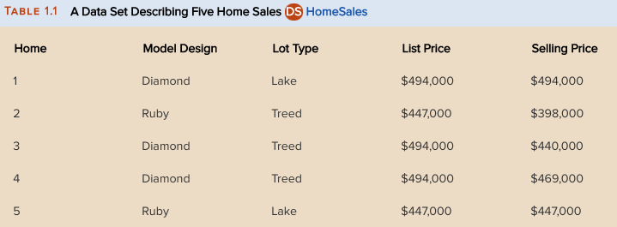

- $398,000 for a Ruby model on a treed lot

1.7 Consider the five homes in Table 1.1. What do you think you would have to pay for a Diamond model on a lake lot? For a Ruby model on a lake lot?

- $494,000 for a Diamond model on a lake lot
- $447,000 for a Ruby model on a lake lot

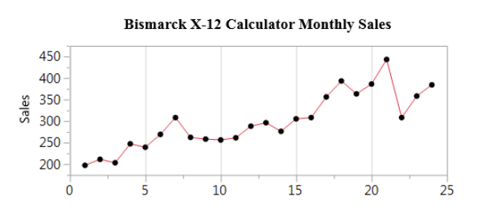
1.8 The number of Bismark X-12 electronic calculators sold at Smith’s Department Stores over the past 24 months have been: 197, 211, 203, 247, 239, 269, 308, 262, 258, 256, 261, 288, 296, 276, 305, 308, 356, 393, 363, 443, 308, 358, and 384. Make a time series plot of these data. That is, plot 197 versus month 1, 211 versus month 2 and so forth. What does the time series plot tell you?

This chart shows that sales are increasing over time.

1.9 (1) Define a population. (2) Give an example of a population that you might study when you start your career after graduating from college. (3) Explain the difference between a census and a sample
(1) A population is the set of all elements about which we wish to draw conclusions.
(2) You might study the population of all purchasers of a particular laundry detergent.
(3) A census is the examination of all of the population measurements. A sample is a subset of the elements in a population.

1.10 Explain each of the following terms:
a. Descriptive analysis
b. Statistical inference
c. Random sample
d. Process

- Descriptive statistics is the science of describing the important aspects of a set of measurements.
- Statistical inference is the science of using a sample of measurements to make generalizations about the important aspects of a population of measurements.
- A random sample is a subset of size 𝑛 chosen from a population in such a way that every possible set of elements of size 𝑛 has the same chance of being chosen. Briefly, the sample is chosen fairly, with no favoritism or prejudice.
- A process is a sequence of operations that takes input(s) and generates output(s).

1.11 Explain why sampling without replacement is preferred to sampling with replacement.
- When we choose a sample of size 𝑛 without replacement, all 𝑛 elements selected are different. However, when selecting with replacement, we might choose some elements multiple times. We tend to get a more complete picture of the population when we sample without replacement.

1.12 Randomly select five of these companies
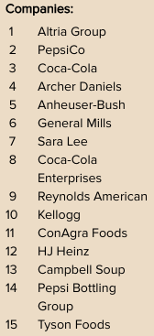

We would select companies 3, 8, 9, 14, and 7, so our random sample would contain Coca-Cola, Coca-Cola Enterprises, Reynolds American, Pepsi Bottling Group, and Sara Lee.

1.13 Suppose that 65 customers are interviewed, and their composite scares are given. Using the largest and smallest observations in the data, estimate limits between which most of the 73,219 composite scores would fall. Also estimate the proportion of the 73,219 scores that would be at least 42.
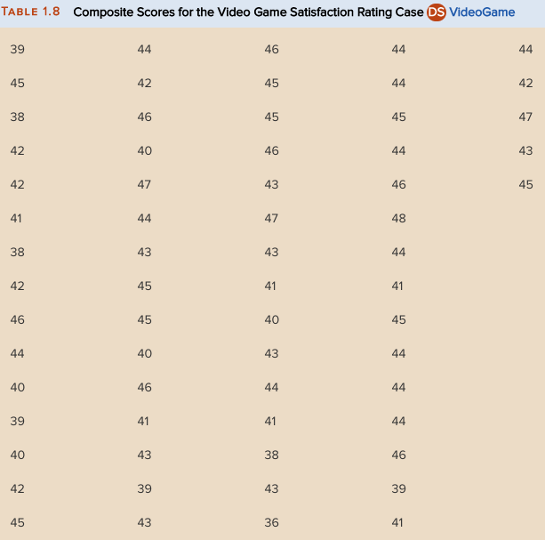

Most of the 73,219 scores should fall between 36 and 48, the most extreme scores in the sample. Since 46 of the 65 sample values are 42 or higher, we estimate that approximately 46/65 = 70.77% of all scores would be at least 42.

1.15 The results showed that 96% of respondents were very or somewhat concerned about sex on TV, and 97% of respondents were very or somewhat concerned about violence on TV. Do you think that these results could be generalized to all televisions viewers in 1995? Why or why not?
No. This is a voluntary response sample and thus is probably not representative of the population of all television viewers.

1.17 Why are predictive analytics supervised learning techniques?
Predictive analytics are supervised learning techniques since there is a particular response variable we are trying to predict.

1.18 Why are descriptive analytics unsupervised learning techniques?
Descriptive analytics are unsupervised learning techniques since there is not a particular response variable we are trying to predict.

1.19 What is data mining?
Data mining is the process of discovering useful knowledge in extremely large data set.
1.20 What are prescriptive analytics?
Prescriptive analytics are techniques that combine external and internal constraints with results from descriptive and predictive analytics.

1.21 Discuss the difference between a ratio variable and an interval variable
- A ratio variable is a quantitative variable measured on a scale such that ratios of values of the variables are meaningful and there is an inherently defined zero value.
- An interval variable is a quantitative variable such that ratios of values of the variable are not meaningful and there is not an inherently defined zero value.

1.22 Discuss the difference between an ordinal variable and a nominative variable.
- An ordinal variable is a qualitative variable such that there is a meaningful ordering, or ranking, of the categories.
- A nominative variable is a qualitative variable such that there is no meaningful ordering, or ranking, of the categories.

1.23 Classify each of the following qualitative variables as ordinal or nominative. Explain your answers.
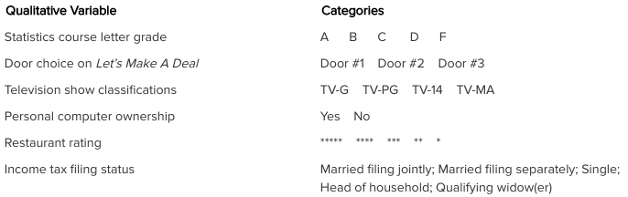

- Letter Grades: Ordinal – each grade from A to F indicates an increasingly lower grade.
- Door Choices: Nominative – each door is the same except for the number given. For example, Door 1 is not better or worse or higher or lower than Door 3.
- TV Classifications: Ordinal – each category from TV-G to TV-MA indicates programming appropriate for increasingly older viewers.
- PC Ownership: Nominative – no ordering of categories.
- Restaurant Ratings: Ordinal – each rating from 5-star to 1-star indicates an increasingly lower rating.
- Filing Status: Nominative – no ordering of categories.

1.24 Classify each of the following qualitative variables as ordinal or nominative. Explain your answers. 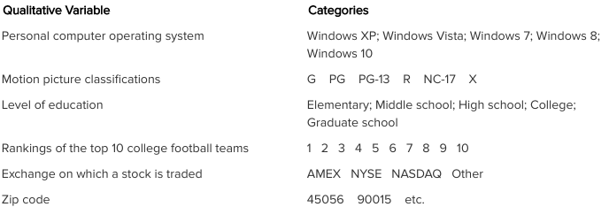

- PC OS: Nominative – no ordering of categories.
- Movie Classifications: Ordinal – each category from G to X indicates a movie appropriate for increasingly older audiences.
- Education Level: Ordinal – each ranking from Elementary to Graduate School indicates an increasingly higher educational level.
- Football Rankings: Ordinal – each ranking from 1 to 10 indicates a team with an increasingly lower ranking (not as good).
- Stock Exchanges: Nominative – no ordering of categories.
- Zip Codes: Nominative – no ordering of categories. For example, zip code 45056 is not lower than zip code 90015.

1.25 When is it appropriate to use stratified random sampling? What are strata, and how should strata be selected?
- When the population consists of two or more groups that differ with respect to the variable of interest.
- Strata are non-overlapping groups of similar units and should be chosen so that the units in each stratum are similar on some characteristic (often a categorical variable).

1.26 When is cluster sampling used? Why do we describe this type of sampling by using the term cluster?
Cluster sampling is often used when selecting a sample from a large geographical region. The name derives from the fact that, at each stage, we “cluster” elements into subpopulations.

1.27 Explain how to take a systematic sample of 100 companies from the 1,853 companies that are members of a industry trade association.

First divide 1853 by 100 (since 𝑛 is 100) and round down to 18. We randomly select one company from the first 18 (in a list of all the companies). From the company selected we simply count down the list of companies by 18 to get to the next company to select. We continue this process until we have reached a sample size of 100.

1.28 Explain how a stratified random sample is selected. Discuss how you might define the strata to survey student opinion on a proposal to charge all students a $100 fee for a new university-run bus system that will provide transportation between off-campus apartments and campus location.

A stratified random sample is selected by dividing the population into some number of strata, and then randomly sampling inside each stratum.

Potential strata: (1) students who live off campus and (2) students who live on campus

1.29 Marketing researchers often use city blocks as clusters in cluster sampling. Using this fact, explain how a market researcher might use multistage cluster sampling to select a sample of consumers from all cities having a population of more than 10,000 in a large state having many such cities.

(1) List all cities with population > 10,000.
(2) Randomly select a number of such cities.
(3) Within each selected city, randomly select a number of city blocks.
(4) Within each selected city block, take a random sample of individuals.

1.30 Explain
a. Three types of surveys and discuss their advantages and disadvantages
b. Three types of survey questions and discuss their advantage and disadvantages

a.
- Phone survey: inexpensive, but impersonal with a low response rate
- Mail survey: inexpensive, but impersonal with a low response rate
- Mall survey: more expensive, personal interview, questions more easily explained, higher response rate
b.
- Dichotomous: yes/no, easily analyzed but very limited in range or depth of response Multiple choice: more range or depth of response
- Open ended: much more difficult to analyze, but significantly more nuance to responses

1.31 Explain each of the following terms:
a. Under coverage
b. Nonresponse
c. Response bias.

- Under coverage occurs when some elements in the population are left out of the process of choosing the sample.
- Nonresponse occurs when data cannot be obtained from an element selected in a sample.
- Response bias occurs when respondents are reluctant to answer honestly or when the questions are slanted to influence responses.

1.32 A market research firm sends out a web-based survey to assess the impact of advertisements placed on a search engine’s results page. About 65 percent of the surveys were answered and sent back. What types of errors are possible in this scenario?

The sample may be biased because it is not stated that the recipients of the survey were chosen at random. In addition, there may be errors of under coverage and nonresponse. Since the return of a survey is voluntary, it is possible that people having strong opinions are more likely to respond than those whose opinions are more moderate.

