Formulas for Statistics Midterm
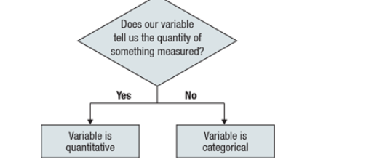
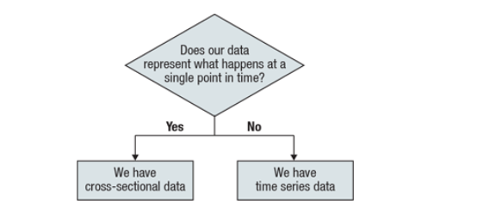

Probability Rules
Notation Alert
- (A or B) written as (A∪B)
- (A and B) written as (A (A∩B)

Rule : For two independent events A and B, the probability that both A and B occur is the product of the probabilities of the two events.

P(A and B)=P(A)×P(B), if A and B are independent

Rule: 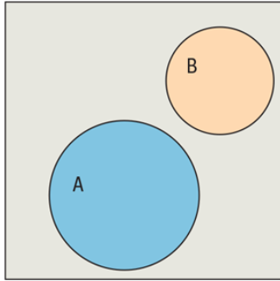 P(A or B)=P(A)+P(B) if A and B are disjoint.
Rule: 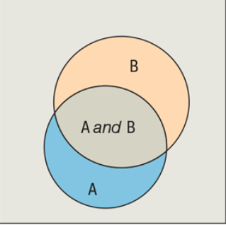 Two events A and B that are not disjoint. The event (A and B) is their intersection: P(A or B)=P(A)+P(B)−P(A and B)

Example: What about one, but not the other?
P(Stat 1)=0.02 P(Accounting)=0.015 P(Stat 1 and Accounting)=0.005
Probability of stat 1 but not accounting?
=0.02-0.005

Conditional Probability
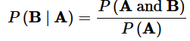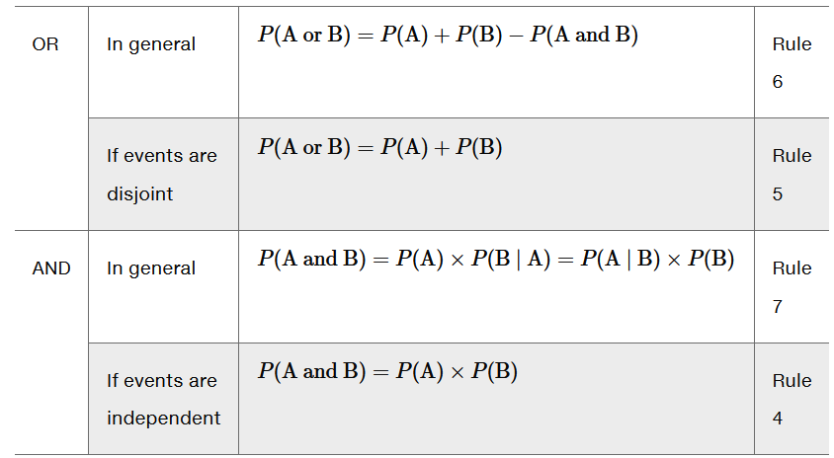

Independent Versus Disjoint
Independent: Check whether P(A and B)= P(A) x (B)
OR does P(A)= P(A|B) If they are the same, they are independent
Disjoint= If P(A and B)=0

Probability Trees
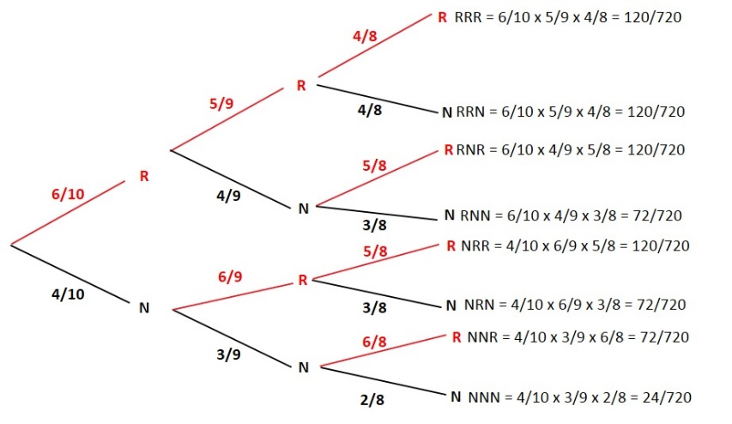

Bayes’ Theorem
P(A|B)= $\frac{P\left(A\right)*P(B|A)}{P\left(A\right)*P\left(B | A\right)+P\left(A^{'}\right)+P(B|A^{'})}$

Expected Value
E(X)=∑x⋅P(x)
Example: How much can an fundraising company expect to make? If the expected value of each ticket price is -$2.10. Then $2.10 is the amount, on average that the lottery gains per ticket. If they sell 500 tickets they can expect to make 500 x $2.10
Expected Value is often in terms of money. So if you have a lady that does 2 hours of tutoring and the probability is 0.4, you would have to multiply this by the amount she charges per hour which is 25$.

Variance
Var(x)= (x-E(x))²*P(x)
Var(x)= SD²

Standard Deviation
SD(X)=
SD(X)=$\sqrt{{SD}^{2}}$
-The square root of the sum of the variance
-Higher the standard deviation means greater the risk, because the greater the chance that the number can fluctuate.

Random Variables and Constant
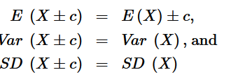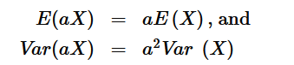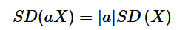

Adding Random Variables
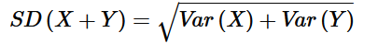

Correlation

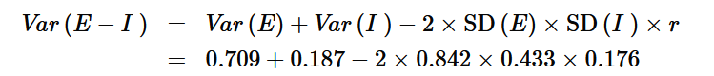
Coefficient of Variation= $\frac{SD(x)}{E(X)}$

Geometric Distribution
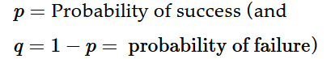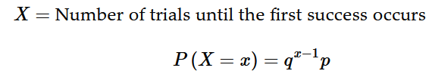
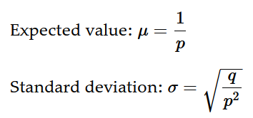
Example: 3% defective chips
-Find the probability they find a bad chip within the first 10 they examine:
P=0.03 1=0.97
=1-(0.97)¹⁰

Binomial Distribution
n=Number of trials
p=probability of success
q=probability of failure 1-p
X= Number of successes in n trials
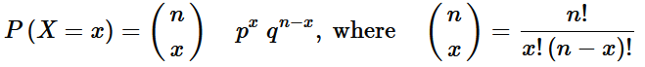
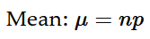
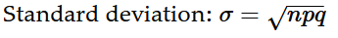
P(X>1)=1-P(X=0)-P(x=1)
P(at least 2)=1-P(X=0)-P(X=1)

Poisson Distribution
X=Number of occurrences per unit of time
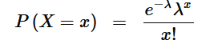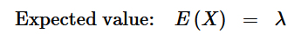

Example: What is the probability that the business will receive more than 6 calls in one hour?
P(X>6)=1-P(0)+P(1)+P(2)+P(3)+P(4)+P(5)+P(6)

