IShort Answers - Not really short answers when all you have to do is list things out.

One on the Mini case - How would you do it
1.Create Spreadsheet,
2.Add Plugins,
3.Set formulas
4.Set up Constraints
5.Evaluate Data

Name 5 Media Storage Device
1.SSD
2.HDDf
3.USB
4.Flash Memory
5.RAID

Relations between operating system, computer hardware, and Application software
An operating system is a set of programs containing instructions that work together to coordinate all the activities among computer hardware resources. It drives the hardware to perform such tasks and computer hardware support applications

Name 3 unethical behaviours performed on the internet
1.Media Piracy
2. Identity Theft
3.Financial Theft

Name 3 software for you to access Internet at home.
Applications software to access internet would be
1.Chrome
2.Explorer
3. Firefox
4. Safari

Qty and relevant images
Consistent and simple design template
Use contrasting colors for texts and backgrounds

Differences between operating and utility system
An operating system is a set of programs containing instructions that work together to coordinate all the activities among computer hardware resources
A utility program is a type of system software that allows a user to perform maintenance-type tasks
- 5 software needed for a graphic design computer
Illustrator
InDesign
Photoshop
Inkscape
CorelDraw
- Name 5 hardware needed for a home internet set up
Internet Modem
Ethernet Hub
Unshielded twisted-pair, UTP
Wireless Router
- What hardware components may have an important impact on your work, if you are a graphic designer or media developer (name 5)
System devices
Memory and storage devices
Input devices
Output devices
Communication devices
- Types of Software Licenses
Freeware: Any copyrighted software you can use for free.
Beta versions: Under development version of the software. Free of charge.
Shareware: Run for a limited time free of charge. When the initial trial period is over, the licenseagreement is broken.
Open Source Software: Free to use of condition that any changes you make.
Concurrent, site licenses, mulit-user and single user

Multiple choice questions
A_______is the portion of virus code that is unique to a particular computer virus.
compression code
encryption code
virus signature
virus pattern

Which of the following is NOT a type of UTP cable you would use in a wired Ethernet network?
Cat 7B
Cat 6
Cat 5E
Cat 6A

Ethical hackers are also known as white-hat hackers.
True
False

All of the following are terms related to part of the boot process EXCEPT ________.
USB
CMOS
ROM
RAM
Computer-aided design software is used by ________.
web designers to create websites
architects to create virtual models
game makers to create games
project managers to track tasks

All viruses cause serious destruction of computer data.
True
False

C: denotes a_ directory that is at the top of the filing structure of a computer.
root
cluster
upper-level
top-level

To transfer data packets between two or more networks, a ________ is used.
firewall
router
switch
Hub

A large network designed to provide access to a specific geographic area, such as a large city, is a ________.
WAN
PAN
LAN
MAN

Windows 10 uses a _____ account for easy access and storage of online files.
Chrome
OneDrive
iCloud
eye OS

To remove all the changes made to your system, the Windows ________ utility returns your computer to the state it was in when it came from the factory.
Backup
Refresh
Restore
Erase

The amount of RAM storage is measured in ________.
GHz
Hz
GB
MHz

Which of the following is the lightest computer?
Desktop
Laptop
Ultrabook
Tablet

The appropriate software to use for creating research papers is ________ software.
presentation
spreadsheet
word processing
database

Inkjet printers and laser printers are examples of ________ printers.
dot-matrix
nonimpact
thermal
Impact
_____________________________________________________________________________
Gaming consoles, such as Xbox One and PlayStation 4, do not need an operating system.
True
False

Which statement pertaining to system reliability is FALSE?
Having the latest version of software products can make your system more reliable.
You can clean out unnecessary programs from your Startup folder.
When you defrag your hard drive, it works more efficiently.
An accumulation of temporary Internet files has no effect on your computer's overall performance.

The operating system provides the means for users to interact with a computer.
True
False

Each device attached to your computer has a special program called a_ that enables the device and operating system to communicate with each other.
device configurator
interpreter
device driver
translator

A________ software installation installs all the most commonly used files to your computer's hard drive.
custom
new
full
upgrade
___________________________________________________________________________
Which of the following optical storage media has the greatest storage capacity?
BD
DVD DL
CD
DVD

P2P networks are most commonly used in home networks.
True
False

A_ device facilitates file sharing and data backup.
NAS
UTP
WAN
NOS

The most popular transmission media option for wired home Ethernet networks is ________ cable.
fiber-optic
coaxial
power-line
unshielded twisted-pair (UTP)

________ is the maximum speed at which data can be transferred between two nodes.
Bandwidth
Throughput
Broadband
Through speed

The terms data and information can be used interchangeably.
True
False

The area that holds all the startup instructions the computer needs to start is the ________.
CPU
ROM
RAM
USB
Wireless network devices use ________ to communicate with each other.
fiber optics
satellites
DSL
radio waves

All of the following activities may infect your computer with a virus EXCEPT ________.
downloading video files from peer-to-peer sites
printing a document
sharing flash drives
downloading or running an e-mail attachment file

The Mac OS was the first commercially available OS to incorporate ________.
point and click technology
networking
sound
color graphics

You can use PowerPoint to trim video clips without having to use a separate video-editing program.
True
False
__________ is the abbreviation for the place in the computer where the programs and data the computer is currently using are temporarily stored.
ROM
RAM
CPU
USB

Video cards are designed with their own RAM storage.
True
False

All viruses cause serious destruction of computer data.
True
False

When using multiple monitors, you must have multiple video cards.
True
False
The arithmetic logic unit (ALU) controls all of the functions performed by the computer's other components and processes all the commands issued to it by software instructions.
True
False

A packet analyzer is a program that can enable a hacker to do all of the following EXCEPT ________.
launch a denial of service (DoS) attack on your computer
use your debit card information to purchase items illegally
assume your identity
steal your log-ons and passwords for various accounts

Unwanted or unneeded software included by manufacturers on new computers is called ________.
bloatware
shareware
adware
malware

Software as a Service (SaaS) hosts web-based applications.
True
False
________________________________________________________________________________
A stealth virus is designed to infect multiple file types to fool the antivirus software.
True
False

The heads of a hard disk drive touch the surface of the platter to read or write the data.
True
False

Client-server networks are controlled by a central server that runs specialized software called a________.
service set identifier (SSID)
information management system (ISM)
digital subscriber line (DSL)
network operating system (NOS)
________ software is used to perform calculations and numerical analyses.
Word Processing
Spreadsheet
Presentation
Personal information manager

A P2P network needs network operating system software installed on every node.
True
False

The ________ contains the central electronic components of the computer.
motherboard
peripheral unit
input unit
arithmetic logic unit
______________________________________________________________________________
A_ software installation enables you to decide which features you want to install on the hard drive.
full
custom
partial
upgrade
______________________________________________________________________________
Creating and distributing ________ is one of the most widespread types of cybercrimes.
cookies
spam
zombies
computer viruses
______________________________________________________________________________
When your computer runs out of RAM, the operating system borrows space from the CPU.
True
False
______________________________________________________________________________
Using a network without the network owner's permission is known as ________.
Phishing
Hijacking
Spamming
Piggybacking
______________________________________________________________________________
Which computer port transmits audio and video without the need for compression?
LCD
HDMI
VGA
USB
______________________________________________________________________________
A_device facilitates file sharing and data backup.
NAS
UTP
WAN
NOS
_____________________________________________________________________________
A ________ is a virus that is triggered on a certain date.
logic bomb
time bomb
macro
Worm
_____________________________________________________________________________
A personal computer can only have one operating system installed on it.
True
False
_____________________________________________________________________________
Computer-aided design software is used by ________.
web designers to create websites
architects to create virtual models
game makers to create games
project managers to track tasks
______________________________________________________________________________
With regard to computer protection, quarantining is defined as ________.
updating your antivirus software
deleting an infected file
placing a found virus in a secure area on the hard drive
repairing an infected file
______________________________________________________________________________
Starting a computer when it is powered off is called a warm boot.
True
False
_____________________________________________________________________________
FBI-related scams involve ________.
convincing people to send money as a "good faith" gesture
collecting funds and not delivering the goods
running auctions that do not exist
people pretending to represent official organizations such as the Dept. of Homeland Security or IRS
____________________________________________________________________________
Some of the cache memory of a CPU is ________.
inside the CPU, itself
on the hard disk drive
in cloud storage
on a nearby SSD
_____________________________________________________________________________
Application software helps run the computer and coordinates instructions with the hardware.
True
False
____________________________________________________________________________
Desktop publishing software enables you to create newsletters and annual reports.
True
False
______________________________________________________________________________
Which of the following is NOT a virus category?
Worm
Pharming
Macro
Logic bomb
_____________________________________________________________________________
File names in Windows are case-sensitive.
True
False
______________________________________________________________________________
A CD stores the same number of songs in the uncompressed format as in MP3 format.
True
False
_____________________________________________________________________________
WEP is a stronger form of security than WPA.
True
False
_____________________________________________________________________________
The terms virus and worm actually mean the same thing.
True
False
______________________________________________________________________________
When your computer runs out of RAM, the operating system borrows space from the CPU.
True
False
______________________________________________________________________________
Currently, there are no antivirus programs for mobile devices.
True
False
______________________________________________________________________________
The area that holds all of the instructions the computer needs to start up is the RAM.
True
False
____________________________________________________________________________
Processing is manipulating, calculating, or organizing data into information.
True
False
____________________________________________________________________________
A full software installation enables you to choose which program features you want
installed on your hard drive.
True
False
____________________________________________________________________________
Sharing files is a benefit of a network.
True
False
____________________________________________________________________________
An encryption virus replicates itself onto a hard drive's master boot record.
True
False
______________________________________________________________________________
Android is an open source operating system for personal computers and network servers.
True
False

Ethernet networks are always connected using twisted-pair cable technology.
True
False
______________________________________________________________________________
Which of the following capabilities of UNIX is FALSE?
It is only for super computers.
It is multitasking.
It is a network OS.
It is multi-user.
______________________________________________________________________________
Video cards are designed with their own RAM storage.
True
False
______________________________________________________________________________
Cache memory is a form of ROM.
True
False
______________________________________________________________________________
Which of the following is NOT a common network architecture type?
intraoffice area network (IAN)
personal area network (PAN)
home area network (HAN)
local area network (LAN)
______________________________________________________________________________
Which type of virus was the famous Michelangelo virus?
An e-mail virus
A time bomb
A worm
A script virus
______________________________________________________________________________
Installing a device driver can sometimes cause system instability.
True
False
______________________________________________________________________________
The use of multiple cores on one CPU chip allows the execution of two or more sets of instructions at the same time.
True
False

Which of the following computers is large, expensive and supports many simultaneous users and manages large amounts of data?
Mainframe computer
Desktop computer
Embedded computer
Supercomputer

Which of the following is the smallest unit of measure?
Gigabyte
Megabyte
Terabyte
Petabyte

If you reformat the hard drive on a computer, it erases all personal information from your computer and makes it safe to donate.
True
False

Running the Disk Defragmenter utility will ________.
make the hard drive work more efficiently
detect and remove spyware
clean out your Startup folder
mark bad memory cells

Which of the following is the most common audio compression format?
WAV
WMA
AU
MP3

All of the following are names for a flash drive EXCEPT _ drive.
Hard
Jump
Thumb
USB

Current wired Ethernet networks in the United States are based on the IEEE 802.11ac standard.
True
False

Which of the following does NOT determine processor power?
Amount of cache memory
Clock speed
Number of cores
Speed of the motherboard

All of the following are extra precautions you can take to secure a wireless network EXCEPT ________.
turn on security protocols
change your network name (SSID)
create a passphrase
enable SSID broadcast

Desktop computer systems are less reliable than laptop computers.
True
False

Running the CPU at a faster speed than the manufacturer recommends is called ________.
hyperthreading
latency
overclocking
fetching

Check your understanding:

Unit 1:
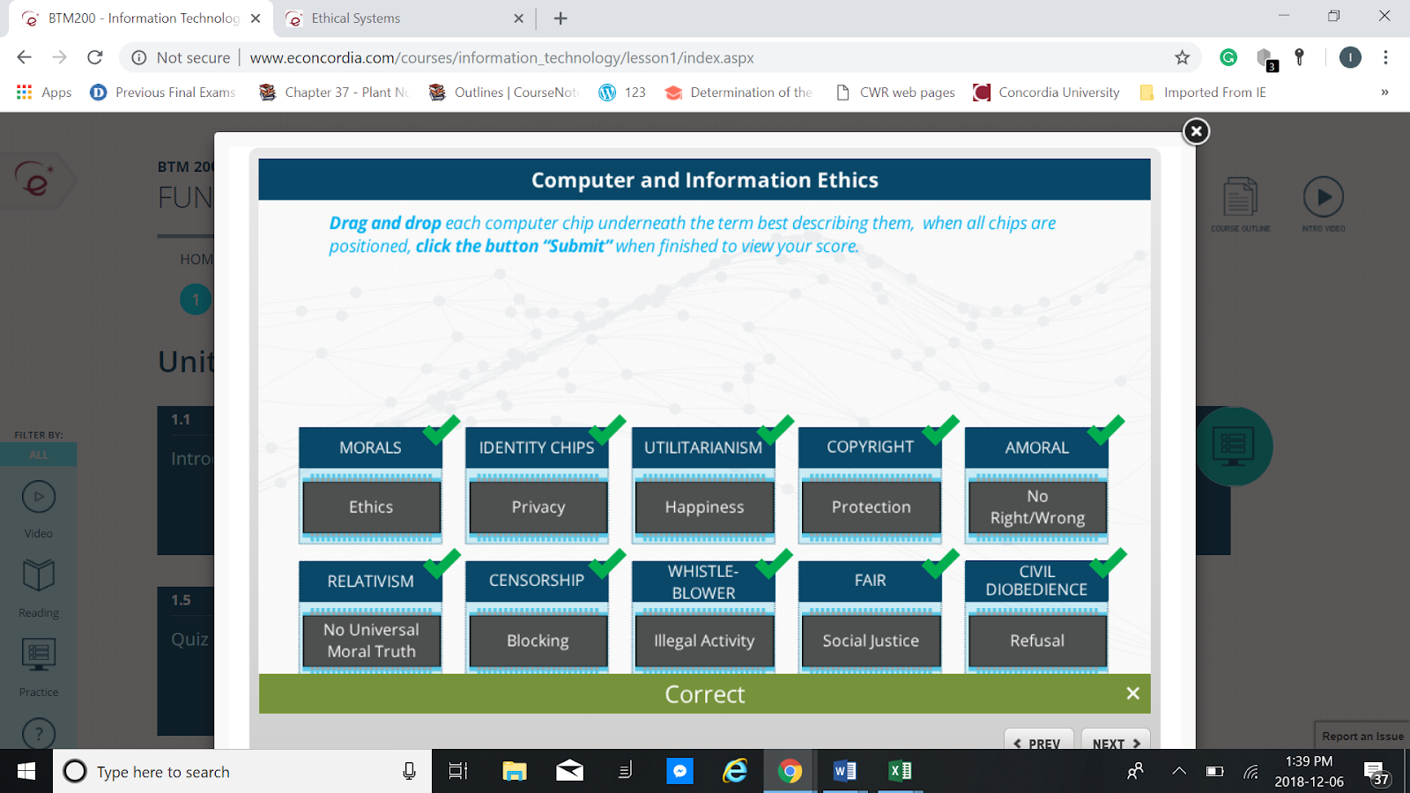

A smartphone is a computer.
True
False
When using a spreadsheet, SUM in the expression =SUM(B10:B16), is called a_.
(1 points)
operator
function
formula
operant
A zombie is another person's computer controlled by a hacker.
True
False
Most word processing programs come with a find-and-replace tool that enables you to locate and replace specific text.
True
False
A unidirectional microphone picks up sounds equally well from all directions.
True
False
Hybrid drives are a combination of a mechanical hard drive and an SSD drive.
True
False
_______ provides high-speed information processing by enabling a new set of instructions to start before the previous set is finished.
(1 points)
Cache memory
Hyperthreading
Overclocking
Multitasking
Software that manages "back office" functions such as billing, production, inventory management, and human resources management is called ________ software.
(1 points)
enterprise resource planning
customer relationship management
project management
accounting
All of the following are tips for a great presentation EXCEPT ________.
(1 points)
use images to convey a thought or illustrate a point
limit bullet points per slide to 4-6
use a variety of animations on most slides to keep your audience's attention
keep the font size large enough to be read from the back of the room
A peer-to-peer (P2P) network is an example of ________ administration.
(1 points)
wide area
central
local
corporate
Limiting your signal range does not help increase wireless network security.
True
False

FBI-related scams involve ________.
(1 points)
convincing people to send money as a "good faith" gesture
collecting funds and not delivering the goods
running auctions that do not exist
people pretending to represent official organizations such as the Dept. of Homeland Security or IRS
All of the following are tips for a great presentation EXCEPT ________.
(1 points)
use images to convey a thought or illustrate a point
limit bullet points per slide to 4-6
use a variety of animations on most slides to keep your audience's attention
keep the font size large enough to be read from the back of the room
A peer-to-peer (P2P) network is an example of ________ administration.
(1 points)
wide area
central
local
corporate
Limiting your signal range does not help increase wireless network security.
True
False
FBI-related scams involve ________.
(1 points)
convincing people to send money as a "good faith" gesture
collecting funds and not delivering the goods
running auctions that do not exist
people pretending to represent official organizations such as the Dept. of Homeland Security or IRS
Blackboard is an example of ________ software.
(1 points)
gaming
course management
drawing
utility

WEP is a stronger form of security than WPA.
True
False
Android is an open source operating system for personal computers and network servers.
True
False
Computer-aided design software is used by ________.
(1 points)
web designers to create websites
architects to create virtual models
game makers to create games
project managers to track tasks
Ethernet networks are always connected using twisted-pair cable technology.
True
False
On a network, a_ helps prevent data packets from colliding with each other.
(1 points)
adapter
switch
hub
access point
Apple's OS X and Microsoft Windows are examples of ________ software.
(1 points)
operating system
communication
application
utility
All of the following are terms related to part of the boot process EXCEPT ________.
(1 points)
USB
CMOS
ROM
RAM
______________________________________________________________________________
How many channels are in a Dolby 7.1 Surround Sound System?
12
6
7
8
______________________________________________________________________________
The basic input output system (BIOS) is stored on a ________ chip.
RAM
CMOS
ROM
CPU

Which of the following computers is large, expensive and supports many simultaneous users and manages large amounts of data?
Mainframe computer
Desktop computer
Embedded computer
Supercomputer

The ________ has the largest capacity of any storage device.
DVD
CD
SSD
mechanical hard drive

The most popular transmission media option for wired home Ethernet networks is ________ cable.
fiber-optic
coaxial
power-line
unshielded twisted-pair (UTP)

All of the following are examples of database software EXCEPT ________.
OneNote
MySQL
Microsoft Access
Oracle

The terms virus and worm actually mean the same thing.
True
False

The Internet is a WAN.
True
False

Apache OpenOffice is an example of a_ productivity suite.
web-based
desktop publishing
system
open source

Some of the responsibilities of a_ are installing new hardware and software on the network and monitoring performance.
network administrator
programmer analyst
computer technician
IT manager
Software designed specifically for managing real estate is an example of ________ software.
e-commerce
vertical market
project management
general business

Hybrid drives are a combination of a mechanical hard drive and an SSD drive.
True

