International Economics, 17e (Pugel)
Chapter 12 Trade Blocs and Trade Blocks

1) Which of the following allows member countries to import from other member countries freely, but imposes trade barriers against imports from outside countries?
A) A trade embargo
B) A trade bloc
C) A cultural union
D) A trade union

Answer: B
Difficulty: 1 Easy
Topic: Types of Economic Blocs
Bloom's: Remember
AACSB: Reflective Thinking
Accessibility: Keyboard Navigation

2) Which of the following features does a free-trade area necessarily have?
A) Absence of trade barriers among the member nations
B) Equal tariff rates
C) Free movement of factors of production across the member nations
D) Harmonization of all economic policies

Answer: A
Difficulty: 1 Easy
Topic: Types of Economic Blocs
Bloom's: Remember
AACSB: Reflective Thinking
Accessibility: Keyboard Navigation

3) Which of the following is true of a common market?
A) The member countries export similar products to the non-member countries.
B) The member countries do not import goods from the non-member countries.
C) The member countries have identical monetary and fiscal policies.
D) There is free movement of capital and labor among the member countries.

Answer: D
Difficulty: 1 Easy
Topic: Types of Economic Blocs
Bloom's: Remember
AACSB: Reflective Thinking
Accessibility: Keyboard Navigation

4) Which of the following is true of an economic union?
A) Free movement of resources, but restricted movement of goods among the member countries
B) The members have a common set of tariffs among themselves but the external tariff rates are determined independently.
C) Free movement of goods, but restricted movement of resources across the member countries
D) Harmonization of all economic policies in the member countries

Answer: D
Difficulty: 1 Easy
Topic: Types of Economic Blocs
Bloom's: Remember
AACSB: Reflective Thinking
Accessibility: Keyboard Navigation

5) Which of the following features does a customs union have?
A) Free trade among those members with similar economic policies
B) Common set of external tariffs
C) Free movement of factors of production
D) Harmonization of all economic policies

Answer: B
Difficulty: 1 Easy
Topic: Types of Economic Blocs
Bloom's: Remember
AACSB: Reflective Thinking
Accessibility: Keyboard Navigation

6) The Southern Common Market (MERCOSUR) is actually a
A) free-trade area.
B) customs union.
C) economic union.
D) common market.

Answer: B
Difficulty: 1 Easy
Topic: Types of Economic Blocs
Bloom's: Remember
AACSB: Reflective Thinking
Accessibility: Keyboard Navigation

7) The North American Free Trade Agreement (NAFTA) is an example of a(n)
A) free-trade area.
B) customs union.
C) common market.
D) economic union.

Answer: A
Difficulty: 1 Easy
Topic: Types of Economic Blocs
Bloom's: Remember
AACSB: Reflective Thinking
Accessibility: Keyboard Navigation

8) Which of the following is closest to being a full economic union?
A) The North American Free Trade Agreement (NAFTA)
B) The European Union (EU)
C) The Southern Common Market (MERCOSUR)
D) The Trans-Pacific Partnership

Answer: B
Difficulty: 1 Easy
Topic: Is Trade Discrimination Good or Bad?
Bloom's: Remember
AACSB: Reflective Thinking
Accessibility: Keyboard Navigation

9) Formation of trade blocs can be considered beneficial because it
A) encourages purchases from higher-cost producers.
B) causes international friction when certain countries are let in the bloc and others are left out.
C) diverts world trade from low-cost producers to high-cost producers by encouraging too much trade within blocs.
D) encourages increased total trade by each member country.

Answer: D
Difficulty: 1 Easy
Topic: Is Trade Discrimination Good or Bad?
Bloom's: Remember
AACSB: Reflective Thinking
Accessibility: Keyboard Navigation

10) Which of the following states that any trade concession given to any foreign country must be given to all other countries having the same status?
A) The principle of reciprocity
B) The structural adjustment program
C) The most favored nation principle
D) The purchasing power parity theory

Answer: C
Difficulty: 1 Easy
Topic: Is Trade Discrimination Good or Bad?
Bloom's: Remember
AACSB: Reflective Thinking
Accessibility: Keyboard Navigation

11) Which of the following refers to trade creation?
A) The net increase in exports when the currency of a country depreciates with respect to a foreign currency
B) The net increase in imports when foreign firms lower the prices of their exports
C) The net volume of new trade that results from the formation of a trade bloc
D) The net change in the volume of trade among member countries when they form a trade bloc

Answer: C
Difficulty: 2 Medium
Topic: The Basic Theory of Trade Blocs: Trade Creation and Trade Diversion
Bloom's: Understand
AACSB: Reflective Thinking
Accessibility: Keyboard Navigation

12) Which of the following refers to trade diversion?
A) The volume of trade that is redirected from low-cost exporters to higher-cost domestic firms when the domestic government imposes import restrictions
B) The volume of trade redirected from low-cost exporters to higher-cost trade bloc member countries
C) The amount of the imported goods that is replaced by domestically produced goods
D) The change in the trade pattern such that the good which was formerly imported is now exported as the government subsidizes its production

Answer: B
Difficulty: 2 Medium
Topic: The Basic Theory of Trade Blocs: Trade Creation and Trade Diversion
Bloom's: Understand
AACSB: Reflective Thinking
Accessibility: Keyboard Navigation

13) The figure below shows the U.S. market for imported wine. For simplicity, we consider export supply curves to be flat. Chilean wine is available for $480 per barrel and French wine is available for $420 per barrel.

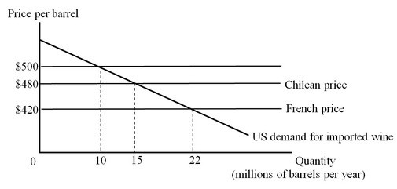

Under free trade, how many barrels of wine will the United States import and who will they import from?
A) 15 million barrels from Chile
B) 22 million barrels from France
C) 10 million barrels from France
D) 22 million barrels from Chile

Answer: B
Difficulty: 2 Medium
Topic: The Basic Theory of Trade Blocs: Trade Creation and Trade Diversion
Bloom's: Understand
AACSB: Reflective Thinking
Accessibility: Keyboard Navigation

14) The figure below shows the U.S. market for imported wine. For simplicity, we consider export supply curves to be flat. Chilean wine is available for $480 per barrel and French wine is available for $420 per barrel.

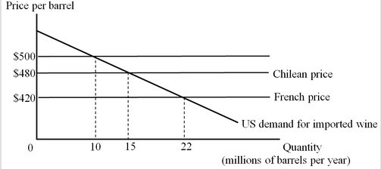

Suppose that the United States imposes a tariff of $80 per barrel on imported wine. How many barrels of wine will the United States import and who will they import from?
A) 15 million barrels from Chile
B) 22 million barrels from France
C) 10 million barrels from France
D) 10 million barrels from Chile

Answer: C
Difficulty: 3 Hard
Topic: The Basic Theory of Trade Blocs: Trade Creation and Trade Diversion
Bloom's: Apply
AACSB: Analytical Thinking
Accessibility: Keyboard Navigation

15) The figure below shows the U.S. market for imported wine. For simplicity, we consider export supply curves to be flat. Chilean wine is available for $480 per barrel and French wine is available for $420 per barrel.

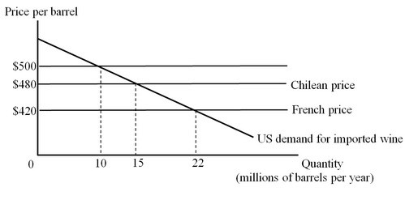

Suppose the United States has a tariff of $80 per barrel on imported wine. Then, the United States joins a free-trade area with Chile. How many barrels of wine will the United States import after joining the free-trade area?
A) 15 million barrels
B) 22 million barrels
C) 10 million barrels
D) zero barrels

Answer: A
Difficulty: 3 Hard
Topic: The Basic Theory of Trade Blocs: Trade Creation and Trade Diversion
Bloom's: Apply
AACSB: Analytical Thinking
Accessibility: Keyboard Navigation

16) The figure below shows the U.S. market for imported wine. For simplicity, we consider export supply curves to be flat. Chilean wine is available for $480 per barrel and French wine is available for $420 per barrel.

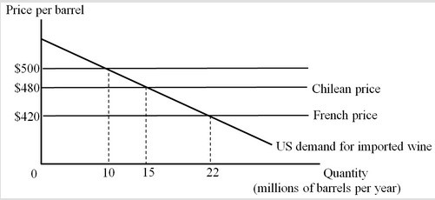

Suppose the United States has a tariff of $80 per barrel on imported wine. Then, the United States joins a free-trade area with Chile. At what price per barrel will the imported wines be purchased by the U.S. consumers?
A) $420
B) $480
C) $500
D) $560

Answer: B
Difficulty: 2 Medium
Topic: The Basic Theory of Trade Blocs: Trade Creation and Trade Diversion
Bloom's: Understand
AACSB: Reflective Thinking
Accessibility: Keyboard Navigation

17) The figure below shows the U.S. market for imported wine. For simplicity, we consider export supply curves to be flat. Chilean wine is available for $480 per barrel and French wine is available for $420 per barrel.

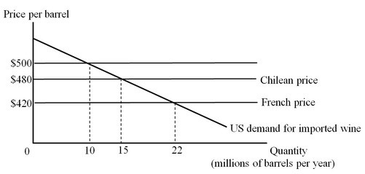

Suppose the United States has a tariff of $80 per barrel on imported wine. Then, the United States joins a free-trade area with Chile. What will be the change in the net national surplus after the United States enters into a free-trade agreement with Chile?
A) +$50 million
B) +$250 million
C) –$50 million
D) –$970 million

Answer: B
Difficulty: 3 Hard
Topic: The Basic Theory of Trade Blocs: Trade Creation and Trade Diversion
Bloom's: Apply
AACSB: Analytical Thinking
Accessibility: Keyboard Navigation

18) The figure below shows the U.S. market for imported wine. For simplicity, we consider export supply curves to be flat. Chilean wine is available for $480 per barrel and French wine is available for $420 per barrel.

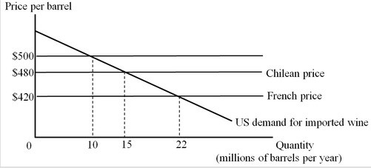

Suppose the United States has a tariff of $80 per barrel on imported wine. Then, the United States joins a free-trade area with Chile. How much will the U.S. government tariff revenue change (as a result of joining the free trade area)?
A) Increase by $50 million
B) Decrease by $300 million
C) Increase by $600 million
D) Decrease by $800 million

Answer: D
Difficulty: 3 Hard
Topic: The Basic Theory of Trade Blocs: Trade Creation and Trade Diversion
Bloom's: Apply
AACSB: Analytical Thinking
Accessibility: Keyboard Navigation

19) The figure below shows the U.S. market for imported wine. For simplicity, we consider export supply curves to be flat. Chilean wine is available for $480 per barrel and French wine is available for $420 per barrel.

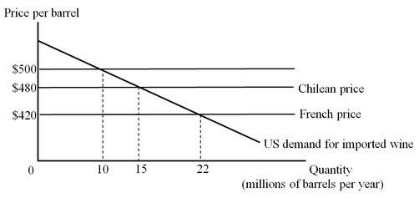

Suppose the United States has a tariff of $80 per barrel on imported wine. Then, the United States joins a free-trade area with Chile. Calculate the gain arising from trade creation after the United States joins the free-trade area.
A) $50 million
B) $250 million
C) $550 million
D) $800 billion

Answer: A
Difficulty: 3 Hard
Topic: The Basic Theory of Trade Blocs: Trade Creation and Trade Diversion
Bloom's: Apply
AACSB: Analytical Thinking
Accessibility: Keyboard Navigation

20) The figure below shows the U.S. market for imported wine. For simplicity, we consider export supply curves to be flat. Chilean wine is available for $480 per barrel and French wine is available for $420 per barrel.

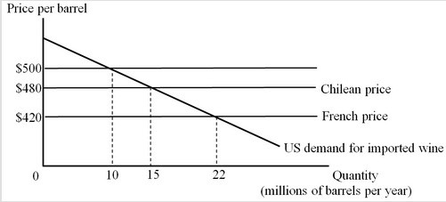

Suppose the United States has a tariff of $80 per barrel on imported wine. Then, the United States joins a trade bloc with Chile. Calculate the loss suffered by the United States arising from trade diversion.
A) $50 million
B) $250 million
C) $600 million
D) $800 million

Answer: C
Difficulty: 3 Hard
Topic: The Basic Theory of Trade Blocs: Trade Creation and Trade Diversion
Bloom's: Apply
AACSB: Analytical Thinking
Accessibility: Keyboard Navigation

21) The figure below shows the U.S. market for imported wine. For simplicity, we consider export supply curves to be flat. Chilean wine is available for $480 per barrel and French wine is available for $420 per barrel.

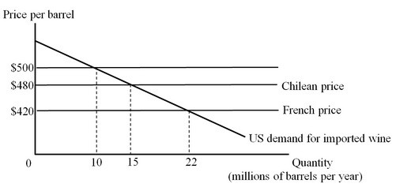

Suppose the United States has a tariff of $80 per barrel on imported wine. Then, the United States joins a trade bloc with Chile. What is the net effect of joining the trade bloc on U.S. well-being?
A) The national welfare increases by $50 million.
B) The national welfare decreases by $550 million.
C) The national welfare decreases by $800 million.
D) The national welfare increases by $250 billion.

Answer: B
Difficulty: 2 Medium
Topic: The Basic Theory of Trade Blocs: Trade Creation and Trade Diversion
Bloom's: Understand
AACSB: Reflective Thinking
Accessibility: Keyboard Navigation

22) Which of the following statements about a trade bloc is accurate?
A) The gains from a trade bloc are shared equally by each member.
B) Increased competition within a trade bloc can result in higher commodity prices in the domestic markets of the member countries.
C) A trade bloc may lower firms' costs by allowing them to exploit economies of scale.
D) A trade bloc can increase the opportunities for domestic business investments but usually repels foreign direct investments into the member countries.

Answer: C
Difficulty: 2 Medium
Topic: Other Possible Gains from a Trade Bloc
Bloom's: Understand
AACSB: Reflective Thinking
Accessibility: Keyboard Navigation

23) The gains from trade creation are likely to be larger for a country if
A) its import demand curve is relatively elastic.
B) it mainly imports primary products.
C) the country's government sufficiently subsidizes the production of its exportable goods.
D) the supply of the imported good by the foreigners is relatively inelastic.

Answer: A
Difficulty: 1 Easy
Topic: The Basic Theory of Trade Blocs: Trade Creation and Trade Diversion
Bloom's: Remember
AACSB: Reflective Thinking
Accessibility: Keyboard Navigation

24) The net loss from trade diversion for a country is likely to be smaller if
A) the county's import demand is more elastic.
B) the country's tariff rate on the product is higher.
C) the good can be produced at relatively lower cost in the bloc-partners than in the outside world.
D) the bloc partner's export price is closer to the tariff-inclusive price for imports from countries outside the bloc.

Answer: C
Difficulty: 1 Easy
Topic: The Basic Theory of Trade Blocs: Trade Creation and Trade Diversion
Bloom's: Remember
AACSB: Reflective Thinking
Accessibility: Keyboard Navigation

25) Which of the following identifies an important reason why empirical studies find that joining the European Economic Community (EEC) in 1973 may have imposed a substantial net cost on Britain?
A) Trade creation for British manufactured goods
B) Removal of trade barriers on imports from Australia and New Zealand
C) Trade diversion on agricultural products
D) Withdrawal of subsidies received by British farmers

Answer: C
Difficulty: 1 Easy
Topic: The EU Experience
Bloom's: Remember
AACSB: Reflective Thinking
Accessibility: Keyboard Navigation

26) Which of the following is NOT among the features that were phased in gradually during the integration of new members in the European Union (EU)?
A) The subsidies that the farmers of the new members receive started at only one-fourth of the standard levels for the common agricultural policy.
B) The new members were not full members of the common market for labor.
C) The citizens of the new members were not generally free to work in most other EU countries until several years after the country joined the EU.
D) The new members were allowed to impose a nominal tariff on the imports from the other members to stabilize themselves for the first several years.

Answer: D
Difficulty: 2 Medium
Topic: The EU Experience
Bloom's: Understand
AACSB: Reflective Thinking
Accessibility: Keyboard Navigation

27) Which countries joined the European Union (EU) in 2007?
A) The Czech Republic and Slovakia
B) Portugal and Spain
C) Bulgaria and Romania
D) Macedonia and Montenegro

Answer: C
Difficulty: 1 Easy
Topic: The EU Experience
Bloom's: Remember
AACSB: Reflective Thinking
Accessibility: Keyboard Navigation

28) The newest member country of the European Union (EU) is
A) Serbia
B) Turkey
C) Croatia
D) Ukraine

Answer: C
Difficulty: 1 Easy
Topic: The EU Experience
Bloom's: Remember
AACSB: Reflective Thinking
Accessibility: Keyboard Navigation

29) Which of the following was an observable effect of the North American Free Trade Agreement (NAFTA)?
A) NAFTA led to a substantial decrease in the volume of trade among the three member countries.
B) Low-cost firms in Canadian manufacturing industries were replaced by the high-cost firms.
C) Imports of clothing and textiles into the member countries were diverted away from low-cost suppliers in Asia.
D) There was massive shift of jobs toward Mexico.

Answer: C
Difficulty: 2 Medium
Topic: North America Becomes a Bloc
Bloom's: Understand
AACSB: Reflective Thinking
Accessibility: Keyboard Navigation

30) H. Ross Perot's famous claim in 1992 that the North American Free Trade Agreement (NAFTA) would cause a "great sucking sound" referred to
A) a huge increase in foreign direct investment in the United States.
B) an instant shift of jobs from the United States to the Mexico.
C) a rapid increase in U.S. exports to Mexico.
D) a rapid increase in the wage inequality in Mexico.

Answer: B
Difficulty: 1 Easy
Topic: North America Becomes a Bloc
Bloom's: Remember
AACSB: Reflective Thinking
Accessibility: Keyboard Navigation

31) Which of the following correctly identifies the impact of the formation of the North American Free Trade Agreement (NAFTA) on Mexico?
A) Mexico's import of financial services and high-tech equipment from the United States declined.
B) After Mexico joined NAFTA, the average wage rates for the unskilled workers declined.
C) Mexican exports of fruits and vegetables to the United States declined substantially.
D) NAFTA allowed Mexico to better exploit its comparative advantage in such products as apparel and food crops.

Answer: D
Difficulty: 1 Easy
Topic: North America Becomes a Bloc
Bloom's: Remember
AACSB: Reflective Thinking
Accessibility: Keyboard Navigation

32) ________ determine(s) which products have been produced within a free-trade area and which products have been produced outside the area and therefore are subject to trade barriers.
A) Trade diversion
B) Trade creation
C) Rules of origin
D) The most favored nation principle

Answer: C
Difficulty: 1 Easy
Topic: North America Becomes a Bloc
Bloom's: Remember
AACSB: Reflective Thinking
Accessibility: Keyboard Navigation

33) Which of the following is true of trade embargoes?
A) A trade embargo refers to a uniform tariff being imposed on all imported products by a country.
B) Embargoes are discriminatory restrictions or bans on economic exchange.
C) Unlike other trade restrictions, a trade embargo does not harm the imposing country.
D) Trade embargoes refer to import bans on tangible goods, but not on services.

Answer: B
Difficulty: 2 Medium
Topic: Trade Embargoes
Bloom's: Understand
AACSB: Reflective Thinking
Accessibility: Keyboard Navigation

34) A trade embargo harms
A) only the target country.
B) only the country that initiates the embargo.
C) both the target country and the country initiating the embargo.
D) the target country and the non-embargoing countries.

Answer: C
Difficulty: 1 Easy
Topic: Trade Embargoes
Bloom's: Remember
AACSB: Reflective Thinking
Accessibility: Keyboard Navigation

35) The figures below illustrate a situation of a trade embargo. In Figure (a) Dd and Sd are the domestic demand and supply curves of the embargoing countries. Prior to the embargo there was free trade at the world price of P0.

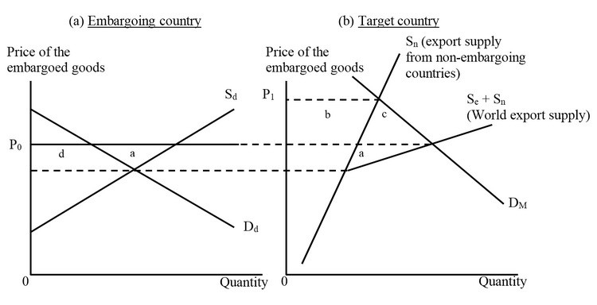

The embargoing country loses area ________ while the target country loses area.
A) (b + c); (a + c).
B) (a + d); (b + c).
C) a; b.
D) a; (b + c).

Answer: D
Difficulty: 2 Medium
Topic: Trade Embargoes
Bloom's: Understand
AACSB: Reflective Thinking
Accessibility: Keyboard Navigation

36) The figures below illustrate a situation of a trade embargo. In Figure (a) Dd and Sd are the domestic demand and supply curves of the embargoing countries. Prior to the embargo there was free trade at the world price of P0.

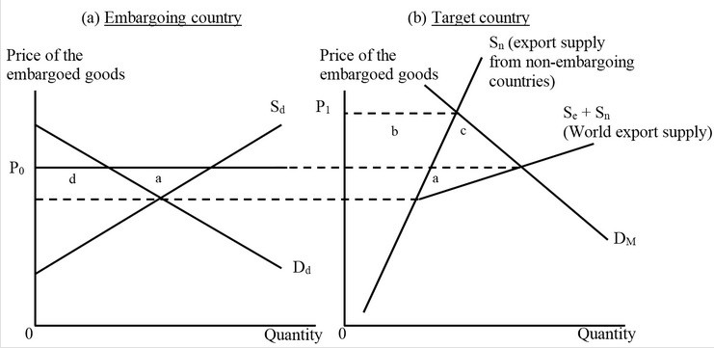

As a result of this embargo, the exporting countries not participating in the embargo gain Area
A) a.
B) b.
C) c.
D) (b + c).

Answer: B
Difficulty: 3 Hard
Topic: Trade Embargoes
Bloom's: Analyze
AACSB: Analytical Thinking
Accessibility: Keyboard Navigation

37) The figures below illustrate a situation of a trade embargo. In Figure (a) Dd and Sd are the domestic demand and supply curves of the embargoing countries. Prior to the embargo there was free trade at the world price of P0.

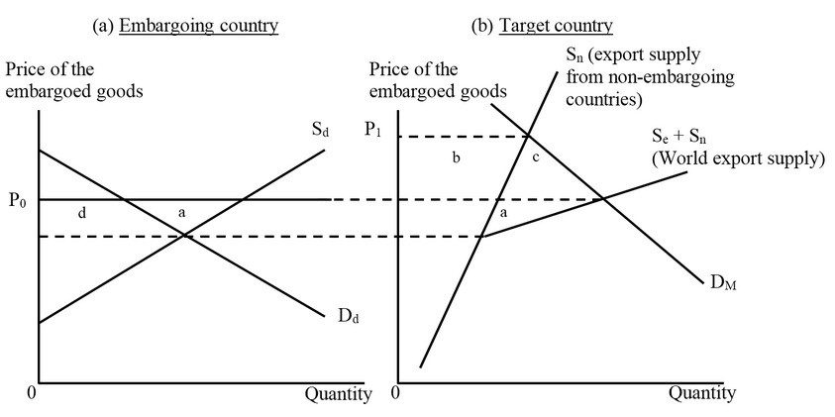

As a result of this embargo, the world as a whole loses Area
A) a.
B) (a + b + c + d).
C) (a + c).
D) (b + c).

Answer: C
Difficulty: 3 Hard
Topic: Trade Embargoes
Bloom's: Analyze
AACSB: Analytical Thinking
Accessibility: Keyboard Navigation

38) A political failure of a trade embargo is most likely to occur if
A) the target country is a dictatorship and the dictatorship is jeopardized by retreating from the policy that provoked the embargo.
B) the target country is a colony of the imposing country and the embargo adversely affects the imposing country.
C) the embargo imposes more damage on the target country than on the country imposing the embargo.
D) the imposing country is a relatively smaller country than the target country in terms of trade volume.

Answer: A
Difficulty: 2 Medium
Topic: Trade Embargoes
Bloom's: Understand
AACSB: Reflective Thinking
Accessibility: Keyboard Navigation

39) An economic failure of an embargo is said to have occurred if
A) the embargo inflicts little damage on the target country but possibly a greater damage on the imposing country.
B) the target country suffers a greater welfare loss than does the imposing country.
C) the price of the good exported by the imposing country to the target country rises substantially in the target country when the embargo is imposed.
D) the prices of the embargoed goods do not decline in the imposing country.

Answer: A
Difficulty: 2 Medium
Topic: Trade Embargoes
Bloom's: Understand
AACSB: Reflective Thinking
Accessibility: Keyboard Navigation

40) Embargoes are more likely to be effective when
A) the supply curve of the embargoing country is highly inelastic.
B) the demand for imports by the target country is relatively elastic.
C) a small county imposes an embargo on a large country.
D) the embargo is sudden and comprehensive when first imposed.

Answer: D
Difficulty: 1 Easy
Topic: Trade Embargoes
Bloom's: Remember
AACSB: Reflective Thinking
Accessibility: Keyboard Navigation

41) A trade bloc allows member countries to import from other member countries freely, but imposes trade barriers against imports from countries outside the bloc.

Answer: TRUE
Difficulty: 1 Easy
Topic: Types of Economic Blocs
Bloom's: Remember
AACSB: Reflective Thinking
Accessibility: Keyboard Navigation

42) In a customs union, members remove all trade barriers among themselves and adopt a common set of external barriers.

Answer: TRUE
Difficulty: 1 Easy
Topic: Types of Economic Blocs
Bloom's: Remember
AACSB: Reflective Thinking
Accessibility: Keyboard Navigation

43) Members of a free trade area not only remove barriers among themselves but also engage in free trade with non-member countries.

Answer: FALSE
Difficulty: 1 Easy
Topic: Types of Economic Blocs
Bloom's: Remember
AACSB: Reflective Thinking
Accessibility: Keyboard Navigation

44) The World Trade Organization (WTO) does not permit any deviation from the most favored nation (MFN) principle, except for the developing countries.

Answer: FALSE
Difficulty: 2 Medium
Topic: Types of Economic Blocs
Bloom's: Understand
AACSB: Reflective Thinking
Accessibility: Keyboard Navigation

45) The gains from joining a trade bloc are tied to trade diversion and the losses are tied to trade creation.

Answer: FALSE
Difficulty: 1 Easy
Topic: Types of Economic Blocs
Bloom's: Remember
AACSB: Reflective Thinking
Accessibility: Keyboard Navigation

46) Gains from joining a trade bloc will be higher if the import demands of the member countries are relatively elastic.

Answer: TRUE
Difficulty: 2 Medium
Topic: Types of Economic Blocs
Bloom's: Understand
AACSB: Reflective Thinking
Accessibility: Keyboard Navigation

47) When a few countries join a trade bloc, it not only expands the market for these countries' firms but also makes it easier for firms located in nonmember countries to export to the countries in the trade bloc.

Answer: FALSE
Difficulty: 1 Easy
Topic: Types of Economic Blocs
Bloom's: Remember
AACSB: Reflective Thinking
Accessibility: Keyboard Navigation

48) The formation of a trade bloc necessarily improves well-being worldwide because it is a step toward free trade.

Answer: FALSE
Difficulty: 1 Easy
Topic: Types of Economic Blocs
Bloom's: Remember
AACSB: Reflective Thinking
Accessibility: Keyboard Navigation

49) The Single European Act that came into effect in 1992 removed restrictions on people working in other member countries but retained restrictions on the flows of financial investments across the member countries.

Answer: FALSE
Difficulty: 2 Medium
Topic: The EU Experience
Bloom's: Understand
AACSB: Reflective Thinking
Accessibility: Keyboard Navigation

50) Turkey joined the European Union (EU) in 2007 after implementing the necessary political and economic policy changes.

Answer: FALSE
Difficulty: 1 Easy
Topic: The EU Experience
Bloom's: Remember
AACSB: Reflective Thinking
Accessibility: Keyboard Navigation

51) After the formation of North American Free Trade Agreement (NAFTA), Mexico became a more attractive country for business investments of foreign firms.

Answer: TRUE
Difficulty: 1 Easy
Topic: North America Becomes a Bloc
Bloom's: Remember
AACSB: Reflective Thinking
Accessibility: Keyboard Navigation

52) North American Free Trade Agreement (NAFTA) has not only eliminated all tariffs and nontariff barriers to trade among the member countries but also allows free human migration between the member countries.

Answer: FALSE
Difficulty: 1 Easy
Topic: North America Becomes a Bloc
Bloom's: Remember
AACSB: Reflective Thinking
Accessibility: Keyboard Navigation

53) What is the difference between a free-trade area and a customs union? Provide a real-world example of each.

Answer: POSSIBLE RESPONSE: A free-trade area is a type of economic bloc in which members remove trade barriers among themselves, but keep their separate national barriers against trade with the outside world. Most trade blocs operating today are free-trade areas. One example is the North American Free Trade Agreement (NAFTA), which formally began at the start of 1994. A customs union is a type of economic bloc in which members remove barriers to trade among themselves and adopt a common set of external barriers. The European Economic Community (EEC) from 1957 to 1992 included a customs union along with some other agreements. The Southern Common Market (MERCOSUR), formed by Argentina, Brazil, Paraguay, and Uruguay in 1991, is actually a customs union.
Difficulty: 1 Easy
Topic: Types of Economic Blocs
Bloom's: Understand
AACSB: Reflective Thinking
Accessibility: Keyboard Navigation

54) Briefly discuss why an embargo is more likely to be successful in an economic sense if the target country of an embargo has a very inelastic demand for imports.

Answer: POSSIBLE RESPONSE: To wage economic warfare, or to induce a desired behavior, one nation or a group of nations could impose economic sanctions or embargoes, which are discriminatory restrictions or bans on economic exchange with the target country. What is being restricted or banned can be ordinary trade, or it can be trade in services or financial assets, as in the case of a ban on loans to a particular country. Success is more likely when the target country has low trade elasticities, or, in other words, an inelastic demand for the imported products or services covered by the embargo. This means that the target country cannot easily do without the products or services provided by the embargoing countries. The costs to the embargoed country from the lost trade then tends to be greater than the cost to the embargoing country or countries.
Difficulty: 2 Medium
Topic: Trade Embargoes
Bloom's: Understand
AACSB: Reflective Thinking
Accessibility: Keyboard Navigation

55) Suppose Colombia joins a trade bloc formed by Argentina, Brazil, Paraguay, and Uruguay. Before joining the trade bloc, the Colombian government has a tariff of 30 percent on imported meat, and Colombia's imports of 40,000 tons of meat came exclusively from the United States. The United States sold meat at a price of $2,000 per ton in the international market. After joining the trade bloc, Colombia switched to importing meat from the other member countries at a price of $2,100 per ton. Its imports increased to 50,000 tons. Calculate the amount of trade creation and trade diversion as a result of this change. For this product, did Colombia gain economic well-being from joining the trade bloc? If so, then how much? If not, then what is the minimum amount that Colombian imports of meat would have to increase for Colombia to benefit from joining the trade bloc?

Answer: POSSIBLE RESPONSE: The tariff-inclusive price of meat imported from the United States to Colombia is (30% × $2,000) + $2,000 or $2,600 per ton. The trade creation gain for Colombia is thus the increase in imports, i.e., (50,000 - 40,000) tons multiplied by the difference in price paid by the domestic consumers, ($2,600 - $2,100), divided by two. This equals (10,000 × $500/2) = $2,500,000. The trade diversion loss for Colombia is the effect caused by the shift of trade volume from the low-cost U.S. exporters to the higher-cost bloc partners. It equals [40,000 × ($2,100 - $2,000)] = (40,000 × $100) = $4,000,000. Because the trade diversion exceeds the trade creation, we conclude that Colombia lost welfare by joining the trade bloc. The welfare loss is estimated at ($4,000,000 - $2,500,000) = $1,500,000.

Let Colombia's imports of meat increase by the Quantity Z after joining the trade bloc. For the trade creation gain to exceed the trade diversion loss, the inequality ($500 × Z)/ 2 > $4,000,000 must hold. Thus, imports would have to increase by a little more than ($4,000,000 / $500) × 2 = 8,000 × 2 = 16,000 tons for Colombia to benefit from joining the trade bloc.
Difficulty: 3 Hard
Topic: The Basic Theory of Trade Blocs: Trade Creation and Trade Diversion
Bloom's: Analyze
AACSB: Analytical Thinking
Accessibility: Keyboard Navigation

56) Suppose the constant marginal cost of producing an automobile is $11,000 in Canada, $8,000 in the United States, and $12,000 in Japan. Each country's automobile industry is perfectly competitive.

a. Under free trade, would Canada produce its own cars or import them? If it imports, which country will it import from?

b. If the Canadian government imposes a 100 percent tariff on all auto imports, would it produce its own automobiles or import them? If it imports, which country will it import from?

c. Canada has a tariff of 100 percent on imported autos. Then Canada decides to join a customs union with the United States (with a uniform external tariff of 100 percent). After the customs union is formed, what will the domestic price of automobiles be in Canada?

d. If Canada decides to join this customs union with the United States, will there be trade creation, trade diversion, or both? Explain.

Answer: POSSIBLE RESPONSE:

a. Canada does not produce its own cars. Canada imports automobiles from the United States.

b. With a 100 percent tariff on imported foreign automobiles, Canadian consumers will buy only Canadian-produced autos because U.S. autos will cost $16,000 and Japanese autos will cost $24,000 to the Canadian consumer.

c. The U.S. automobiles would cost $8,000 in Canada and the Japanese automobiles would cost $24,000. Canada will import automobiles from the United States, and the Canadian domestic price will be $8,000.

d. Before Canada joined the customs union, Canadian consumers were buying only Canadian autos because foreign autos were more expensive (inclusive of the tariff). After Canada joined the customs union with the United States, U.S. autos became cheaper, and Canadian consumers shifted to buying U.S. autos. So, there is trade creation. Trade diversion is nonexistent here, because consumers did not shift purchases from Japanese to U.S. autos.
Difficulty: 2 Medium
Topic: The Basic Theory of Trade Blocs: Trade Creation and Trade Diversion
Bloom's: Remember; Understand
AACSB: Reflective Thinking
Accessibility: Keyboard Navigation

57) "Countries usually experience substantial net economic gains from joining trade blocs." Do you agree or disagree with this statement? Why? In your answer, include discussion of the roles of trade creation and trade diversion. Also include discussion of other gains or losses that can arise in a country that chooses to join a trade bloc.

Answer: POSSIBLE RESPONSE: In general, the formation of trade blocs does not always lead to an improvement of economic well-being worldwide, or even in the member countries. On the one hand, the formation of trade blocs is a removal of some trade barriers and thus a step toward free trade. This can be beneficial to the country if it leads to lowering of domestic prices, higher trade volumes, and higher surplus (trade creation gain). On the other hand, the formation of trade blocs can lead to shifting of imports to less-efficient producers in partner countries who gain an advantage over more-efficient producers in countries that are not members of the trade bloc. This shifting of imports is called trade diversion and creates a welfare loss for the member country. Whether or not a country gains from joining a trade bloc depends on the benefits from trade creation, the losses from trade diversion, and the possible gains from an array of other effects that may be difficult to quantify. These additional possible sources of benefits include the following.

First, an increase in competition can reduce prices. If, before the formation of the bloc, firms in the different member countries had monopoly power in each national market, then, when national markets are joined in a bloc-wide market, firms bloc-wide must compete with each other. Prices are likely to move closer to marginal costs.

Second, an increase in competition can lower costs of production. The increased level of competition increases the pressure on firms to implement new technologies and minimize costs.

Third, firms can lower costs by expanding their scale of production. Before the formation of a bloc, each firm may have been limited to serving only its national market. If scale economies are substantial, the expansion of firm sales in the bloc-wide market can lower its cost of production.

Finally, forming a trade bloc might lead to additional opportunities for business investments. By expanding the market that can be served, a trade bloc might be able to attract more foreign direct investment into the member countries.
Difficulty: 2 Medium
Topic: Is Trade Discrimination Good or Bad?
Bloom's: Understand
AACSB: Reflective Thinking
Accessibility: Keyboard Navigation

58) Explain the basic requirements a country needs to fulfill to become a member of the European Union (EU) and the process of integration of new members.

Answer: POSSIBLE RESPONSE: The basic requirements to join the EU are that the country should have a functioning democracy, a commitment to respecting human rights, a market economy, and the capacity to adapt and implement EU rules and standards. Integration of new members has been smooth, yet goes through several stages. For instance, EU agricultural subsidies that farmers in new member countries receive usually start out lower than the standard level for common agricultural policy. Also, citizens of the new member countries may not be allowed to work in most other EU countries, and it may take a number of years before they gain this freedom.
Difficulty: 1 Easy
Topic: The EU Experience
Bloom's: Remember
AACSB: Reflective Thinking
Accessibility: Keyboard Navigation

59) What experiences have developing countries had with trade blocs?

Answer: POSSIBLE RESPONSE: Developing countries have had diverse experiences with trade blocs. In 1960 Mexico and South America created the Latin American Free Trade Agreement. The hopes were that this customs union would create a market large enough to support large-scale producers in each modern manufacturing sector by protecting this market from competitors from industrialized nations. Yet, the Latin American countries lacked binding commitment to free international trade, and by 1969 the union split into small groups with minimal bilateral agreements. Some Caribbean states and the East African Community (Kenya, Tanzania, and Uganda) had similar experiences with unstable agreements. Later attempts to form trade blocs in Latin America were more successful. In 1991, Argentina, Brazil, Paraguay, and Uruguay formed MERCOSUR (the Southern Common Market), which is among the most prominent of the current developing country blocs.
Difficulty: 1 Easy
Topic: Trade Blocs Among Developing Countries
Bloom's: Remember
AACSB: Reflective Thinking
Accessibility: Keyboard Navigation

60) What is a trade embargo? While the embargo is in effect, does it benefit or hurt the embargoing countries? The country on which the embargo is being imposed? What conditions lend themselves toward a successful embargo?

Answer: POSSIBLE RESPONSE: A trade embargo is a trade policy of a country or a group of countries which imposes restrictions or bans on economic exchange with another country (the target country). The trade embargo, being a trade restriction, is associated with welfare losses both for the target country and the countries imposing the embargo. An embargo is more likely to succeed if it causes high damages to the country which is the target of the embargo and has low costs to the countries imposing the embargo. The effect of the embargo on the target country depends on the elasticity of the import demand curve of the target country and the elasticity of non-embargo supplies. The damage to the target country will be high when the elasticity of demand of the target country is low and the elasticity of alternative supplies is low. Sanctions are more likely to be successful, i.e., they are more likely to achieve their goal, when they are extreme and sudden when first imposed. They also appear to be more effective when the target is a democracy, as the citizens who are hurt by the embargo can exert pressure on political leaders. Embargoes are less effective against dictatorships as the ruling dictator can stay in power despite the embargo.
Difficulty: 2 Medium
Topic: Trade Embargoes
Bloom's: Understand
AACSB: Reflective Thinking
Accessibility: Keyboard Navigation

