International Economics, 17e (Pugel)
Chapter 11 Pushing Exports

1) Which of the following refers to dumping?
A) Selling domestic goods in the international market at much lower prices.
B) Selling domestic goods of inferior quality in the international markets at higher prices.
C) Restricting the sale of domestic goods within the geographic boundary of the country.
D) Selling domestic goods at discounted prices to local consumers and selling the same at much higher prices to foreign consumers.

Answer: A
Difficulty: 1 Easy
Topic: Dumping
Bloom's: Remember
AACSB: Reflective Thinking
Accessibility: Keyboard Navigation

2) ________ occurs when a firm temporarily charges a low price in the foreign export market, with the purpose of driving its foreign competitors out of business.
A) Persistent dumping
B) Cyclical dumping
C) Predatory dumping
D) Seasonal dumping

Answer: C
Difficulty: 1 Easy
Topic: Dumping
Bloom's: Remember
AACSB: Reflective Thinking
Accessibility: Keyboard Navigation

3) Which of the following is said to occur when a firm lowers its price to limit the decline in the quantity sold during a period of recession?
A) Persistent dumping
B) Cyclical dumping
C) Predatory dumping
D) Seasonal dumping

Answer: B
Difficulty: 1 Easy
Topic: Dumping
Bloom's: Remember
AACSB: Reflective Thinking
Accessibility: Keyboard Navigation

4) Which of the following is said to occur when a firm lowers its price to sell off excess inventories of a product?
A) Persistent dumping
B) Cyclical dumping
C) Predatory dumping
D) Seasonal dumping

Answer: D
Difficulty: 1 Easy
Topic: Dumping
Bloom's: Remember
AACSB: Reflective Thinking
Accessibility: Keyboard Navigation

5) Which of the following is said to occur when a firm with market power uses price discrimination between markets to increase its total profit?
A) Persistent dumping
B) Cyclical dumping
C) Predatory dumping
D) Seasonal dumping

Answer: A
Difficulty: 1 Easy
Topic: Dumping
Bloom's: Remember
AACSB: Reflective Thinking
Accessibility: Keyboard Navigation

6) A firm maximizes profits by charging a lower price to foreign buyers if
A) it has a greater monopoly power in the foreign market than it has in its home market.
B) the foreign demand for its good is more elastic than the domestic demand.
C) the buyers in the home country have access to cheaper imports from the rest of the world.
D) the size of the foreign market is much larger than the home market.

Answer: B
Difficulty: 1 Easy
Topic: Reacting to Dumping: What Should a Dumpee Think?
Bloom's: Remember
AACSB: Reflective Thinking
Accessibility: Keyboard Navigation

7) Persistent dumping can occur if a profit-maximizing firm faces a ________ demand in the home market and sells its good in a ________ international market.
A) relatively elastic; less competitive
B) relatively inelastic; less competitive
C) relatively inelastic; highly competitive
D) relatively elastic; highly competitive

Answer: C
Difficulty: 2 Medium
Topic: Reacting to Dumping: What Should a Dumpee Think?
Bloom's: Understand
AACSB: Reflective Thinking
Accessibility: Keyboard Navigation

8) Which country had no antidumping cases until the early 1990s, but became the top initiator of antidumping cases for the time period 2012-2016?
A) Canada
B) India
C) China
D) United States

Answer: B
Difficulty: 1 Easy
Topic: Actual Antidumping Policies: What is Unfair?
Bloom's: Remember
AACSB: Reflective Thinking
Accessibility: Keyboard Navigation

9) In early 2018, nearly half of all antidumping duties in effect in the United States were on
A) textiles.
B) chemicals.
C) steel products.
D) food grains.

Answer: C
Difficulty: 1 Easy
Topic: Actual Antidumping Policies: What is Unfair?
Bloom's: Remember
AACSB: Reflective Thinking
Accessibility: Keyboard Navigation

10) Which of the following statements about dumping is true?
A) Consumers and import-competing producers in the importing country are both hurt by dumping.
B) Logically, an import country should never allow seasonal and introductory-price dumping.
C) Dumping helps to improve the importing country's terms of trade.
D) Predatory dumping occurs quite frequently in modern markets.

Answer: C
Difficulty: 1 Easy
Topic: Actual Antidumping Policies: What is Unfair?
Bloom's: Remember
AACSB: Reflective Thinking
Accessibility: Keyboard Navigation

11) Which of the following is NOT a way in which a safeguard policy is better than antidumping policies?
A) Firms and governments do not need to show that foreign exporters have done anything unfair.
B) There is pressure for import-competing firms to adjust their production to be more competitive with foreign exporters.
C) The interests of consumers can be disregarded since they do not play a role in determining whether to invoke a safeguard policy.
D) The protection provided to the import-competing sector is explicitly temporary.

Answer: C
Difficulty: 1 Easy
Topic: Proposals for Reform
Bloom's: Remember
AACSB: Reflective Thinking
Accessibility: Keyboard Navigation

12) Which of the following statements about an export subsidy on a particular product is accurate?
A) An export subsidy can switch the product from being exported to being imported.
B) An export subsidy reduces the amount available in the domestic market of the exporting country and increases the amount imported by the foreign country.
C) An export subsidy increases the price paid by foreign buyers, relative to the price that local consumers pay for the product.
D) An export subsidy increases the net national well-being of a large exporting country.

Answer: B
Difficulty: 1 Easy
Topic: Export Subsidies
Bloom's: Remember
AACSB: Reflective Thinking
Accessibility: Keyboard Navigation

13) The figure below represents the domestic market for wheat in a small country. Imports of wheat are prohibited.

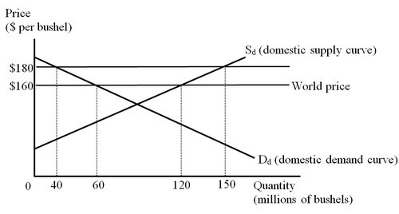

At a world price of $160 per bushel, the country produced ________ bushels of wheat and exported ________ bushels of wheat.
A) 60; 120
B) 120; 80
C) 120; 60
D) 150; 120

Answer: C
Difficulty: 2 Medium
Topic: Export Subsidies
Bloom's: Understand
AACSB: Reflective Thinking
Accessibility: Keyboard Navigation

14) The figure below represents the domestic market for wheat in a small country. Imports of wheat are prohibited.

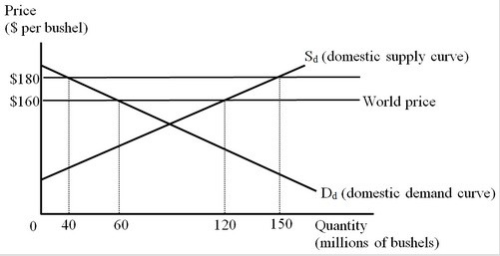

Following the imposition of a $20 per bushel export subsidy to the country's wheat exports, the country consumed ________ bushels of wheat and exported ________ bushels of wheat.
A) 40; 110
B) 60; 90
C) 60; 60
D) 40; 80

Answer: A
Difficulty: 2 Medium
Topic: Export Subsidies
Bloom's: Understand
AACSB: Reflective Thinking
Accessibility: Keyboard Navigation

15) The figure below represents the domestic market for wheat in a small country. Imports of wheat are prohibited.

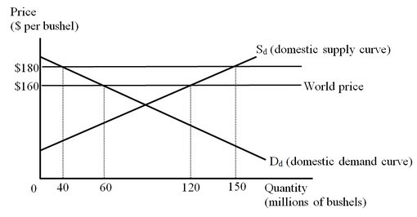

With an export subsidy of $20 per bushel, the production effect of the export subsidy amounts to
A) $200 million.
B) $300 million.
C) $1 billion.
D) $2.2 billion.

Answer: B
Difficulty: 3 Hard
Topic: Export Subsidies
Bloom's: Apply
AACSB: Analytical Thinking
Accessibility: Keyboard Navigation

16) The figure below represents the domestic market for wheat in a small country. Imports of wheat are prohibited.

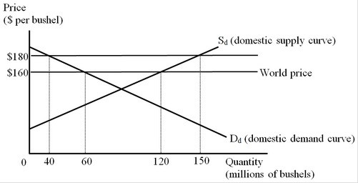

With an export subsidy of $20 per bushel, the consumption effect of the export subsidy amounts to
A) $200 million.
B) $300 million.
C) $1 billion.
D) $2.2 billion.

Answer: A
Difficulty: 3 Hard
Topic: Export Subsidies
Bloom's: Apply
AACSB: Analytical Thinking
Accessibility: Keyboard Navigation

17) The figure below represents the domestic market for wheat in a small country. Imports of wheat are prohibited.

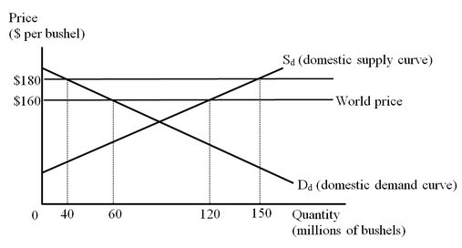

With an export subsidy of $20 per bushel, the cost to the government of paying the export subsidy is
A) $1.2 billion.
B) $3 billion.
C) $600 million.
D) $2.2 billion.

Answer: D
Difficulty: 3 Hard
Topic: Export Subsidies
Bloom's: Apply
AACSB: Analytical Thinking
Accessibility: Keyboard Navigation

18) The figure below represents the domestic market for wheat in a small country. Imports of wheat are prohibited.

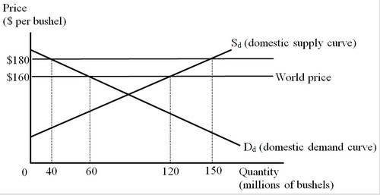

With an export subsidy of $20 per bushel, the net loss in national well-being as a result of the export subsidy is
A) $200 million.
B) $300 million.
C) $500 million.
D) $2.2 billion.

Answer: C
Difficulty: 2 Medium
Topic: Export Subsidies
Bloom's: Understand
AACSB: Reflective Thinking
Accessibility: Keyboard Navigation

19) The figure below illustrates the impact of an export subsidy as imposed by a large country. No imports are permitted.

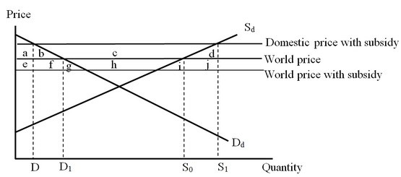

The cost to the government of the indicated export subsidy is shown by area(s)
A) (a + b + c + d + e + f + g + h + i + j)
B) (c + h)
C) (b + c + d)
D) (b + c + d + f + g + h + i + j)

Answer: D
Difficulty: 3 Hard
Topic: Export Subsidies
Bloom's: Apply
AACSB: Analytical Thinking
Accessibility: Keyboard Navigation

20) The figure below illustrates the impact of an export subsidy as imposed by a large country. No imports are permitted.

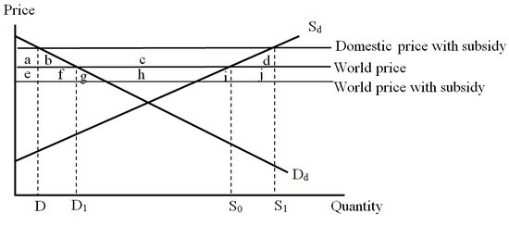

What is the net impact on the consumer surplus of the export subsidy provided by the domestic government?
A) The consumer surplus increases by area a.
B) The consumer surplus falls by area (a + b).
C) The consumer surplus falls by area (a + b + e + f + g).
D) The consumer surplus increases by area (a + b + c).

Answer: B
Difficulty: 3 Hard
Topic: Export Subsidies
Bloom's: Apply
AACSB: Analytical Thinking
Accessibility: Keyboard Navigation

21) The figure below illustrates the impact of an export subsidy as imposed by a large country. No imports are permitted.

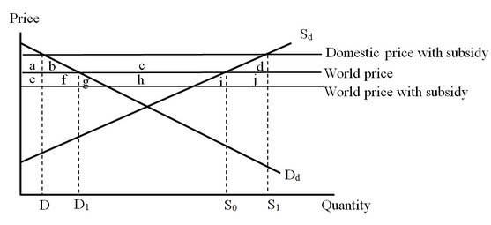

What is the net impact on the producer surplus of the export subsidy provided by the domestic government?
A) The producer surplus falls by area (a + b).
B) The producer surplus increases by area (a + b + c + d).
C) The producer surplus falls by area (a + b + c + e + f + g + h).
D) The producer surplus increases by area (a + b + c).

Answer: D
Difficulty: 3 Hard
Topic: Export Subsidies
Bloom's: Apply
AACSB: Analytical Thinking
Accessibility: Keyboard Navigation

22) The figure below illustrates the impact of an export subsidy as imposed by a large country. No imports are permitted.

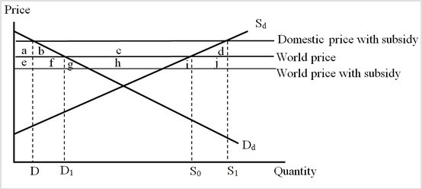

The production effect of the export subsidy is shown by area(s)
A) b.
B) d.
C) (d + i + j).
D) (b + f + g).

Answer: B
Difficulty: 3 Hard
Topic: Export Subsidies
Bloom's: Apply
AACSB: Analytical Thinking
Accessibility: Keyboard Navigation

23) The figure below illustrates the impact of an export subsidy as imposed by a large country. No imports are permitted.
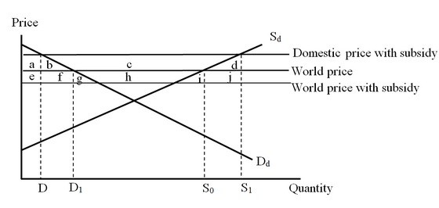

The consumption effect of the export subsidy is shown by area(s)
A) b.
B) d.
C) (d + i + j).
D) (b + f + g).

Answer: A
Difficulty: 3 Hard
Topic: Export Subsidies
Bloom's: Apply
AACSB: Analytical Thinking
Accessibility: Keyboard Navigation

24) The figure below illustrates the impact of an export subsidy as imposed by a large country. No imports are permitted.

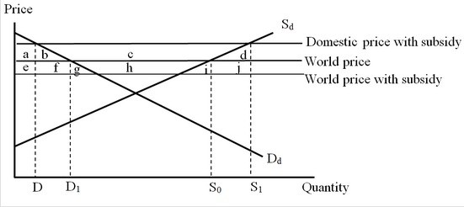

Which of the following correctly identifies the net change in national welfare due to the provision of the export subsidy by the domestic government?
A) The net gain in well-being for the exporting country is area c.
B) The net loss in well-being for the exporting country is area (b + d).
C) The net gain in well-being for the exporting country is area (b + d + f + g + i +j).
D) The net loss in well-being for the exporting country is area (b + d + f + g + h + i + j).

Answer: D
Difficulty: 3 Hard
Topic: Export Subsidies
Bloom's: Apply
AACSB: Analytical Thinking
Accessibility: Keyboard Navigation

25) An export subsidy imposed by a large country can be more damaging to national welfare than an export subsidy imposed by a small country because
A) the production effect is necessarily larger for the large country.
B) the consumption effect is necessarily larger for the large country.
C) the terms of trade worsen for the large country but not for the small country.
D) the net national gains of the large country are overshadowed by the net welfare loss of the world.

Answer: C
Difficulty: 1 Easy
Topic: Export Subsidies
Bloom's: Remember
AACSB: Reflective Thinking
Accessibility: Keyboard Navigation

26) Country X imports rice from the world market. Which of the following policy instruments, if adopted by its government, may result in a switch from rice being imported to being exported?
A) An agricultural price ceiling that creates domestic excess demand
B) Division of land holdings
C) Taxing imports of agricultural inputs
D) An agricultural price support that includes the government selling any excess production to foreign buyers

Answer: D
Difficulty: 2 Medium
Topic: Should the Importing Country Impose Countervailing Duties?
Bloom's: Understand
AACSB: Reflective Thinking
Accessibility: Keyboard Navigation

27) Which of the following subsidies is prohibited under World Trade Organization (WTO) rules?
A) Subsidies to research and development
B) Subsidies to assist disadvantaged regions within the exporting country
C) Subsidies to assist firms in meeting environmental regulations
D) Subsidies to encourage firms in a developed country to export more

Answer: D
Difficulty: 1 Easy
Topic: WTO Rules on Subsidies
Bloom's: Remember
AACSB: Reflective Thinking
Accessibility: Keyboard Navigation

28) Assume that Country A provides a subsidy on its exports to Country B. Country B is about to impose a countervailing duty (of the same magnitude as the export subsidy) on the imports from Country A. Which of the following statements is true in this context?
A) The exporters in Country A gain surplus when the government of Country B imposes a countervailing duty.
B) The import-competing producers in Country B are worse off after the imposition of the countervailing duty by the government.
C) The overall national well-being of Country B would be lower when the domestic government imposes a countervailing duty to offset the impact of the export subsidy.
D) The consumers in Country B are better off after the government of Country B imposes a countervailing duty.

Answer: C
Difficulty: 2 Medium
Topic: Should the Importing Country Impose Countervailing Duties?
Bloom's: Understand
AACSB: Reflective Thinking
Accessibility: Keyboard Navigation

29) The figure below represents the U.S. market for steel imports from South Korea. The South Korean government provides an export subsidy of $25 per ton, and South Korean firms use the subsidy to reduce their export price to the United States to $375 per ton.

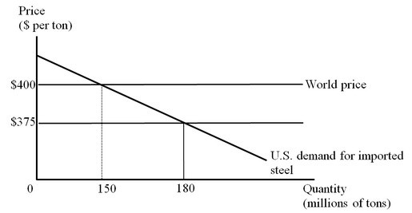

The change in national welfare in the United States when the South Korean government provides an export subsidy of $25 per ton is
A) + $375 million.
B) – $3.75 billion.
C) + $4.125 billion.
D) –$4.5 billion.

Answer: C
Difficulty: 3 Hard
Topic: Export Subsidies
Bloom's: Apply
AACSB: Analytical Thinking
Accessibility: Keyboard Navigation

30) The figure below represents the U.S. market for steel imports from Korea. The Korean government provides an export subsidy of $25 per ton, and Korean firms use the subsidy to reduce their export price to the United States to $375 per ton.

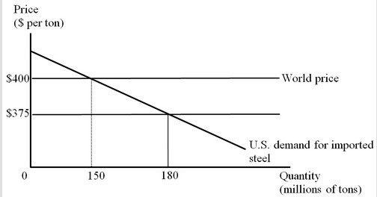

What is the cost of the export subsidy to the Korean government?
A) $375 million
B) $3.75 billion
C) $4.5 billion
D) $67.5 billion

Answer: C
Difficulty: 3 Hard
Topic: Export Subsidies
Bloom's: Apply
AACSB: Analytical Thinking
Accessibility: Keyboard Navigation

31) The figure below represents the U.S. market for steel imports from Korea. The Korean government provides an export subsidy of $25 per ton, and Korean firms use the subsidy to reduce their export price to the United States to $375 per ton.

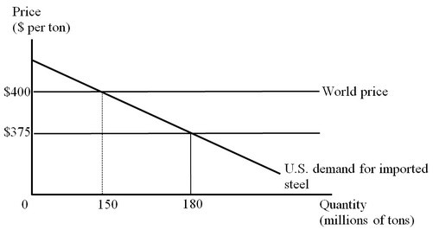

Suppose the United States now imposes a countervailing duty on its steel imports from Korea to offset the impact of the subsidy provided by the Korean government on its steel exports. The change in U.S. national well-being due to the imposition of this duty is
A) –$375 million.
B) +$3.375 billion.
C) +$3.75 billion.
D) –$4.125 billion.

Answer: A
Difficulty: 3 Hard
Topic: Export Subsidies
Bloom's: Apply
AACSB: Analytical Thinking
Accessibility: Keyboard Navigation

32) The figure below represents the U.S. market for steel imports from Korea. The Korean government provides an export subsidy of $25 per ton, and Korean firms use the subsidy to reduce their export price to the United States to $375 per ton.

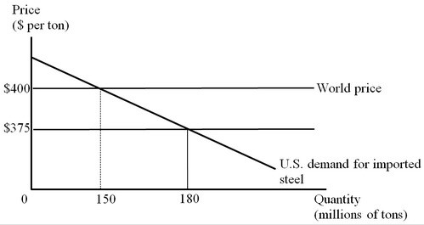

Consider the combination of the Korean export subsidy and a U.S. countervailing duty on the imports of steel, both at the rate of $25 per ton. Who among the following is effectively paying the countervailing duty?
A) The consumers of steel in the United States
B) The government of Korea
C) The steel-producers in the United States
D) The steel-producers in Korea

Answer: B
Difficulty: 3 Hard
Topic: Should the Importing Country Impose Countervailing Duties?
Bloom's: Analyze
AACSB: Analytical Thinking
Accessibility: Keyboard Navigation

33) The figure below represents the U.S. market for steel imports from Korea. The Korean government provides an export subsidy of $25 per ton, and Korean firms use the subsidy to reduce their export price to the United States to $375 per ton.

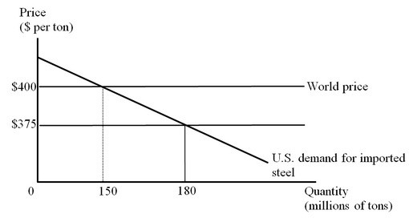

Suppose the United States imposes a countervailing duty on the imports of steel at the rate of $25 per ton. What is the amount of revenue collected by the U.S. government by imposing this countervailing duty?
A) $750 million
B) $3.75 billion
C) $4.125 billion
D) $375 million

Answer: B
Difficulty: 3 Hard
Topic: Should the Importing Country Impose Countervailing Duties?
Bloom's: Apply
AACSB: Analytical Thinking
Accessibility: Keyboard Navigation

34) The figure below represents the U.S. market for steel imports from Korea. The Korean government provides an export subsidy of $25 per ton, and Korean firms use the subsidy to reduce their export price to the United States to $375 per ton.

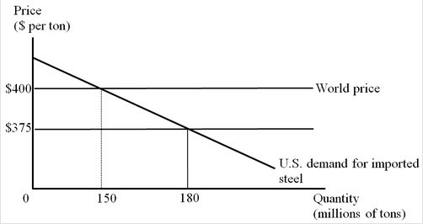

Suppose the United States now imposes a countervailing duty on the imports of steel at the rate of $25 per ton. Which of the following is true in this context?
A) The well-being of the world as a whole is reduced by $750 million.
B) Korea's loss of well-being exceeds the U.S. gain of well-being.
C) The producers in the United States lose, whereas the producers in Korea gain.
D) The world price level and volume of trade become similar to the free-trade condition.

Answer: D
Difficulty: 3 Hard
Topic: Should the Importing Country Impose Countervailing Duties?
Bloom's: Analyze
AACSB: Analytical Thinking
Accessibility: Keyboard Navigation

35) The impact on world well-being of an export subsidy and a countervailing duty (of the same size as the subsidy) is
A) zero.
B) negative due to overproduction.
C) negative due to under-consumption.
D) negative due to deadweight loss.

Answer: A
Difficulty: 1 Easy
Topic: Should the Importing Country Impose Countervailing Duties?
Bloom's: Easy
AACSB: Reflective Thinking
Accessibility: Keyboard Navigation

36) An export subsidy can be good for a country if
A) the subsidy allows the country's only exporting firm to capture the entire world market.
B) the subsidy decreases the export price so the export quantity increases.
C) the subsidy is offset by a countervailing duty.
D) the international market for the export product is highly competitive.

Answer: A
Difficulty: 1 Easy
Topic: Strategic Export Subsidies Could Be Good
Bloom's: Remember
AACSB: Reflective Thinking
Accessibility: Keyboard Navigation

37) In 1992, the bilateral agreement of the United States with the European Union regarding the subsidies for production of civil aircraft included that
A) direct government support for new airplane development is limited to one-tenth of the total development costs.
B) indirect government support is limited to 4 percent of a firm's civil aircraft sales.
C) marketing subsidies could be provided to the firm, but production subsidies could not.
D) subsidies could only be in the form of loans at a market rate of interest with a short repayment period.

Answer: B
Difficulty: 1 Easy
Topic: Should the Importing Country Impose Countervailing Duties?
Bloom's: Easy
AACSB: Reflective Thinking
Accessibility: Keyboard Navigation

38) Consider Firm X belongs to Country A and Firm Y belongs to Country B. Suppose it's technologically feasible for both firms to produce Good Z. Also, assume that if they do, then they will be the only suppliers of Good Z in the world. Now, both the firms have to decide simultaneously whether to produce Good Z or not. Figure (a) shows the payoffs for both firms if their respective governments do not provide them with export subsidies. Figure (b) shows the payoffs when the government of Country B grants an export subsidy to Firm Y, but the government of Country A does not grant an export subsidy to Firm X. From Figure (a), we can correctly infer that

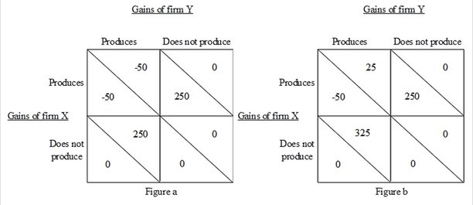

A) it is optimal for Firm X not to produce if Firm Y does not produce.
B) both firms can decide to produce since they can anticipate that the other firm will not produce.
C) it is optimal for Firm Y not to produce no matter what Firm X does.
D) both firms will suffer losses if they produce simultaneously.

Answer: D
Difficulty: 2 Medium
Topic: Strategic Export Subsidies Could Be Good
Bloom's: Understand
AACSB: Reflective Thinking
Accessibility: Keyboard Navigation

39) Consider Firm X belongs to Country A and Firm Y belongs to Country B. Suppose it's technologically feasible for both firms to produce Good Z. Also, assume that if they do, then they will be the only suppliers of Good Z in the world. Now, both firms have to decide simultaneously whether to produce Good Z or not. Figure (a) shows the payoffs for both firms if their respective governments do not provide them with export subsidies. Figure (b) shows the payoffs when the government of Country B grants an export subsidy to Firm Y, but the government of Country A does not grant an export subsidy to Firm X. From Figure (b), the decision of Country B's government to subsidize Firm Y

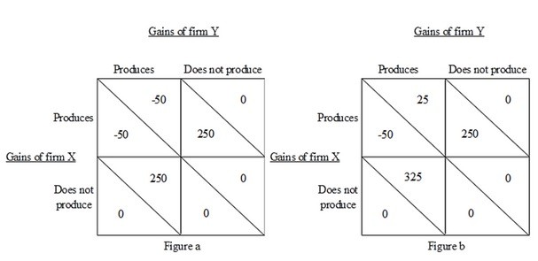

A) can be good for Country B because Firm X will decide not to produce.
B) will be good for Country B only if the government of Country A decides to subsidize Firm X.
C) can never lead to an optimal solution since Firm X will surely produce.
D) will be suboptimal since it will lose its customers in Country A.

Answer: A
Difficulty: 2 Medium
Topic: Strategic Export Subsidies Could Be Good
Bloom's: Understand
AACSB: Reflective Thinking
Accessibility: Keyboard Navigation

40) Aggressive competition in the foreign market through exports by a domestic firm due to a protected home market is known as
A) cyclical dumping.
B) persistent dumping.
C) strategic dumping.
D) seasonal dumping.

Answer: C
Difficulty: 1 Easy
Topic: Dumping
Bloom's: Remember
AACSB: Reflective Thinking
Accessibility: Keyboard Navigation

41) The fight over export policy usually focuses on artificial export limits rather than artificial promotion of exports.

Answer: FALSE
Difficulty: 1 Easy
Topic: Actual Antidumping Policies: What Should a Dumpee Think?
Bloom's: Remember
AACSB: Reflective Thinking
Accessibility: Keyboard Navigation

42) Firms that are participating in persistent dumping will sell less in the foreign market and charge a higher price than in the home market.

Answer: FALSE
Difficulty: 1 Easy
Topic: Dumping
Bloom's: Remember
AACSB: Reflective Thinking
Accessibility: Keyboard Navigation

43) Firms that are engaging in persistent dumping need to be able to prevent resale between the foreign and domestic markets.

Answer: TRUE
Difficulty: 2 Medium
Topic: Dumping
Bloom's: Understand
AACSB: Reflective Thinking
Accessibility: Keyboard Navigation

44) If markets are competitive, policies that restrict imports are usually harmful to the importing country while policies that encourage exports are usually beneficial to the exporting country.

Answer: FALSE
Difficulty: 1 Easy
Topic: Actual Antidumping Policies: What Should a Dumpee Think?
Bloom's: Remember
AACSB: Reflective Thinking
Accessibility: Keyboard Navigation

45) Antidumping duties increase overall economic well-being in a country by protecting the domestic import-competing firms.

Answer: FALSE
Difficulty: 1 Easy
Topic: Actual Antidumping Policies: What Should a Dumpee Think?
Bloom's: Remember
AACSB: Reflective Thinking
Accessibility: Keyboard Navigation

46) In the United States, the tests used to evaluate injury from dumping not only consider the loss of well-being of the import-competing producers from dumping but also emphasize the benefits to consumers of the low-priced imports.

Answer: FALSE
Difficulty: 1 Easy
Topic: Actual Antidumping Policies: What Should a Dumpee Think?
Bloom's: Remember
AACSB: Reflective Thinking
Accessibility: Keyboard Navigation

47) While the U. S. government investigates few claims of dumping, nearly all of the claims are upheld by the International Trade Commission.

Answer: FALSE
Difficulty: 1 Easy
Topic: Actual Antidumping Policies: What Should a Dumpee Think?
Bloom's: Remember
AACSB: Reflective Thinking
Accessibility: Keyboard Navigation

48) Proposals for reform of antidumping policy include restricting its use to cases where predatory dumping is plausible, accounting for consumer interests in the analysis of injury from dumping, and replacing antidumping policy with safeguard policy.

Answer: TRUE
Difficulty: 1 Easy
Topic: Proposals for Reform
Bloom's: Remember
AACSB: Reflective Thinking
Accessibility: Keyboard Navigation

49) For developed countries, more price supports and subsidies are provided to agriculture worldwide than to any other sector of the economy.

Answer: TRUE
Difficulty: 1 Easy
Topic: Actual Antidumping Policies: What Should a Dumpee Think?
Bloom's: Remember
AACSB: Reflective Thinking
Accessibility: Keyboard Navigation

50) An export subsidy imposed in a large exporting country will cause the country's international terms of trade to improve.

Answer: FALSE
Difficulty: 1 Easy
Topic: Export Subsidies
Bloom's: Remember
AACSB: Reflective Thinking
Accessibility: Keyboard Navigation

51) A large enough production subsidy can turn an imported product into an exportable product.

Answer: TRUE
Difficulty: 1 Easy
Topic: Export Subsidies
Bloom's: Remember
AACSB: Reflective Thinking
Accessibility: Keyboard Navigation

52) A price support on agricultural products is a minimum domestic price set by the government. The government outlaws transactions below the price support, but usually has no commitment to buy any amounts that farmers cannot sell at this price.

Answer: FALSE
Difficulty: 1 Easy
Topic: Should the Importing Country Impose Countervailing Duties?
Bloom's: Remember
AACSB: Reflective Thinking
Accessibility: Keyboard Navigation

53) Briefly describe the World Trade Organization (WTO) rules on subsidies that affect exports of a product and responses by importing countries to such subsidies.

Answer: POSSIBLE RESPONSE: As a result of the agreements reached in the Tokyo and Uruguay Rounds of trade negotiations, the World Trade Organization (WTO) has established rules regarding export subsidies. WTO rules divide subsidies into either those that are linked directly to exports or those that are not linked directly to exports. Subsidies linked directly to exporting are prohibited, except export subsidies used by the lowest-income developing countries. An example of a subsidy that is directly linked to an export would be a firm that receives a tax break based on the amount that it exports. Subsidies that are not linked directly to exporting but still have an impact on exports are considered actionable. An example of a subsidy that is not directly linked to an export would be a government providing low-priced electricity to assist local firms in an industry that exports a portion of its production. If an importing country's government believes that a foreign country is using a prohibited subsidy or an actionable subsidy that is causing harm to an industry, the importing country can follow one of two procedures. The importing country can file a complaint with the WTO and use its dispute settlement procedure or, what is more common, use a national procedure similar to that used for dumping. If the importing country can show the existence of a prohibited or actionable subsidy and harm to its industry, the WTO rules permit the importing country to impose a countervailing duty. A countervailing duty is a tariff used to offset the price or cost advantage created by the subsidy to foreign exports.
Difficulty: 2 Medium
Topic: Should the Importing Country Impose Countervailing Duties?
Bloom's: Remember
AACSB: Reflective Thinking
Accessibility: Keyboard Navigation

54) Briefly discuss the effects of export subsidies given a competitive industry.

Answer: POSSIBLE RESPONSE: An export subsidy expands exports and production of the subsidized product. If the export subsidy is large enough it could even result in a product that a country would otherwise import becoming an export. If the exporting country is large enough to affect world prices, then the export subsidy lowers the price that the importing country pays for these exports. The importing country overall is better off, but the import-competing industry is harmed. For the export subsidy to work as intended, the government subsidizes only exports and not domestic purchases of the product. Additionally, something must prevent local buyers from importing the product at the lower foreign price. The export subsidy benefits the specific exporting industry but reduces the net national well-being of the exporting country as a whole.
Difficulty: 2 Medium
Topic: Export Subsidies
Bloom's: Remember
AACSB: Reflective Thinking
Accessibility: Keyboard Navigation

55) What is the full definition of dumping? If an importing country suspects dumping, what action can be taken?

Answer: POSSIBLE RESPONSE: Dumping is selling exports at a price below the normal value (or fair market value). There are two definitions of normal value. The traditional definition of normal value is the price charged in the home market. Dumping in this case means international price discrimination. The second definition of normal value is the average cost of production. Under this second definition dumping is selling goods abroad at a price below average production cost. If an importing country discovers dumping and domestic injury from dumping, the country can use antidumping measures such as imposing antidumping duties.
Difficulty: 1 Easy
Topic: Dumping
Bloom's: Understand
AACSB: Reflective Thinking
Accessibility: Keyboard Navigation

56) What is predatory dumping? How likely is dumping to be predatory? Discuss.

Answer: POSSIBLE RESPONSE: Predatory dumping occurs when a foreign firm temporarily charges a low price with the intention to drive local firms out of business, and eventually attain monopoly power and raise prices. Predatory dumping is likely to be rare in modern markets. An exporting company will engage in predatory dumping only if the profits in the distant future outweigh the current losses associated with the temporary reduction in price. However, future profits are likely to be quite uncertain. Even if the firm succeeds in driving current competitors out of business, once prices are raised, new firms will enter the industry as competitors, and prices will not continue to be high for very long.
Difficulty: 2 Medium
Topic: Dumping
Bloom's: Understand
AACSB: Reflective Thinking
Accessibility: Keyboard Navigation

57) With free trade the United States imports about half of its steel consumption from China. Show this graphically, using a graph of the U.S. national market for steel (including both domestic steel supply and imported steel supply), and explain the impact on the United States of an export subsidy on steel provided by the Chinese government. (Assume the Chinese export subsidy lowers the price that Chinese steel exporters charge.) Would it be beneficial for the United States to impose an equal amount of countervailing duty on the import of steel? Why or why not?

Answer: POSSIBLE RESPONSE: To evaluate the impact of the export subsidy provided by the Chinese government, let's first take a look at the diagram below which illustrates the U.S. market for steel.

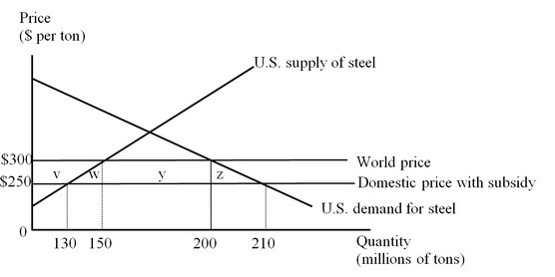

Let's assume the current world price is $300 per ton. After the Chinese government provides a subsidy to steel exports, the price of the imported steel in the U.S. market falls to $250. Steel consumers in the United States gain an additional consumer surplus equal to the area (v + w + y + z). Producers lose a surplus equal to the area 'v'. So, the net benefit to the United States from the Chinese export subsidy is represented by the area (w + y + z).

If the U.S. government decides to impose a countervailing duty on the imports of Chinese steel to offset the impact of the subsidy, the price of the imported steel in the U.S. market climbs back to the initial level of $300 per ton. The steel producers in the United States get back their lost surplus as shown by the area 'v'. The U.S. consumers on the other hand, lose surplus given by the area (v + w + y + z). The U.S. government collects tariff revenue equal to the area 'y'. From the figure we can conclude that the countervailing duty lowers welfare in the United States by the area (w + z). Thus, imposing a countervailing duty would actually harm the U.S. economy.
Difficulty: 3 Hard
Topic: Actual Antidumping Policies: What Should a Dumpee Think?
Bloom's: Analyze
AACSB: Analytical Thinking
Accessibility: Keyboard Navigation

58) The farmers in Country A harvest and sell 150 tons of rice at the price of $80 per ton. Of the total produced, 30 tons are exported. If the government bans all exports of rice, the domestic price of rice would drop to $60. But the production and sales would also drop to 120 tons. How much loss would the domestic farmers incur due to the export ban? Use a graph to illustrate your answer.

Answer: POSSIBLE RESPONSE: This problem is illustrated in the following graph.

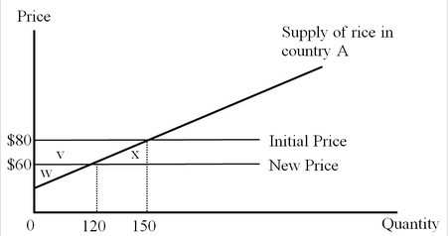

The initial situation defines a producer surplus measured by the area (w + v). The ban on the exports of rice lowers the price to $60, and the new producer surplus is given by area w. The loss is area v, which can be calculated as (v + x) – x = (80 - 60) × 150 – (150 - 120) × (80 - 60)/2 = 3,000 – 300 = $2,700.

So, due to the export ban, the domestic farmers would suffer an amount of loss equivalent to $2,700.
Difficulty: 3 Hard
Topic: Should the Importing Company Impose Countervailing Duties?
Bloom's: Analyze
AACSB: Analytical Thinking
Accessibility: Keyboard Navigation

59) Country X is a small country, with demand and supply functions for the food grains:

QD = 150 – 0.6P

QS = –40 + 0.5P

where QD and QS are in millions of tons and P is the price per ton. The world price of grain is $200 per ton.

a. In a situation of free trade, how much food grains would be produced, consumed, and traded in Country X?

b. As a response to alleged unfair foreign practices, Country X farmers successfully lobby for a $20 export subsidy per ton of the grains exported. Assuming that imports of food grains are banned, show graphically and explain the impact of the export subsidy on domestic prices, consumption, production, and exports of grain by this country. Also indicate, using your graph, the effects on well-being of domestic producers and consumers and the cost of the subsidy to the government, as well as the net change in well-being in Country X. For each of these changes, calculate the money amount of each of the changes in well-being and government cost.

Answer: POSSIBLE RESPONSE:

a. Using the equations and the world price of $200, the quantity supplied of food grains by producers in Country X is 60 million tons and the quantity demanded of grains is 30 million tons. Therefore 30 million tons of food grains are exported by this country.

b. As Country X is a small country in the world market, there will be no effect on the world price when the export subsidy provided to the food grain producers in this country is implemented. For the food grain producers in Country X, the revenue per ton exported rises to $220, and the exporting firms must receive this amount as the selling price from domestic buyers as well. Domestic production rises from 60 to 70 million tons, domestic consumption falls from 30 to 18 million tons, and the country's exports increase from 30 million tons to (70 - 18) = 52 million tons. Domestic producers gain surplus equal to the area (e + f + g) or $1.3 billion, domestic consumers lose surplus equal to the area (e + f) or $480 million, and the cost to the government of paying the export subsidy is area (f + g + h) or $1.04 billion. The net loss in national well-being resulting from the export subsidy equals the sum of the areas f and h or $220 million.

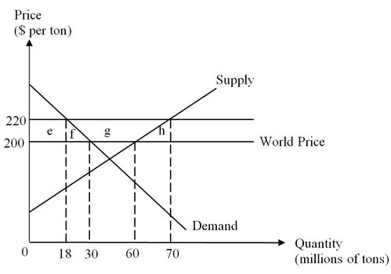
Difficulty: 3 Hard
Topic: Export Subsidies
Bloom's: Analyze
AACSB: Analytical Thinking
Accessibility: Keyboard Navigation

60) Firm X belongs to Country A and Firm Y belongs to Country B. The two firms are a global duopoly. Each is considering initiating exports to a large foreign country that currently has no imports and no domestic production or consumption of this product. The figure shows the payoffs if neither, one, or both of the firms initiates exports of this product. Explain why this game has no clear solution, so both firms could decide not to export. Explain why country B's government should consider subsidizing Firm Y's exports.

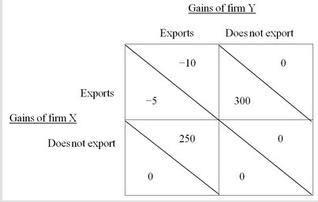

Answer: POSSIBLE RESPONSE: The figure shows the payoffs for both firms when no subsidies are given. The rivalry game without subsidies has no clear-cut result. If one of the firms decides to export, it is best for the other firm not to export. Each firm would like to be the only exporter, but if both export both will lose. If the firms are unable to coordinate, both firms could decide not to export.

Should Country B's government offer a subsidy to Firm Y's exports? The subsidy could induce Firm Y to export regardless of what Firm X does. The subsidy would have to be at least $11. Let's say the subsidy is actually $15. Then the payoffs for both firms with the subsidy to exports by Firm Y are now:

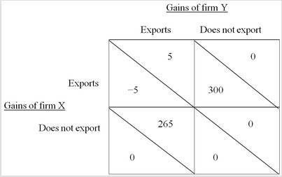

With the export subsidy, Firm Y should export regardless of what Firm X does. Knowing that Firm Y will export, Firm X will find it best not to export, and Firm Y will serve the entire foreign market. Firm Y, Country B, and the world as a whole would gain, compared to no production by either firm.
Difficulty: 3 Hard
Topic: Strategic Export Subsidies Could Be Good
Bloom's: Analyze
AACSB: Analytical Thinking
Accessibility: Keyboard Navigation

