International Economics, 17e (Pugel)
Chapter 10 Arguments for and against Protection

1) Which of the following is an expected effect of a tariff or a nontariff barrier (NTB) on a product?
A) A decrease in the domestic production of the product
B) An increase in the employment of labor and other resources used in the import-competing industry in the tariff-imposing country
C) An increase in domestic consumption of the imported product
D) A decrease in government revenue

Answer: B
Difficulty: 1 Easy
Topic: The Ideal World of First Best
Bloom's: Remember
AACSB: Reflective Thinking
Accessibility: Keyboard Navigation

2) If there is something extra bad about local consumption of a product, then a tariff can be good for the country because
A) the tariff makes all residents richer.
B) the tariff brings down the domestic price of the product.
C) the tariff leads to higher domestic price for the product.
D) the tariff revenue is invested in the production of substitute products.

Answer: C
Difficulty: 1 Easy
Topic: The Ideal World of First Best
Bloom's: Remember
AACSB: Reflective Thinking
Accessibility: Keyboard Navigation

3) In a "first-best" world
A) each economy is self-sufficient enough not to indulge in free trade.
B) free trade is economically efficient.
C) free trade benefits only the consumers of the importing country.
D) free trade benefits only the exporting nations.

Answer: B
Difficulty: 1 Easy
Topic: The Ideal World of First Best
Bloom's: Remember
AACSB: Reflective Thinking
Accessibility: Keyboard Navigation

4) Which of the following is valid for a "first-best" world?
A) Social Marginal Benefit (SMB) > Price (P) = Buyer's Private Marginal Benefit (MB) = Seller's Private Marginal Cost (MC) = Social Marginal Cost (SMC)
B) Social Marginal Cost (SMC) > Price (P) = Buyer's Private Marginal Benefit (MB) = Seller's Private Marginal Cost (MC) = Social Marginal Benefit (SMB)
C) Price (P) = Buyer's Private Marginal Benefit (MB) = Seller's Private Marginal Cost (MC) = Social Marginal Cost (SMC) = Social Marginal Benefit (SMB)
D) Social Marginal Benefit (SMB) > Social Marginal Cost (SMC)

Answer: C
Difficulty: 2 Medium
Topic: The Ideal World of First Best
Bloom's: Understand
AACSB: Reflective Thinking
Accessibility: Keyboard Navigation

5) If Social Marginal Cost (SMC) > Price (P) = Buyer's Private Marginal Benefit (MB) = Seller's Private Marginal Cost (MC) = Social Marginal Benefit (SMB), it implies that
A) the product is oversupplied.
B) there is an excess demand for the product.
C) the socially optimal amount of the product is supplied.
D) firms are not maximizing profits.

Answer: A
Difficulty: 2 Medium
Topic: The Ideal World of First Best
Bloom's: Understand
AACSB: Reflective Thinking
Accessibility: Keyboard Navigation

6) If Social Marginal Benefit (SMB) > Price (P) = Buyer's Private Marginal Benefit (MB) = Seller's Private Marginal Cost (MC) = Social Marginal Cost (SMC), it implies that
A) too much of the product is supplied.
B) not enough of a good is being demanded.
C) the socially optimal amount is supplied.
D) the buyers are not maximizing utility.

Answer: B
Difficulty: 2 Medium
Topic: The Ideal World of First Best
Bloom's: Understand
AACSB: Reflective Thinking
Accessibility: Keyboard Navigation

7) In a "second-best" world
A) tariffs are economically optimal.
B) private actions are dictated by government agencies.
C) social marginal cost of a transaction equals social marginal benefit.
D) private actions do not lead to the best possible outcomes for society.

Answer: D
Difficulty: 1 Easy
Topic: The Realistic World of Second Best
Bloom's: Remember
AACSB: Reflective Thinking
Accessibility: Keyboard Navigation

8) Which of the following refers to the positive or negative effect on parties who are not directly involved in a transaction?
A) Invisible hand
B) Incentive distortions
C) Consumption effect
D) Externality

Answer: D
Difficulty: 1 Easy
Topic: The Realistic World of Second Best
Bloom's: Remember
AACSB: Reflective Thinking
Accessibility: Keyboard Navigation

9) Which of the following statements reflects a situation in which there are external benefits?
A) John paints his house and cleans his paintbrushes in the nearby stream.
B) John pays 5 percent of his income as taxes.
C) John's decision to get vaccinated for smallpox reduces the chances that his neighbor Pete will get smallpox.
D) John sells his car to his neighbor Pete at half the first-hand price.

Answer: C
Difficulty: 2 Medium
Topic: The Realistic World of Second Best
Bloom's: Understand
AACSB: Reflective Thinking
Accessibility: Keyboard Navigation

10) Which of the following statements reflects a situation in which there are external costs?
A) Suzanne invites her neighbors to a party on her birthday.
B) Suzanne paints her house and landscapes her yard. Her newly beautified house and yard help her neighbors to sell their house for more than the asking price.
C) Suzanne pays for a professional fireworks show for her family. Her neighbors also enjoy the show.
D) Suzanne dumps her household garbage around the corner of the street.

Answer: D
Difficulty: 1 Easy
Topic: The Realistic World of Second Best
Bloom's: Remember
AACSB: Reflective Thinking
Accessibility: Keyboard Navigation

11) Which of the following is a plausible solution to a distortion?
A) Centralizing the privately owned enterprises
B) Shutting down any industry which is contributing to atmospheric pollution
C) Imposing a tax or subsidy on the activity if the social marginal cost or the social marginal benefit exceeds the market price
D) Imposing an importation ban on manufactured goods

Answer: C
Difficulty: 1 Easy
Topic: The Realistic World of Second Best
Bloom's: Remember
AACSB: Reflective Thinking
Accessibility: Keyboard Navigation

12) Suppose manufacturing of paper results in substantial ground-water pollution. One possible policy that can be used to reduce the inefficiency caused by this externality is
A) to subsidize the production of paper by the domestic firms.
B) to impose a tax on the production of paper.
C) to raise tariff barriers on paper imports.
D) to provide tax benefits to the firms exporting paper.

Answer: B
Difficulty: 1 Easy
Topic: The Realistic World of Second Best
Bloom's: Remember
AACSB: Reflective Thinking
Accessibility: Keyboard Navigation

13) Suppose that the domestic production of computer games creates enjoyment for those who play the games. Domestic production of computer games also results in knowledge spillovers that positively impact many other industries. One possible policy that could be employed to encourage increased production of computer games by domestic firms is
A) to impose tariffs on computer game imports.
B) to tax the production of computer games.
C) to tax the consumption of computer games.
D) to eliminate all restrictions on the importation of computer games.

Answer: A
Difficulty: 2 Medium
Topic: The Realistic World of Second Best
Bloom's: Understand
AACSB: Reflective Thinking
Accessibility: Keyboard Navigation

14) The tax-or-subsidy approach for solving externality problems was developed by
A) Arthur Pigou.
B) Ronald Coase.
C) Eli Heckscher.
D) Bertil Ohlin.

Answer: A
Difficulty: 1 Easy
Topic: The Realistic World of Second Best
Bloom's: Remember
AACSB: Reflective Thinking
Accessibility: Keyboard Navigation

15) The ________ states that it is usually more efficient to use the government policy tool that acts as directly as possible on the source of the distortion that is separating private and social benefits or costs.
A) Pigou effect
B) spillover effect
C) sudden-damage effect
D) specificity rule

Answer: D
Difficulty: 1 Easy
Topic: The Realistic World of Second Best
Bloom's: Remember
AACSB: Reflective Thinking
Accessibility: Keyboard Navigation

16) Which of the following is true of the specificity rule?
A) The specificity rule suggests that tariffs should be imposed only on specific products.
B) According to the specificity rule, government policy should target as closely as possible the source of the distortion that separates private and social benefits (or costs).
C) The specificity rule posits that a tariff imposed on a good favors only the interests of a specific group within a country.
D) According to the specificity rule, only specific industries should be allowed to participate in government lobbying.

Answer: B
Difficulty: 1 Easy
Topic: The Realistic World of Second Best
Bloom's: Remember
AACSB: Reflective Thinking
Accessibility: Keyboard Navigation

17) Suppose that the training, skills, and attitudes received by employees in the computer gaming development industry have positive spillover effects as workers leave the industry and move to other jobs. The specificity rule suggests that the best way to achieve more employment in this industry is to
A) impose a tariff on the importation of computer games.
B) remove all sales taxes from the purchases of computer games.
C) give computer game developing firms a subsidy tied to their level of employment.
D) tax the production of computer games.

Answer: C
Difficulty: 2 Medium
Topic: The Realistic World of Second Best
Bloom's: Understand
AACSB: Reflective Thinking
Accessibility: Keyboard Navigation

18) The figure below shows the national market for mopeds in a country. Dd and Sd are the domestic demand and supply curves of mopeds, respectively.

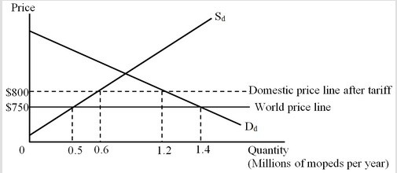

Calculate the welfare loss arising from the production effect of the tariff.
A) $14 million
B) $2.5 million
C) $5 million
D) $7.5 million

Answer: B
Difficulty: 3 Hard
Topic: Promoting Domestic Production or Employment
Bloom's: Apply
AACSB: Analytical Thinking
Accessibility: Keyboard Navigation

19) The figure below shows the national market for mopeds in a country. Dd and Sd are the domestic demand and supply curves of mopeds, respectively.

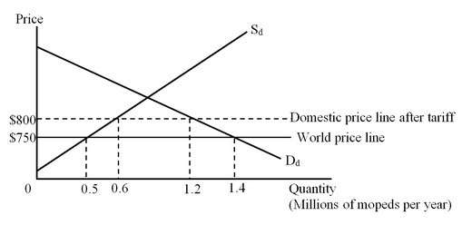

Calculate the welfare loss arising from the consumption effect of the tariff.
A) $14 million
B) $2.5 million
C) $5 million
D) $7.5 million

Answer: C
Difficulty: 3 Hard
Topic: Promoting Domestic Production or Employment
Bloom's: Apply
AACSB: Analytical Thinking
Accessibility: Keyboard Navigation

20) The figure below shows the marginal external benefit curve (MEB) from the domestic production of mopeds. A tariff has caused domestic production to increase from 500,000 to 600,000.

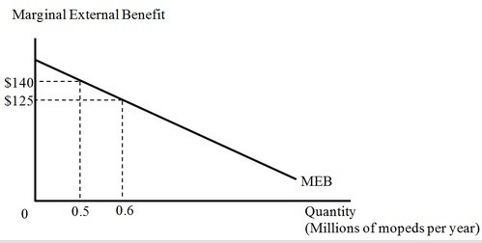

The increase in external benefits to the nation of the increased production of mopeds because of the tariff is
A) $13.25 million.
B) $2.5 million.
C) $5 million.
D) $7.5 million.

Answer: A
Difficulty: 3 Hard
Topic: Promoting Domestic Production or Employment
Bloom's: Apply
AACSB: Analytical Thinking
Accessibility: Keyboard Navigation

21) The figure below shows the national market for mopeds in a small country. Dd and Sd are the domestic demand and supply curves of mopeds, respectively.

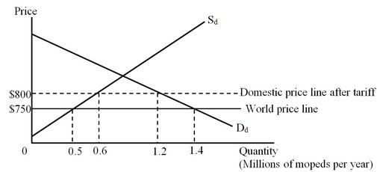

The figure below shows the marginal external benefit curve (MEB) of the country from the domestic production of mopeds.

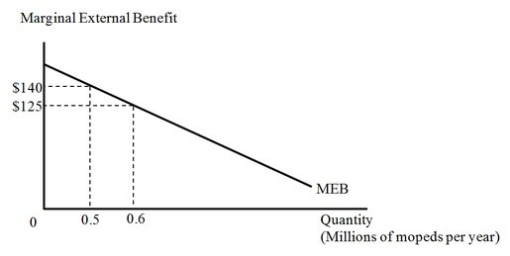

The overall impact of the tariff on the nation would be
A) a loss of $15 million.
B) a loss of $20.75 million.
C) a gain of $13.25 million.
D) a gain of $5.75 million.

Answer: D
Difficulty: 3 Hard
Topic: Promoting Domestic Production or Employment
Bloom's: Analyze
AACSB: Analytical Thinking
Accessibility: Keyboard Navigation

22) The figure below shows the national market for mopeds in a small country. Dd and Sd are the domestic demand and supply curves of mopeds respectively.

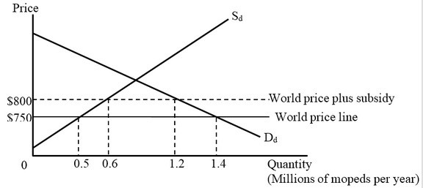

If there is initially free trade, and then a $50 per unit subsidy is given to the domestic producers of mopeds, domestic production will increase by
A) 100,000 units.
B) 600,000 units.
C) 700,000 units.
D) 1,200,000 units.

Answer: A
Difficulty: 3 Hard
Topic: Promoting Domestic Production or Employment
Bloom's: Analyze
AACSB: Analytical Thinking
Accessibility: Keyboard Navigation

23) The figure below shows the national market for mopeds in a small country. Dd and Sd are the domestic demand and supply curves of mopeds, respectively.

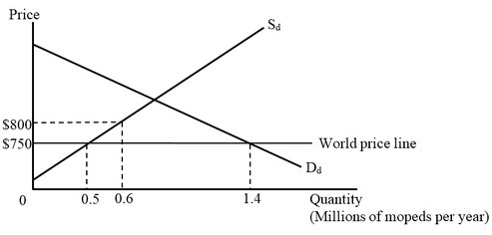

The figure below shows the marginal external benefit curve (MEB) of the country from the production of domestic mopeds.

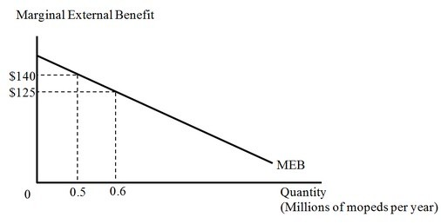

If there is initially free trade, and then a $50 per unit subsidy is given to the domestic producers of mopeds, domestic consumption of mopeds would
A) increase by 100,000 units.
B) decrease by 200,000 units.
C) decrease by 800,000 units.
D) remain unchanged.

Answer: D
Difficulty: 3 Hard
Topic: Promoting Domestic Production or Employment
Bloom's: Analyze
AACSB: Analytical Thinking
Accessibility: Keyboard Navigation

24) The figure below shows the national market for mopeds in a small country. Dd and Sd are the domestic demand and supply curves of mopeds, respectively. Initially, the country's government has a tariff on imports of mopeds.

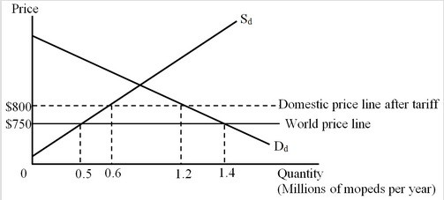

The figure below shows the marginal external benefit curve (MEB) of the country from the production of domestic mopeds.

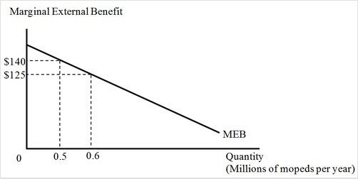

What will be the impact on the national well-being if, instead of imposing a tariff of $50 per unit, the government provides a subsidy of $50 per unit to the domestic manufacturers of mopeds?
A) The national welfare will increase by $5 million.
B) The national welfare will decline by $2.5 million.
C) The national welfare will increase by $10.75 million.
D) The national welfare will decline by $5 million.

Answer: A
Difficulty: 3 Hard
Topic: Promoting Domestic Production or Employment
Bloom's: Analyze
AACSB: Analytical Thinking
Accessibility: Keyboard Navigation

25) Which of the following asserts that temporary protection from international competition is needed for a nascent industry that initially has high costs?
A) The developing government argument
B) The infant industry argument
C) The dying industry argument
D) The optimal tariff argument

Answer: B
Difficulty: 1 Easy
Topic: The Infant Industry Argument
Bloom's: Remember
AACSB: Reflective Thinking
Accessibility: Keyboard Navigation

26) What is most likely to happen when firms in an import-competing infant industry are offered subsidies?
A) The firms will suffer from diseconomies of scale.
B) The firms will be able to sustain only if they charge a higher price than the foreign firms.
C) The firms will be able to charge a price equal to the world price and still earn a profit.
D) The firms will face a perfectly inelastic demand curve.

Answer: C
Difficulty: 1 Easy
Topic: The Infant Industry Argument
Bloom's: Remember
AACSB: Reflective Thinking
Accessibility: Keyboard Navigation

27) Under which of the following situations will the infant industry argument for protection be valid?
A) New firms are unable to obtain funds from the financial market owing to inherent imperfections in the banking system.
B) Benefits from early business investments accrue to the firms making these early investments.
C) Firms that produce important military hardware have substantial political support.
D) The more a country exports, the more the price of its exports falls relative to its imports.

Answer: A
Difficulty: 1 Easy
Topic: The Infant Industry Argument
Bloom's: Remember
AACSB: Reflective Thinking
Accessibility: Keyboard Navigation

28) Which of the following statements is true?
A) If new firms are struggling to obtain funds from underdeveloped financial markets, the most efficient policy solution would be to offer a production subsidy to these firms.
B) If the government's goal is to induce early production, even when the new firms are not cost-competitive by world standards, a barrier to the import of the product produced by these firms would be an ideal policy.
C) If young firms are struggling to retain their trained workers, then government should offer a subsidy to offset the costs of training workers.
D) If the domestic firms do not supply anything at the world price, the government should lower the barriers to importing the product to spur domestic production.

Answer: C
Difficulty: 2 Medium
Topic: The Infant Industry Argument
Bloom's: Understand
AACSB: Reflective Thinking
Accessibility: Keyboard Navigation

29) Which of the following asserts that import-competing firms that are struggling to stay in business should be provided protection in order to maintain jobs and continue domestic production?
A) The developing government argument
B) The infant industry argument
C) The dying industry argument
D) The optimal tariff argument

Answer: C
Difficulty: 1 Easy
Topic: The Dying Industry Argument and Adjustment Assistance
Bloom's: Remember
AACSB: Reflective Thinking
Accessibility: Keyboard Navigation

30) Which of the following statements is correct?
A) In a first-best world, imports would not cause import-competing firms to go out of business and workers in these industries to lose their jobs.
B) If we want to help workers who lose jobs when a domestic industry shrinks, the specificity rule suggests that the government should provide subsidies to those workers to retrain or to relocate to areas where jobs are available.
C) The most efficient policy to maintain production in import-competing industries is to impose barriers on imports.
D) In a first-best world, if rising import competition is driving domestic producers out of business, the government must intervene to protect the domestic firms.

Answer: B
Difficulty: 1 Easy
Topic: The Dying Industry Argument and Adjustment Assistance
Bloom's: Remember
AACSB: Reflective Thinking
Accessibility: Keyboard Navigation

31) In the United States, trade adjustment assistance
A) provides workers who have been displaced from import-competing firms with additional months of unemployment compensation.
B) provides subsidies to firms who produce exportable commodities.
C) provides incentives for workers to search for new jobs outside an import-competing industry before they lose their jobs in this industry.
D) is often criticized on the ground that it provides benefits to millions of workers each year who have not actually been affected by increased imports.

Answer: A
Difficulty: 1 Easy
Topic: The Dying Industry Argument and Adjustment Assistance
Bloom's: Remember
AACSB: Reflective Thinking
Accessibility: Keyboard Navigation

32) According to the developing government argument, tariffs imposed by a developing country
A) benefit the country because they represent an efficient mechanism for the country's rulers to obtain funds for their personal use.
B) can benefit the country by creating net social gains.
C) will be as inefficient as tariffs imposed by developed countries.
D) are likely to represent only a very small fraction of government revenues because the volume of imports in developing countries is relatively small.

Answer: B
Difficulty: 1 Easy
Topic: The Developing Government (Public Revenue) Argument
Bloom's: Remember
AACSB: Reflective Thinking
Accessibility: Keyboard Navigation

33) Which of the following arguments for protection is derived from the fact that funding of public goods in some countries is difficult given little or no means to collect income or sales taxes?
A) The developing government argument
B) The infant industry argument
C) The dying industry argument
D) The national defense argument

Answer: A
Difficulty: 1 Easy
Topic: The Developing Government (Public Revenue) Argument
Bloom's: Remember
AACSB: Reflective Thinking
Accessibility: Keyboard Navigation

34) The French highly value domestic production of traditional French cheese made by high-cost, traditional production methods. According to the specificity rule, the most efficient policy tool to protect this traditional industry would be
A) to provide a production subsidy to the domestic firms.
B) to impose an import tariff on cheeses produced in other countries.
C) to impose an import ban on cheeses produced in other countries.
D) to tax French exports of non-traditional cheeses.

Answer: A
Difficulty: 1 Easy
Topic: The Realistic World of Second Best
Bloom's: Remember
AACSB: Reflective Thinking
Accessibility: Keyboard Navigation

35) The United States produces some of the electronic components used as inputs in its fighter planes. But due to the limited number of companies that produce these items, it imports these parts from Japan as well. There is concern that in the case of a prolonged war, these important imports may not be available. Fearing that the Air Force may be unable to fulfill its tasks in the case of a prolonged war, the specificity rule suggests that the United States should
A) ban the importation of these electronics parts to protect jobs in this industry.
B) impose tariffs on the imports of these electronic parts.
C) subsidize the domestic production of these electronics parts.
D) impose high taxes on the production of these electronic parts.

Answer: C
Difficulty: 2 Medium
Topic: Promoting Domestic Production or Employment
Bloom's: Understand
AACSB: Reflective Thinking
Accessibility: Keyboard Navigation

36) Direct democracy makes tariffs less likely to be voted into law because
A) the size of the individual losses would be larger than the individual gains from any potential protectionist measure.
B) domestic producers threatened by increased imports will lobby against the trade agreements entered into by the countries.
C) each person does not vote on the basis of his/her direct interest as a winner or loser from protection.
D) the number of people who are hurt by protectionist measures exceeds the number of people who gain from protectionist measures.

Answer: D
Difficulty: 1 Easy
Topic: The Politics of Protection
Bloom's: Remember
AACSB: Reflective Thinking
Accessibility: Keyboard Navigation

37) Tariffs are more likely to be imposed when
A) the lobbying efforts of consumer advocacy groups are much stronger than those of the producers.
B) the average gain per proponent far exceeds the average cost per opponent.
C) the number of people who are hurt by protectionist measures exceeds the number of people who gain from protectionist measures.
D) import-competing producers are unorganized.

Answer: B
Difficulty: 2 Medium
Topic: The Politics of Protection
Bloom's: Understand
AACSB: Reflective Thinking
Accessibility: Keyboard Navigation

38) Instead of placing a tariff on the imports of steel, a government has decided to offer steel workers trade adjustment assistance which will allow them to pre-qualify for unemployment benefits and retraining. Such a policy is consistent with
A) the developing worker argument.
B) the specificity rule.
C) the infant industry argument.
D) the national pride argument.

Answer: B
Difficulty: 1 Easy
Topic: The Realistic World of Second Best
Bloom's: Remember
AACSB: Reflective Thinking
Accessibility: Keyboard Navigation

39) Import tariff rates are typically higher on final consumption goods than on intermediate goods and raw materials sold to manufacturing firms. This tendency is known as
A) the tariff escalation pattern.
B) the terms of trade effect.
C) the spillover effect.
D) the sudden-damage effect.

Answer: A
Difficulty: 1 Easy
Topic: The Politics of Protection
Bloom's: Remember
AACSB: Reflective Thinking
Accessibility: Keyboard Navigation

40) Whenever the benefits of group effort fall on every member of a large dispersed group, regardless of individual contributions, there can be a
A) sudden-damage effect.
B) spillover effect.
C) free-rider problem.
D) negative externality.

Answer: C
Difficulty: 1 Easy
Topic: The Politics of Protection
Bloom's: Remember
AACSB: Reflective Thinking
Accessibility: Keyboard Navigation

41) If it is desirable to enhance the incomes of factors used intensively in the import-competing industry, then a tariff actually lowers national welfare.

Answer: FALSE
Difficulty: 1 Easy
Topic: The Ideal World of First Best
Bloom's: Remember
AACSB: Reflective Thinking
Accessibility: Keyboard Navigation

42) In a first-best world, for any commodity, the price of the commodity, the private marginal benefit, the private marginal cost of producing it, the social marginal benefit, and the social marginal cost are all equal at the margin.

Answer: TRUE
Difficulty: 1 Easy
Topic: The Ideal World of First Best
Bloom's: Remember
AACSB: Reflective Thinking
Accessibility: Keyboard Navigation

43) External effects from a transaction indicate there is a misalignment between private and social benefits or costs.

Answer: TRUE
Difficulty: 1 Easy
Topic: The Ideal World of First Best
Bloom's: Remember
AACSB: Reflective Thinking
Accessibility: Keyboard Navigation

44) While trade restrictions for a small country do provide gains to certain segments in the economy, in a second-best world such restrictions will always lower national welfare for a small country.

Answer: FALSE
Difficulty: 1 Easy
Topic: The Ideal World of First Best
Bloom's: Remember
AACSB: Reflective Thinking
Accessibility: Keyboard Navigation

45) In a second-best world, private actions will lead to the best possible outcomes for the society.

Answer: FALSE
Difficulty: 1 Easy
Topic: The Realistic World of Second Best
Bloom's: Remember
AACSB: Reflective Thinking
Accessibility: Keyboard Navigation

46) Arthur Pigou put forward the idea that positive and negative externalities can be resolved by creating new private property institutions.

Answer: FALSE
Difficulty: 1 Easy
Topic: The Realistic World of Second Best
Bloom's: Remember
AACSB: Reflective Thinking
Accessibility: Keyboard Navigation

47) Too much of a good is produced if some external benefits of producing or consuming it are ignored by the private decision makers.

Answer: FALSE
Difficulty: 1 Easy
Topic: The Realistic World of Second Best
Bloom's: Remember
AACSB: Reflective Thinking
Accessibility: Keyboard Navigation

48) Monopoly power can create distortions because a powerful seller can raise prices and profits by restricting output.

Answer: TRUE
Difficulty: 1 Easy
Topic: The Realistic World of Second Best
Bloom's: Remember
AACSB: Reflective Thinking
Accessibility: Keyboard Navigation

49) Tariffs and quotas are one-size-fits-all measures that work as tools to internalize external effects.

Answer: FALSE
Difficulty: 1 Easy
Topic: The Realistic World of Second Best
Bloom's: Remember
AACSB: Reflective Thinking
Accessibility: Keyboard Navigation

50) If additional domestic production will lead to positive spillover effects, then an import tariff that increases domestic production would better adhere to the specificity rule than would a government subsidy to domestic production.

Answer: FALSE
Difficulty: 1 Easy
Topic: The Realistic World of Second Best
Bloom's: Remember
AACSB: Reflective Thinking
Accessibility: Keyboard Navigation

51) The infant industry argument is valid if the present value of the stream of national benefits is less than the present value of the stream of national costs.

Answer: FALSE
Difficulty: 1 Easy
Topic: The Infant Industry Argument
Bloom's: Remember
AACSB: Reflective Thinking
Accessibility: Keyboard Navigation

52) Government loans are more efficient than production subsidies if a young industry faces financial markets that are unwilling to provide funding to the industry due to the high risk.

Answer: TRUE
Difficulty: 2 Medium
Topic: The Infant Industry Argument
Bloom's: Understand
AACSB: Reflective Thinking
Accessibility: Keyboard Navigation

53) Briefly explain how import tariffs can be part of a set of government policies to increase national well-being for small developing countries where government revenue is difficult to obtain by other means such as an income or sales tax.

Answer: POSSIBLE RESPONSE: In a poor or developing nation, tariffs as a source of revenue may be beneficial and even better than alternative policies, both for the nation and for the world as a whole. In principle, a developing-country's government can use tariff revenues to create net social gains. The developing government argument states that in poor, developing nations the import tariff becomes a crucial source of government revenue. Revenue can be raised more inexpensively with a few customs officials who tax imports than by levying other forms of taxes.

Taxes on production, consumption, income, and property may be insufficient to achieve the country's social welfare objectives. Additionally, taxes on these sources of wealth may not be effectively collected in developing nations if they cannot be measured and monitored. The developing government argument is a valid reason why very low-income countries receive, on average, about 13 percent of their government revenue from customs duties, which is a higher dependence on customs revenue than is found in equally trade-oriented high-income countries.
Difficulty: 2 Medium
Topic: The Developing Government (Public Revenue) Argument
Bloom's: Understand
AACSB: Reflective Thinking
Accessibility: Keyboard Navigation

54) Briefly explain the national defense argument for the use of import barriers on goods that would be important in the case of a military emergency.

Answer: POSSIBLE RESPONSE: National defense is used as an argument for trade protectionist policies because the industries involved include defense-related companies and high-tech firms. The argument is that industries such as aerospace, advanced electronics, and semi-conductors are vital to the national defense of the country and that relying on foreign manufacturers would endanger the nation's defense in time of an emergency. The national defense argument for protectionism asserts that to ensure the nation's security, protection of defense-related manufacturing industries from foreign competition is necessary.
Difficulty: 1 Easy
Topic: Other Arguments for Protection: Noneconomic Objectives
Bloom's: Remember
AACSB: Reflective Thinking
Accessibility: Keyboard Navigation

55) "It is good to protect domestic production for a nation as a whole and not just for workers and firms in the industry receiving protection." Give three scenarios to justify this statement.

Answer: POSSIBLE RESPONSE: The case for protection can be made when there is a discrepancy between social and private benefits or cost from an activity. Protection of domestic production might be desirable in situations in which domestic production creates positive external effects such as the following:

  - The production in this industry creates know-how or management techniques that can be used in other industries.

  - Workers in the industry are acquiring skills and attitudes that can be useful in other industries.

  - The country and its citizens can take pride from producing the product locally, or the product is essential to national defense.

Protecting domestic production can also be beneficial in the following circumstances:

  - It is expected that firms in the industry can eventually find ways to lower costs (or increase product quality), after they have been producing for a while (the infant industry argument).

  - Workers face high costs if they are forced to switch to jobs in a different industries.
Difficulty: 2 Medium
Topic: Promoting Domestic Production or Employment
Bloom's: Understand
AACSB: Reflective Thinking
Accessibility: Keyboard Navigation

56) Suppose a recent study shows that in Country A, consumers pay an average of about $169,000 per job per year maintained by import protection. Given that these employees earned much less than $169,000 per year, it would be much cheaper to simply pay these workers not to work and impose no import restrictions. Why do you think that, in spite of the fact that there is a net loss in national well-being, the government of Country A has maintained these barriers?

Answer: POSSIBLE RESPONSE: The findings of the study are consistent with the idea that the cost of protection often exceeds the benefit, and overall a country loses from import restrictions. Among the losers are the final consumers, and among the gainers are the firms and the workers in the protected industries. Import restrictions are often imposed by politicians under pressure from lobbying groups. Producer groups are more effective than consumer groups when it comes to political lobbying. The producer groups are small, concentrated groups which can better solve the free-rider problem. Consumer groups, in contrast, are large, anonymous, and dispersed groups that are unable to effectively resolve the free-rider problem within the group. Therefore, politicians who are responsive to well-organized, import-competing producer groups are more likely to use restrictions to trade although it is not beneficial to the well-being of the country as a whole.
Difficulty: 2 Medium
Topic: The Realistic World of Second Best
Bloom's: Understand
AACSB: Reflective Thinking
Accessibility: Keyboard Navigation

57) The United States could begin building a new type of flat-panel, three-dimensional television (FP3D). However, Japanese firms have been producing such televisions for a couple of years and are already low-cost, high-quality producers. Should the United States impose temporary protection in the form of a tariff on this product to protect the domestic industry until it is mature enough to compete with the Japanese producers? Why or why not?

Answer: POSSIBLE RESPONSE: This situation relates to the infant industry argument. The infant industry argument asserts that protection is justified temporarily until domestic producers learn how to produce at low enough cost, and eventually be able to compete without a tariff. To be able to answer the question, the government should compare the future producer surplus to the cost to the country while the tariff is in place. A problem for the government is in assessing whether U.S. producers will eventually become efficient enough to compete internationally and realize surpluses.

According to the infant industry argument, firms make losses when they begin operation and then become profitable later on. The protection would be the right choice under two circumstances. One would be the circumstance in which there are imperfections in the financial markets and firms do not have access to financial capital. U.S. firms are unlikely to suffer from this problem as the United States has well-developed financial markets. The second circumstance would be the case in which the future profits resulting from early business investments do not accrue to the firms making these early investments. Again, this may be unlikely to happen in the United States due to its well-developed patent laws. So, we can see that both scenarios do not provide much support for temporary protection to be offered to these firms in the United States.
Difficulty: 3 Hard
Topic: The Infant Industry Argument
Bloom's: Analyze
AACSB: Analytical Thinking
Accessibility: Keyboard Navigation

58) Suppose Russia can produce automobiles relatively cheaply, but they have poor gas mileage and create a great deal of air pollution. The U.S. government, concerned about the quality of air, would like to see fewer Russian automobiles and more cleaner-running American automobiles on the road.

a. What is the nature of the market failure that would justify the U.S. government taking some action against the importation of Russian automobiles?

b. Explain why imposing a tariff is a second-best policy to employ in this case and what policy choice would be more efficient.

Answer: POSSIBLE RESPONSE:

a. The market failure in this case is a negative external effect that arises because of the air pollution from the Russian automobiles. There is misalignment between the private marginal cost facing the individual consumer who purchases a Russian car, and the social marginal cost, which also includes the damage arising from air pollution. In the presence of such external cost, U.S. government action is warranted.

b. Imposing a tariff can reduce the number of Russian cars on the streets, so the gap between the social marginal benefit and the social marginal cost narrows. The specificity rule says to try to use a government policy that acts as directly as possible on the source of the problem. In this particular example, the government should impose a tax on air pollution. That means car drivers should pay a tax commensurate to the damage they cause to society due to the air pollution. This is a first-best policy because it also provides an incentive for Russian automobile firms to look for cost-effective ways to produce cars that produce less pollution.
Difficulty: 2 Medium
Topic: The Realistic World of Second Best
Bloom's: Understand
AACSB: Reflective Thinking
Accessibility: Keyboard Navigation

59) Suppose the government of a small country has to frame a policy which would promote the level of domestic production of an import-competing industry, because domestic production is believed to create extra benefits for the country. The government believes that it has a choice of either imposing a tariff on the foreign goods or providing production subsidies to the domestic firms. Which policy should the government choose and why? Explain with a diagram. Is there a particular principle that can guide the government's decision? If so, name it and state it.

Answer: POSSIBLE RESPONSE: A small country cannot affect the international prices by lowering its imports, so our analysis is not complicated by any effects of the trade barrier on the country's international terms of trade. Let's consider a case where the government of the country wants to encourage domestic production of import-competing industries because it has positive extra or spillover effects elsewhere in the country. It can do that by imposing a tariff on the imports or by providing production subsidies to the import-competing industries.

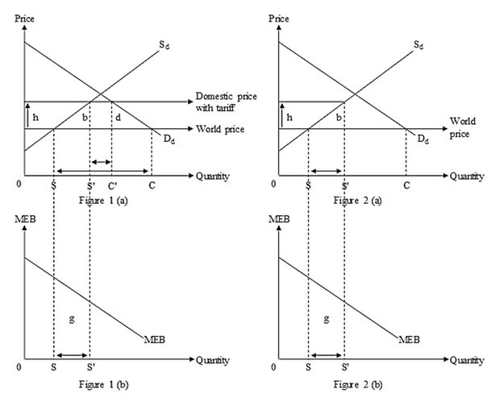

Figure 1(a) illustrates the impact of a tariff imposed by the government. Dd is the domestic demand curve. Sd is the pre-tariff domestic supply curve. The domestic price with tariff rises by the amount 'h'. Post-tariff, domestic production increases by SS' and domestic consumption declines by CC'. Therefore, the quantity imported decreases from SC units to S'C' units. The deadweight losses are given by the areas of the triangles b and d. Area b is the production effect of the tariff. It represents the loss arising from shifting from lower-cost imports to higher-cost domestic production. Area d is the consumption effect of the tariff. It is the consumer surplus loss on the reduced domestic consumption. In Figure 1(b), area g represents the gain in marginal extra or external benefits (MEB) due to the increase in domestic production from 0S to 0S'. So, the net national gain is (g – b – d).

Figure 2(a) instead depicts the effect of production subsidy. Here, the amount of subsidy provided by the government is denoted by the amount h which is equivalent to the amount of price rise in the case of the tariff. Domestic production also increases by an equivalent amount of SS'. But the domestic consumption remains unchanged. So, the deadweight loss in this case is only given by the area 'b' which is due to the production effect. MEB also increases by the area g, similar to the post-tariff case, which is shown in the Figure 2 (b). Here, the net national gain is (g - b).

Comparing the effects of tariff imposition and production subsidy on national well-being, we can see that, although domestic production increases by the same amount in both cases, the net national gain is larger if the government offers a production subsidy rather than if it imposes a tariff. We can say that providing the production subsidy is more efficient than the tariff because it addresses the objective of raising domestic production without generating the additional loss of area 'd', the consumption effect. This follows the specificity rule, which states that it is usually more efficient to use the government policy tool that acts as directly as possible on the source of the distortion separating private and social benefits or costs. Domestic production is the source of the extra benefits.
Difficulty: 3 Hard
Topic: Promoting Domestic Production or Employment
Bloom's: Analyze
AACSB: Analytical Thinking
Accessibility: Keyboard Navigation

60) What is the declining or dying industry argument for establishing barriers to imports? What are its merits and weaknesses? What measure(s) is/are more efficient than an import tariff if the intention is to help workers who would be displaced from a dying industry? Why? What measure(s) is/are more efficient than an import tariff if maintaining current production levels is the goal of government policy?

Answer: POSSIBLE RESPONSE: The dying industry argument is based on the assertion that in a second-best world, production resources such as workers, managers, capital, and land cannot quickly be reemployed to other uses. Especially for workers there are significant extra costs to switching to jobs in other industries. Because this transition cannot take place smoothly, there is a case for government intervention in industries which lose their competitiveness to foreign producers. A temporary trade barrier may help to retain domestic jobs. It prevents the labor market from "congestion," the situation in which many workers do not have the skills that match the available jobs. There might be circumstances in which government protection indeed causes less damage than the extra costs of shifting resources to other industries.

However, using a tariff on imports is not the most efficient measure for the government. According to the specificity rule, the government should use policies that target as directly as possible the source of distortion. If the goal of the government is to help displaced workers, the government should use policies such as trade adjustment assistance which helps in workers' transition to other industries or occupations. The trade adjustment assistance provides workers with unemployment compensation that gives them income during the time they need to acquire the skills to be successful in their new employment. If the country is just interested in maintaining the current production level, the country should grant subsidies to producers. This measure will assist domestic producers in competing against imports, resulting in the production effect loss but avoiding the consumption effect loss.
Difficulty: 3 Hard
Topic: The Dying Industry Argument and Adjustment Assistance
Bloom's: Analyze
AACSB: Analytical Thinking
Accessibility: Keyboard Navigation

