International Economics, 17e (Pugel)
Chapter 9 Nontariff Barriers to Imports

1) Restricting imports into a small country by the government
A) protects domestic producers from foreign competition.
B) increases consumer welfare in the country.
C) increases the general welfare of the importing nation.
D) all of the above.

Answer: A
Difficulty: 1 Easy
Topic: The Import Quota
Bloom's: Remember
AACSB: Reflective Thinking
Accessibility: Keyboard Navigation

2) Which of the following is NOT true of nontariff barriers to imports?
A) Nontariff barriers can limit imports with greater certainty than tariffs.
B) Unlike tariffs, nontariff barriers do not increase the price of imported goods in the domestic markets.
C) Some nontariff barriers create uncertainty about the conditions under which imports will be permitted.
D) Like tariffs, nontariff barriers result in a net welfare loss in a small country.

Answer: B
Difficulty: 1 Easy
Topic: Types of Nontariff Barriers to Imports
Bloom's: Remember
AACSB: Reflective Thinking
Accessibility: Keyboard Navigation

3) One of the reasons protectionists and government officials may favor using a quota instead of a tariff is
A) quotas generate more revenue for the government than tariffs.
B) quotas ensure that the quantities of imports are strictly limited.
C) quotas create less market distortions than tariffs.
D) quotas give less power to politicians than tariffs.

Answer: B
Difficulty: 1 Easy
Topic: The Import Quota
Bloom's: Remember
AACSB: Reflective Thinking
Accessibility: Keyboard Navigation

4) Which of the following is true of a quota?
A) Imposition of a quota causes domestic prices to fall below world prices.
B) Imposition of a quota by a country causes the world price of the good imported by this country to rise.
C) A quota is a quantitative restriction on imports.
D) A quota is usually less inefficient than a tariff.

Answer: C
Difficulty: 1 Easy
Topic: The Import Quota
Bloom's: Remember
AACSB: Reflective Thinking
Accessibility: Keyboard Navigation

5) Under which of the following situations will a tariff imposed by a country fail to reduce imports by as much as expected?
A) The current tariff rate is less than the prohibitive tariff rate.
B) The foreign export quantity supplied of the good imported by this country is more responsive to changes in the world price than was expected.
C) The domestic supply of the import-competing products is more price-elastic than was expected.
D) The domestic quantity demanded of the imported product is less responsive to price changes than was expected.

Answer: D
Difficulty: 2 Medium
Topic: The Import Quota
Bloom's: Understand
AACSB: Reflective Thinking
Accessibility: Keyboard Navigation

6) In the case of a small country, the effects of a quota and a tariff are (almost) identical if
A) the government allocates licenses for free to importers using a rule or process that involves (almost) no resource cost.
B) the government auctions off import licenses to the highest bidder.
C) the government allocates licenses to importers through application and selection procedures that require the use of substantial resources.
D) the government allocates import licenses directly to the public using a free lottery system.

Answer: B
Difficulty: 1 Easy
Topic: The Import Quota
Bloom's: Remember
AACSB: Reflective Thinking
Accessibility: Keyboard Navigation

7) Which of the following is a means of allocating import licenses by assigning the licenses without competition, applications, or negotiation?
A) Fixed favoritism
B) Resource-using application procedures
C) Domestic content requirements
D) None of the above

Answer: A
Difficulty: 1 Easy
Topic: The Import Quota
Bloom's: Remember
AACSB: Reflective Thinking
Accessibility: Keyboard Navigation

8) The figure below shows the market for MP3 players in a small country. Dd and Sd are the domestic demand and domestic supply curves of the MP3 players. QQ is the quota quantity. How many MP3 players can be imported from abroad after the quota is imposed?

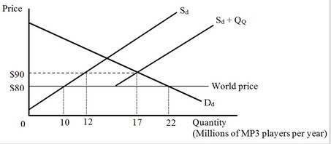
A) 2 million
B) 5 million
C) 12 million
D) 17 million

Answer: B
Difficulty: 3 Hard
Topic: The Import Quota
Bloom's: Apply
AACSB: Analytical Thinking
Accessibility: Keyboard Navigation

9) The figure below shows the market for MP3 players in a small country. Dd and Sd are the domestic demand and domestic supply curves of the MP3 players. QQ is the quota quantity. The quota on MP3 players will cause domestic producers to

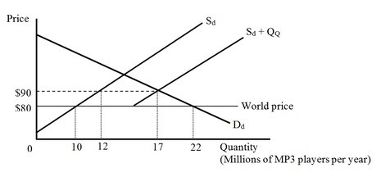
A) gain $150 million.
B) lose $100 million.
C) gain $110 million.
D) lose $120 million.

Answer: C
Difficulty: 3 Hard
Topic: The Import Quota
Bloom's: Apply
AACSB: Analytical Thinking
Accessibility: Keyboard Navigation

10) The figure below shows the market for MP3 players in a small country. Dd and Sd are the domestic demand and domestic supply curves of the MP3 players. QQ is the quota quantity. The quota on MP3 players will cause domestic consumers to

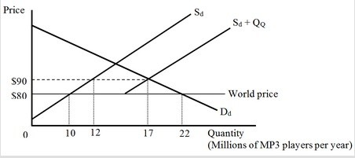
A) lose $25 million.
B) gain $25 million.
C) lose $170 million.
D) lose $195 million.

Answer: D
Difficulty: 3 Hard
Topic: The Import Quota
Bloom's: Apply
AACSB: Analytical Thinking
Accessibility: Keyboard Navigation

11) The figure below shows the market for MP3 players in a small country. Dd and Sd are the domestic demand and domestic supply curves of the MP3 players. QQ is the quota quantity. According to the figure, how much revenue can the government expect to receive if the import licenses are auctioned?

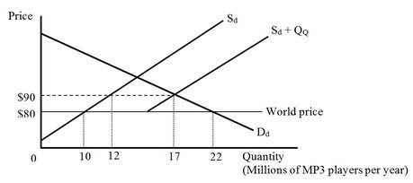
A) $20 million
B) $50 million
C) $120 million
D) $170 million

Answer: B
Difficulty: 3 Hard
Topic: The Import Quota
Bloom's: Apply
AACSB: Analytical Thinking
Accessibility: Keyboard Navigation

12) The figure below shows the market for MP3 players in a small country. Dd and Sd are the domestic demand and domestic supply curves of the MP3 players. QQ is the quota quantity. If the government auctions the import licenses, the quota on MP3 players will result in a(n) ________ in the national well-being by

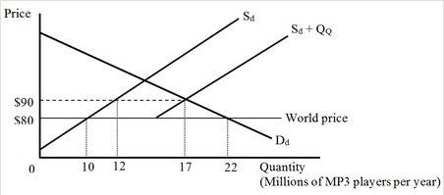
A) decrease; $35 million.
B) decrease; $85 million.
C) increase; $50 million.
D) increase; $195 million.

Answer: A
Difficulty: 3 Hard
Topic: The Import Quota
Bloom's: Apply
AACSB: Analytical Thinking
Accessibility: Keyboard Navigation

13) The figure below shows the market for MP3 players in a small country. Dd and Sd are the domestic demand and domestic supply curves of the MP3 players. QQ is the quota quantity. According to the figure, if import licenses are allocated based on a resource-using procedure, the loss to the economy will be

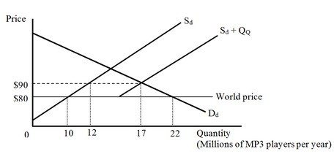
A) $35 million.
B) less than $10 million.
C) greater than $35 million.
D) $25 million.

Answer: C
Difficulty: 3 Hard
Topic: The Import Quota
Bloom's: Apply
AACSB: Analytical Thinking
Accessibility: Keyboard Navigation

14) The figure below shows the market for MP3 players in a small country. Dd and Sd are the domestic demand and domestic supply curves for MP3 players. Referring to the figure, if the country's imports are limited to the quantity QQ by a voluntary export restraint (VER), the loss to this importing nation is

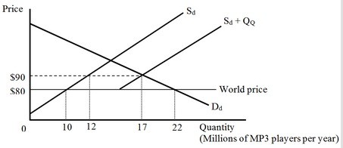
A) $35 million.
B) $50 million.
C) $85 million.
D) $195 million.

Answer: C
Difficulty: 3 Hard
Topic: The Import Quota
Bloom's: Apply
AACSB: Analytical Thinking
Accessibility: Keyboard Navigation

15) A small country imports T-shirts. With free trade at a world price of $10, domestic production is 10 million T-shirts and domestic consumption is 42 million T-shirts. The country's government now decides to impose a quota to limit T-shirt imports to 20 million per year. With the import quota in place, the domestic price rises to $12 per T-shirt and domestic production rises to 15 million T-shirts per year. The quota on T-shirts causes domestic producers to
A) gain $5 million.
B) lose $5 million.
C) gain $25 million.
D) gain $30 million.

Answer: C
Difficulty: 2 Medium
Topic: The Import Quota
Bloom's: Understand
AACSB: Reflective Thinking
Accessibility: Keyboard Navigation

16) A small country imports T-shirts. With free trade at a world price of $10, domestic production is 10 million T-shirts and domestic consumption is 42 million T-shirts. The country's government now decides to impose a quota to limit T-shirt imports to 20 million per year. With the import quota in place, the domestic price rises to $12 per T-shirt and domestic production rises to 15 million T-shirts per year. The quota on T-shirts causes domestic consumers to
A) gain $7 million.
B) lose $7 million.
C) lose $70 million.
D) lose $77 million.

Answer: D
Difficulty: 2 Medium
Topic: The Import Quota
Bloom's: Understand
AACSB: Reflective Thinking
Accessibility: Keyboard Navigation

17) A small country imports T-shirts. With free trade at a world price of $10, domestic production is 10 million T-shirts and domestic consumption is 42 million T-shirts. The country's government now decides to impose a quota to limit T-shirt imports to 20 million per year. With the import quota in place, the domestic price rises to $12 per T-shirt and domestic production rises to 15 million T-shirts per year. If the government auctions the quota licenses, calculate the revenue collected by the government.
A) $30 million
B) $40 million
C) $70 million
D) $240 million

Answer: B
Difficulty: 2 Medium
Topic: The Import Quota
Bloom's: Understand
AACSB: Reflective Thinking
Accessibility: Keyboard Navigation

18) A small country imports T-shirts. With free trade at a world price of $10, domestic production is 10 million T-shirts and domestic consumption is 42 million T-shirts. The country's government now decides to impose a quota to limit T-shirt imports to 20 million per year. With the import quota in place, the domestic price rises to $12 per T-shirt and domestic production rises to 15 million T-shirts per year. If the government auctions the import licenses, the national well-being will ________ by
A) increase; $40 million.
B) decrease; $12 million.
C) increase; $65 million.
D) decrease; $5 million.

Answer: B
Difficulty: 2 Medium
Topic: The Import Quota
Bloom's: Understand
AACSB: Reflective Thinking
Accessibility: Keyboard Navigation

19) A small country imports T-shirts. With free trade at a world price of $10, domestic production is 10 million T-shirts and domestic consumption is 42 million T-shirts. The country's government now decides to impose a quota to limit T-shirt imports to 20 million per year. With the import quota in place, the domestic price rises to $12 per T-shirt and domestic production rises to 15 million T-shirts per year. If the import licenses are allocated for free based on fixed favoritism, how much will be gained by the importers with the quota licenses?
A) $40 million
B) $70 million
C) $200 million
D) $240 million

Answer: A
Difficulty: 2 Medium
Topic: The Import Quota
Bloom's: Understand
AACSB: Reflective Thinking
Accessibility: Keyboard Navigation

20) A small country imports T-shirts. With free trade at a world price of $10, domestic production is 10 million T-shirts and domestic consumption is 42 million T-shirts. The country's government then compels the exporting country to limit its T-shirt exports to 20 million per year. With the voluntary export restraint (VER) in place, the domestic price rises to $12 per T-shirt and domestic production rises to 15 million T-shirts per year. How much does the importing nation lose as a result of the VER?
A) $12 million
B) $20 million
C) $52 million
D) $77 million

Answer: C
Difficulty: 2 Medium
Topic: The Import Quota
Bloom's: Understand
AACSB: Reflective Thinking
Accessibility: Keyboard Navigation

21) A domestic monopoly producing a close substitute of an imported product would prefer to be protected by a quota than a tariff that results in the same amount of imports because
A) the deadweight loss will be smaller with a quota.
B) after the imposition of the tariff the price of the imported good declines in the domestic market.
C) unlike a tariff, a quota does not generate revenue for the government.
D) a quota allows the monopoly to charge a higher price.

Answer: D
Difficulty: 1 Easy
Topic: The Import Quota
Bloom's: Remember
AACSB: Reflective Thinking
Accessibility: Keyboard Navigation

22) In which of the following cases does an import quota result in a higher welfare loss than a tariff?
A) The domestic firms producing an import-competing product set the product's price equal to the marginal cost of producing it.
B) The government auctions the import licenses to the highest bidders.
C) The quota licenses are allocated through resource-using application procedures.
D) The domestic industry in the importing country is highly competitive.

Answer: C
Difficulty: 1 Easy
Topic: The Import Quota
Bloom's: Remember
AACSB: Reflective Thinking
Accessibility: Keyboard Navigation

23) Which of the following is the least efficient method of allocating import licenses by the government?
A) Fixed favoritism
B) A competitive auction
C) Resource-using application procedures
D) A free lottery

Answer: C
Difficulty: 2 Medium
Topic: The Import Quota
Bloom's: Understand
AACSB: Reflective Thinking
Accessibility: Keyboard Navigation

24) When a large country imposes an import quota
A) the product's world price rises.
B) the product's world price falls.
C) the product's domestic price falls.
D) domestic production of the product falls.

Answer: B
Difficulty: 1 Easy
Topic: The Import Quota
Bloom's: Remember
AACSB: Reflective Thinking
Accessibility: Keyboard Navigation

25) The figure below shows the domestic demand (Dd) and domestic supply (Sd) curves of mopeds in a country before an import quota is imposed by the government. After the imposition of the quota, the maximum import quantity is QQ.

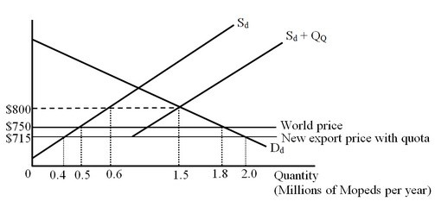

After the quota is imposed by the government, the domestic producers
A) lose $2.5 million.
B) gain $27.5 million.
C) gain $42.5 million.
D) lose $45 million.

Answer: B
Difficulty: 3 Hard
Topic: The Import Quota
Bloom's: Apply
AACSB: Analytical Thinking
Accessibility: Keyboard Navigation

26) The following figure shows the domestic demand (Dd) and domestic supply (Sd) curves of mopeds in a country before an import quota is imposed by the government. After the imposition of the quota, the maximum import quantity is QQ.

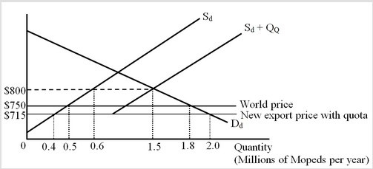

After the quota is imposed, the domestic consumers
A) lose $7.5 million.
B) lose $22.5 million.
C) lose $82.5 million.
D) gain $52.5 million.

Answer: C
Difficulty: 3 Hard
Topic: The Import Quota
Bloom's: Apply
AACSB: Analytical Thinking
Accessibility: Keyboard Navigation

27) The figure below shows the domestic demand (Dd) and domestic supply (Sd) curves of mopeds in a country before an import quota is imposed by the government. After the imposition of the quota, the maximum import quantity is QQ.

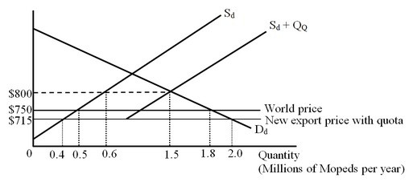

If the government auctions the quota licenses, how much will it collect as revenue?
A) $31.5 million
B) $45 million
C) $72 million
D) $76.5 million

Answer: D
Difficulty: 3 Hard
Topic: The Import Quota
Bloom's: Apply
AACSB: Analytical Thinking
Accessibility: Keyboard Navigation

28) The figure below shows the domestic demand (Dd) and domestic supply (Sd) curves of mopeds in a country before an import quota is imposed by the government. After the imposition of the quota, the maximum import quantity is QQ.

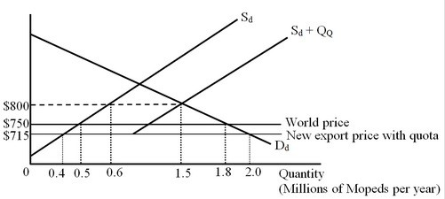

If the government auctions the quota licenses, the importing nation will
A) lose $10 million.
B) lose $29.75 million.
C) gain $31.5 million.
D) gain $21.5 million.

Answer: D
Difficulty: 3 Hard
Topic: The Import Quota
Bloom's: Apply
AACSB: Analytical Thinking
Accessibility: Keyboard Navigation

29) The figure below shows the international market for moped. DM is a country's demand for imports curve and SX is the foreign export supply curve. The importing country now imposes an import quota of 0.9 million, with the licenses given for free to the existing import distributors.

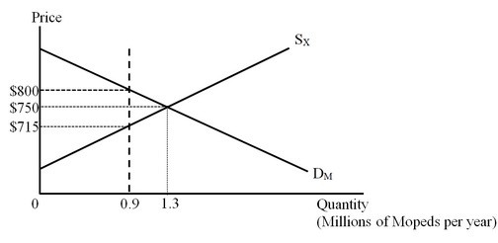

As a result of the quota being imposed on moped imports by this country, the world as a whole will
A) lose $7 million.
B) gain $10 million.
C) lose $17 million.
D) gain $31.5 million.

Answer: C
Difficulty: 3 Hard
Topic: The Import Quota
Bloom's: Apply
AACSB: Analytical Thinking
Accessibility: Keyboard Navigation

30) Which of the following is true of a voluntary export restraint (VER)?
A) A voluntary export restraint ensures that foreign exporting firms are unable to exercise monopoly power.
B) A voluntary export restraint usually requires that the foreign exporting firms act like a cartel, restricting sales and raising prices.
C) A voluntary export restraint generates more revenue for the government of the importing country than would a tariff or quota.
D) Voluntary export restraints have mostly been used by developing countries to protect their domestic industries.

Answer: B
Difficulty: 1 Easy
Topic: Voluntary Export Restraints
Bloom's: Remember
AACSB: Reflective Thinking
Accessibility: Keyboard Navigation

31) Governments choose to use voluntary export restraints (VERs) rather than tariffs because
A) voluntary export restraints have the potential to generate higher revenue.
B) voluntary export restraints do not generate any welfare loss in the importing country.
C) tariffs more obviously violate the international rules of the World Trade Organization (WTO).
D) the increase in the price of the imported good in the domestic market is lower in the case of a VER than a tariff.

Answer: C
Difficulty: 1 Easy
Topic: Voluntary Export Restraints
Bloom's: Remember
AACSB: Reflective Thinking
Accessibility: Keyboard Navigation

32) With a voluntary export restraint (VER), the markup revenue (economic rent) created for the quantitatively limited trade is collected by
A) the government of the importing county.
B) the consumers in the importing country.
C) the producers in the importing country.
D) the exporting firms in the foreign countries

Answer: D
Difficulty: 1 Easy
Topic: Voluntary Export Restraints
Bloom's: Remember
AACSB: Reflective Thinking
Accessibility: Keyboard Navigation

33) Which of the following mandates that an import distributor must buy a certain percentage of the product locally?
A) An import quota
B) A mixing requirement
C) A voluntary export restraint
D) None of the above

Answer: B
Difficulty: 1 Easy
Topic: Voluntary Export Restraints
Bloom's: Remember
AACSB: Reflective Thinking
Accessibility: Keyboard Navigation

34) The Buy America Act of 1933 mandates that
A) the sales taxes on goods manufactured by the local labor force must be lower than the sales taxes on goods manufactured by immigrant workers.
B) durable goods produced locally must be priced lower than comparable imported goods.
C) purchases funded by the U.S. government must favor domestic products.
D) household consumers buying more of local products will be given suitable tax incentives.

Answer: C
Difficulty: 1 Easy
Topic: Voluntary Export Restraints
Bloom's: Remember
AACSB: Reflective Thinking
Accessibility: Keyboard Navigation

35) Suppose a small country sets all of its tariffs at 40 percent which causes a reduction in imports by 20 percent. If the total imports affected by the tariffs are 40 percent of the gross domestic product (GDP), the net national loss from the tariffs as a percentage of GDP is
A) 1.6%.
B) close to 90%.
C) 6.4%.
D) 3.2%.

Answer: A
Difficulty: 2 Medium
Topic: How Big Are the Costs of Protection?
Bloom's: Understand
AACSB: Reflective Thinking
Accessibility: Keyboard Navigation

36) Which of the following allows the president of the United States to negotiate to eliminate unfair trade practices put in place by foreign governments?
A) Tariff-quota requirements
B) The General Agreement on Tariffs and Trade
C) Section 301 of the Trade Act of 1974
D) The United Nations

Answer: C
Difficulty: 1 Easy
Topic: International Trade Disputes
Bloom's: Remember
AACSB: Reflective Thinking
Accessibility: Keyboard Navigation

37) Which of the following is NOT true of the Uruguay Round of the multilateral trade negotiations?
A) The Uruguay Round initiated a process of liberalizing trade in services.
B) The Uruguay Round agreements began a process of liberalizing trade in agricultural products.
C) The Uruguay Round included agreement requiring member countries to provide minimum levels of ownership protection for intellectual property.
D) The Uruguay Round narrowed down the set of nontariff barrier (NTB) codes as set up by the Kennedy Round and the Tokyo Round.

Answer: D
Difficulty: 1 Easy
Topic: International Trade Disputes
Bloom's: Remember
AACSB: Reflective Thinking
Accessibility: Keyboard Navigation

38) What is the percent reduction in import quantity in a country due to the tariffs imposed by the government, if the country's import tariffs are all 10 percent, the total imports affected by the tariffs are 40 percent of the GDP, and the net national loss from the tariffs as a percentage of GDP is 0.6 percent?
A) 40%
B) 30%
C) 20%
D) 10%

Answer: B
Difficulty: 2 Medium
Topic: How Big Are the Costs of Protection?
Bloom's: Understand
AACSB: Reflective Thinking
Accessibility: Keyboard Navigation

39) The general formula used for calculating the net national loss from a trade barrier as a percentage of gross domestic product (GDP) may fail to account for
A) the production effect of the trade barrier.
B) the consumption effect of the trade barrier.
C) the government revenue generated from the trade barrier.
D) the rent-seeking costs of local firms.

Answer: D
Difficulty: 1 Easy
Topic: How Big Are the Costs of Protection?
Bloom's: Remember
AACSB: Reflective Thinking
Accessibility: Keyboard Navigation

40) Which of the following nontariff barriers (NTBs) may generate revenue for the government?
A) Government procurement
B) Voluntary export restraint
C) Import quota
D) Domestic content requirement

Answer: C
Difficulty: 1 Easy
Topic: How Big Are the Costs of Protection?
Bloom's: Remember
AACSB: Reflective Thinking
Accessibility: Keyboard Navigation

41) The World Trade Organization has rules that try to limit the use of tariffs but not the use of nontariff barriers (NTBs).

Answer: FALSE
Difficulty: 1 Easy
Topic: The Import Quota
Bloom's: Remember
AACSB: Reflective Thinking
Accessibility: Keyboard Navigation

42) Compared to a tariff, a quota gives the government a better control over the quantity of imports.

Answer: TRUE
Difficulty: 1 Easy
Topic: The Import Quota
Bloom's: Remember
AACSB: Reflective Thinking
Accessibility: Keyboard Navigation

43) Unlike a tariff, a quota does not cause either a production effect or a consumption effect.

Answer: FALSE
Difficulty: 1 Easy
Topic: The Import Quota
Bloom's: Remember
AACSB: Reflective Thinking
Accessibility: Keyboard Navigation

44) Unlike a tariff, a quota does not allow a domestic monopoly to assert its monopoly pricing powers.

Answer: FALSE
Difficulty: 1 Easy
Topic: The Import Quota
Bloom's: Remember
AACSB: Reflective Thinking
Accessibility: Keyboard Navigation

45) Most or all of the mark-up revenue from a quota can be captured by the government if the government auctions off import licenses.

Answer: TRUE
Difficulty: 1 Easy
Topic: The Import Quota
Bloom's: Remember
AACSB: Reflective Thinking
Accessibility: Keyboard Navigation

46) While a large country can either be better off or worse off due to the imposition of a tariff, the same country will necessarily be worse off as a result of imposing an equivalent import quota.

Answer: FALSE
Difficulty: 2 Medium
Topic: The Import Quota
Bloom's: Understand
AACSB: Reflective Thinking
Accessibility: Keyboard Navigation

47) When an importing country compels the foreign exporting country to agree "voluntarily" to restrict its exports to this country, the exporting firms in the foreign country are worse off than they would be if the importing country had instead imposed a comparable import quota.

Answer: FALSE
Difficulty: 1 Easy
Topic: Voluntary Export Restraints
Bloom's: Remember
AACSB: Reflective Thinking
Accessibility: Keyboard Navigation

48) In an attempt to restrict imports into a country, using a tariff is likely to be less costly to the country than using a voluntary export restraint.

Answer: TRUE
Difficulty: 2 Medium
Topic: Voluntary Export Restraints
Bloom's: Understand
AACSB: Reflective Thinking
Accessibility: Keyboard Navigation

49) The voluntary export restraint (VER) is not only a politically attractive way of offering protection to an import-competing industry but is also economically less harmful to the importing country than other trade barriers would be.

Answer: FALSE
Difficulty: 1 Easy
Topic: Voluntary Export Restraints
Bloom's: Remember
AACSB: Reflective Thinking
Accessibility: Keyboard Navigation

50) The revenue earned by the government in allocating quota licenses through resource-using application procedures is approximately equal to the revenue it would earn from a tariff that resulted in the same import quantity.

Answer: FALSE
Difficulty: 1 Easy
Topic: The Import Quota
Bloom's: Remember
AACSB: Reflective Thinking
Accessibility: Keyboard Navigation

51) Government procurement practices can restrict imports if the purchasing processes are heavily biased toward products with large local content.

Answer: TRUE
Difficulty: 1 Easy
Topic: Other Nontariff Barriers
Bloom's: Remember
AACSB: Reflective Thinking
Accessibility: Keyboard Navigation

52) Evidence shows that governments usually impose the same import duties on the import of similar goods even if the goods fall under different product categories.

Answer: FALSE
Difficulty: 1 Easy
Topic: The Import Quota
Bloom's: Remember
AACSB: Reflective Thinking
Accessibility: Keyboard Navigation

53) Briefly discuss Section 301 of the Trade Act of 1974, along with its use in 2017-2018.

Answer: POSSIBLE RESPONSE: Section 301 of the Trade Act of 1974 provides the United States with the authority to enforce trade agreements, resolve trade disputes, and open foreign markets to U.S. goods and services. Under the law the government may impose trade sanctions on foreign countries that violate trade agreements or engage in other unfair trade practices. When negotiations to remove the offending trade practice fail, the United States may retaliate by increasing tariffs on the foreign country's products. In 2017 the U.S. government initiated an investigation under Section 301 of the Trade Act of 1974 into the Chinese government's acts, policies, and practices related to technology transfer, intellectual property, and innovation. In 2018 President Trump imposed retaliatory tariffs, which began a trade war with China as China objected and imposed tariffs on Chinese imports from the United States.
Difficulty: 1 Easy
Topic: International Trade Disputes
Bloom's: Understand
AACSB: Reflective Thinking
Accessibility: Keyboard Navigation

54) Briefly discuss the similarities and differences of the effects of an import quota and a tariff on domestic price, quantities, and well-being, for a small country producing and selling a product in a competitive world market. (Assume a tariff level that would restrict imports just as much as the quota would.)

Answer: POSSIBLE RESPONSE: Quotas restrict quantity while tariffs effectively raise the price of the good consumers purchase in the domestic market. For a competitive market, the effects of a quota on domestic price, quantities, domestic producer surplus, and domestic consumer surplus are the same as those of an equivalent tariff. A quota, because it restricts quantity, results in a higher domestic price, lower domestic quantity consumed, and larger domestic quantity produced. As a result, there is a loss of domestic consumer surplus and increase in domestic producer surplus. These are the same as the effects of an equivalent tariff placed on an imported good. Additionally, both a quota and a tariff result in the same deadweight losses that result from domestic production inefficiency and domestic consumption inefficiency. The one effect of a tariff and a quota that is different is related to government revenue. A tariff generates revenue for the importing country's government. Quotas do not necessarily generate revenue for the importing government. The additional price that consumers pay accrues as import markup revenue. While the government could gain this markup revenue as its own revenue if it auctions or sells quota licenses, the markup revenue would instead go to importers if they receive the quota licenses without payment to the government.
Difficulty: 1 Easy
Topic: The Import Quota
Bloom's: Understand
AACSB: Reflective Thinking
Accessibility: Keyboard Navigation

55) Briefly discuss different methods of allocating quota licenses to the importers by the government. Also explain the inefficiency implications of each method.

Answer: POSSIBLE RESPONSE: There are three different methods to allocate quota licenses to import. First, the allocation of import licenses on the basis of fixed favoritism implies that the government simply assigns the licenses to firms without competition, applications, or negotiations. In this case the importers who receive the licenses realize gains from the difference between the domestic and the international price of the product. This method does not create any additional inefficiency beyond the deadweight losses from the production effect and the consumption effect of the quota. Also, it does not generate revenue for the government. Second, revenue for the government will be generated if the licenses are allocated through an auction (or some other way in which the government is paid for the licenses). The auction is a bidding process in which firms compete for the licenses by specifying the amount they are willing to pay, and the licenses are awarded to the highest bidders. Importing firms are willing to pay to acquire licenses because they will realize gains from the difference between the domestic and the international price of the imported product. For this method, there is also little or no additional inefficiency beyond the deadweight losses from the production and consumption effects of the quota.

Third, the government can require firms to compete for the licenses in some way other than simple bidding or bribing. Resource-using application procedures include allocating the quota licenses on a first-come, first-served basis, or on the basis of demonstrating need or worthiness, or through negotiations. Resource-using procedures encourage rent-seeking activities and are wasteful. For the country as a whole, resource-using procedures are the most inefficient method because the resources used in rent-seeking are drawn away from producing something that is truly valuable for society, in addition to the inefficiency from the production and consumption effects of the quota.
Difficulty: 2 Medium
Topic: The Import Quota
Bloom's: Understand
AACSB: Reflective Thinking
Accessibility: Keyboard Navigation

56) Show graphically and explain the effects of imposition of a quota by a small country under competitive conditions. The quota rights are given away for free to a fixed set of import distributor firms in the country.

Answer: POSSIBLE RESPONSE:

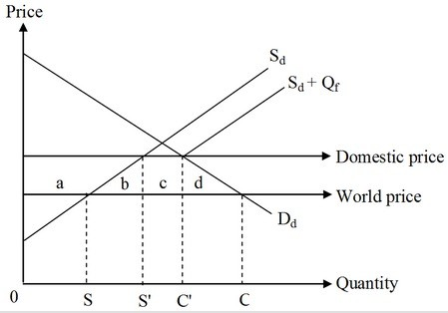

According to the figure, the domestic price was equal to the world price and the quantity imported by this country was represented by the distance SC in the absence of any trade barriers. However, after the government restricts imports by imposing a quota of amount Qf,', the domestic price of the good increases, as shown by the domestic price line. Consequently, domestic production increase to 0S' and domestic consumption declines to 0C'. The loss in consumer surplus due to an increase in the price of the product is given by the sum of the areas a, b, c, and d. The producer surplus increases by the area a. If the government allocates the licenses based on fixed favoritism, area c is obtained by the license holders, who can now sell the imported good at a higher price. The economic cost of a quota arises from the production and the consumption effects resulting from the change in the domestic price of the product. The consumption effect, area d, is the deadweight loss associated with the lower consumption of the good due to the increased price in the domestic market. The production effect, area b, is the deadweight loss arising from the replacement of some low-cost imports with high-cost production in the domestic economy. Thus, a quota imposed by a small importing country will result in a net welfare loss for the country given by the sum of the triangles b and d.
Difficulty: 3 Hard
Topic: The Import Quota
Bloom's: Apply
AACSB: Analytical Thinking
Accessibility: Keyboard Navigation

57) What are nontariff barriers (NTBs)? Discuss any three forms of NTBs other than quotas and voluntary export restraints (VERs).

Answer: POSSIBLE RESPONSE: Nontariff barriers (NTBs) to imports are government policies, other than taxes on imports, that reduce imports below their free-trade levels. In addition to quotas and voluntary export restraints (VERs), there are many other kinds of NTBs. Here are three.

- A government can write product standards in ways that protect local producers. Such standards can be noble efforts to enhance society's well-being, by addressing market failures that lead to unsafe conditions and environmental degradation. But such standards can also be specified so that they can be met more easily by local products than by imported products. For instance, the standards can be tailored to fit local products, but to require costly modifications to foreign products. Or, the standards can be higher for imported products or enforced more strictly. Or, the testing and certification procedures can be more costly, slower, or more uncertain for foreign products.
- A domestic content requirement mandates that a product produced and sold in a country must have a specified minimum amount of domestic production value, in the form of wages paid to local workers or materials and components produced within the country. Domestic content requirements can create import protection at two levels. They can be a barrier to imports of the products that do not meet the content rules. And they can limit the import of materials and components that otherwise would have been used in domestic production of the products.
- Government procurement practices can be another form of nontariff barrier to imports if the purchasing processes are biased against foreign products, as they often are. In many countries the governments buy relatively few imported products and instead buy mostly locally produced products.
Difficulty: 2 Medium
Topic: Other Nontariff Barriers
Bloom's: Understand
AACSB: Reflective Thinking
Accessibility: Keyboard Navigation

58) Suppose a country's government is deciding whether or not to impose an import quota to protect the domestic automobile industry. Will the domestic steel-producing firms be in favor of a quota designed to protect the local automobile producers? Why or why not?

Answer: POSSIBLE RESPONSE: Steel is a major input in the automotive industry. The automobile industry is a major consumer of steel, so the demand for steel is linked to the demand for automobiles. In particular, it can be expected that the protection provided to the local automotive producers from foreign competition will raise the local production of automobiles, which means there will be more demand for steel locally. This would probably benefit domestic steel-producing firms, so they will be in favor of such government policy.
Difficulty: 2 Medium
Topic: How Big Are the Costs of Protection?
Bloom's: Understand
AACSB: Reflective Thinking
Accessibility: Keyboard Navigation

59) If there is only one domestic automobile manufacturing firm in a small country, will there be a difference in terms of national economic well-being between using a tariff and using a quota to protect the firm? If so, what is the difference? Clearly explain your answer.

Answer: POSSIBLE RESPONSE: If there is only one automobile manufacturing firm in the domestic economy, it would mean that this firm may have monopoly power in the domestic automobile industry. With free trade, the monopolist will lose its monopoly power completely. Facing competition from foreign producers, the monopolist will turn into a price taker that charges the international price. Now, if a tariff is imposed, the domestic producer will be able to charge a price equal to the world price plus the amount of the tariff, but the producer will still remain a price taker, because imports can still increase without limit at this price. If, instead, an import quota is used, there is no import competition at the margin, once the quota is filled. The domestic producer then will be able to determine the domestic price of the product by deciding how much to produce. A profit-maximizing monopolist will decide on its production quantity in such a way that the marginal revenue from the last unit produced equals the marginal cost of production of the last unit. With a quota, the monopolist will be able to charge a higher price by restricting production, knowing that domestic consumers cannot purchase imported automobiles beyond the quota quantity. Because the domestic price diverges more from the world price, the quota results in a larger inefficiency—a larger deadweight loss.
Difficulty: 2 Medium
Topic: How Big Are the Costs of Protection?
Bloom's: Understand
AACSB: Reflective Thinking
Accessibility: Keyboard Navigation

60) Explain how the cost of a country's tariffs is calculated as a percentage of gross domestic product (GDP). Which effects are captured in this process? Why is the true cost of import protection probably larger than what can be shown in simple graphs or as calculated by the net national loss formula?

Answer: POSSIBLE RESPONSE: The cost of the country's tariffs is calculated as a percentage of GDP by the net national loss formula:

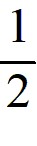 × Tariff rate × Percent reduction in import quantity × 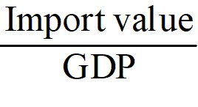

The formula captures the losses arising from the production and consumption effects of a tariff. However, estimates based on this simple calculation can underestimate the losses as a share of GDP, because imposing a tariff can also bring about additional, indirect effects. First, some countries exporting the products may retaliate and erect trade barriers of their own. In the worst scenario this can lead to a trade war in which all countries maintain high import barriers. Second, imposing and maintaining trade barriers is associated with enforcement and rent-seeking costs within the country. Third, in the case of voluntary export restraints (VERs), foreign exporters are allowed to charge a higher price for their product, thus putting domestic consumers at a further disadvantage. Finally, the protection of domestic producers may lead to a lack of innovation and a decrease in the variety of the products available in the domestic market. All of the above-mentioned situations can actually take a larger social toll and raise the cost of import protection over and above what can be calculated from graphs or the net national loss formula.
Difficulty: 2 Medium
Topic: How Big Are the Costs of Protection?
Bloom's: Understand
AACSB: Reflective Thinking
Accessibility: Keyboard Navigation

