International Economics, 17e (Pugel)
Chapter 8 Analysis of a Tariff

1) A(n) ________ is a tax on imports that is stipulated as a money amount per unit.
A) specific tariff
B) ad valorem tariff
C) effective tariff
D) optimal tariff

Answer: A
Difficulty: 1 Easy
Topic: A Preview of Conclusions
Bloom's: Remember
AACSB: Reflective Thinking
Accessibility: Keyboard Navigation

2) Which of the following is an impact of tariffs on the country imposing them?
A) The domestic producers of import-competing products are forced to charge a lower price for their products to retain market share.
B) The supply of the domestic import-competing products declines.
C) The domestic consumers pay a higher price for the imported products.
D) The demand for the imported goods by the domestic consumers increases.

Answer: C
Difficulty: 1 Easy
Topic: The Effect of a Tariff on Domestic Consumers
Bloom's: Remember
AACSB: Reflective Thinking
Accessibility: Keyboard Navigation

3) Which of the following correctly identifies the impact of tariffs on the producers of import-competing products in the imposing country?
A) They can price their products higher than the imported goods.
B) They can expand their production and sales.
C) They are forced to go out of business in the long run.
D) They are forced to charge a price equal to the average cost of production.

Answer: B
Difficulty: 1 Easy
Topic: The Effects of a Tariff on Domestic Producers
Bloom's: Remember
AACSB: Reflective Thinking
Accessibility: Keyboard Navigation

4) If a small country imposes a tariff on imported motorcycles, the world price of motorcycles will ________ and the domestic price of motorcycles will
A) rise; fall.
B) fall; rise.
C) remain constant; rise.
D) remain constant; fall.

Answer: C
Difficulty: 1 Easy
Topic: The Effects of a Tariff on Domestic Producers
Bloom's: Remember
AACSB: Reflective Thinking
Accessibility: Keyboard Navigation

5) If a small country imposes a tariff on imported motorcycles
A) the surplus of the domestic producers of motorcycles will decline, but the surplus of the domestic consumers will increase.
B) the surplus of both the domestic producers and consumers of motorcycles will decline.
C) the surplus of both the domestic producers and consumers of motorcycles will increase.
D) the surplus of the domestic producers of motorcycles will increase, but the surplus of the domestic consumers will decline.

Answer: D
Difficulty: 1 Easy
Topic: The Effects of a Tariff on Domestic Producers
Bloom's: Remember
AACSB: Reflective Thinking
Accessibility: Keyboard Navigation

6) Which of the following is the basis for the consumption effect of a tariff imposed on imported automobiles?
A) The decline in the purchase of the product due to the increase in its price
B) The net increase in the availability of the domestic automobiles for the consumers owing to higher prices
C) The net increase in the government revenue by taxing the domestic consumers who buy the imported automobiles
D) The net increase in the consumption of imported automobiles by the domestic consumers

Answer: A
Difficulty: 2 Medium
Topic: The Net National Loss from a Tariff
Bloom's: Understand
AACSB: Reflective Thinking
Accessibility: Keyboard Navigation

7) Which of the following refers to the extra cost of shifting to more expensive home production following the imposition of a tariff?
A) Production effect
B) Revenue effect
C) Deadweight loss
D) Producer surplus

Answer: A
Difficulty: 1 Easy
Topic: The Net National Loss from a Tariff
Bloom's: Remember
AACSB: Reflective Thinking
Accessibility: Keyboard Navigation

8) The figure below shows the market for shoes in a small importing country. Dd and Sd are the domestic demand and supply curves of shoes, respectively.

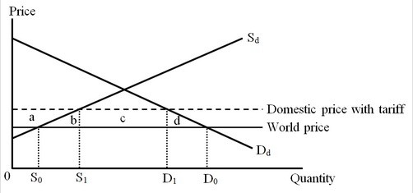

Following the imposition of a tariff, the domestic producer surplus ________ by the area
A) increases; a.
B) decreases; a.
C) increases; (a + b).
D) increases; (S1 - S0).

Answer: A
Difficulty: 2 Medium
Topic: The Effects of a Tariff on Domestic Producers
Bloom's: Understand
AACSB: Reflective Thinking
Accessibility: Keyboard Navigation

9) The figure below shows the market for shoes in a small importing country. Dd and Sd are the domestic demand and supply curves of shoes, respectively.

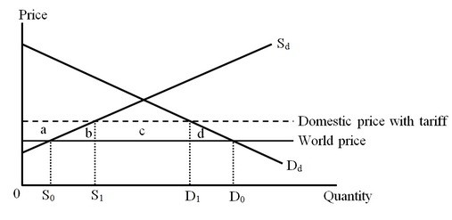

Following the imposition of a tariff, the domestic consumer surplus ________ by the area
A) increases; (D0 - D1).
B) decreases; d.
C) decreases; (a + b + c +d).
D) increases; (b + d).

Answer: C
Difficulty: 2 Medium
Topic: The Effect of a Tariff on Domestic Consumers
Bloom's: Understand
AACSB: Reflective Thinking
Accessibility: Keyboard Navigation

10) The figure below shows the market for shoes in a small importing country. Dd and Sd are the domestic demand and supply curves of shoes, respectively.

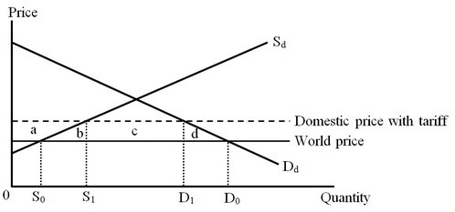

The tariff revenue of the country's government is shown by area
A) (a + b + c + d).
B) (a + b).
C) c.
D) (b + c + d).

Answer: C
Difficulty: 2 Medium
Topic: The Tariff as Government Revenue
Bloom's: Understand
AACSB: Reflective Thinking
Accessibility: Keyboard Navigation

11) The figure below shows the market for shoes in a small importing country. Dd and Sd are the domestic demand and supply curves of shoes, respectively.

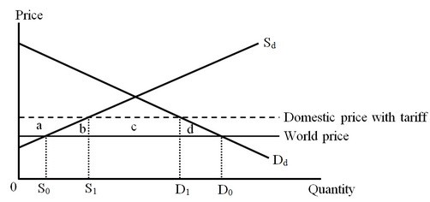

The imposition of a tariff on shoes caused economic well-being in the country to ________ by an amount measured by the area
A) fall; c.
B) fall; (b + d).
C) rise; (b + c+ d).
D) rise; (a + c).

Answer: B
Difficulty: 2 Medium
Topic: The Tariff as Government Revenue
Bloom's: Understand
AACSB: Reflective Thinking
Accessibility: Keyboard Navigation

12) The figure below shows the market for shoes in a small importing country. Dd and Sd are the domestic demand and supply curves of shoes, respectively.

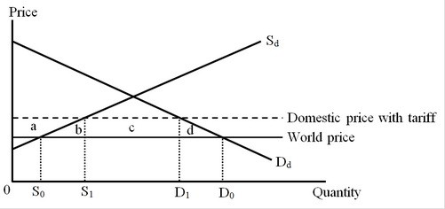

The production effect of the tariff on shoes is measured by the area
A) a.
B) b.
C) c.
D) (a + b).

Answer: B
Difficulty: 2 Medium
Topic: The Net National Loss from a Tariff
Bloom's: Understand
AACSB: Reflective Thinking
Accessibility: Keyboard Navigation

13) The figure below shows the market for shoes in a small importing country. Dd and Sd are the domestic demand and supply curves of shoes, respectively.

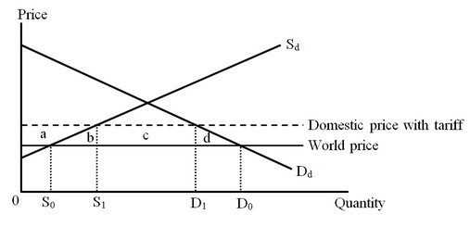

The consumption effect of the tariff on shoes is measured by the area
A) (a + b + c + d).
B) b.
C) c.
D) d.

Answer: D
Difficulty: 2 Medium
Topic: The Net National Loss from a Tariff
Bloom's: Understand
AACSB: Reflective Thinking
Accessibility: Keyboard Navigation

14) The figure below shows the market for computers in a small importing country. Dd and Sd are the domestic demand and supply curves of computers, respectively.

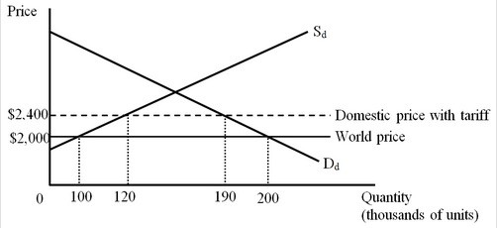

Under free trade the country imported ________ computers but following the imposition of the tariff the country began to import ________ computers.
A) 100,000; 70,000
B) 70,000; 100,000
C) 200,000; 190,000
D) 90,000; 100,000

Answer: A
Difficulty: 2 Medium
Topic: The Effect of a Tariff on Domestic Consumers
Bloom's: Apply
AACSB: Analytical Thinking
Accessibility: Keyboard Navigation

15) The figure below shows the market for computers in a small importing country. Dd and Sd are the domestic demand and supply curves of computers, respectively.

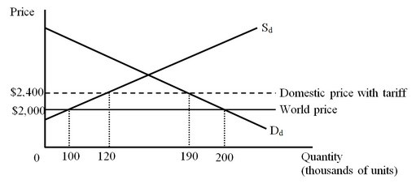

The imposition of a tariff on computers caused the surplus of the domestic producers to ________ by
A) rise; $20 million.
B) rise; $800,000.
C) rise; $44 million.
D) fall; $48 million.

Answer: C
Difficulty: 3 Hard
Topic: The Effects of a Tariff on Domestic Producers
Bloom's: Apply
AACSB: Analytical Thinking
Accessibility: Keyboard Navigation

16) The figure below shows the market for computers in a small importing country. Dd and Sd are the domestic demand and supply curves of computers, respectively.

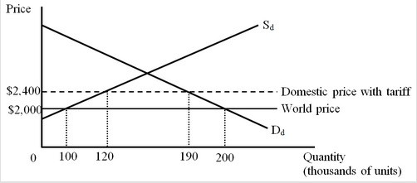

The imposition of a tariff on computers caused the surplus of the country's consumers to ________ by
A) fall; $10 million.
B) fall; $40 million.
C) rise; $76 million.
D) fall; $78 million.

Answer: D
Difficulty: 3 Hard
Topic: The Effect of a Tariff on Domestic Consumers
Bloom's: Apply
AACSB: Analytical Thinking
Accessibility: Keyboard Navigation

17) The figure below shows the market for computers in a small importing country. Dd and Sd are the domestic demand and supply curves of computers, respectively.

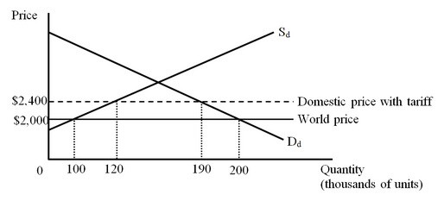

Calculate the tariff revenue of the country's government.
A) $400,000
B) $40 million
C) $28 million
D) $76 million

Answer: C
Difficulty: 3 Hard
Topic: The Tariff as Government Revenue
Bloom's: Apply
AACSB: Analytical Thinking
Accessibility: Keyboard Navigation

18) The figure below shows the market for computers in a small importing country. Dd and Sd are the domestic demand and supply curves of computers, respectively.

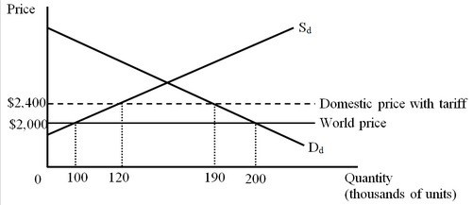

The imposition of a tariff on computers caused economic well-being in the country to ________ by
A) fall; $4 million.
B) fall; $6 million.
C) rise; $34 million.
D) fall; $34 million.

Answer: B
Difficulty: 3 Hard
Topic: The Tariff as Government Revenue
Bloom's: Apply
AACSB: Analytical Thinking
Accessibility: Keyboard Navigation

19) The figure below shows the market for computers in a small importing country. Dd and Sd are the domestic demand and supply curves of computers, respectively.

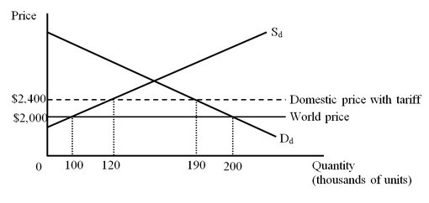

The production effect of the tariff on computers is worth
A) $48 million.
B) $4 million.
C) $8 million.
D) $44 million.

Answer: B
Difficulty: 3 Hard
Topic: The Effects of a Tariff on Domestic Producers
Bloom's: Apply
AACSB: Analytical Thinking
Accessibility: Keyboard Navigation

20) The figure below shows the market for computers in a small importing country. Dd and Sd are the domestic demand and supply curves of computers, respectively.

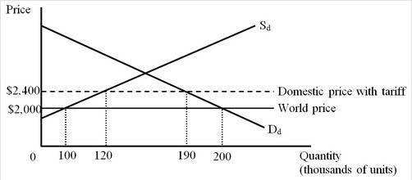

The consumption effect of the tariff on computers is worth
A) $2 million.
B) $4 million.
C) $76 million.
D) $78 million.

Answer: A
Difficulty: 3 Hard
Topic: The Net National Loss from a Tariff
Bloom's: Apply
AACSB: Analytical Thinking
Accessibility: Keyboard Navigation

21) A small country is considering imposing a tariff on imported wine at the rate of $5 per bottle. Economists have estimated the following based on this tariff amount:

World price of wine (free trade): | $20 per bottle
Domestic production (free trade): | 500,000 bottles
Domestic production (after tariff): | 600,000 bottles
Domestic consumption (free trade): | 750,000 bottles
Domestic consumption (after tariff): | 650,000 bottles

Before the tariff is imposed, the country imports ________ bottles of wine, but following the imposition of the tariff, the country will import ________ bottles of wine.
A) 100,000; 100,000
B) 250,000; 50,000
C) 150,000; 50,000
D) 750,000; 650,000

Answer: B
Difficulty: 2 Medium
Topic: The Effect of a Tariff on Domestic Consumers
Bloom's: Understand
AACSB: Reflective Thinking
Accessibility: Keyboard Navigation

22) A small country is considering imposing a tariff on imported wine at the rate of $5 per bottle. Economists have estimated the following based on this tariff amount:

World price of wine (free trade): | $20 per bottle
Domestic production (free trade): | 500,000 bottles
Domestic production (after tariff): | 600,000 bottles
Domestic consumption (free trade): | 750,000 bottles
Domestic consumption (after tariff): | 650,000 bottles

The imposition of the tariff on wine will cause the surplus of the domestic producers to ________ by about
A) rise; $1 million.
B) rise; $500,000.
C) fall; $2.5 million.
D) rise; $2.75 million.

Answer: D
Difficulty: 2 Medium
Topic: The Effects of a Tariff on Domestic Producers
Bloom's: Understand
AACSB: Reflective Thinking
Accessibility: Keyboard Navigation

23) A small country is considering imposing a tariff on imported wine at the rate of $5 per bottle. Economists have estimated the following based on this tariff amount:

World price of wine (free trade): | $20 per bottle
Domestic production (free trade): | 500,000 bottles
Domestic production (after tariff): | 600,000 bottles
Domestic consumption (free trade): | 750,000 bottles
Domestic consumption (after tariff): | 650,000 bottles

The imposition of the tariff on wine will cause the surplus of the domestic consumers to ________ by about
A) fall; $10 million.
B) fall; $250,000.
C) fall; $3.5 million.
D) rise; $3.5 million.

Answer: C
Difficulty: 2 Medium
Topic: The Effect of a Tariff on Domestic Consumers
Bloom's: Understand
AACSB: Reflective Thinking
Accessibility: Keyboard Navigation

24) A small country is considering imposing a tariff on imported wine at the rate of $5 per bottle. Economists have estimated the following based on this tariff amount:

World price of wine (free trade): | $20 per bottle
Domestic production (free trade): | 500,000 bottles
Domestic production (after tariff): | 600,000 bottles
Domestic consumption (free trade): | 750,000 bottles
Domestic consumption (after tariff): | 650,000 bottles

Calculate the government revenue from the tariff.
A) $250,000
B) $1.25 million
C) $3.75 million
D) $125,000

Answer: A
Difficulty: 3 Hard
Topic: The Tariff as Government Revenue
Bloom's: Apply
AACSB: Analytical Thinking
Accessibility: Keyboard Navigation

25) A small country is considering imposing a tariff on imported wine at the rate of $5 per bottle. Economists have estimated the following based on this tariff amount:

World price of wine (free trade): | $20 per bottle
Domestic production (free trade): | 500,000 bottles
Domestic production (after tariff): | 600,000 bottles
Domestic consumption (free trade): | 750,000 bottles
Domestic consumption (after tariff): | 650,000 bottles

The imposition of the tariff on wine will cause the country's economic well-being to ________ by about
A) fall; $0.5 million.
B) rise; $0.75 million.
C) fall; $100,000.
D) fall; $0.75 million.

Answer: A
Difficulty: 2 Medium
Topic: The Tariff as Government Revenue
Bloom's: Understand
AACSB: Reflective Thinking
Accessibility: Keyboard Navigation

26) A small country is considering imposing a tariff on imported wine at the rate of $5 per bottle. Economists have estimated the following based on this tariff amount:

World price of wine (free trade): | $20 per bottle
Domestic production (free trade): | 500,000 bottles
Domestic production (after tariff): | 600,000 bottles
Domestic consumption (free trade): | 750,000 bottles
Domestic consumption (after tariff): | 650,000 bottles

The production effect of the tariff on wine is worth about
A) $250,000.
B) $500,000.
C) $2.5 million.
D) $2.75 million.

Answer: A
Difficulty: 3 Hard
Topic: The Effects of a Tariff on Domestic Producers
Bloom's: Apply
AACSB: Analytical Thinking
Accessibility: Keyboard Navigation

27) A small country is considering imposing a tariff on imported wine at the rate of $5 per bottle. Economists have estimated the following based on this tariff amount:

World price of wine (free trade): | $20 per bottle
Domestic production (free trade): | 500,000 bottles
Domestic production (after tariff): | 600,000 bottles
Domestic consumption (free trade): | 750,000 bottles
Domestic consumption (after tariff): | 650,000 bottles

The consumption effect of the tariff on wine is worth about
A) $250,000.
B) $500,000.
C) $3.5 million.
D) $2.75 million.

Answer: A
Difficulty: 3 Hard
Topic: The Net National Loss from a Tariff
Bloom's: Apply
AACSB: Analytical Thinking
Accessibility: Keyboard Navigation

28) If the imposition of a tariff on a commodity alters the relative international prices of the imposing country's exports to its imports, it is referred to as the
A) total price effect of the tariff.
B) production effect of the tariff.
C) consumption effect of the tariff.
D) terms-of-trade effect of the tariff.

Answer: D
Difficulty: 2 Medium
Topic: The Terms-of-Trade Effect and a Nationally Optimal Tariff
Bloom's: Understand
AACSB: Reflective Thinking
Accessibility: Keyboard Navigation

29) Which of the following is defined as the percentage by which the entire set of a nation's trade barriers raises an industry's value added per unit of output?
A) One-dollar, one-vote metric
B) Revenue effect
C) Effective rate of protection
D) Terms-of-trade effect

Answer: C
Difficulty: 1 Easy
Topic: The Net National Loss from a Tariff
Bloom's: Remember
AACSB: Reflective Thinking
Accessibility: Keyboard Navigation

30) Calculate the effective rate of protection for the domestic MP3 player industry following the imposition of a 20 percent tariff on the imports of MP3 players. The cost of material inputs used in the production of MP3 players in the country is $100 per unit, and there is free trade in these material inputs. The world price of MP3 players is $175 per unit. Assume that the country is a small country.
A) 20%
B) 46⅔%
C) 35%
D) 72⅔%

Answer: B
Difficulty: 3 Hard
Topic: The Net National Loss from a Tariff
Bloom's: Apply
AACSB: Analytical Thinking
Accessibility: Keyboard Navigation

31) At free-trade prices, a tennis racquet in Country A, a small country, sells for $100 and contains $40 worth of aluminum inputs and $30 worth of plastic. In Country A, the nominal tariff rates are 40 percent on tennis racquets, 20 percent on aluminum, and 10 percent on plastic. Based on this information, what is the effective rate of protection for the racquet industry in Country A?
A) 40%
B) 133⅓%
C) 10%
D) 96⅔%

Answer: D
Difficulty: 3 Hard
Topic: The Net National Loss from a Tariff
Bloom's: Apply
AACSB: Analytical Thinking
Accessibility: Keyboard Navigation

32) At free-trade prices, a bicycle in Country X sells for $100 when the per-unit cost of material inputs is $90. Country X has a nominal tariff rate of 15 percent on bicycles, and 10 percent on the material inputs. Based on this information, calculate the effective rate of protection for the bicycle industry in Country X. Assume that Country X is a small country.
A) 25%
B) 60%
C) 5%
D) 15%

Answer: B
Difficulty: 3 Hard
Topic: The Net National Loss from a Tariff
Bloom's: Apply
AACSB: Analytical Thinking
Accessibility: Keyboard Navigation

33) Which of the following statements is NOT correct?
A) Tariffs are likely to decrease world economic well-being.
B) Tariffs can increase, decrease, or leave unchanged the country's economic well-being if imposed by a large country.
C) Tariffs always decrease economic domestic well-being if imposed by a small country.
D) Tariffs hurt producers and help consumers in the country imposing the tariff.

Answer: D
Difficulty: 1 Easy
Topic: A Preview of Conclusions
Bloom's: Remember
AACSB: Reflective Thinking
Accessibility: Keyboard Navigation

34) Suppose Country A collectively enjoys monopsony power in Good X. If Country A imposes a tariff on the imports of Good X, the world price of Good X will
A) fall.
B) rise.
C) remain unaffected.
D) become equal to the tariff-inclusive price in Country A.

Answer: A
Difficulty: 1 Easy
Topic: A Preview of Conclusions
Bloom's: Remember
AACSB: Reflective Thinking
Accessibility: Keyboard Navigation

35) The lower the price elasticity of foreign supply of a country's imports
A) the lower will be the prohibitive tariff imposed by this country.
B) the lower will be tariff revenue of the government of the imposing country.
C) the higher will be the optimum tariff imposed by this country.
D) the higher will be the fluctuation in the availability of the imported goods in this country.

Answer: C
Difficulty: 2 Medium
Topic: A Preview of Conclusions
Bloom's: Understand
AACSB: Reflective Thinking
Accessibility: Keyboard Navigation

36) A large country can gain from imposing a tariff on the import of a good if
A) the tariff drives the quantity imported to zero.
B) the tariff is high enough that the country becomes an exporter of the product.
C) the part of the tariff paid by the foreign exporters is greater than the losses arising from the production and consumption effects of the tariff in the domestic market
D) the tariff revenue collected by the domestic government is equal to the losses caused by the production and consumption effects of the tariff.

Answer: C
Difficulty: 1 Easy
Topic: The Net National Loss from a Tariff
Bloom's: Remember
AACSB: Reflective Thinking
Accessibility: Keyboard Navigation

37) Under free trade, a large country produces one million leather bags per year and imports another two million bags per year at the world price of $60 per bag. Assume the country imposes a specific tariff of $5 per bag. As a result, the per-unit price of leather bags decreases to $58 in the international market and the import of leather bags drops to 1.6 million. The domestic production, on the other hand, increases to 1.1 million.

Following the imposition of the tariff, the domestic consumers pay a price of ________ for each bag.
A) $60
B) $58
C) $63
D) $65

Answer: C
Difficulty: 2 Medium
Topic: The Effect of a Tariff on Domestic Consumers
Bloom's: Understand
AACSB: Reflective Thinking
Accessibility: Keyboard Navigation

38) Under free trade, a large country produces one million leather bags per year and imports another two million bags per year at the world price of $60 per bag. Assume the country imposes a specific tariff of $5 per bag. As a result, the per-unit price of leather bags decreases to $58 in the international market and the import of leather bags drops to 1.6 million. The domestic production, on the other hand, increases to 1.1 million.

Calculate the tariff revenue collected by the domestic government.
A) $13.5 million
B) $4 million
C) $10 million
D) $8 million

Answer: D
Difficulty: 2 Medium
Topic: The Tariff as Government Revenue
Bloom's: Understand
AACSB: Reflective Thinking
Accessibility: Keyboard Navigation

39) Under free trade, a large country produces one million leather bags per year and imports another two million bags per year at the world price of $60 per bag. Assume the country imposes a specific tariff of $5 per bag. As a result, the per-unit price of leather bags decreases to $58 in the international market and the import of leather bags drops to 1.6 million. The domestic production, on the other hand, increases to 1.1 million.

As a result of the tariff being imposed
A) the country gains national well-being because the tariff increases domestic production.
B) the country loses national well-being because the tariff hurts the domestic consumers.
C) the country loses national well-being because the government revenue from the tariff is insufficient to compensate for the losses arising from the production and consumption effects.
D) the country gains national well-being because the amount of the tariff revenue effectively paid by the exporters more than offsets the consumption and the production effects.

Answer: D
Difficulty: 2 Medium
Topic: The Terms-of-Trade Effect and a Nationally Optimal Tariff
Bloom's: Understand
AACSB: Reflective Thinking
Accessibility: Keyboard Navigation

40) The nationally optimal tariff is the tariff for which
A) the production effect is equal to the consumption effect of the tariff.
B) the government collects the highest tariff revenue.
C) the difference between the government tariff revenue and the sum of consumption and production effect is the highest.
D) the difference between the part of the tariff paid by the exporters and the welfare loss associated with the consumption and production effects is the highest.

Answer: D
Difficulty: 1 Easy
Topic: The Terms-of-Trade Effect and a Nationally Optimal Tariff
Bloom's: Remember
AACSB: Reflective Thinking
Accessibility: Keyboard Navigation

41) Which of the following has overseen the global rules of government policy toward international trade since 1995?
A) The World Trade Organization
B) The General Agreement on Tariffs and Trade
C) The International Monetary Fund
D) The World Bank

Answer: A
Difficulty: 1 Easy
Topic: A Preview of Conclusions
Bloom's: Remember
AACSB: Reflective Thinking
Accessibility: Keyboard Navigation

42) Country A is a large country that imports good-quality processed chicken from Country B. Suddenly, Country A's government decides to impose a tariff on this import. Who among the following will be adversely affected by this policy?
A) Consumers of chicken in Country B
B) Consumers of ham in Country B
C) Producers of chicken in Country B
D) Producers of chicken in Country A

Answer: C
Difficulty: 3 Hard
Topic: The Effects of a Tariff on Domestic Producers
Bloom's: Analyze
AACSB: Analytical Thinking
Accessibility: Keyboard Navigation

43) An ad valorem tariff is a money amount per unit of import that is due when the good reaches the importing country.

Answer: FALSE
Difficulty: 1 Easy
Topic: A Preview of Conclusions
Bloom's: Remember
AACSB: Reflective Thinking
Accessibility: Keyboard Navigation

44) When a tariff is imposed on an imported good, the prices of the similar products produced within the country also increase.

Answer: TRUE
Difficulty: 1 Easy
Topic: A Preview of Conclusions
Bloom's: Remember
AACSB: Reflective Thinking
Accessibility: Keyboard Navigation

45) A tariff always lowers the well-being of each nation, including the nation imposing the tariff.

Answer: FALSE
Difficulty: 1 Easy
Topic: A Preview of Conclusions
Bloom's: Remember
AACSB: Reflective Thinking
Accessibility: Keyboard Navigation

46) Within a country, a tariff mainly causes a redistribution of well-being between the domestic producers and the government.

Answer: FALSE
Difficulty: 2 Medium
Topic: A Preview of Conclusions
Bloom's: Understand
AACSB: Reflective Thinking
Accessibility: Keyboard Navigation

47) A tariff imposed by a small country hurts the tariff-imposing country but the rest of the world gains.

Answer: FALSE
Difficulty: 1 Easy
Topic: A Preview of Conclusions
Bloom's: Remember
AACSB: Reflective Thinking
Accessibility: Keyboard Navigation

48) A competitive producer supplies an additional unit of a good as long as the price is greater than the average per unit cost.

Answer: FALSE
Difficulty: 1 Easy
Topic: The Effects of a Tariff on Domestic Producers
Bloom's: Remember
AACSB: Reflective Thinking
Accessibility: Keyboard Navigation

49) The consumption effect of a tariff indicates the welfare loss to a country resulting from the domestic consumers shifting from cheaper imports to more expensive local goods.

Answer: FALSE
Difficulty: 1 Easy
Topic: The Effect of a Tariff on Domestic Consumers
Bloom's: Remember
AACSB: Reflective Thinking
Accessibility: Keyboard Navigation

50) The production effect of a tariff measures the welfare gain of domestic producers who can sell their product at a higher price as a result of the tariff.

Answer: FALSE
Difficulty: 1 Easy
Topic: The Effects of a Tariff on Domestic Producers
Bloom's: Remember
AACSB: Reflective Thinking
Accessibility: Keyboard Navigation

51) The one-dollar, one-vote metric implies that every dollar of gain or loss is just as important as every other dollar of gain or loss, regardless of who the gainers or losers are.

Answer: TRUE
Difficulty: 1 Easy
Topic: The Net National Loss from a Tariff
Bloom's: Remember
AACSB: Reflective Thinking
Accessibility: Keyboard Navigation

52) Firms in a given industry are affected by the tariff imposed on the product they sell, but not by the tariffs imposed on their purchased inputs.

Answer: FALSE
Difficulty: 1 Easy
Topic: The Effects of a Tariff on Domestic Producers
Bloom's: Remember
AACSB: Reflective Thinking
Accessibility: Keyboard Navigation

53) Explain how tariff revenue can be considered an element of the importing country's national gain or loss from imposing a tariff.

Answer: POSSIBLE RESPONSE: The transfer of consumer surplus from consumers to producers and the deadweight loss to the nation as a whole are not the only effects on the importing country. As long as it is not so high as to completely prohibit all imports, a tariff is a source of revenue to the imposing country's government. This revenue equals the unit amount of the tariff times the volume of imports with the tariff. The government could use the tariff revenue to the benefit of the country. For instance, the country's government could use the tariff revenue to increase government spending on socially worthwhile projects that benefit the country as a whole. The tariff revenue could also be used to reduce some other tax, such as the personal income tax. The increased government revenue to the country should be considered along with the consumer losses and producer gains from the tariff.
Difficulty: 1 Easy
Topic: The Tariff as Government Revenue
Bloom's: Remember
AACSB: Reflective Thinking
Accessibility: Keyboard Navigation

54) Discuss two reasons why a country's government could conclude that imposing an export duty on a product the country exports is a good idea.

Answer: POSSIBLE RESPONSE: Here are three possible reasons. First, the country's government may use export taxes or duties, as it would any other tax, to raise revenue for the government. This revenue equals the unit amount of the duty times the volume of exports. The extra government revenue can then be used to expand under-provided government services such as education or health care. Second, the country's government may use export taxes to benefit local consumers such as households. The duty effectively lowers the price domestic producers receive for their products and reduces the amount of product they export. This ultimately results in lower prices for domestic consumers of the product as producers try to increase domestic sales by lowering their price. If the domestic consumers of the product are firms in other industries that use the product as an input to production, the export tax artificially lowers their production costs and encourages expansion of these user industries. A third reason is that, for a large country, the government may be using the export tax to gain national well-being at the expense of foreign buyers, by increasing the world price of the exported product.
Difficulty: 1 Easy
Topic: The Net National Loss from a Tariff
Bloom's: Understand
AACSB: Reflective Thinking
Accessibility: Keyboard Navigation

55) When a small country imposes a tariff, the domestic price of the good increases. This causes a production effect and a consumption effect. Explain carefully these two effects, and discuss whether they increase or decrease the country's well-being.

Answer: POSSIBLE RESPONSE: Small countries cannot influence the international prices of goods when they impose tariffs or other trade barriers. If a small country imposes a tariff, the domestic price of the product increases by the size of the tariff. This will have an effect on the decisions of domestic producers and consumers.

Producers will start to produce more because they can now sell the product domestically at a higher price. From the viewpoint of the society as a whole, this increase of production is actually a loss. The increased production costs more resources to make at home than to import from abroad. This loss is called the "production effect."

Consumers will start to consume less of the product due to its higher domestic price although they value the product more than its international price (without the tariff). This is the source of the "consumption effect," which again is a loss for the country.
Difficulty: 2 Medium
Topic: The Net National Loss from a Tariff
Bloom's: Understand
AACSB: Reflective Thinking
Accessibility: Keyboard Navigation

56) Suppose the world price of automobiles is $20,000 and automobile manufacturers in Country A use $10,000 worth of imported inputs and no domestic inputs. What is the effective rate of protection for the automobile industry in Country A, if there is a tariff of 25 percent on imported automobiles and a tariff of 50 percent on imported inputs used in this industry?

Answer: POSSIBLE RESPONSE: The effective rate of protection for an industry is measured as the percentage change in the value added per unit which results from all protective measures on inputs and the final good. With free trade, the value added for an automobile is ($20,000 − $10,000) = $10,000. When a tariff of 25 percent is imposed on imported automobiles, the new price for an automobile rises to $25,000. Accounting for the tariff on imported inputs, the new value of the inputs is $15,000. The new value added for an automobile is ($25,000 − $15,000) = $10,000. The effective rate of protection for the automobile industry in Country A is therefore ($10,000 − $10,000) / $10,000 = 0%.
Difficulty: 3 Hard
Topic: The Net National Loss from a Tariff
Bloom's: Apply
AACSB: Analytical Thinking
Accessibility: Keyboard Navigation

57) Compare and contrast the effects of a tariff on prices and national well-being imposed in a small country with the effects of a tariff imposed in a large country. Illustrate your answer with the help of suitable diagrams.

Answer: POSSIBLE RESPONSE: The figure below depicts the impact of a tariff imposed by a small country.

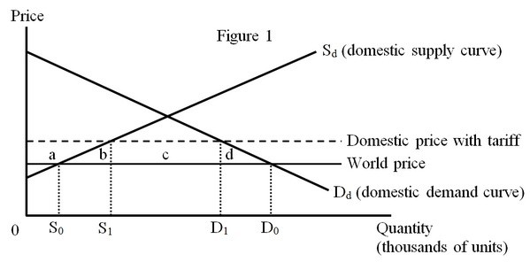

The figure below depicts the impact of a tariff imposed by a large country.

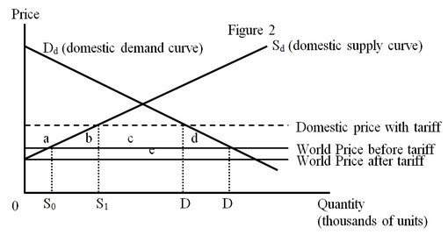

A tariff imposed by a small country will not have an impact on the world price of the good. So, the domestic price will rise by the amount of the tariff. A small country suffers welfare losses after the imposition of the tariff. Figure 1 illustrates the welfare implications of the tariff in a small country. The economic inefficiencies resulting from the tariff are measured by the sum of the production effect (area b) and the consumption effect (area d). As a result of the tariff, consumers lose the area (a + b + c + d), producers gain the area (a), and the government collects the area (c) in tariff revenues resulting in a net loss given by the sum of the area of the triangles b and d.

A tariff imposed by a large country will have an effect on the world price of the imported good. The large country collectively has monopsony power for the imported good. The importing country can exploit this monopsony power by reducing its demand for the imported good, so that the price it pays to the foreign exporters decreases. As shown in Figure 2, the world price will decrease once the tariff is imposed. The resulting effects on consumers and producers (areas a, b, c, and d) will be similar to the effects for the case of a small country. The difference (compared to the case of a small country) is the government tariff revenue. Area (e) measures the portion of the tariff that is effectively paid by the foreign exporters. The foreign exporters are compelled to sell their goods at a lower price after the tariff is imposed. Whether a large country eventually gains or losses from the tariff depends on whether the gain associated with the shift of the burden of the tariff to the foreigners, as shown by area (e), is larger or smaller than the domestic inefficiencies represented by the area (b + d).
Difficulty: 3 Hard
Topic: The Effects of a Tariff on Domestic Producers
Bloom's: Analyze
AACSB: Analytical Thinking
Accessibility: Keyboard Navigation

58) The table below shows the pre-tariff and post-tariff prices, domestic production, and consumption of copper in the United States. Suppose the U.S. government imposes a specific tariff of $0.20 per pound on copper imports by the country.

 | Pre-tariff | Post-tariff
World price | $0.50 per lb. | $0.40 per lb.
U.S domestic price | $0.50 per lb. | $0.60 per lb.
U.S consumption | 250 million lb. | 210 million lb.
U.S production | 100 million lb. | 140 million lb.

a. Calculate the loss to U.S. consumers of copper from the tariff.

b. Calculate the gain to U.S. producers of copper from the tariff.

c. Calculate the revenue collected by the U.S. government from taxing copper imports.

d. Calculate the net gain or loss to the U.S. economy as a whole from the tariff.

Answer: POSSIBLE RESPONSE:

a. As a result of the tariff the domestic price rises by $0.10 (from $0.50 to $0.60) per pound. Domestic consumption in the United States declines by (250 − 210) = 40 million pounds. The decline in the consumer surplus arising from the higher domestic price is $23 million, equal to the $21 million loss for the 210 million units that consumers continue to purchase plus the $2 million loss on the 40 million units that consumers no longer purchase.

b. U.S. producers receive $0.10 more per pound and expand their production by 40 million pounds. The gain in producer surplus from greater production is (½ × $0.10 × 40 million) = $2 million. The gain in surplus arising from selling the initial output at a higher price is (100 million × $0.10) = $10 million. Therefore, the total gain in producer surplus is $12 million.

c. The tariff revenue to the U.S. government equals the product of the imported quantity and the tariff per unit. After imposing the tariff, U.S. imports decline to (210 − 140) = 70 million pounds. U.S. revenue is ($0.20 × 70 million) = $14 million.

d. The net gain to the United States as a whole is given by the difference between the part of the tariff burden borne by the foreign exporters and the sum of the losses arising from the production and consumption effects of the tariff. The part of the tariff burden borne by foreign exporters equals $7 million. The loss arising from the production and consumption effects sum to $4 million. Therefore, the net gain to the United States from the tariff is $(7 − 4) million = $3 million.
Difficulty: 3 Hard
Topic: The Effects of a Tariff on Domestic Producers; The Net National Loss from a Tariff; The Tariff as Government Revenue
Bloom's: Apply
AACSB: Analytical Thinking
Accessibility: Keyboard Navigation

59) A country can actually improve its well-being if it is in a position to impose a non-zero "optimal tariff." Explain what an optimal tariff is, what conditions must be in place to implement an optimal tariff, and how such a tariff will increase national welfare. Assuming a country could impose an optimal tariff, would you suggest it do so? Justify your answer.

Answer: POSSIBLE RESPONSE: An optimal tariff is a tariff which maximizes the well-being of a country. It is measured by the gain in tariff revenue that is essentially paid by the foreign exporters to the government of the importing country minus the loss associated with the consumption and production effects arising from the tariff. A country can gain by a tariff only if the country is large enough to influence the international price of the imported product by restricting its imports. In other words, the country must collectively have monopsony power, even in cases in which no individual buyer within the nation has it. By imposing a tariff the country can improve its terms of trade, and may experience a net gain. One needs to exert caution when advising government officials on the implementation of a tariff. Such a decision should incorporate the eventuality that the trading partners of this country may retaliate by imposing trade restrictions on its exports.
Difficulty: 2 Medium
Topic: The Terms-of-Trade Effect and a Nationally Optimal Tariff
Bloom's: Understand
AACSB: Reflective Thinking
Accessibility: Keyboard Navigation

60) "The higher the tariff, the more domestic production is increased. Thus, a prohibitive tariff is socially optimal." Explain whether or not this statement is valid.

Answer: POSSIBLE RESPONSE: The statement is based on the premise that more domestic production is better than less. The statement fails to account for the well-being of other groups in the economy who are not producers of the product. With a prohibitive tariff, consumers are worse off because the domestic price of the good is high, and the government collects no tariff revenue if imports fall to zero.

The economic inefficiencies of a prohibitive tariff show that the prohibitive tariff is not optimal. It's true that the higher the tariff the higher will be the quantity supplied by domestic producers. However, for the society as a whole this extra domestic production is too costly. It involves valuable resources that can be better used in other industries. The deadweight loss associated with such cost-inefficient production is the production effect.

A prohibitive tariff hurts domestic consumers because the higher domestic price leads consumers to buy less. The deadweight loss associated with the reduced consumption is the consumption effect.

Overall, a prohibitive tariff means that the country is giving up all the gains from trade in this product.
Difficulty: 2 Medium
Topic: The Terms-of-Trade Effect and a Nationally Optimal Tariff
Bloom's: Understand
AACSB: Reflective Thinking
Accessibility: Keyboard Navigation

