International Economics, 17e (Pugel)
Chapter 4 Trade: Factor Availability and Factor Proportions Are Key

1) In international trade jargon, constant-cost production-possibility curves are associated with ________ specialization, while increasing-cost production-possibility curves are associated with ________ specialization.
A) no; partial
B) complete; no
C) complete; partial
D) partial; complete

Answer: C
Difficulty: 1 Easy
Topic: Production with Increasing Marginal Costs
Bloom's: Remember
AACSB: Reflective Thinking
Accessibility: Keyboard Navigation

2) Which of the following statements is true about production-possibility curves?
A) Constant-cost production-possibility curves are straight lines and usually lead to complete specialization under free trade.
B) Under free trade, bowed-out production-possibility curves are associated with partial specialization, because the opportunity cost of producing each good is constant along the curve.
C) Increasing-cost production-possibility curves provide us with information about consumer preferences.
D) Constant-cost production-possibility curves are convex to the origin.

Answer: A
Difficulty: 1 Easy
Topic: Production with Increasing Marginal Costs
Bloom's: Remember
AACSB: Reflective Thinking
Accessibility: Keyboard Navigation

3) Which of the following best explains why increasing marginal costs of production arise?
A) The factor endowments vary across countries.
B) All the factor inputs are not fully utilized in the production of different commodities.
C) Different consumers have different tastes and preference sets.
D) Different commodities use inputs in different proportions.

Answer: D
Difficulty: 2 Medium
Topic: Production with Increasing Marginal Costs
Bloom's: Understand
AACSB: Reflective Thinking
Accessibility: Keyboard Navigation

4) Assume that Country X produces two goods—sugar and shoes—and that the country's production possibility curve is "bowed-out." As the country produces more sugar the opportunity cost of sugar in terms of shoes foregone will
A) increase.
B) decrease.
C) initially increase and then decrease.
D) remain unchanged.

Answer: A
Difficulty: 1 Easy
Topic: Production with Increasing Marginal Costs
Bloom's: Remember
AACSB: Reflective Thinking
Accessibility: Keyboard Navigation

5) Consider a two-country, two-commodity model. Each country has an increasing-cost production-possibility curve. In this model the amounts of the goods that are produced in a country in the no-trade situation are determined by:
A) the relative prices of the goods.
B) the factor endowments in the economy.
C) technology differences between the industries.
D) total income in the economy.

Answer: A
Difficulty: 1 Easy
Topic: Production and Consumption Together
Bloom's: Remember
AACSB: Reflective Thinking
Accessibility: Keyboard Navigation

6) In the figure below, AB is the production-possibility curve of Canada. I1 and I2 are two of the community indifference curves of Canada. In the absence of trade Canada will:

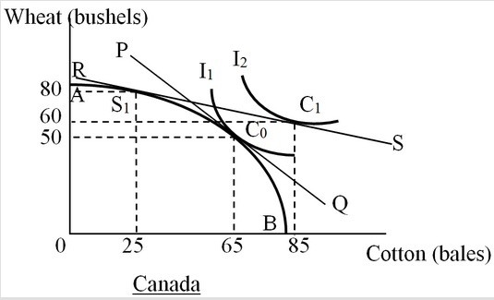

A) produce and consume at point S1.
B) produce and consume at point C0.
C) produce at point S1 and consume at point C0.
D) produce at point S1 and consume at point C1.

Answer: B
Difficulty: 3 Hard
Topic: Production with Increasing Marginal Costs
Bloom's: Analyze
AACSB: Analytical Thinking
Accessibility: Keyboard Navigation

7) In the figure below, AB is the production-possibility curve of Canada. The line PQ shows the price ratio of one bushel of wheat/bale of cotton. The international price ratio is 0.25 bushels of wheat/bale of cotton as shown by the line RS. I1 and I2 are two of the community indifference curves of Canada. After Canada engages in free trade, it will:

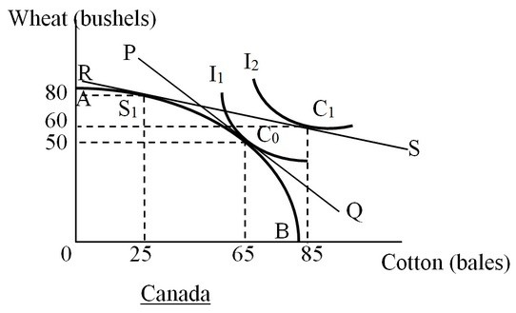

A) produce at point S1 and consume at point C0.
B) produce and consume at point C0.
C) produce at point S1 and consume at point C1.
D) produce and consume points not labeled in the graph.

Answer: C
Difficulty: 3 Hard
Topic: Production with Increasing Marginal Costs
Bloom's: Analyze
AACSB: Analytical Thinking
Accessibility: Keyboard Navigation

8) In the following figure, AB is the production-possibility curve of Canada. The line PQ shows the price ratio of one bushel of wheat/bale of cotton. The international price ratio is 0.25 bushels of wheat/bale of cotton as shown by the line RS. I1 and I2 are two of the community indifference curves of Canada. Which of the following can be inferred from this figure?

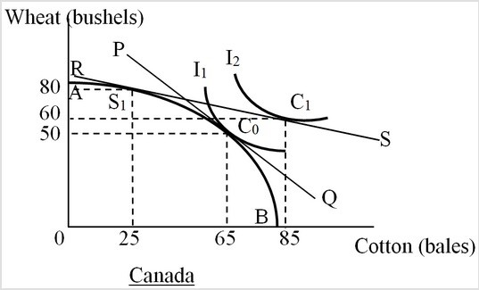

A) Canada has a comparative advantage in the production of wheat.
B) Canada has a comparative advantage in the production of cotton.
C) Canada has an absolute disadvantage in the production of both goods.
D) Canada has an absolute advantage in the production of both goods.

Answer: A
Difficulty: 3 Hard
Topic: Production with Increasing Marginal Costs
Bloom's: Analyze
AACSB: Analytical Thinking
Accessibility: Keyboard Navigation

9) In the figure below, AB is the production-possibility curve of Canada. I1 and I2 are two of the community indifference curves of Canada. With free trade, the international price ratio is 0.25 bushel of wheat/bale of cotton, and Canada will export:

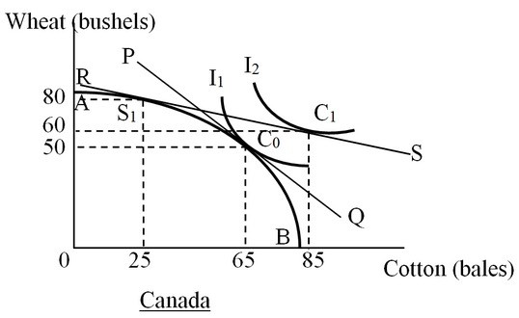

A) eighty bushels of wheat.
B) twenty bushels of wheat.
C) forty bales of cotton.
D) sixty bales of cotton.

Answer: B
Difficulty: 3 Hard
Topic: Production with Increasing Marginal Costs
Bloom's: Apply
AACSB: Analytical Thinking
Accessibility: Keyboard Navigation

10) In the figure below, AB is the production-possibility curve of Canada. I1 and I2 are two of the community indifference curves of Canada. With free trade, the international price ratio is 0.25 bushel of wheat/bale of cotton, and Canada will import:

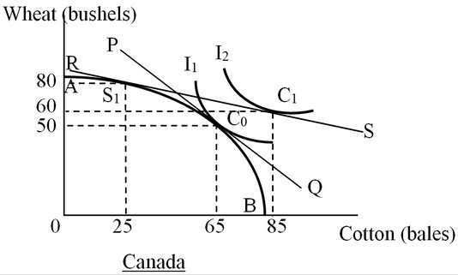

A) sixty bales of cotton.
B) forty bales of cotton.
C) twenty bushels of wheat.
D) eighty bushels of wheat.

Answer: A
Difficulty: 3 Hard
Topic: Production with Increasing Marginal Costs
Bloom's: Apply
AACSB: Analytical Thinking
Accessibility: Keyboard Navigation

11) In the figure below, AB is the production-possibility curve of Canada. The line PQ shows the price ratio of one bushel of wheat/bale of cotton. I1 and I2 are two of the community indifference curves of Canada. With free trade, Canada can achieve a level of well-being corresponding to I2. In the absence of international trade, one bushel of wheat will exchange for ________ bale(s) of cotton in Canada. After Canada engages in international trade, one bushel of wheat will exchange for ________ bale(s) of cotton.

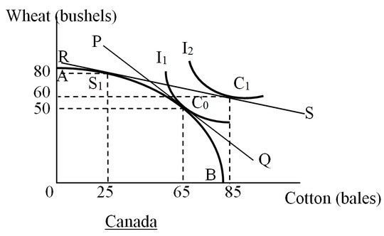

A) one; 0.25
B) four; one
C) one; four
D) 65, 85

Answer: C
Difficulty: 3 Hard
Topic: Production with Increasing Marginal Costs
Bloom's: Apply
AACSB: Analytical Thinking
Accessibility: Keyboard Navigation

12) The figure below shows the production-possibility curves of Canada (AB) and the rest of the world (CD). I1 and I2 are community indifference curves for Canada and the rest of the world. In the absence of trade, Canada consumes ________ bales of cotton and ________ bushels of wheat.

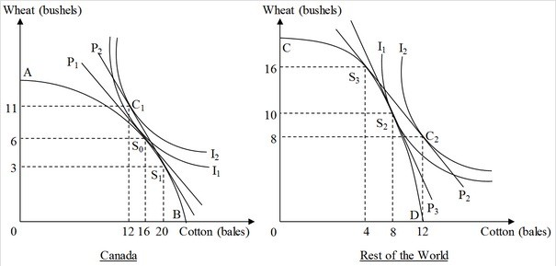

A) twenty; three
B) sixteen; six
C) twenty; six
D) twelve; eleven

Answer: B
Difficulty: 3 Hard
Topic: Production and Consumption Together
Bloom's: Apply
AACSB: Analytical Thinking
Accessibility: Keyboard Navigation

13) The figure below shows the production-possibility curves of Canada (AB) and the rest of the world (CD). I1 and I2 are community indifference curves for Canada and the rest of the world. In the absence of trade, the rest of the world produces ________ bales of cotton and ________ bushels of wheat.

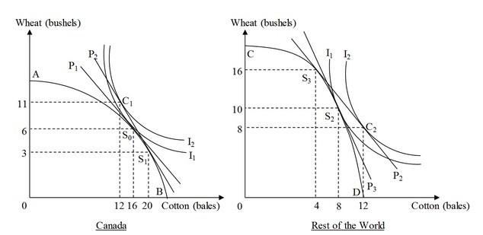

A) ten; eight
B) four; sixteen
C) twelve; eight
D) eight; ten

Answer: D
Difficulty: 3 Hard
Topic: Production and Consumption Together
Bloom's: Apply
AACSB: Analytical Thinking
Accessibility: Keyboard Navigation

14) The figure below shows the production-possibility curves of Canada (AB) and the rest of the world (CD). The international price ratio faced by the countries is represented by the line P2. I1 and I2 are community indifference curves for Canada and the rest of the world. After engaging in free trade, Canada consumes ________ bales of cotton and ________ bushels of wheat.

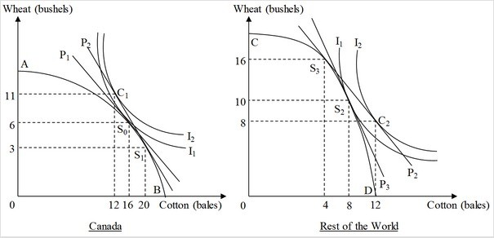

A) twelve; eleven
B) twenty; eleven
C) three; twenty
D) sixteen; six

Answer: A
Difficulty: 3 Hard
Topic: Production and Consumption Together
Bloom's: Apply
AACSB: Analytical Thinking
Accessibility: Keyboard Navigation

15) The following figure shows the production-possibility curves of Canada (AB) and the rest of the world (CD). I1 and I2 are community indifference curves for Canada and the rest of the world. Before Canada entered into trade with the rest of the world, the total amount of cotton produced in the world was ________ bales and the total amount of wheat produced in the world was ________ bushels.

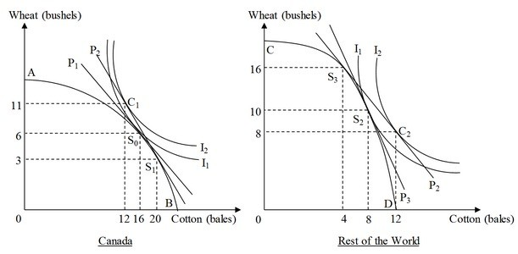

A) twenty-four; nineteen
B) twenty-four; sixteen
C) nineteen; twenty-four
D) eighteen; twenty-four

Answer: B
Difficulty: 2 Medium
Topic: Production and Consumption Together
Bloom's: Understand
AACSB: Reflective Thinking
Accessibility: Keyboard Navigation

16) The following figure shows the production-possibility curves of Canada (AB) and the rest of the world (CD). The international price ratio faced by the countries is represented by the line P2. I1 and I2 are community indifference curves for Canada and the rest of the world. In the shift from no trade to free trade, cotton production in the world increases by ________ bale(s) and wheat production increases by ________ bushel(s).

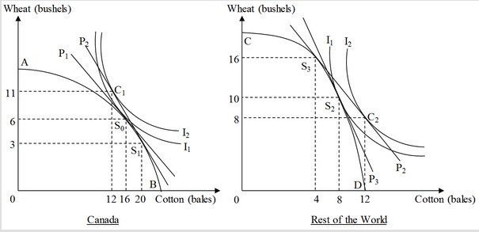

A) zero; three
B) zero; one
C) twenty-four; nineteen
D) one; zero

Answer: A
Difficulty: 2 Medium
Topic: Production and Consumption Together
Bloom's: Understand
AACSB: Reflective Thinking
Accessibility: Keyboard Navigation

17) The following figure shows the free-trade production and consumption in Country Y. AB is the production-possibility curve of Country Y. I1 is the community indifference curve of Country Y. Here, Country Y's production-possibility curve indicates that it faces ________ marginal costs of production.

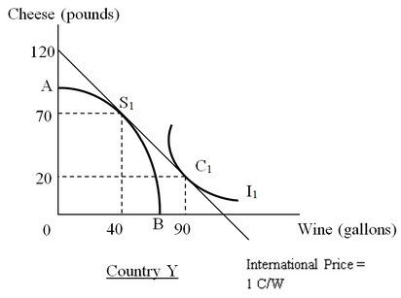

A) constant
B) increasing
C) decreasing
D) fluctuating

Answer: B
Difficulty: 2 Medium
Topic: Production with Increasing Marginal Costs
Bloom's: Understand
AACSB: Reflective Thinking
Accessibility: Keyboard Navigation

18) The figure below shows the free-trade production and consumption in Country Y. AB is the production-possibility curve of Country Y. I1 is the community indifference curve of Country Y. Country Y imports

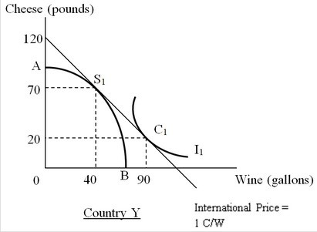

A) forty gallons of wine.
B) seventy pounds of cheese.
C) fifty gallons of wine.
D) twenty pounds of cheese.

Answer: C
Difficulty: 3 Hard
Topic: Trade Affects Production and Consumption
Bloom's: Apply
AACSB: Analytical Thinking
Accessibility: Keyboard Navigation

19) The following figure shows the free-trade production and consumption in Country Y. AB is the production-possibility curve of Country Y. I1 is the community indifference curve of Country Y. Country Y exports

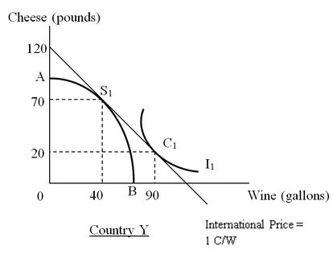

A) fifty gallons of wine.
B) fifty pounds of cheese.
C) ninety gallons of wine.
D) seventy pounds of cheese.

Answer: B
Difficulty: 3 Hard
Topic: Trade Affects Production and Consumption
Bloom's: Apply
AACSB: Analytical Thinking
Accessibility: Keyboard Navigation

20) A country which has a higher ratio of capital to other factors of production than does the rest of the world is
A) relatively capital-scarce.
B) relatively capital-abundant.
C) said to have a low capital-output ratio.
D) operating at a point inside its production-possibility curve.

Answer: B
Difficulty: 2 Medium
Topic: Production and Consumption Together
Bloom's: Understand
AACSB: Reflective Thinking
Accessibility: Keyboard Navigation

21) The United States is relatively capital-abundant because
A) capital costs more in the United States than in the rest of the world.
B) the United States has more capital than the rest of the world.
C) the United States produces and exports primary products to the rest of the world and imports manufactured goods.
D) the ratio of capital to other inputs is greater in the United States than that in the rest of the world.

Answer: D
Difficulty: 2 Medium
Topic: Production and Consumption Together
Bloom's: Understand
AACSB: Reflective Thinking
Accessibility: Keyboard Navigation

22) Which of the following theories predicts that a country will export those goods that use the country's abundant factor(s) intensively and import those goods that use the country's scarce factor(s) intensively?
A) The theory of absolute advantage
B) The theory of comparative advantage
C) The Heckscher-Ohlin theory
D) The theory of purchasing power parity

Answer: C
Difficulty: 1 Easy
Topic: The Heckscher-Ohlin Theory
Bloom's: Remember
AACSB: Reflective Thinking
Accessibility: Keyboard Navigation

23) Suppose Country A is labor-abundant and capital-scarce, and Country B is labor-scarce and capital-abundant. Good X is produced using a labor-intensive technology and Good Y is produced using a capital-intensive technology. Which of the following can most reasonably be inferred from the given information?
A) Country A would export Good X.
B) Country B would import Good Y.
C) Country A would import Good X.
D) Country B would import both Good X and Good Y.

Answer: A
Difficulty: 2 Medium
Topic: The Heckscher-Ohlin Theory
Bloom's: Understand
AACSB: Reflective Thinking
Accessibility: Keyboard Navigation

24) China has 20 percent of the world's population and 10 percent of the world's farmable land. Which of the following will be predicted by the Heckscher-Ohlin theory if China begins to trade with other countries?
A) China will export land-intensive goods like wheat and import labor-intensive goods like clothing.
B) China will shift resources into the production of agricultural goods and away from manufactured goods.
C) China will shift resources from the production of agricultural goods to the production of labor-intensive goods.
D) China will export capital-intensive goods like automobiles and import labor-intensive goods like clothing.

Answer: C
Difficulty: 2 Medium
Topic: The Heckscher-Ohlin Theory
Bloom's: Understand
AACSB: Reflective Thinking
Accessibility: Keyboard Navigation

25) If Country A has a higher ratio of labor to land than Country B, it can be inferred that
A) Country A can produce labor-intensive goods at lower costs than Country B.
B) Country A is a relatively labor-scarce country.
C) Country B can produce labor-intensive goods at lower costs than Country A.
D) Country B is a relatively labor-abundant country.

Answer: A
Difficulty: 2 Medium
Topic: The Heckscher-Ohlin Theory
Bloom's: Understand
AACSB: Reflective Thinking
Accessibility: Keyboard Navigation

26) Which of the following can be concluded from the relationships given below?

(U.K. capital stock) < (rest of the world's capital stock)

(U.K. labor supply) > (rest of the world's labor supply)

A) The United Kingdom is relatively labor-abundant compared to the rest of the world.
B) The United Kingdom is relatively capital-abundant compared to the rest of the world.
C) The rest of the world will export labor-intensive goods.
D) The rest of the world will export both commodities.

Answer: A
Difficulty: 2 Medium
Topic: The Heckscher-Ohlin Theory
Bloom's: Understand
AACSB: Reflective Thinking
Accessibility: Keyboard Navigation

27) Which of the following economists proposed an international trade model that explains international trade patterns using factor proportions?
A) Paul Krugman and Elhanan Helpman
B) David Ricardo and Adam Smith
C) Eli Heckscher and Bertil Ohlin
D) John Maynard Keynes

Answer: C
Difficulty: 1 Easy
Topic: The Heckscher-Ohlin Theory
Bloom's: Remember
AACSB: Reflective Thinking
Accessibility: Keyboard Navigation

28) Assume a two-country, two-commodity, and two-input model. Let the two countries in this model be the United States and the Rest of the World and the two goods being produced by each of the countries be steel and wheat. The two factors of production used in producing the goods in each country are capital and land. If the United States is capital-abundant and steel production is capital-intensive, the Heckscher-Ohlin model would predict that the United States would
A) export steel and import wheat.
B) export wheat and import steel.
C) import both the goods from the Rest of the World.
D) export both the goods to the Rest of the World.

Answer: A
Difficulty: 2 Medium
Topic: The Heckscher-Ohlin Theory
Bloom's: Understand
AACSB: Reflective Thinking
Accessibility: Keyboard Navigation

29) Assume a two-country, two-commodity, and two-input model. Let the two countries in this model be the United States and the Rest of the World and the two goods being produced by each of the countries be steel and wheat. The two factors of production used in producing the goods in each country are capital and land. If the United States is capital-abundant and wheat production is land-intensive, the Heckscher-Ohlin model would predict that the Rest of the World would
A) export steel and import wheat.
B) export wheat and import steel.
C) import both the goods from the United States.
D) export both the goods to the United States.

Answer: B
Difficulty: 2 Medium
Topic: The Heckscher-Ohlin Theory
Bloom's: Understand
AACSB: Reflective Thinking
Accessibility: Keyboard Navigation

30) Assume a two-country, two-commodity, two-input model where the following relationships hold:

(K/L)U.S. > (K/L)ROW

(K/L)automobiles > (K/L)shoes

(K/L)U.S. is the capital-labor ratio in the United States, (K/L)ROW is the capital-labor ratio in the Rest of the World, (K/L)automobiles indicates the capital-labor ratio in the production of automobiles, and (K/L)shoes indicates the capital-labor ratio in the production of shoes.

Assume further that technology and tastes are the same in the United States and the Rest of the World. This information indicates that the United States
A) is a relatively capital-scarce country.
B) has a scarcity of land.
C) is a relatively land-abundant country.
D) is a relatively capital-abundant country.

Answer: D
Difficulty: 2 Medium
Topic: The Heckscher-Ohlin Theory
Bloom's: Understand
AACSB: Reflective Thinking
Accessibility: Keyboard Navigation

31) Assume a two-country, two-commodity, two-input model where the following relationships hold:

(K/L)U.S. > (K/L)ROW

(K/L)automobiles > (K/L)shoes

(K/L)U.S. is the capital-labor ratio in the United States, (K/L)ROW is the capital-labor ratio in the Rest of the World, (K/L)automobiles indicates the capital-labor ratio in the production of automobiles, and (K/L)shoes indicates the capital-labor ratio in the production of shoes.

Assume further that technology and tastes are the same in the United States and the Rest of the World. Which of the following statements is true?
A) Production of automobiles is relatively labor-intensive.
B) Production of shoes is relatively labor-intensive.
C) Production of shoes is relatively cheaper in the United States than the Rest of the World.
D) The laborers in the United States are less productive than the laborers in the Rest of the World.

Answer: B
Difficulty: 2 Medium
Topic: The Heckscher-Ohlin Theory
Bloom's: Understand
AACSB: Reflective Thinking
Accessibility: Keyboard Navigation

32) Assume a two-country, two-good, two-input model where the following relationships hold:

(K/L)U.S. > (K/L)ROW

(K/L)automobiles > (K/L)shoes

(K/L)U.S. is the capital-labor ratio in the United States, (K/L)ROW is the capital-labor ratio in the Rest of the World, (K/L)automobiles indicates the capital-labor ratio in the production of automobiles, and (K/L)shoes indicates the capital-labor ratio in the production of shoes.

Assume further that technology and tastes are the same in the United States and the Rest of the World. The relationships shown here indicate that, with no trade, in the United States
A) the relative labor endowment is higher than in the Rest of the World.
B) the price of automobiles relative to shoes is lower than in the Rest of the World.
C) the price of shoes relative to automobiles is lower than in the Rest of the World.
D) the relative capital endowment is the same as in the Rest of the World.

Answer: B
Difficulty: 1 Easy
Topic: The Heckscher-Ohlin Theory
Bloom's: Remember
AACSB: Reflective Thinking
Accessibility: Keyboard Navigation

33) Assume a two-country, two-commodity, two-input model where the following relationships hold:

(K/L)U.S. > (K/L)ROW

(K/L)automobiles > (K/L)shoes

(K/L)U.S. is the capital-labor ratio in the United States, (K/L)ROW is the capital-labor ratio in the Rest of the World, (K/L)automobiles indicates the capital-labor ratio in the production of automobiles, and (K/L)shoes indicates the capital-labor ratio in the production of shoes.

Assume further that technology and tastes are the same in the United States and the Rest of the World. The relationships shown in here indicate that the United States has a comparative advantage in the production of ________ while the Rest of the World has a comparative advantage in the production of
A) both the goods; neither shoes nor automobiles
B) shoes; automobiles
C) automobiles; shoes
D) neither shoes nor automobiles; both goods

Answer: C
Difficulty: 1 Easy
Topic: The Heckscher-Ohlin Theory
Bloom's: Remember
AACSB: Reflective Thinking
Accessibility: Keyboard Navigation

34) Assume a two-country, two-commodity, two-input model where the following relationships hold:

(K/L)U.S. > (K/L)ROW

(K/L)automobiles > (K/L)shoes

(K/L)U.S. is the capital-labor ratio in the United States, (K/L)ROW is the capital-labor ratio in the Rest of the World, (K/L)automobiles indicates the capital-labor ratio in the production of automobiles, and (K/L)shoes indicates the capital-labor ratio in the production of shoes.

Assume further that technology and tastes are the same in the United States and the Rest of the World. If trade opens up between the United States and the Rest of the World, according to the Heckscher-Ohlin model, the United States will export ________ and import
A) both goods; neither good.
B) shoes; automobiles.
C) automobiles; shoes.
D) neither good; both goods.

Answer: C
Difficulty: 2 Medium
Topic: The Heckscher-Ohlin Theory
Bloom's: Understand
AACSB: Reflective Thinking
Accessibility: Keyboard Navigation

35) Assume a two-country, two-commodity, two-input model where the following relationships hold:

(K/L)U.S. > (K/L)ROW

(K/L)automobiles > (K/L)shoes

(K/L)U.S. is the capital-labor ratio in the United States, (K/L)ROW is the capital-labor ratio in the Rest of the World, (K/L)automobiles indicates the capital-labor ratio in the production of automobiles, and (K/L)shoes indicates the capital-labor ratio in the production of shoes.

Assume further that technology and tastes are the same in the United States and the Rest of the World. If trade opens up between the United States and the Rest of the World, according to the Heckscher-Ohlin model, the Rest of the World will export ________ and import
A) both the goods; neither good.
B) shoes; automobiles.
C) automobiles; shoes.
D) neither good; both goods.

Answer: B
Difficulty: 1 Easy
Topic: The Heckscher-Ohlin Theory
Bloom's: Remember
AACSB: Reflective Thinking
Accessibility: Keyboard Navigation

36) Assume a two-country, two-commodity, two-input model where the following relationships hold:

(K/L)U.S. > (K/L)ROW

(K/L)automobiles > (K/L)shoes

(K/L)U.S. is the capital-labor ratio in the United States, (K/L)ROW is the capital-labor ratio in the Rest of the World, (K/L)automobiles indicates the capital-labor ratio in the production of automobiles, and (K/L)shoes indicates the capital-labor ratio in the production of shoes.

Assume further that technology and tastes are the same in the United States and the Rest of the World. According to the Heckscher-Ohlin model, free trade between the United States and the Rest of the World would result in
A) an improvement in economic well-being in the United States but deterioration of economic well-being in the Rest of the World.
B) no change in economic well-being in the United States but an improvement in economic well-being in the Rest of the World.
C) an improvement in economic well-being in both the United States and the Rest of the World.
D) deterioration of economic well-being in the United States but an improvement in economic well-being in the Rest of the World.

Answer: C
Difficulty: 1 Easy
Topic: The Heckscher-Ohlin Theory
Bloom's: Remember
AACSB: Reflective Thinking
Accessibility: Keyboard Navigation

37) The table below shows the units of land and labor required to produce a unit of bread and cheese respectively in Country X. Identify the correct statement.

 | 1 Unit of Bread | 1 Unit of Cheese
Labor Input | 5 units | 20 units
Land Input | 4 units | 10 units

A) Production of bread is relatively labor-intensive in the country.
B) Production of bread is relatively land-intensive in the country.
C) The opportunity cost of producing an extra unit of bread is four units of cheese.
D) The domestic price ratio in the country is two units of bread per unit of cheese.

Answer: B
Difficulty: 2 Medium
Topic: The Heckscher-Ohlin Theory
Bloom's: Understand
AACSB: Reflective Thinking
Accessibility: Keyboard Navigation

38) The table below shows the units of land and labor required to produce a unit of bread and cheese respectively in Country X. If Country X is a relatively land-abundant country, the opening up of free trade would cause the price of bread relative to cheese to

 | 1 Unit of Bread | 1 Unit of Cheese
Labor Input | 5 units | 20 units
Land Input | 4 units | 10 units

A) rise.
B) fall.
C) stay the same.
D) initially rise but fall afterward.

Answer: A
Difficulty: 2 Medium
Topic: The Heckscher-Ohlin Theory
Bloom's: Understand
AACSB: Reflective Thinking
Accessibility: Keyboard Navigation

39) The table below shows the units of land and labor required to produce a unit of bread and cheese respectively in Country X. If Country X is land-abundant, the opening up of free trade would result in

 | 1 Unit of Bread | 1 Unit of Cheese
Labor Input | 5 units | 20 units
Land Input | 4 units | 10 units

A) a decline in the production of both bread and cheese in the country.
B) an increase in the production of bread but a decline in the production of cheese in the country.
C) an increase in the production of both bread and cheese in the country, but production of cheese will rise at a lesser pace than the production of bread.
D) a decline in the production of bread but an increase in the production of cheese in the country.

Answer: B
Difficulty: 2 Medium
Topic: The Heckscher-Ohlin Theory
Bloom's: Understand
AACSB: Reflective Thinking
Accessibility: Keyboard Navigation

40) Country Y has fifteen thousand acres of land and forty-five thousand laborers, whereas the Rest of the World has one hundred thousand acres of land and two hundred thousand laborers. These countries produce a labor-intensive Good A, and a land-intensive Good B. Based on the information given here, we can conclude that
A) Country Y is relatively labor-abundant.
B) Country Y enjoys absolute advantage in the production of Good B.
C) the Rest of the World is relatively labor-abundant.
D) the factor proportions are the same in both Country Y and the Rest of the World.

Answer: A
Difficulty: 2 Medium
Topic: The Heckscher-Ohlin Theory
Bloom's: Understand
AACSB: Reflective Thinking
Accessibility: Keyboard Navigation

41) Country Y has fifteen thousand acres of land and forty-five thousand laborers, whereas the Rest of the World has one hundred thousand acres of land and two hundred thousand laborers. These countries produce a labor-intensive Good A, and a land-intensive Good B. When trade opens up between these countries, it can be inferred that Country Y will
A) export both goods.
B) export Good B, and import Good A.
C) export Good A, and import Good B.
D) import both goods.

Answer: C
Difficulty: 1 Easy
Topic: The Heckscher-Ohlin Theory
Bloom's: Remember
AACSB: Reflective Thinking
Accessibility: Keyboard Navigation

42) Increasing-cost production-possibility curves are bowed-out from the origin.

Answer: TRUE
Difficulty: 1 Easy
Topic: Production with Increasing Marginal Costs
Bloom's: Remember
AACSB: Reflective Thinking
Accessibility: Keyboard Navigation

43) In a two-country, two-commodity model, the opening of trade will necessarily lead to complete specialization in the production of one good by one country and complete specialization in the production of the other good by the other country.

Answer: FALSE
Difficulty: 1 Easy
Topic: Trade Affects Production and Consumption
Bloom's: Remember
AACSB: Reflective Thinking
Accessibility: Keyboard Navigation

44) When increasing amounts of a variable factor are added to a fixed factor, the output increases, but at a diminishing rate.

Answer: TRUE
Difficulty: 2 Medium
Topic: Production with Increasing Marginal Costs
Bloom's: Understand
AACSB: Reflective Thinking
Accessibility: Keyboard Navigation

45) As a country moves up along its "bowed-out" production-possibility curve, the opportunity cost of producing more of the good measured on the y-axis decreases.

Answer: FALSE
Difficulty: 2 Medium
Topic: Production with Increasing Marginal Costs
Bloom's: Understand
AACSB: Reflective Thinking
Accessibility: Keyboard Navigation

46) The production-possibility curve alone does not provide enough information to determine the amount of each good produced by the economy.

Answer: TRUE
Difficulty: 1 Easy
Topic: Production with Increasing Marginal Costs
Bloom's: Remember
AACSB: Reflective Thinking
Accessibility: Keyboard Navigation

47) The production-possibility curve illustrates the consumption preferences of a country's population, and explains why all people prefer to be employed rather than unemployed.

Answer: FALSE
Difficulty: 1 Easy
Topic: Production and Consumption Together
Bloom's: Remember
AACSB: Reflective Thinking
Accessibility: Keyboard Navigation

48) In the absence of trade, a country produces at a point where its production-possibility curve is tangent to the highest possible community indifference curve.

Answer: TRUE
Difficulty: 1 Easy
Topic: Production with Increasing Marginal Costs
Bloom's: Remember
AACSB: Reflective Thinking
Accessibility: Keyboard Navigation

49) An indifference curve shows the various consumption bundles that result in the same level of well-being for an individual.

Answer: TRUE
Difficulty: 1 Easy
Topic: Community Indifference Curves
Bloom's: Remember
AACSB: Reflective Thinking
Accessibility: Keyboard Navigation

50) The community indifference curves illustrate the technological capabilities of a country.

Answer: FALSE
Difficulty: 1 Easy
Topic: Community Indifference Curves
Bloom's: Remember
AACSB: Reflective Thinking
Accessibility: Keyboard Navigation

51) According to the Heckscher-Ohlin theory, if the proportion of labor to capital in a country is greater than the proportion of labor to capital in the rest of the world, we can conclude that the country is labor-abundant and will have a comparative advantage in the production of goods that use labor intensively.

Answer: TRUE
Difficulty: 1 Easy
Topic: The Heckscher-Ohlin Theory
Bloom's: Remember
AACSB: Reflective Thinking
Accessibility: Keyboard Navigation

52) If Country A is relatively abundant in labor and Country B is relatively abundant in capital, the Heckscher-Ohlin theory predicts that Country A will export relatively labor-intensive goods and Country B will export relatively capital-intensive goods.

Answer: TRUE
Difficulty: 1 Easy
Topic: The Heckscher-Ohlin Theory
Bloom's: Remember
AACSB: Reflective Thinking
Accessibility: Keyboard Navigation

53) Briefly explain the Heckscher-Olin (H-O) Theory.

Answer: POSSIBLE RESPONSE: The H-O theory focuses on an important source of production-side differences that cause countries' production-possibility curves (PPC) to skew in different ways. International differences in the shapes of bowed-out PPCs can occur because (1) different products use the factors of production in different proportions and (2) countries differ in their relative factor endowments. The H-O theory of trade patterns predicts that a country exports products that are produced with more intensive use of the country's relatively abundant factors in exchange for imports of products that use the country's relatively scarce factors more intensively.
Difficulty: 1 Easy
Topic: The Heckscher-Ohlin Theory
Bloom's: Remember
AACSB: Reflective Thinking
Accessibility: Keyboard Navigation

54) Compare the standard modern theory of international trade that assumes increasing marginal costs with the constant-cost assumption about production costs used in the Ricardian approach.

Answer: POSSIBLE RESPONSE: In the Ricardian approach, the marginal costs of producing one good as measured in terms of what must be given up to produce other goods is constant. This is illustrated using the straight-line production-possibilities curve (PPC) with a constant slope that shows the combinations of amounts of different products that a country can produce, given the country's available resources. With the more realistic assumption of increasing marginal costs, as the production one good expands at the expense of others, increasing production of the amounts of the other goods must be given up. With increasing marginal costs, the PPC is "bowed out." This reflects that, to produce more of one good, the country must give up increasing amounts of all other goods. This is because the production of different goods uses factor inputs in different proportions.
Difficulty: 1 Easy
Topic: Production with Increasing Marginal Costs
Bloom's: Understand
AACSB: Reflective Thinking
Accessibility: Keyboard Navigation

55) Explain the differences between the two-country, two-commodity model with constant costs of production and the two-country, two-commodity model with increasing costs of production. Adequately describe the production-possibilities curves for each country in each case. Describe free-trade production and the degree of specialization in each country under both cost situations.

Answer: POSSIBLE RESPONSE: If the cost of production of each good is constant, the opportunity cost of production of one good (in terms of production foregone of the other good) is also constant. In an economy with constant cost of production, the production-possibility curve (PPC) is a straight line. With free-trade and constant-production costs, it is beneficial for a country to fully specialize in the production of one good and export this good in exchange for imports of the other good. The good that will be produced is the good with an opportunity cost that is lower than the relative international price of this good (the price of the good expressed in units of the other good). Conversely, the good with an opportunity cost higher than the international price will be imported. The result is complete specialization. This is based on Ricardo's idea of comparative advantage and complete specialization. Ricardo assumed that all goods are produced with one factor of production—labor—and to double the production of a product, a producer just needs to double the amount of the input factor—the labor hours. Realistically, however, production requires a variety of factor inputs: land, skilled labor, unskilled labor, capital, etc., and different products use factor inputs in different proportions. The difference in factor proportions leads to an increasing cost of production. That means the production-possibilities curve is bowed-out. In other words, the opportunity cost of production of one good is not constant but rather increasing with increased production of this good. Under such a situation, when a country engages in free trade, it will usually produce both goods (incomplete specialization). Still, it will export that good which it can produce at a relatively lower cost and import the other good.
Difficulty: 3 Hard
Topic: Production and Consumption Together
Bloom's: Analyze
AACSB: Analytical Thinking
Accessibility: Keyboard Navigation

56) "In the two-good, two-country model with increasing costs, the output quantities are determined only by considering society's preferences as illustrated with community indifference curves. However, in the same model, it is possible to determine the post-trade consumption point in each country without indifference curves." Are these statements true, false, or partly true and partly false? Justify your answer.

Answer: POSSIBLE RESPONSE: The community indifference curves reflect the preferences of the country's consumers for both goods. With or without trade, the output decision of a country will depend on both the technology and the available factors of production (summarized in the production-possibility curve) and the demands for the goods (summarized in the relative price ratio). Therefore it will not be possible to determine the output quantities without the production-possibility curve.

It is not possible to determine free-trade consumption in each country without community indifference curves as we will not know which consumption point is preferred by the consumers in the country. So, the given statement is false.
Difficulty: 2 Medium
Topic: Community Indifference Curves
Bloom's: Understand
AACSB: Reflective Thinking
Accessibility: Keyboard Navigation

57) Assume a two-country, two-commodity, two-input model. Let the countries in the model be the United States and the Rest of the World and the goods be steel and wheat. The two factors of production are capital and land. Further, the United States is capital-abundant and steel production is capital-intensive. Suppose, in the absence of trade, the United States operates at a point on its production-possibility curve where it produces and consumes twenty units of wheat and twenty units of steel. Once it engages in free trade, the international price of one unit of steel is two units of wheat. In response to the opening of trade, the United States moves along its production-possibility curve to a new point where it produces thirty units of steel and ten units of wheat. Is the United States better off following the opening of trade? Provide a logical proof of your answer.

Answer: POSSIBLE RESPONSE: The opening of trade allows the United States to partially specialize in the production of steel because steel is capital-intensive and the United States is relatively capital-abundant. We need to compare the well-being of the United States in the absence of trade to that after it engages in free trade. In the absence of trade, the United States consumes twenty units of steel and twenty units of wheat.

When free trade is allowed, the United States can extend the production of steel to thirty units, that is, by ten units. The amount of wheat foregone is also ten units; the production of wheat decreases from twenty units to ten units. However, in the international market the United States can exchange one unit of steel for two units of wheat. If the United States would sell the ten extra units of steel produced for twenty units of wheat, the United States could consume thirty units of wheat and twenty units of steel. This is better than the no-trade situation of consuming only twenty units of wheat and twenty units of steel. The country is thus better off following the opening of free trade.
Difficulty: 2 Medium
Topic: Trade Affects Production and Consumption
Bloom's: Understand
AACSB: Reflective Thinking
Accessibility: Keyboard Navigation

58) After the North American Free Trade Agreement (NAFTA) was signed, trade restrictions among Canada, the United States, and Mexico were eased and cross-border trade increased. What predictions would the Heckscher-Ohlin model make concerning output changes in labor-intensive industries such as textiles in both Mexico and the United States and in capital-intensive industries such as steel in both Mexico and the United States, as a result of NAFTA?

Answer: POSSIBLE RESPONSE: The Heckscher-Ohlin model predicts that free trade will allow countries to specialize in the production of goods that intensively use their relatively abundant factors of production. The Heckscher-Ohlin model would predict that after the trade restrictions are withdrawn, Mexico is likely to expand its production of textiles as they require intensive use of labor. The United States, on the other hand, will expand its production of steel, which is a capital-intensive industry, because it is a relatively capital-abundant country.
Difficulty: 2 Medium
Topic: The Heckscher-Ohlin Theory
Bloom's: Understand
AACSB: Reflective Thinking
Accessibility: Keyboard Navigation

59) Using the concepts of community indifference curves and the production-possibility curve, explain how the international price of a good is determined in the Heckscher-Ohlin two-commodity model. What is the unit of measurement for the price of a good in this model?

Answer: POSSIBLE RESPONSE: The production-possibility curve (PPC) illustrates the maximal quantities of two goods that a country can produce with full employment of its resources. The combination of quantities that the producers will eventually decide to produce along the PPC will depend on the relative price of the good (expressed in terms of the other good to be given up). A community indifference curve indicates all combinations of quantities of the two goods, which provide the same well-being to the community. The PPC can be used to derive the marginal cost of a product (expressed in terms of the other good to be given up), which in turn, defines the supply of this product. Community indifference curves can be used to derive the demand for the product. The international price of a good in the Heckscher-Ohlin model is determined in such a way, that the excess domestic supply in one of the countries is matched by the shortage (excess domestic demand) in the other country. The first country exports the good in exchange for importing the other good.
Difficulty: 3 Hard
Topic: The Heckscher-Ohlin Theory
Bloom's: Analyze
AACSB: Analytical Thinking
Accessibility: Keyboard Navigation

60) Assume a two-country, two-product model where the countries are A and B and the products are Y and Z. In the free trade equilibrium, the international price of good Z is less than the no trade price of good Z would be in Country A. Explain why, for Country A, Ricardo's comparative advantage model predicts full specialization, while the Heckscher-Ohlin model predicts only partial specialization in the production of two goods.

Answer: POSSIBLE RESPONSE: When trade becomes possible, the international price of a good Z initially is lower than the opportunity cost of producing it in Country A. This implies that, starting from no trade, it is cheaper to buy good Z in the international market in exchange for the other good, good Y. The production of good Z decreases, and resources in Country A can instead be more efficiently employed in the production of good Y. How far does this shift of resources go?

Ricardo considered only labor as a production resource and assumed that production has constant costs. This implies that to double production, the producer just needs to employ twice as much labor. The opportunity cost in Ricardo's model is constant, which implies that the production possibilities curve is a straight line. Since the marginal cost remains unchanged, irrespective of the quantities of both goods being produced, Country A can completely specialize in the production of good Y and exchange it for good X in the international market. In contrast, the Heckscher-Ohlin model has (at least) two factors of production, and this implies that the opportunity cost of producing a good increases with an increase in its output. So, there can be a certain quantity combination of the two goods along the PPC, where the opportunity cost will match the international price. This is the optimal quantity combination of production for Country A, and only partial specialization takes place.
Difficulty: 2 Medium
Topic: The Heckscher-Ohlin Theory
Bloom's: Understand
AACSB: Reflective Thinking
Accessibility: Keyboard Navigation

