International Economics, 17e (Pugel)
Chapter 3 Why Everybody Trades: Comparative Advantage

1) According to the Mercantilists, governments should
A) subsidize and encourage imports.
B) subsidize and encourage exports.
C) allow for free trade unencumbered by government regulations and restrictions.
D) not spend much on national defense.

Answer: B
Difficulty: 1 Easy
Topic: Adam Smith's Theory of Absolute Advantage
Bloom's: Remember
AACSB: Reflective Thinking
Accessibility: Keyboard Navigation

2) ________ wrote the Wealth of Nations.
A) David Ricardo
B) Paul Samuelson
C) Adam Smith
D) Karl Marx

Answer: C
Difficulty: 1 Easy
Topic: Adam Smith's Theory of Absolute Advantage
Bloom's: Remember
AACSB: Reflective Thinking
Accessibility: Keyboard Navigation

3) When Adam Smith presented his theory of absolute advantage, he assumed that all "value" in an economy was determined by and measured in terms of the ________ used in the production of the various goods.
A) area of land
B) labor hours
C) amount of physical capital
D) amount of money

Answer: B
Difficulty: 1 Easy
Topic: Adam Smith's Theory of Absolute Advantage
Bloom's: Remember
AACSB: Reflective Thinking
Accessibility: Keyboard Navigation

4) Labor productivity refers to:
A) the number of units of output a worker can produce in one hour.
B) the money value of a good that all workers in a firm produce in one day.
C) the number of hours it takes a worker to produce one unit of output.
D) the total numbers of hours it takes all the workers in a firm to produce a given money value of a good in one day.

Answer: A
Difficulty: 1 Easy
Topic: Adam Smith's Theory of Absolute Advantage
Bloom's: Remember
AACSB: Reflective Thinking
Accessibility: Keyboard Navigation

5) Which of the following is true of mercantilism?
A) Mercantilists believed that free trade is always beneficial for the trading nations.
B) Mercantilists believed that under free trade each of the trading countries benefit equally.
C) Mercantilists believed that a nation does not benefit directly from its exports.
D) Mercantilism believed that national well-being was based on national holdings of gold and silver.

Answer: D
Difficulty: 1 Easy
Topic: Adam Smith's Theory of Absolute Advantage
Bloom's: Remember
AACSB: Reflective Thinking
Accessibility: Keyboard Navigation

6) If Country X has higher labor productivity in the production of umbrellas than the rest of the world, we would say that Country X has a(n) ________ in the production of umbrellas.
A) comparative advantage
B) absolute advantage
C) absolute disadvantage
D) comparative disadvantage

Answer: B
Difficulty: 1 Easy
Topic: Adam Smith's Theory of Absolute Advantage
Bloom's: Remember
AACSB: Reflective Thinking
Accessibility: Keyboard Navigation

7) Consider a two-country, two-commodity model. The table below shows the units of Good X and Good Y produced in Country A and Country B per labor hour. The number of labor hours required to produce one unit of Good X in Country A is

Productivity | Country A | Country B
Good X | 1.00 | 0.50
Good Y | 0.20 | 0.70

A) 0.5.
B) 1.
C) 1.43.
D) 2.

Answer: B
Difficulty: 2 Medium
Topic: Ricardo's Theory of Comparative Advantage
Bloom's: Understand
AACSB: Reflective Thinking
Accessibility: Keyboard Navigation

8) Consider a two-country, two-commodity model. The table below shows the units of Good X and Good Y produced in Country A and Country B per labor hour. The number of labor hours required to produce one unit of Good Y in Country B is

Productivity | Country A | Country B
Good X | 1.00 | 0.50
Good Y | 0.20 | 0.70

A) 0.5.
B) 1.
C) 1.43.
D) 2.

Answer: C
Difficulty: 2 Medium
Topic: Ricardo's Theory of Comparative Advantage
Bloom's: Understand
AACSB: Reflective Thinking
Accessibility: Keyboard Navigation

9) Consider a two-country, two-commodity model. The table below shows the units of Good X and Good Y produced in Country A and Country B per labor hour. Which of the following statements is true?

Productivity | Country A | Country B
Good X | 1.00 | 0.50
Good Y | 0.20 | 0.70

A) Country B has an absolute advantage in the production of both Good X and Good Y.
B) Country A has an absolute advantage in the production of Good X.
C) Country A has an absolute advantage in the production of both Good X and Good Y.
D) Country B has an absolute advantage in the production of Good X.

Answer: B
Difficulty: 2 Medium
Topic: Ricardo's Theory of Comparative Advantage
Bloom's: Understand
AACSB: Reflective Thinking
Accessibility: Keyboard Navigation

10) Consider a two-country, two-commodity model. The table below shows the units of Good X and Good Y produced in Country A and Country B per labor hour. Country B has an absolute advantage in the production of

Productivity | Country A | Country B
Good X | 1.00 | 0.50
Good Y | 0.20 | 0.70

A) neither Good X nor Good Y.
B) both Good X and Good Y.
C) only Good X.
D) only Good Y.

Answer: D
Difficulty: 2 Medium
Topic: Ricardo's Theory of Comparative Advantage
Bloom's: Understand
AACSB: Reflective Thinking
Accessibility: Keyboard Navigation

11) Consider a two-country, two-commodity model. The table below shows the units of Good X and Good Y produced in Country A and Country B per labor hour. If Country A transfers one labor hour from the production of Good Y to the production of Good X, total world production of Good X will ________ by ________ unit(s).

Productivity | Country A | Country B
Good X | 1.00 | 0.50
Good Y | 0.20 | 0.70

A) increase; one
B) decrease; 1.43
C) increase; 0.5
D) decrease; 0.7

Answer: A
Difficulty: 2 Medium
Topic: Ricardo's Theory of Comparative Advantage
Bloom's: Understand
AACSB: Reflective Thinking
Accessibility: Keyboard Navigation

12) Consider a two-country, two-commodity model. The table below shows the units of Good X and Good Y produced in Country A and Country B per labor hour. If Country B transfers one labor hour from the production of Good X to the production of Good Y, total world production of Good Y will ________ by ________ unit(s).

Productivity | Country A | Country B
Good X | 1.00 | 0.50
Good Y | 0.20 | 0.70

A) increase; 0.7
B) decrease; one
C) decrease; 1.5
D) increase; 0.5

Answer: A
Difficulty: 2 Medium
Topic: Ricardo's Theory of Comparative Advantage
Bloom's: Understand
AACSB: Reflective Thinking
Accessibility: Keyboard Navigation

13) The theory of comparative advantage was proposed by
A) Adam Smith.
B) Karl Marx.
C) David Ricardo.
D) Eli Heckscher.

Answer: C
Difficulty: 1 Easy
Topic: Ricardo's Theory of Comparative Advantage
Bloom's: Remember
AACSB: Reflective Thinking
Accessibility: Keyboard Navigation

14) If a country exports the products it can produce at a low opportunity cost and imports the products it would otherwise produce at a high opportunity cost, we say that such trade is based on the
A) theory of absolute advantage.
B) arbitrage pricing theory.
C) theory of factor endowments.
D) theory of comparative advantage.

Answer: D
Difficulty: 1 Easy
Topic: Ricardo's Theory of Comparative Advantage
Bloom's: Remember
AACSB: Reflective Thinking
Accessibility: Keyboard Navigation

15) The table below shows the number of labor hours required to produce one umbrella and one bushel of corn in the United Kingdom and the rest of the world. The United Kingdom has an absolute advantage in the production of

Labor hours to make: | In the United Kingdom | In the Rest of the World
1 umbrella | 3.00 | 2.00
1 bushel of corn | 1.00 | 0.25

A) neither corn nor umbrellas.
B) both corn and umbrellas.
C) only corn.
D) only umbrellas.

Answer: A
Difficulty: 2 Medium
Topic: Ricardo's Theory of Comparative Advantage
Bloom's: Understand
AACSB: Reflective Thinking
Accessibility: Keyboard Navigation

16) The table below shows the number of labor hours required to produce one umbrella and one bushel of corn in the United Kingdom and the rest of the world. The rest of the world has an absolute advantage in the production of

Labor hours to make: | In the United Kingdom | In the Rest of the World
1 umbrella | 3.00 | 2.00
1 bushel of corn | 1.00 | 0.25

A) both corn and umbrellas.
B) only umbrellas.
C) only corn.
D) neither corn nor umbrellas.

Answer: A
Difficulty: 2 Medium
Topic: Ricardo's Theory of Comparative Advantage
Bloom's: Understand
AACSB: Reflective Thinking
Accessibility: Keyboard Navigation

17) The table below shows the number of labor hours required to produce one umbrella and one bushel of corn in the United Kingdom and the rest of the world. Which of the following statements is true?

Labor hours to make: | In the United Kingdom | In the Rest of the World
1 umbrella | 3.00 | 2.00
1 bushel of corn | 1.00 | 0.25

A) The United Kingdom has a comparative advantage in the production of corn.
B) The United Kingdom has an absolute advantage in the production of umbrellas.
C) The United Kingdom has a comparative advantage in the production of umbrellas.
D) The United Kingdom has a comparative advantage in the production of both goods.

Answer: C
Difficulty: 2 Medium
Topic: Ricardo's Theory of Comparative Advantage
Bloom's: Understand
AACSB: Reflective Thinking
Accessibility: Keyboard Navigation

18) The table below shows the number of labor hours required to produce one umbrella and one bushel of corn in the United Kingdom and the rest of the world. What is the opportunity cost of producing a bushel of corn in the United Kingdom?

Labor hours to make: | In the United Kingdom | In the Rest of the World
1 umbrella | 3.00 | 2.00
1 bushel of corn | 1.00 | 0.25

A) 1/8 of an umbrella
B) 1/3 of an umbrella
C) Three umbrellas
D) Eight umbrellas

Answer: B
Difficulty: 2 Medium
Topic: Ricardo's Theory of Comparative Advantage
Bloom's: Understand
AACSB: Reflective Thinking
Accessibility: Keyboard Navigation

19) The table below shows the number of labor hours required to produce one umbrella and one bushel of corn in the United Kingdom and the rest of the world. Calculate the opportunity cost of producing an umbrella in the rest of the world.

Labor hours to make: | In the United Kingdom | In the Rest of the World
1 umbrella | 3.00 | 2.00
1 bushel of corn | 1.00 | 0.25

A) 1/8 of a bushel of corn
B) 1/3 of a bushel of corn
C) Three bushels of corn
D) Eight bushels of corn

Answer: D
Difficulty: 2 Medium
Topic: Ricardo's Theory of Comparative Advantage
Bloom's: Understand
AACSB: Reflective Thinking
Accessibility: Keyboard Navigation

20) The table below shows the number of labor hours required to produce one umbrella and one bushel of corn in the United Kingdom and the rest of the world. If the United Kingdom and the rest of the world begin to trade with each other, the international price of umbrellas will lie between ________ and

Labor hours to make: | In the United Kingdom | In the Rest of the World
1 umbrella | 3.00 | 2.00
1 bushel of corn | 1.00 | 0.25

A) 1/3 of a bushel of corn per umbrella; three bushels of corn per umbrella.
B) three bushels of corn per umbrella; eight bushels of corn per umbrella.
C) 1/8 of a bushel of corn per umbrella; 1/3 of a bushel of corn per umbrella.
D) 1/8 of a bushel of corn per umbrella; eight bushels of corn per umbrella.

Answer: B
Difficulty: 3 Hard
Topic: Ricardo's Theory of Comparative Advantage
Bloom's: Analyze
AACSB: Analytical Thinking
Accessibility: Keyboard Navigation

21) The table below shows the number of labor hours required to produce one umbrella and one bushel of corn in the United Kingdom and the rest of the world. If the United Kingdom and the rest of the world begin to trade with each other, the international price of corn will lie between ________ and

Labor hours to make: | In the United Kingdom | In the Rest of the World
1 umbrella | 3.00 | 2.00
1 bushel of corn | 1.00 | 0.25

A) 1/3 of an umbrella per bushel of corn; three umbrellas per bushel of corn.
B) three umbrellas per bushel of corn; eight umbrellas per bushel of corn.
C) 1/8 of an umbrella per bushel of corn; 1/3 of an umbrella per bushel of corn.
D) 1/8 of an umbrella per bushel of corn; eight umbrellas per bushel of corn.

Answer: C
Difficulty: 3 Hard
Topic: Ricardo's Theory of Comparative Advantage
Bloom's: Analyze
AACSB: Analytical Thinking
Accessibility: Keyboard Navigation

22) The table below shows the number of umbrellas and bushels of corn produced in the United Kingdom and the rest of the world per labor hour. The rest of the world has an absolute advantage in the production of

Productivity | In the United Kingdom | In the Rest of the World
Umbrellas per labor hour | 0.25 | 1.00
Bushels of corn per labor hour | 0.50 | 0.67

A) both goods.
B) neither corn nor umbrellas.
C) only umbrellas.
D) only corn.

Answer: A
Difficulty: 2 Medium
Topic: Ricardo's Theory of Comparative Advantage
Bloom's: Understand
AACSB: Reflective Thinking
Accessibility: Keyboard Navigation

23) The table below shows the number of umbrellas and bushels of corn produced in the United Kingdom and the rest of the world per labor hour. The United Kingdom has a comparative advantage in the production of

Productivity | In the United Kingdom | In the Rest of the World
Umbrellas per labor hour | 0.25 | 1.00
Bushels of corn per labor hour | 0.50 | 0.67

A) both goods.
B) neither umbrellas nor corn.
C) only umbrellas.
D) only corn.

Answer: D
Difficulty: 2 Medium
Topic: Ricardo's Theory of Comparative Advantage
Bloom's: Understand
AACSB: Reflective Thinking
Accessibility: Keyboard Navigation

24) The table below shows the number of umbrellas and bushels of corn produced in the United Kingdom and the rest of the world per labor hour. The opportunity cost of producing a bushel of corn in the United Kingdom is

Productivity | In the United Kingdom | In the Rest of the World
Umbrellas per labor hour | 0.25 | 1.00
Bushels of corn per labor hour | 0.50 | 0.67

A) 2/3 of an umbrella.
B) three umbrellas.
C) 1/2 of an umbrella.
D) two umbrellas.

Answer: C
Difficulty: 3 Hard
Topic: Ricardo's Theory of Comparative Advantage
Bloom's: Apply
AACSB: Analytical Thinking
Accessibility: Keyboard Navigation

25) The table below shows the number of umbrellas and bushels of corn produced in the United Kingdom and the rest of the world per labor hour. The opportunity cost of producing an umbrella in the United Kingdom is

Productivity | In the United Kingdom | In the Rest of the World
Umbrellas per labor hour | 0.25 | 1.00
Bushels of corn per labor hour | 0.50 | 0.67

A) two bushels of corn.
B) three bushels of corn.
C) 3/2 bushels of corn.
D) 1/3 of a bushel of corn.

Answer: A
Difficulty: 3 Hard
Topic: Ricardo's Theory of Comparative Advantage
Bloom's: Apply
AACSB: Analytical Thinking
Accessibility: Keyboard Navigation

26) The table below shows the number of umbrellas and bushels of corn produced in the United Kingdom and the rest of the world per labor hour. If the United Kingdom and the rest of the world begin to trade with each other, the international price of umbrellas will lie between ________ and

Productivity | In the United Kingdom | In the Rest of the World
Umbrellas per labor hour | 0.25 | 1.00
Bushels of corn per labor hour | 0.50 | 0.67

A) 2/3 of a bushel of corn per umbrella; two bushels of corn per umbrella.
B) 2/3 of a bushel of corn per umbrella; 3/2 bushels of corn per umbrella.
C) 1/2 of a bushel of corn per umbrella; 3/2 bushels of corn per umbrella.
D) 1/3 of a bushel of corn per umbrella; three bushels of corn per umbrella.

Answer: A
Difficulty: 3 Hard
Topic: Ricardo's Theory of Comparative Advantage
Bloom's: Analyze
AACSB: Analytical Thinking
Accessibility: Keyboard Navigation

27) The table below shows the number of umbrellas and bushels of corn produced in the United Kingdom and the rest of the world per labor hour. If the United Kingdom and the rest of the world begin to trade with each other, the international price of corn will lie between ________ and

Productivity | In the United Kingdom | In the Rest of the World
Umbrellas per labor hour | 0.25 | 1.00
Bushels of corn per labor hour | 0.50 | 0.67

A) 2/3 of an umbrella per bushel of corn; three umbrellas per bushel of corn.
B) 2/3 of an umbrella per bushel of corn; 3/2 umbrellas per bushel of corn.
C) 1/2 of an umbrella per bushel of corn; 3/2 umbrellas per bushel of corn.
D) 3/2 umbrellas per bushel of corn; three umbrellas per bushel of corn.

Answer: C
Difficulty: 3 Hard
Topic: Ricardo's Theory of Comparative Advantage
Bloom's: Analyze
AACSB: Analytical Thinking
Accessibility: Keyboard Navigation

28) The table below shows the number of labor hours required to produce one gallon of wine and one pound of cheese in the United States and France. The United States has an absolute advantage in the production of

Labor hours to make: | In the United States | In France
1 gallon of wine | 4.00 | 1.00
1 pound of cheese | 1.00 | 2.00

A) neither wine nor cheese.
B) only wine.
C) both wine and cheese.
D) only cheese.

Answer: D
Difficulty: 2 Medium
Topic: Ricardo's Theory of Comparative Advantage
Bloom's: Understand
AACSB: Reflective Thinking
Accessibility: Keyboard Navigation

29) The table below shows the number of labor hours required to produce one gallon of wine and one pound of cheese in the United States and France. What is the relative price of cheese (the price of cheese in terms of wine) in France under a no-trade situation?

Labor hours to make: | In the United States | In France
1 gallon of wine | 4.00 | 1.00
1 pound of cheese | 1.00 | 2.00

A) Two gallons of wine per pound
B) One gallon of wine per pound
C) 0.5 gallon of wine per pound
D) 0.25 gallon of wine per pound

Answer: A
Difficulty: 2 Medium
Topic: Ricardo's Theory of Comparative Advantage
Bloom's: Understand
AACSB: Reflective Thinking
Accessibility: Keyboard Navigation

30) The table below shows the number of labor hours required to produce one gallon of wine and one pound of cheese in the United States and France. The opportunity cost of producing cheese in the United States is

Labor hours to make: | In the United States | In France
1 gallon of wine | 4.00 | 1.00
1 pound of cheese | 1.00 | 2.00

A) one gallon of wine.
B) four gallons of wine.
C) 0.25 gallon of wine.
D) 0.5 gallon of wine.

Answer: C
Difficulty: 2 Medium
Topic: Ricardo's Theory of Comparative Advantage
Bloom's: Understand
AACSB: Reflective Thinking
Accessibility: Keyboard Navigation

31) The table below shows the number of labor hours required to produce one gallon of wine and one pound of cheese in the United States and France. The United States has a comparative advantage in the production of

Labor hours to make: | In the United States | In France
1 gallon of wine | 4.00 | 1.00
1 pound of cheese | 1.00 | 2.00

A) both goods.
B) only cheese.
C) only wine.
D) neither cheese nor wine.

Answer: B
Difficulty: 2 Medium
Topic: Ricardo's Theory of Comparative Advantage
Bloom's: Understand
AACSB: Reflective Thinking
Accessibility: Keyboard Navigation

32) The following table shows the number of labor hours required to produce one gallon of wine and one pound of cheese in the United States and France. If the United States and France engage in free trade with each other, the international price of wine will lie between ________ and

Labor hours to make: | In the United States | In France
1 gallon of wine | 4.00 | 1.00
1 pound of cheese | 1.00 | 2.00

A) one pound of cheese per gallon; four pounds of cheese per gallon.
B) 0.5 pound of cheese per gallon; four pounds of cheese per gallon.
C) one pound of cheese per gallon; two pounds of cheese per gallon.
D) 0.5 pound of cheese per gallon; two pounds of cheese per gallon.

Answer: B
Difficulty: 3 Hard
Topic: Ricardo's Theory of Comparative Advantage
Bloom's: Analyze
AACSB: Analytical Thinking
Accessibility: Keyboard Navigation

33) The table below shows the number of labor hours required to produce one gallon of wine and one pound of cheese in the United States and France. If the United States and France engage in free trade with each other, the international price of cheese will lie between ________ and

Labor hours to make: | In the United States | In France
1 gallon of wine | 4.00 | 1.00
1 pound of cheese | 1.00 | 2.00

A) 0.5 gallon of wine per pound; one gallon of wine per pound.
B) two gallons of wine per pound; four gallons of wine per pound.
C) 0.25 gallon of wine per pound; two gallons of wine per pound.
D) one gallon of wine per pound; four gallons of wine per pound.

Answer: C
Difficulty: 3 Hard
Topic: Ricardo's Theory of Comparative Advantage
Bloom's: Analyze
AACSB: Analytical Thinking
Accessibility: Keyboard Navigation

34) Which of the following is NOT true of a nation's production-possibility curve?
A) The production-possibility curve shows all combinations of amounts of different products that an economy can produce when its resources are fully employed.
B) Points inside the production-possibility curve are feasible, but may represent unemployment of some of the economy's resources.
C) Points outside the production-possibility curve are not feasible production points given the resources in the economy.
D) The negative slope of the production-possibility curve indicates declining productivity.

Answer: D
Difficulty: 2 Medium
Topic: Ricardos Constant Costs and the Production-Possibilities Curve
Bloom's: Understand
AACSB: Reflective Thinking
Accessibility: Keyboard Navigation

35) Which of the following is true of a constant-cost production-possibility curve?
A) A constant-cost production-possibilities curve is drawn as a positively sloped straight line.
B) Along a constant-cost production-possibilities curve, the opportunity cost of producing more of a good is constant.
C) When a country engages in free trade, the constant-cost production-possibility curve shifts to the right.
D) A country with a constant-cost production-possibility curve partially specializes in the production of goods when it engages in free trade with other nations.

Answer: B
Difficulty: 2 Medium
Topic: Ricardos Constant Costs and the Production-Possibilities Curve
Bloom's: Understand
AACSB: Reflective Thinking
Accessibility: Keyboard Navigation

36) The figure below shows the production-possibility curves for Canada (AB) and the rest of the world (CD). The opportunity cost of producing a bushel of corn in Canada and in the rest of the world are ________ liters and ________ liters of maple syrup, respectively.

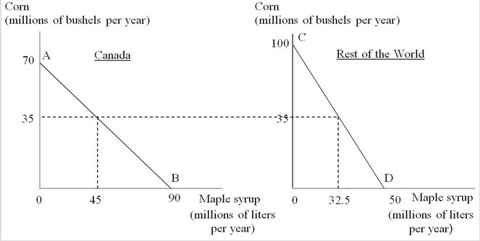
A) 9/7; two
B) 7/9; two
C) 9/7; 1/2
D) 7/9; 1/2

Answer: C
Difficulty: 2 Medium
Topic: Ricardo's Theory of Comparative Advantage
Bloom's: Understand
AACSB: Reflective Thinking
Accessibility: Keyboard Navigation

37) The figure below shows the production-possibility curves for Canada (AB) and the rest of the world (CD). The opportunity cost of producing one liter of maple syrup in Canada and in the rest of the world are ________ bushels and ________ bushels of corn, respectively.

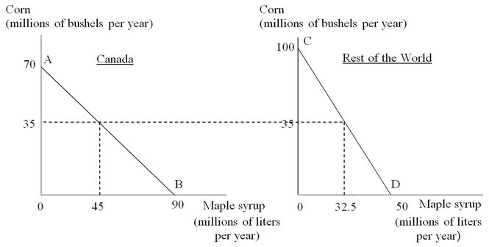
A) 9/7; two
B) 7/9; two
C) 9/7; 1/2
D) 7/9; 1/2

Answer: B
Difficulty: 2 Medium
Topic: Ricardo's Theory of Comparative Advantage
Bloom's: Understand
AACSB: Reflective Thinking
Accessibility: Keyboard Navigation

38) The following figure shows the production-possibility curves for Canada (AB) and the rest of the world (CD). Suppose Canada begins to trade with the rest of the world. If, in the international market, one bushel of corn is exchanged for one liter of maple syrup, Canada will produce ________ bushels of corn and the rest of the world will produce ________ liters of maple syrup.

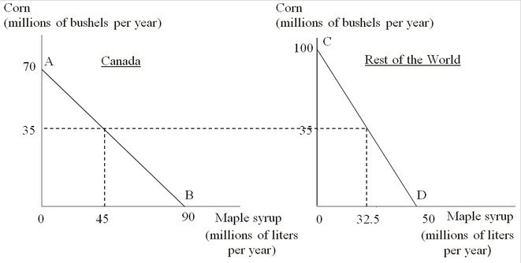
A) 35; 32.5
B) 70; 50
C) 0; 0
D) 90; 100

Answer: C
Difficulty: 3 Hard
Topic: Ricardo's Theory of Comparative Advantage
Bloom's: Apply
AACSB: Analytical Thinking
Accessibility: Keyboard Navigation

39) A bottle of wine can be produced in France with two labor hours, and in the United States with four labor hours. A pound of beef can be produced in France with one labor hour, and in the United States with ½ labor hours. Given this context, which of the following is true?
A) France has a comparative advantage in the production of beef.
B) France has an absolute advantage in the production of beef.
C) The United States has an absolute but not a comparative advantage in the production of beef.
D) The United States has both a comparative and absolute advantage in the production of beef.

Answer: D
Difficulty: 3 Hard
Topic: Ricardo's Theory of Comparative Advantage
Bloom's: Analyze
AACSB: Analytical Thinking
Accessibility: Keyboard Navigation

40) Vineland and Moonited Republic produce wine and cheese. The opportunity cost for the production of a bottle of wine in Vineland is two pounds of cheese, and in the Moonited Republic is 2.5 pounds of cheese. Based on this information, it can be concluded that
A) based on comparative advantage trade between the two countries is not possible.
B) Vineland has a comparative advantage in the production of wine.
C) Vineland has a comparative advantage in the production of cheese and Moonited has a comparative advantage in the production of wine.
D) Vineland has an absolute disadvantage in the production of both goods.

Answer: B
Difficulty: 2 Medium
Topic: Ricardo's Theory of Comparative Advantage
Bloom's: Understand
AACSB: Reflective Thinking
Accessibility: Keyboard Navigation

41) In a two-country, two-commodity model, if a country has a comparative advantage in the production of a certain good, it implies that this country
A) also has an absolute advantage in the production of this good.
B) will start importing this good from the other country.
C) can produce this good at a lower opportunity cost than the other country.
D) uses most of its resources in the production of this good.

Answer: C
Difficulty: 2 Medium
Topic: Ricardo's Theory of Comparative Advantage
Bloom's: Understand
AACSB: Reflective Thinking
Accessibility: Keyboard Navigation

42) In a two-country, two-commodity model, if a country has an absolute advantage in the production of a certain good, it implies that
A) it is not possible that this country can gain by importing this good from the other country.
B) this country also has a comparative advantage in the production of this good.
C) this country has greater resources than the other country.
D) this country has higher labor productivity in the production of this good.

Answer: D
Difficulty: 2 Medium
Topic: Ricardo's Theory of Comparative Advantage
Bloom's: Understand
AACSB: Reflective Thinking
Accessibility: Keyboard Navigation

43) Adam Smith's theory of absolute advantage is based on the labor theory of value.

Answer: TRUE
Difficulty: 1 Easy
Topic: Adam Smith's Theory of Absolute Advantage
Bloom's: Remember
AACSB: Reflective Thinking
Accessibility: Keyboard Navigation

44) Mercantilists believed that a country gains from international trade only at the expense of another country or countries.

Answer: TRUE
Difficulty: 1 Easy
Topic: Adam Smith's Theory of Absolute Advantage
Bloom's: Remember
AACSB: Reflective Thinking
Accessibility: Keyboard Navigation

45) If Country X has a higher labor productivity than the rest of the world in the production of a good, then Country X has a comparative advantage in the production of the good.

Answer: FALSE
Difficulty: 2 Medium
Topic: Adam Smith's Theory of Absolute Advantage
Bloom's: Understand
AACSB: Reflective Thinking
Accessibility: Keyboard Navigation

46) If a country does not have an absolute advantage in the production of at least one commodity, then it cannot gain from free trade.

Answer: FALSE
Difficulty: 2 Medium
Topic: Adam Smith's Theory of Absolute Advantage
Bloom's: Understand
AACSB: Reflective Thinking
Accessibility: Keyboard Navigation

47) The opportunity cost of producing a good is the additional labor cost incurred to produce an extra unit of the good.

Answer: FALSE
Difficulty: 1 Easy
Topic: Ricardo's Theory of Comparative Advantage
Bloom's: Remember
AACSB: Reflective Thinking
Accessibility: Keyboard Navigation

48) In a two-country, two-commodity model, if a country has higher labor productivity in producing both the goods, it must produce and export both the goods to the other country.

Answer: FALSE
Difficulty: 2 Medium
Topic: Ricardo's Theory of Comparative Advantage
Bloom's: Understand
AACSB: Reflective Thinking
Accessibility: Keyboard Navigation

49) In the two-country, two-commodity model, both countries can gain from trade as long as their relative advantages and disadvantages in producing different goods are different.

Answer: TRUE
Difficulty: 2 Medium
Topic: Ricardo's Theory of Comparative Advantage
Bloom's: Understand
AACSB: Reflective Thinking
Accessibility: Keyboard Navigation

50) The act of buying at a low price in one place and selling at a high price in another place is called relative pricing.

Answer: FALSE
Difficulty: 1 Easy
Topic: Adam Smith's Theory of Absolute Advantage
Bloom's: Remember
AACSB: Reflective Thinking
Accessibility: Keyboard Navigation

51) Arbitrage is the act of buying at one place and selling at another place in order to profit from the price differences that exist between the two places.

Answer: TRUE
Difficulty: 1 Easy
Topic: Adam Smith's Theory of Absolute Advantage
Bloom's: Remember
AACSB: Reflective Thinking
Accessibility: Keyboard Navigation

52) Straight-line production-possibility curves indicate that the opportunity cost of producing additional units of each good is constant.

Answer: TRUE
Difficulty: 2 Medium
Topic: Ricardos Constant Costs and the Production-Possibilities Curve
Bloom's: Understand
AACSB: Reflective Thinking
Accessibility: Keyboard Navigation

53) Briefly discuss the implications of a country operating inside its production-possibility curve. Use a graph in your discussion.

Answer: POSSIBLE RESPONSE: The production-possibility curve (PPC) shows all combinations of the amounts of different products that an economy can produce with full employment of its resources and maximum feasible productivity of those resources.

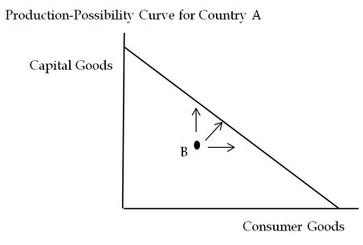

The economy of Country A (above) produces two types of goods—consumer goods and capital goods. If the economy of Country A is operating at Point B inside the PPC it is not operating at peak efficiency. This may reflect unemployment or inefficient use of resources or both. It also implies that the country could produce more of both types of goods, or more of one of the goods without foregoing any production of the other type of good.
Difficulty: 2 Medium
Topic: Ricardos Constant Costs and the Production-Possibilities Curve
Bloom's: Analyze
AACSB: Analytical Thinking
Accessibility: Keyboard Navigation

54) Briefly explain the principle of comparative advantage.

Answer: POSSIBLE RESPONSE: David Ricardo's principle of comparative advantage shows that beneficial trade can occur even if one country is worse (less productive) at producing all products. The principle of comparative advantage is based on the importance of opportunity cost—the number of units of other products that must be forgone to produce more of a particular product. The principle states that a country will export products that it can produce at low opportunity cost in return for imports of products that it would otherwise produce at high opportunity cost.
Difficulty: 1 Easy
Topic: Ricardo's Theory of Comparative Advantage
Bloom's: Remember
AACSB: Reflective Thinking
Accessibility: Keyboard Navigation

55) Briefly discuss the primary features of the mercantilist philosophy. Mention two major criticisms of the mercantilist theory as put forward by Adam Smith and other economists.

Answer: POSSIBLE RESPONSE: Mercantilist philosophy guided European thinking about international trade for several centuries before Adam Smith published the Wealth of Nations in 1776. Mercantilists considered that international trade could be a major source of benefits to a nation. They also believed that government regulation of trade was necessary to provide maximum benefits. Mercantilists emphasized the accumulation of gold and silver by a country. They believed that exports are beneficial for an economy and imports are harmful. According to them, if a country exports more than it imports then its trading partners would have to pay for their excess purchases with gold and silver. This, in turn, would increase this country's stock of gold and silver and consequently its well-being. Imports were considered to be harmful because they tended to deplete the country's stock of these precious metals. Mercantilists viewed trade as a zero-sum activity. According to them, a country can gain from free trade only at the expense of its trading partners.

Major criticisms, as pointed out by Adam Smith and other economists, include the following:

- The well-being of a country is mainly determined by its people's ability to consume products at present and in the future. Imports usually help to expand national consumption and hence need not be suppressed.
- Exports are useful because they help to pay for imports. That is, exports are what the country gives up, to get the imports that add to national consumption.
Difficulty: 2 Medium
Topic: Adam Smith's Theory of Absolute Advantage
Bloom's: Understand
AACSB: Reflective Thinking
Accessibility: Keyboard Navigation

56) Explain how a mutually beneficial trade is possible in a two-country, two-commodity model even when one of the countries has absolute advantage in the production of both the commodities.

Answer: POSSIBLE RESPONSE: In a two-country, two-commodity model, even if one of the countries enjoys absolute advantage in the production of both the goods, a mutually beneficial trade is possible between them. In such a situation, the basis for beneficial trade between the countries is the difference in opportunity costs of producing the goods in each country. According to Ricardo, in this case, a country will produce and export the good that it can produce at a lower opportunity cost compared to the other country. On the other hand, a country will import the good for which it incurs a higher opportunity cost, compared to the other country.

The following example explains how a beneficial trade takes place between two countries on the basis of comparative advantage. Assume Country A and Country B produce Good X and Good Y. Country A requires two labor hours to produce one unit of Good X and one labor hour to produce one unit of Good Y. On the other hand, Country B requires 0.5 labor hours to produce one unit of Good X and 0.75 labor hours to produce one unit of Good Y. Thus, Country B has an absolute advantage in the production of both the goods. However, a mutually beneficial trade is still possible between the countries. The opportunity cost of producing Good X in Country A is two units of Good Y, but the opportunity cost of producing Good X in Country B is only 0.67 units of Good Y. Looked at the other way, the opportunity cost of producing Good Y in Country A is 0.5 units of Good X and that in Country B is 1.5 units of Good X. Therefore, we can see that Country A has a comparative advantage in producing Good Y and Country B has a comparative advantage in producing Good X. If, in the international market, one unit of Good X is exchanged for one unit of Good Y, both the countries can gain by exporting the good in which they have a comparative advantage and importing the other good. Country A will receive one unit of Good X in exchange for one unit of Good Y under free trade as compared to 0.5 units of Good X under autarky. On the other hand, Country B will receive one unit of Good Y in exchange for one unit of Good X, as compared to 0.67 units under autarky. Therefore, both countries gain when they enter into free trade with each other.
Difficulty: 3 Hard
Topic: Ricardo's Theory of Comparative Advantage
Bloom's: Analyze
AACSB: Analytical Thinking
Accessibility: Keyboard Navigation

57) Using relevant diagrams, illustrate a two-country, two-commodity model in which one country has an absolute advantage in the production of both goods, but each has a comparative advantage in the production of only one good. Assume both countries have the same total amount of national labor to use in production in the country, and labor is the only factor of production.

Answer: POSSIBLE RESPONSE: The following figure shows the quantities of wheat and cotton that both Country A and Country B can produce in a year.
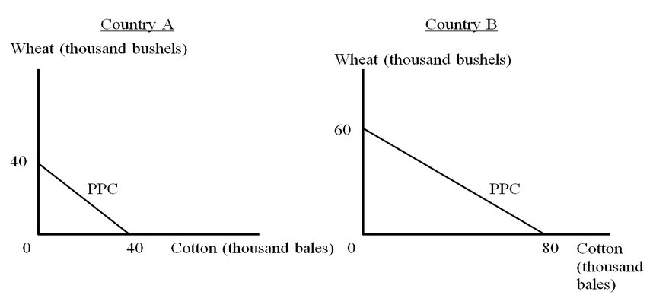

Assume countries A and B have the same national endowment of labor, and labor is the sole factor of production. From the figures, we can see that Country B has an absolute advantage in the production of both commodities, because, with the same amount of labor, Country B can produce more of each commodity (if each country were to devote all of its labor to producing only that product). However, the opportunity cost of producing wheat in Country A is 40/40=1C/W and that in Country B is 80/60 = (4/3) C/W. The opportunity cost of producing wheat is lower in Country A; hence Country A has a comparative advantage in the production of wheat. On the other hand, the opportunity cost of producing cotton in Country A is 40/40=1W/C and that in Country B is 60/80 = (¾) W/C. Therefore, Country B has a comparative advantage in the production of cotton.
Difficulty: 2 Medium
Topic: Ricardo's Theory of Comparative Advantage
Bloom's: Understand
AACSB: Reflective Thinking
Accessibility: Keyboard Navigation

58) Suppose labor productivity in France is such that one hour of labor is required to produce one gallon of wine while two hours of labor are required to produce one pound of cheese. Assuming the availability of one million labor hours, draw a constant-cost production-possibility curve for France with the quantity of cheese measured along the vertical axis and the quantity of wine on the horizontal axis. If the free-trade price of wine is two pounds of cheese per gallon, show where, with free trade, France will produce on its production-possibilities curve. Then, draw and use a trade line to illustrate how France can gain from free trade.

Answer: POSSIBLE RESPONSE:

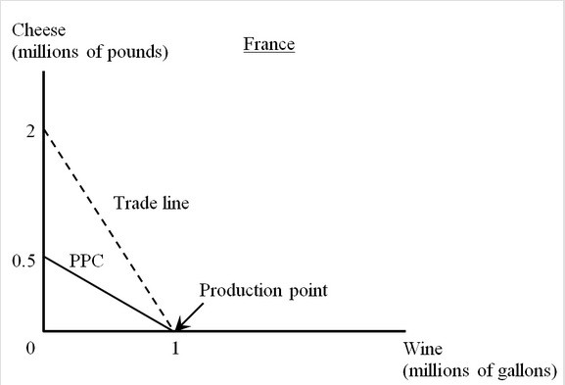

If France produces only cheese, with one million labor hours France will be able to produce half a million pounds of cheese. If France produces only wine, France will be able to produce one million gallons of wine. The production-possibility curve for France is a straight line as shown in the graph. The opportunity cost of one gallon of wine in France is half a pound of cheese. In the international market, one gallon of wine is exchanged for two pounds of cheese, which is higher than the opportunity cost of wine production in France. This implies that it will be beneficial for France to produce only wine and trade it for cheese instead of producing cheese itself. With free trade France can consume any combination of quantities of wine and cheese lying on the trade line shown in the graph. France gains from trade because these combinations lie clearly beyond France's production-possibility curve, which means they are unattainable under autarky.
Difficulty: 3 Hard
Topic: Ricardos Constant Costs and the Production-Possibilities Curve
Bloom's: Analyze
AACSB: Analytical Thinking
Accessibility: Keyboard Navigation

59) Explain how products produced by high-wage workers in the United States can compete with the products manufactured in countries whose workers earn much lower wages.

Answer: POSSIBLE RESPONSE: Assuming that comparative advantage forms the basis for international trade, the United States is expected to have a comparative advantage in a set of goods in which its productivity advantage is the largest. Although wages in the United States are higher than those in the developing nations, the United States will still have a comparative cost advantage because U.S. workers are highly productive. If the productivity advantage is large enough, the cost of manufacturing these products in the United States will be lower despite the higher wages. The United States will thus be able to successfully export these products and import the products for which it does not have a comparative advantage.
Difficulty: 2 Medium
Topic: Ricardo's Theory of Comparative Advantage
Bloom's: Understand
AACSB: Reflective Thinking
Accessibility: Keyboard Navigation

60) With the help of a suitable diagram, explain how in a two-country, two-commodity model one of the countries may fail to specialize completely despite enjoying comparative advantage in one of the goods.

Answer: POSSIBLE RESPONSE: Let us consider a two-country, two-commodity model with constant opportunity costs. Here, one of the two trading countries may fail to specialize completely only in the special case in which the international price ratio coincides with the price ratio prevailing in that country in the absence of trade. In this case, the country whose price ratio does not change is a "large" country and the other country is a "small" country. The large country continues to produce both goods under free trade because the "small" country cannot export enough to satisfy the total demand for this product in the "large" country.

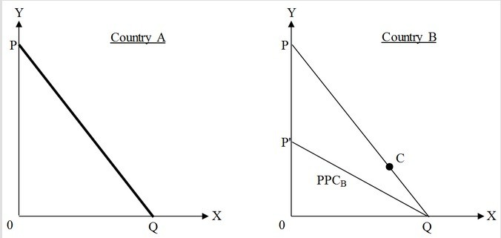

In this example Country A is the "large" country and Country B is the "small" country. PQ and P'Q are the production-possibility curves of Country A and Country B, respectively. Let the international trade line be PQ. From the graph, it is evident that Country A enjoys a comparative advantage in the production of Commodity Y and Country B enjoys the same in producing Commodity X. Since Country B is "small," it can completely specialize in Commodity X and can choose a consumption point on the international price ratio line or the trade line, say Point C. But for Country A, the trade line coincides with its PPC. This implies that there is no difference in its domestic price ratio and international price ratio. Country B is unable to export the amount needed to meet total domestic demand for Commodity X in Country A. So, Country A has to produce some of Commodity X for its own consumption, as well as producing Commodity Y and exporting some of its Commodity Y production to Country B. Therefore, in spite of having a comparative advantage in producing Commodity Y, Country A is unable to specialize completely.
Difficulty: 3 Hard
Topic: Ricardo's Theory of Comparative Advantage
Bloom's: Analyze
AACSB: Analytical Thinking
Accessibility: Keyboard Navigation

