MANA 444 – LESSON 1 - Introduction

PERFORMANCE MANAGEMENT

Performance management: the process of establishing performance goals and designing interventions and programs to develop employees and improve their performance. Signals what is important and ensures accountability. It is a comprehensive ongoing and continuous process – involves various activities and programs designed to develop employees and improve performance.

Performance Management Process
By performing activities and programs to develop employees and improve performance:
- Establishing performance goals and expectations (SMART)
- Monitoring employee performance and providing feedback
- Performance evaluation with consequences
- Employee development plans

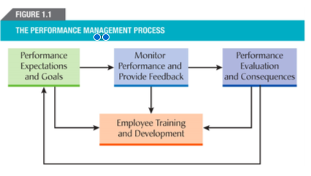

TRAINING AND DEVELOPMENT

Training: formal and planned efforts to help employees acquire KSAs to improve performance in their current job. Goal: short-term focus.

Development: formal and planned effort to help employees acquire KSAs required to perform future job responsibilities. Goal: prepare individuals for promotions and future jobs, as well as additional responsibilities and often for managerial careers (long-term focus)

Human resource development (HRD): systematic and planned activities that are designed by an organization to provide employees with opportunities to learn necessary skills to meet current and future job demands. Main functions: training and development, career development, organizational development. Core: learning.

Objective of T&D: Develop and maximize an org’s human capital + facilitate social capital

BENEFITS OF TRAINING AND DEVELOPMENT

Benefits to organizations
-Help obtain a sustained competitive advantage
-Facilitate strategy, increase effectiveness, improve employee recruitment and retention

Strategy
By linking training to an organization’s strategy, training becomes a strategic activity that operates in concert with other programs and activities to achieve an organization’s strategic business objectives.

Effectiveness
Training has been found to be more effective than other interventions. Both empowerment and extensive training were related to productivity and together they accounted for a 9 percent increase in value added per employee.

Employee recruitment and retention
Training is often used by organizations to increase their attractiveness to prospective employees and to retain current employees.

Benefits to employees
Can be categorized as internal or intrinsic to an individual, such as knowledge and attitudes, and those that are external such as salary.

Intrinsic benefits
Trained employees benefit by acquiring knowledge and skills that enable them to perform better. Positive effect on behavior and performance, they also develop greater confidence or self-efficacy. Describe feelings of increased usefulness and belonging.

Extrinsic benefits
Include such things as higher earnings as a result of increased knowledge and skills, improved marketability, greater security of employment, and enhanced opportunities for advancement and promotion.

Benefits to society

Training and development that organizations provide for their employees helps create an educated and skilled population that benefits the economy and standard of living.

Educated and skilled population
Employees report using their new skills to better manage their personal lives.

Economy and standard of living
Key to a country’s standard of living, incomes, and overall prosperity are its productivity and productivity growth. One way to improve productivity is by improving education and skills of the workforce.

TRAINING AND DEVELOPMENT IN CANADA

Canadian organizations tend to under-invest in training and development. Rank: 21 in 2006. This underinvestment might lead to a gap in essential knowledge and skills.

QC Training Law (Bill 90) Act to Foster the Development of Manpower Training 1995, companies with payrolls of $2 mil or more MUST invest a minimum of 1% of their payroll on training or pay provincial fund

Training Bond: Contract between the employer and employee that states that the employer will pay for the employee’s training as long as the employee remains with the org for a minimum period of time following completion of the training program.

THE CONTEXT OF TRAINING AND DEVELOPMENT

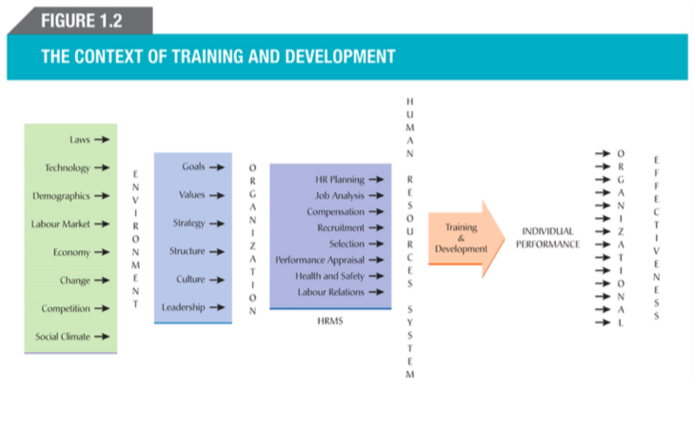

The environmental context of training and development
key factors

Global Competition
Increasing global competition has forced organizations to improve their productivity and quality of g.a.s. – which requires employees to learn new skills.

Technology
New technologies can provide organizations with improvements in productivity and a competitive advantage. Technology will lead to productivity gains only when employees receive the necessary training to exploit technology.

Labor market
Changes in the labor market and supply or labor require changes in the amount and type of training

Change
The technological revolution, increasing globalizations and competition have resulted in a highly uncertain and constantly changing environment. To survive and remain competitive, organizations must adapt and change.

Organizational context of training and development
T&D are also affected by internal events within the organization

Strategy
T&D can help an organization achieve its strategic objectives and gain a competitive advantage when it is aligned with an organization’s strategy.

Strategic human resource management (SHRM): the alignment of human resources practices with an organization’s business strategy. Greater alignment = greater performance.

Strategic training and development (ST&D): the alignment of an organization’s training needs and programs with a organization’s strategy and objectives. Training as well as other HR practices must be designed to reinforce and support their strategy.

Structure
Structure also affects T&D activities. Changes to an organization’s structure often lead to changes in employees’ tasks and responsibilities and necessitate the need for training.

Culture

Organizational culture: the shared beliefs, values and assumptions that exist in an organization.

Culture determines the norms and expected behaviors.

Human Resources System

In addition to being linked to business strategy, HR practives should also be aligned and linked to each other. 2 kind of linkages:

- HR practices should be linked to business strategy
- HR practices should be linked to each otherso they work to achieve strategy.

High performance work system (HPWS): an interrelated system of HR practices and policies that usually includes rigorous recruitment and selection procedures, performance-contingent incentive compensation, performance management, a commitment to employee involvement, and extensive training and development programs. They increase knowledge, skills, abilities, and motivation. Leads to positive attitudes, lower turnover and higher productivity.

INSTRUCTIONAL SYSTEMS DESIGN (ISD) MODEL OF TRAINING AND DEVELOPMENT

Instructional systems design (ISD) model: a rational and scientific model of the training and development process that consists of a needs analysis, training design and delivery and training evaluation. (Begins with performance gap)

critical first step is: needs analysis to determine the nature of the problem. Needs analysis consists of three levels known as organizational analysis, task analysis, and person analysis. Each is conducted to gather important information about problems and the need for training.

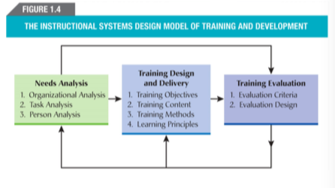

ADDIE MODEL
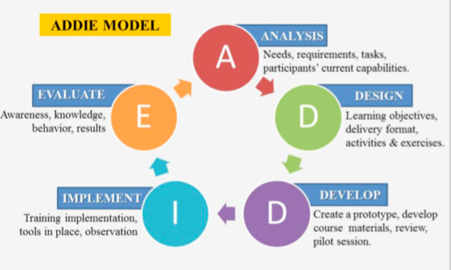
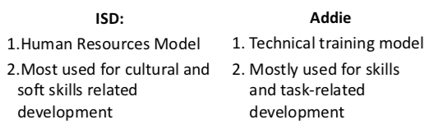

LESSON 2 – Types of Training Programs

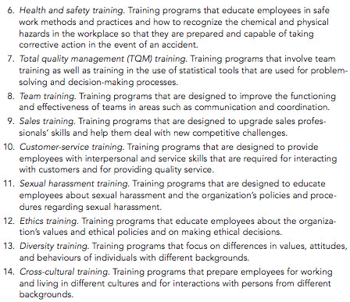
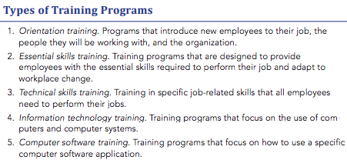

ORIENTATION TRAINING

Orientation training: programs that introduce new employees to their job, the people they will be working with, and the organizations. Formal orientation and training programs are one of the main methods used by organizations to socialize new employees.

Employees who attend orientation training programs have been found to be more socialized in terms of their knowledge and understanding of the organization’s goals and values, history and involvements with people to have higher organizational commitment. Effective orientation programs can also shape corporate culture, increase new employees, speed-to-proficiency, and lower turnover. Furthermore, a recent study on the training of new hires found that those units used to hired training program to greater extend had higher customer service performance, greater retention, and higher financial performance.

ESSENTIAL SKILLS TRAINING

Essential skills: skills required for work, learning and life. They are necessary and foundation for learning other skills and being able to adapt to workplace change. There are nine types:
- Reading text
- Document use
- Numeracy
- Writing
- Oral communication
- Working with others
- Continuous learning
- Thinking skills
- Computer use

Literacy: the ability to understand and employ printed information in daily activities, at home, at work, and in the community – to achieve one’s goals, and to develop one’s knowledge and potential.

Organizations must provide their workforces with essential skills training if they are to compete and survive in a global high-tech workplace. Evidence suggests that without first providing trainees with essential skills training, other programs and initiatives will not succeed.

Benefits of Essential skills training:
-Improvements in productivity and quality
-Decrease in absenteeism, turnover, damages, and workers compensation claims
-Improvement in cross-cultural communication and morale
-Attractive ROI
For employees: improves confidence, skills, career opportunities, job security

TECHNICAL SKILLS TRAINING

Technical skill training: training in specific job-related skills that all employees need to perform their jobs. Among manufacturing firms, training for specific job skills is the most frequent type of training provided. With increasing global competition, organizations have had to find new ways to stay competitive and to survive, often by adopting new technologies and ways to stay competitive and to survive, often by adopting new technologies and the redesign of work arrangements and systems. As a result, employees have had to undergo a considerable amount of technical skills upgrading and training.

Non-Technical skills training: Training in a variety of skills that employees require to work and interact with others such as communication skills, interpersonal skills, and negotiation skills.

INFORMATION TECHNOLOGY TRAINING

Information technology training: refers to computers and computer systems training. Information systems training is a key factor in the successful implementation of information systems technology. Research has shown that technological failures in the workplace are most often the result of training issues rather than the technology.

Information technology training usually involves either introductory computer training programs in which trainees learn about computer hardware and software, or applications training in which trainees are instructed on specific software applications to be used within the organization. Applications training is required whenever an organization upgrades its computer systems.

Computer software training: Training programs that focus on how to use a specific computer software application. It is one of the most common types of information technology. It has been shown to increase trainee’s ability to use the system and their motivation to use the software.

HEALTH AND SAFETY TRAINING

Health and safety training: training programs that educate employees in safe work methods and practices and how to recognize the chemical and physical hazards in the workplace so that they are prepared and capable of taking corrective action in the event of an accident.

Workplace Hazardous Materials Information System (WHMIS): legislation to ensure that workers across Canada are aware of the potential hazards of chemicals in the workplace and are familiar with emergency procedures for the clean-up and disposal of the spill.

An important component of WHMIS legislation is employee training. Training in WHMIS is designed so that employees can identify WHMIS hazard symbols, read WHMIS supplier and workplace labels, and read and apply the information on material safety data sheets (MSDS), which outline the hazardous ingredient(s) in a product and the procedures for the safe handling of that product.

Research on safety training has found that it can have a significant positive effect on employee learning (i.e., safety knowledge) and safety performance. However, the effectiveness of safety training depends on the training method and the severity of exposure to workplace hazards. Safety training that involves the use of highly engaging instructional methods (e.g., behavioural modelling, simulations, hands-on training) is more effective for both learning and safety performance than less engaging instructional methods (e.g., lectures, films, reading materials, and video-based training). This is especially the case when the training is for work situations that involve high exposure to hazardous conditions that could result in severe illness, injury, or death.

TOTAL QUALITY MANAGEMENT TRAINING

Total quality management training: a systematic process of continual improvement of the quality of an organization’s products and services. In addition to an emphasis on quality and continual improvement, TQM also involves teamwork and a customer focus.

TQM places the training function in a pivotal position, as the process often requires significant changes in employees’ skills and the way employees work

Total quality management training: training programs that involve team training as well as training in the use of statistical tools that are used for problem-solving and decision-making processes. TQM advocates emphasize the importance of training and development. Training and development is the primary method of reinforcing employee commitment to the consistent delivery of high-quality products and services.

TEAM TRAINING

Team training: training programs designed to improve the functioning and effectiveness of teams in areas such as communication and coordination, compensatory behaviour, mutual performance monitoring, exchange of feedback, and adaptation to varying situational demands.

BOTTOM AND BALOFF: team training is an attempt to improve a group’s process through the use of interventions targeted at specific aspects of the process such as effective communication. Group processes are usually the focus of team training; however, because team members are often expected to perform a variety of the group tasks, they often must also receive technical training to become multi-skilled.

Team training focuses on two general types of skills:
Task-work skills: refers to skills that are required to perform the team’s tasks
Teamwork skills: skills that team members require in order to interact, communicate, and coordinate tasks effectively with other team members.

Both types of skills must be able to included in team training programs, and it is recommended that team members first master task-work and technical skills before they are trained on teamwork skills.

Positive Effects: 1) Cognitive outcomes (ex: declarative knowledge)
2) Affective outcomes (ex: trust)
3) Teamwork processes (ex: Communication)
4) Performance outcomes (efficiency and effectiveness)

SALES TRAINING

Sales training: training programs that are designed to upgrade sales professionals’ skills and help them deal with new competitive challenges.

At the centre of these new training initiatives is an emphasis on “relationship-based” sales training. Sales professionals are being trained to develop more strategic and complex relationships with clients, and to create relationships across client functions. They are also being trained to become knowledgeable about their customers’ business needs, and to develop customized sales strategies.
Without follow-up, salespeople will lose up to 90% of what they learned within a month

CUSTOMER-SERVICE TRAINING

Customer-service training: training programs that are designed to provide employees with interpersonal and service skills that are required for interacting with customers and for providing quality service. The training can be either informal or formal. Informal training might involve pairing new hires with the organization’s best employees in terms of customer-service behaviour and philosophy. The kind of formal training required will depend on the type of service business that an organization is in and its service strategy. In other words, the training program must be tailored to an organization’s strategy and characteristics as well as its customers.
Service employees must have both the ability and motivation to perform effectively. Because you cannot always hire people with the required abilities or motivation, you must be able to train them. Many organizations that have reputations for superb customer service are successful because of their commitment to training. Organizations that provide the best service also provide the most training.

SEXUAL HARASSMENT TRAINING

Sexual harassment: unwelcome sexual advances, requests for sexual favours and verbal or physical conduct of a sexual nature that is a condition of employment, interferes with work performance, or creates a hostile work environment.

Sexual harassment training: training programs that are designed to educate employees about sexual harassment and the organization’s policies and procedure regarding sexual harassment.
The most effective way for organizations to prevent sexual harassment is to develop policies and procedures for filing complaints and providing training.

The most practical way to prevent harassment is to implement a training program and develop policies and procedures for filing complaints. Provide mandatory annual training.
Management should undergo SEPARATE training on how to deal w complaints + include bystander intervention, usually done in workshops or small discussions.

ETHICS TRAINING

Ethics training is important for creating an ethical culture and workplace, and for attracting and retaining the right type of employee.

Ethics training: programs that educate employees about the organization’s values and ethical policies and on making ethical decisions. This usually involves opportunities for employees to practice company values and its code of ethics to hypothetical situations.

It is important that ethics training programs go beyond ethical guidelines and focus on how to effectively recognize and respond to common ethical problems in the workplace. As a result, employees learn to recognize ethical dilemmas and how to respond to them.

To be most effective, ethical training programs must be mandatory for all employees and include a copy of the organization’s code of ethics, a discussion of relevant compliance laws, an ethical decision-making model, resources for help, and role-playing scenarios. Organizations should first set standards for ethical behaviour and determine what the training should accomplish. Key elements of strong ethical programs are responsibility, respect, fairness, honesty, and compassion. Employees should be trained on the laws that apply to their jobs as well as decision-making models with questions they can ask themselves to help them make ethical decisions. Employees should also be taught how to report ethics violations and where they can go for assistance. Practical scenarios should be included in the training so employees can test their ethical knowledge. Ethical topics can include workplace romance, email appropriateness, Internet use, confidentiality, security, and harassment (physical, verbal, and emotional).

DIVERSITY TRAINING

One of the most common and effective ways for organizations to manage diversity.

Diversity training: programs designed to address the differences in values, attitudes and behaviour of individuals with different backgrounds. The objectives are to increase awareness and understanding cultural diversity, and to improve interaction and communication among employees with different backgrounds and between employees and the organization’s customers/clients.

Diversity training is reported to be one of the most widely used strategies for managing diversity in the workplace and there has been a dramatic rise in diversity training programs in the last decade. It has three main objectives:
- Increase awareness about diversity issues
- Reduce biases and stereotypes
- Change behaviours to those required to work effectively in a diverse workforce.
Some diversity training programs are designed to change people’s attitudes by creating an awareness of diversity and an understanding of differences in values and behaviours. The expectation is that, by creating awareness and understanding of these differences, people will change their behaviour and overcome any stereotypes they might hold. Another approach to diversity training is to change behaviour. This approach emphasizes learning new behaviours that might then lead to changes in attitudes.

CROSS-CULTURAL TRAINING

Cross-cultural training: training programs that prepare employees for working and living in different cultures and for interactions with people from different backgrounds.

Training rigor: a critical factor in the success of cross-cultural training. It refers to the degree of mental involvement and effort that must be expended by the trainer and trainee in order for the trainee to learn the required concepts. It also refers to the length of time spent on training.

Cross-cultural training programs that are considered to have a high degree of rigour include interactive language training, cross-cultural simulations, and field trips. Programs with a moderate degree of training rigour include role-plays, cases, and survival-level language. Cross-cultural training programs that are considered to be the lowest in terms of training rigour include lectures, films, books, and area briefings. More rigorous cross-cultural training programs require trainees to be much more active and involved in practising cross-cultural skills.

The degree of cross-cultural training rigor required by an expatriate for a particular foreign assignment depends on three dimensions: cultural toughness, communication toughness, and job toughness.
- Cultural toughness refers to how difficult it is to adjust to a new culture. Generally speaking, cultural toughness will increase the greater the difference or distance between one’s own culture and the foreign culture.
- Communication toughness is a function of the extent to which the expatriate will have to interact with the locals of the host country. When an expatriate will be required to have frequent interactions with host nationals that will involve face-to-face, two-way, and informal communication, the level of communication toughness will be high, and more rigorous communication training will be required.
- Job toughness refers to how difficult the tasks will be for the expatriate compared to what he/she is used to doing. If the expatriate will be working in a new area and the demands of the job will be different and require new responsibilities and challenges, then the degree of job toughness will be greater. As a result, the expatriate will require more rigorous job-specific training.

As the levels of these three dimensions increase, the type of cross-cultural training required will need to be more rigorous. In addition to pre-departure training, it is also important that the expatriates and their families also receive follow-up or in-country cross-cultural training in the host country.50 Research on the effectiveness of cross-cultural training has found that it is effective for enhancing one’s success on overseas assignments and is related to expatriate adjustment and performance. However, the effectiveness of cross-cultural training depends on a number of factors such as the timing of the training and the cultural differences between one’s own country and the assignment country.

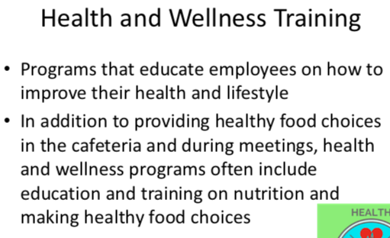
LESSON 3
WHAT IS LEARNING

Learning: the process of acquiring knowledge and skills. And a change in individual behavior as a result of some experience. It is the result of experiences that enable one to exhibit newly acquired behaviors. When a behavior has been learned, it can be thought of as a skill.
1)Knowledge 2)Skills 3)Behavior

Workplace learning: the process of acquiring job-related knowledge and skills through both formal training programs and social interaction among employees.
- 70-20-10 Model (on the job, relationships/interactions, formal learning)

Informal learning: learning that occurs naturally as part of work and is not planned or designed by the organization. It is spontaneous, immediate and task specific.

Formal learning: learning that is structured and planned by the organization.

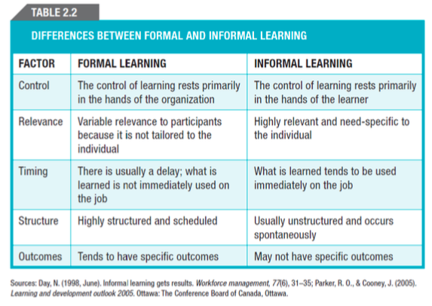

Gagne: Five categories of learning outcomes:
- Verbal information: facts knowledge, principles, and packages of information, or what is known as declarative knowledge
- Intellectual skills: concepts, rules, and procedures that are known as procedural knowledge. Procedural rules govern many activities in out daily lives such as driving and automobile or shopping.
- Cognitive strategies: the application of information and techniques, and understanding how and when to use information and knowledge.
- Motor skills: the coordination and execution of physical movements that involve the use of muscles.
- Attitudes: preferences and internal states associated with one’s beliefs and feelings. Attitudes are learned and can be changed. However, they are considered to be the most difficult domain to influence through training.

Adaptive Character of Thought (ACT) theory: learning takes place in three stages that are known as declarative knowledge, knowledge compilation, and procedural knowledge or proceduralization

Resource allocation theory: individuals possess limited cognitive resources that can be used to learn a new task.

Three stages of learning:
- The first stage – declarative knowledge: involves learning knowledge, facts, and information. One must devote all of its attention and cognitive resources to the task of learning. Performance is resource dependent – all the attention and cognitive resources are required to learn the task.
- The second stage – knowledge compilation: involves integrating tasks into sequences to simplify and streamline the task. The learner acquires the ability to translate the declarative knowledge acquired in the first stage into action. Performance is faster and more accurate. Attention requirements are lower, performance is still somewhat fragmented.
- The final stage – procedural knowledge: the learner has mastered the task and performance is automatic and habitual.

ACT recognizes the fact that learning is a sequential and stage-like process that involves three important stages. It recognizes that different types of learning take place at different stages, and motivational interventions might be more or less effective depending on the stage of learning.
Speed of acquisition, requirements different for earlier vs later stages.

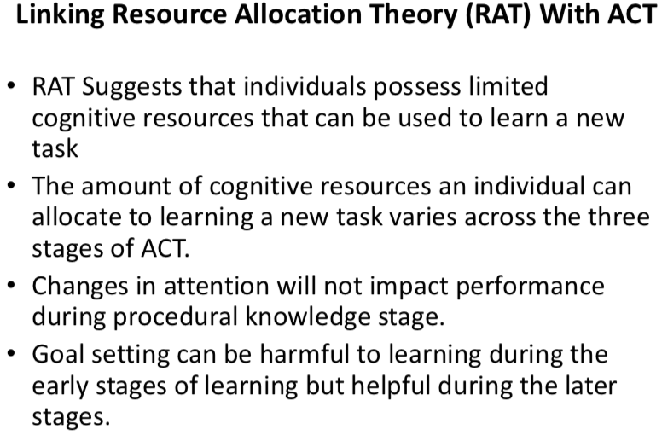

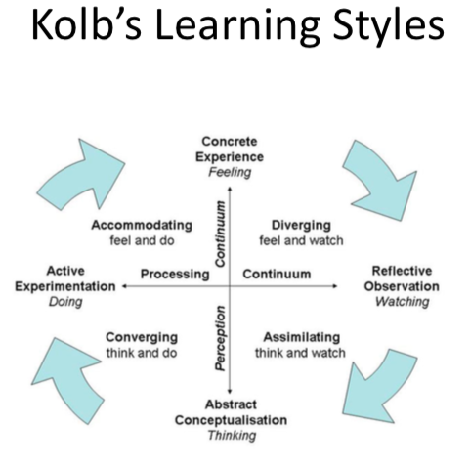
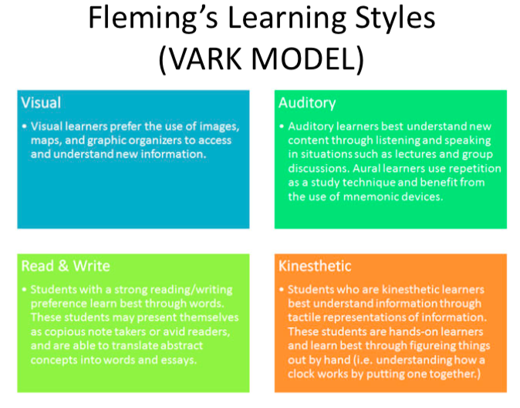
LEARNING THEORIES

Conditioning theory (Skinner)

Learning is a relatively permanent change in behavior in response to a particular stimulus or set of stimuli. It is a result of reward and punishment.

>Positive reinforcement: application of something positive following to a desired response
>Negative reinforcement: removal of a stimulus after an undesired action
>Punishment: application of negative consequence in response to undesired action

Conditioning process
Involves linking desired behavior to pleasurable consequences. Accomplished through three connected concepts:
- Shaping: the reinforcement of each step in a process until mastered, the WD the reinforcer until next step is mastered.
- Chaining: the reinforcement of entire sequences of a task
- Generalization: conditioned response occurs in circumstances different from those during learning
Social cognitive theory

Social learning: learning through interactions with others – can be formal or informal.

Observation
Learning by observing the actions of others and their consequences. If the person being observed is credible and knowledgeable, their behavior is more likely to be imitated. The imitation will occur particularly if the role model is rewarded for the behavior. Four key elements:
- Attention
- Retention
- Reproduction
- Reinforcement

Self-efficacy
Beliefs that people have about their ability to successfully perform a specific task. It is a cognitive belief that is task-specific. Influences by four sources of information (in order of importance):
- Observation
- Verbal persuasion
- Social influence
- One’s physical/emotional state

Self-regulation
An individual’s behavior is regulated by external agents who administer reward and punishment.

Self-regulation: managing one’s own behavior through a series of internal processes. Enables people to structure and motivate their own behavior through the use of internal processes – these involve observing and monitoring one’s own behavior (self-monitoring) as well as the behavior of others.

Self-regulation prompts: asking trainees questions about their learning, goals and goal progress to encourage self-regulation during training.

- Set goals
- Develop learning strategy
- Focus on learning
- Monitor learning outcomes
- Modify

Adult Learning Theory

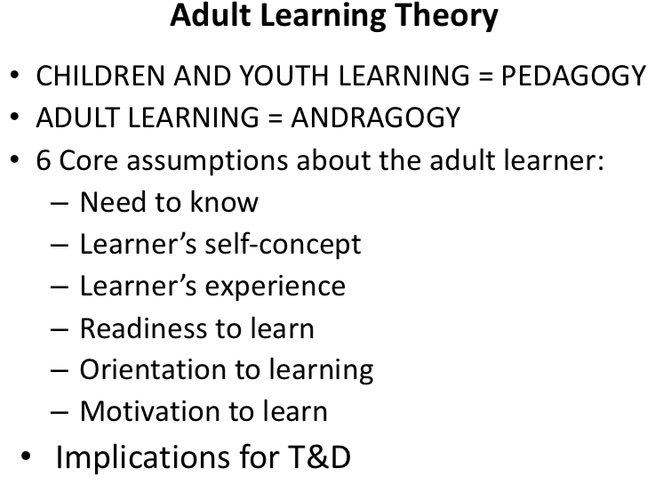
Input in training, design, and delivery and evaluation
+ Climate for learning

How is Motivation defined?
- Intensity – how hard the person tries
- Direction – what a person is trying to accomplish
- Persistence – how long they try

Goal Setting Theory
A goal is the object/aim of an action, they direct and motivate behavior
Requirements;
-Specific: level & time frame
-Challenging: stretch to increase motivation
-Supported by feedback: Know how you are doing
-Commitment: to support motivation

SMART goals: specific, measurable, achievable, realistic, time bound

Distal goal: long term or end goal (distant)
Proximal goal: Short-term goal or sub-goal that is instrumental for achieving a distal goal (especially important for complex tasks)

