ANALYSIS OF MEASUREMENTS AND MOTION

PHY1121

Prof: Z. Stadnik, and M. Wong

TA: Erin. F, and Pedram

September 30th, 2020

1)Distance Running
Q:1.a) Based on the data shown in table 1, student 1 would be the stronger runner. This is based solely on the fact that they were able to finish all 6 laps a minute faster than student 2 while they also had a faster average time/speed per lap as shown in calculation 1.a/1.c).

C:1.a) t_{av(1)}= (total time)/ (number of laps) t_{av(2)}= (total time)/ (number of laps)
= 333s/ 6 = 393/ 6
= 55.5s = 65.5s
C:1.b) s₍₁₎= = √ [(𝑥1 − 𝑥̅) 2 + (𝑥2 − 𝑥̅) 2 + ⋯ + (𝑥𝑛 − 𝑥̅) 2]/ (n-1)
= 3.271
s₍₂₎= √ [(𝑥1 − 𝑥̅) 2 + (𝑥2 − 𝑥̅) 2 + ⋯ + (𝑥𝑛 − 𝑥̅) 2]/ (n-1)
= 3.332
SE₍₁₎=𝑠/√n SE₍₁₎=𝑠/√n
= 1.335 = 1.360
Table 1:
“Lap times, standard deviation, and standard error for two students running on an indoor track”
 | Time  (Lap 1)  (s) | Time  (Lap 2)  (s) | Time  (Lap 3)  (s) | Time  (Lap 4)  (s) | Time  (Lap 5)  (s) | Time  (Lap 6)  (s) | Standard Deviation | Standard Error
Student 1 | 55 | 57 | 50 | 56 | 55 | 60 | 3.271 | 1.335
Student 2 | 64 | 64 | 64 | 68 | 71 | 62 | 3.332 | 1.360

C:1.c) V_{av(1)}= Δd/ t V_{av(2)}= Δd/ t
= 2400m/ 333s = 2400m/ 393s
= 7.207 m/ s = 6.107 m/ s
C:1.d) Vav(1)= 1/ tav Vav(2)= 1/ tav
= 1/ 0.1378 = 1/ 0.1659
= 7.257 m/s = 6.028 m/s

Q:1.b) %Difference₍₁₎= |(value 1- value 2)/ (1/2)(value 1+ value 2)| x 100%
= |(7.257-7.207)/(1/2)(7.257+7.207)| x 100%
= 0.691%
%Difference₍₂₎= |(value 1- value 2)/ (1/2)(value 1+ value 2)| x 100%
=|(6.028- 6.107)/(1/2)(6.028+ 6.107)| x 100%
= 1.302%
In my opinion, I do agree that the values of speed agree with each other. As shown from the above calculation, each value was approximately within a 1% difference of the accepted value which is not the largest difference when looking at how fast each runner was running.

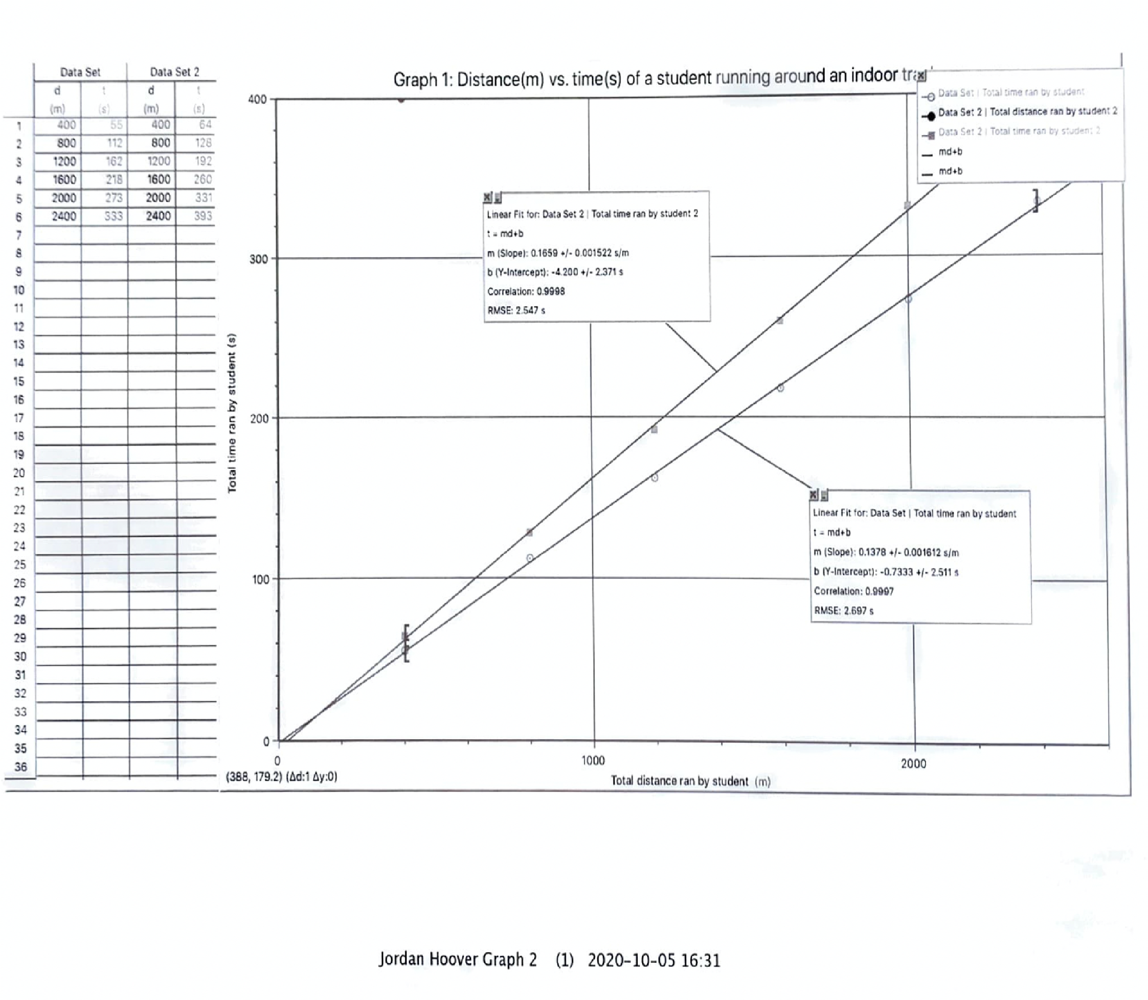
Graph 1:

track

2)Projectile Motion
C:2.a) R_{av(25º)}= (R₁+R₂…+R₅)/ 5
= (1.585+ 1.575+ 1.58+ 1.595+ 1.57)/ 5
= 1.581 m
R_{av(35º)}= (R₁+R₂…+R₅)/ 5
= (1.945+ 1.935+ 1.935+ 1.95+ 1.945)/ 5
= 1.942 m Rav(45º)=(R1+R2…+R5)/ 5
=(2.065+ 2.055+ 2.055+ 2.075+ 2.075)
= 2.065 m Rav(50º)=(R1+R2…+R5)/ 5
= (2.02+ 2.035+ 2.035+ 2.02+ 2.03)/ 5
= 2.028m Rav(60º)=(R1+R2…+R5)/ 5
= (1.795+ 1.79+ 1.77+ 1.79+ 1.79)/ 5
= 1.787m Rav(70º)=(R1+R2…+R5)/ 5
= (1.325+ 1.325+ 1.325+ 1.32+ 1.325)/ 5
= 1.324m

C:2.b) g_{exp}= (V_{o})²/ slope
= (4.50)²/ 2.068
= 9.79m/s²

Q:2) %Error= |(accepted- experimental)/ (accepted)| x 100%
= |(9.81- 9.79)/ (9.81)| x 100%
= 0.204%

C:2.c)i) t_{h}= (V_{o}sinθ)/ g ii) h= ((V_{o})²(sin²θ))/ 2g
= (4.50 x sin60)/ 9.81 = ((4.50)²(sin²(60))/ (2(9.81))
= 0.397s = 0.774m [Up]
iii) R= ((V_{o}²)sinθ)/ g = ((4.50)²sin60)/ 9.81
= 1.788m [Forward]

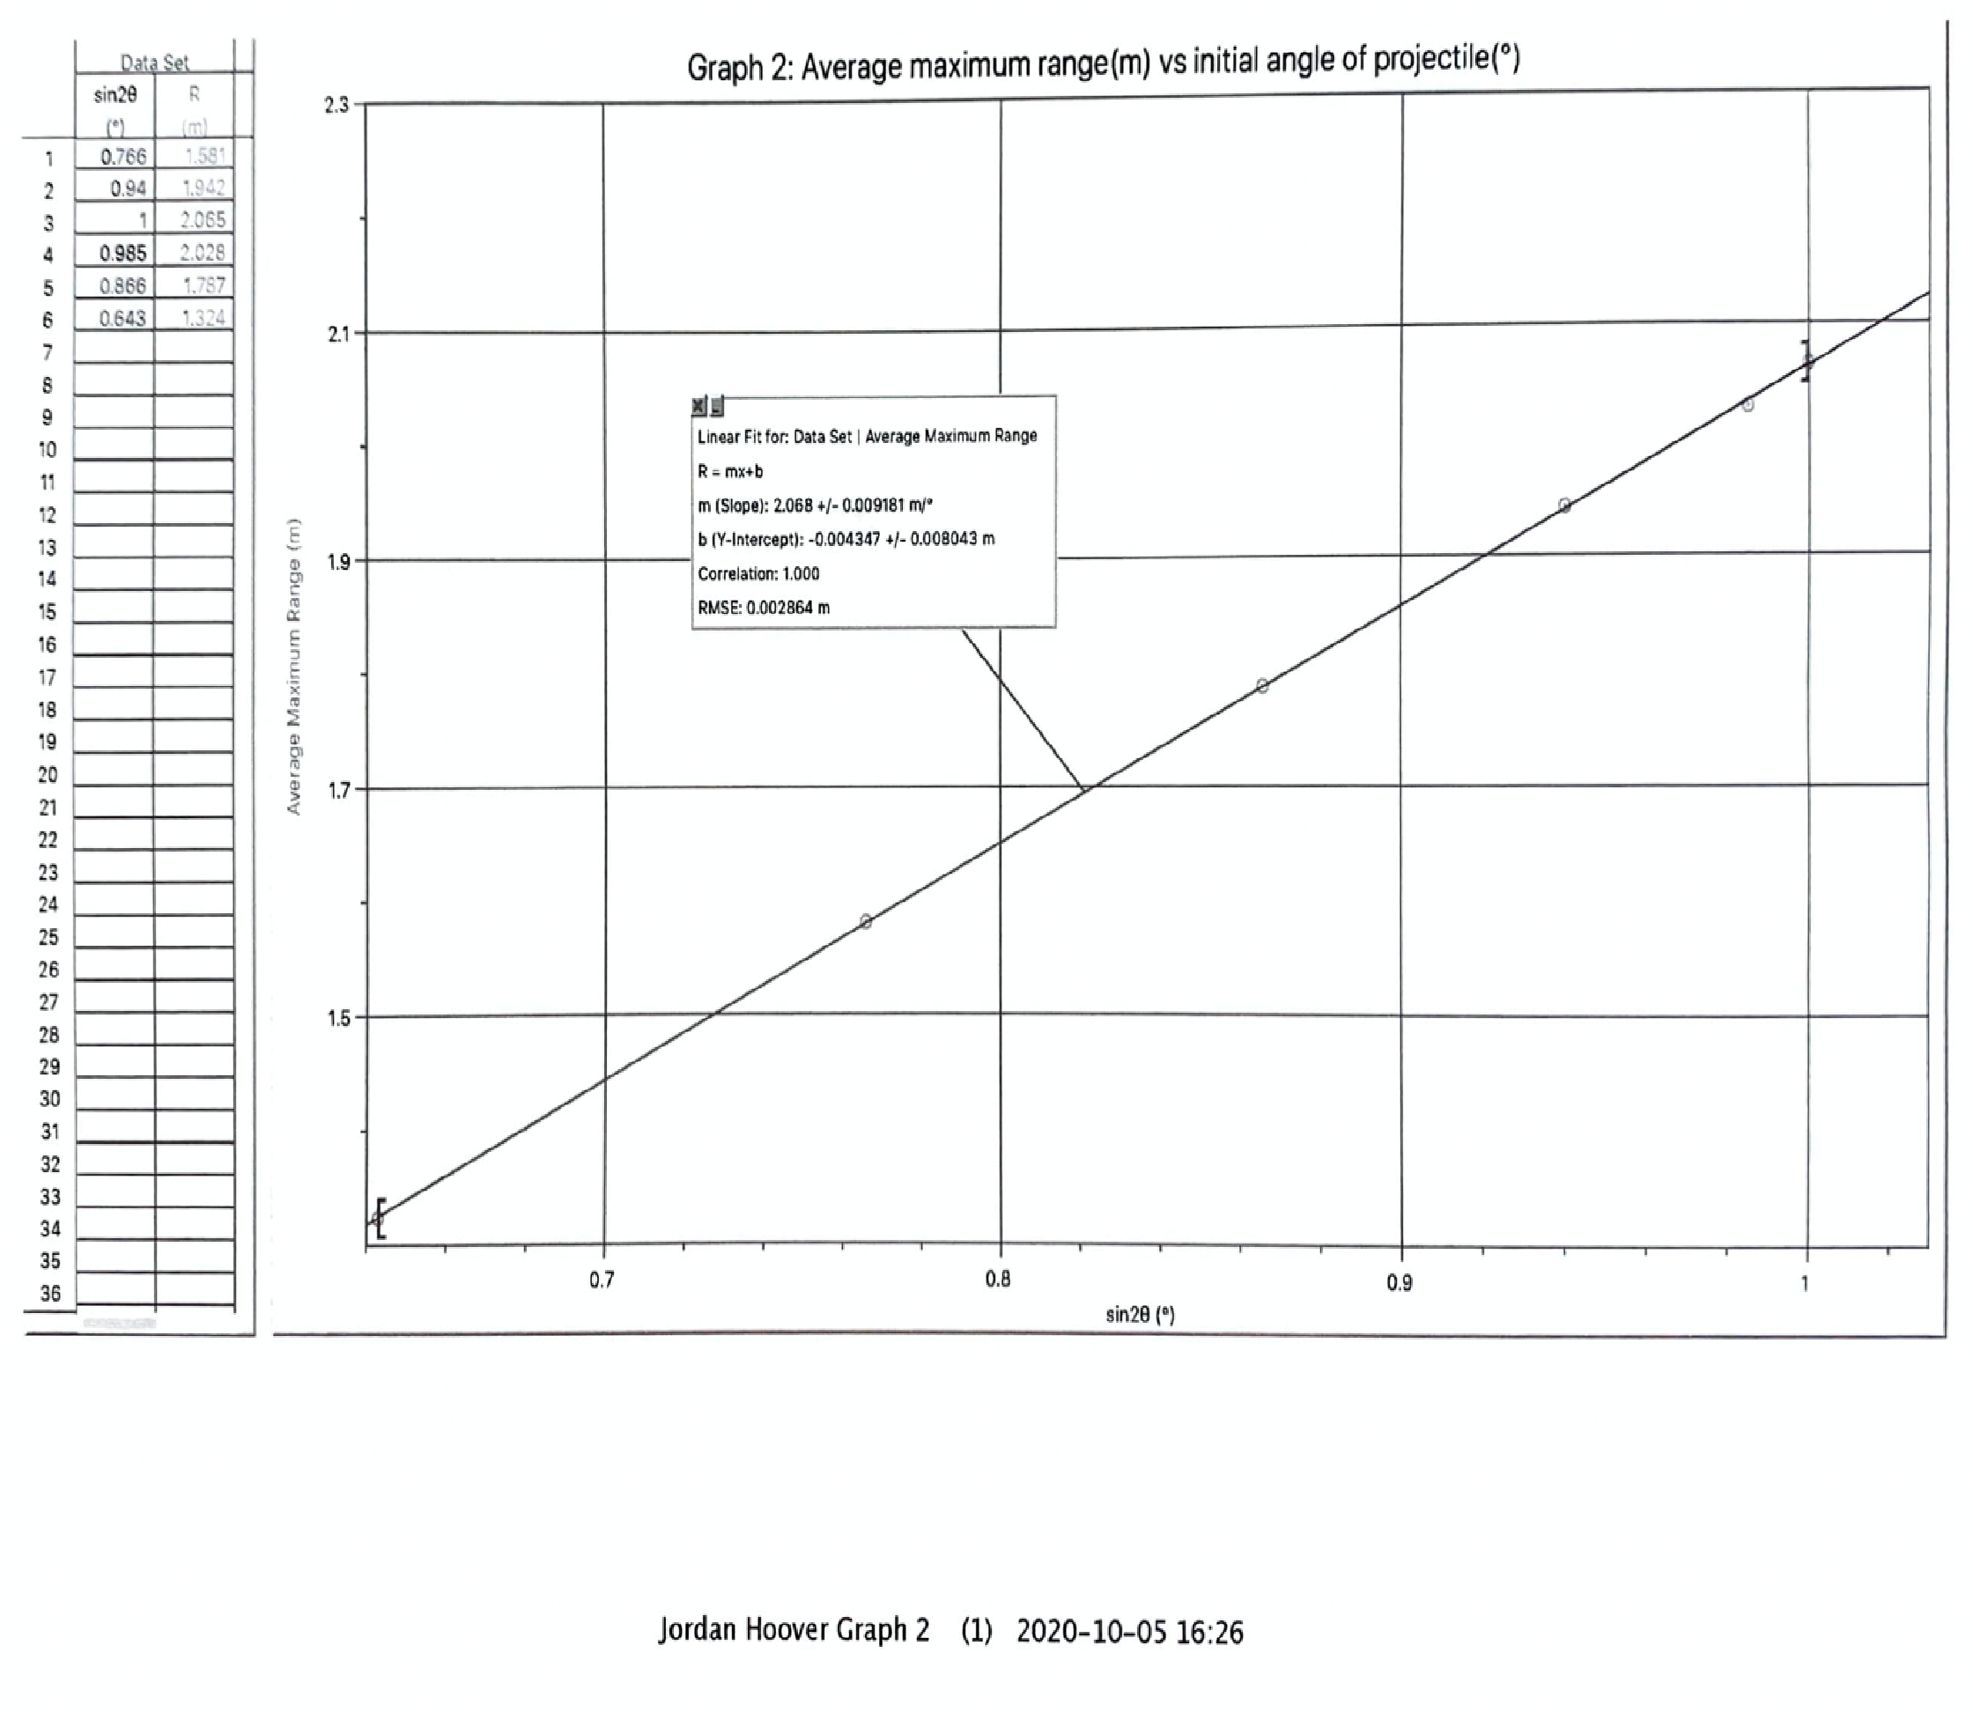
Graph 2:

3)Ferris Wheels
C:3.a) r₍₁₎= (0.3048 x (ft))/ 2 r₍₂₎= (0.3048 x (ft))/ 2
=(.3048(36.0))/ 2 =(.3048(28.0))/ 2
= 5.486m = 4.267m
C:3.b) T_{av(1)}= (t₁+ t_{2...}+t₅)/ 5 T_{av(2)}= (t₁+ t_{2...}+t₅)/ 5
= (16+ 16.5+ 16+ 17+ 17)/ 5 = (13+ 14+ 14+ 12.5+ 15)/ 5
= 16.5s = 13.7s
Uncertainty= ±0.5s Uncertainty= ±1.3s

C:3.c) V_{av(1)}= 2πr/ T V_{av(2)}= 2πr/ T
=2π(5.486)/ 16.5 = 2π(4.267)/ 13.7
= 2.089m/s = 1.957m/s ac(1)= 4π2r/ T2 ac(2)= 4π2r/ T2
= 4π2(5.486)/ (16.5)2 = 4π2(4.267)/ (13.7)2 = 0.796m/s2 = 0.898m/s2

Q:3) Wheel operator #2 was correct when stating that their wheel provided a bigger thrill for their riders. Although the diameter of the wheel may have been smaller, it is shown in the above calculations, that the acceleration of wheel two was higher by approximately 0.102m/s² in a time difference of approximately 2.8 seconds, meaning that it would feel as if the wheel were to be accelerating at a speed that makes quite the difference on such a large scale over the course of a smaller amount of time.

