Topic #1
Anatomical Terms
(pp.13-20)

Anatomical terms

Standard Anatomical position: Initial reference point to descried body parts/positions accurately:
- Body erect
- Feet slightly apart
- Face facing forwards
- Palms facing forward with thumbs
- Pointing away from body

Directional terms: used to descried one body structure in relation to another body structure.
- Direction is always based on standard anatomical position
- Right and left refer to the body viewed (patient/cadaver), not the observer.

Directional Terms

Anterior (ventral): Toward or at the front

Posterior (dorsal): Toward or at the back

Superior (cranial): Toward the head or upper part

Inferior (caudal): Away from the head or toward the lower part

Lateral: away from midline

Medial: toward or at midline

Intermediate: between a more medial and a more lateral structure

Proximal: closer to the origin or point of attachment to the body

Distal: Away from origin or point of attachment to the body

Superficial (External): towards the surface

Deep (Internal) Away from surface

Regional terms

There are two fundamental divisions of body

- Axial
  - Head
  - Neck
  - Trunk

- Appendicular
  - Limbs
  - Pelvic bones
  - Clavicle and scapula
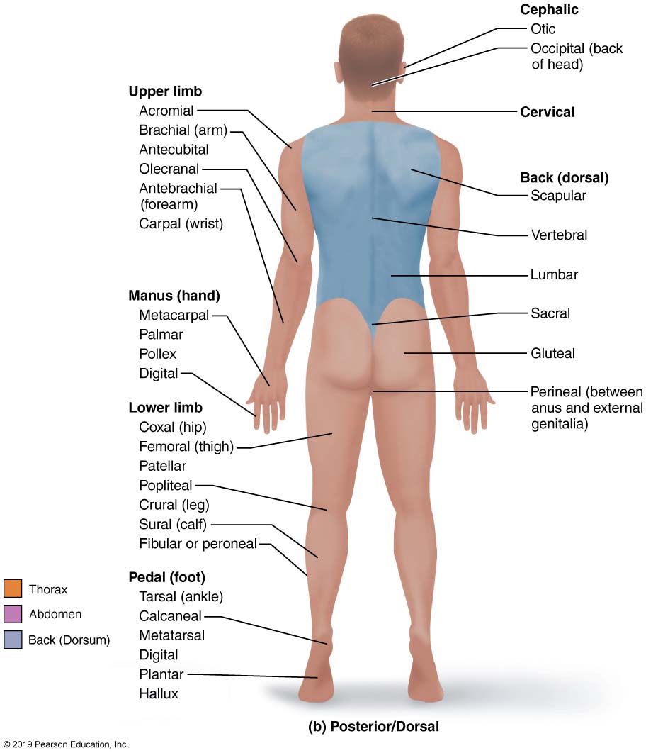

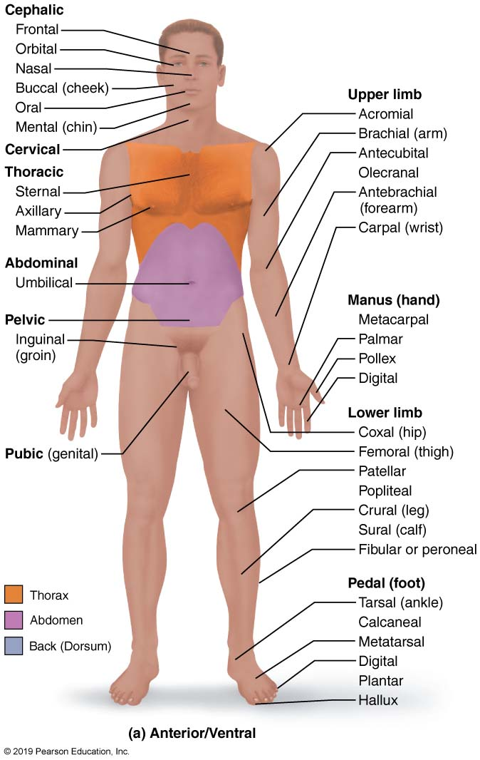

Cephalic thoracic

Body Planes and Sections

Body planes

- Surfaces along which body or structures may be cut for anatomical study

- 3 most common plans: 2 are vertical and 1 is horizontal

  - Sagittal plane
  - Frontal (coronal) plane
  - Transverse (horizontal) plane

Sections

- Cuts or sections made along a body plane
  - Named after plane, so a sagittal cut results in a sagittal section

- Sagittal plane

- Vertical plane
- Divides body into right and left parts
- Produces a sagittal section if cut along this place

Why not right and left halves? What is a midsagittal or median plane? What is a parasagittal plane?

- Midsagittal (Median) planes: Sagittal plane that is exactly on the midline.
- Parasagittal plane: Cut was off-centered, not on midline.

- Frontal (coronal) plane:
Vertical plane that divides the body into anterior and posterior parts

- Transverse (horizontal) plane:
Divides body horizontally into superior and inferior parts
- Produces a cross section

Oblique section
- Result of cuts at angle other than 90 degrees to vertical plane

What is the content and boundaries of each cavity?

Body Cavities and Membranes
Two sets of cavities
- Dorsal body cavity
- Ventral body cavity

- Dorsal body cavity:

- Cranial cavity
  - Contains the brain and enclosed by the skull
- Vertebral (spinal) cavity:
  - Contains the spinal cord and enclosed by the vertebral column

Both cavities are continuous and well protected.

- Ventral body cavity:
Larger; houses the viscera

- Thoracic cavity: subdivided into:
  - 2 lateral pleural cavities: surround lungs
  - Central pericardial cavity: enclose heart
- Abdominopelvic cavity: subdivided into
  - Superior abdominal cavity: contains stomach, intestines, spleen, liver
  - Inferior pelvic cavity: houses urinary bladder, reproductive organs, rectum

Test your self

Q: What structure separates the thoracic and abdominopelvic cavities?? The abdominal and pelvic cavities??
The diaphragm separated the thoracic and abdominopelvic cavities.

Q: In which body cavity do the organs receive the least protection from physical trauma??
Organs in the abdominal cavity receive less protection

Right hypochondriac region Epigastric region left hypochondriac region

Right lumbar region umbilical region Left lumbar region

Right iliac (inguinal) region hypogastric (pubic) region Left iliac (inguinal) region

