Seline Knight
3000157689

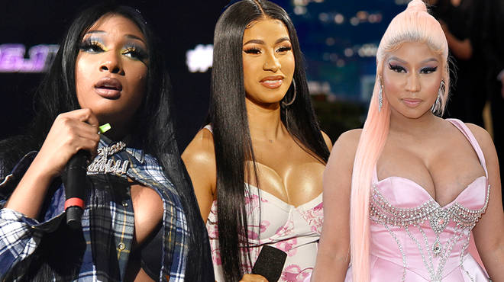
Popularity and Controversy, the rise of female rappers

Rap is a type of popular music genre that allows people to express themselves in a manner in which words are recited rhythmically over a pre-recorded backing. For the past decade, the number of successful female rappers has significantly increased in that industry that is male dominated. The current leading ladies of the genre are Nicki Minaj, Cardi B and Meg Thee Stallion. Although these women are successful and talented, other than being celebrated for the music, they seem to always trend when they’re involved in controversial events that are often related to their personal lives or each other (as indicated in the chart below).
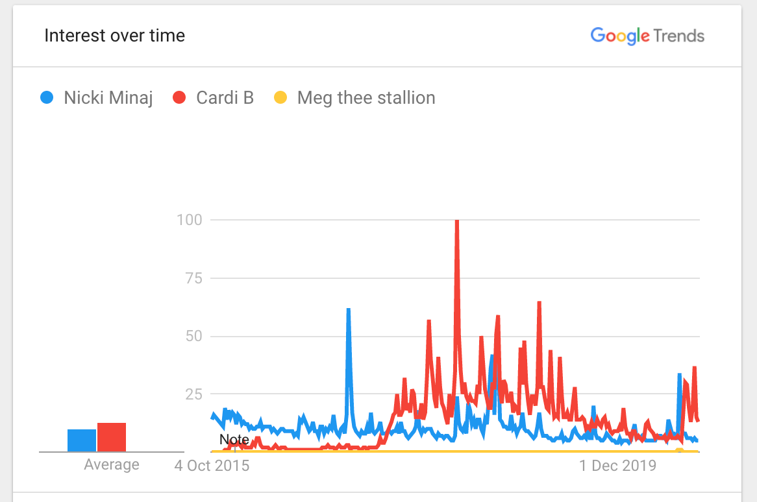
Compared to the other two, Meg as only gained in popularity in the past three years as she is relatively to the industry.

Click to view an interactive Google Trend chart comparing search volume for Nicki Minaj, Cardi B, and Meg thee Stallion (2015-2019)

- As shown in the graph, Cardi B has been the most popular in the world for the past year, with Nicki Minaj following right behind her. Nonetheless, they appear in each other’s related queries a lot.
- Relative popularity of the search terms: For the past 5 year, Nicki has been the most popular one, worldwide, between the three with a score of 17. She is closely followed by Cardi B with a score of 15. While Meg’s is <1. Although Meg’s score remains the same in the United states, Cardi’s score (14) is higher than Nicki Minaj (10). Which shows that their popularity depends on the specific location of the search.
- popularity of the search terms over time. While Meg thee stallion has a relatively stable popularity, Cardi’s song “Bodak yellow” made her a huge topic of conversation in April 2018 where it scored a 100 (peak popularity) and then her popularity severely decreased after she got subpoenaed for illegal practices later on in 2019. As shown in the graph above, Nicki Minaj’s popularity has significantly decreased since its abrupt peak in 2017 (where it scored a 63) due to being in involved in a feud with fellow rapper Remy ma and her brother’s involvement in a child molestation case. From June 2020 to September 2020, there was a slight increase which coincidence with the controversies each of those rappers were involved in. First, when Nicki announced her pregnancy with her husband (who is allegedly a child molester) in July her score skyrocketed to a 100 then abruptly dropped 11 a week later. Coincidently, Meg’s popularity slightly rose because she was arrested by the police. While, Cardi’s spiked in September (score of 63) when she announced her divorce. Thus, all three of these rappers’ popularity seem to be attached to scandals.
- My interpretation (a subjective discussion) First of all, I strongly believe that Nicki Minaj has been slightly more popular for the past 5 years because she has had a longer career than her peers. Secondly, Meg’s search popularity is a lot less than her comrades because she is seldom involved in controversies. Nonetheless, these peaks in popularity has negatively affected their brand. People seem to only tune in when they are involved in scandal and are lot less interested in their craft.
Samson, A. (2006). Understanding the buzz that matters: negative vs positive word of mouth. International Journal of Market Research, 48(6), 647-657.This article indicates that not all publicity is good publicity and that negative word of mouth could dangerously affect a brand.
For example, Nicki Minaj’s popularity peaks solely when she is involved in a scandal
and it will take a long time for her image to be restored.

