Science
- Intellectual and practical activity encompassing the systematic study of the structure and behaviour of the physical and natural world through observation and experiment
  - Based on real data evidence observation and experiment
- Biology Science of life
- Scientific inquiry: ways in which scientists study the natural world and propose explanations based on the evidence derived from their work

Two Approaches:
- Description-based describing nature
  - New species: e.g. flat fish describe nature in order to get explanations about nature
  - Cannot protect what you do not know catalogue species
- Hypothesis-based explaining nature
  - Reinforce view of nature
  - Mechanism

Scientific Method
- Inductive reasoning linked to a descriptive-based approach
  - Making a generalization often based on numerous specific observations
  - Particular general
- Deductive reasoning (linked to a hypothesis-based approach):
  - Hypothesis and drawing conclusions (after experimentation or observation) from this hypothesis
  - General particular

Observations
__Generalization_

Inductive reasoning

Scientific Process
- Observation: oranges are sweet
- Generalization: all oranges are sweet
- All scientific inquiry starts with one or multiple observations
- The scientific process must be implemented
  - Fish found dead in a river
  - 4x fish were found dead within a month is it safe to swim/eat the fish
  - Speculation inductive reasoning (looking for answers) the cause?
    - Fish died from gas bubble disease caused by the outflow of a hydroelectric dam on the river
- Scientific hypotheses must be verifiable, refutable, reproducible
  - Test or refute science tends to refute the hypothesis, not prove
- Reproducibility is an issue in science

- From a hypothesis make a prediction
- Predictions must be testable and give clear results
- If..then..statement
- Hypothesis can be falsified or not falsified
- We can never prove that a hypothesis is the scientific truth
- If a hypothesis has survived multiple falsification attempts THEORY
- In science: we never say that’s the only truth
  - Close to the truth

- Observation: orange is sweet
- Hypothesis: all organs are sweet
- Prediction: If I taste all kinds of oranges, then they will always be sweet
- Test: tasting all kinds of oranges
  - Travel to Madagascar: tasted a very sour orange hypothesis falsified
  - Modify the hypothesis might not ever get the truth, but open minded
  - Must continuously test not science if you accept truth

- Contract: acquisition of knowledge and science
  - Specific way of acquiring knowledge (qualities) accepted as empirical evidence
  - Clause:
    - Skepticism
    - Realism
    - Rationality
    - Methodological
    - Materialism

RATIONALITY:
Observations
Hypothesis
Predictions
Tests
Hypothesis
Not Refuted
Hypothesis
Refuted
Additional
tests

Contract between science and knowledge (or the ability to know)
- Initial skepticism on facts
  - We ask honest questions on facts and hypothesis (tangible/real things) and we always re-test what has been found
- Realism
  - The world is older and exists independently from my perception of it (the realm of ideas does not have the priority over the real world)
- Rationality
  - Logic: demonstrations from a scientist must be the result of coherent steps
  - Parsimony: methodological principle which states that acceptable theories are hypothetically the most economical assumptions
    - Several explanations simplest/logical explanation wins
- Methodological materialism
  - All that is experimentally accessible in the real world is material or has a material origin real explanations (not God/aliens, etc. no evidence = abstract concept)

Mimicry: Batesien hypothesized that non-toxic butterfly mimics toxic butterfly
- Viceroy (non-toxic) vs Monarch (toxic)
- Batesien theory was debunked (via re-testing)
Mimicry: Mullerian two toxic butterflies mimic each other to increase prey deterrence

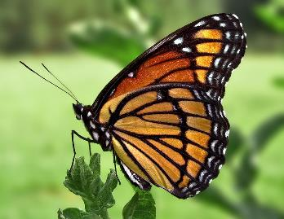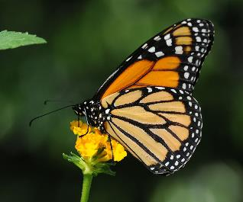
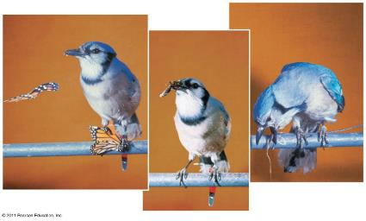

Causative hypothesis
- Case Study:
- Fur colouration in Peromyscus polionotus, the oddfield mouse
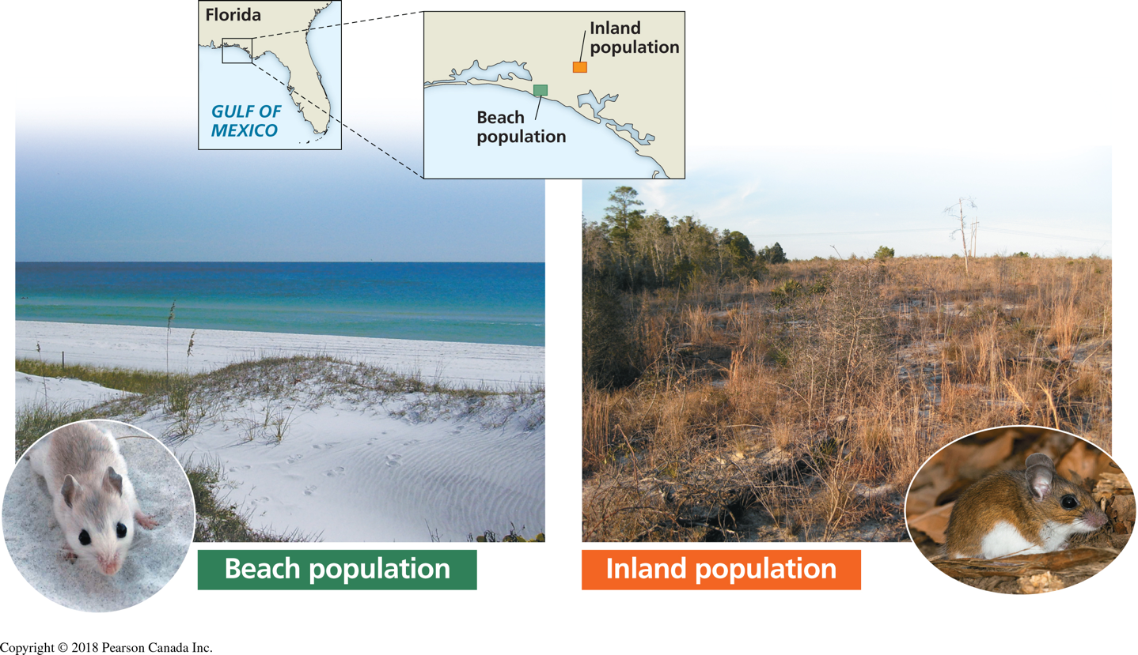

- Colours match their environment
  - Evolution: protection against predators
    - If you stop here: this is inductive reasoning
- Hypothesis: fur colouration patterns has evolved as camouflage in their native environments
- Prediction: if mice have a colouration that does not match their habitat then they will be preyed on more heavily than the native, well-matched mice
- Test:
  - Plasticine mice sprayed-painted in beach or inland colours
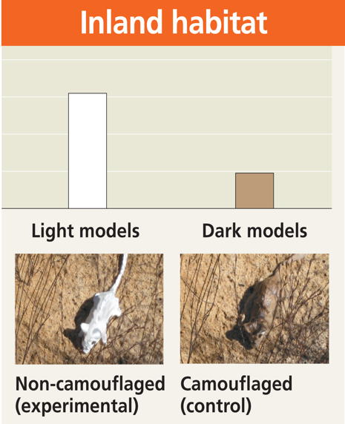
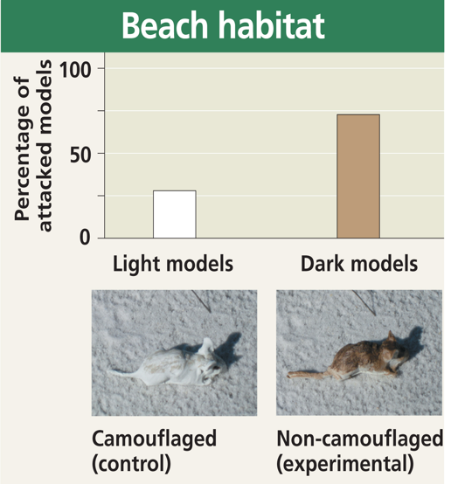
  - Spread both color models (control and experimental) in equal numbers in both habitats
  - Count signs of attacks

Case Study: the introduction of fish in Gatineau Park (Descriptive hypothesis)
- The introduction of species has an impact on fish biodiversity
- In Canada, the value of a lake is often linked with the quality of recreational fishing
- The introduction of species for recreational fishing are made to enhance the value of a lake
- Fish species for recreational fishing are often piscivores (prey on other fish species)
- Impact of piscivorous fish introductions on indigenous species have been the subject of few studies
- Gatineau park has dozens of small lakes where species were introduced for recreational fishing
- Observation:
  - Small lakes in which recreational fish species (piscivores) have been introduced do not have schools of small fish near shore
  - This was based on schools of fish near the shallows of the water compared to other lakes with none piscivores
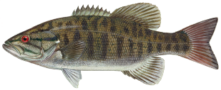

Northern Pike Largemouth Bass Smallmouth Bass
Sample Area
- Gatineau Park: the introduction of piscivores species in 20 small lakes (less than 60 hectares) at the beginning of the 20th century (experimental group)
- There are still about 25 small lakes without piscivores species (control group)
- Hypothesis: introduction of piscivore fish species in small lakes would result in a decline in the numbers of smaller species
- Prediction: in small lakes from the same region, if lakes contain introduced piscivorous species then they will have fewer smaller fish species than lakes without the piscivores
- Testing the prediction: determine the number of fish species in both types of lakes
  - A comparative analysis of fish species diversity in a region with small lakes with and without introduced piscivores
- Results: Lakes without introduced piscivorous fish species have significantly more (50%) small-sized fish species than lakes with introduced piscivores
- Recommendation: no piscivorous species introduction in Gatineau Park lakes to preserve the park’s biodiversity

Conclusion
- In this chapter, we have established the definition of science and scientific research
- We have explained the scientific method/process with several examples
- We have established the distinction between science and non-science using the clauses of the contract between the acquisition of knowledge and science
  - Science vs Non-Science make sure to under the clauses really well

