BIOLOGY: SEPTEMBER 9TH, 2020—LECTURE 1, CHAPTER 1: Science—definition, methodology and perception

Evolution: Locomotion in Cheetahs
Locomotion: movement from one place to another
Main Success: Acceleration (0-70km/hr)/ jumps of 7meters w/elements of surprise
MOST Important section for movement of a cheetah:
- Head
- Front legs & Scapula
- Hind legs
HUMANS
Shoulder Girdle/Pectoral Girdle: connect to the arms—made up of the scapula and clavicle—in humans is intended for tree movement
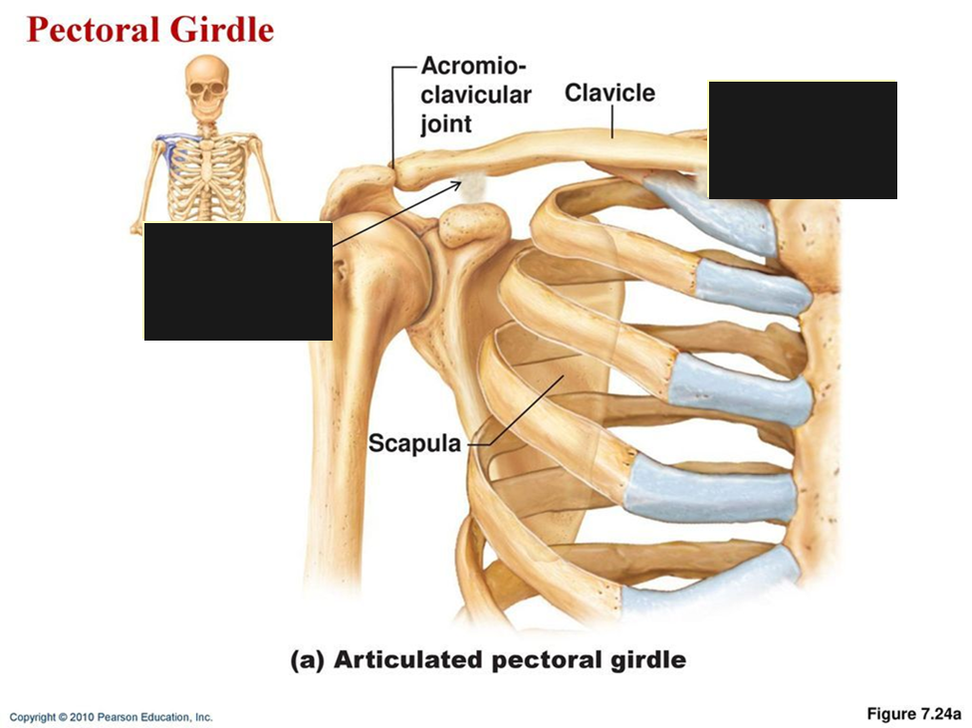

CHEETAH
- Hind legs fused to the pelvic girdle (pelvis) fused to vertebral column propulsion (speed)
- Front legs fused to the pectoral girdle (scapula) not directly attached to vertebral column slides on rib cage propulsion, orientation, stride length
- Front limbs attached to muscle that attach to the rib cage Shock Absorber
- Head stable = monitor prey movement
- Front legs orient themselves in accordance to capture the prey
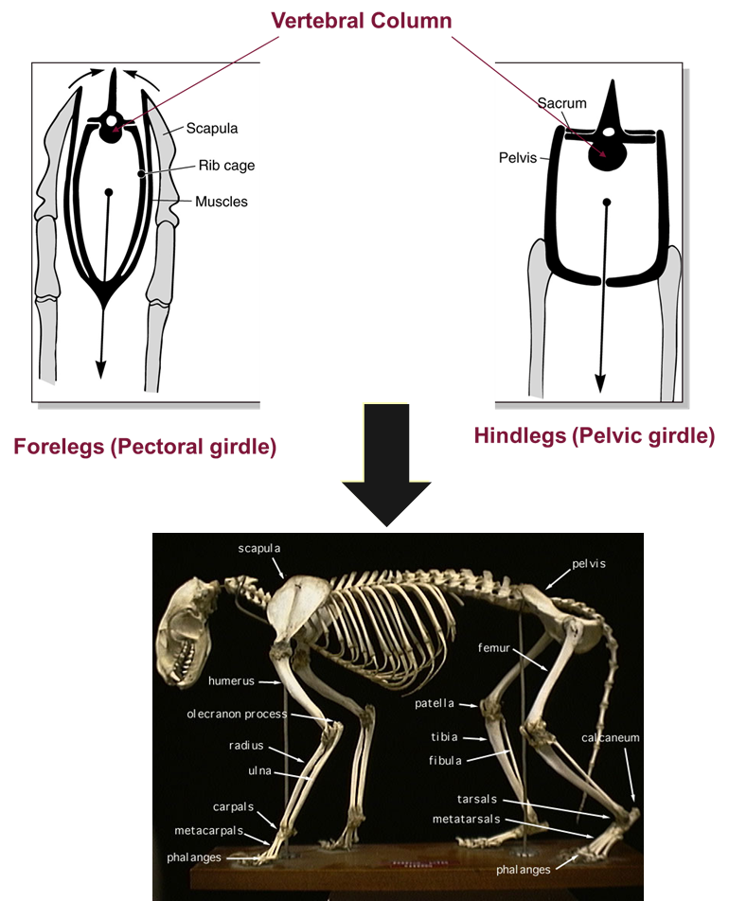
- This morphology is not unique to the cheetah (humans have legs attached to sacrum), but more sophisticated in the cheetah built for speed only for hunting not for FIGHTING/Defence
MORPHOLOGY
- Appearance of limbs 440 million years ago
ADAPTATION
Adaptation of Vertebrates (w/a backbone or spinal column) in cheetahs
- Locomotion organs (fins or limbs)
Adaptations of terrestrial tetrapods (4-footed + snakes) in cheetahs
- Pectoral girdle (scapula) detached from the skull
- Pelvic girdle (pelvis) fused to the vertebral column
Adaptations of mammals (give birth from womb, hair, warm-blooded, vertebrates, etc.) in cheetahs
- Rotation of the knees and elbows under the body (support and/or speed)
Adaptations of the order Carnivores in the cheetahs
- Walk on fingertips (digitigrade)
Adaptations of the cheetah compared to other felines (cats)
- Fur pigmentation
- Long and think limbs especially in the distal end (stride length)
- Lightweight, slender and muscular body (speed)
- Flexibility of the spine (speed, stride length) extends when jumping
- Wide nostrils, heart and lungs with functional capacity (burst of speed)
What is a cheetah
- Characterized by few derived traits (evolutionary innovations) unique from other cat species
- Results of 3500myr of evolution life originated from a common species (life unified by DNA)
  - Heritable traits
- 99% of characteristics evolved from species now extinct
- 1% of its features are unique
- Cheetah is the result of the history of its ancestors than of its own history
- This applies to all living species, including humans
Genetic Variability: Importance
- Restricted to Africa (now, & restricted)
- Almost clones (almost 100% similar genes) endangered
- Genetic variability = resilience Cheetah do not have this
  - Population bottleneck event (climate/disease) reduced the population
  - Few were left to populate the rest of the Cheetah population now
- Royal cheetah is the same as a normal cheetah but mutated pigment genes = more pigmented

- American Cheetah (Extinct for 20,000 years) independently developed fast genes (not a common ancestor with a cheetah)
- Pronghorn (North America) interaction with a predator that must be fast (NA has no fast predator)
- Fossils tend to have the answers*

