Consumer behaviour is a process
- Marketers need to understand that the wants and needs of different consumer segments
- Understand that popular culture is both a product of and an inspiration for marketers
- Internet has changed consumer behaviours

- Many ethical issues to consider in the domain of marketing and consumer behaviour
- Various behaviours can have negative impacts on consumers and society: “dark side of consumer behaviour”
- Many different research methodologies can be used to understand consumer behaviour

- Demographic impact
  - Gender, income, occupation
- Psychographic impact
  - Lifestyle and opportunities
- Consumption communities
  - Sharing opinions and recommendations
Consumer behaviour
- the study of the processes involved when individuals or groups select, purchase, use, or dispose of products, services, ideas, or experiences to satisfy needs and desires

Process
- Consumer behaviour is more than just a process
  - Pre purchase process
    - Budget, online reviews...etc.
  - Actual purchase
    - You feel feelings of anxiety, or satisfaction, depending on external factors like shipping and budgetary factors.
  - Post purchase
    - Typical feeling is regret (Buyer’s remorse) which can last between 2 minutes to 2 months
- Involves the issues that influence the consumer before, during, and after the purchase

Consumer Impact
- Understanding consumer behaviour is good business
  - Once you understand their needs, you will be able to market to them better
- This is because the marketing concept is all about understanding consumer needs
- Data about consumers help marketers define the market
- The purpose of understanding consumer behaviour is to predict the future
Marketing segmentation
- Identifying groups of consumers who are similar to one another in one or more ways and then devises marketing strategies that appeal to one or more groups
  - Our diverse culture stresses a segmentation strategy to be formed
  - Importance of the 80/20 rule
    - 20% of your customers deliver 80% of your sales
    - 80% of your sales come from 20% of your customers

- Demographics
  - Stats that measure the observable aspects of a population, such as birth rate, age distribution, and income
    - Stats Canada is a major source of demographic data on families
      - Ex, Rogers and Bell develop certain marketing tactics based off of stats and market towards certain families
      - Ex, during surveys, they ask demographic segmentation questions to help further accuracy
      - Ex, body care companies sell MEN’s and WOMEN’s products
    - Table below prices a typical Canadian consumer
      - Each piece of information below will help certain marketing portion of companies
        - Ex, Rogers may be interested in how much Canadians spend so they can properly market their services
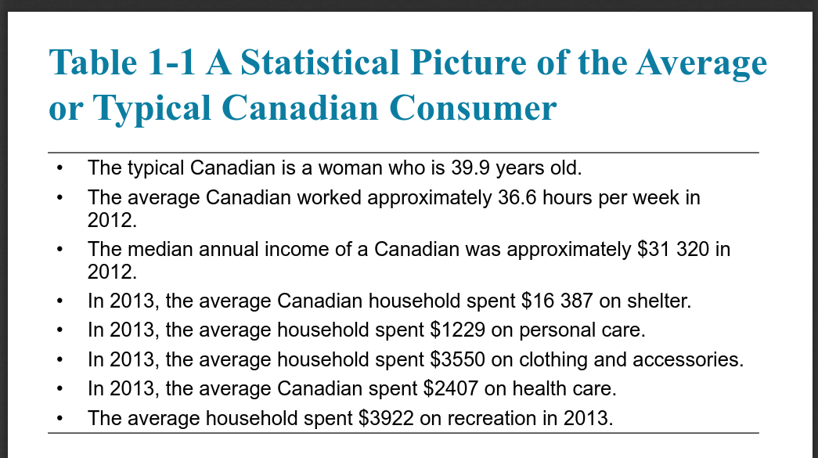

- Psychographics
  - Differences in consumers’ personalities, altitudes, values, and lifestyles
    - The way we feel about ourselves
      - Ex, Kelloggs, selling different kinds of cereals
    - Our attitudes to things and others around us
    - The things we value
    - The things we do in our spare time

Important demographic Dimensions
- Following are important demographic dimensions which influence strategic marketing decisions
  - Age
  - •Gender
  - •Family structure and Life Style
  - •Social Class and Income
  - •Ethnicity•
  - Geography•
  - Lifestyles: Beyond Demographics
  - •Segmenting by Relationship and Big Data

Relationship Marketing
- Involves making an effort to interact with customers on a regular basis, giving them reasons to maintain a bond with the company over time
- One way to recreate relationships with customers is through database marketing…
- Some other types of relationships a person might have a product include
  - Self-concept attachment

  - Nostalgic attachment
    - osrs
  - Interdependence
  - Love
Database Marketing
- Database marketing tracks specific consumers’ buying habits very closely and crafts products and messages tailored precisely to people’s wants and needs based on this information

Marketing and Culture
- Popular culture
  - Inspirational and an influential
  - Tweeting, Boxing day shopping, Playoffs...etc.
  - As are movie heroes, professional sports players, product usage
- Consumer generated content
  - Opinions on brands and products
  - Social networking
The Global Consumer
- Culture has united people around the globe by common devotion to:
  - Brand name consumer goods
  - Movie Stars
  - Celebrities
- Influenced by
  - U-commerce - use of Ubiquitous networks
  - RFID tags - communication chips
  - COmpanies expanding overseas

