BIO1130 LECTURE NOTES
Lecture 2: September 11, 2020.
Chapter 1: The Scientific Method
1.1 Important definitions
- Science: It is the intellectual and practical activity encompassing the systematic study of the structure and behavior of the physical and natural world through observation and experiment.
- Biology: It is the science of life.
- Scientific Inquiry: The diverse ways in which scientists study the natural world and propose explanations based on the evidence derived from their work.
When anyone says that something is based on science, it means that there is real data/ evidence behind it. And evidence is generated by observation and experiment.
In science, we usually deal with 2 approaches:-
1) Description based approach: This is based on describing nature. It is impossible to understand and protect nature if we do not know about it/ cannot describe it and thus, there are fields of science that are dedicated to describing nature/ the natural world.
2) Hypothesis based approach: This is based on explaining nature. In this, we try to reinforce our view of nature in terms of its description. If our objective is to explain nature or to try and find a mechanism of the natural world, then we use the hypothesis-based approach.
1.2 The Scientific Method and Reasoning in Science
- Inductive Reasoning: It is linked to the descriptive based approach. It involves making a generalization/ a statement often based on numerous specific observations. So, we go from the particular to the general.
E.g.) You wake up in the morning, go to the window and look at the nice blue sky. Looking at the sky, you generalize that it is going to be a beautiful day. This is inductive reasoning based on your observation of the sky.
Imagine you are standing on campus at the back of an auditorium and you start to see many students enter a classroom. So, you automatically assume that there is going to be a lecture in that room. This is inductive reasoning.

However, these types of generalizations are not very powerful as the lack of relevance/ probability of error is fairly high.
For example, maybe the sky is beautiful in the morning, but it starts to rain in the afternoon. And maybe the students entered the classroom for an assembly, a meeting, or even to watch a movie! Thus, we prefer deductive reasoning.
- Deductive Reasoning: It is linked to the hypothesis-based approach. Inductive reasoning is never the end point of the research process due to the high probability of error, thus scientists prefer to continue their research based on deductive reasoning.
It involves stating a hypothesis and drawing conclusions (after experimentation or observation) from the hypothesis. So, we go from general (making a hypothesis) to particular (making a conclusion through various experiments).
E.g.) You see the nice blue sky and make a hypothesis that it is going to be a beautiful day. But after that, you test the hypothesis by maybe going on the internet and checking the weather forecast so that you can get closer to the truth. In case of the classroom, you might maybe go and check if it is a lecture that is going on or if it is something totally unrelated.

The Scientific Process
Inductive reasoning involves directly making a generalization based on observations without any testing. For example, if I eat an orange and observe that it is sweet, I conclude that all oranges are sweet. Even if I eat many oranges, I might still get the same conclusion. Scientific research and generalization are based on observation. But, the quality of the generalization might not always be accurate, so we cannot stop there as the it might be wrong and so, we have to test further.
After reading about the bulb hypothesis (next page) we can now use deductive reasoning to say the following statements:-
1) Observation: This orange is sweet.
2) Hypothesis: All oranges are sweet.
3) Prediction: If I taste all kinds of oranges, then they all will be sweet.
4) Test: Tasting all kinds of oranges. Travelled to Madagascar and tasted a very sour orange.
5) Conclusion: Hypothesis is falsified.

There are many cases in the media wherein speculations are made based on inductive reasoning.
All scientific inquiry starts with one or multiple observations. Subsequently, the scientific process must be implemented. For example, In the summer of 2019, there were massive fish deaths in the Ottawa River near the Lievre River on the Gatineau side. Within a month, there were 4 episodes of death. This caused quite a stir and the media was involved, so this news made the headlines for a couple of days. Due to the number of episodes, people started to wonder if it was safe to eat the fish and to go swimming in the river. There were a lot of speculations made based on inductive reasoning: that maybe it was a toxic spill or anoxia (lack of oxygen in the water due to pollution). Eventually, the fish deaths stopped.
So, the scientists from the ministry collected a couple of fish and took a few weeks to do analyses and research on these dead fish. Eventually, they established a cause of death.
The necropsies revealed that the cause of death was a gas bubble disease caused by the outflow of a hydro-electric dam on the Lievre River close to the Ottawa River. Very quickly, the engineers ensured that this situation where bubbles would come with high concentration of oxygen and exist in the water, would be controlled.
Gas bubble disease is a situation where gas will be coming out of solution in the blood stream of the fishes and so they will form little bubbles on their bodies. Basically, the partial pressure within the fish is quite high compared to it’s outside and this eventually causes the death of the fish.
This is the closest hypothesis we have to the truth but there is always a possibility that maybe not all the fishes died due to this.

Scientific hypotheses must be verifiable, refutable (in science, we have the tendency to refute a hypothesis and not prove it) and reproducible (this means that if we do the experiment and conclude with a hypothesis and another scientist wants to test that particular hypothesis, he/she should also come up with the same conclusion, or there is a problem). E.g.:-
- From a hypothesis, you can make a prediction. (Prediction is a tool which will allow us to test the hypothesis and it can preferably be stated in an ‘if then’ statement.) For example, for Hypothesis 1, we can say ‘If’ the bulb is improperly screwed ‘then’ we can reinstall it. This is our prediction which needs to be tested.
- Testing of prediction will be done by reinstalling the bulb.
- If the result comes out to be that the bulb does not work, then our hypothesis is not supported, and it is refuted/falsified.
- Then we move on to the 2nd hypothesis and predict that replacing the bulb will fix our problem.
- If the result is that the lamp works, then our hypothesis is supported and is not falsified.
- However, although the hypothesis is supported, that might not be the actual cause of the problem. Maybe there was a power outage and that is why the lamp did not work at that point and by the time you changed the bulb, the power might have come back on. So, we can never prove that the hypothesis is a scientific truth. But a supported hypothesis is usually our closest option to the truth. Therefore, sometimes science gets a bad press i.e.- a scientist might state that there is a high probability of the hypothesis being true, but we know that it is not the actual truth. So, it gets a bad name around those who prefer yes/no answers.
- If a hypothesis has survived multiple falsification attempts, we might consider it as a theory. E.g.) the theory of evolution.
Observations
Hypothesis
Predictions
Tests
Hypothesis not refuted.
__________
Hypothesis refuted.
_______
Additional
tests

1) All Scientific work starts with observation. These observations usually result in a generalization. We could/ could not stop at that generalization.
2) If we do not stop, we go ahead and make it a hypothesis. Hypotheses can be tested using predictions. If tested, the hypothesis could be supported/not refuted. If you stop testing and just accept a statement, then you are out of the scientific process.
3) If the hypothesis is not refuted, it requires additional tests and if it is refuted, you need to build a new hypothesis and put it through the deduction process again.
This general procedure is usually used by scientists to obtain evidence. Yet, the scientific process is a complex one. For the past 200 years, our knowledge about nature has largely increased but, it is based mainly on a contract between acquisition of knowledge and science. However, this contract has clauses:-
1) Skepticism
2) Realism
3) Rationality
4) Methodological Materialism
The picture above is a part of rationality i.e. scientists must use a logical approach when generating data.
CONTRACT BETWEEN SCIENCE AND KNOWLEDGE (OR THE ABILITY TO KNOW)
This contract can help us to distinguish science from non-science. There are 4 clauses in this contract, and if even 1 of the clauses is not met, it is not science.
1) Initial skepticism on facts: We ask honest questions on facts and hypothesis (tangible/real things) and we always re-test what has been found. We need to access things as objectively as possible. Having doubts about a hypothesis is healthy although it may be perceived as a negative point. However, science progresses only by retesting and refining hypotheses.
2) Realism: The world is older and exists independently from my perception of it (the realm of ideas does not have the priority over the real world). In science, we need to put preconceived ideas aside and only analyze the real world. Our analysis should not be tainted by ideologies that may bias our perception of the real world and this is one of the most difficult things to do.
3) Rationality:
- Logic: Demonstrations from a scientist must be a result of coherent steps.
- Principle of Parsimony: This is a methodological principle which states that acceptable theories are hypothetically the most economical in assumptions. This means that when there are several explanations to explain something, a scientist usually prefers the simplest one. This is done to ensure that they minimize the number of assumptions associated with the solution for a specific problem. E.g.) Say you are driving through the countryside in Ottawa and you wish to stop by and take a picture. As you are taking the picture, you hear galloping in the field behind you. So, you automatically assume that they are horses. However, it is also possible that they are zebras. But we do not necessarily assume that because there are a lot of assumptions to be considered if zebras are in the field. Zebras are not commonly found in Ottawa and they probably escaped from the zoo. So, in this case, the simplest explanation for the galloping is obviously the horse. This is the principle of parsimony.
Another example is the Crop Circle Enigma. In Britain during the 1970s, people noticed the appearance of some geometric figure in agricultural fields overnight. These figures were quite extensive and were more visible if you looked at them from the air (from top). At that time, there were many controversies and some people thought that it was something associated with extra-terrestrial life or that it was a signal of something going on in space. The most parsimonious hypothesis associated with this is that humans have done it. Indeed, in the late 1970s, some men came out and accepted that they did it.
So, often when we hear news and think about it, it is usually the simplest hypothesis that comes out to be closest to the truth.
4) Methodological Materialism: All that is experimentally accessible in the real world is material or has material origin. This means that if you want to test a hypothesis, you need to do it using real data coming from the real world and you cannot use supernatural ideas, god, etc. It makes no sense to use all these ideas in science as they are still only concepts. Especially in terms of diseases, not relying on science is not good at all.
Examples:-
1) This example is based on re-testing: In the late 1900s, a scientist called Dr. Bates put forward a concept about the morphology of some living organism. He articulated the concept of Batesian Mimicry.
Overview: The monarch butterfly is a well-known North American butterfly that will reproduce and have their caterpillar in Canadian regions, and then the adult will migrate across North America up to Mexico where all the monarchs will congregate in a protected forest in a fairly small area; and a high density of these monarchs will spend the winter there and finally in the spring they will start a northern migration.
When these monarchs arrive in Canada, they aim to find one type of plant called the Milkweed. These plants are commonly found in the ditches/ fields and they create beautiful fruits in the fall. There is a species of milkweed that attracts adult monarchs because they will use that specific plant to a) deposit their eggs on their leaf and b) the caterpillar will eat the leaves of this plant. When they eat the leaves, they eat a kind of milky substance which contains all kinds of chemical compounds and it so happens to be that these chemical compounds are toxic to the potential predators of the monarchs i.e. the birds. The picture on top of the slide (Fig 51-9) shows Blue Jay eating a monarch and it does not take long before it spits it out (due to the chemical). So, the bright color of the monarch is advertising the fact that the butterfly is toxic and thus, the predator will not attack it because of the association it made between the color and the toxicity.
Now, what Bates found out was that there was another species of butterfly called the Viceroy that showed pretty much the same advertisement color as the monarch and Bates determined that this butterfly was not toxic and it could be eaten by birds. In fact, the Viceroy would have evolved a coloration that looks like the monarch and that would provide it protection against predation.
Batesian Mimicry: It is the phenomenon in which a non-toxic species imitates a toxic species to escape predation.
Now, about 10 years ago, a scientist decided to retest things and found out that this was not a case of batesian mimicry, but it was a case of Mullerian mimicry as developed by Dr. Muller. They found out that toxic species actually look alike, and that the Viceroy was actually toxic to birds! So Mullerian mimicry is the phenomenon in which 2 toxic species look alike so as to send a stronger message to predators.
2) This example is based on rationality: The first example will be a causative hypothesis that aims at defining how coloration patterns evolve.
Case Study: Fur coloration in Peromyscus polionotus, the oddfield mouse. These species are found in North America and we will be considering 2 populations, the beach population and inland population. These 2 populations have different colors as seen in the images: the beach population has a grey-whitish color whereas the inland one has a brownish color. Both these colors tend to match the color of the environment. So, the scientists decided to use scientific reasoning:-
1) Hypothesis: In this species, fur coloration patterns have evolved as camouflage in their native environments.
2) Prediction: If mice have a coloration that does not match their habitat then they will be preyed on more heavily than the native, well matched mice.
3) Test:- The scientists made some plasticine mice and spray-painted them in beach and inland colors. Then, they spread both color models (control and experimental) in equal numbers in both habitats. Then, they counted the attacks and noticed that it was indeed true (as shown in below graphs). Therefore, the hypothesis was supported and not falsified.
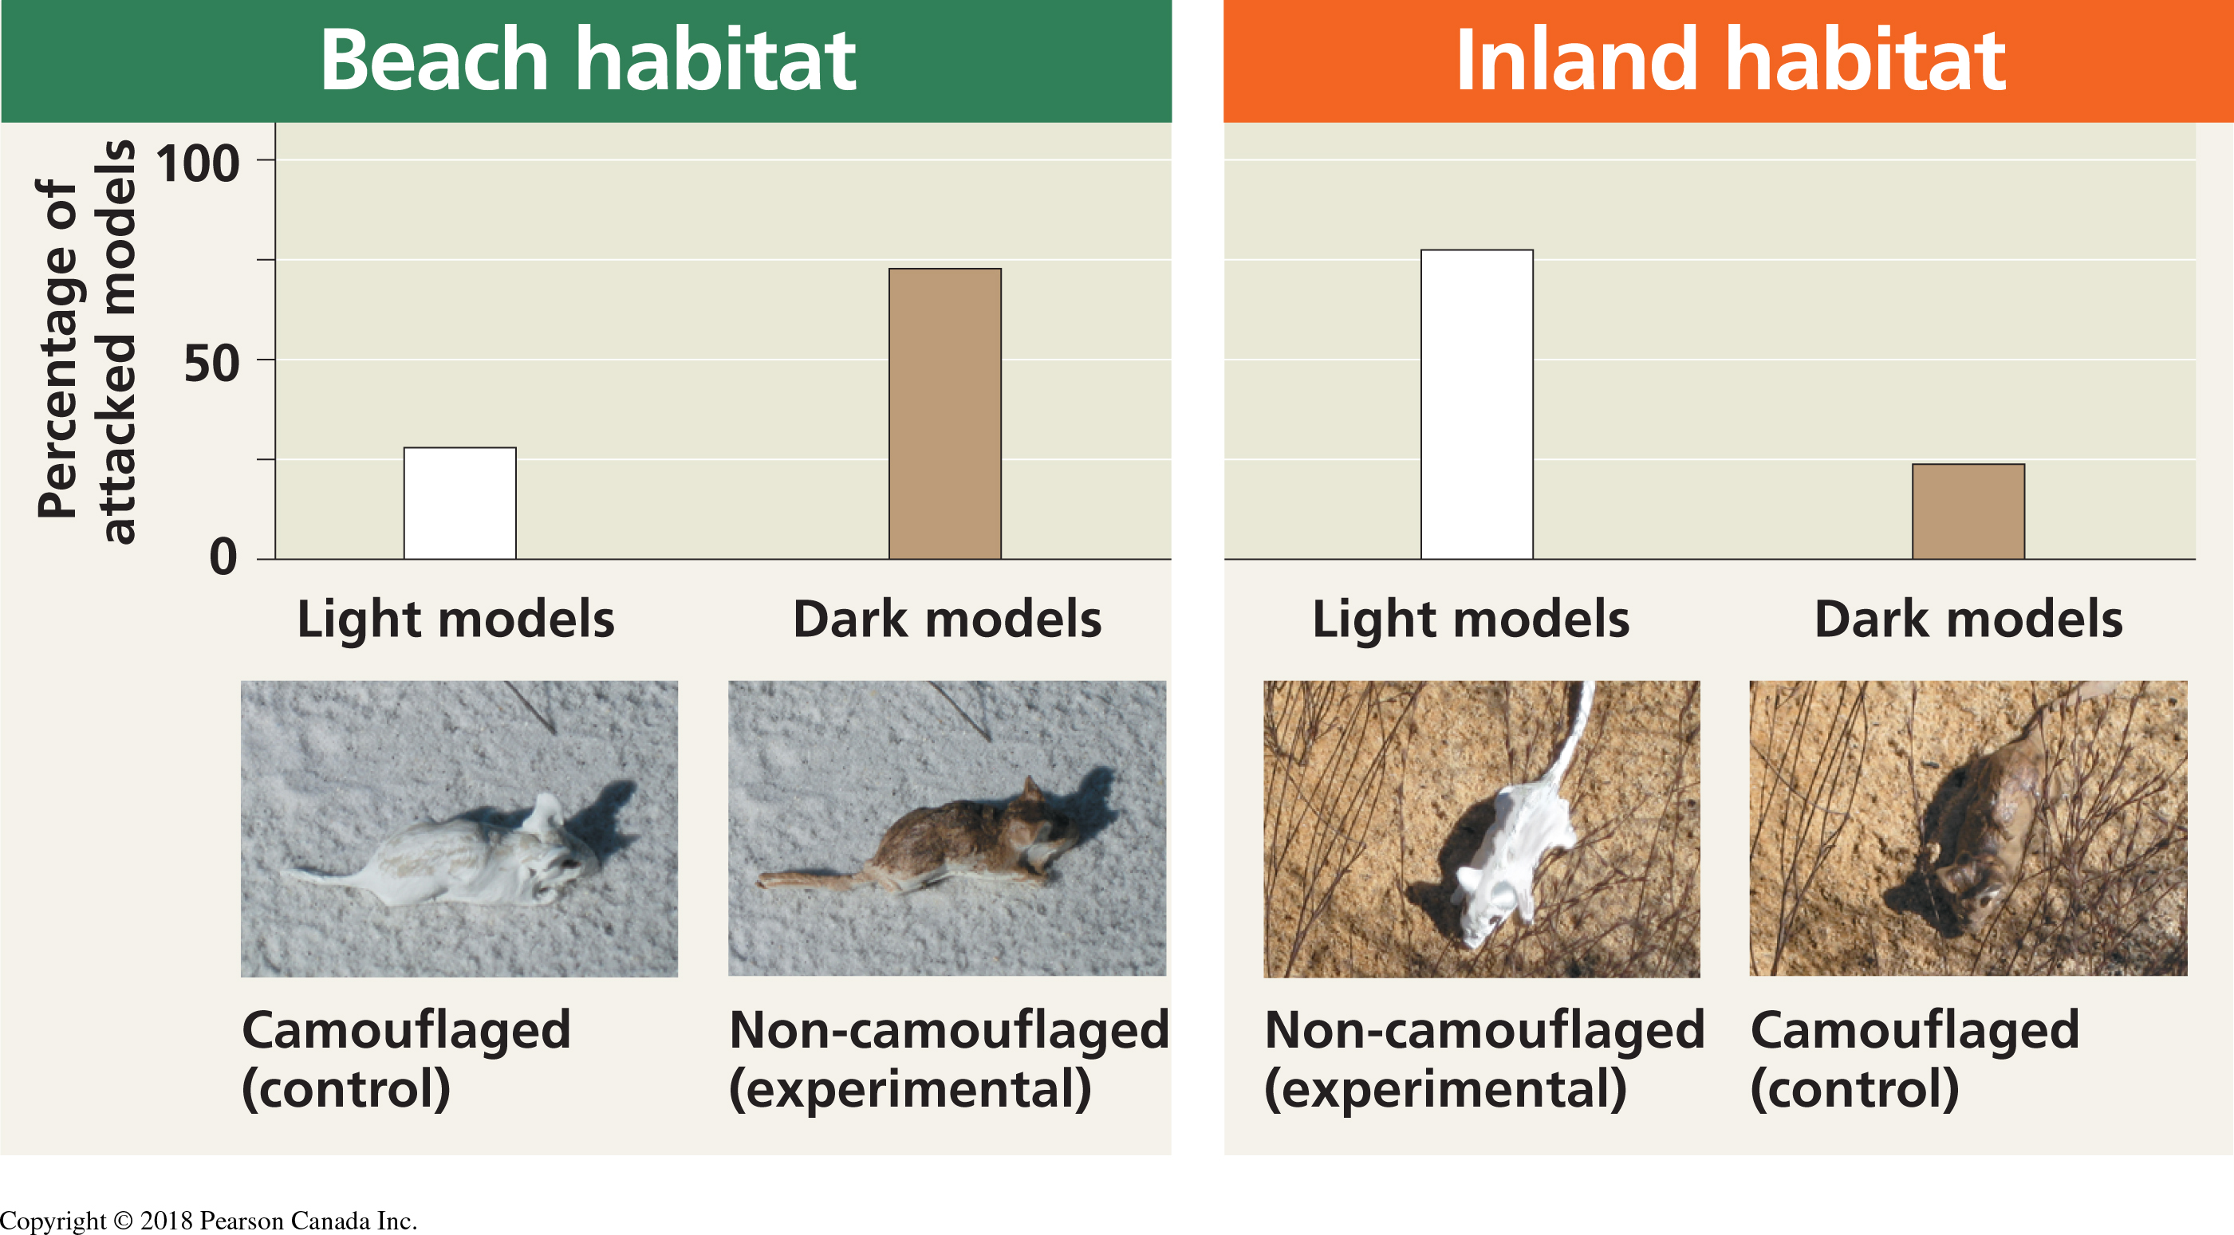
This second example is based on the Introduction of fish in Gatineau Park. (Descriptive hypothesis)
The introduction of species in a new environment has a large impact on fish biodiversity. In Canada, the ‘value’ of a lake is often linked with the quality of recreational fishing. Now, if the lake is located in an easily accesible area, it is highly possible that there will be introduction of fishes for recreational fishing to enhance the value of the lake. Interestingly, in North America, the fish species introduced are usually piscivores (meaning that they prey on other fish species). So, this tends to be a problem if they are introduced in lakes where there are no predators and so, the fish biodiversity is highly disturbed. Additionally, this is a greater problem if the lake is very small and there is no place for the prey to escape.
Now, Gatineau Park has dozens of small lakes where species were introduced for recreational fishing. The observation has been that small lakes in which recreational fish species (piscivores) have been introduced, do not have schools of small fish near shore.
Sample Area: Gatineau Park: The introduction of piscivore species in 20 small lakes (less than 60 hectares) at the beginning of the 20th century (experimental group) and there are still about 25 small lakes without piscivore species (control group). Now, we can apply the scientific process:-
1) Hypothesis: Introduction of piscivore fish species in small lakes would result in a decline in the number of smaller species. Smaller species because they will be the prime target for large predators.
2) Prediction: In small lakes from the same region, if lakes contain introduced piscivorous species then they will have fewer smaller fish species than lakes without the piscivores.
3) Testing the prediction: Determine the number of fish species in both types of lakes. A comparative analysis of fish species diversity in a region with small lakes with and without introduced piscivores.
The data collected in the experiment is seen in Slide 21. Names of fishes in next slides are not to be memorised.
4) Result: Lakes without introduced piscivore fish species have a significantly more (50%) small-sized fish species than lakes with introduced piscivores. Example of Northern Pike??
5) Recommendations were made to the Gatineau Park that there should be no piscivorous species introduction in Gatineau Park lakes to preserve the park’s biodiversity.

