BIO1130 LECTURE NOTES
Lecture 1: September 9, 2020.
An example of Evolution: Locomotion in Cheetahs
Introduction:-
Cheetah is the fastest animal on this planet (attain speeds higher than 110 km/h) However, the main reason for its success (success rate- 50%) is not its speed, it is the acceleration. They are very efficient and rely on the element of surprise by creeping up close to capture their prey. Common preys include Thompson’s Gazelle and Grant’s Gazelle.
Morphology of the Cheetah:-
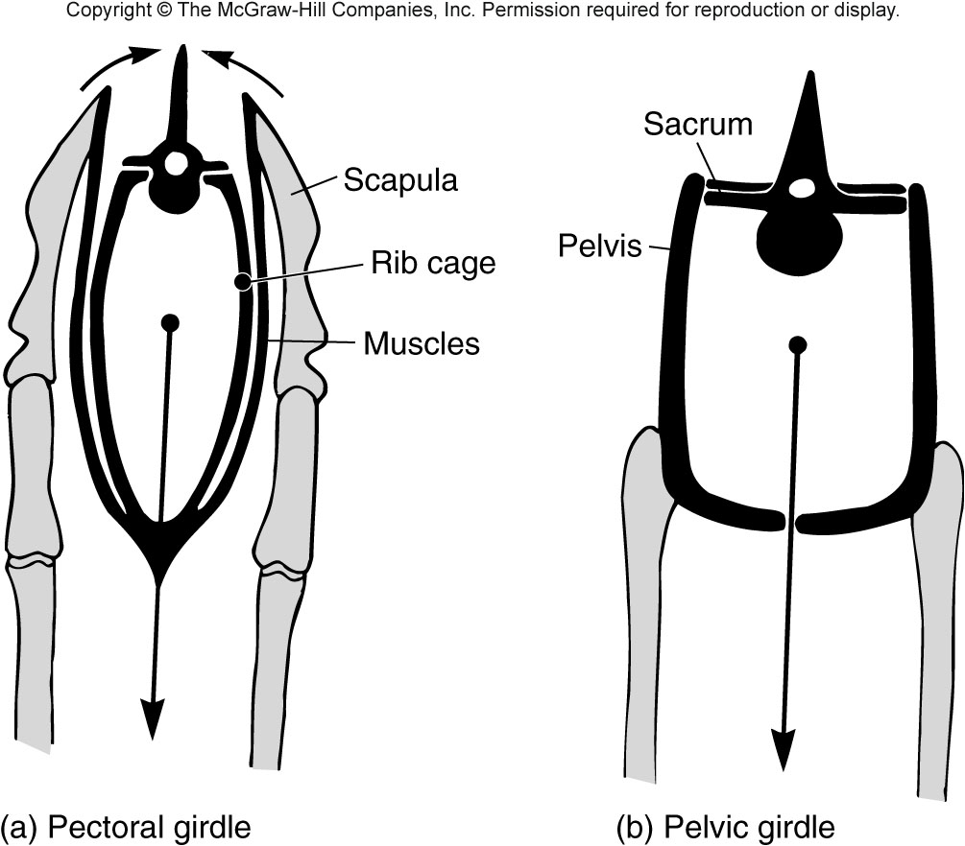
Forelegs (Pectoral Girdle) Hindlegs (Pelvic Girdle)
1) Hindlegs: The hindlegs are attached to the pelvis which is attached to the vertebral column. Therefore, everything is fused together. This allows the hindlegs to propulse the cheetah forward. Thus, hindlegs are the motor of the cheetah and it provides the speed.
2) Forelegs: They react very quickly to any movement of the prey. They provide orientation to the body allowing it to capture the prey.
The scapula is not directly attached to the vertebral column. (This contributes to the stability of the legs which transmits to the head (stability of head allows it to easily detect movement of prey)). The scapula lies beside the rib cage thereby allowing the motion of the forelegs as a pendulum in only one direction. (Adaptation of humans: The scapula is above our rib cage allowing a full 360 degrees of motion). The scapula lies in the same line as the legs therefore increasing the length and making the cheetah more powerful.
The rib cage sits in a sling of muscle which corresponds to the abdominal cavity. This sling of muscle absorbs shock for the anterior part of the body.
While the structure of forelegs and hindlegs is similar to most mammals, the structure of forelegs in cheetah is more sophisticated. Cheetahs run for about 200-300 meters and then stop to catch their breath thus they push their metabolism to the maximum.
However, being very fast implies some constraints in their behavior:-
It does not have the ability to defend its prey because if it gets hurt in the process, it loses its edge and the capacity to hunt therefore effecting survival and reproductive ability. This is called an evolutionary compromise.
Evolution of Cheetah:-
1) Appearance of Limbs: They are not evolved, and they date back to 440 myrs from now (as seen in fish). So, the fins in fish correspond to limbs (for locomotion and support) in terrestrial vertebrates. Bones are visible in some species of fish too and they are evolved to stabilize the body in aquatic environment. Fish move around with angulation of the body. (SLIDE 19)
2) Pelvic girdle fused to vertebral column: Not evolved by the cheetah and has been seen a long time ago in ancestors. Older fish do not have pelvic girdle fused and it is free for maintaining orientation and equilibrium of the fish in the water body. However, the later ones (primitive amphibians (appeared 385 myrs ago) and fish associated with tetrapods) have evolved and have it fused to provide support outside the body. (SLIDE 20)
3) Rotation of the knee and elbow under the body: This is an evolutionary event and characteristic for all mammals (not just cheetah). Primitive land vertebrates (like the crocodiles, lizards, and amphibians like salamander) walk in a sprawl position (humerus being parallel to the ground). The push up lifts the body from the ground, thus, allowing the animal to move. This is very efficient in water but has limitations in the land as every time you lift the body, the movement is associated with the torsion of the torso and this requires a lot of energy. Especially crocodiles being large and for this reason are not very agile outside of water.
So, Some groups of vertebrates have evolved (occurred 220myrs ago) allowing rotation of the knee and elbow underneath the body and this transforms the limbs to columns under the body and thus provides a support system (Characteristic of mammals- presence of 4 limbs acting as a pillar to support the body). This feature lifts the constraint of size. (Pendulum movement of limbs in cheetah makes them fast and efficient) (SLIDE 21)
4) Most carnivores walk on their fingers (Digitigrade) (occurred 65 myrs ago): This is not exclusive for cheetahs; it is for all carnivores. They walk on the tip of their fingers as it increases the length of their stride therefore making them faster. Exception: Bears and squirrels are like humans- they walk on the palm of their feet and hands and are thus called Plantigrade.
Unguligrade (e.g.- deer): They run on their toes as they are the only part of the deer that touch the ground. Structure of foreleg of deer:-Scapula (pectoral girdle), followed by humerus, radius and ulna (fused together) (forearm), carpals (correspond to wrist bones), followed by metacarpals (only 1 bone is left), 2 phalanges (finger) tipped by hooves (nails). Thus, their legs are very long and simple/ thin (they have very little muscle). This is an adaptation for fast running. (SLIDE 22)
5) All cats (lion, tiger, cat) have retractable claws: They have the ability to retract their claws within their paw and use them only when needed (their muscles allow this movement and this is unique to all cats including cheetah). Unique feature of hindlegs of cheetah: They have semi-retractable claws. Even at rest, a portion of their claws are visible. This trait is 2.5 myrs ago (age of the species of cheetah). Reason of this evolution is difficult to determine, but because the cheetah relies on its speed and ability to change direction very quickly, it makes sense that it needs semi-retractable claws as it gives them a better grip on the ground while running.
Conclusion:-
1) Hindlegs of Cheetah is the result of 440 myrs of evolution i.e.- the structure is 440 myrs old.
2) Adaptation of vert. in cheetah: Many features of cheetahs are characteristics that suggest a common ancestor to several groups of vertebrates.
3) Adaptations of terrestrial tetrapods in cheetahs: Pelvic girdle fused to VC. In fishes, the pectoral girdle is attached to cranium whereas in all terrestrial vertebrates, pectoral girdle is detached from cranium and lies on the side of the ribcage. This detachment allows for the evolution of a neck.
4) Adaptation of mammals in cheetahs: Rotation of knees and elbows.
5) Adaptations of the older carnivores in cheetahs: Cheetah has evolved semi retractable claws from retractable ones.
Adaptations of the cheetah compared to other felines:-
1) Fur pigmentation: It is easy to recognize them from lions and leopards due to color.
2) Long and thin limbs especially in the distal end (stride length): Less muscles are present and thus they are lighter and easier to move and therefore gain faster speeds.
3) They are lightweight, slender and have a muscular body which contributes to speed.
4) Flexibility of the spine (speed, stride length): This is an adaptation and it is not seen in lions.
5) Wide nostrils, heart and lungs with high functional capacity for bursts of speed (endurance).
What is a Cheetah? (SLIDE 28)
1) The species is the result of 3500 Myr of evolution because: If we accept Darwin’s theory that life originated from a common species, then, that first species at feature that we find in cheetah is the DNA. All life on this planet is unified by DNA. Cheetah bears traces of that evolution.
2) More than 99% of its characters have evolved in species that are now exist.
3) Less than 1% of its features are unique. Thus, a cheetah is more of a result of the history of its ancestors than its own history. This applies to all living species, including humans. We share 98.8% of our DNA with chimpanzees.
IMPORTANCE OF GENETIC VARIABILITY
The former range of the cheetah was a lot but now, Cheetahs are only restricted to a few regions in Africa with medium-high density. There are about 5000-10,000 Cheetahs now.
From a genetic view, they are almost clones. They have almost 100% similarity in terms of genes and this similarity is striking! The lack of genetic variability explains why they are endangered regardless of being 5000-10,000 in number.
Resilience of a species is associated with genetic variability: Because of homogeneity of the genome of cheetah among all individuals, if there is a disease that kills 1 individual, it will kill all as all individuals have the same capacity to fight the disease unlike us humans who have a lot of genetic variability.
Cheetahs lost the capacity to be resilient genetically maybe because they went through a Population Bottleneck: It is an event associated with climate/ disease which reduces the population of old species to only a few individuals and then the few individuals will be the seed for the next population. But the few remaining individuals have only a small portion of genetic variability.
Royal cheetah (mutation): They have very striking lines at the back with heavy pigmentation of the body. It is the malfunction of a gene associated with the expression of gene linked to pigmentation that makes more melanin in the fur of these animals.
Pronghorn in North America is a prey which can speed up to 95km/h which is very unusual for a prey. Scientists figured that it is because of co-evolution (to survive from predator), which was confirmed by the fossils of American cheetah: Miracinonyx (extinct for 20,000 years maybe due to climate change). Similar phenomenon is seen in African Cheetah as Gazelles have increased their speed significantly to escape the cheetah for overall survival.
The American Cheetah shares common ancestors with North American Big Cats like Cougar and not with African Cheetah. Their fast speeds is a result of convergence: each of these cheetahs evolved their speeds individually.

