Solutions and Solubility - Study Guide

4.1 - Classifying Solutions
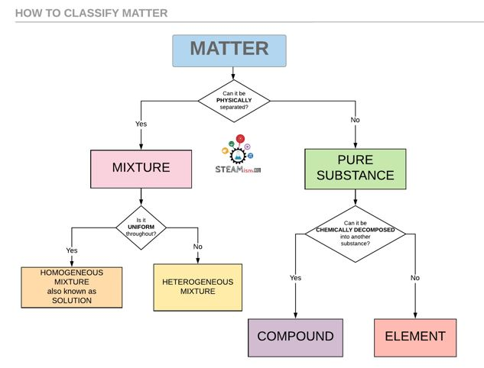
Homogenous mixture: A uniform mixture of only one phase.
Dissolve: To become incorporated into a substance to form a solution.
Aqueous solution: A solute dissolved in water.

Solutions
Solution: A homogeneous mixture of substances composed of at least one solute and one solvent.
Standard solution: A solution containing a precisely known concentration of an element or substance.
Stock solution: A concentrated solution that you make or buy, and use to make more diluted solutions.
Solvent: The medium in which a solute is dissolved. Retains its phase and present in larger amounts.
Solute: A substance that is dissolved in a solvent. Changes phases and present in lesser amounts.
- Making a solution is a PHYSICAl change, not CHEMICAL, therefore all solutions can be separated into its components and the process can be reversed

Solubility
3 forces of attraction that determine solubility:
- Attraction between solute particles
- Attraction between solvent particles
- Attraction between solute and solvent
Soluble: It dissolves.
Insoluble: Does not dissolve.
Miscible: Liquids that dissolve together.
Immiscible: Liquids that do not dissolve together.
Dissociation: The separation of ions that occurs when an ionic compound dissolves in water.
- For something to dissolve, the solute must be attracted to the solvent
- “Like dissolves like”
  - Molecular compounds dissolve in solvents that have similar intermolecular forces
  - Polar molecules dissolve well in polar solvents & solvents with hydrogen bonds
  - Non-polar molecules only dissolve in non-polar solvents

Water, the Universal Solvent
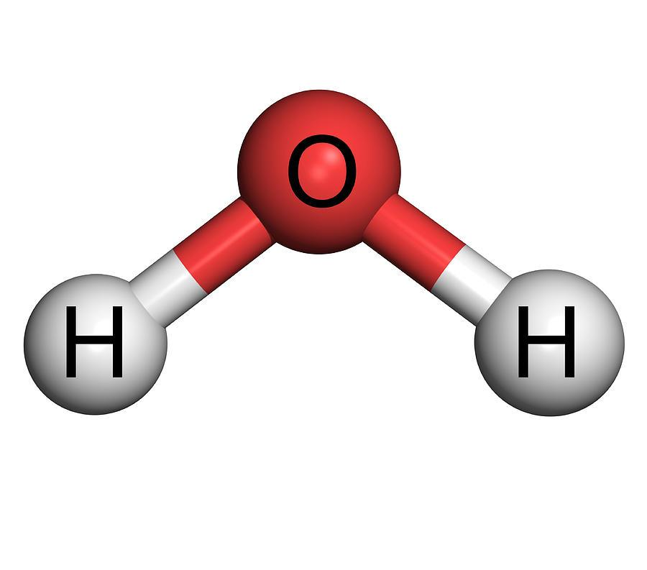
- Water dissolves more substances than any other liquid
- The shape of water is “bent”
- The O-H bonds are polar covalent bonds, water is a polar molecule
  - Hydrogen bonding
  - Can dissolve ionic and molecular bonds
  - Occurs between H, N, O, F
- Hydration occurs when salts dissolve in water
  - The ions are completely surrounded by water molecules and so become part of the solution

Polarity
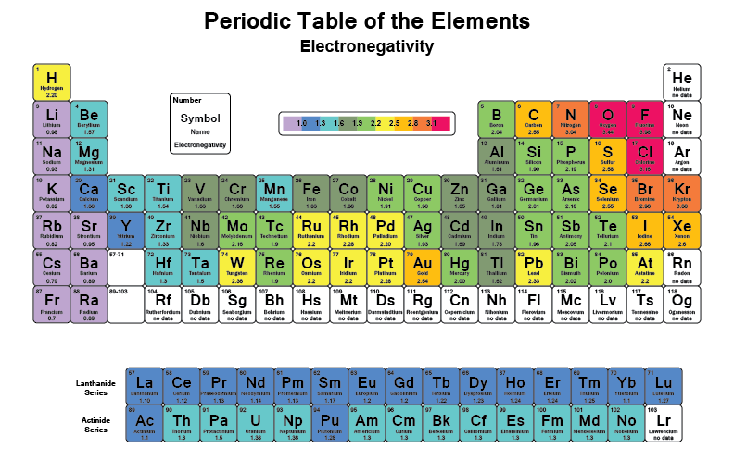
Electronegativity: A measure of the tendency of an atom to attract a bonding pair of electrons.

Polar | - The covalent bond between 2 atoms where the electrons forming the bond are unequally distributed  - Lewis diagram is not symmetrical
Non-polar | - If the electrons are shared equally by the atoms and there is no resulting charge  - Lewis diagram is symmetrical

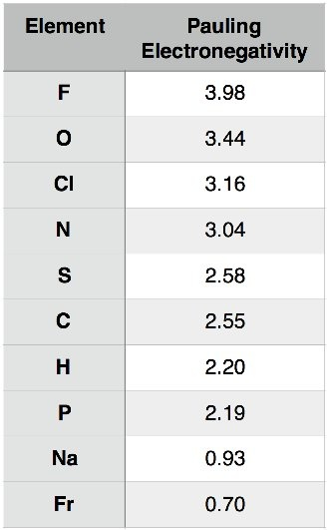
Pauling Scale
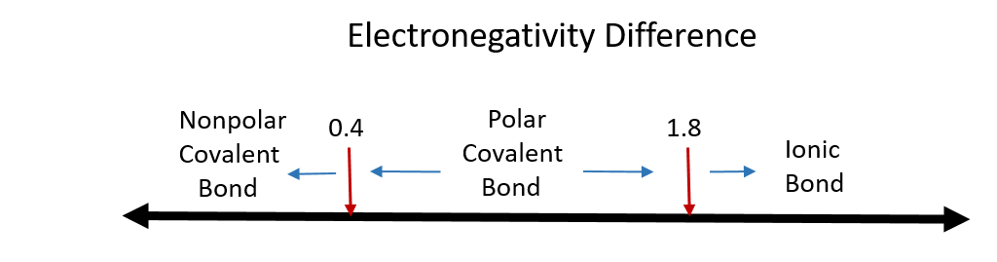
$Δ$E = | E_{atom 1} - E_{atom 2} |

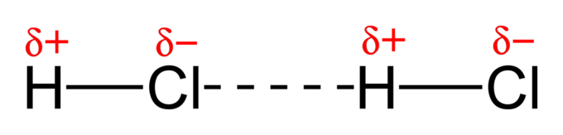

Intermolecular Forces
Hydrogen Bonding | - Strongest attraction  - Dipole-dipole attraction in which hydrogen is bound to a highly electronegative atom  - Attraction between molecules with extremely polar bonds
Dipole-Dipole Interaction | - Molecules with dipoles orient themselves so that the + and - ends of the dipoles are close to each other  - Strength can vary, but weaker than H-bonds, stronger when closer together
London Dispersion Forces | - Weak, instantaneous attractions present between all non-polar atoms and molecules in non-polar solvents  - Results from temporary, uneven e-distribution

4.2- Factors that Affect Solubility - Day 1

Like Dissolves Like
- Substances with similar IMF’s tend to dissolve in each other
- E.g. sugar (polar covalent) and water (polar covalent)
  - Since both are polar, water disrupts the IMF’s and forms a hydration shell around individual sugar molecules - forming a solution

Surfactants
- A substance that acts on the surface of a liquid
- Ex: soaps and detergents - helps oil and water mix
- Breaks down hydrogen bonds at the surface of water
- This allows water (polar) to mix with oil (non-polar)

Solubility
- The mass of a substance that will dissolve in a given volume of a solvent at a specific temperature
- Unsaturated: The solvent is able to dissolve more solute at the temperature and volume of the solvent
  - Additional solute will continue to disappear
- Saturated: The max amount of solute that can be dissolved at that temperature and volume of solvent
  - Additional solute cannot dissolve, thus falls to the bottom
- Supersaturated: More solute is dissolved at a certain temp and volume
  - Obtained by heating & cooling
  - The addition of more solute causes the precipitation of the solute to the saturation point

Solubility Categories
- When more than 1.0 g of a solute dissolves in 100 mL of water = highly soluble
- If solubility is 1.0 > x > 0.1 g per 100 mL = slightly soluble
- When < 0.1 g dissolves per 100 mL = insoluble

Factors that affect solubility
- Molecule Size
  - Smaller solute molecules are more soluble
  - Harder to disrupt the IMF’s that bigger molecules form
  - More difficult to hydrate a bigger molecule
- Temperature
  - In general, higher temp = greater solubility for solids
  - Doesn’t affect liquid-liquid solubility as much
  - EXCEPTION: gas-gas solubility DECREASES at higher temperatures
  - Need energy to break bonds for dissociation
- Pressure
  - Negligible effect on solids and liquids
  - Solubility of a gas increases as the pressure of the gas is increased
  - External pressure keeps gases in solution

Solubility Graphs
Solubility curve: A graph of the solubility of a given solute against temperature. Each point along the curve reps the max mass of solute that will dissolve at that temperature.
- Points directly on the curve represent a saturated solution.
- Points below the curve represent an unsaturated solution.
- Points above the curve represent a supersaturated solution
- The vertical difference between a point below the curve and a point on the curve is the mass of solute needed to saturate the solution @ that temp.
- The vertical difference between a point below the curve and a point on the curve is the mass of solute that will crystallize out of the solution at that temperature.

4.3- Concentration and Dilutions

Concentration
- The quantity of solute per unit volume of solution
- Concentrated: relatively large amount of dissolved solute per unit of solution
- Diluted: relatively small amount of dissolved solute per unit of solution

3 Types of concentration
% V/V = $\frac{Vsolute}{Vsolvent}$ x 100% | % W/V = $\frac{Wsolute}{Vsolvent}$ x 100% | % W/W = $\frac{Wsolute}{Wsolvent}$ x 100%
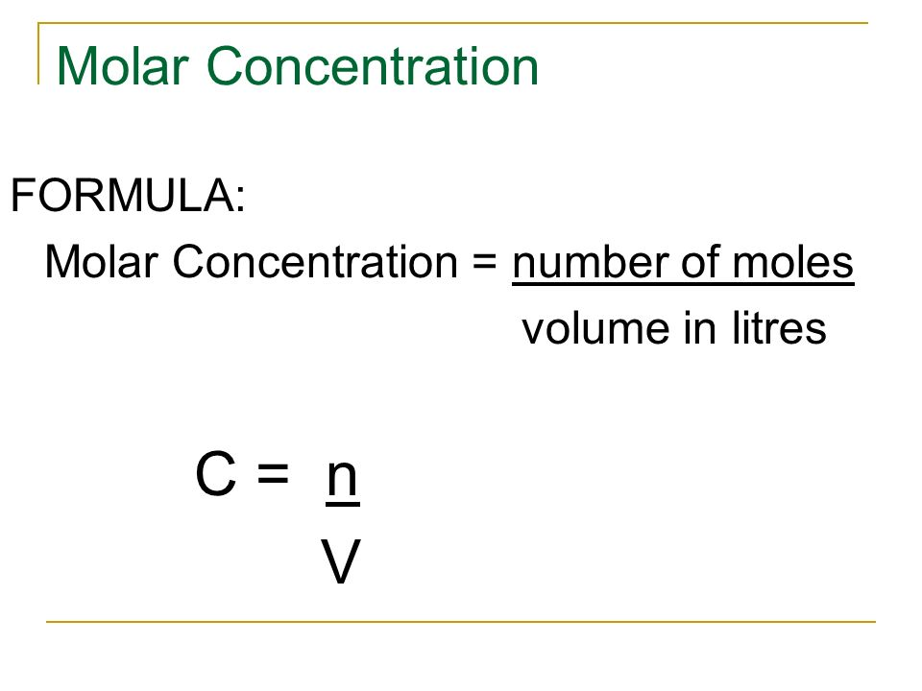
Molar Concentration
- Expressed as moles/litre
- [ ] means concentration
Ex: A saline solution contains 0.90 g of NaCl, is dissolved in 125 mL of water. What is the concentration of the solution?
- Use mass and molar mass to solve for n
- Use moles and volume to solve for concentration

Concentration vs Solubility

→ Concentration = amount of solute/amount of solution
→ Solubility = amount of solute/amount of solvent

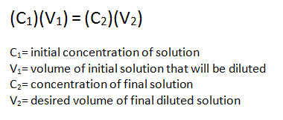
Dilutions
Dilution: The process of reducing the concentration of a solution by adding more solvent.
- During dilution, the amount of solute (in moles) does not change
- The concentration changes because the volume of solution is increased

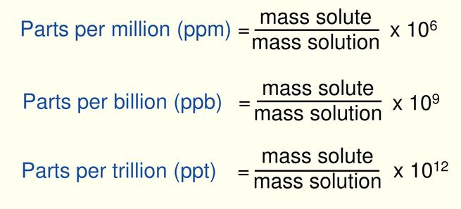
Extremely low concentrations (ppm)
- Useful for reporting very small quantities
- Often used in ecology and toxicology
- Ppm: Parts per million
- Ppb: Parts per billion
- Ppt: Parts per trillion
(Can also do m/m, V/V, or m/V)
4.4- Net Ionic Equations

Mixing Solutions
- There are 2 possible outcomes when you mix aqueous ionic solutions
  - Both remain in solution
  - They react in a double displacement reaction - formation of a precipitate, gas, or water
  - Precipitate: An insoluble solid that emerges from a liquid solution
  - Spectator ions: The other ions that do not form a precipitate - ions that exist in the same form as reactants and products

Steps to Writing a Net Ionic Equation
- Write a balanced equation (with states)
  - Pb(NO₃)_{2(aq)} + 2 KI_{(aq)} → PbI_{2(s)} + 2 KNO_{3(aq)}

- Write the total ionic equation
  - Pb²⁺_{(aq)} + 2 NO₃⁻¹_{(aq)} + 2 K⁺¹_{(aq)} + 2 I⁻¹_{(aq)} → PbI_{2(s)} + 2 K⁺¹_{(aq)} + 2 NO₃⁻¹_{(aq)}

- Cancel out spectator ions
  - Pb²⁺_{(aq)} + 2 NO₃⁻¹_{(aq)} + 2 K⁺¹_{(aq)} + 2 I⁻¹_{(aq)} → PbI_{2(s)} + 2 K⁺¹_{(aq)} + 2 NO₃⁻¹_{(aq)}

- Write the net ionic equation
  - Pb²⁺_{(aq)} + 2 I⁻¹_{(aq)} → PbI_{2(s)}

Predicting if a precipitate forms
The following are soluble - will not precipitate
- All Group 1 compounds
- NO3, NH4, CH3COO (acetate), H+ ions, and ClO4
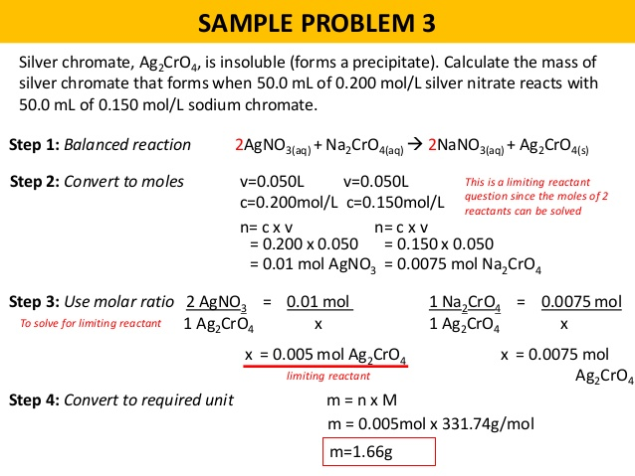
4.5 - Solution Stoichiometry
Steps to solving solution stoichiometry problems:
- Given the concentration and volume of a given substance, use appropriate conversion to determine the amount of given substance in moles
- Then use mole ratio to determine the amount of substance required in moles
- Use appropriate conversion to determine the quantity of required substance, with known concentration or volume
***REFER TO WORKSHEETS WITH PRACTICE PROBLEMS***

4.6 - Acids and Bases

Properties of Acids and Bases
Acids | Bases
- They have a H in them  - When acids are put into water, they ionize into H+ and an anion  - It is the H+ ion in a solution that gives it acidic properties  - pH less than 7  - Tastes sour, corrosive | - Usually has an OH in them  - Mostly ionic compounds, dissolves if soluble  - The OH- anion gives the basic properties when in water  - pH higher than 7  - Feels soapy
Strong vs Weak Acids and Bases
Strong Acids | Weak Acids
- Ionize completely in water  - Contain halogens: HCl, HBr, HI BUT not HF  - H2SO4, HNO3, HClO4 | - Do not completely ionize in water  - When added to water, some molecular acid remains  - HF, CH3COOH, HCN, H3PO4
Strong Bases | Weak Bases
- Fully dissociates into its ions  - Group 1 hydroxides: NaOH, LiOH  - Some group 2 hydroxides: Ba(OH)2 | - Only partially dissociates  - E.g. Ammonia (NH3)

Acid and Base Theories
Arrhenius Theory  - Provided the first comprehensive theory of acids and bases  - Acids ionize and release H+ into a solution  - Bases ionize and release OH- into a solution | Revised Arrhenius Theory  - An acid reacts with water to increase the hydronium ion concentration  HNO3(aq) + H2O(l) → H3O+(aq) + NO3(aq)  - A base dissolves in water to increase the hydroxide ion concentration
Bronstead-Lowry Theory  - This theory deals with the exchange of protons (H+)  - A compound can act as a BL base or acid in a given reaction  - It is reaction specific | Bronstead-Lowry Acid  - Donates a proton  - Hydrochloric acid donates a proton to water, and a hydronium ion results  Bronstead-Lowry Base  - Accepts a proton  - Ammonia acts as a BL base in this reaction  NH3(aq) + H2O(l) → OH-(aq) + NH4(aq)+

Conjugate Pairs
- When a species behaves as an acid, the product formed can act as a base
  - This is the conjugate base
- HCl(aq) + H2O(l) → H3O+(aq) + Cl-(aq)
- The strength of the conjugate helps determine if the acid is strong or weak
- Can also look at if the conjugate base is strong enough to reverse the reaction

- When a species behaves as a base, the product formed can act as a acid
  - This is the conjugate acid
- NH3(aq) + H2O(l) → OH-(aq) + NH4+(aq)
  - NH3 is a weak base because it’s strong enough to donate a proton to water and act like an acid
  - There will still be NH3 in solution because it gets reformed (NH4 is conjugate acid)
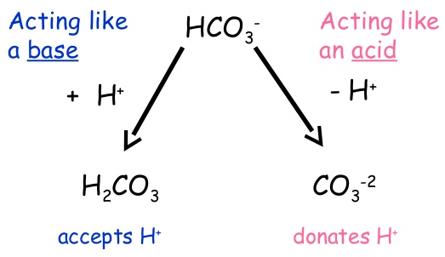
Amphiprotic and Amphoteric
Amphiprotic: A compound that can act as a proton acceptor in one reaction, and a proton donor in another.
Amphoteric: A compound able to act both as an acid and a base
- All amphiprotic substances are also amphoteric but the reverse is not ture
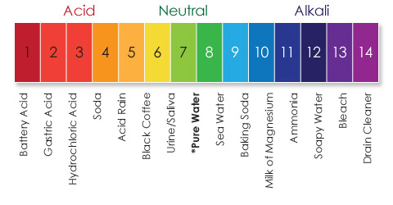
  - There are amphoteric substances that don’t donate or accept H ions when they act as acids or bases

4.7 - Neutralization and Titration

pH
- A way of indicating the [H+] in a solution
- The more H+ present, the more acidic, the more OH- present, the more basic
Equations:
pH = -log[H+] | pOH = -log[OH-] | [H+] = 10^{-pH} | [OH-] = 10^{-pOH} | pH + pOH = 14

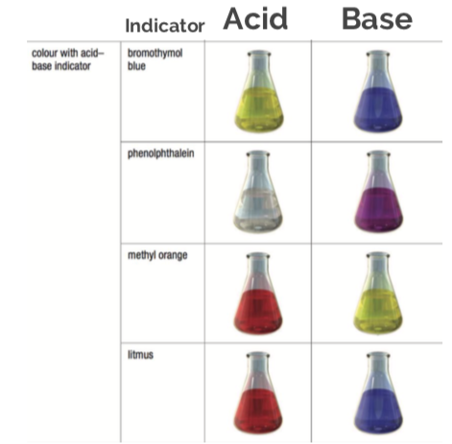
Neutralization
- Acids and bases neutralize each other
  - The H+ and OH- ions will react
  - The acidic or basic character of the solution will diminish
- When H+ and OH- are equal, the solution will be neutral (pH of 7)
- Water is a product

Titration
- A lab technique used when a known acid or base is added to an unknown acid or base until the solution is neutral (can then solve for unknown concentration)
- Purpose is to determine the molarity of an acid
Titrate: The solution of known concentration used in titration.
Analyte: Substance being analyzed.
Equivalence point: When enough titrant is added to react exactly with the analyte (neutralization is complete)
End point: The point in titration when there is an observable change (i.e. change of colour)
Indicators
- Mostly weak acids
- Useful because the molecular acid and associated anion are different colours

4.8 - Water
Property | Physical or biological significance
High melting and boiling points | - permits water to exist as liquid @ room temp  - keeps body fluids liquid over large range of temps
Expansion when cooling from 4℃ to 0℃ | - causes ice to float  - makes water freeze from the top down, life can continue to live below it
High surface tension | - pulls water into round droplets  - insects can “walk” on it
Ability to exchange thermal energy with little temp change | - enables water to absorb great deal of thermal energy  - has a moderating effect on temp changes in organisms and the environment
Inability to mix with non-polar compounds | - enables organisms to retain water because of a waterproof coating  - allows organisms to store non-polar substances (fat, oils)

Water Hardness
- Hard water: Contains relatively high concentrations of the ions Ca2+, Mg2+, and occasionally Fe3+. These ions dissolve in the water as it moves through the ground
- Soft water: Water with low concentrations of these ions.
- Both look and feel the same but they react differently with soap
  - Hard water does not lather, leaves behind a soap scum (scum = precipitate)
  - Can be softened by exchanging the ions with sodium ions, removing the cations causing it to be hard

Water Treatment
- Collection
  - Removal of debris and other large particles
- Coagulation, flocculation, and sedimentation
  - Coagulants mix with the water, making the small particles in the water to clump together
  - Flocculation (mixing) forms a light, fluffy precipitate (floc)
  - During sedimentation the floc sinks very slowly, taking suspended particles to the bottom of the tank
- Filtration
  - The water flows by gravity through filters made of sand and carbon
  - This removes remaining floc and other impurities (bacteria)
- Disinfection
  - Disinfectants (like chlorine) kill microorganisms
- Aeration
  - Air, ozone, oxygen may be mixed with the water to reduce colour/taste problems
- Softening
  - Sodium carbonate and calcium hydroxide may be added to reduce hardness
- Fluoridation
  - A small quantity of fluoride is adding because it makes teeth enamel more resistant to decay
- Post-chlorination
  - A final chlorine disinfection treatment kills any remaining organisms
  - pH level in the water is adjusted to be slightly basic to not corrode pipes
- Ammoniation
  - Ammonia stabilizes the chlorine so that it remains in the water for longer

