FINAL COMM 210
Chandler
- Economies of Scale: large plants produce at lower costs than small plants b/c cost/unit ↓ as vol. of output ↑
  - E.g.: High fixed cost of a national network (tap water)
- Economies of Scope: large plants use existing resources to make array of products and benefit from low average costs (like scale)
- E.g.: firm produces soft drinks → uses marketing and distribution to make alcoholic beverages

- Major claims:
- For firms to benefit from economies of scale and scope (3 conditions):
- Flows of materials= CONSTANT
- National/international marketing + distribution functions must be created (functions means departments)
- Teams of lower/middle managers need to be recruited (hierarchy)

- Secondary claims:
- Once a firm loses opportunity to be 1st mover→ hard to regain competitive advantage
- First mover: competitive advantage earned when company is 1st to enter particular market/industry (1st to invest)
- Challengers: create distribution + sales to try to capture markets where 1st movers are already established
- Entrepreneurial companies that don’t make investments to create organizational capabilities can’t achieve long-term success
- Growth through unrelated diversification is a poor corporate strategy (DQ-hot food vs. ice cream)
(Chandler related diversification strategy)
- Business ownership patterns decrease potential for long-term success (DQ-partnership)

- Concept list:
- Scale vs. scope
- Functional division, management hierarchy, geographical expansion
- 1st movers vs. challengers
- Research and development (innovation)
- Related and unrelated diversification
- Entrepreneurial enterprise (staying small) Managerial enterprise (large firms)
- Separation of top / middle managers (in case of unrelated diversification)
- Stock market pressure (due to ownership pattern)
- Short-term thinking (due to market pressure)

- Ownership pattern: many different owners = AGAINST Chandler b/c then decisions are difficult to make; people disagree
- Unrelated diversification: AGAINST idea of owning array of different products (coffee vs. shoes)
- Related diversification: FOR making products that are related (shoes and shoe laces)

Greiner
- Major claims:
- Organizations grow through a series of evolution and revolution phases that are a function of the age and size organization
- Mgmt practices that go well in one phase bring crisis in another
- Secondary claims:
- Organizations shouldn’t skip phases
- Growth isn’t inevitable (unavoidable)
- Top mgmt who style is no longer appropriate; should remove themselves (2nd cup- eliminating top people that were no longer applicable)
- Concept list:
- Age of the organization: the life span of an organization
- Size of the organization: company’s problems/solutions tend to change as number its employees and sales vol. increase
- Stages of evolution: periods of prolonged growth
- Stages of revolution: time of crisis and turmoil between periods of evolution
- Growth rate of industry: speed rate at which industry goes through stages is related to the market environment of the industry
- Mgmt style
- Organizational structure
- 5 phases of growth:

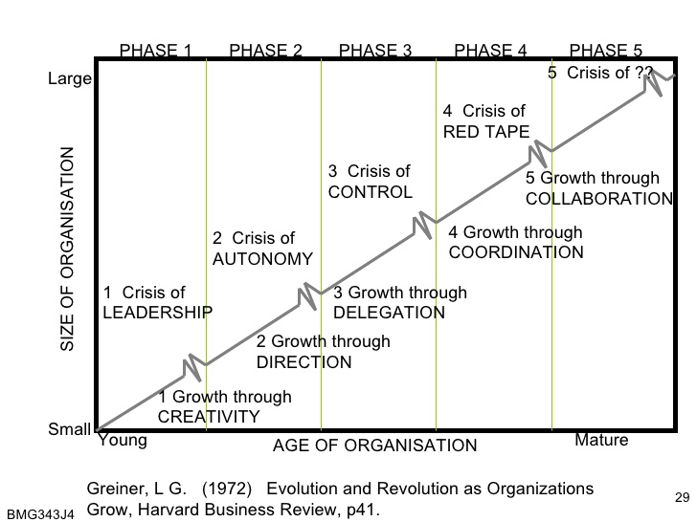

- Creativity:
- Entrepreneurial
- informal communication
- low profits
- reactive to customers
- Issues: larger production = requires knowledge about efficiencies of manufacturing, standardization, employee + mgmt motivation, more capital, unwanted mgmt responsibilities
- Crisis of leadership: who will lead the company out of confusion and solve the managerial problems confronting it?
- Solution: strong manager needed

- Direction:
- Functional organizational structure introduced to separate manufacturing from marketing activities
- incentives, budgets, work standards are adopted
- new mgmt assumes most of responsibility; lower-level supervisors are treated like functional specialists
- Issues: too much control, employees feel torn between following procedure and taking initiative, employees have more direct knowledge than mgmt
- Crisis of autonomy: employees want more responsibility and ability to take initiative
- Solution: delegating responsibility to lower-level managers

- Delegation:
- need to decentralize, give employees more responsibility, top mgmt steps back
- bonuses for motivation = achieving growth through motivation
- Issues: loss of control, info isn’t received
- Crisis of Control: mgmt is trying to regain control, need new techniques
- Solution: special coordination techniques
- Coordination:
- use of formal systems to achieve better coordination
- decentralized units become product groups
- formal planning
- control + review
- centralize certain functions
- use profit-sharing = achieve growth through resource allocation
- Issues: lack of confidence grows between staff, all controls become a burden + time consuming
- Crisis of Red tape : producers take over problem solving, too bureaucratic (overly concerned with procedure at expense of efficiency or common sense), no innovation
- Examples of RED TAPE:
- Each dept. has its own agenda; depts. Don’t cooperate to help other depts. To get the job done
- Top mgmt = misinformed and insulated from what is happening on front-line
- Quantity over quality
- Employees/customers=treated like numbers
- Solution: collaboration to over-come red tape crisis
- Collaboration: strong interpersonal collaboration, spontaneous action through teams, self-discipline, flexible, behavioral approach to mgmt, matrix structure (for senior mgmt)
- Issues: organizations begin to look outside for partners/opportunity, to sell itself to larger company
- Advantages of large, bureaucratic organizations
- Hierarchal authority: promises control and responsibility
- Specialization of sub-units: promises accountability, control and expertise
- Mgmt by rules: promises control and consistency
- Being impersonal: promises objectivity, consistency and equality

Tannenbaum and Schmidt

- How to lead:
- Forces in the manager
- Value system
- Confidence in subordinates
- Own leadership inclinations
- Feelings of security
- Forces in the subordinate
- High need for independence
- Readiness to assume responsibility
- High tolerance for ambiguity
- Identify with organizations problems and goals
- Have knowledge and experience
- Learned to be a part of decision making
- Forces in the situation
- Type of organization
- Group effectiveness
- Nature of the problem
- Time pressures
- Long-run strategy
- Objectives to be obtained
Exhibit 1: Continuum of leadership behavior (old model 1958) | Exhibit 2: Continuum of manager- non-manager behavior (new model 1970)
- Closed system  - Determined external forces  - Manager decides where to operate on the continuum  - Employees referred to as “subordinates” | - Interaction with external forces  - Employees = “non-managers”  - Both mgmt and non-mgmt have control in group environment  - Group can function without mgmt  - Managerial functions are shared amongst group  - More focus on interdependency (mutual dependence between things)
Mgmt Behavioral points (old model)  - makes decision + announces it  - “sells” decision  - presents ideas + invites questions  - presents tentative decision; subject to change  - defines limits, asks group to decision  - permits subordinate to function within limits defined by superior | Mgmt Behavioral points (new model)  - makes decision which non-mgmt accept  - must “sell” his decision before acceptance  - presents decision but MUST respond to questions  - presents decision subject to change after non-mgmt input  - defines limits within non-mgmt make decision  - mgmt + non-mgmt jointly make decisions within limits defined by organization constraints

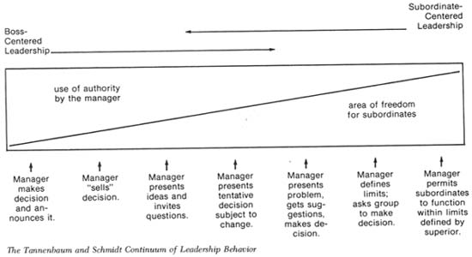
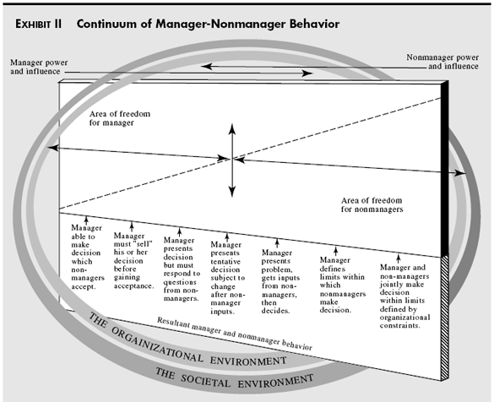
Collins and Porras
Vision: provides guidance about what CORE to preserve + what FUTURE to stimulate progress toward
Core ideology
- enduring character of the organization; consistent identity that transcends product/market life cycles, technological breakthroughs, management fads, and individual leaders
- glue that holds business together
Core Values
- 3-5 values
- essential/enduring tenets
- require no external justification
- small set of timeless guiding principles
- beliefs about what is important
Core purpose
- 100 year test
- organization’s reason for being
- the idealistic motivations for doing a company’s work
- can never be fulfilled
- captures the soul of the organization (why do we exist?)
Envisioned future: “Creative Process”
- what we aspire to become
- audacious/vivid goals that stimulate progress
BHAGs: Big, Hairy, Audacious, Goal
- 10-30 years
- Powerful way to stimulate progress
- Clear/compelling; + unifying focal point of efforts
- Promotes team spirit
- Takes little or no explanation
- Not a sure bet…!
Goal Achievement
- Vivid description
- beware of the “we’ve arrived” syndrome
- what it would feel like to achieve BHAG
- picture people can carry around
- passion, emotion, conviction: essential
Discovering core ideology:
- You do not create/set core ideology
- Description of what actually is, not what we wish existed
- Meaningful/inspirational only to people inside organization
- Find people who are inclined to share org. core values/purpose
- More than creating a perfect statement
Mintzberg
Manager’s Roles
Myth: managers plan, organize, coordinate and control
Realities:
Interpersonal roles
- Figurehead (a nominal leader without real power): performs ceremonial duties
- Leader: responsible for work of people in their unit
- Liaison (cooperation/relationship): contacts people outside the vertical chain of command
Informational roles
- Monitor: scanning environment for information
- Disseminator: passes privileged info to subordinates
- Spokesperson: passes info to people outside the unit
Decisional roles
- Entrepreneur: seeks to improve unit
- Disturbance-handler: responds to conflicts
- Resource-allocator: decides who will get what resource
- Negotiator: deal-making
French & Raven
The concept of “POWER”: power is a relationship, not an attribute
Types of Power:
- Reward: based on one’s perception that the other has the ability to mediate (bring about) rewards for him
- Coercive: based one one’s perception that the other has the ability to mediate punishments on him
- Legitimate: based one one’s perception that the other has a legitimate right to prescribe behavior to him
- Referent: based one one’s identification with the other
- Expert: based one one’s perception that the other has some special knowledge/expertise
Barney
SWOT analysis (NOT BARNEY’S FRAMEWORK)
- Traditional tool for strategic analysis
- Two components: internal and external environment analysis
- Internal: internal resources and capabilities of the firm (strengths and weaknesses)
- External: business and societal trends, industry conditions and competitive environment (opportunities and threats)
Barney → provides a tool to assess company’s internal resources/capabilities
Major claims:
- Firm will have a sustained, competitive advantage if its resources/capabilities are valuable, rare, matchless and organized in a way that allows it to achieve potential opportunities
- A firm will be successful if it has resources with the right attributes/characteristics
- The most careful/complete analysis of firm’s competitive environments cannot (by itself) define their success
- Strategists also need to analyze the competitive implications of firms’ internal strengths/weaknesses
Firm’s Resources/Capabilities: financial, physical, human, organizational assets used to develop, and deliver products/services to consumers
- Financial: debt, equity, retained earnings, etc.
- Physical: machines, manufacturing facilities, buildings
- Human: experience, knowledge, judgement, wisdom, etc.
- Organizational: history, relationships, trust, culture, formal reporting structure, patents, etc.
4 important questions about resources/capabilities
- Question of value: do they enable firm to achieve an opportunity, and/or neutralize a threat?
- Question of rareness: how many competing firms already possess them?
- Question of imitability: do firms without a resource/capability face a cost disadvantage in obtaining it to firms that already possess it?
- Importance of history: valuable/rare resources acquired through unique historical circumstances can be considered sustainable, competitive advantages
- Importance of numerous small decisions: firm’s competitive advantage depends on several small decisions through which resources/capabilities are developed/achieved
- Importance of socially complex resources: reputation, trust, friendship, teamwork and culture, while not patentable are difficult to imitate
- Question of organization: is a firm organized to achieve the full competitive potential of its resources/capabilities?
Value, Rarity, Inimitable, Organized Properly- VRIO Framework

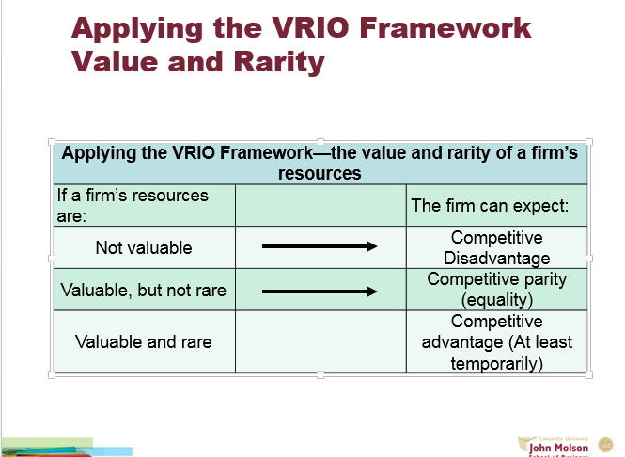
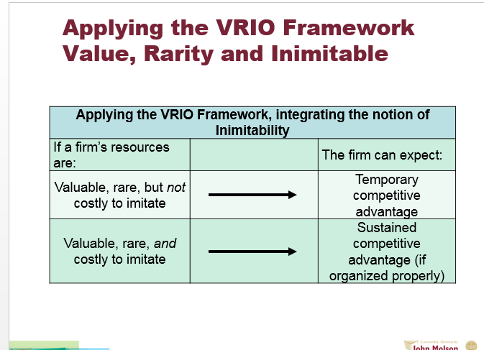
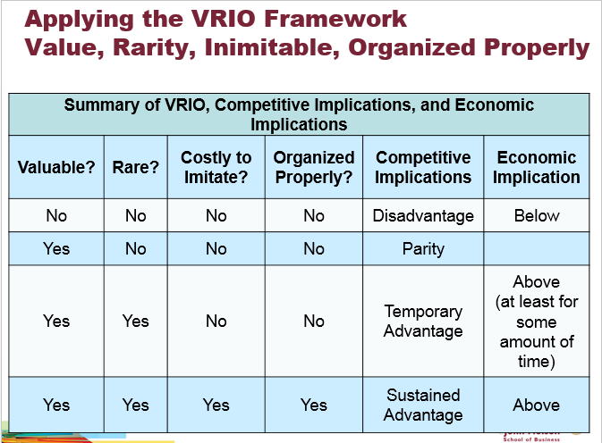
Kaplan & Norton
The balance scorecard
- a performance measurement system/tool
- what you measure if what you get
- the traditional financial performance measures worked well for the industrial era
- the “bottom line” is not enough
Four perspectives for balanced scorecard:
- Customer perspective: what matters most to customers
- Internal business perspective: how we can meet customer expectations
- Innovation and learning perspective: how can we make continual improvements
- Financial perspective: how can we ensure profitability for shareholders

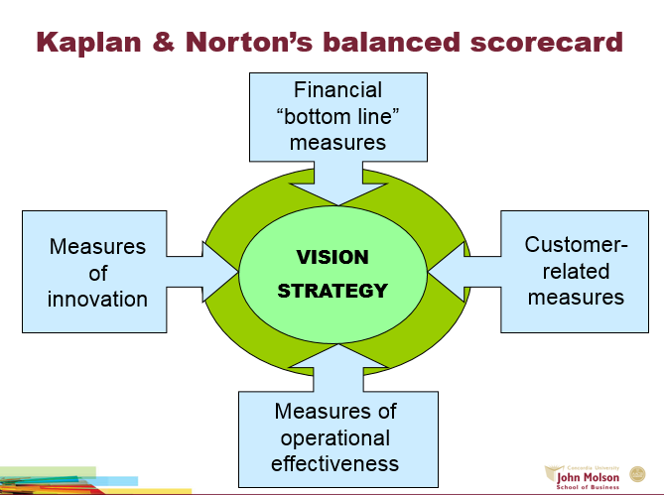

Handy
Sigmoid Curve
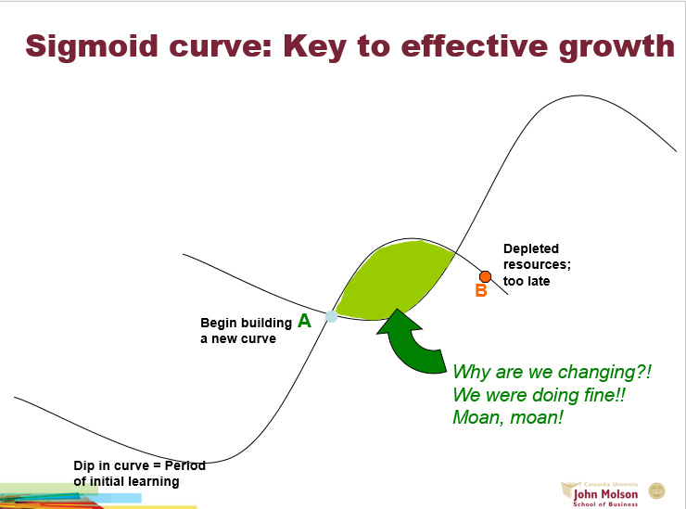

The S-shaped curve:
- Empires, corporations, product life cycle, love and relationships, personal career, etc.
- The 2 curves: when should the 2nd curve begin?
- Who should lead the 2nd curve?
- Turmoil: time of great confusion
The “discipline” of the 2nd curve:
- Always assume → you’re near peak of 1st curve (POINT A) + start preparing for 2nd curve. Even if you’ll be on 1st curve much longer→ prepare for downturn + alternatives for 2nd curve
- Keeping the 2 curves going should be a habit
- Benefits of the discipline of devising the 2nd curve: prepared for downturn
- Traditional four-stage of discovery:
- Questions: what if X happens?
- Ideas: come up with alternatives
- Test + Review: possible scenarios
- Essential: let go of past
“Curvilinear logic”
- Conviction the world (and everything in it) is a Sigmoid curve → Nothing lasts forever; it means starting life over again
- Paradox of success: “What got you where you are won’t keep you where you are”
- Starting life again → harder as you get older
- Entrust curvilinear logic to next generation
- Be careful not to abandon 1st curve too soon
Fertilizing 2nd curve
- Seniors: permission + encouragement
- New ideas can co-exist with old
The paradox of time
- By the time you know where you have to go, it’s too late to go there
- If you keep on going the way you are, you’ll miss the road to the future
- Easy to explain things looking backward → we think we can predict them going forward
Herzberg
How to motivate employees:
- Hygiene factors
- Motivators
- Dissatisfaction/satisfaction
- Job enrichment/Vertical job loading
- Job enlargement/Horizontal job loading
- Negative KTA
- Positive KTA
Principles of Vertical Job Loading
- Remove some controls while retaining accountability
- Increase accountability of individuals for own work
- Give person a complete natural unit of work
- Grant additional authority; job freedom
- Make periodic reports directly available to workers themselves rather than supervisors
- Introduce new, more difficult tasks
- Assign workers to specialized tasks, enabling them to become experts
Some steps for job enrichment
- Select jobs + approach them with conviction they can be changed
- Brainstorm changes
- Screen to remove hygiene suggestions + horizontal job loading
- Avoid direct participation by the employees who jobs are to be enriched
- Be prepared for an initial drop in performance
- Expect first-line supervisors to suffer some anxiety
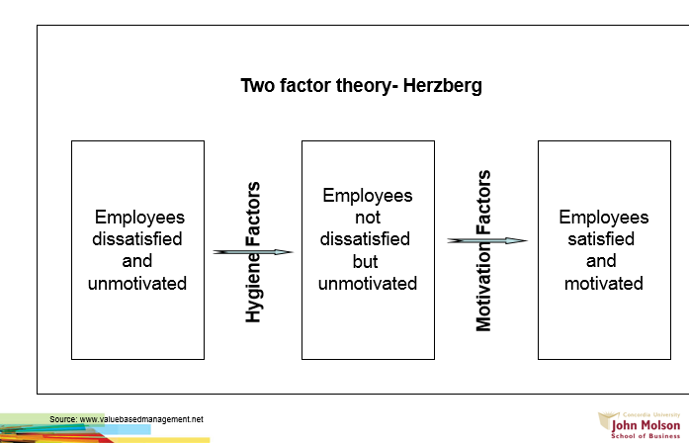

Terminology
- Claim: major conclusion author is trying to persuade you to accept
- Implicitly stated: not directly expressed
- Explicitly stated: clear and in detail
- Cue words: “therefore”, “thus”, “in summary”, “I believe that”, “clearly”, “in short”…
- Presenting claims: concept list/maps
- Concept maps: simple boxes-and-arrows figures that highlight main-issues and show relationships
- Unproblematic claim
- Consistent with our own experiences/observations
- Facts independent of interpretation
- Agreement amongst experts
- Strongly supported general claims (common sense)
- Technical/mathematical claims
- Contestable claims
- Not commonly accepted knowledge
- Often introduce new ideal → awaken curiousity
- Sometimes presented as if it were a fact
- Cannot stand on their own
- Note: a once uncontested claim can be re-examined in later years
- Critical thinking: analyzing validity of arguments presented in text
- Identify author’s claim
- Describe and evaluate supporting evidence
- Evidence: any statement that is a response to the question “why is this true?”
- Criteria
- Accuracy: difficult to judge without an independent source of info
- 2 ways to proceed:
- Do our own research to verify accuracy
- Use proxies to evaluate accuracy: trivial errors, grammar, spelling mistakes, inaccurate quotes or lack of precision
- Precision
- Creates the impression of accuracy
- come from numbers and quotes
- 18.4% is better than “quite well” or almost 20%
- Ambiguous words shouldn’t be overused
- Numbers and direct quote should be provided
- Beware of over-precision
- Sufficiency
- How much evidence?
- Importance of claim
- Potential damage
- Fallacy of hasty generalization
- Representativeness (fallacy of hasty generalization)
- Variety in the sources of evidence should match the variety in the population
- Fallacy of hasty generalization
- Authority
- Training, credentials, experience of others
- Classics or current writing
- Context-dependent
- Fallacy of false appeal to authority
- Fallacy of argumentation ad populum (bandwagon)
- Clarity of expression (quotations, etc)
- Quantitative data should be interpreted
- Direct quotation should also be interpreted
- Other objections: issues of relevance related to underlying assumptions
Business terms and popular expression
- Board of directions: group of people with legal responsibility to guide corporate affairs
- Bottom line: summary number which determines success of company (net income, profit)
- Chief executive officer: CEO, head of firms activities
- Emotional intelligence: measured in E.Q *emotional quotient. Ability to understand/manage own emotions and other and use them competently to sustain good relationships
- Globalization: the steady increase in the extent to which markets, labor, knowledge and technology as well as commercial, social and political activities in countries around the world, are integrated
- Knowledge workers: employees who work primarily with intellect and knowledge
- Outsourcing: delegating some of organization activities to external manufacturer/service supplier
- Research and development: R&D
- Shareholders: part-owners of corporation
- Vision: image of the future held by leaders of organization

Underlying Assumptions: logical link that fills the gap between the evidence and the claim
- Implicit/explicit principles that form the bases of our beliefs and reasoning
- Tell us whether evidence provided for claim = relevant
- E.g.:
- Claim: Canada good should be boycotted
-Evidence: Canada good kills Coyotes to make fur-lined hoods
-Underlying Assumption (gap): Wearing fur is wrong
Reality assumption: our beliefs about reality; about the way things are
Value assumption: our ideals; standards of right/wrong; way things out to be
Causal Claims: author’s interpretation of cause and effect relationships
Rival Causes: the same evidence can be consistent with different interpretations
- E.g.: Due to high quality of our product, sales have increased. (Or back order of competitor products? Or pricing?)
Three types of rival causes:
- Differences between groups
-E.g.: Team A is more organized than Team B so will they get a higher bonus (smarter? More experienced? Older? Better equipment?)
- Association of characteristics
-reverse causation: E.g.: Using Ipads makes students more creative → Creative students tend to use ipads
-effect of 3rd variable: E.g.: Absenteeism is high and so is sales of tea in cafeteria (3rd variable: flu season)
- The post hoc, ergo, propter hoc fallacy (after this, therefore, because of this)
-E.g.: After change of management, our sales dropped therefore the decrease in sales was because of new management (or recession, or low demand…)
Persuasion
Techniques of persuasion
- Anticipate objections based on:
-negative evidence
-alternative causes
-conflicting assumptions
- Counter-argue objections
- Limit claims you cannot rebut
-Acknowledge limitations makes your writing more persuasive
-Limit to generalizations
-Level of probability less than 100%
-Re-defining terms
- Rhetoric use of language to convince
-detail (evidence and assumptions)
-tone (clarity vs. narrative)
-vividness (being concrete draws attention)
Writing a Persuasive Essay
Outline your (contestable) claim and sub-claims
- Ask yourself: “Why do I think this claim is true?” List reasons
- Logic of your argument must be clear
Arrange evidence
- 2-3 pieces of evident for each sub-claim (sufficient; accurate)
- Views of experts, quotes from interviews (authoritative; precise)
- Examples from your own experience, diverse, variety of others (representative)
- Detailed descriptions/background information (precise)
Give each section of your essay a meaningful subtitle (clear)
Ask yourself: any negative evidence? Anticipate reader objections? Need more evidence?
Write your 1st draft
- Don’t perfect 1st time
- Don’t plagiarize
Revise
- Team contributions have to be integrated similarly
- Introductory sentences → engage reader’s interest/attention
- Concluding sentences → strong, summarizes
- Visual aids → charts, photos, clipart, concept maps
Full list of references

