Even in Canada.
- We see regional differences
- By province
- City vs. rural?
- We see sex differences in aging
- But these may be changing
- We see ethnic group difference
- Confounded with regional/ city?

WEIRDness (Universal across all human science)
- Western(ized)
- Educated
- Industrialized
- Rish
- Democratic countries
Aging worldwide: 2000
- A lot of older people in Japan, western europe
- Better health care
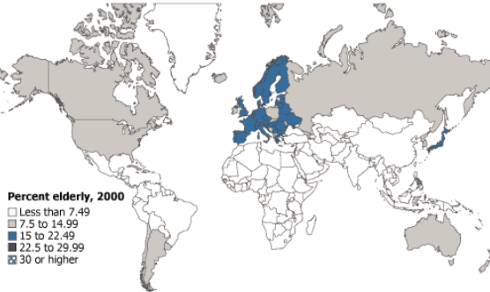
Aging worldwide: 2050
- A lot of WEIRD countries will have more older adults in the future
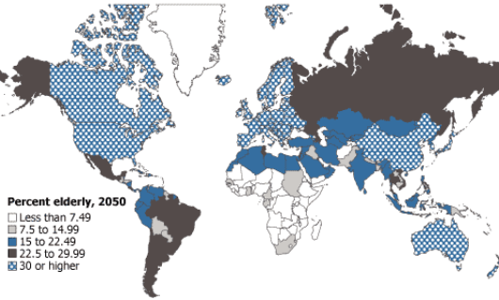
Almost always differences
- The 6 questions above.
Sometimes big ones
- Living as long as possible
  - 70% Brazilian said it is important to live as long as possible
  - 10% Japanese said it is important
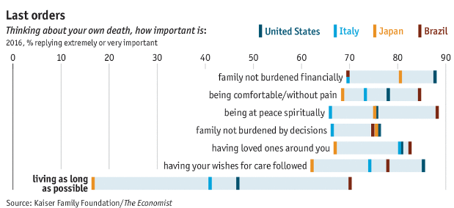
Successful aging definition
- Rowe and Kahn definition of successful aging: Absence of disease and disability, high cognitive and physical functioning, engagement with life
- Critiques
- Definition is unclear, overly focused on physical and cognitive health, lacking psychological traits e.g. spirituality and well-being
- Criteria exclude from the definition of successful agers people with health conditions
- Self-ratings of successful aging were more strongly related to a wider variety of variables than objectively determined ratings from the Rowe and Kahn definition
  - E.g. From the media we can see successful ager have 1/ more age-related limitation
- Does not take into account the individual’s social context in the form of cultural norms or life-span constraints on educational and occupational opportunities
- Different people have different views on successful aging
- Remaining active and belief that slowing down speeds up the aging process
- For older Inuit culture
  - Men meant continuing hung and fish as younger man
  - Cultural transmission of wisdom and knowledge to grandson
- World Health Organization (WHO) definition of active aging: The process of optimizing opportunities for health, participation, security in order to enhance quality of life as people age
- Ecological perspective: Role of social, health care, economic determinants
- Importance of physical environment
- Explicit the role of autonomy and independence
- Placing greater emphasis on ability to get around in environment than on whether the individual needs physical accommodation because disability
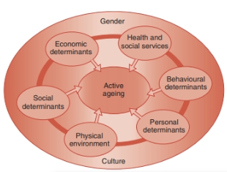

Women’s Health Initiative (WHI) longitudinal study on women self-rated successful aging
- Women highest in subjectively rated successful aging had high score s in hat they called psychological protective factors of resilience, self-efficacy, optimism; were high in positive emotional functioning (low in CES-D and self-rated emotional symptoms), and rated themselves low in physical symptoms
- Performance on cognitive tests did not predict self-rated successful aging
- Show that Rown and Kahn definition of successful aging is overly narrow
- Psychological resilience, optimism are more important contributors to older individual’s own sense of aging well
- Older adults may employ a range of active coping methods to help them achieve their desired goal
- Sexuality is component of successful aging that is known to play a role in overall health, well-being in mid-life and later years
- No correlations between age and sexual satisfaction
- The overall scores of these women on successful aging measures related to sexual satisfaction, but not related to actual sexual activity
- Actual physical health appear to be less important
- Physical environment is important to support successful aging
- Neighbourhood walkability is an index that uses geographic information system to combine factors e.g. residential density, land-use mix, street connectivity to determine whether environments support walking to destinations
- Research: Older residents of high walkability neighbourhood reported 400% more transport activity
- Older adults who were least mobiled benefited most from walkable
- Contribute to physical exercise -> successful aging
- Age-friendly communities is important
- Walkability and accessibility of neighbourhoods, opportunities for being socially active, information that is easy to find and understand, opportunities for volunteer and political engagement and employment
- Again, exercise is an important preventive measure in predicting well-being!
  - But, even those highest in successful aging factor reported they have several chronic health conditions
Successful cognitive aging
- Successful cognitive aging: Cognitive performance that is above the average for an individual’s age group as objectively measured
- “SuperAgers”: 80 and older with superior episodic memory
- Thicker cerebral cortex
- Memory performance correlated positively with cortical thickness
- Greater volume of cingulate cortex, an area may be involved in preventing episodic memory loss
- Successful brain agers are more likely to show brain plasticity
- The sheer size of a brain region may not be as important as the way which that brain region is organized/ functions
- Successful brain aging was related to successful cognitive aging
- Positive association between brain activity and cognitive performance showed up for the frontal cortex
- Highly educated -> successful cognitive aging
- Cognitive aging is best understood as maintaining relative superiority to a person’s age peers, not standard based on performance of younger adults
- Factors predict successful cognitive functioning in older adults
- C-reactive protein (CRP)
  - Known risk factor for cardiovascular disease in mid-life, seems to serve a protective function against dementia
  - Higher CRP levels -> less likely to develop dementia
- Remaining engaged with life
  - Including social support, particularly support from family

Expectation of aging vs. experience of aging among American adults
- Social indicator model: Demographic and social structural variables (like age, gender, marital status, income) account for individual differences in levels of well-being
- Because by demographic standards older individual are in a disadvantaged position on these indices, they should be less happy than young
- An older adults avoid becoming depressed by the potentially disturbing circumstances of poor health, widowhood, low income seems deserving of some kind of special recognition
- There is a gap!!
- Young people expect many negative things to happen, but actually not a lot of older people experience it
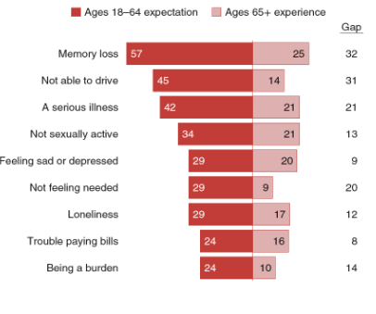
Factors that promote successful aging
- Positive psychology: Seeks to provide a greater understanding of the strengths and virtues that enable individuals and communities to thrive
- Life satisfaction: Overall assessment of an individual’s feelings and attitudes about his life at a particular point in time
- Subjective well-being: Individual’s overall sense of happiness
- Difference!!
- Life satisfaction may be more of cognitive evaluation
- Subjective well-being is more affective
- Together, they show complete picture of a person’s well-being
- Paradox of well-being: Well-established finding that older adults maintain high subjective well-being despite facing challenged from their objective circumstances
- Some findings contradict predictions from socioemotional selectivity theory
- Lucas, Donnellan conclude that life satisfaction across adulthood nearly stable until very oldest ages, dropping slightly after 70 and then more steady in 80s
  - They were able to control for so many competing interpretations
- British household panel study (BHPS) found that life satisfaction decreased early in adulthood, increased from mid to late,then declined at very end of life
- Set point perspective: People’s personality influences their level of well-being throughout life
- E.g. Uni students higher in neuroticism were found to have more negative life events occur to them -> influence their levels of well-being
- Child high in self-esteem in childhood -> high self-esteem throughout life -> well-being
- Personality traits may change in tandem with changes in well-being in adult
  - People higher on positive poles of five factors model had higher levels of well-being. Positive changes correlated with increase in well-being
- Subjective well-being:
  - Physical functioning, financial support, participation in physical activity
  - Education level predicts high levels of physical, cognitive functioning -> subjective well-being
  - Reflects an individual’s evaluation of his life circumstances
    - Research determine health, income, housing, spouse, job, social life, amount and use of leisure time
    - When people arrive at their sense of overall well-being, they do so by mentally combining all specific domains
    - Life satisfaction will be high if the positive outweigh the negatives, but will be low if adults experience themselves more negatively in sub-domain that contribute to overall well-being
- Self-rated physical health may differ from a more objective measure of physical functioning
- Social comparison: When people rate themselves relative to their primary reference group
- E.g. If people in older adult’s reference group are in poor health, the individual’s self-rated health will be higher than if comparison group is in better health
- Physical functioning had a decreasing relationship to self-rated health as individuals grew older, but there is cultural difference!
- White American more likely to have actual physical functioning affect self-rated health, as were older adults with advanced educational degree
- The relationship between physicalfunctioing and self-rated health is weaker among non-white racial/ ethnic groups, those with less education, and those health is disadvantaged
  - Due to social comparison influences this relationship and these group are more likely to compare themselves with members of a group that is in poor health
- Life story (narrative view of the past): Express identity over the course of time
- The process of constructing life story continues throughout life and can serve a variety of adaptive functions
- Benefit from life story that emphasizes achievements, experiences reflect favourably on identity, ater the way they interpret events that might otherwise detract from their self-esteem
- Exploring alternative benefits for arriving at identity commitment, as long as the exploration does not involve high degree of rumination/ self-criticism
- Identity process provides a means of maintaining high levels of well-being in the face of less than satisfactory circumstances
- Identity assimilation allows them to place positive interpretation on what might otherwise cause them to feel that they are not accomplishing their desired objectives

Save money now!
- Young adults have time to prepare resources for retirement life!
- Starting earlier, earning more
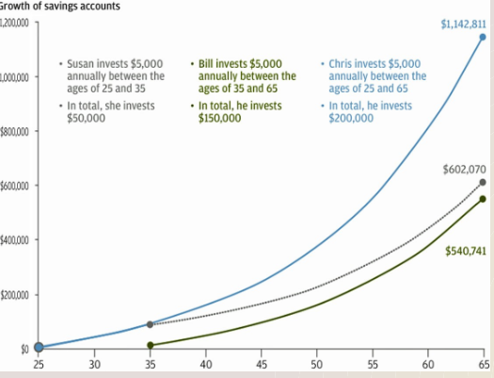
- How to make yourself save money?
- Future projection and self-empathy
  - Make it more concrete to think yourself when you age
  - E.g. Take a selfie, age enhance it, you know i will be old in 1 day, may help you to save more money for the old you
Follow your grandmother's advice on health!
- Possible protective factors may reduce AD (and other age-related disease)
- Mental activity, social support, physical experiences, mediterrancean diet, limited alcohol
- Ottawa neighbourhood study
- Look at different neighbourhoods and compare them
- Some criteria may be more important
- Challenge: Neighbourhood that offers more benefits tend to be expansive
- Volunteering may help age more successfully!

Creativity
- Creativity: ABility to generate products/ ideas that are original, appropriate and that have an impact on others
- “Big C”: Eminent genius creativity
- Highly successful artists, musicians, writers, performers
- “Little c”: Everyday behavior exhibited creativity in individual’s life
- E.g. cooking, scrapbooking, taking photo, wearing different hairstyle
- “Mini-c": Creativity in constructing personal/ self, understanding
- Entire brain is activated during creative activity, NOT JUST RIGHT SIDE
- For men, higher openness score related to activation anterior cingulate cortex (monitoring processes)
- Prefrontal activation (reflecting flexibility) related to women’s openness scores
- For both sexes, openness related to frontal lobe activation
- Personality openness protective factors against mortality
- Research: Positive association between scores on creativity facet of openness to experience and lower risk of mortality
- Creativity highest when prefrontal cortex has matured to the extent that people are able to be flexible but at same time had enough training in their area of expertise
- Put flexibility to good use
- Can be enhanced by exercising these areas of brain thru mental activity
- Stimulate cognitive functioning and well-being, also illustrates the ability of older adults to engage creatively with life

Creative older adults
- Lehman’s Age and Achievement: Peak of productivity in adults years tend to occur prior to age of 40 (often between 30-35)
- Found that earlier peaks are reached in science in fields in which success is dependent on intellectual imagination and physical ability
- Older adults have edge in fields that rely on experience, judgement e.g. politics, diplomacy
- Artist who lied until a very old age produced their best works very late in life
- Planck hypothesis: Tendency of peak scientific productivity to occur in early adulthood
- Young scientists is more innovative than older scientist
- Age and productivity by discipline as judged by dennis
- Although there is a rather steep decline after peak age in arts, somewhat less steep decline in science, scholarly productivity is steady in later adulthood
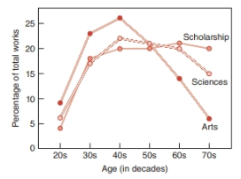
- Simonton’s model: Based on career age, which is the age at which an individual embarks on his career. On average, productivity in later life is higher among people who begin their career at a later age
- Life expectancy continues to increase with improvements in health care and other living conditions, older adults are likely to have a longer empty nest period after their child leave the home
- Individual’s productivity also reflects creative potential, which is the total number of works that a person could hypothetically produce in a life span with no upper limit
- High: produce thousands of works of art during career
- Low: May produce 10,20 or just 1 (“one-hit wonder”)

Creative potential | Career Age | Example
Low | Younger | Laurie London (recorded “hes got the whole would in his hands” at 13)
Low | Older | Margaret Mitchell (published gone with the wind at 37)
High | Younger | Pablo Picasso
High | Older | Anna Mary Robertson

- Equal-odds rule: Predicts that creative individuals who produce more works are more likely to produce one/ more of high quality than are those who produce fewer works
- Same law in sports that “If you dont shoot you cant score”
- Implies people are most likely to produce their best work during their peak period of productivity on the basis of probability alone
- Contemporary older adults have better chance of remaining productive throughout their later years than those living in previous centuries
- Modern tech makes more resources available on internet, the artist need not be the :Ione genius”
- With more leisure time, have chance to pursue multiple interests, develop the personality openness that fosters creativity
- Improved communication allows creative individuals from many fields can collaborate
Characteristics of last works
- There are some changes in the work as the artist ages
- Eg. Rembrandt’s self-portraits change overtime (AD..)
- Old age style: Simpler and more powerful (including “swan song”)
- Likely to have strong emotional reaction
- Presents the reality of the artist’s life and impending death in a manner that may have particular clarity and strong impact on viewers
- Stimulated by proximity of death, desire to leave behind a legacy, perhaps age-related changes/ health problems
- Swan song: Creative work produced at very end of artist life
  - Short main themes and simpler melodies than the previous works of the composer -> evocative, easy to remember
- Lastingness: Endurance over time
- Integration and synthesis: Incorporates complex and multiple features
- Willingness to criticize: Ability to see own work objectively
- Also, older artist coping with physical limitation alter their medium/ mode of creating
- Older creative adults may become better at critiquing their own work

Sociocultural perspectives on creativity and aging-
- Socio-economically and racially disadvantaged individual have lower chance to reach old age
- Definition of eminence used in studies of aging and creativity
- Women are far less likely than would be expected on the basis of chance to appear in lists of the creative and productive at any age
- Only children’s literature where women ~50%
- Difference in educational opportunities, cultural values play a role in determining the ultimate achievement of people from non-majority backgrounds
- Those manage to break thru cultural barriers are likely to receive considerable recognition within their own as well as the majority culture

Successful aging: Final perspectives
- Many creative people have produced notable contributions in later adult years, HOW？
- The talent needed to sustain such a long and productive career may have a neurological basis
- Personality may also play a role
- Research: Men with highest number of awards, notable publication at72 were higher tolerance, psychological-mindedness at 27
- Trait of flexibility and plasticity, looking forward to new goals and new creative enterprises rather than dwelling on their accomplishment of the past
- Maintain curiosity, openness to experience, keep up with time, adapt to changing circumstances
- Grips with recognition of how cultural constraints have affected your ability to realize the hopes and dreams of youth

Practice question
1. The Rowe and Kahn definition of successful aging regards the optimum state to be the absence of disease and disability, high cognitive and physical functioning, and engagement with life. What are some critiques of this model?
- Definition is unclear overly focused on physical and cognitive health, lacking psychological traits such as spirituality and well-being
- Overly narrow, the psychological resilience and optimism are more important contributors to older individual’s own sense of aging well
- Criteria exclude from the definition of successful agers people with health condition, the rating is objectively determined
- It does not take into account that individual’s social context, in the form of cultural norms/ life-span constraints on educational and occupational opportunities

2. Define “active aging”.
- The process of optimizing opportunities for health, participation, security in order to enhance quality of life as people age

3. Define the SHARE’s definition of successful aging. What are the advantages of the SHARE definition of successful aging in relation to the Rowe-Kahn model?
- SHARE’s definition of successful aging: Successful aging is best viewed as a lifelong process reflecting the influence of multiple factors, including favourable/ unfavourable childhood conditions
- Advantage of the model: ???????/

4. Successful cognitive aging can be defined as cognitive performance that is above the average for an individual’s age group as objectively measured. What are some factors that contribute to this?
- C-reactive protein (CRP), known risk factor for cardiovascular disease in mid-life, seems to serve a protective function against dementia. Higher CRP -> less likely dementia
- Remaining engaged with life, including social support, particularly support from family

5. Life satisfaction is the overall assessment of an individual’s feelings and attitudes about one’s life at a particular point in time. Subjective well-being is the individual’s overall sense of happiness. What is one difference between the two?
- Life satisfaction may be more of a cognitive evaluation, while subjective well-being is more affective

6. What are the three contrasting models of subjective wellbeing and aging? Explain each model.
- Paradox of well-being: The well-established finding that older adults maintain high subjective well-being despite facing challenges from their objective circumstance
- Set point perspective: People’s personality influence their level of well-being throughout life
- Social comparison： Process that occurs when peopel rate themselves relative to their primary reference group
7. What is the “age-friendly environment”? What are the WHO’s criteria for age-friendly environments?
- Age-friendly
- Criteria: Walkability and accessibility of neighbourhoods, also housing that is affordable and well designed for seniors, good public transportation, safe neighbourhood, opportunities for being socially active, information that is easy to find and understand, and opportunities for volunteer and political engagement and employment

8. According to the __________________________________________________, their own ways of seeing, and talking about, themselves can influence the way older adults feel about aging and, ultimately, their actual ability to age successfully. According to this model, what are some communication strategies that older adults should use to be able to avoid the limitations of ageism?

9. Define creativity. What do “Big C”, “little c”, and “mini-C” mean?
- “Big C”: Eminent creative genius
- “Little c”: Everyday creativity
- “Mini-C”: Creativity in constructing personal/ self-. understanding

10. The Planck hypothesis is the tendency of peak scientific productivity to occur in early adulthood.

11. Explain Simonton’s model of creativity. What are some criticisms of the model?
- Simonton’s model proposes that on average, productivity in later life is higher among people who begin their career at later life
- Criticism
- Individual’s productivity reflects creative potential, which is the total number of works that a person could hypothetically produce in a life span with no upper limits
- Average productivity rates do not take into account the individual variations shown in the quality and quantity of works
- One-hit wonder, just 1 work and never again
- Start late in life, none of accomplishments would count toward the productivity score for early adulthood
- Began career in childhood, wrote at least 600 pieces but death at 35, cant calculate productivity in old age

12. What is the “equal odds rule”? Explain.
- Equal-odds rule predicts that creative individuals who produce more works are more likely to produce one or more of high quality than are those who produce fewer works

13. What are some negative and positive characteristics of Old Age Style?
- Old-age style is an approach to art that eliminates the fine details and instead presents the essence of the work’s intended meaning
- Disadvantage: The reality of the artist’s life and impending death in a manner that may have particular clarity and strong impact on the viewer
- Advantage: May portray the characters in their novels more realistically, come to take on greater complexity and a sense of timelessness

14. What is the “swan song”? Is there evidence to support this?
- Swan song is a creative work produced at the very end of an artist's life. In music, a swan song has a shorter main theme and simpler melodies than the previous work. Mozart’s last work “the Requiem Mass in D minor” is an evidence

15. Explain the biopsychosocial model of creativity in later life.
- Age-related change/ health problem, proximity of death, desire to leave behind a legacy

