Econ 203

Introduction to Macroeconomics

Based on:
Principles of Macroeconomics an Open Text
By Douglas Curtis and Ian Irvine
Version 2017 – Revision B

Winter 2019

Chapter 4 - Key Concepts
Macroeconomics
- Studies the whole national economy as a system
- Examines expenditure decisions by households,businesses, and governments
- Examine the total flow of goods and services produced
- Examine the total flow of incomes earned

Economic Growth
- Increase in real GDP

Rate of economic Growth
- Annual percentage change in real GDP

Price Level
- Measure of the average prices of all goods produced in an economy

Price Index
- Measure of the price level in one year compared with prices in a base year

Labour Force
- Adult employment plus those not employed but actively looking for work

Employment
- Number of adults employment full-time and part-time and self-employed

Unemployment
- Number of adults not working but actively looking for work

Participation Rate
- Percent of the population that is either working or unemployed

Unemployment Rate
- Number of unemployed persons as a percentage of the labour force

Cyclical Unemployment
- Would be eliminated by higher levels of economic activity

Frictional Unemployment
- Result of the time involved in adjusting to changing labour force and employment opportunities

Structural Unemployment
- Caused by changes in economic structure relative to labour characteristics

Natural Unemployment Rate
- Unemployment rate at “full employment”

Employment Rate
- Percent of the population, 15 years old and over that are employed

Final Goods
- Goods are purchased by the ultimate users

Value Added
- Difference between the market value of the output of the business and the cost inputs purchased from other business

Intermediate Inputs
- Services, materials, and components purchased from other businesses and used in the production of final goods

Fluctuation
- Important aspects of recent economic performance in canada
  - Growth rate of real GDP
  - Inflation rates
  - Unemployment rates
- Expenditures by households, the production of goods by businesses, and the incomes that result are illustrated by the circular flow of real resources and money payment

Circular Flow Diagram
- Show the flows of money payments, real resources, and goods between household and business
- 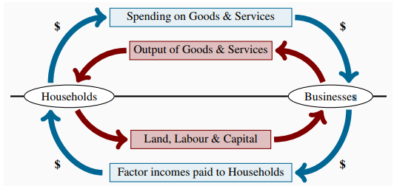

National Accounts
- Provide a framework for the measurement of the output of the economy and the incomes earned in the economy

Nominal GDP
- Measures the output of final goods at market prices in the economy, and the money incomes earned by the factor of production

Output-Based GDP
- Sum of value added by all industries in Canada
- Output less the cost of goods purchased from other business

Income-Based GDP
- Records the earnings generated by the production of goods

Expenditure-Based GDP
- Equal to expenditure on final goods produced

Real GDP
- Measure the output of final goods and services produced, and incomes earned at constant prices

Per Capita Real GDP
- Crude measure of national and individual welfare
- Ignore non-market activities, the composition of output, and the distribution of income among industries and households

GDP Deflator
- Measure of the price level for all final goods in the economy
- Index of current final output prices relative to base year prices

Chapter 4 - Equations

$Real Growth of Real GDP = \frac{Real GDP year 2 - Real GDP year 1}{Real GDP year 1}* 100\%$

$Inflation Rate = \frac{CPI current year - CPI base year}{CPI base year}* 100\%$

$Participation Rate = \frac{Labour Force}{Population 15+ years old}* 100\%$

$Unemployment Rate = \frac{Labour Force - Employment}{Labour Force}* 100\%$

$Employment Rate = \frac{Employment}{Population 15+ years old}* 100\%$

$Expenditure-Based GDP =C + I + G + X - IM$

$Factor Income=W + GCS + GMI$

$Income-Based GDP=W + GCS + GMI + Tin$

$GDP Deflator = \frac{Nominal GDP}{Real GDP}* 100$

$Real GDP year t = \frac{GDP year t}{GDP deflator}* 100$

$Per Capita Real GDP = \frac{Real GDP}{Population}$

$Employee Compensation per Unit of Output = \frac{W}{Y}$

$Gross Business Income per Unit of Output = \frac{(GCS + GMI)}{Y}$

$Net Indirect Tax per Unit of Output = \frac{Tin}{Y}$

Chapter 5 - Key Concepts

Aggregate Demand and Supply
- Model provides a framework for our study of the operation of the economy
- Framework used to explain the behaviour of real output and prices in the national economy
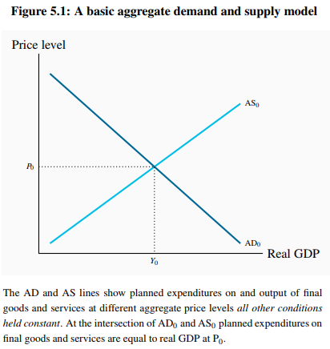

Equilibrium GDP
- Planned expenditure equals current output and provides business revenues that cover current costs including expected profits

Aggregate Demand
- Determines total output, real GDP
- Negative relationship between planned aggregate expenditure on final goods and the price level
- Assuming all other conditions in the economy are constant
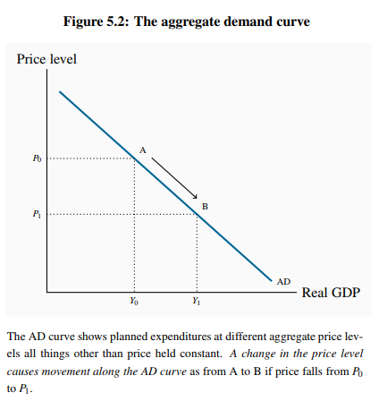

Aggregate Supply
- Positive relationship between outputs of goods and the price level
- Assuming factor prices, capital stock, and technology are constant
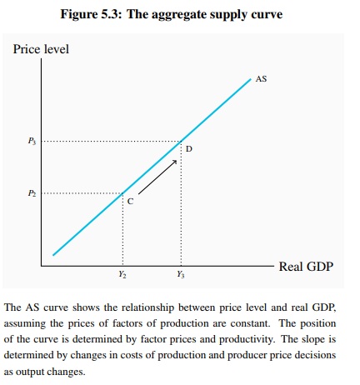

Short-Run
- Time frame in which prices, supplies of factors of production, and technology are fixed by assumption

Short-Run Equilibrium Real GDP and Price
- Determined by short-run aggregate demand and aggregate supply
- Illustrated by the intersection of the AD and AS curves

Potential Output
- Output the economy can produce on an ongoing basis with given labour, capital, and technology
- Without putting persistent upward pressure on prices or inflation rate

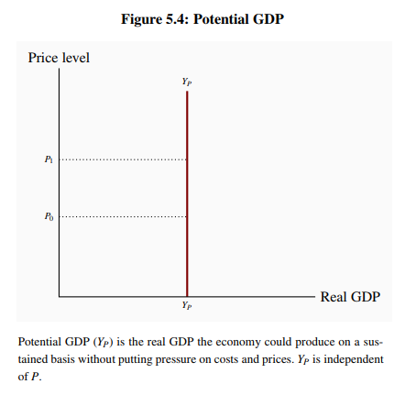

Natural Unemployment Rate
- “Full Employment” unemployment rate observed when the economy is in equilibrium at potential output

Growth in Potential Output
- Comes from growth in the labour force and growth in labour productivity coming from improvements in technology as a result of investment in fixed and human capital

Business Cycles
- Short-run fluctuation in real GDP and employment relative to Potential Output (GDP) and full employment caused by short-run changes in aggregate demand and supply

Output Gaps
- Differences between actual real GDP and potential GDP that occur during business cycle

Inflationary Gap
- Measure of the amount by which actual GDP is greater than potential GDP
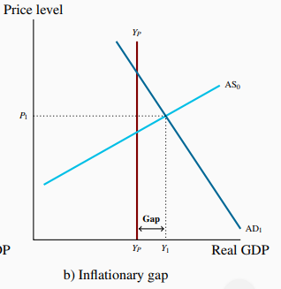

Recessionary Gap
- Measure of the amount by which actual GDP is less than potential GDP
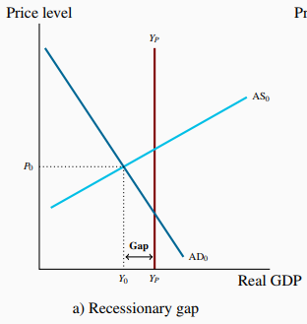
Unemployment rate
- Fluctuate with output gaps

Inflationary Gaps and Recessionary Gaps
- Terms used to describe positive and negative output gaps based on the effects the gaps have on factor prices

Actual Output Adjusts to Potential Output if ...
- Overtime if factor input and final output prices are flexible
- Changes in prices shift the aggregate supply curve to equilibrium with aggregate demand at Yp

Fiscal and Monetary Policy
- Tools governments and monetary authorities can use to stabilize real output and employment or speed up the economy’s adjustment to output gaps

Chapter 5 - Equations

$Equilibrium GDP =AD = AS$

$Output Gap = Y - Yp$

$Output Gap (\%) = \frac{Y - Yp}{Yp} * 100$

$Inflationary Gap = Actual GDP > Potential GDP$

$Recessionary Gap = Actual GDP < Potential GDP$

Chapter 6 - Key Concepts

Aggregate Demand
- Real output (Y) and national income in short-run when price are constant
- Aggregate expenditure (AE) at different price levels when all other conditions are constant

GDP (Y)
- National accounts measure of the sum of actual expenditure and income in the economy

Aggregate Expenditure (AE)
- Planned expenditure by business and households
- Sum of planned induced and autonomous expenditure in the economy

Induced Expenditure
- Planned expenditure
- Determined by current income
- Changes when income change

Marginal Propensity to Consume (mpc)
- Change in consumption expenditure
- Caused by change in income

Marginal Propensity to Import (mpm)
- Change in imports
- Caused by a change in income

Induced Expenditure ((c-m)Y)
- Planned consumption expenditure
- Net of imports
- Changes when income changes

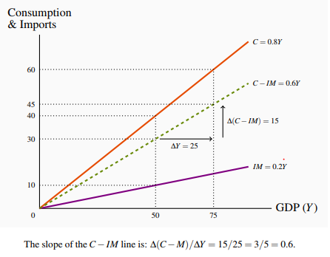

Autonomous Expenditure (A)
- Planned expenditure
- NOT determined by current income

Short-Run Equilibrium Output
- Aggregate expenditure and current output are equal
Constant
- Wages, prices, money supply, interest rates, and exchange rate
- Autonomous and induced expenditures are different
- Equilibrium real GDP requires output equal to planned expenditure

Unplanned Changes in Business Inventories
- Indicators of disequilibrium between planned and actual expenditures
- Incentives for businesses to adjust levels of employment and output (Y)

Aggregate demand($Δ$Y/$Δ$A)
- Ratio of change in equilibrium income Y to the change in autonomous expenditure A that caused it

Chapter 6 - Equations

$Induced C = mpc = c = ΔC / ΔY$

$Induced IM = mpm = m = ΔIM / ΔY$

$Induced Expenditure = (ΔC-ΔIM) / ΔY$

$Autonomous Expenditure =A$

$Aggregate Expenditure = AE = Ao + (c-m)Y$

$Short-Run Equilibrium output=Y=AE$

$Y=Ao + (c-m)Y$

$Y- (c-m)Y=Ao$

$Y(1- (c-m))=Ao$

$Y=Ao/(1- (c-m))$

$Y=A/(1-Slope of AE)$

$NEW Short-Run Equilibrium output=Yo-(mutiplier*ΔAE)$

$Unplanned Change in Inventory = Y-AE$

$Multiplier = ΔY/ΔA$

$Multiplier = 1/(1-Slope of AE) =1/(1-c+m)$

Chapter 6 - Problems

Impact of change in autonomous consumption on new short run equilibrium
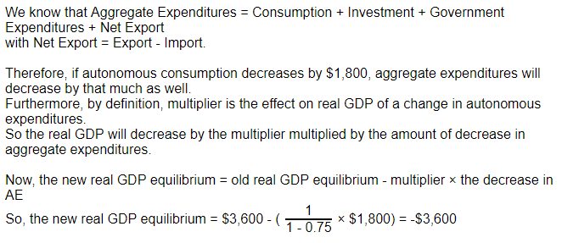

Chapter 7 - Key Concepts

Government Expenditure (G)
- Government spending on currently produced goods and services
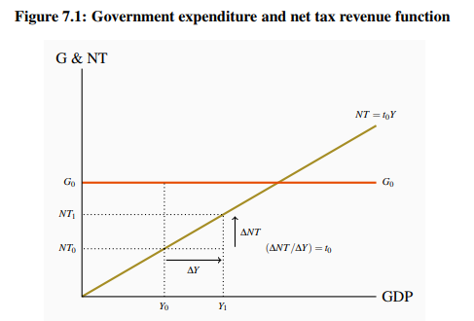

Net Taxes (NT = tY)
- Taxes on income minus transfer payments
- Revenue collected by government from households are difference between taxes collected and transfers paid

Net Tax Rate (t)
- Reduces changes in disposable income relative to national income
- Reduces the marginal propensity to consume out of national income to c(1-t)
- Lowering the slope of AE and therefore the size of the multiplier

Disposable Income (YD)
- National Income minus net taxes
- Changes in disposable income cause changes in household consumption expenditure based on the MPC
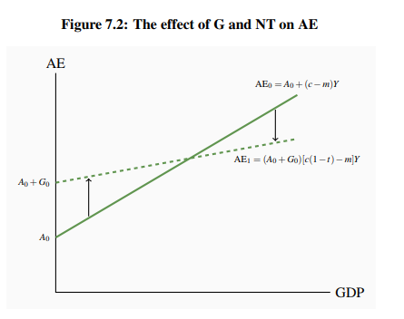
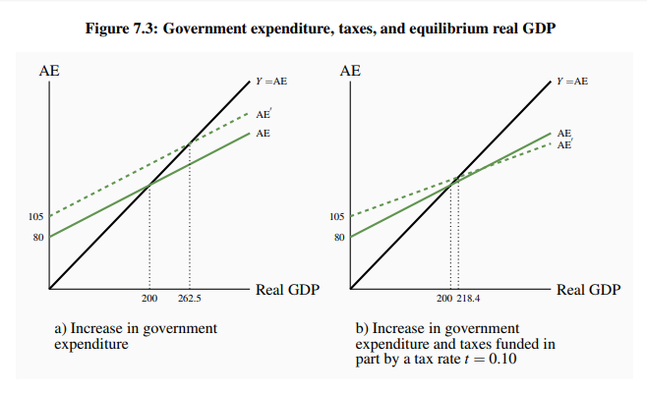

Government Budget
- Planned government spending and revenue
- Most spending is financed by taxes, some comes from charges for services
Balanced Budget
- Revenues are equal to expenditures
Budget Surplus
- Revenues are greater than expenditures
Budget Deficit
- Expenditure are greater than revenues
Budget Function
- Relationship between the budget balance and the level of national income for a specific budget program
Determined by
- Net tax rate set by government
- Level of expenditure set by the government
- Level of output Y determined by AE and AD
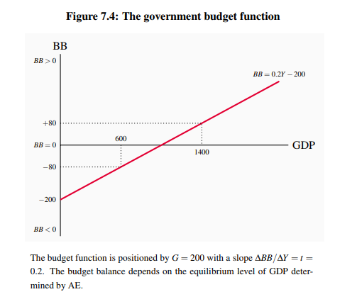
Fiscal Policy
- Government use of taxes and spending to affect aggregate demand and equilibrium GDP
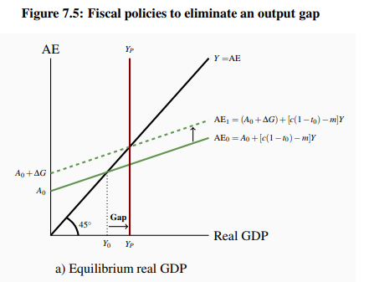
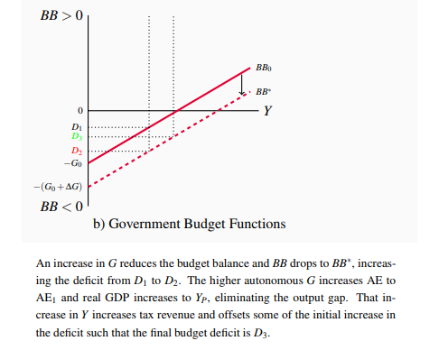

Fiscal Austerity
- Cuts in government expenditure and or increases in taxes aimed at improving the government’s budget balance
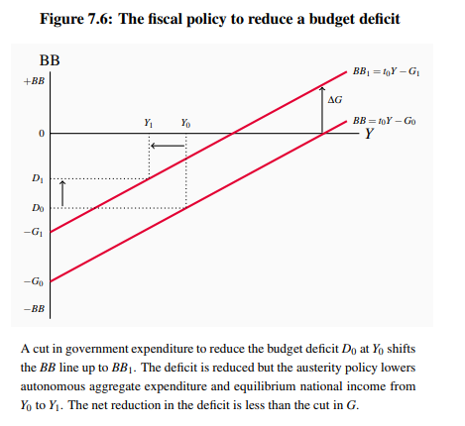
Structural Budget Balance (SBB)
- Government budget balance at potential output
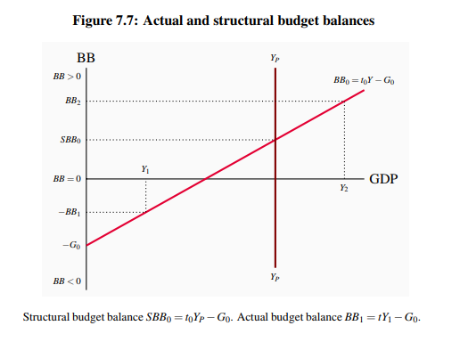

Automatic Stabilizers
- Tax and transfer programs
- Reducing the size of the multiplier
- Reducing the effects of transitory fluctuations in autonomous expenditures on equilibrium GDP

Discretionary Fiscal Policy
- Changes in net tax rates and government expenditure
- Intended to offset persistent autonomous expenditure shocks
- Intended to stabilize aggregate expenditure and output
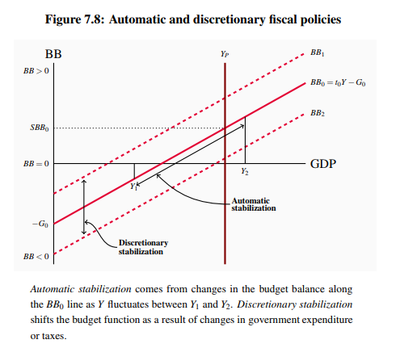
Public Debt (PD)
- Outstanding stock of government bonds issued to finance government budget deficits

Public Debt Ratio (PD/Y)
- Ratio of outstanding government debt to GDP

*Recent debt crisis due to high and rising debt ratio
- Portugal
- Ireland
- Greece
- Spain

*Government sector and fiscal policy
- Are important determinants of aggregate demand and equilibrium GDP
- Government expenditures are an autonomous policy variable
- Net tax rate and policy affect the size of the multiplier
- Changes in government expenditure and tax programs through the setting of the government’s budget affects AE, AD, and equilibrium GDP

Chapter 7 - Equations

$Disposable Income = YD = Y - NT$

$\frac{ΔAE}{ΔY}=c(1-t)-m$ PAGE 159 for more details

$Multiplier=\frac{ΔY}{ΔA}=\frac{1}{1-c(1-t)+m}$

$Budget Balance=Net Tax Revenue - Government Expenditure$

$BB=tY-G$
$BB=o.4+equilibrium$

$SBB=tYp-G$

$ΔPD=-BB$

$Public Debt Ratio=PD/Y$

$Y=\frac{A+G}{1-slope of AE}$

$Y=\frac{A+G}{1-c(1-t)+m}$

$Y=C+I+G+X-IM$

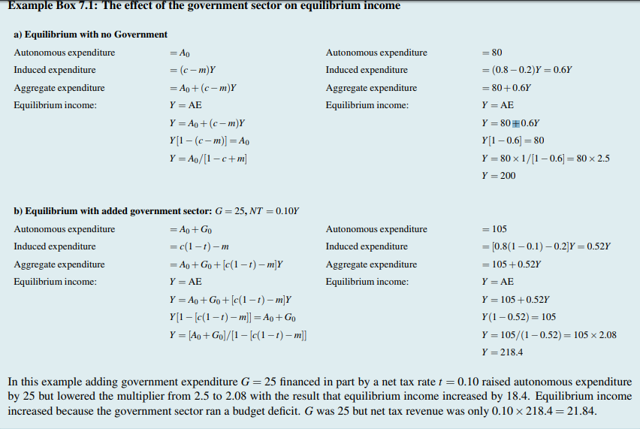

Chapter 7 - Problems
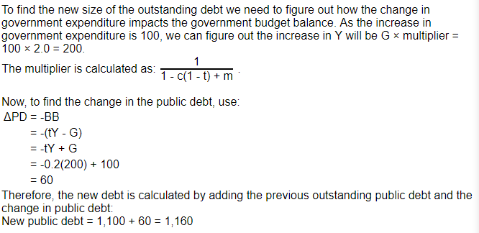

Chapter 8 - Key Terms

Money Four Important Functions
- A mean of payment as a medium of exchange
- Unit of account
- Store of value
- Standard of deferred payment

Means of Payment
- Commodity or token generally accepted in payment for goods and services or repayment of debt

Barter Exchanges
- Direct exchanges of goods or services for goods or services without the use of money

Unit of Account
- Standard in which prices are quoted and accounts are kept

Store of Value
- Asset that carries purchasing power forward in time for future purchases

Standard of Deferred Payments
- Units in which future financial obligations are measured

Token Money
- Convertible claims on commodity money

Legal Tender
- Money that by law must be accepted as a means of payment

Bank Reserves
- Cash (Legal Tender) held by banks to meet possible withdrawals by depositors

Fiat Money
- Money the government has declared as legal tender

Credit Money
- Debt of a private business or individual

Money Supply
- Means of payment in the economy, namely currency (notes and coin) in circulation outside the banks and bank deposits
- Notes and coin in circulation outside banks plus bank deposits

Monetary Base
- Legal tender comprising notes and coins in circulation plus the cash held by the banks

E-payments
- Online payment

Centralized E-Money

Decentralized E-Money
- Cryptocurrency

Financial Intermediary
- Business that specializes in bringing borrowers and lenders together

Bank of Canada
- Canada’s central bank
Provides
- Banking services for the commercial banks in the system
- Banking services for the federal government
- Lender-of-last-resort facilities in times of liquidity crises and reserve shortfall

Liquidity
- Cost, speed, and certainty with which asset values can be converted into cash

Net Interest Income
- Excess of loan interest earned over deposit interest paid

Bankers Risk
- Risk that customers may demand cash for their deposits

Four Key Conditions for the ability to Create Money
- Non-bank public has confidence in banks and is willing to hold and use bank deposits as money
- Non-bank public is willing to borrow from the banks to finance expenditure or assets purchases
- Banks are willing to operate with cash reserves equal to some small fraction of their deposit liabilities
- Banks are willing to accept the risks involved in lending to the non-bank public

Reserve Ratio - (rr)
- Ratio of cash reserves to deposit liabilities held by banks
Financial Panic
- Loss of confidence in banks and rush to withdraw cash

Money Supply is Determined by
- Source of the cash in the economy
- Amount of that cash that is deposited in the banking system, rather than held as cash balances by the public
- Relationship between the cash supply to the economy and the money supply that results from public and bank behaviour

Monetary Base - (MB)
- Legal tender comprising notes and coins in circulation plus the cash held by the banks

Deposit Multiplier
- Change in the bank deposits caused by a change in the monetary base

Chapter 8 - Equations
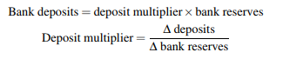
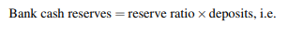
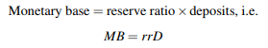
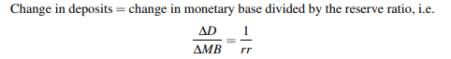
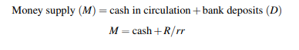
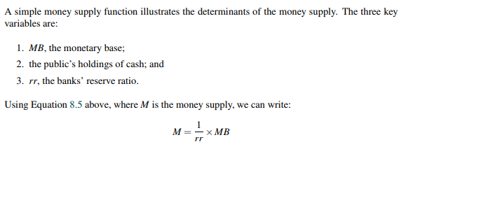
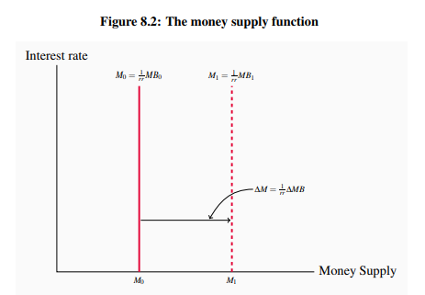

Chapter 8 - Problems

Chapter 9 - Key Terms
Bond
- Financial contract that makes one or more fixed money payment at specific dates in the future

Interest Rate
- Current market rate paid to lenders or charges to borrowers

Bond Coupon
- Annual fixed money payment paid to a bond holder
Price of a Marketable Bond
- Current price at which the bond trades in the bond market

Yield on a Bond
- Return to a bond holder expressed as an annual percentage

Bond Price
- Present value of future payments of interest and principal

Present Value
- Discounted value of future payment

Three Parts of Money Demand
- Transactions demand
- Precautionary demand
- Asset or speculative demand

Real Money Supply
- Nominal money supply (M) divided by the price level (P)
(M/P)
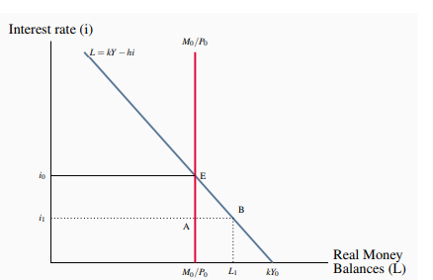
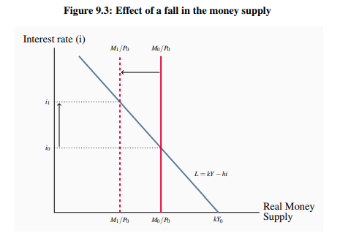

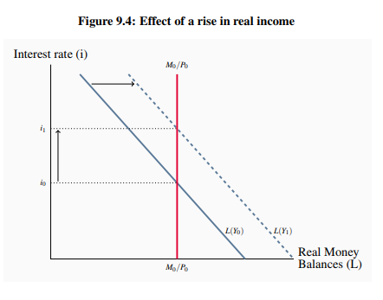

Foreign Exchange Rate
- Domestic currency price of a unit of foreign currency

Appreciation of the National Currency
- Increase in the value of the currency relative to other national currencies
- Results in a fall in the domestic currency price of foreign currencies

Transmission Mechanism
- Links money, interest rates, and exchange rates through financial markets to output and employment and prices
Three Important Channels of Transmission Mechanism
- Effect of interest rate changes on Consumption Expenditure
- Effect of interest rate changes on Investment Expenditure
- Effect of interest rate changes on Foreign Exchange Rates and Net Exports

Effect of Interest Rate Changes on Consumption Expenditure
- Wealth effect from changes in the prices of financial assets
- Cost of credit effect

Wealth Effect
- Change in expenditure caused by a change in real wealth

Cost of Credit
- Cost of financing expenditures by borrowing at market interest rates

Investment Function
- Explains the level of planned investment expenditure at each interest rate

Chapter 9 - Equations
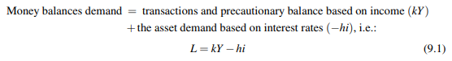
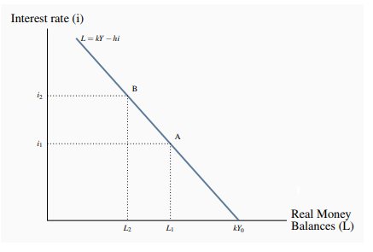
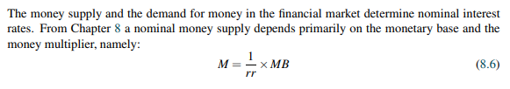
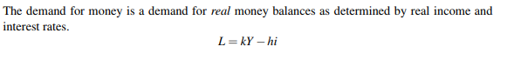
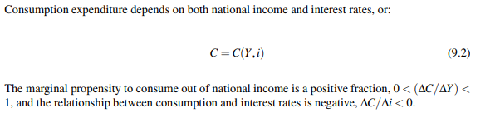
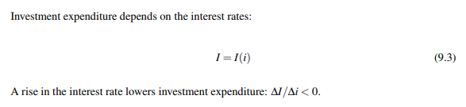

Chapter 9 - Problems

Chapter 10 - Key Terms
Central Bank
- Institution conducting monetary policy using its control of monetary base and interest rates

Difference Between Private and Central Bank
Private Banks
- For-profit organization
- Provides financial services to businesses and households
Central Bank
- Operates to influence the behavior of other banks and intermediaries in the financial system
- Not profits oriented (but still generates profits)
- Serve as banker to the government and to the banks
Monetary Policy
- Central bank action to control inflation and support economic growth
- Through control of the money supply, interest rates, and exchange rates
- To change aggregate demand and economic performance

Central Bank Operating Techniques
The money multiplier is larger when
- Reserve ratio (rr) banks hold is smaller
- The amount of currency the non-bank public wishes to hold is small and constant
If both are constant
- Central bank can change the size of the money supply by changing the size of the monetary base
Techniques to control Monetary Base and Money Supply
- Establishing reserve requirements
- Using open-market operations
- Adjusting central bank lending rates

Required Reserve Ratio
- Legal minimum ratio of cash reserves to deposits
(Ratio Reserve is also a key determinant of the money multiplier)

Open Market Operation
- Central bank purchases or sales of government securities in the open financial market
- Alters the money supply
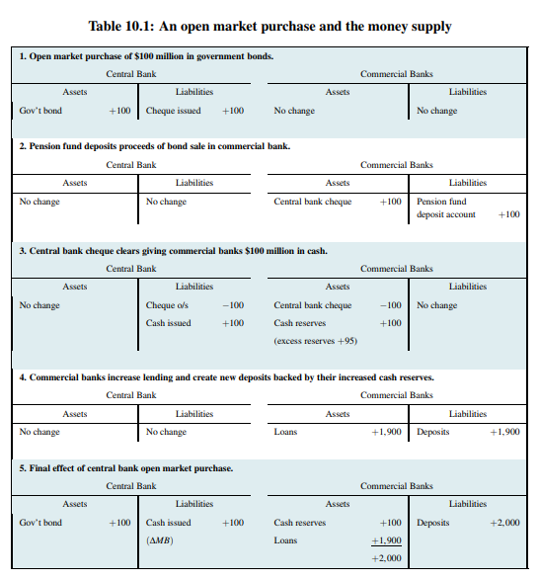

Bank Rate
- Interest rate the central bank charges on its loans to commercial banks
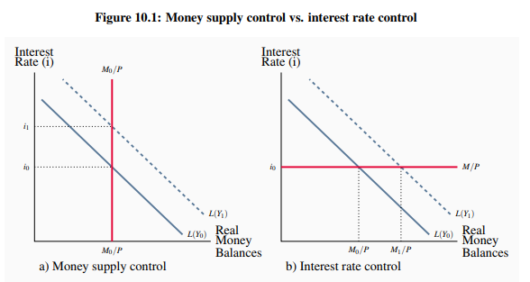
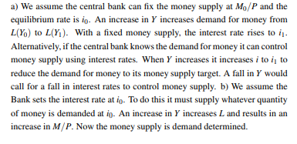
Exchange Rate Target
- Monetary policy maintains a fixed price for foreign currency in term of domestic currency

Money Supply Target
- Central bank adjust interest rates and the monetary base
- To control the nominal money supply
- Or, to control the rate of growth of nominal money supply

Inflation Rate Target
- Monetary policy objective defined as an announced target inflation rate

Monetary Policy Instrument
- Monetary variable the central bank manipulates in pursuit of its policy target

Overnight Rate - (ONR)
- Interest rate large financial institutions receive or pay on loans from one day until the next
- Target are at midpoint of an operating band, plus or minus 25 points
Upper Limit

Prime Lending Rate
- Base for setting the interest rates charged by banks on loans and lines of credit

Special Purchase and Resale Agreement - (SPRA)
- A bank of Canada purchase of securities one day combined with an agreed resale of the securities the next day
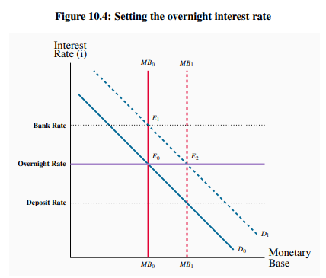

Sale and Repurchase Agreement - (SRA)
- A bank of Canada sale of securities one day combined with an agreed repurchase of the securities the next day

Taylor Rule
- Central bank interest rate settings based on inflation and output targets

Effective Lower Bound - (ELB)
- A Bank’s policy interest rate cannot be set below a small positiv e number

Moral Suasion
- A central bank persuades and encourages banks to follow its policy initiatives and guidance

Quantitative Easing
- Large scale purchase of government securities to increase the monetary base

Credit Easing
- Management of the central bank’s assets designed to support lending in specific financial markets

Forward Guidance
- Information on the timing of future changes in the central bank’s interest rate setting

Monetary Policy Indicators
- Variables that provide information about the stimulus or restraint coming from the central bank’s policy

Chapter 10 - Equations
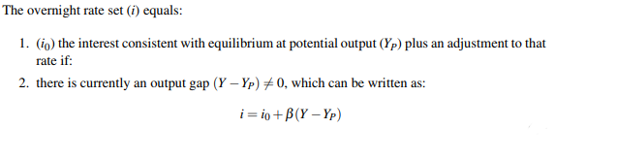
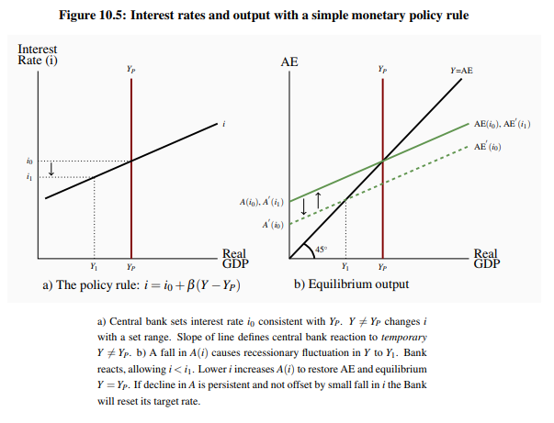

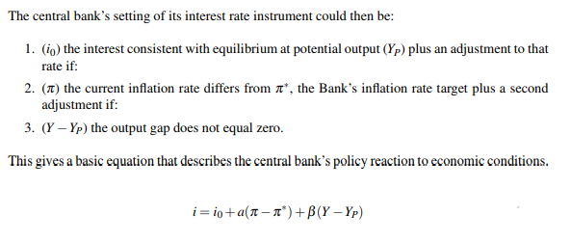

Chapter 10 - Problems

  - When Y (Real Output) decreases
L(Y) (Demand Curve) decreases (Goes to the left)
  - Money Supply decreases when Interest Rate is constant, Only Money Supply is Affected
  - Ibid

  - When $π=π*$ and $Y=Yp$, $i=i0$
  - Given $π=π*$ and $Y-Yp = -3\%$, $i=i0-3\%$
  - When i drops, firms invest more, AD and AE will create an upward pressure on inflation
  - $π*=2\%$, $π=π*-0.5(Δi)$, $Δ=i1-i0=7\%-10\%=-3\%$ therefore $π=2-0.5(-3\%)=3.5\%$

  - When bank A has a surplus,
Holding Deposit = Minimum Operating Band
Another Bank = Max Operating Band
  - When Bank B has a shortage
Can Borrow from Bank of Canada or another Bank
Minimum Rate to Borrow Funds from other Banks = Min Operating Band
Rate Paid to Bank of Canada = Max Operating Band
  - Excess balance rate
Shortage rate

  - When $π=π*$, $Y=Yp$, then, $ONR=i0$
  - $β(Y-Yp)$ times 100 for basis point change
$[β(Y-Yp)/Yp*100]*100$, $0.2(1332-1200)/1200*100*100=220$
  - $a(π-π*)$ times 100 for basis point change,$a(π-π*)*100$, $4.3(-0.4)*100$

  - Bank of Canada three main monetary policy instrument
    - Open market operations
    - Changes in ONR
    - Government deposit switching
  - When a central bank sets an inflation rate target as the primary goal of monetary policy
    - It must also accept the money supply, exchange, and interest rate consistent with its inflation target
  - Main objective of a central bank’s operations is
    - Manage the size of the monetary base
    - Manage the size of the currency
    - Manage the size of the central bank deposits used by other financial institutions and the public
  - Suppose the Bank of Canada wants to eliminate an inflationary gap that threatens its inflation rate target by reducing aggregate expenditure and aggregate demand
    - Increase its setting for the ONR and the bank rate
  - If a central bank conducts monetary policy by setting a target for the money supply, or the money supply growth rate, as the Bank of Canada did in the late 1970
    - It must then accept the interest rate, exchange rate, and inflation rate required by its money supply target

Chapter 11 - Key Concepts

Economy’s Output Depends on
- State of technology
- Quantities of factor inputs to production (Labour, capital, land, energy, and entrepreneurship)
- Efficiency with which resources and technology are used

Production Function
- Outputs determined by technology and inputs of labour and capital

Productivity
- Output per unit of input

Potential Output - (Yp)
- Real GDP the economy can produce on a sustained basis
- With current labour capital and technology
- Without generating inflationary pressure on price

NAIRU
- Non-Accelerating Inflation Rate of Unemployment
- Correspond to Nf at Yp
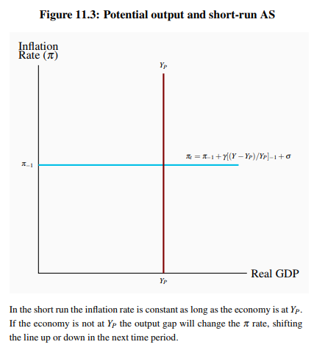
Public Debt Ratio - (PD/Y)
- Ratio of government debt to GDP

Primary Budget Balance - (PBB = tY-G)
- Difference between net tax revenue at Yp and government program expenditure
- Excludes interest payments on the public debt

Disinflation
- Persistent fall in the inflation rate

Deflation
- Persistent fall in the general price level
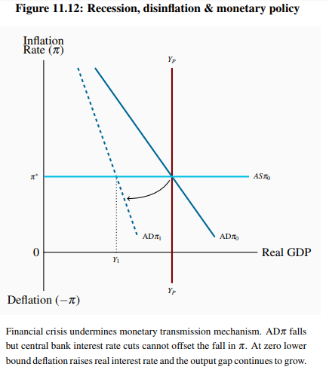
Quantitative Easing
- Central bank purchase of financial assets to increase its asset holdings and the monetary base

Credit Easing
- Management of the central bank’s assets designed to support lending in specific financial markets

Chapter 11 - Equations

Chapter 11 - Problems

Chapter 12 - Key Concepts

Balance of Payments Accounts
- Record of trade and financial transactions between residents of one country and the rest of the world

Current Account
- Record of trade in goods, services, and transfer payments

Nominal Exchange Rate - (er)
- Domestic currency price of a unit of foreign currency

Real Exchange Rate
- Relative price of goods and services from different countries measured in a common currency

Financial Account
- Record of capital transfers and the purchases and sales of real and financial assets

Perfect Capital Mobility
- When very small differences in expected returns cause very large international flows of funds

Change in Official International Reserves
- Change in the Government of Canada’s foreign currency balances

Balance of Payments
- Sum of the balances in current accounts and financial accounts
- Minus the change in the holdings of official reserves

Current Depreciation
- Fall in external value of the domestic currency that raises domestic currency price of foreign currency

Currency Appreciation
- Rise in external value of the domestic currency that lowers the domestic currency price of foreign currency

Exchange Rate Regime
- Policy choice that determines how foreign exchange market operate

Flexible Exchange Rates
- Supply and demand in the foreign exchange market determine the equilibrium exchange rate without central bank intervention

Fixed Exchange Rate
- Exchange rate set by government policy that does not change as a result of changes in market conditions
Convertible Currency
- National currency that can be freely exchanged for a different national currency at the prevailing exchange rate

Official Exchange Reserves
- Government foreign currency holdings managed by the central bank

Central Bank Intervention
- Purchases or sales of foreign currency intended to manage the exchange rate

Devaluation/Revaluation
- Reduction/Increase in the international value of the domestic currency

Chapter 12 - Equations

Chapter 12 - Problems

Chapter 13 - Key Concepts

Economic Growth
- Annual percentage change in real GDP or per capita real GDP

Very Long Run
- Time required for changes to occur in the stock of capital, the size of the labour force, and the technology of production

Total Factor Productivity - (TFP)
- Output relative to the combined inputs of labour and capital, the total factor inputs to production

Actual Real GDP
- A is determined by the current state of technology
- K and N measure the actual use of capital and labour

Growth Accounting
- Measurement of the contributions of labour, capital, and technology to growth in output

Growth in the Real GDP
The sum of:
- Effect of growth in Total Factor Productivity
- Effect of growth in Labour Inputs
- Effect of growth in Capital Inputs

Growth in Potential GDP
- Growth in total factor productivity PLUS weighted sum of the growth in the capital and labour input to production

Solow Residual
- Growth in the real GDP or per capita real GDP
- Not caused by growth in factors inputs
- Attributed to improved technology

Marginal Product
- Change in total output caused by a change of one unit in the input of that factor to production

Constant Returns to Scale
- Equal percentage increases in inputs of labour and capital increase output by the same percentage

Sustained Growth in Per Capita Real GDP
- Improvements in technology overcome the diminishing returns to increases in the capital to labour ratio

Invention
- Discovery of new knowledge

Innovation
- Application of new knowledge into production techniques

Exogenous Variable
- Variable with a value determined outside the model
- Out

Endogenous Growth
- Growth determined economic behaviour and policy within the model
- In

Chapter 13 - Equations

Chapter 13 - Problems

