Experiment 1- Microscopy

- Infinity Capture
- Compound microscope, Dissecting (Stereoscopic) microscope
- Dissecting/Stereoscopic microscope
- Revolving nosepiece
- Stage
- Coarse focus knob
- Fine focus knob
- Ocular/eyepiece
- Objective
- Condenser
- Condenser height adjustment knob
- Aperture iris diaphragm, angle
- Magnification
- Numerical aperture/ resolving power of the objective
- Maximum coverslip thickness in mm
- Kimwipes
- e
- “upside down” e
- Decreases
- Decreases
- Stereoscopic
- Reflected, transmitted
- Reflected, opaque, Transmitted, translucent
- Eukaryotic, prokaryotic
- Eukaryotic, prokaryotic
- Eukaryotic, prokaryotic
- Elodea, plant
- Photosynthesis
- Chlorophyll
- Cytoplasmic streaming
- Plasma membrane, 5% NaCl, cell wall, protoplast
- Oscillatoria
- Artemia, protoslow

Experiment 2- Permeability of the Red Blood Cell

- Erythrocytes
- Isotonic NaCl, serum at 4°C
- Hemoglobin
- Ruptures, hemolysis
- Osmosis, aquaporins
- Tonicity adjustment
- Hypotonic
- Hypertonic
- Diffusion
- Speeds
- Hypotonic
- Isosmotic
- Transparent
- More
- A

Experiment 3- Cellular Processes in Amoeba proteus

- Contractile vacuole, Amoeba proteus
- Light
- Amoebozoa group
- Single, eukaryote
- The bottoms of freshwater ponds and lakes
- Pseudopodia, vacuoles
- Pseudopodia, actin
- G-actin, F-actin
- Osmosis, contractile vacuole
- One
- Releases all its content of the C.vacuole to the outside, systole
- 4-6
- Bulk-phase or nonspecific, proteins & amino acids & salts
- 0.05% Alcian blue at pH 4.4 containing 1% bovine plasma albumin
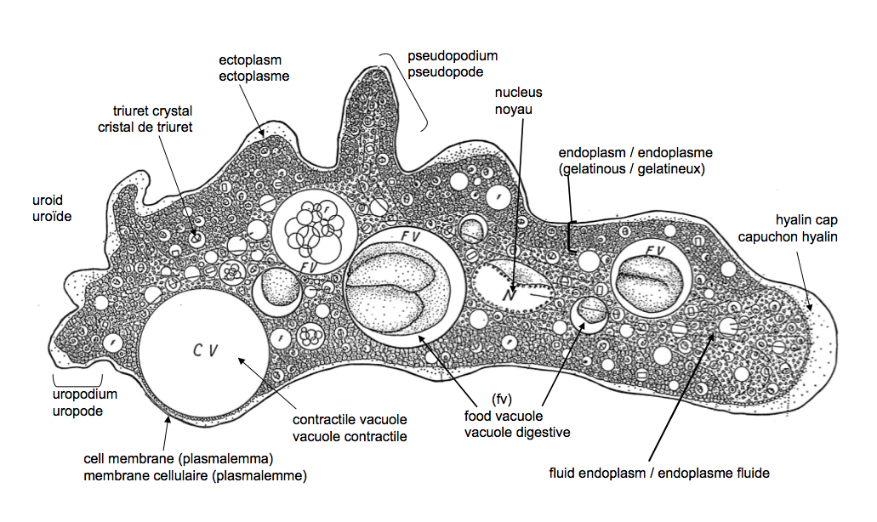

16.
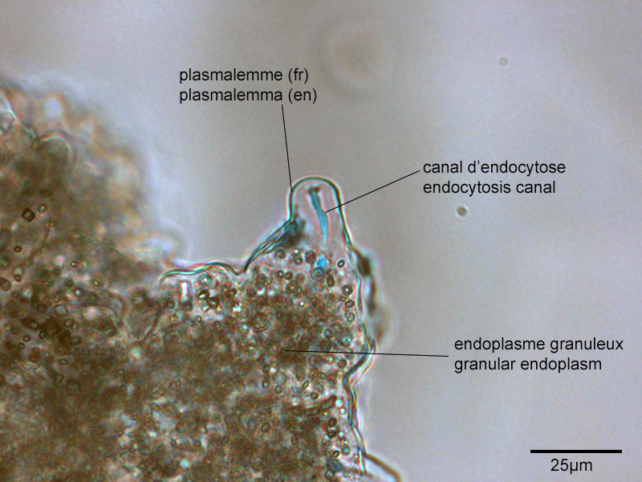
17.
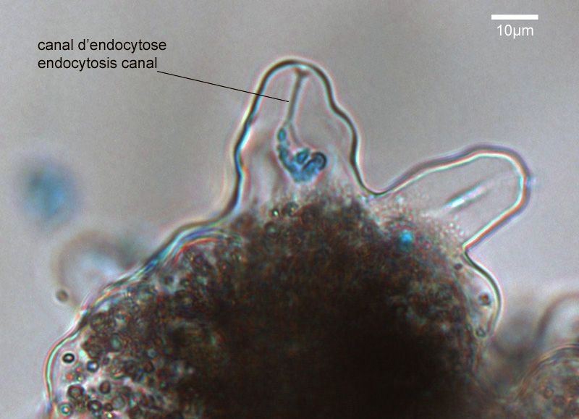

Experiment 4- Mitosis

- Reproduce
- Cellular division
- Mitosis
- M phase, Interphase
- Mitosis, cytokinesis
- G0, G1, S, G2
- Interphase
- G1
- S
- G2
- G0
- Chromatids, cohesins
- Mitosis
- Prophase, prometaphase, metaphase, anaphase, Telophase
- Cytokinesis
- Interphase
- Prophase
- Prometaphase
- Metaphase
- Anaphase
- Telophase, cytokinesis
- Plant
- Feulgen, magenta red
- HCl, apurinic acid
- 10

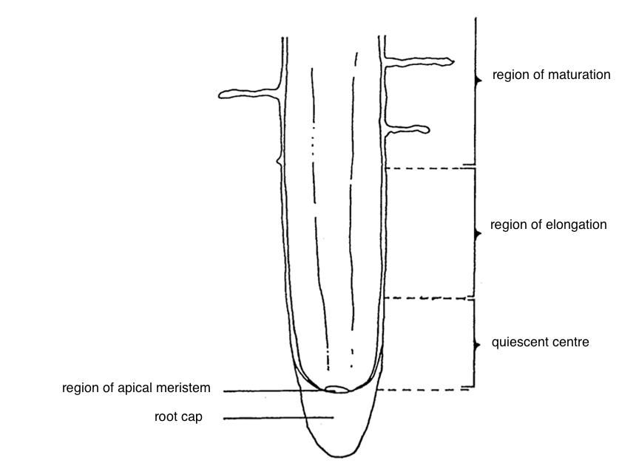

Experiment 5- Meiosis

- spermatogenesis, oogenesis

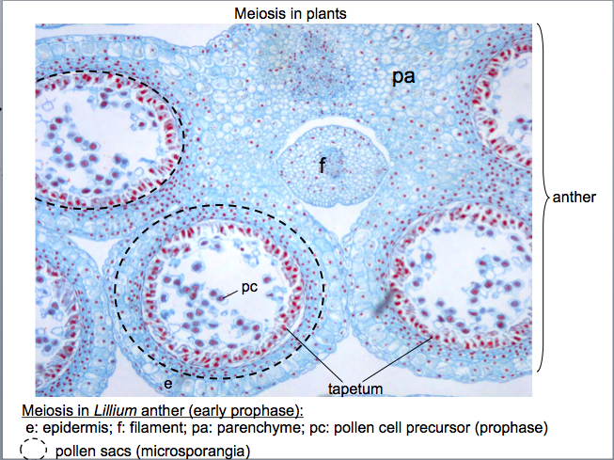
3.
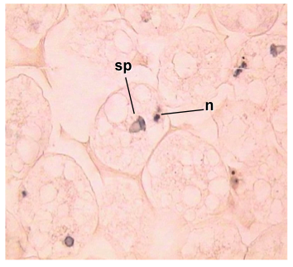
4. Meiosis
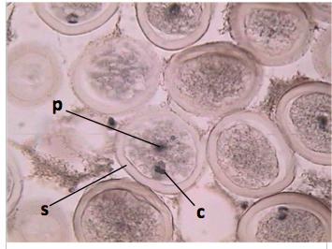
5. Anaphase 1
6. Metaphase 2,
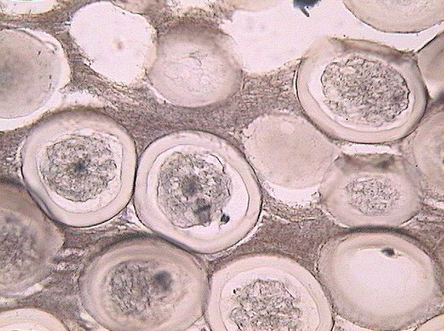

pb
7. Anaphase 2
8. pronuceli, fertilization
9. 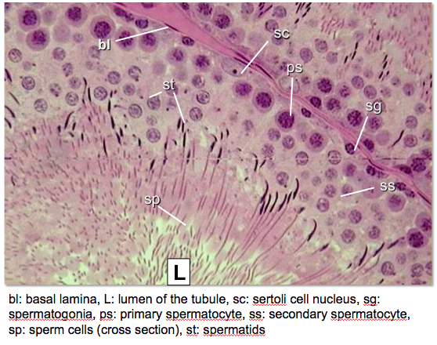
10.
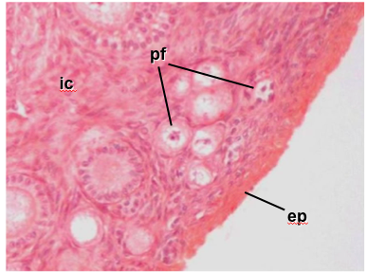

11.
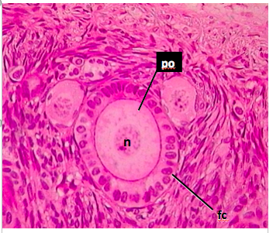
12.
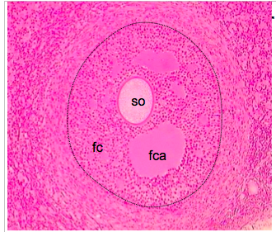

- Yes
- 4, different
- n
- Sexually
- Spores, gametophytes, zygotes, sporic meiosis
- Premeiotic interphase, identical
- Prophase 1
- Leptotene, Zygotene, Pachytene, Diplotene, Diakinesis
- Metaphase 1, kinetochores
- Anaphase 1
- Nuclear membrane
- Interkinesis, no
- 4
- Angiosperm
- Lilium
- Spermatogenesis
- 4
- Oogenesis
- Polar body
- Ascaris
- One
- Pronuclei
- Telophase 1, Telophase 2
- Perivitelline space
- Fertilization

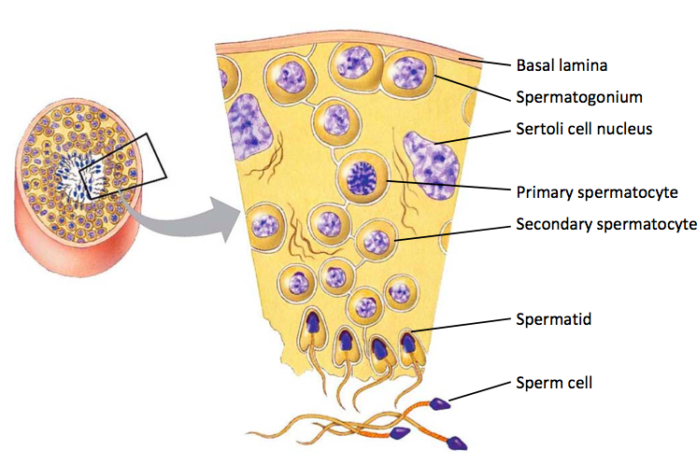

- Sertoli cells
- Spermatozoa
- Spermatid
- Oogonia
- Follicle cells, primary follicle
- Primary follicles
- Secondary follicles
- Graadian follicles

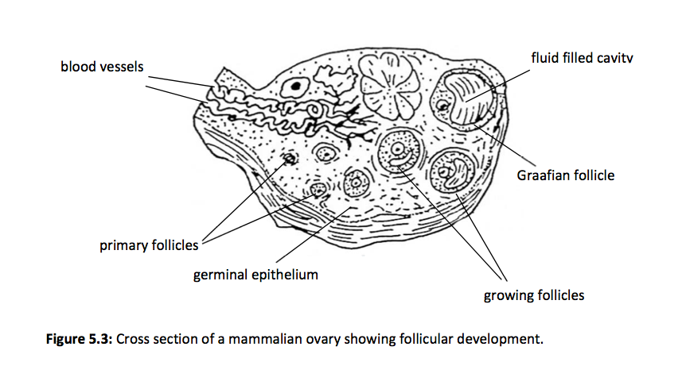

Appendix

- y
- Histograms
- Straight-line
- Scatterplots
- Caption
- 3-5
- Scale
- Symbol key
- Separately
- Above
- Vertical
- Foot notes
- Left, half
- No
- No
- On the drawing, pointer
- Scale
- Below
- End

