Lecture Notes
Week 1: Intro to information systems
Why should I study information systems
- We are the most connected generation in history and have grown up online. We use the most information technologies (aka digital devices). MIT refers to us as Homo Conexus.
- We study MIS to become an informed user; a person knowledgeable about info systems and tech. Informed users get more value from whatever tech they use. Benefits of becoming an informed user:
  - You benefit more from your org’s IT apps since you understand what’s behind those apps
  - Can enhance the quality of your org’s IT apps with your input
  - Even as a new grad, you can recommend IT apps that your org will use
  - Understand how using IT can improve performance, teamwork and productivity
  - Can help if you decide to start your own business
  - Will keep you up to date on new developments on tech and this will help you anticipate impacts that new tech will have on your org

Traditional functions of MIS:
- Managing systems development and project management
- Managing computer operations including the computer centre
- Staffing, training and developing IS skills
- Providing tech services
- Infrastructure planning, development and control

New functions of MIS:
- Initiating and designing specific strategic info systems. Your info needs will often mandate the development of new strategic info systems. You decide which strategic systems you need and provide input into developing these systems
- Incorporating the internet and electronic commerce into the business
- Managing system integration, including the internet, intranets and extranets. Your business needs will determine how you may want to use the internet for your goals etc.
- Educating the non-MIS managers about IT
- Educating the MIS staff about the business
- Partnering with business unit execs
- Managing outsourcing
- Proactively using business and tech knowledge to seed innovative ideas about IT
- Creating business alliances with business partners
Competing in the information age
- Business ideas integrated with tech
  - Amazon first created by Bezos to offer customized, lower cost books
  - Netflix wanted to offer unlimited viewing of rented movies
  - Better use of time for young professionals was the goal that inspired Grocery Gateway

Information systems impact on business operations
- Business undertake enterprise-wide IT initiatives to:
  - Lower costs
  - Improve productivity
  - Generate growth
- IT provides
  - Communication
  - Data and info analysis
- Org’s usually operate by functional areas of silos. Departments must function interdependently to share common info
  - Challenges with this is differentiation between how departments function independently, no standardization.
  - Horizontal flow of information so departments can communicate and interact with each other
The basics…
- Info systems - computer based tools that used to work with info and support the info and info-processing needs of an org. IS is an enabler of business success and innovation
- Include: hardware, software, trained personnel, policies and procedures and security measures
- Info tech - the acquisition, processing, storage and distribution of voice, graphics, text and numbers and other info by a combo of computers and telecommunications networks
- Management info systems - the function that plans, develops and implements and maintains IS hardware, software, and apps that people use to support the goals of an org
  - MIS is a business function kind of like finance and HR
  - Includes decisions regarding policies

Data | Information | Business Intelligence | Knowledge
Raw facts that describe the characteristics of an event or object | Data converted into a meaningful and useful context | Info collected from many sources that analyze patterns, trends, and relationships for strategic decision making | Skills, experience and expertise coupled with info and intelligence that creates a person’s intellectual resources
Order date, amount sold, customer number, quantity ordered | Best/worst-selling product, best/worst customer | Lowest sales per week compared with the economic interests rates | Choosing not to fire a sales rep that is underperforming knowing that person is experiencing family problems

Relationships between people, processes, info tech and info - people use the processes to work with info systems to produce info

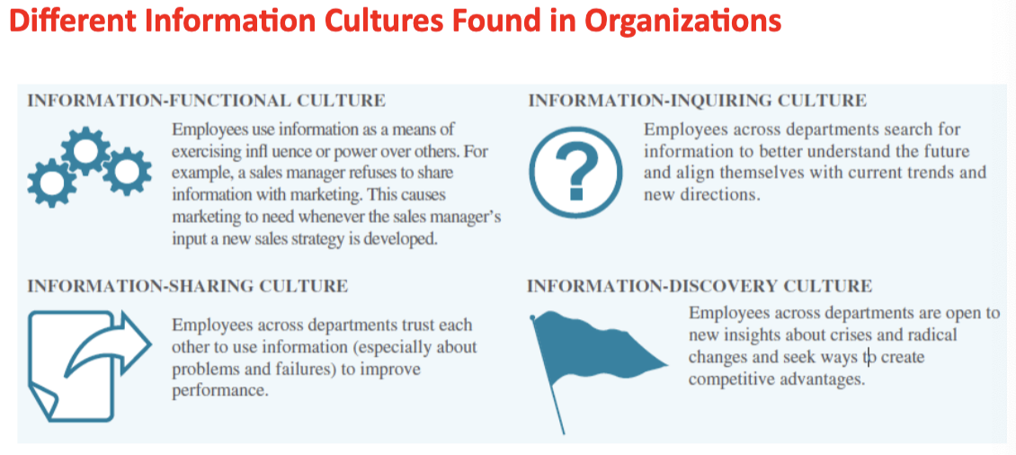
Info system roles and responsibilities
- Chief info officer (CIO) - oversees all uses of IT and ensure the strategic alignment of IT with business goals and objectives
- Chief knowledge officer (CKO) - responsible for collecting, maintaining and distributing the org’s knowledge
- Chief privacy officer (CPO) - responsible for ensuring the ethical and legal use of info
- Chief security officer (CSO) - responsible for ensuring the safety of IT resources including data, hardware, software and people
- Chief tech officer (CTO) - responsible for ensuring the throughput, speed, accuracy, availability and reliability of IT
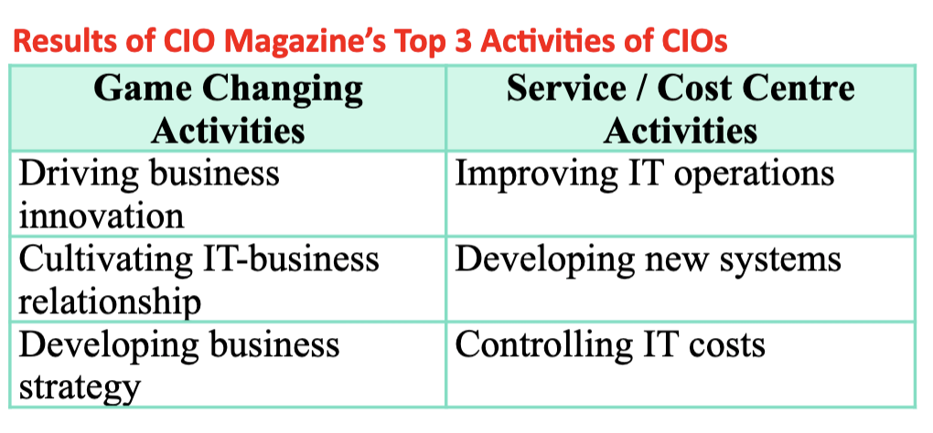
Overview of computer-based info systems
- The purpose of information systems has been defined as getting the right info to the right people at the right time, in the right amount and in the right format
- Hardware - consists of devices such as the processor, monitor, keyboard, and printer. Together they accept, process and display data and info
- Software - program or collection of programs that enable the hardware to process data
- Database - a collection of related files or tables containing data
- Network - connecting system (wireless or wired) that allows different computers to share resources
- Procedures - instructions for combining the above components to process info and generate the desired output
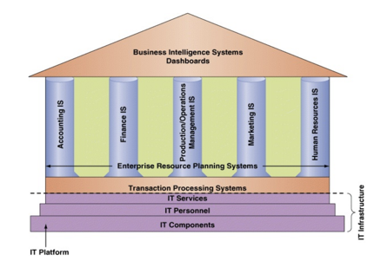
Major capabilities of info systems
- Perform high-speed, high volume numerical computations
- Provide fast, accurate communication and collaboration within and among org’s
- Store huge amounts of info in an easy to access yet small space
- Allow quick and inexpensive access to vast amounts of info worldwide
- Interpret vast amounts of data quickly and efficiently
- Automate both semi-automatic business processes and manual tasks

Week 2: Organizational strategy, competitive advantage and information systems
An organizational strategy is a planned approach that the org takes to reach its goals and mission statement.

Competitive advantage is an advantage over competitors in some measure like cost, quality or speed which leads to control of a market and to larger than average profits.

Business process = collection of related activities (inputs, resources and outputs) that produce a product or service of value to the org, business partners or customers
- Accounting, finance, marketing, HR, etc

Info systems (IS) are enablers of an org’s business processes.
- Execution of a process such as doing the work, calculations, comparisons or creation of data or docs.
  - Ex: when a sale is made, compare inventory quantity on hand to re-order. If inventory is less than re-order level, generate purchase requisitions for the purchasing department
- Capturing and storing process data (such as format the data, store it in the correct data file on a physical storage device such as a hard drive)
  - Once the purchase requisition has been approved by the purchasing department, increase the quantity on order field and store the purchase requisition data in the open purchase requisition file
- Monitoring process performance (such as examine, analyze and assess the business process to ensure compliance and to evaluate the process)
  - Reports can be automatically produced to identify purchase requisitions where goods have not been received, where too much or too little has been received, and or purchase requisitions waiting to be approved.

Cross-functional processes = where no single functional area is responsible for its execution. Multiple functional areas collaborate to perform the process
For example the materials procurement process includes all of the tasks involved in acquiring needed materials externally from a vendor. Procurement has 5 steps that are completed in 3 different functional areas of the firm: warehouse, purchasing and accounting.

How does an org ensure business process excellence?
- Business process reengineering (BPR) is a radical strategy for improving the efficiency and effectiveness of an org’s business processes. Known as the clean slate approach
- Business process improvement (BPI) is a more incremental approach with lower risk and cost than BPR. Six sigma is a popular version
- Business process management (BPM) is a management technique that includes methods and tools to support the design, analysis, implementation and optimization of business processes.

Measure of excellence in executing business processes
- Customer satisfaction
- Cost reduction
- Cycle and fulfillment time reduction
- Quality
- Differentiation
- Productivity

Business process improvement (BPI)
- Five basic phase of successful BPI
  - Define - plot the process visually
  - Measure - things you want to improve, time, cost, and customer satisfaction. Sets a benchmark
  - Analyze
  - Improve
  - Control - monitor and measure again
BPI | BPR
- Low risk/low cost  - Incremental change  - Bottom up approach  - Takes less time  - Quantifiable results  - All employees trained in BPI | - High risk/high cost  - Radical redesign  - Top-down approach  - Time consuming  - Impacts can be overwhelming  - High failure rate

BPM: management system used to support continuous BPI initiatives for core business processes over time
- Importance of BPM is through process modeling, web-enabled tech and business activity monitoring (BAM)
- Business process management suite (BPMS) - an integrated set of applications used for BPM
- Emerging trend of social BPM
  - Tech enabling employees to collaborate across functions internally and externally using social media tools

Business pressures, org responses and IT support
- Market - pressures are generated by the global economy, intense competition, the changing nature of the workforce and powerful customers
- Tech - pressures involving tech innovation and obsolescence and info overload
- Societal - includes social responsibility, gov regulation and deregulation, spending for social programs, spending to protect against terrorism and ethics. Should look at them as opportunities
  - Going green - IT execs listed 3 areas where IT is valuable for going green
    - Facilities design and management
    - Carbon management
    - International and canadadian environmental laws
Market pressures
- The global economy and strong competition; the need for real-time operations
- Changing nature of the workforce
  - Workforce is becoming more diversified women, single parents, minorities and people with disabilities. IT is enabling telecommuting employees
- Powerful customers
  - Increasing consumer sophistication and expectations. Consumer is more knowledgeable about products and services, price comparisons and electronic auctions
Globalization
- Individuals can connect and compete anywhere, anytime
- Competition is increased as people and orgs can provide resources worldwide
- The internet has flattened the world, making anywhere accessible to anyone anytime

Organizational responses - strategic systems, customer focus, make-to-order and mass customization, e-commerce

Competitive advantage and strategic info systems:
- Porter’s competitive forces model

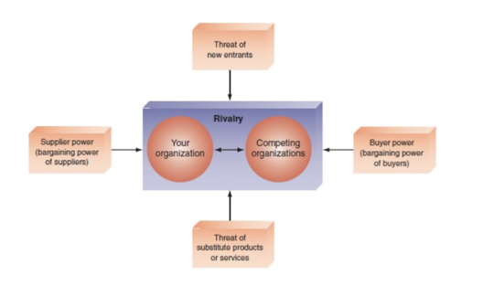
  - Threat of entry of new competitors - the theory that new competitors will enter your market is high when entry is easy and low when there are significant barriers to entry
    - Entry barrier: a product or service that customers have come to expect and that must be provided by all new competitors, increasing the cost to enter a new market
    - Internet increases the threat that new competitors will enter a market because its easy for new competitors to set up a web presence
  - The bargaining power of suppliers is high when buyers have few choices from whom to buy and low when buyers have many choices
    - Impact of the internet is mixed
    - Buyers can find alternative suppliers and compare prices easily, reducing the power of suppliers
    - Companies can use the Internet to integrate their supply chain, suppliers prosper and their power increases (they can charge higher prices), locking in their customers
  - The bargaining power of customers (buyers is high when buyers have many choices from whom to buy and low when buyers have few choices
    - Since the internet increases access to info customer power is increased since customers can look for the lowest price
    - As sellers implement online loyalty programs they can lock in their customers, reducing customer power
  - The threat of substitute products or services is high when there are many alternatives for an org’s products or services and low where there are few alternatives
    - The internet increases the use of substitutes since buyers can readily search for them online
    - Info-based industries are in the greatest danger from this threat (i.e. music, ebooks software, since the internet can be used to send digital info quickly and efficiently)
  - The rivalry among firms in an industry is high when there is intense competition among many firms in an industry. The threat is low when the competition is among fewer firms and is not as intense
    - Rivalry has increased since rivals can easily see via the internet what their competitors are doing and replicate such systems. In the past propriety systems were easier to keep secret, lengthening the time that such systems provided a strategic advantage to orgs
- Porter’s value chain model
- Strategies for competitive advantage
- Business-info tech alignment
  - Alignment is the tight integration of the IT function with the org’s strategy, mission and goals of the org. That is, the IT function directly supports the business objectives of the org
  - Organizations
    - View IT as an engine of innovation that continually transforms the business, often creating new revenue streams
    - View their internal and external customers and their customer service function as supremely important
    - Rotate business and IT professionals across departments and job functions
    - Provide overarching goals that are completely clear to each IT and business employee
    - Ensure that it employees understand how the company makes or loses money
    - Create a vibrant and inclusive company culture
- Competitive strategy - document’s a business’s approach to compete and how it will accomplish those goals, for example in increasing market share
- Competitive advantage - helps a company function profitability within a market and generate larger than average profits
- Strategic information systems - provide a competitive advantage by helping an organization implement its strategic goals and improve its performance and productivity

IT governance
- A structure of relationships and processes to direct and control the enterprise in order to
  - Achieve the enterprise's goals
  - By adding value
  - While balancing risk versus return over IT and its processes
  - Helps org’s effectively manage their IT operations to align with their business strategies
  - Managing IT throughout the org includes
    - Planning, acquisition, implementation, ongoing support as well as monitoring and evaluation.

Week 3: Ethics and Privacy
Ethical issues - basically ethics refers to the principles of right and wrong that individuals use to make choices that guide their behaviour

Ethical frameworks - standards used to develop general frameworks for ethics or ethical decision making
- Utilitarian: provides the most good or does the least harm
- Rights : best protects and respects the moral rights of the affected parties
- Fairness: treat all humans equally or if unequally, then fairly based on some defensible standard
- Common good: respect and compassion for all others is the basis for ethical actions

How to solve ethical issues (traditional and GVV approach)
Traditional | GVV
- Recognize an ethical issue  - Get the facts  - Evaluate alternative actions  - Make a decision and test it | - Identify an ethical issue  - Purpose and choice  - Stakeholder analysis  - Powerful response  - Scripting and coaching

Ethics in the corporate environment
- Code of ethics = a collection of principles that are intended to guide decision making by members of an org.
- Fundamental tenets of ethics include
  - Responsibility - accepting consequences
  - Accountability - determining who is responsible
  - Liability - legal concept about having the right to recover for damages done
- Ethics for students in an academic environment as well

Ethics and IT
- Four general categories of ethical issues in IT
  - Privacy - about collecting, storing and disseminating info about people
    - Privacy = the right to be left alone and to be free of unreasonable personal intrusions
    - Info privacy = the right to determine when and to what extent info about you can be gathered and communicated to others
    - Privacy rights = apply to people, groups and institutions
    - Court's ruling on defining privacy
      - The right of privacy is not absolute, your privacy must be balanced against the needs of society
      - The public’s right to know supersedes the individual's right of privacy
  - Accuracy - authenticity, accuracy and fidelity of info that’s collected and processed
  - Property - ownership and value of info
  - Accessibility - who should have access to info and if fees should be paid for such access
- IT tech that impact privacy
  - Data aggregators and profiling (creation of digital dossiers)
    - Collect public (telephone numbers) and non-public (social insurance numbers and financial data) the aggregate these data to form digital dossiers on most adults in North America
  - Electronic surveillance
    - The law supports the right of employers to read their employee’s emails and other documents and to monitor their internet use
  - Personal info in databases
    - Examples of potential locations of personal data in databases: banks and financial institutions, utility companies, employers, government agencies (CRA), credit reporting agencies (EQUIFAX), hospitals, schools and universities, etc.
  - Info on social media
    - Chat rooms, corporate intranets, blogs, etc.
    - Government of Canada: Canada Business Network = gove article on the pros and cons of social networking in business, provides suggestions for improving security in the use of social media

Privacy codes and policies
- Privacy policies or privacy codes = an org’s guidelines for protecting the privacy of its customers, clients and employees
- Use of the opt-in model means an org collects personal info only when the customer specifically authorizes it (Canada Anti-Spam legislation)
- Use of the opt-out model means the org collects personal info until the customer specifically requests that the data not be collected (American Express U.S Privacy Statement)

Privacy in Canada: privacy policy guidelines that could help org’s comply with PIPEDA
Ten basic principles
- Accountability  - Identifying purposes  - Consent  - Limiting collection  - Limiting use, disclosure and retention | - Accuracy  - Safeguards  - Openness  - Individual access  - Challenging compliance

International aspects of privacy
- About 50 countries have some form of data protection laws. Laws of one country may conflict with those of others or they require specific security measures. Some nations have no laws at all. Whose laws have jurisdiction when records are stored in a different country for reprocessing would be determined by a court of law.

