- Unit 1
Weather vs Climate
- Weather: take a look out your window and describe the weather. If you have a thermometer you might report the temperature or you might say something about the cloud cover and/or precipitation. Weather describes what is happening now (or in the short term)
- Climate: refers to long term averages of weather. So you might say that the temperature today is way below average for this time of year – this would be a climate statement.

The atmosphere (circulation, composition, etc.)
- Layers of the atmosphere
- Troposphere: where humans live, where most of the atmospheric circulation occurs (air is thickest here; air thins out as we move further up the atmosphere), where weather and climate occurs. Highest mountains, jet planes. Temperature decreases as we go up in the troposphere.
Approx 6 miles up is tropopause: transition from Troposphere to Stratosphere

- Stratosphere: Second layer in the atmosphere. Ozone layer (O3 gas) occurs here; ozone layer protects us from highly energetic UV radiation. Temperature increases in the stratosphere (via absorption of UV rays).
Approx 31 miles up is stratopause: transition from S.sphere to M.sphere

- Mesosphere: Third layer in atmosphere. Temperature decreases again in the mesosphere, coldest temperatures in atmosphere found here. Most meteors burn up here.
Approx 53 miles up is mesopause: transition from M.sphere to The.sphere

- Thermosphere: Fourth and final layer in atmosphere. Temperature increases here (would still freeze solid here because the air is so thin). Where satellites are (ISS).
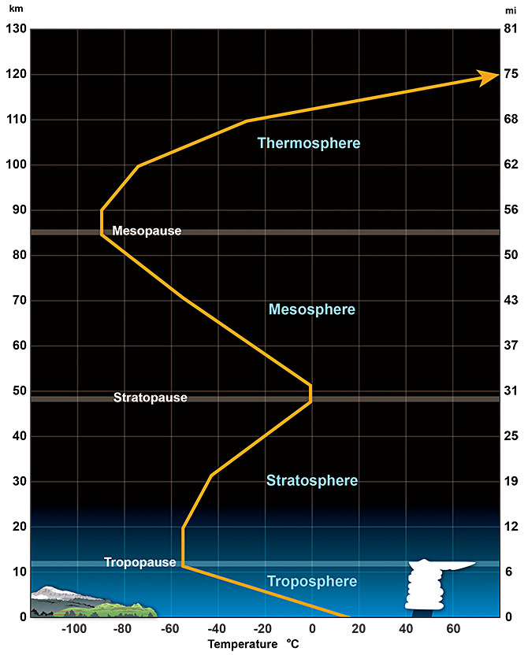
- Composition of the Atmosphere

- 78% Nitrogen (N₂), 21% Oxygen (O₂), <1% Argon, <0.5% of H₂, Krypton, Neon, Helium, Carbon Dioxide, and Methane (GHGs)
- Also contains water vapour (a greenhouse gas), very temperature dependent

- Atmospheric Circulation

- The sun is the source of all energy and is the main driving force of atmospheric circulation.
- Solar insolation: power per unit area received from the sun
- Watt = energy per unit of time (a second)
- Watts per meter squared

- Why is there more solar insolation at the equator than at the poles?
- Earth is a sphere, more radiation per meter squared around the centre of the earth because there is less surface area to heat
- More surface area to heat at higher latitudes

- Temperature gradients drive convection cells. Convection is the movement of heat from one place to another by the movement of air. Warm air is less dense, cold air is more dense. Less dense air moves up, more dense air moves downwards.
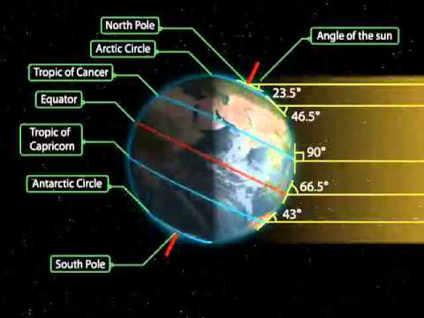
- Also, dry air is more dense, moist air is less dense.
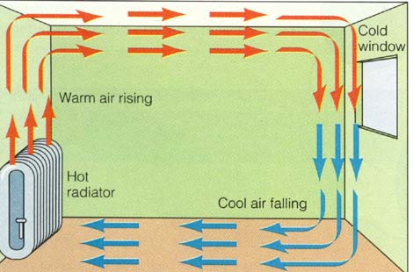
1

- How does this work on Earth?
- Air sinks at the poles (high pressure), and rises at the equator (low pressure). Air flows from high pressure areas to low pressure areas. This is an example of one circulation or convection cell.
- The Earth spins and is not smooth or one substance, so this isn’t exactly correct as to what happens on Earth.
- The Earth spins at different speeds at different places.
- Spins fastest at the equator, and not spinning at all at the poles.

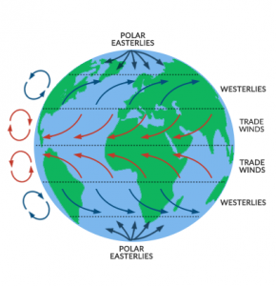
- The Coriolis Effect: describes the pattern of deflection taken by objects not firmly connected to the ground as they travel long distances around Earth. The Coriolis effect is responsible for many large-scale weather patterns. Moves objects to left in Southern Hemisphere, and to the right in the North Hemisphere. (think of the way your toilet flushes)
- KNOW THESE DIAGRAMS , BE ABLE TO IDENTIFY/LABEL THEM

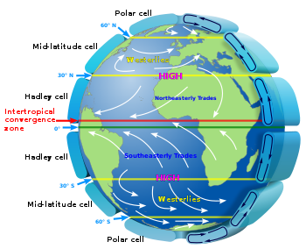

Hadley Cell: 0-30 degrees, occurs in the tropics. Warm moist air rises, cools around 30 degree mark, then descends back towards the equator along the earth’s surface.

Polar Cell: 60-90 degrees, same idea as Hadley cell, warmer/moist air at lower latitude, cools around 90 degrees, then descends back down along the earth’s surface.

- Both thermally direct cells, both operating as a result of temperature difference.

Ferrel Cell: 30-60 degrees, thermally indirect - rotates opposite the way in which we think it would rotate because it is being dragged/influenced by the other cells.

High pressure zones (poles, 30degrees latitude/subtropical highs): clear skies, descending air.

Lower pressure zones (equatorial low, 60degree subpolar low): rising air, overcast skies with lots of precipitation.
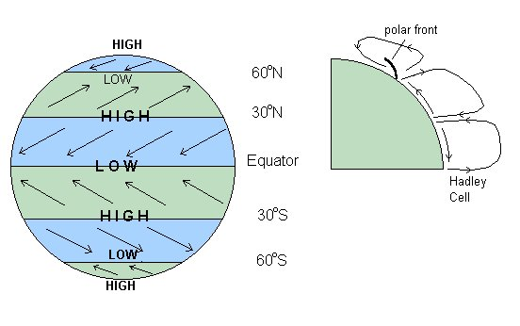

- Global Wind Belts

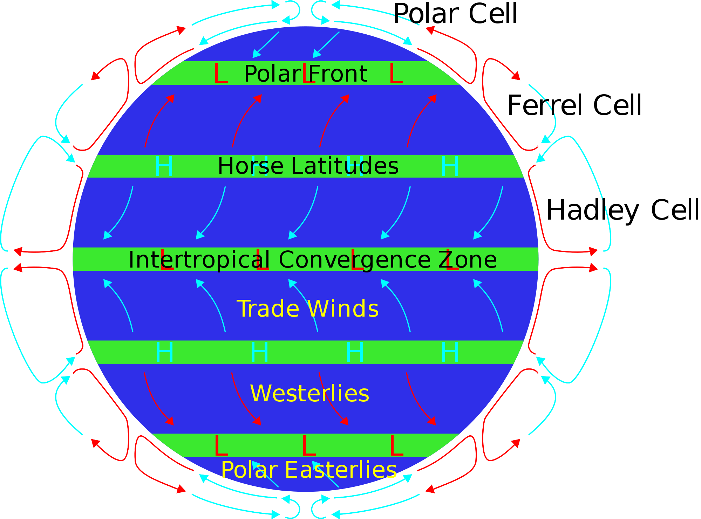

Between 30 degrees and the equator the air is being dragged downwards and to the right (coriolis effect) and that’s why we get the northeast trade winds.

In the ferrel cell the air is being pulled upwards and to the right and that's why we get the prevailing westerlies.

In the polar cell, the winds are being dragged southward and being deflected to the right, hence the polar easterlies.

- Dragged by circulation cell, deflection by the coriolis effect.

Boundaries between wind belts:
- At equator: equatorial doldrums, intertropical convergence zone, winds converge here between two hemispheres
- Horse latitudes: around 30 degrees latitude (sub-tropical zone), winds move away from here
- Polar front: around 60 degrees latitude

Southern hemisphere: same idea but winds are being deflected to the left
- SE trade winds instead of NE

The three cell model isn’t perfect either, does make an assumption about the nature of the surface of the earth, no topography. Distribution also changes with seasonal differences and differences in heat capacity on continents and in the oceans.

Ocean Circulation

Oceans are able to store and move a lot of heat. Requires a lot of heat to raise the temperature of water. Water has therefore absorbed a huge amount of heat.

- Salinity: open-ocean have a salt value of 33-38‰ (per mille).

- Salinity varies by latitude. Generally salinity increases as the temperatures does (towards the equator), but at the equator there is actually a decrease in salinity. Near the equator there is a lot of precipitation (low pressure area), so there is a lot of water being added to the oceans, which decreases salinity.

- Processes affecting salinity: melting icebergs, melting sea ice, precipitation and run-off from land all add water to the oceans and therefore decrease salinity. Sea ice formation and evaporation remove water from the oceans, and therefore increase salinity.

-Equator: high precipitation, low salinity
-Sub-tropical latitudes: higher salinity due to increased evaporation and low amount of precipitation
-Mid latitudes: decreased evaporation and more rainfall = decreased salinity
-Higher latitudes: highly variable, many competing factors

Also, increased salinity means increase in density of the water. Higher temperatures of water decreases the density.

Also, deep waters (below 1000m) are generally much colder and saltier than surface level waters (100-400m), and therefore are more dense. The pycnocline prevents the mixing of these two different layers of the ocean, and is considered a transition zone.

- Oceans make up 71% of the Earth’s surface, and are in continual motion due to differences in density the winds and the rotation of the earth.
- Water is much denser than air so currents move much slower than the movement of the atmosphere
- Two types of ocean currents: deep currents (driven by differences in salinity and temperature; horizontal and vertical movement), and surface currents (driven by wind; primarily horizontal)
- Important deep current: Thermohaline Circulation
- North Atlantic Deep Water sinks because it is highly dense, then slowly moves southward, heats up at the equator, then slowly moves back towards the north
- This is known as the great ocean conveyor belt, and it is partially responsible for redistributing heat (along with atmospheric circulation)

- Surface currents: major impact on weather and climate, even though it only accounts for 10% of the oceans’ total volume. Surface currents are influenced by wind blowing over the ocean, and the motion is deflected by the coriolis effect. Also impacted by continent distribution.
- Coriolis Effect and the Ekman Spiral: The Ekman spiral is a structure of currents or winds near a horizontal boundary in which the flow direction rotates as one moves away from the boundary. Surface currents move at an angle to the wind. Water is increasingly deflected by the coriolis effect as you move deeper down. Average movement of seawater: 90 degrees to the right in the North; 90 degrees to the left in the South.

4. At the equator, winds converge but waters diverge. This diverge draws deeper water towards the surface. Band of cool water being pulled up, zone of high biological productivity.

5. Subtropical Gyres: large, circular loops of water centred around 30 degrees latitude due to the effect of wind moving water one way, and then it being deflected by the coriolis effect.
- Moving clockwise in the North, counter clockwise in the South
- 5 important subtropical gyres: Indian ocean gyre, North Atlantic gyre, South Atlantic gyre, North pacific gyre, South pacific gyre
- Gulf Stream: Western boundary current apart of the North Atlantic Gyre, the extension of this current (the North Atlantic Drift), moderates the climate of europe

Earth’s Energy Budget/Balance
Earth doesn’t just absorb heat and store it, it releases it too. Most of the heat released is released in the sub-tropical areas. Earth is in radiative equilibrium when flow of heat in = flow of heat out. So if we change one of these inputs, then the temperature of the earth will change.

Solar irradiance: primary source of energy from the Sun to Earth, and solar irradiance is how it is measured and reported. The output of light energy measured on the earth (generally around 340W/m2)

Short-wave and long-wave radiation: consider the electro-magnetic spectrum. Shows us the range of all types of electro-magnetic radiation. Greatest intensity of sunlight comes in the UV, visible and IR parts of the electro-magnetic spectrum.
- Shorter waves: more energy
- Total solar irradiance is less on the planet then at the top of the atmosphere because 1) half of the earth isn’t exposed at any time, and 2) for most the planet sunlight is coming in at an angle

So what happens to the energy that reaches the top of the atmosphere?
- 29% is reflected (clouds, atmospheric particles bright surfaces [snow and ice])
- 23% is captured in the atmosphere as clouds and gases
- 48% absorbed at the surface

After evaluating and measuring the various effects that impact how much energy is being transported in and out of the atmosphere, there is about 0.6W/m2 net absorbed by Earth, when this number should be 0 in order to maintain equilibrium. This is the global warming/global radiation value.

The energy that is being absorbed by the atmosphere and re-irradiated back down to the surface is made possible by GHGs. This is what makes the earth warmer than it should be (~33degrees celsius warmer)
- Greenhouse effect: gases in the atmosphere trapping heat and sending it back to the earth
- However, this is being enhanced by human activity, and not enough heat is escaping back into space, due to more of these gases being put into the atmosphere by humans

GHGs: without GHGs Earth’s atmosphere would be -18 degrees celsius, would make earth essentially uninhabitable

Global Warming Potential: different gases have different warming abilities; CO2 is the reference gas
- GWP of Methane is 21 (21 times more powerful than CO2)
- GWP of Nitrous Oxide is 310 (310 more powerful)
- CO2 is the most abundant GHG, why it's the reference gas
Carbon dioxide, CO2 | Carbon dioxide is the GHG that is most often discussed. This is because we produce more of this gas than any of the other GHGs. It is the gas most responsible for global warming and climate change.  It is produced primarily from the combustion of fossil fuels for energy, heat, transportation, industrial processes, etc. It is also produced from the cutting down and burning of trees.
Methane, CH4 | Methane is a more powerful GHG than carbon dioxide, but, since there is less of it in the atmosphere; it contributes less to global warming and climate change.  There are many sources of methane (and many are linked to agriculture) including:  - Raising livestock (particularly ruminants, like cows and sheep)  - Rice paddies  - Landfills (methane is produced as trash breaks down)  - Producing and transporting natural gas (natural gas is predominantly made up of methane gas)
Nitrous Oxide, N2O | Nitrous oxide is a very powerful GHG (in fact it is 310 times more powerful than carbon dioxide) but it is also found in lower quantities in the atmosphere and therefore doesn’t have the same impact as carbon dioxide.  Agriculture is the main source of nitrous oxide emissions particularly from fertilized soils and livestock manure. Other sources include fossil fuel combustion and industrial processes.
Water, H2O | Water vapour in the atmosphere is a rather complicated GHG. As the planet gets warmer more water evaporates and this increased water vapour can lead to even more warming. This is an example of positive feedback. However more water vapour can also lead to more cloud cover which can “shield” the earth from incoming solar radiation. This is an example of negative feedback.
Chlorofluorocarbons, CFCs | Chlorofluorocarbons are very powerful GHGs. They are synthetic (or “man-made”) chemicals that were used as solvents, refrigerants and aerosol sprays. In the 1970s scientists discovered that these chemicals were making their way to the upper atmosphere where they were involved in chemical reactions that resulted in the destruction of the ozone layer. This was a big concern because the ozone layer protects us from harmful UV radiation. In the 1980s CFCs were banned and atmospheric concentrations of CFCs have been decreasing ever since.
Ozone, O3 | Ozone in the upper atmosphere (the stratosphere) protects us from harmful UV radiation. However ozone at ground level (or in the lower atmosphere) is a harmful pollutant and a GHG.  There are no direct sources of ground level ozone, however it is a pollutant created by photochemical reactions (reactions that require sunlight) between other pollutants in the atmosphere. Ground level ozone is one of the pollutants that is considered in the air quality health index (AQHI).

Radiative Forcing

In order to fully understand the earth's energy balance we need to examine the concept of radiative forcing. There are actually several factors that can warm the planet (and there are even some that can cool the planet). Radiative forcing allows us to identify and characterize these potential factors and can help us to see which factors are the most important and which might be associated with human behaviour.

- Radiative forcing means that Earth’s energy balance has been disturbed
- Instantaneous change in the net irradiance at the tropopause due to a change in an external driver of climate change
- Energy in does not equal energy out
- Positive forcing = warming (GHGs)
- Negative forcing = cooling

- What Causes these forcings?

Solar forcing: Solar irradiation varies with sunspot activity, more sunspots means more total solar irradiation
GHG forcing: 2.83W/m2 from all well-mixed GHGs (CH4, CO2, etc.)
Black Carbon and Organic Carbon: from incomplete combustion of fossil fuels and burning of biomass (reflects and absorbs sun energy), negative and positive forcing

There is also negative forcing
- Albedo: a measure of how strongly sunlight is reflected by Earth’s surface and atmosphere. Clouds, snow, ice, and deserts have higher albedos than forest, lakes, oceans, tundra, and agricultural land. Likely been a slight increase in albedo, more reflectivity, therefore overall negative forcing.
- Aerosols: particles of solid and liquid that become suspended in the atmosphere, global dimming

The Carbon Cycle
The carbon cycle explains how carbon moves between four very important "reservoirs"
- Lithosphere Carbon Store: This includes fossil fuels like coal and gas, and carbonate rich rocks like limestone (CaCO3).
- Atmosphere Carbon Store: This includes the gas CO2 (and also methane, CH4) in the atmosphere
- Ocean Carbon Store: This includes CO2 gas dissolved in the oceans and calcium carbonate (CaCO3) shells of marine organisms.
- Biosphere Carbon Store: This includes organic material in both living and dead organisms and organic materials in soils. Remember that ALL biologically derived materials (plants and animals) contain carbon.
Forms of Carbon:
- Gases in the atmosphere (CO2 and CH4)
- Organic Materials in plants, soils, and animals
- Rocks and Sediments (limestone)
- Co2 in the oceans

Earth’s Crust is the largest reservoir, contains 100 million gigatonnes of carbon, followed by the ocean with 40k gigatonnes

The most important process by which we move carbon dioxide is photosynthesis, respiration by plants is the reverse process of this. Slightly more CO2 is being brought in by this process than there is being released.

5.5 gigatonnes of carbon released into the atmosphere by anthropogenic activity per year, burning of fossil fuels, and land use changes like deforestation.

90 gigatonnes of carbon released into the atmosphere from the ocean, 92 gigatonnes of carbon moves from the atmosphere to the oceans every year.

Calcification converts gaseous CO2 into calcium carbonate CaCO3 forms, long term process. (Oceans and freshwater, also lithosphere)

- Unit 2
Scientists and the Peer-Review Process
This process is used to provide an effective system of checks and balances for scientific research.
· Difficult to define
- Focuses on Natural World
- Aims to express natural world
- Uses testable ideas
- Relies on Evidence
- Involves the scientific community
- Leads to ongoing research
- Benefits from scientific behaviour

· No one type of scientific method
o Pragmatic: uses what works
- Deduction, induction, mathematics, experiments
o Continuous process of refinement
Steps to the scientific method
- Identify Problem
- Form a Hypothesis
- Make observations/test hypothesis
- Organize and Analyze data
- If results support hypothesis, draw conclusions (If not, new experiments)
- Draw conclusions
- Communicate results
· Standard concept of scientific method (hypotheses, theories, laws):
o Law: a general statement about the expectation that certain events will occur where certain conditions are met (e.g. law of gravity) – tells us what to expect but not why
o Hypothesis: human mental construct that provides a preliminary causal explanation of a set of facts
o Theories: more mature, more complex, and more wide-ranging human mental construct than a hypothesis
- A theory or hypothesis that is repeatedly confirmed is provisionally accepted
- A theory or hypothesis that is overwhelmingly invalidated is rejected (falsifiable)
Science isn’t about absolute truth. It is our current best understanding, the best science is falsifiable (can be proven wrong).
- Peer Review Process
- Scientist publishes their findings based on their methods and results, submit it to a peer review journal
- Editor of journal decides if publication is worthy of review
- A few specialist reviewers read the publication and write their recommendation (accept or reject)
- Editor either accepts or rejects, or asks for revisions based on reviewers comments
- Original author makes changes based on recommendations, and re-submits
- Editor makes final decision about official publication
Scientists are constantly checking each others findings, kick out ideas that don't work.
- But this is not perfect, scientists aren't as objective as they could be (they’re people too)
- Generally we do not redo experiments to test them

- Case Study: the Ozone Hole
- In the 1970s scientists noticed depletion of the ozone layer at the poles
- Connected these results to other studies that showed high concentrations of CFCs (more CFC, more ozone depletion)
- Hypothesis: CFCs in stratosphere depleting ozone
- However, correlation doesn’t always mean causation (not enough evidence on its own)
- Earlier work by some researchers had shown some CFCs exposed to UV radiation can cleave off the chlorine atom and pull oxygen atoms from ozone particles
- New hypothesis: chlorine from CFCs were depleting ozone layer because stratosphere contained high levels of ClO

Intergovernmental Panel on Climate Change (IPCC)
The IPCC doesn't actually DO scientific research; instead it assesses the state of scientific knowledge on climate change by reviewing the scientific literature every 5 to 7 years. These extensive assessments result in comprehensive reports which are available for free to anyone from the IPCC website. To date the IPCC has produced five comprehensive Assessment Reports (AR):
- 1st (FAR) in 1990
- 2nd (SAR) in 1995
- 3rd (TAR) in 2001
- 4th (AR4) in 2007
- 5th (AR5) in 2014
The Assessment Reports are made up of three volumes; one from each of three working groups. The three volumes are titled:
- The Physical Science Basis
- Impacts, Adaptation and Vulnerability
- Mitigation of Climate Change
· Was created in 1988 to provide policymakers with regular scientific assessments on climate change, its implications and potential future risks, as well as to put forward adaptation and mitigation options
· Provides scientific information relevant to understanding the scientific basis of the risk of human-induced climate change
- Open to all members of the United Nations and the World Meteorological Organization (currently 195 members)
- Also creates special reports that focus on interdisciplinary topics and also methodology reports (authoritative force on climate change)
Importance of Isotopes
· Climate change = driven by greenhouse gases
· Gasses are compounds made up of elements
· Atomic number = number at the top-right hand corner of the element box
· Protons = positive charge
· Neutrons = neutral charge
· Electrons = negative charge
· Atomic mass = p + n
· Atoms of the same element (same atomic number) but different atomic masses = isotopes
Carbon is the 6th element on the periodic table, so EVERY carbon atom has 6 protons in its nucleus.. This is called the atomic number and for carbon it is ALWAYS 6 because the number of protons an atom has defines what element it is. However atoms of the same element can have different numbers of neutrons in their nucleus.
- Atoms of the same element (i.e. the same atomic number) but different atomic masses (i.e. different numbers of neutrons) are called ISOTOPES. So, as explained above, C has three important isotopes and we generally write these isotopes like this: 12C, 13C, 14C.

- Unit 3
Global Temperature
· Average temp is 15 degrees C
· How do we take the temp of planet?
o Cannot
o Divide earth’s surface into grid cells (e.g. 5 degrees X 5 degrees)
o Obtain measurements and averages of each box
o “stack” grid cells and find average for those
· Problematic: some grids are not the same size
o Need to use a weighted average
· Another problem: many parts of the world do not have a lot of data (e.g. the poles)
o Most temperature stations on land are developed around high population areas
o Poles are poorly represented
o Ocean temperature has very little data (instead, have coastal data)
Measuring Temperatures
· Land surface temperature readings come from thermometers
o Associated with government, universities have weather stations
o “temperature boxes” that provide shade and ventilation to the thermometer
· Ocean air and sea surface from coastal stations, ships and Argo devices
o Argo: free drifting, profiling floats that measure salinity, temperature and other factors
· Use satellites
o Measure air temps of lower troposphere using microwave sounding units
- Goes back to 1970s
- Good agreement with surface temperature data
o Help sea surface temperature
· Weather balloons – air balloons
· Merge all data together and get global average temperature
Temperature Anomalies
· Difference between the temperatures of an area over a particular period of time (month, year) and the average for that period of time over a selected baseline period
- Positive: heating. Negative: cooling
· Baseline periods:
o Cover a long period of time (at least 15 years, usually 100)
o Need a long period because we need to even out any ups and downs along a period of time (ex: volcanic activity)
· Why we use temperature anomalies?
o More accurately describe climate variability over larger areas
o More meaningful comparisons
- Gives us an indication of temperature trends
o More accurate calculations of temperature trends
Different datasets deal with lack of data in remote parts of the world in different ways, also: size of grid boxes, number of land stations, measurement errors, change in instrumentation all contribute to differences in results
NASA Goddard Institute for Space Studies has the most comprehensive data (99%) of globe, grid boxes 2x2, uses statistical methods to fill in gaps
NOAA Global Analysis
· 2016 annual average temperature was 0.94 degrees celsius above 20th century average (13.9)
· On land:
o 1.43 over
· Oceans:
o 0.75 over
· 16/17 warmest years on record have occurred during 21st century
· 40th consecutive year (since 1977) that annual temperature has been above 20th century average
Human Fingerprints
· Lines of evidence that the excess CO2 are human caused
· Keeling Curve shows there is more and more industrial carbon in the atmosphere since at least 1960
o 1960: below 320 PPM (parts per million)
o Now: over 400 PPM
· How do we know it’s industrial carbon (human caused)
o recall isotopes: atoms with the same atomic number but different mass number
§ number of neutrons change
o radioactive isotope = reactive isotope
o 12C (carbon) is better absorbed by plants than 13C because they are lighter
§ If these plants are dying and eventually turning into gas, there will still be more C12 in the atmosphere
When plants die and over millions of years are compressed into fossil fuels, they still contain more 12C than 13C
§ When you are burning that fossil fuel, adding more 12C and less 13C
· Result of us burning fossil fuel
- Indicates that most of the carbon being released into the atmosphere is human caused

Paleoclimate (and Climate Proxies)
One of the arguments used by climate change deniers is that changes in climate have been naturally occurring for billions of years. Therefore, how do we know that recent climate change is not just part of this natural process? In order to address this argument, we need to examine past climates. This area of research is generally called Paleoclimatology (paleo = old or ancient).
Why Reconstruct Past Climates?
- To see how unusual our recent and anticipated climate changes are
- To see if CO2 played a role in past climate at all
- To find out how rapidly climate has changed historically
- And, what can these changes tell us about possible future climate changes
How is Climate Reconstructed?
· Past climates can be reconstructed from preserved physical characteristics of the past (proxies)
· “climate proxies”
o Natural archives of climate
o Record information about climate at the time of their formation
o Biological and geophysical
o E.g. ice cores, corals, lake and ocean sediments, etc.
· Tree rings (dendroclimatology)
o Growth rates are associated with climatic fluctuations
o Width of ring and density of wood very sensitive to local climate (thicker the tree ring, better the growing conditions, tree rings give us an idea of past climate)
· Ice cores
o Most informative
o Temperatures in these regions is always below 0
§ Snow accumulated and forms ice
§ Deeper ice = older snow
o Climate information in ice cores:
§ Thickness of layers (more snow in a year, the thicker the layer)
§ Ash and dust (shows dryer years, volcanic activity)
§ Air bubbles (CO2 concentrations) + storing old air
§ O2 and Hydrogen isotope chemistry (heavy water evaporates less readily, condenses more readily) & different temperatures lead to different stable isotope ratios. Warm air holds more moisture, warmer global climate means less precipitation, means more heavier ice at the poles. Colder air cannot hold as much heavy water, so its precipitated out on the way to the poles.
Recall Stable Isotopes
· These don’t decay
· Generally have more neutrons than the “original” à “heavier”
· In ice cores, oxygen and hydrogen stable isotopes are important (H2O)
· Water isotopes
o 1H2/16O = regular, most common type
o 1H2H16O = heavy water
o 1H2/18O – heavy water
o Heavy water evaporates less readily, condenses more readily
· Different temperatures lead to different stable isotope ratios (“heavy”/normal)
Lake and Marine Sediments
· Accumulate over time
o Progressively older sediments buried with increasing depth
· Extremely stable
· Contain:
o Mineral particles
o Aquatic organisms
o Pollen
§ Pollen from wind pollinated plants
§ Preserved in lakes, estuaries, bogs, etc
§ Highly resistant outer layer
§ Distinct morphology allow for identification
§ Palynology = pollen analysis
§ Reconstruction of vegetative history (many plant species occur in a narrow range of climatic conditions (climate tolerances))
Corals
· Seasonal layers similar to tree rings
· Thickness related to temperature
· 100s of years
Stalagmites and Stalactites - grow depending on temperature
· Limestone “karst”
· Similar to ice cores (store stable isotopes)
· 1000s of years
Why use different proxies? All proxies differ in their resolution, timespan, and climate indicators.
Resolution and Timespan
· Resolution: the smallest discrete quantity of time for which information can be extracted from a climate proxy
· Timespan: the total amount of time that a climate proxy can give us information
How old is a proxy?
- Assign a chronology
- Use of radioisotopes (14C dating using the rare and unstable isotope). 14C is decaying over time at a stable rate, the amount of 14C in anything can tell us how old it is. Use half life of 14C (5730 years)
- Dendrochronology: count the amount of rings. Also can use crossdating: using samples from living trees to match with samples of dead trees. Can learn when trees died and when they were born. Can extend the lifetime of a tree.
- Biological organisms where age can be estimated from growth rate and patterns of organism
Orbital Cycles
Temperature from Vostok Ice Core over the last 400k years shows us the pattern of cooling patterns (glacial periods) and warming patterns (interglacial periods). Follows a fairly regular pattern.
· Milankovitch Cycles
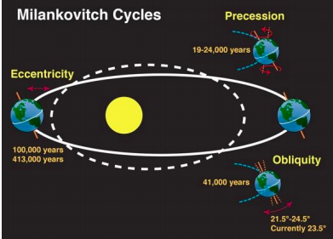
· Intensity of radiation from the sun varies with cyclical changes in:
o The tilt of the earth’s axis (obliquity)
o The shape of the earth’s orbit (eccentricity)
o The way the axis “wobbles” (precession)
· Determines how the Earth’s climate shifts between glacial and interglacial phases
o Orbital cycles interact to control the amount of solar radiation reaching the atmosphere
Milankovitch Theory
· Ice ages occur when orbital variations cause lands at about 65 Degrees north to receive less sunshine in the summer
o A cold summer instigates ice ages
o Don’t get all the ice melting in the summer which starts the ice age
· Accurate in terms of timing but not in terms of magnitude (difference between warming and cooling amounts)
· Needed another mechanism to determine magnitude
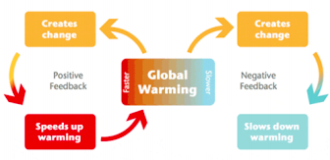
Climate Feedbacks
· A climate feedback is a process that can either increase (amplify) or decrease (diminish) the effects of climate forcings
· Initial warming leads to further warming = positive feedback
- paleoclimatic ice records can provide us with a record of past greenhouse gas levels and of past temperatures. In many cases, the records indicate that at the end of ice ages temperature increases came first and were then followed by rising CO2 levels (This is opposite to what we are seeing today!). One example of this was found by a group of scientists working on sediment cores in the southern hemisphere. A positive feedback might explain this phenomenon. Very simply, this is how it might have worked. First due to predictable orbital cycles we had increased solar radiation and therefore increased warming. This warming led to warming of the oceans (in this case the Southern Ocean). Because warmer water can actually hold less dissolved CO2, we get large quantities of CO2 escaping from the oceans. This released greenhouse gas then warms the climate even more.
· Initial warming leads to cooling = negative feedback
- Negative feedback is used to explain a very interesting climate event called the Younger Dryas. Greenland ice cores indicate a very rapid cooling period and then a very rapid warming period that occurred between approximately 12,800 and 11,500 years ago (see Figure 3.3 below). This kind of rapid climate change is not really predicted by orbital parameters because Milankovitch's theory predicts fairly slow climate changes. However, a negative feedback might explain rapid changes. Once again, very simply, this is how it might have worked. First due to predictable orbital cycles we had increased solar radiation and therefore increased warming. This warming led to a tremendous amount of ice melting in Greenland and therefore a lot of freshwater entered the North Atlantic Ocean. This essentially warmed and diluted (decreased salinity) the ocean and shut down the global thermohaline circulation and resulted in a rapid cooling in the northern hemisphere. This cool period lasted around 1300 years but eventually the thermohaline circulation began to work again and brought about a rapid warming.

- Water vapour leads to positive feedback and negative
- Negative feedback: leads to slowing down of warming

Water Vapour Example
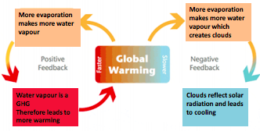

Unit 4

Climate Models
Climate models use quantitative methods to describe extremely complex climate processes. We use these models to explore and understand the climate. They are used by scientists to answer questions like what caused warming in the past, why is the climate changing, and how might it change in the future.

What is the input for the models?
GHG (greenhouse gas) emissions or radiative forcing values go into the vertical grid

Less saline water = less dense
-That stopped the thermohaline circulation for a while
-Recent warm climates= paleoclimates
-There have been 5 ice ages

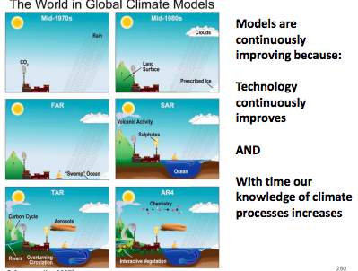
Why do we need so many models?
- Limits to models due to computer speed
  - Large number of processes/mechanisms involved (climate is very complex!)
- Modellers make trade-offs:
  - Between speed and process/mechanism representation
  - Spatial and temporal resolution
- We are looking for “robustness” of projections (i.e. how “similar” are they?)
- Can calculate multi-model mean projection or model “ensembles”
-There are limits to our computer power
Robust= models saying the same thing
-In order to understanding the GHG emission in the future we need to know things about the past
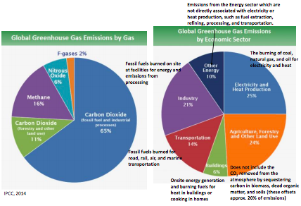

What is the input for the models?
-Different pathways or scenarios for how population, technology, energy, land use, and GHG concentration could change over the centuries ahead
-Scientists use the same inputs so that they can directly compare results

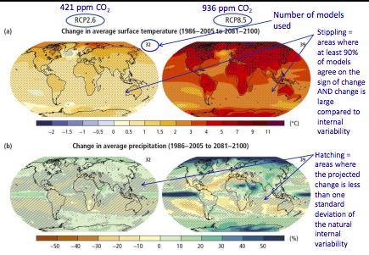
RCP2.6, RCP4.5, RCP6, RCP8.5 (Four different Representative concentration pathways and their associated radiative forcing values [w/m2] by the end of the century.

Summary: Temperature Predictions
Climate models consistently project increases in temperature
Global mean temperatures projected to rise 0.5 to 4°C in the next century
Variability in regional temperatures
Poles affected the most
Heat waves will very likely occur with higher frequency and duration
Summary: Precipitation Predictions
Changes in precipitation in the next century are likely to occur
Difficult to predict
Less reliable projections
High latitudes and equator will likely experience increases
Mid-latitudes and sub-tropics will likely experience decreases
Some areas will likely experience more extreme precipitation events
Temperature Projections for Canada
-All of Canada is expected to warm over the next 80 years
-Possible exception is Atlantic offshore area
Temperature increases greatest in high arctic and central portions of the country
Warming greatest in winter months
Especially in Hudson Bay and high Arctic
Precipitation Projections for Canada
-More difficult to predict
-Increased total annual precipitation during the current century
-By 2080s precipitation increases range from 0 to 10% in the far south up to 40 to 50% in the high Arctic
-Precipitation increases projected to be low during summer and fall in southern Canada
-In some regions (south-central Prairies and south-western British Columbia) precipitation is even expected to decline in the summer
-Increase in the percentage of precipitation falling as rain rather than snow
-Increase in extreme daily precipitation in some areas

Unit 5

Oceans:
- Threats to ocean waters (The deadly trio)
- Ocean warming
- Ocean acidification
- Anoxia (not necessarily related to climate change)- Oxygen depletion
- 4th could be plastic
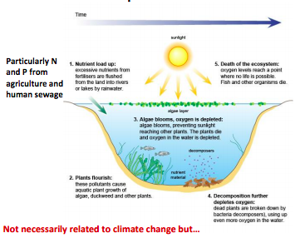
Anoxia- decomposition depletes oxygen in the water
If the oxygen depletes then fish die and every organism suffers
Algae like warm water
Corals are 2 organisms

Anoxia: Eutrophication and Dead Zones (Eutrophication: excessive richness of nutrients in a lake or other body of water, frequently due to runoff from the land, which causes a dense growth of plant life and death of animal life from lack of oxygen). When the algae die, their decay consumes a large amount of oxygen from the water and this leads to oxygen depletion. This is the cause of ocean "dead zones" that you might have heard about in the media.

Due to temperature increases and changes in ocean circulation the ocean dead zones are getting worse globally due to climate change

Impacts of Ocean Warming
- Impacts many kinds of sea life
- Affects ocean and atmospheric circulation (weather patterns)
- Causes more powerful tropical storms
Example: Coral Bleaching
-Corals live in mutually beneficial relationship (or symbiosis) with small algae
-Algae “feed” (via photosynthesis) the coral
-Algae also responsible for the beautiful colours
-Coral provides shelter and nutrients to the algae
-Algae are very sensitive to warmer water
- If ocean temperature increases (by even a small amount) algae are expelled
- Results in coral bleaching or even coral death
- Coral bleaching- when they lose colour
Coral Film
- Coral bleaching is killing corals worldwide
- Corals provide protection for algae
- Coral triangle 10-30% now bleached when none were last year
- 70% of coral reefs are threatened
- 25% of the biodiversity of life aka 25% of marine species will die too
- Coral bleaching - loss of diversity and wellbeing on the planet
- Getting worse because of climate change around 2011-2013
- Effects on tourism and they protect coastlines

Ocean Warming impacts on Fisheries:
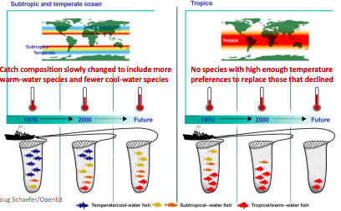

Ocean Acidification:
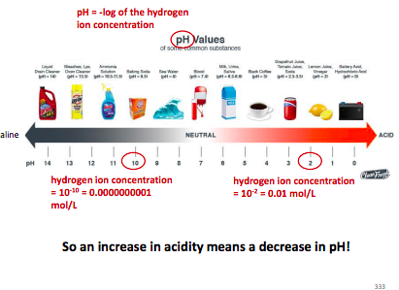
Left = ALKALINE (figure ^ above)

We are measuring decreasing pH levels
pH is a logarithmic scale – scale for acidity and
What make things acidic are hydrogen atoms of hydrogen plus and the p is the negative log of the hydrogen ion concentration
When CO2 reacts with water it releases Hydrogen atoms which are positively charged and lead to increased acidity, take away carbonates
Decreasing ph means decreasing carbonate
Plankton and phytoplankton are the “potato chips” of the sea

What does the IPCC say?
- Ocean acidification poses substantial risks to marine ecosystems
  - Particularly coral reefs and shellfish
  - Also polar systems
    - Colder water more readily absorbs CO2; therefore acidification may be happening faster here

Sea-Level Rise

Sea Level measured by Tidal Gauges and Satellites
- More ice, lower sea level (reversible)
- Not every where will experience an increase in sea level
- The impacts of sea level change can vary regionally due to: the position of coastal areas above sea level.
- the resistance of land to saturation.
- glacial isostatic adjustment (rising and sinking of land).
- prevailing winds and ocean currents.
There is no doubt that the world's oceans have already risen and we are quite certain that they will continue to rise. Evidence from tide gauge readings, shoreline sediment and, most recently, satellite measurements indicate that since 1900 the seas have been rising at a rate of 1 to 2.5 mm per year. Recent satellite data indicate a rate of rise of about 3 mm per year. This has resulted in a total average sea-level rise of approximately 0.19 meters (190 mm) between 1901 and 2010.
There are two components to this rise:
- Thermal Expansion
  - As you learned in Unit 01, water expands as it warms up; this is called thermal expansion. Even though the temperature increases are small (and therefore the expansion is small), oceans are so large that thermal expansion can result in a significant increase in the volume of water.
- Melting land ice and snow (especially from large land based ice sheets, and from glaciers).
  - Oceans rise only as a result of melting land ice and snow, i.e. the melting of sea ice does NOT significantly impact the volume of water in our oceans. In order to understand this, think of a glass of ice water; as the ice melts the glass does not overflow!
- Ice sheets and glaciers in Greenland and Antarctica melt three ways: from above due to warming air, from the sides as they break off into the sea, and from below due to warming ocean water where the ice extends over the sea.

Sea level rise is not just a problem of water, it is also a problem of salt. Imagine if salt water flooded a farmer's field, or a coastal forest. Not only does the area have to survive flooding, but also a drenching in salt water that can kill plants and irreversibly alter soil chemistry. Saltwater flooding can mean death for these ecosystems. Already scientists have seen stands of "ghost forests" where once-healthy trees were killed by saltwater flooding, and farmers' fields are being converted to tidal marsh and salt flats.

- With sea level rise, we could see flooding every 28 days due to the lunar tide cycle
- Polar ice caps have been frozen for 3 million years, but could be ice free in 20 years
- 1 foot increase in sea level rise can see the loss of around 3 meters of shoreline

Why are SIDS (Small island developing states) particularly vulnerable to climate change?

- They are generally poorer nations with less money to protect against sea-level rise.
- They are small and low lying and sea-level rise therefore affects a large part of the island.
- They are among the countries most heavily affected by negative impacts on fish and seafood production.

Unit 6
IPCC Terminology
Hazard: The potential occurrence of a natural or human-induced physical event or trend or physical impact that may cause loss of life, injury, or other health impacts, as well as damage and loss to property, infrastructure, livelihoods, service provision, ecosystems, and environmental resources.

Exposure: The presence of people, livelihoods, species or ecosystems, environmental functions, services, and resources, infrastructure, or economic, social, or cultural assets in places and settings that could be adversely affected.
Vulnerability: The propensity or predisposition to be adversely affected. Vulnerability encompasses a variety of concepts and elements including sensitivity or susceptibility to harm and lack of capacity to cope and adapt.
Risk: The potential for consequences where something of value is at stake and where the outcome is uncertain, recognizing the diversity of values. Risk is often represented as probability of occurrence of hazardous events or trends multiplied by the impacts if these events or trends occur. Risk results from the interaction of vulnerability, exposure, and hazard.
Adaptation: The process of adjustment to actual or expected climate and its effects. In human systems, adaptation seeks to moderate or avoid harm or exploit beneficial opportunities. In some natural systems, human intervention may facilitate adjustment to expected climate and its effects.
Resilience: The capacity of social, economic, and environmental systems to cope with a hazardous event or trend or disturbance, responding or reorganizing in ways that maintain their essential function, identity, and structure, while also maintaining the capacity for adaptation, learning, and transformation."

- In 2018, the IPCC published a report called “Special Report: Global Warming of 1.5oC”.
- One of the most important, and alarming, figures contained in this report, is the “Reasons for Concern (RFCs)”
- The Five Reasons for concern are:
  - “RFC1 - Unique and threatened systems: ecological and human systems that have restricted geographic ranges constrained by climate-related conditions and have high endemism or other distinctive properties. Examples included coral reefs, the Arctic and its indigenous people, mountain glaciers and biodiversity hotspots.
  - RFC2 – Extreme weather events: risks/impacts to human health, livelihoods, assets and ecosystems from extreme weather events such as heat waves, heavy rain, drought and associated wildfires, and coastal flooding.
  - RFC3 – Distribution of impacts: risks/impacts that disproportionately affect particular groups due to uneven distribution of physical climate change hazards, exposure or vulnerability.
  - RFC4 – Global aggregate impacts: global monetary damage, global-scale degradation and loss of ecosystems and biodiversity.
  - RFC5 – Large-scale singular events: are relatively large, abrupt and sometimes irreversible changes in systems that are caused by global warming. Examples include disintegration of the Greenland and Antarctic ice sheets.”
- 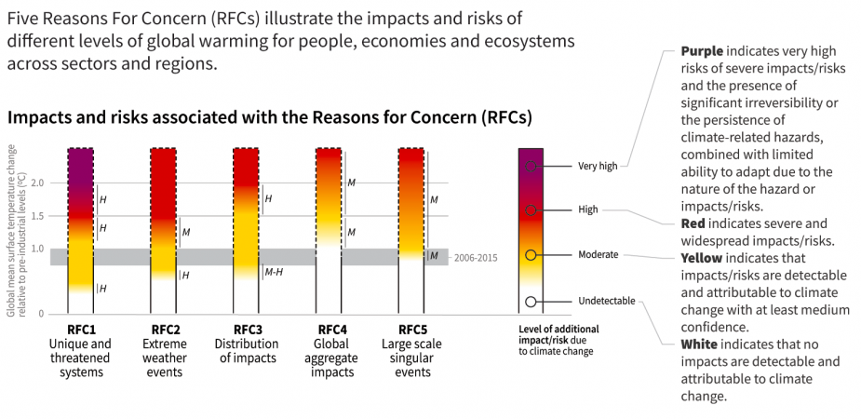

Impacts on Natural Ecosystems
- “Many terrestrial, freshwater, and marine species have shifted their geographic ranges, seasonal activities, migration patterns, abundances, and species interactions in response to ongoing climate change (high confidence). "
Future Risks

- "A large fraction of both terrestrial and freshwater species faces increased extinction risk under projected climate change during and beyond the 21st century, especially as climate change interacts with other stressors, such as habitat modification, over-exploitation, pollution, and invasive species (high confidence)."
- "For medium- to high-emission scenarios (RCP4.5, 6.0, and 8.5), ocean acidification poses substantial risks to marine ecosystems, especially polar ecosystems and coral reefs, associated with impacts on the physiology, behavior, and population dynamics of individual species from phytoplankton to animals (medium to high confidence)" .

How will ecosystems respond?
- Many organisms will adapt to a changing climate by changing their geographic ranges or changing their behaviours. Many organisms are quite mobile and are often observed to shift their habitats to colder areas
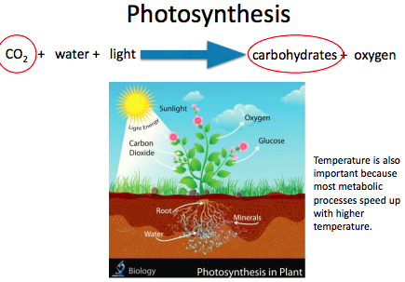
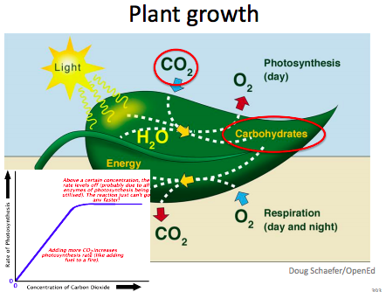
- many plants and animals are capable of moving up mountains, towards the poles, or, in the case of aquatic organisms, to deeper depths. This might be bad considering invasive plant species
- Insects are often very capable of moving with shifting climate and this is why we are concerned about the impacts of climate change on shifting pest infestation problems.
- Most organisms have the ability to change in response to environmental conditions. For example, an organism will reach a larger body size if there is more food available (developmental change), or a polar bear might eat goose eggs if seals are not available (behavioural change), or a rabbit can grow white fur in the winter and brown fur in the summer (physical change).
  - These are all examples of phenotypic plasticity
  - An organism’s phenotype is their observable characteristics and plasticity means changeable. There is also evidence that organisms are actually evolving to adapt to climate change. Evolution leads to heritable changes to an organism's DNA
- Generally, the most vulnerable species are those that cannot "escape" because there is nowhere else to go, or they are large, slow growing organisms that are unable to adapt quickly to a changing climate

- Elevated CO2 has a positive effect on plant growth via the so-called fertilization effect
- greenhouse production of vegetables takes advantage of this phenomenon by artificially increasing levels of CO2 inside greenhouses. However, this positive effect on plant growth can be offset by other climate variables like temperature and precipitation
- C4 plants not greatly affected by CO2 fertilization

Impacts on Humans
- Many aspects of human life, such as food and freshwater availability are directly related to processes within ecosystems

Observed Impacts:
- "Based on many studies covering a wide range of regions and crops, negative impacts of climate change on crop yields have been more common than positive impacts (high confidence)."
- • "Impacts from recent climate-related extremes, such as heat waves, droughts, floods, cyclones, and wildfires, reveal significant vulnerability and exposure of some ecosystems and many human systems to current climate variability (very high confidence)."
- • "Violent conflict increases vulnerability to climate change (medium evidence, high agreement)."
Future Risk
- • "Climate change over the 21st century is projected to reduce renewable surface water and groundwater resources significantly in most dry subtropical regions (robust evidence, high agreement), intensifying competition for water among sectors (limited evidence, medium agreement)."
- • "…global marine-species redistribution and marine-biodiversity reduction in sensitive regions will challenge…fisheries productivity… (high confidence)"
- • "For the major crops (wheat, rice and maize) in tropical and temperate regions, climate change without adaptation is projected to negatively impact production for local temperature increases of 2oC or more…(medium confidence)" (IPCC, 2014).
- • "All aspects of food security are potentially affected by climate change, including food access, utilization, and price stability (high confidence)."
- • "Throughout the 21st century, climate change is expected to lead to increases in ill-health in many regions and especially in developing countries with low income, as compared to a baseline without climate change (high confidence)."

Ecosystem Services
- Pollination – this is the process whereby plants are fertilized through the movement of pollen from the male part of a flower to the female part. Fertilization is required by plants in order for them to produce seeds. It has been estimated that about a third of the world's crop production depends on pollination.
- Water purification – water is constantly recycled throughout the earth and atmosphere via precipitation and evaporation. Ecosystems like forests and wetlands can slow down the movement of water and as the water moves through these ecosystems water becomes purified via many important chemical and biological processes. You can think of ecosystems as being large natural water filtration systems!
- Erosion protection – vegetation protects the banks of rivers and streams and coastal areas from erosion primarily through the stabilization of the soil.

What’s in Store for Canada?
- Some Climate sensitive areas in Canada are:
  - Natural Resources
    - Forestry
      - Increases in fires, pests (ie. mountain pine beetle), diseases, droughts
    - Mining
      - Built and transportation infrastructure
    - Climate change will impact the:
      - Demand
        - Increase in demand during weather events like heat waves
      - Supply
        - Extreme weather can damage production facilities due to flooding, storms, etc.
        - Change in hydropower production
      - And transmission of natural resources
        - Damage to lines, pipes, etc.
  - Food Production
    - Climate change will impact things like
      - Crop productivity
      - Pollinator health
      - Animal production
      - Water supply
      - Food processing
      - Prests
      - International trade
  - Human Health
    - Air quality
      - Ozone will increase
      - Allergens
    - Natural disasters
    - Temperature extremes
    - Climate sensitive diseases (ie. lyme disease)

  - Water andTransportation Services
    - Road distress
    - Railroad buckling
    - Impact to infrastructure
    - Municipal water bans
    - Great lake water levels

Unit 7

To fight climate change we can:
  - o do nothing
  - o choose to adapt
    - Adapt to the climate changing
    - This could be like building a sea wall to fight rising sea levels
  - o mitigate
    - Try to lower the amount of GHG emissions
- Green roofs are an example of both – it takes advantage of the heat but it also avoids using things that cause emissions of harmful gasses
Climate Change Adaptation
- Two kinds – adaptation in natural systems and adaptation in human systems
- Both are capable of adapting to changes in climate
- We talk about adaptive capacity as an of what/to what question
- Capacity for adaptation depends on the extent of climate change and several additional factors
- Adaptations are strategies that are reducing either the exposure and/or the vulnerability to climate change
- Sometimes an adaptation strategy can actually lead to increased GHG emissions
    - For example, to adapt to climate change, we rely on air conditioning more which leads to more emissions which is a problem
- Video – climate change adaptation
- It is not what solves climate change but it helps us deal with it
- Species are changing their habitat – they are moving farther north or up mountains to adapt to the climate
  - Their path is being blocked off because cities are in the way
  - We have to build migration corridors that give them the opportunity to move where they have to move
  - Bridges over highways are an example or this – gives them the opportunity to cross the highway easily
- United nations program – want to make sure that 1,000,000,000 trees are planted per year
- Trees help with
  - Water conservation – this will be important when it gets hotter
  - Mitigation – takes up some carbon and emissions and use it for photosynthesis so this takes it out of the air
- Refugia – places that don't experience much of climate change – we want species to relocate to these areas to protect them
  - Yukon’s peel river watershed is a refugia for a lot of arctic species
  - This is an area that scientists are investigating to see if they should protect it
- Assisted migration – we help species to move – mostly in response to unfavourable environments
- Very controversial because we shouldn’t bother their habitats but it might be necessary
- Florida nutmeg – endangered by warmer temperatures – scientists moved it and were able to save it
- Mostly done in forestry
  - Artificial reforestation
    - Go out and plant seeds
    - Plant seeds more up north
    - Planting where the trees did not originally occur
  - The better species adapt to the environment, the better it is for us
- Green roofs – plants on a roof
  - Reduce heat in a house
  - Lower energy use – mitigation
  - Reduce air pollution
  - Filter rainwater
  - Reduce stormwater runoff
  - Provide habitat
    - Helps as a stepping stone for animals
- Cool roofs
  - Changing type of material and type of colour we put on our houses
  - Black roof heats the house more so it’s not the best option
  - White roof heats up a lot less
  - Metal is also a good option because it reflects the sun rays back into the atmosphere and therefore keeps from getting too warm
  - But white is still the best option because it reflects and doesn’t absorb as much as metal does
- Adapting to floods
  - Store important documents above potential flood zones
  - Move washing machines to first floor
  - o Have sandbags ready
  - o Move hospitals to higher areas
- Floodplain renaturation – adaptation strategy
  - Natural floodplain buffer floods
  - Many projects to re-nature or create floodplains and wetlands
  - In addition, provide important habitat for species and clean and retain freshwater
- Coastal erosion
  - PEI very vulnerable to erosion and might eventually disappear
  - Hard techniques
    - Building walls to block the water from reaching certain areas
  - Soft techniques
    - Plant certain plant species which keep things together and reduce the amount of erosion
- Storm surge barrier
  - Oosterscheldekering has been declared one of the seven modern wonders of the world
  - It is built to block the water during storms so the levels don’t get higher
- Thames barriers
  - Storm surge barriers
  - Block London from experiencing large flooding
  - Each gate is 20 meters high
- Better forecasting methods
  - Early warning systems
  - Better ways of predicting when things like hurricanes will happen so that we can better combat them
- Heat wave adaptations
  - Toronto example
    - Recommendations for every building to have an on site cooling centre
    - HARS (harmonized heat alert and response system
    - 7 cooling centers throughout Toronto
    - Educate people
- Rainwater harvesting
  - Using it for toilets, etc
- Learning activity:
- Farmers may struggle to produce food for all of humanity
- Climate change might affect that
- Agriculture might flourish in some areas, but might suffer in others
- Farmers might react differently
- There was a bad drought and soil got dry and crumbly, they had to hold up the corn with sticks to keep it from wilting
  - They used adaptation strategies and it helped their crop
  - Years after, another drought happened but there weren't any people capable of doing the same work to help it so it did not produce a good crop
  - Same farm, same crop, same problem – different effects
- Scientists use things to estimate the effect of climate change
- If farmers do nothing to adapt, then there will be serious consequences
- Models show where adaptation will be the most beneficial
- A lot of things depend on political aspects
- Better weather forecasting tools is a good idea
- Scientists have developed strategies but did not consult with those who put these into action
  - Scientists must consult with farmers and others who put them in to action because they know the practicality of it
- 1. Why can we not talk about impacts on agriculture without considering adaptation?
  - Impacts without adaptation are much more severe than with adaptations. It is therefore important to know what type of adaptations farmers are taking to discuss the risk of climate change.
- 2. What are some of the adaptations strategies mentioned in this video?
  - Developing and using drought-tolerant seeds
  - Developing weather forecasting tools that allow farmers to change plans
  - Building up soil organic matter that reduces water run-off
  - Making sure farmers have other job options
- 3. Can you think of any other adaptation strategies important for agriculture?
  - Adjusting planting times
  - Planting different crops better suited for future climate
  - Planting a larger diversity of crops
- Irrigating if water is available (maybe even from collected rainwater)
Mitigation
- Mitigation aims to actually decrease and prevent the amount of climate change that occurs
- This is accomplished through the reduction of greenhouse gases
- Bathtub analogy
  - Bathtub is the atmosphere – GHG flows into and out of it like water in a bathtub
    - flow in = sources of carbon
      - fossil fuel combustion
      - deforestation
    - flow out = sinks of carbon
      - land uptake
      - ocean uptake
  - Human activity (fossil fuel combustion and deforestation) has led to a situation where the flow into the bathtub is greater then the flow out, resulting in an increase in the total amount of GHGs in the bathtub
  - There are two ways we can decrease the amount of GHGs in the tub, we can decrease the flow in, or we can increase the flow out
- Decreasing GHGs we emit can be done in two ways
  - Through demand-side strategies
    - Involves changing our behaviours by either decreasing energy consumption through improved energy efficiencies or through energy conservation
      - Focus on consumption of energy
    - Ex. purchasing an energy efficient fridge or walking to work
    - We can improve on energy efficiency – focus on technology
      - Energy efficiency = service provided/energy used
      - Ex. energy efficient cars (hybrids)
      - Green building ex.
        - Uses 60-65% less energy than most office buildings
        - Solar thermal panels for hot water
        - Elevators generate power when descending
      - As countries get richer, their energy efficiency gets better – they can invest in better technologies
      - Their greenhouse gasses increase as well – they may be more efficient, but they still use more energy because they can afford it
      - This is why we need to focus on energy conservation
      - Many of these conservation methods require a political will
    - Energy conservation – focus on human behaviour/choices
  - Through supply-side strategies
    - Involve a conversion from fossil fuel based energy sources to renewable energy sources such as wind or solar
    - Increasing the amount of CO2 from the atmosphere – increasing the sinks – can be done in several ways which are described as carbon capture and storage
    - Renewable energy
      - Derived from “natural” processes that are replenished constantly
      - Low or no carbon emitting sources
      - Solar energy
      - Wind energy
      - Hydroelectricity
      - Biofuels
      - Biomass is used to produce biofuels and some of these are animal waste, crops, forestry, sewage, etc
    - Geothermal energy
      - Geothermal power – water is heated and turned to steam which then creates power
      - Geothermal heat pump
        - o Soil constantly remains around 12º
        - o In the winter, cold water is heated below ground, and in the summer, hot water is cooled off below ground
    - § Nuclear energy – produce heat by splitting uranium atoms (fission)
      - · Heat is converted to steam which drives turbines to produce electricity
      - · Low GHG emissions (but fossil fuels are consumed during uranium mining)
      - Biggest issue is nuclear waste and the fear of nuclear breakdown
    - Alternative energy sources
      - Benefits
        - Reduced carbon emissions
        - Sustainable
        - Diversified economy
        - Decentralized
        - Can be distributed
      - Challenges
        - Costly
        - Variable output – for solar energy, there is not always sun
        - Potential environmental impacts (nuclear waste; biofuels)
        - “Nimbyism” – Not In My Back Yard idea – they want to use wind power but they do not want anything set up in their backyards
- Carbon capture and storage – removing greenhouse gasses from the atmosphere
  - Carbon sequestration – plant forests or other crops that will take up carbon through photosynthesis
  - Non-biological CCS – taking the carbon from the air and storing it deep under ground – geoengineering
  - Other geoengineering strategies
    - Ocean iron fertilization
      - Iron components are dropped into the ocean
      - Iron is a limiting nutrient to phytoplankton
      - Iron fertilization results in diatom-dominated phytoplankton bloom
      - As the phytoplankton dies, it drops to the bottom of the ocean and keeps carbon sequestered there
      - Negative consequence of this is red tides – too many chemicals in the ocean which results in serious ecological issues
  - Solar radiation management
    - Decreasing the amount of solar radiation reaching the earth’s surface (cooling effect)
      - Stratospheric sulfate aerosols
      - Space projects
    - Increasing surface albedo
      - Increasing the albedo of the earth’s surface by painting roofs and roads white
    - What could go wrong?
      - stratospheric aerosols
        - o Unknown impacts on climate (precipitation)
        - o Ozone depletion
        - o If they sink into the troposphere may seed clouds and increased warming
      - Lessened availability of solar power
      - Seen as a crutch to allow continued carbon emissions
        - Continued ocean acidification
        - Danger of rapid climate change – if systems fail
      - We might be able to decrease warming by reflecting sunlight back into the atmosphere, but this does not help the carbon emissions – this could give us a false sense of security
- Role of governments in climate change mitigation
  - They set GHG targets
    - Intensity based reduction targets – reducing the amount of GHGs that we produce per unit of something
      - Target could be set per capita or per barrel of oil
      - The problem with this is the total amount of GHGs in the atmosphere could go up
    - Absolute targets aim to reduce the amount of GHG in the atmosphere all together
      - This can be done by reducing the total of GHG we emit (sources) or by finding ways to increase the sinks

