- Cost of capital: rate of return that a firm must earn on its existing investment (market value of its assets).
  - Can be defined as the minimum rate of return that the firm must earn on new investment in order to satisfy all the firm’s suppliers of capital.
  - Cost of Capital can be calculated with WACC (see equation 2)

- Symbols used in Finance
  - k= WACC
  - t= tax rate
  - I= annual interest payment of debt
  - F= face value of debt
  - n= number of years to maturity of debt
  - D= annual dividend payment per common share
  - P= market price of security
  - NP= net proceeds to the firm selling a security
  - NPp= Net proceeds from sale of a preferred share
  - NPe= Net proceeds from sale of a common share
  - g= compound growth rate
  - kre = cost of retained earnings
  - ke= cost of equity capital
  - kb = after-tax cost of debt capital
  - kp= cost of preferred shares capital
  - V= Value of the firm(B+ E= Total Capital)
  - B = debt capital
  - E= equity capital

- The firm must keep its business risk exposure unchanged. This can be done by only taking investments with the same business risk as its existing mix off investments.
- A firm must ensure new projects are financed in such a way that firms average capital structure is maintained. This is called the firm’s “Target Capital Structure”.
- To compute WACC we must first define and compute the costs of the following major sources of financing;
  - 1) Long-term debt (bonds)
  - 2) Equity( common shares, and retained earnings
  - 3) Preferred Shares
  - 4) Depreciation

Lecture 1; Capital Structure

Example: a Firm with no debt has a book value equity capital o $8 Million made up of 400,000 shares at 20$ per share.
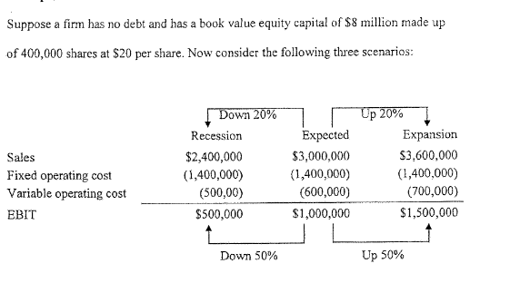

Degree of operating Leverage( DOL)= % Change in EBIT/ % Change in sales

DOL= +50%/+20% or -50%/-20% = 2.5

DOL of 2.5 means when the firm’s sales are up or down by 20% its EBIT is up or down by 50%, by a factor of 2.5.
- The greater the fixes operating cost relative to variable operating cost, the greater the DOL.

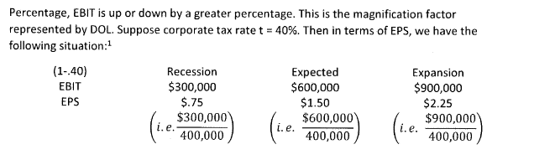

- Degree of Financial leverage ( DFL) : measures the variability of the firm’s EPS in response to the variability of its EBIT in presence of debt in the firm’s capital structure ( see Equation 5)
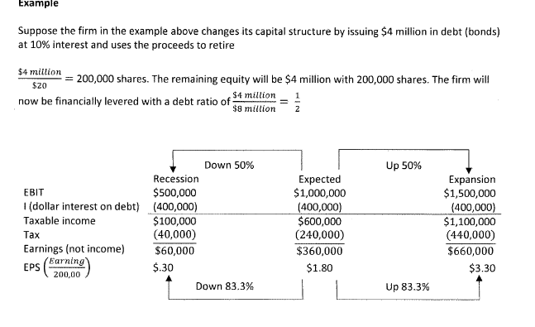
DFL= 83.3%/50% = 1.67
- The DFL off 1.67 means when the EBIT is up or down by 50%, EPS is up r down by 83.3%.
- The Greater the amount of debt to equity, the greater the DFL

 | Recession | Expected | Expansion
EPS | $0.30 | $1.80 | 3.30$

- Firms degree of total leverage ( DTL): combines DOL and DFL ( see equation 6)

- This DTL for the firm = 2.5x1.67= 4.175, which means that when sales are up or down by certain percentage, EPS will be up or down by 4.175 times that percentage.

- DOL reflects the firm’s operating business risk

- DFL reflects financial risk

- DTL reflects the firm’s risk (business and financial)

- Increase in expected EPS comes with increase of financial risk, which means they are rewarding higher risk with higher returns.

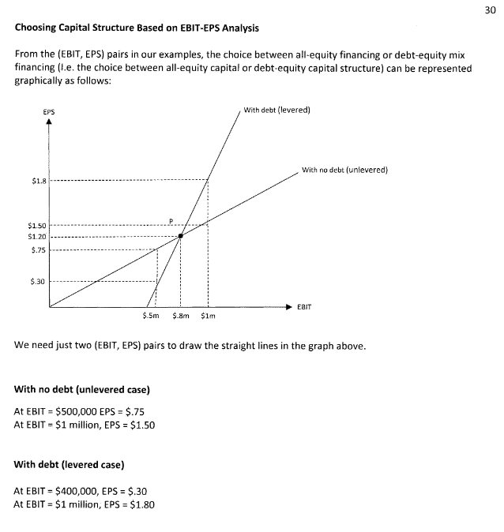
- The EBIT level at which the EPS with no debt equals the EPS with debt is called the Indifference point

Lecture 2

- The greater the debt proportion in the firms financing, the greater the risk of bankruptcy.
- A firm is technically insolvent if the operating income (EBIT) is insufficient to meet its financial obligations as they come due.
  - In other words, the firm is insolvent if the market value of its assets are lower that the market value of its obligations.
  - If a firm does go insolvent that results in equity holders of losing their investment, and debt holders becoming the new owners.
- Capital structures;
  - Let :
    - E= Market value of common equity capital
    - D= market value of debt capital’
    - V= total capital= D+E ( Firms market value)
  - Then capital structure ( assuming no outstanding preferred shares) refers to proportions
    - D/V and E/V ( called weights) refers to the weighted average cost of capital(WACC) or overall
    - Calculated as E/V( cost of equity)+ D/V( after-tax cost of debt)
- Minimizing the firm’s WACC is appropriate goal as any returns in excess of the firm’s WACC are gains earned for shareholders; which reflects in the share price.
- How should optimal Market -Value based capital structure be chosen?
  - Modigliani and Miller ( M&M): Idealized framework of no taxes, no bankruptcy costs, and well-functioning competitive capital markets. This viewpoint established that once a firm’s total capital investment plan is established, changed in the firm’s capital structure will have no effect on the firm’s market value.
    - Overall WAC and cost of capital remains unchanged, debt in tax less world offsets any implicit cost of debt reflected in future equity financing. Since investment plan, future operating cashflows, and operating risk level are fixed, and so is present value of those cashflows (firms market value) remains unchanged. Therefore, WACC is constant. In other words, all firms with the same potential operating income (EBIT) and operating risk will have the same value.

  - M&M with Corporate Taxes;
    - VL = VU+ tcD
      - Assumptions;
        - 1) Debt D is assumed to be raised by the firm by issuing default-risk-free perpetual bond at fixed interest rate i
        - 2) Firms investment plan, assets, and business risk fixed with no growth. No growth in EBIT as firm distributes all its earnings as dividends, and no earnings are retained for new investment ad growth.
        - 3) Firms value is sum of the values of its common stock and debt. With no brokerage -fees for trading/holding.
        - 4) No costs of bankruptcy or financial distress
    - VU= Market Value of unlevered firm, all-equity firm with no debt in capital structure
    - VL= market value of levered firm
    - D= debt at fixed interest rate i
    - Tc= Corporate tax rate
    - tcD= Tax shield

    - Understanding VL+VU+tcD
      - EBIT- I ( Taxable income)
      - Tc( EBIT-I) ( corporate tax payment)
      - ( EBIT- I)-tc( EBIT-1)= ( 1-tc)(EBIT-I) – Earnings or net income.
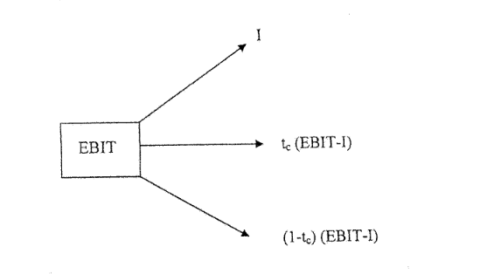
- Total EBIT is distributed into three claimants;
  - I= Dollar interest payments to bondholders who supply debt capital to the firm
  - Tc(EBIT-I)= Corporate tax payments to the government
  - (1-tc)(EBIT-I): Earnings/net income that goes to shareholders who supply equity to the firm.
  - TcI=( tax reduction/ tax savings resulting every year from tax-deductible of interest payments( I)
- When a firm is levered with debt. The equity of the firm is called “ levered equity”( EL)
- EL= VL-D or EL ( SEE EQUATION 7)
- ROE^1= Shareholder’s required rate of return on levered equity ( also known as cost of levered equity of the firm

- M&M Proposition Two ( Under corporate taxes)

  - ROE^U Shareholder required rate of return on unlevered equity(See equation )
  - This formula stats that financial leverage with debt equity ratio of D/EL increases the firm’s cost of equity. This increase is called financial risk premium or implicit cost of debt.
  - As seen with formula 8. leveraging the firm with debt decreases the firm’s overall cost of capital given by WACC
- M&M Propositions in World with no Taxes;
  - Proposition one ( No taxes): changing a firm’s capital structure( debt/equity proportions) does not change the market value of the firm. Unlevered firm with no debt will have the same value as the firm with debt.
  - Proposition two( No taxes): Financial leverage represented by D/EL ratio increases the firm’s cost of equity ( ROE^U- i). This is called financial risk premium
- In a world without taxes, all firms in the same business risk class would have the same cost of capital ROE^U regardless of their debt ratios.

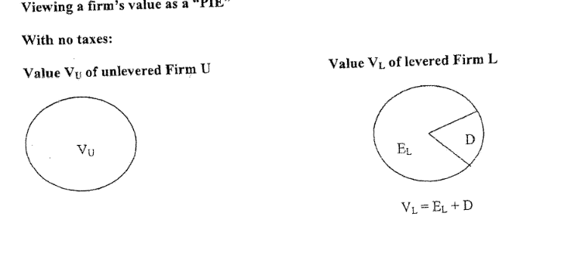
- Under no taxes. The size of the pie for levered and unlevered firms are equal. Financing a firm with mix of debt and equity slices the pie into two pieces ( EL and D).
- In a tax free world only growth of assets, with new economic profitability ( Positive NPV) investments and not financial mix would increase the size of the pie.
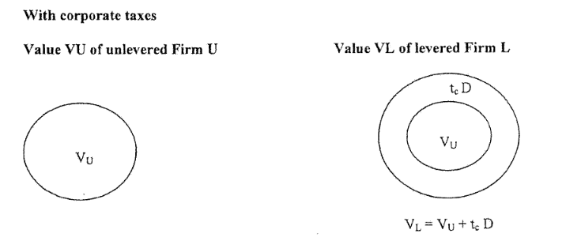
- With corporate taxes, the size of the pie increase, as the value of the ta-shield ( tcD is added).

- In the real world when a firm’ market value of equity reaches zero, it goes bankrupt. VL=EL+D becomes VL=D

- Costs of bankruptcy;
  - Direct Costs: Bankruptcy is a unfriendly divorce between shareholders and bondholders with hefty legal costs of divorce under the bankruptcy law.

  - Indirect costs: Firms on the edge of bankruptcy might restructure debt which can help its survival or simply delay it, in the process it can lose assets as it focuses on staying alive versus staying operational. This can cause further depreciation of assets and lose of assets such as employees, or even simply the business starts in high risk venturing in hopes of staying alive. In anticipating difficulties management may distribute funds through dividends rather than retain them to finance growth and enhance competitive position.

Summary :

- Value of Unlevered Firm ( VU) = Value of Levered firm (VL) M&M Proposition 1 ( No tax)
- Value of any firm= EBIT(1-t)/WACC
- Implication;
  - Share price is constant
  - WACC is constant
- Financial leverage: more leverage increases risk of equity, gains/losses are magnified
- Return cost of equity(rE) : increases with more leverage ; share price remains constant
  - rE= rA+ ( rA-rD)(D/E)

- According to M&M propositions with corporate taxes, a change to debt-levered capital structure will;
  - A) increase market value of the firm
  - B) increase value of the firm’s equity and share price
  - C) increase shareholders required rate or expected rate of return
  - D) decrease the firm’s overall cost of capital (WACC)

Lecture 3;
- Miller’s valuation of a levered firm under both personal and corporate taxes
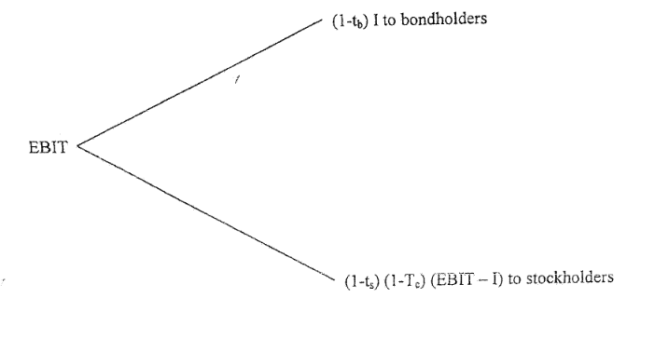

- Tc= Corporate tax rate
- Ts= personal tax rate on cashflows received by stockholders
- Tb= personal tax rate on interest payments received by bondholders

Equation for the valuation below;
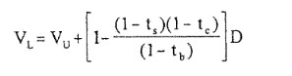
- 1) Interpretations: If there were only coporate tax rates and no personal taxes on equity or interest income received by investors ex; ts= 0 and tb=0 then VL= VU+tcD
- 2) Suppose ts=tb; both equity income and interest income received are taxed but at equal tax rates.
  - VL= VU+tcD

- 3) if (1-tb)= (1-ts)(1-tc) then the factor (1-tb) in the numerator and denominator cancels out giving VL=VU
- 4) If tax rate tb on interest rate is higher than tax rate ts on equity income. This leads to the tax shield gain from leverage to be reduced when the interest income is taxes at a higher rate tb than the equity income at the tax rate ts, which applies in both cases in Canada and US.
- 5) Valuation equation ( 1) ignores the financial distress and bankruptcy costs of default on debt payments.

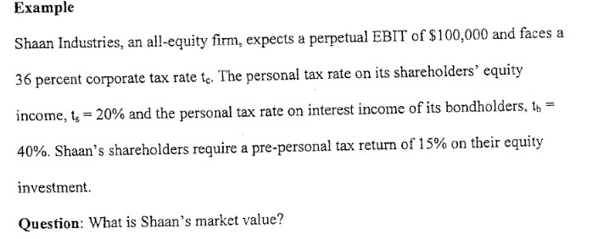
Answer: Shaans’s shareholder earning stream before personal taxes (1-tc) is equal to $100,000, and after personal taxes( 1-ts)(1-tc)100,000 with tc= 36& and ts= 20%, the earning stream = (1-0.20)(1-0.36)100,000 & Shaans shareholders require 15% return from their equity income before personal taxes, so after personal tax requires return= ( 1-0.20)15%

Vu= (1-0.36)100,000/ 0.15 = 426,666.67$ is the market value of Shaan’s firm
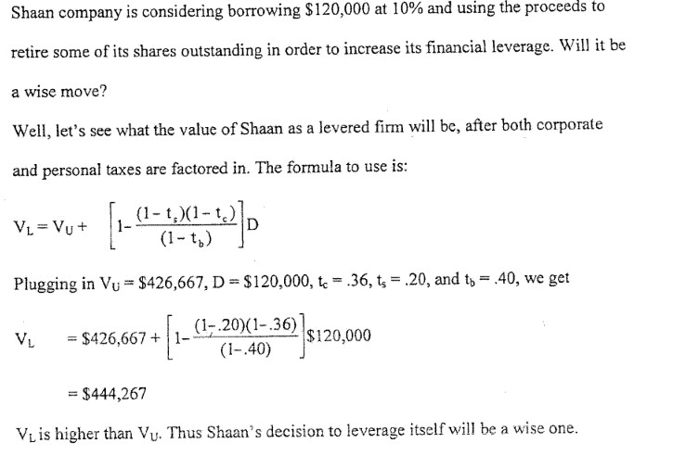

Comment 1; Tax shield advantage of leverage here is 444,267-426,667 = $17600, this is much smaller than tax shield tcD= 0.36x120,000= $43,@00, which would have occurred in the real world with corporate taxes, but no personal taxes.

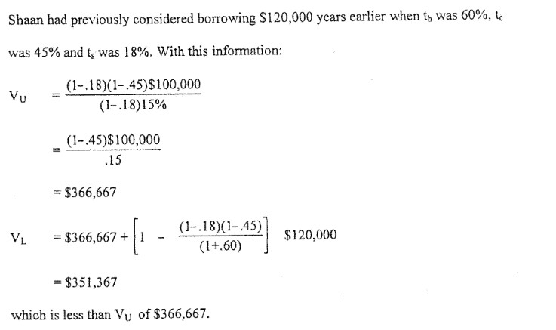
- Vu of $366,667 & VL= 351,367, which means VU is higher, and this would mean it would have not been wise for Shaan to increase leverage years ago since VL<VU, this Is due to the loss of value due to personal tax rates on interest leverage income leverage( tb) was much higher than personal tax rate on equity income ( ts).
  - In essence decrease of corporate taxes and increase of personal taxes would cause a decrease in valuation by market participants.

Dividend policy

- Given a firm’s investment plan, does dividend policy affect the market value or shar price or shareholders wealth? The answer is no (in a world with no taxes)
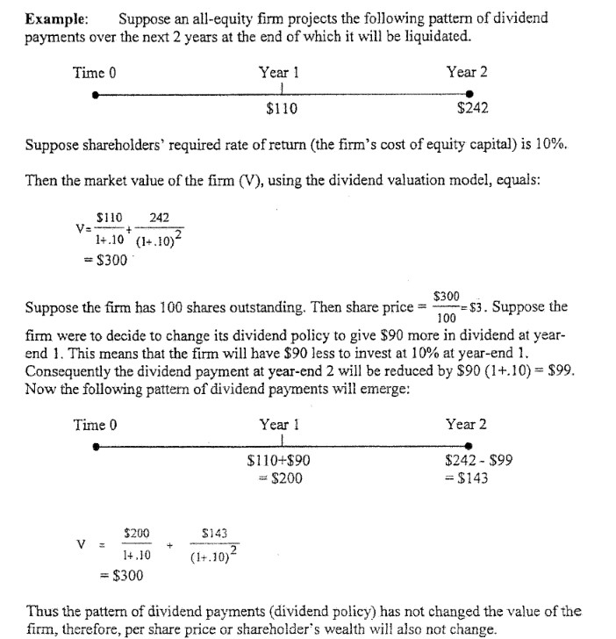

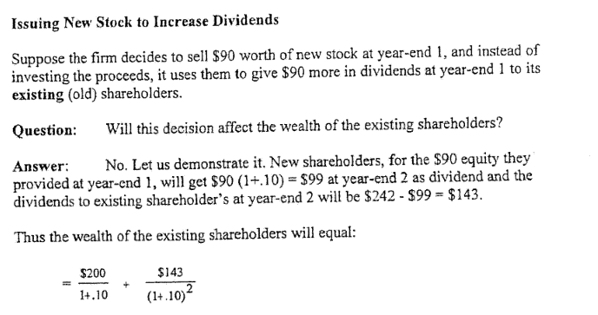

- Real world factors favouring a low dividend payment policy

  - Factor 1: When personal tax rates are higher than corporate tax rates & capital gain tax is lower than dividend tax rate
    - Ex: Company alpha has $1000 extra cash & has the option of 8% 5year T-bills ( Policy 1) or it can give cash as dividend now to its shareholders ( Policy 2) which the investors can invest themselves on the 8% 5 year T-bills. Assume tax rate is 44% for both corporation and shareholder on interest income, and effective tax rate on dividend income is 30%.
    - Question: What amount of cash will shareholders have under each policy.
    - Answer: Under policy 1: After tax interest on T-bill is (1-0.44)8% giving us 4.48%. Investment of 1000$ will lead to $1000(1_0.448)^5 giving us $1244.9. Investors will pay tax rate of 30% on it, therefore (1-0.3)*1244.99 = $871.49
    - Answer 2: Shareholders get 1000$ dividend and must pay 30% tax on it (1-0.30)1000 = $700, which is then invested in T-bill 700(1=0.0448) ^5 = $871.49

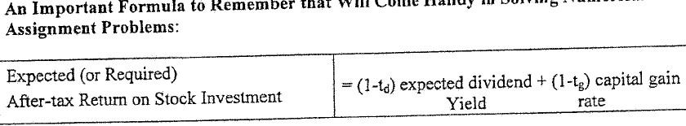
Td= dividend yield = D1/P , where d1 is expected dividend per share at end of the year
P= current stock price
Tg= tax rate on capital gain= Capital gain/P

  - Factor 2: Firm has an incentive for low dividend payouts because with higher dividend payouts, it may have to issue new stock (external equity) to raise new funds to give a higher dividend and thereby incur flotation. Real-world flotation costs lower the firm’s value.
  - Factor 3: Sometimes firms are restricted from dividend payouts above a certain level. Common feature of a bond contract (indenture) has a clause in the contract( covenant) that prohibits dividend payments above a level specified in the contract.

- Real world factors favouring a high dividend payout:

  - Factor 1: Desire for current income
    - In the real world; low yielding dividend stocks usually come with brokerage fees and other transaction fees, while high dividend shares might be able to avoid the direct cash expense.
  - Factor 2: uncertainty of Future Dividend
    - Argued by prof. Myron Gordon that investors price a share by forecasting and discounting future dividends & that a forecast of dividend to be received in the distant future have a greater uncertainty than forecasts in the near-term, and because investors hate uncertainty then lower paying dividend stock could be priced lower due to this.
  - Factor 3: Certain tax and legal benefits from high dividends
    - Corporate investors: When Canadian firms invest in other firms that have high dividend low capital gains stock then they are except from tax. This is an advantage over holding other long-term investments such as bonds due to the fact that interest income is taxable on bonds.
    - Tax-exempt investors: many investors are exempt from tax and high dividend payout might seem more attractive than lower paying dividend stocks.

- The use of unexpected dividend raises or cuts to signal information about expected future dividend is called information content of dividend and phenomenon itself is called signaling model of dividend payouts,
- Clientele Effect: companies with a high dividend payouts attract one group of investors while low-dividend companies attract another, In essence if enough high dividend firms satisfy the dividend loving investors, a firm wont be able to boost its share price by paying high dividend.
- Firms with higher dividend payouts must issue (sell) new stock more often. They are not common a they can be expensive in terms of flotation costs.
- Firms following a residual dividend policy seeks to minimize the need to seeks to minimize the need to sell new ( equity) by maximizing the use of internal equity represented by retained earnings for investment in new projects.
- Firms that pay dividends only after meeting its investment needs from its earning while maintaining a desired debt to equity ratio is called a residual dividend policy.
- Residual dividend policy means that all dividends are only paid after all profitable ( positive NPV) investment opportunities are exhausted. If Investment opportunity in one period is high then dividends would be low or zero.

- Example 1: Firm has $5000 earnings available and has a debt/ratio of ¼. Show what will happen if it follows a residual dividend policy under the following three scenarios
  - Scenario 1:
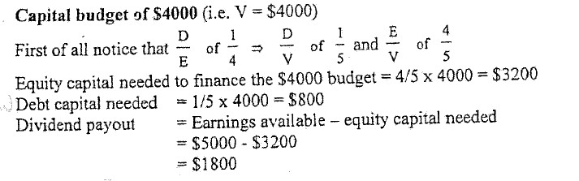

  - Scenario 2:
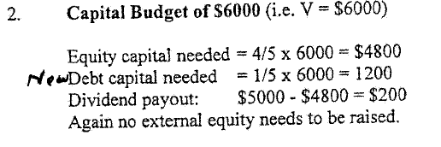
  - Scenario 3: 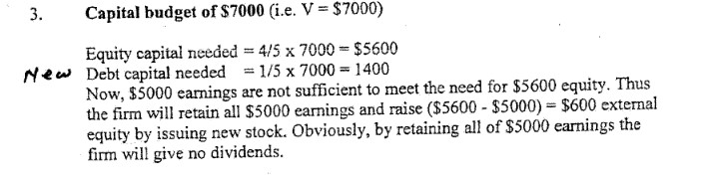

- Young fast-growing firms commonly employ a low dividend payout ratio, while more mature firms use higher dividend payout. An example is Bank of Montreal which ia s lower growing firm with a high payout, vs Canadian tire which is a faster growing firm with a pattern of low payouts.
- Most firms pay out dividend based on the rule of thumb (often called Compromise Dividend Policy
  - 1) Avoid cutting back on economically profitable(+NPV) investment projects to pay a dividend
  - 2)Avoid dividend cuts
  - 3)Avoid the need to sell new equity (ex: new stock for external equity capital)
  - 4)Maintain a target debt/equity ratio(long term goal) even as a shot-term debt/equity ratio varies somewhat.
  - 5) Maintains a target dividend payout ratio.
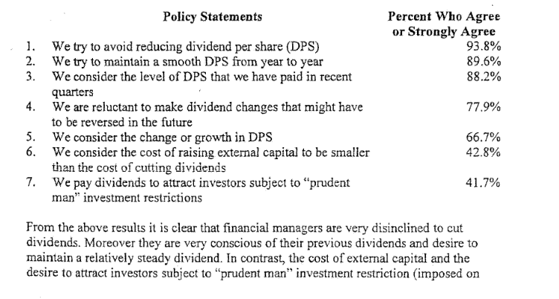

- Example 2: All equity firm has excess cash of $300,000. Firm currently pays no dividends and its earning ( net income) for the year ended at 49,000$
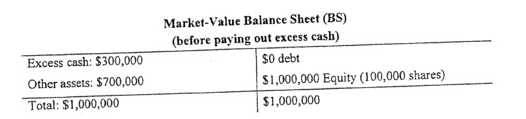
Share price= $1,000,000/100,000 shares = $10 per share
EPS= 49,000/100,000 shares = 0.49$/per share
P/E ratio = $10/0.49 = 20.4

- Option 1: firm pays out the 300,000-excess cash as dividend
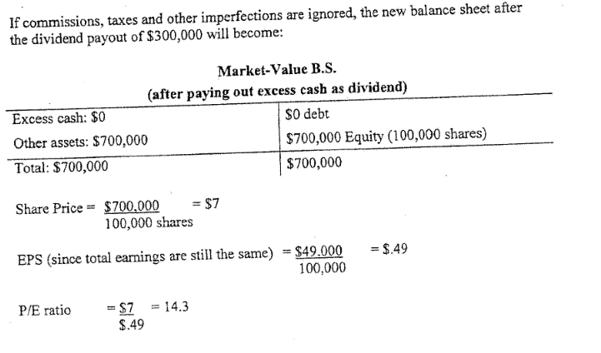
- Option 2: Firm pays out the 300,000 excess cash through share repurchase worth $300,000
  - 300,000/10 = 30,000 shares purchased given the remaining 70,000 owned by investors.
  - Share price – 700,000/70,000 = $10 per share
  - EPS= 49,000/70,0000= 0.70$ per share
  - P/E ratio = 10/0.70 = 14.3
- Under both options the P/E ratio is 14.3. Under the dividend option 14.3 is multiplied with $0.49 giving us a share price of 7$. Under the share repurchase 14.3 is multiplied with 0.70 giving us share price of $10.
- Shares repurchase and Eps; many financial press organizations state that when a share is repurchased it is beneficial as earnings per share increases, however in reality it has no effect on total earnings, just how its distributed, We can look at P/E which remains unchanged in both policies, and that looking at solely EPS will not give any valuable insight.
- Stock dividend: a firm pays out another type of dividend in a form of new stock. This does not change the firm’s value or price of stock.
- Stock- split: Expressed as a ratio example 3 for 2 meaning 3 new stock awarded for 2 old stocks. This is an example of stock dividend. A result of this can cause a decrease in stock price but total value would remain unchanged.
- Reverse split: the opposite of a standard stock split, except shares a reduced. For instance if 3 shares where present earlier, it would be reduced to 1 share. Stock price of share would increase but total value would remain the same.
  - Reasons for reverse split
    - 1) Percent transaction costs to shareholders may be reduced
    - 2) Share price can be increased resulting in a increase of liquidity and marketability of the company’s stock.
    - 3) stocks selling below a certain level are not considered respectable
    - 4) Stock exchanges have minimum price per share requirements
    - 5) Companies who perform reverse split at the same time can buy out any shareholders who end up with less than a certain number of shares. This can be abusive if used to force out minority shareholders.

